**2208-CSE-5331-001**

**DBMS MODELS AND IMPLEMENTATION**

**The University of Texas at Arlington**

**The Department of Computer Science and Engineering**

**Snigdha Kethireddy Geethika Lingamaneni**

**1001757794 1001743466**

**Over all status:** The three policies given to us were CLOCK, LRU and MRU. We executed and passed all the 3 test cases for all the three policies. We used some logics, formulas and new methods as well as functions to obtain the expected output .We calculated all the hit ratio values , retrieved the values of page numbers and number of references for LRU policy in the policytest and policytest2.

**BHR1 and BHR2 values for all the 3 policies:**

**CLOCK:**

|  |  |  |  |  |
| --- | --- | --- | --- | --- |
| ptest | NUMBUF=15 |  | NUMBUF=50 |  |
|  | BHR1 | BHR2 | BHR1 | BHR2 |
| TEST1 | 0.00868 | 0.00876 | 0.00868 | 0.00876 |
| TEST2 | 0.73307 | 2.74539 | 0.73307 | 2.74539 |
|  | 0.73359 | 2.75360 | 0.73359 | 2.75360 |
|  | 0.73381 | 2.75674 | 0.73381 | 2.75674 |
|  | 0.73411 | 2.76093 | 0.73411 | 2.76093 |
|  | 0.73506 | 2.77437 | 0.73506 | 2.77437 |
|  | 0.73530 | 2.77787 | 0.73530 | 2.77787 |
|  | NUMBUF=15 |  | NUMBUF=50 |  |

|  |  |  |  |  |
| --- | --- | --- | --- | --- |
| ptest2 | BHR1 | BHR2 | BHR1 | BHR2 |
| TEST1 | 0.89955 | 8.95556 | 0.89955 | 8.95556 |

**LRU:**

|  |  |  |  |  |
| --- | --- | --- | --- | --- |
| ptest | NUMBUF=15 |  | NUMBUF=50 |  |
|  | BHR1 | BHR2 | BHR1 | BHR2 |
| TEST1 | 0.00868 | 0.00876 | 0.00868 | 0.00876 |
| TEST2 | 0.73301 | 2.74539 | 0.73301 | 2.74539 |
|  | 0.73359 | 2.75360 | 0.73359 | 2.75360 |
|  | 0.73381 | 2.75674 | 0.73381 | 2.75674 |
|  | 0.73411 | 2.76093 | 0.73411 | 2.76093 |
|  | 0.73511 | 2.77520 | 0.73511 | 2.77520 |
|  | 0.73547 | 2.78035 | 0.73547 | 2.78035 |

|  |  |  |  |  |
| --- | --- | --- | --- | --- |
| ptest2 | NUMBUF=15 |  | NUMBUF=50 |  |
|  | BHR1 | BHR2 | BHR1 | BHR2 |
| TEST1 | 0.89955 | 8.95556 | 0.89955 | 8.95556 |

**MRU:**

|  |  |  |  |  |
| --- | --- | --- | --- | --- |
| ptest | NUMBUF=15 |  | NUMBUF=50 |  |
|  | BHR1 | BHR2 | BHR1 | BHR2 |
| TEST1 | 0.32341 | 0.47799 | 0.32341 | 0.47799 |
| TEST2 | 0.80558 | 4.22405 | 0.80558 | 4.22405 |
|  | 0.80826 | 4.21532 | 0.80826 | 4.21532 |
|  | 0.80828 | 4.21584 | 0.80828 | 4.21584 |
|  | 0.80842 | 4.21967 | 0.80842 | 4.21967 |
|  | 0.80830 | 4.21647 | 0.80830 | 4.21647 |
|  | 0.80819 | 4.21349 | 0.80819 | 4.21349 |

|  |  |  |  |  |
| --- | --- | --- | --- | --- |
| ptest2 | NUMBUF=15 |  | NUMBUF=50 |  |
|  | BHR1 | BHR2 | BHR1 | BHR2 |
| TEST1 | 0.89955 | 8.95556 | 0.89955 | 8.95556 |

**All test cases passed for each policy:**

**CLOCK:**

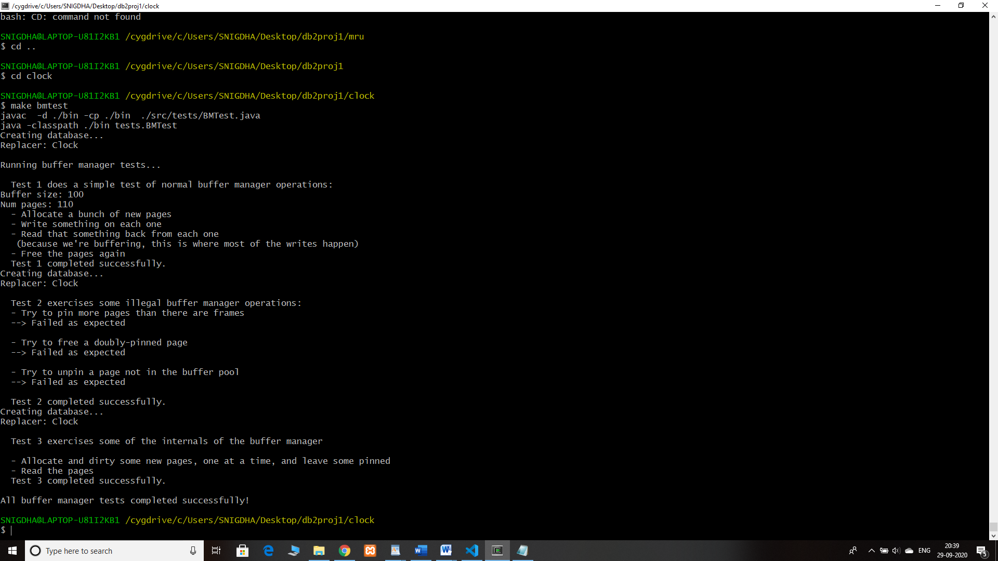

**LRU:**

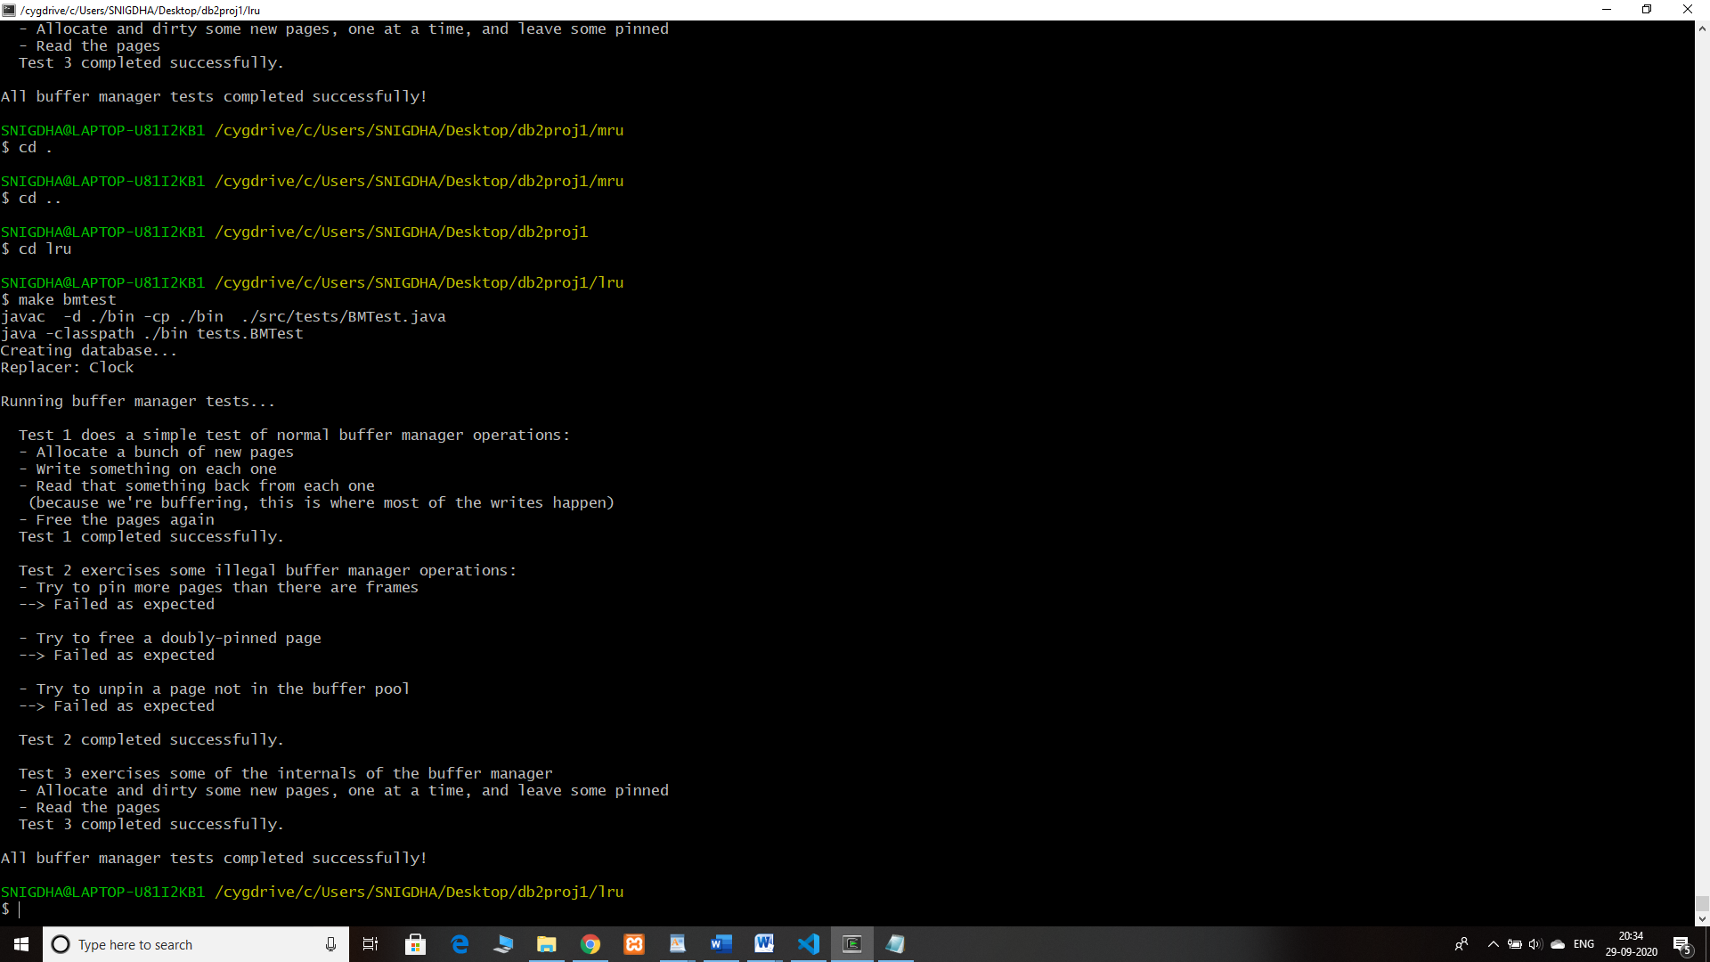

**MRU:**

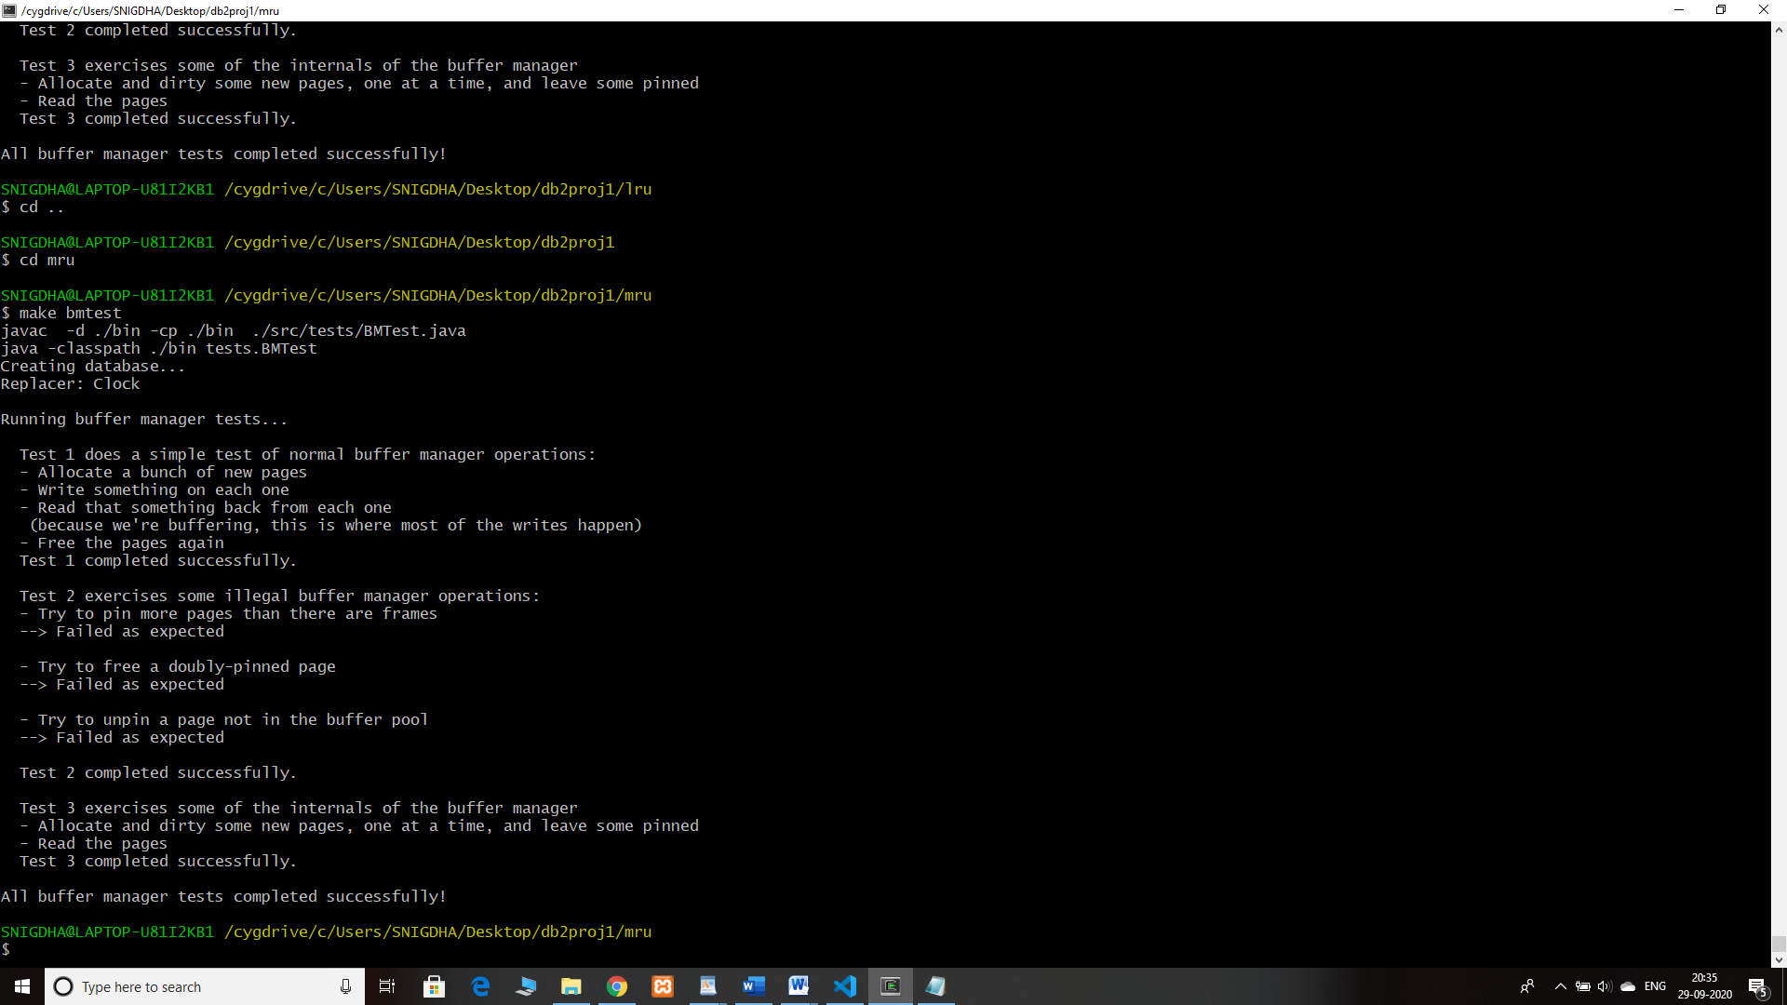

**File Descriptions:**

There are 3 separate subfolders for each policy in the zip folder . Each folder contains src, bin folders makefile and minibase. In src we have bufmgr and test files from which we implemented the execution.

compile and run : make bufmgr

make bmtest

run : make ptest

make ptest2

The file Policy.java in all the 3 folders consists of the code used to implement the policies- clock, lru and mru. We added additional code in pickVictim() and used a new method update() in LRU and MRU to update any changes made to a page. The logic in the method public int pickVictim() and update() is responsible for the policy to run accurately including other functionalities too. We added extra functions for page references in the method sortbyColumn() and used hashmap to calculate the frequency.

**Division of labor:**

* **Snigdha and Geethika–** LRU policy implementation,Clock policy, MRU policy implementation, Report.

Both of us spent a week working on the project together.

**Logical errors and handling:**

* Initially faced errors while running the first test case that is the bmtest itself because of few undefined variables like UNPIN_CLEAN, UNPIN_DIRTY, PIN_DISKIO and PIN_MEMCPY. Then we had to initialize all these variables as Boolean type and set UNPIN_DIRTY=true and PIN_DISKIO=true in bmtest.java
* Calculating bhr1 and bhr2. We initially did not declare the variables properly because we assigned wrong data type which led to conversion problem and the output was 0 for bhr1 and bhr2 even though the other variables had values It took time to figure out that small mistake.
* bufpool exceeded error- Illegal state exception.
* Faced errors while writing the code for sortbyColumn method in BufMgr.java as we did not know how to use hashmap functions exactly but then we were able to figure it out with the help of google.