A Food for Thought: Physics-Guided Mapping of Mountain Hazard Source Zones from Multi-Temporal Satellite Imagery

Abstract
Mountain disasters can begin when water, ice, snow, rock, soil or debris becomes unstable and moves into a valley. This paper sets out a concept for examining these different source materials on a common physical basis. Their approximate gravitational potential energy could be estimated from mass and elevation, while satellite images and terrain data could be used to examine surface change, likely movement routes and downstream exposure. Release magnitude, signs of instability, travel path and exposure are kept separate because a large energy estimate does not mean that failure is imminent. If the method is developed and tested, it may help authorities decide where closer monitoring, field inspection and preparedness are most needed. No dataset has been compiled, no model has been trained and no results are reported. The paper is intended to open discussion and does not replace geological, engineering or emergency-management judgement.
Keywords: mountain hazards; satellite image analysis; gravitational potential energy; change detection; hazard screening; disaster preparedness.

1. Introduction
Mountain regions contain several sources of danger that may interact. A growing glacial lake, an unstable rock face, a weakened natural barrier, heavy rainfall or debris stored in a channel can contribute to the same event. Satellites provide repeated coverage of large and inaccessible areas, but visible change alone does not show how much material may move or how far it may travel. This paper considers whether different source materials can be compared through a common physical measure while retaining the evidence that is specific to each type of hazard.
The paper separates four questions that are often mixed together: how large a release might be, whether the source shows signs of instability, where the material could travel, and what lies along that route. This separation is important because stored energy is not evidence of imminent failure. The proposed method is intended for regional screening and technical review, not for predicting the date or time of a disaster.
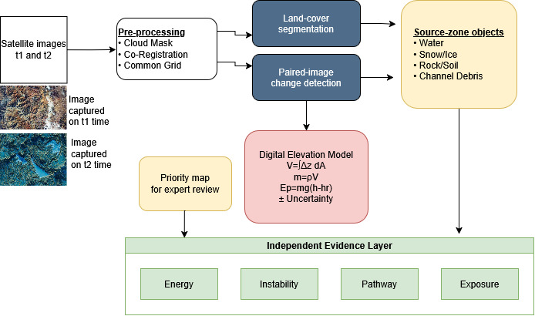
Figure 1. Conceptual outline of the proposed mountain hazard screening method. Satellite observations identify candidate source zones, while terrain and material information support separate estimates of available energy, instability evidence, broad downslope route and downstream exposure.

2. Research Problem and Questions
Hazards are usually studied within separate source classes, which makes comparison across classes difficult. Image-based change detection can reveal where the surface has altered, but it does not show the volume involved, the usable vertical drop, the likely route or the people and infrastructure below. Depth, thickness and density are also uncertain in many mountain settings. The study therefore asks three questions. First, can gravitational potential energy provide a useful basis for comparing source zones? Second, where repeat estimates of available source mass can be made consistently, does the estimated energy change add information beyond a conventional change map? Third, can separate maps of available energy, instability evidence, route and exposure help specialists decide which sites deserve closer examination?
Recent Himalayan disasters, including the 2024 Thame flood in Nepal, show why linked mountain hazards deserve closer study. They do not, however, prove that the method proposed here is effective. Dates, released volumes, route lengths, losses and explanations of cause should come from peer-reviewed papers, official reports or stable data records. News reports may help establish how an event unfolded, but they should not be the final source for measurements or physical interpretation. Testing should begin with well-documented historical cases chosen before the analysis starts.

3. Data Requirements for the Case Study
A case study would begin with corrected Sentinel-2 images, supplemented by Landsat where a longer record is needed. These images can show surface extent and visible change, but they do not normally provide lake depth, material thickness, failure-plane depth or dependable vertical change. A digital elevation model supplies elevation, slope and drainage direction. Volume estimation, however, needs additional three-dimensional or field information. Suitable sources include elevation models from different dates, stereo satellite or aerial images, field or drone photogrammetry, airborne or ground-based lidar, and lake bathymetry. Images should be drawn from comparable seasons, aligned to the same grid and checked for cloud, shadow and seasonal snow.
Reference material could come from published hazard inventories, field records, expert interpretation and licensed high-resolution images. Areas used to develop the method should be kept separate from those used to test it. Image identifiers, acquisition dates, preparation steps, reference sources and reasons for excluding any data should be recorded. None of this work has yet been carried out.

4. Method
The first study is deliberately narrow. It uses two corrected and aligned Sentinel-2 images, one before and one after the period of interest, together with a digital elevation model. A single U-Net labels six surface classes: water, snow or ice, exposed rock, soil, debris and background. Change is identified by comparing the two class maps, after which area and slope rules are applied. A change is called persistent only when it appears on a third usable date or is confirmed by another sensor or field observation. Each candidate source zone is then checked against the original imagery before volume, mass, energy, route and exposure are assessed. No second image model or separate object detector is included in the initial study.

4.1 Minimum Viable Analysis Pipeline
Table 1. Minimum viable analysis pipeline showing the fixed method and expected output at each stage, from input preparation to pathway and exposure screening.
Stage | Input feeds | Fixed method | Output
Input preparation | Sentinel-2 images from two dates and one digital elevation model | Apply cloud masking and co-registration, resample all data to a common grid, and derive slope and elevation layers from the digital elevation model | Matched image pair and terrain layers
Surface mapping | Prepared image pair and reference labels for water, snow or ice, exposed rock, soil, debris and background | Train one U-Net on the six surface classes and apply the same model to both dates | Class map for each date
Change mapping | Class maps from both dates and corresponding spectral bands and indices | Compare the two class maps directly and use band and spectral-index differences as supporting evidence | Changed and unchanged pixels with the type of surface transition
Source-zone formation | Change map, terrain slope, declared area and slope rules, and a third date or independent observation where available | Join adjoining changed pixels, remove small isolated patches, apply the declared rules, and mark persistence only when independently confirmed | Candidate source-zone boundaries
Physical screening | Candidate source-zone boundaries, multi-temporal elevation data, supported thickness, depth or three-dimensional geometry, density ranges and the equations in Section 6 | Estimate changed volume from elevation change; estimate available source volume only where source geometry is independently supported; then calculate mass and energy intervals | Separate intervals for changed volume and mass and, where source geometry is supported, available volume, mass and energy; otherwise retain an area-change record
Pathway and exposure | Candidate source zones, digital elevation model, drainage connections, and mapped settlements and infrastructure | Trace DEM-derived downslope connections from each source and intersect the broad route with settlements and infrastructure; do not estimate runout distance, flow depth, velocity or inundation width at this stage | A broad screening corridor and exposure list, clearly marked as unsuitable for final runout or inundation decisions

This restricted design keeps the central question clear: does a two-date surface map, combined with simple change rules and physical calculations, improve source-zone screening? The same U-Net is applied to both dates and is used only for surface classification. A simpler map based on spectral indices and direct image differences provides the baseline. Testing uses a geographically separate area, and the intermediate maps are inspected so that errors are not hidden inside a single final score. Recent reviews and deep-learning studies of remote-sensing change detection identify image registration errors, illumination differences, pseudo-change and temporal modelling as important methodological issues [11, 12]. Transformer-based bitemporal models provide an additional basis for later comparison because they represent spatial and temporal context jointly [15].
Future work. Once the first case study is complete, later studies may compare DeepLabV3+ with U-Net, examine paired-image or transformer-based change detection, use Mask R-CNN to separate individual objects, test longer image sequences with ConvLSTM, or compare tree-based classifiers built from terrain and weather variables. Each option should be tested separately against the same baseline rather than added to the first study at once. Studies using multiple Sentinel-2 revisits show that the way temporal observations are fused can materially affect segmentation performance, supporting a later controlled comparison of multi-temporal designs [14]. Work on Sentinel-2 land-cover segmentation with sparse labels also shows why reference-label quality, incomplete annotation and domain differences should be examined explicitly [16]. Large-scale landslide detection studies further support separate testing on geographically distinct satellite scenes, especially when labels are incomplete [17].

4.2 Implementation Procedure
The first implementation should be small enough for every stage to be checked by hand. One mountain catchment and at least two dates would allow the full sequence to be tested before it is extended to a larger region. The work may be carried out in Python with standard geospatial, numerical and image-processing libraries. The choice of software matters less than a clear record of the inputs, parameters and intermediate results.
Figure 2 summarizes the main implementation sequence from data collection to source-zone screening. It provides a compact view of the processing stages before the detailed decision logic is considered.

Figure 2. Main implementation sequence. The diagram summarizes data preparation, surface mapping, change detection, source-zone formation, physical screening, route assessment and reporting.
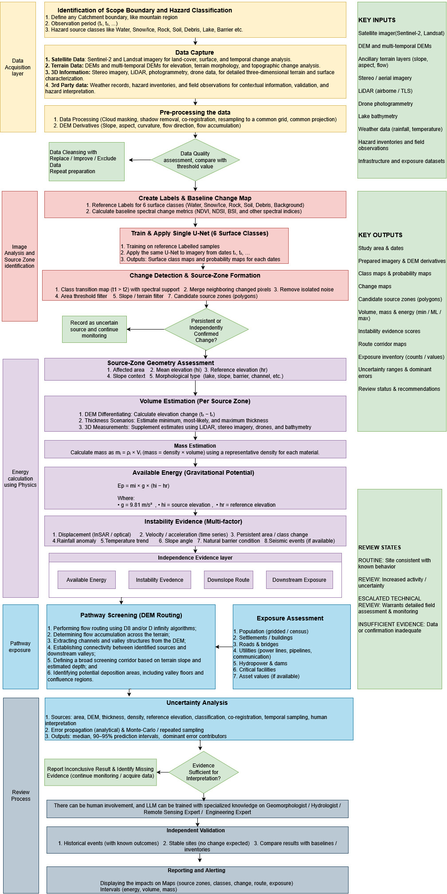
- Define the case. Mark the catchment boundary, observation period, source types and downstream assets to be examined. Record the coordinate system and the reason for choosing each date.
- Collect the inputs. Obtain surface-reflectance satellite images, a digital elevation model, rainfall or temperature records where available, and independent inventories or field observations for checking the result.
- Prepare the images. Apply quality masks, remove cloud and shadow, convert values to physical reflectance where required, resample the bands to a common resolution and align all dates to the same grid. Images that cannot be aligned reliably should be excluded.
- Create reference labels. Mark representative areas for the six classes: water, snow or ice, exposed rock, soil, debris and background. Keep a separate geographic area for evaluation so that nearby pixels from the same feature do not appear in both development and test sets.
- Establish the baseline. Produce a rule-based change map from spectral-index and direct band differences. Use the same geographic test area and the same source-zone rules as the main pipeline.
- Train and check the U-Net. Train one U-Net for the six surface classes and apply the same model to both image dates. Record the input bands, patch size, augmentation, loss function, learning rate, stopping rule and random seed. Inspect the class maps, class probabilities and errors for each surface type.
- Form source-zone objects. Remove isolated noise, join adjoining changed pixels and apply declared limits for area and slope. Record persistence only when a third usable image or an independent observation confirms the change. Assign each object a source type and retain its boundary, date, confidence and supporting evidence.
- Calculate physical quantities. Estimate area from the mapped boundary. Derive released volume from multi-temporal elevation change, or estimate available volume from independently supported thickness or depth measurements. Keep these two quantities separate. If direct measurements are unavailable, use supported low, middle and high scenarios and report volume, mass and available energy as intervals. Do not assign an energy value when depth or thickness is too poorly constrained.
- Screen pathways and exposure. Use terrain flow direction and connected channels to trace a broad downslope route from each source. Intersect this route with settlements, roads, bridges, utilities and other assets. Treat the result only as a first-pass connection map; it does not predict runout distance, velocity, depth, spreading or inundation.
- Represent uncertainty. Repeat the calculations over plausible ranges of area, thickness or height change, density and reference elevation. Keep instability-indicator uncertainty separate. Report the median, interval, data age and main source of uncertainty for every zone.
- Review the result. A specialist checks the imagery, source boundary, physical assumptions and mapped route. Only reviewed cases move to the decision levels described in Section 10.
- Archive the run. Save the image identifiers, code version, model file, parameters, intermediate layers, review comments and final report so that the analysis can be repeated.

4.3 Outputs and Quality Checks
Table 2. Outputs, records and quality checks required at each stage of the proposed mountain hazard screening workflow.
Stage | Record to be kept | Check before continuing
Image preparation | Aligned reflectance images and quality masks | Cloud, shadow and geographic offset are not affecting the study area
Material mapping | Class map and class probabilities | Errors are examined for each material and location, rather than through one overall score
Change detection | Class-transition map, supporting band or index differences, and final change mask | Seasonal snow, shadow, water-level change and image misalignment are considered as alternative explanations
Source-zone identification | Boundary, area, source type and persistence record | The boundary is checked against the original images and terrain
Physical calculations | Separate ranges for changed volume and mass, available volume, mass and energy, and the recorded instability evidence | Units, reference elevation, parameter ranges and assumptions are recorded
Pathway and exposure | Possible route and assets along it | The route is checked for unrealistic crossings or errors in the terrain data
Final assessment | Map, evidence note, uncertainty note and review status | No action level is assigned until a named specialist has reviewed the case

5. Source-Zone Categories and Definitions
- Water storage: expanding glacial lakes, temporary impoundments and weak barriers.
- Snow and ice storage: steep accumulations, thinning glacier fronts and persistent displacement.
- Rock and soil storage: fresh scarps, displaced blocks, exposed surfaces and enlarging debris deposits.
- Channel storage: sediment, boulders or temporary dams capable of joining a later flow.
- Linked sources: spatially connected zones in which one release may initiate another, such as a rockfall entering a lake.

6. Physical Formulation and Uncertainty
Gravitational potential energy is used only as an initial estimate of the energy stored in a mass at elevation. The expression E_{p} = mgΔh places source zones on the same dimensional scale when mass, vertical drop, reference level and uncertainty are estimated consistently. It can therefore support a broad comparison of possible release magnitude. It cannot show whether failure will occur, how quickly material will move, how far it will travel or what force it will exert at a given location.
The later stages depend on material-specific processes. Water movement is governed by breach conditions, discharge, channel shape, turbulence and sediment interaction. Rock failure depends on fractures, block size, impact and basal resistance. Snow and ice respond to temperature, bonding, fragmentation, melting and changes between dry and water-rich flow. Soil and debris may behave as frictional, viscous or mixed materials, with mobility changing as pore pressure and water content change. During travel, any of these flows may gain mass by entraining snow, sediment, rock or water. They may also lose energy through friction, collision, deformation, turbulence, melting and deposition. The fraction of stored energy that becomes motion or destructive work is therefore neither constant nor transferable from one hazard class to another.
Cross-hazard comparison must therefore be limited to clearly defined source properties: estimated mass, vertical drop, gravitational-potential-energy range and, where the data allow, change in that range through time. These quantities may help identify large elevated stores of material and select sites for closer study. Equal energy does not imply equal failure probability, velocity, runout, inundation area, impact pressure, travel time or damage. Two sources with the same mgΔh may have very different consequences because their release mechanisms, material composition, water content, path, entrainment and energy losses are different.
For this reason, source zones should first be compared within the same hazard class using locally supported parameters. Any comparison between different classes should report the energy interval rather than a single value and should keep the hazard class visible. Material-specific analysis must then be applied: breach and hydraulic routing for water; fracture, impact and friction for rock; snow or ice avalanche mechanics and thermal effects for frozen material; and pore-pressure, frictional or rheological flow models for soil and debris. Coupled events, such as a rock–ice avalanche entering a river, require a model that allows changes in material state, entrainment and flow regime. Potential energy remains an initial source-magnitude measure within this framework, not a complete measure of hazard or risk. Physics-informed landslide modelling further supports the principle that regional data-driven analysis should retain explicit physical constraints rather than rely only on statistical associations [13].

6.1 Scientific Assumptions
The screening calculation rests on several assumptions that must be checked in each case. The mapped boundary must represent a real source rather than cloud, shadow, seasonal snow or image offset. The measured height difference, or the chosen thickness range, must reasonably describe the stored or released volume. Density is treated as a range for the bulk material rather than one exact value. The reference elevation is fixed before calculation and is used only to estimate source energy. Terrain routing assumes that the elevation model preserves the important drainage links. Instability indicators are compared only within the same hazard class, season and region. None of these assumptions turns stored energy into a probability of failure, a runout estimate, an impact force or an estimate of loss.
Two different volumes must be kept separate. Released or changed volume, ΔV_{i}, is obtained from elevation difference between two dates. Available source volume, V_{i}, is the material that could take part in a future release and requires independently supported thickness, depth or three-dimensional geometry. A DEM difference does not by itself measure the full available source volume.
ΔVᵢ = ∫Aᵢ Δz(x,y)dA; Δmᵢ = ρᵢΔVᵢ; mᵢ = ρᵢVᵢ (1)
Here, Δz is surface-height change, A_{i} is the mapped zone, ΔV_{i} and Δm_{i} are changed volume and mass, V_{i} and m_{i} are available source volume and mass, and ρ_{i} is bulk density. The changed quantities can be calculated directly only when dependable elevation differences are available. The available quantities require a measured or independently supported thickness, depth or source geometry. Sentinel-2 and Landsat images may define surface boundaries and visible change, but they do not directly measure lake depth, ice or snow thickness, failure-plane depth, deposit thickness or small vertical changes.
Where suitable data exist, Δz should be derived from digital elevation models acquired before and after the observed change. Stereo satellite or aerial images, drone or ground photogrammetry, and airborne or ground-based lidar may provide the required surface geometry. Lake volume should preferably use measured bathymetry; an empirical area–volume relation may be used only as a clearly identified approximation and should be checked against local measurements where possible. Failure-plane depth for rock, soil or debris requires geological, geophysical, borehole or field evidence and should not be inferred from an optical surface image alone.
If no direct thickness or depth measurement is available, the calculation should use declared low, middle and high scenarios supported by published values, local analogues or expert judgement. For each scenario, volume may be written as mapped area multiplied by an assumed mean thickness. The source and range of every assumption should be reported, and area-mapping error, elevation error, image alignment, density and the selected reference elevation should be carried into the mass and energy intervals. When the thickness range is too broad to support a useful estimate, the source should remain an area-change observation and no energy value should be assigned.
Eₚ,ᵢ = ∫Ωᵢ ρᵢ(x,y,z)g(z − hᵣ)dV; Eₚ,total = ΣᵢEₚ,ᵢ = ∫hᵣᴴ g(z − hᵣ)μ(z)dz (2)
Here, g is gravitational acceleration, h_{r} is a fixed downstream reference elevation, Ω_{i} is the independently supported three-dimensional source region, and H is the highest included source elevation. The function μ(z) is available source mass per unit elevation, in kg m⁻¹, summed over non-overlapping source regions connected to the route under study. Equation (2) integrates material stored at different altitudes rather than treating every source as a point mass. For constant density and a mass-weighted mean elevation h_{i}, it reduces to E_{p,i} = m_{i}g(h_{i} − h_{r}). A common reference level and non-overlapping source boundaries prevent inconsistent comparisons and double counting. This is available gravitational energy, not energy necessarily released or delivered downstream. When available source mass is estimated consistently at two dates, the difference may be written as:
ΔEₚ,ᵢ = g[mᵢ(t₂)(hᵢ(t₂) − hᵣ) − mᵢ(t₁)(hᵢ(t₁) − hᵣ)] (3)
A change in estimated energy is interpretable only when the source boundary, density treatment, elevation method, reference elevation and data quality are comparable between dates. Otherwise, ΔE_{p} may reflect mapping or measurement differences rather than a physical change in stored energy. Equation (3) should therefore be reported with an uncertainty interval and a record of all methodological changes.
Uncertainty is carried through the calculation rather than added at the end. Each input is recorded as a measurement with an error, a bounded range or a stated probability distribution. The principal inputs are mapped area, height change or thickness, density, source elevation and reference elevation, together with image-alignment and classification errors where relevant. When the errors are small and nearly independent, the uncertainty in E = ρVgΔh may be estimated from (σ_{E}/E)² ≈ (σ_{ρ}/ρ)² + (σ_{V}/V)² + (σ_{Δh}/Δh)². Related errors, including those between area and thickness, require covariance terms. Where the input ranges are uneven or the calculation is nonlinear, repeated random sampling is more appropriate. Each run draws new input values and recalculates volume, mass and energy. The results should report the median, a 90% or 95% interval, the chance of crossing a screening threshold and the inputs responsible for most of the spread. If the interval is too wide to distinguish one site from another, the result should be reported as inconclusive.

6.2 Altitude-Dependent Cascading Release and Energy Balance
Several stores of water, ice, rock or debris may lie at different elevations along one connected downslope route. A release from an upper source may disturb a lower source through impact, erosion, overtopping or entrainment, allowing previously stationary material to join the event. This secondary release is conditional on local material and barrier conditions; a shared drainage connection alone does not establish that it will occur. The formulation below is a proposed conservation-based extension for research screening, not a calibrated cascade, runout or damage model. It distinguishes stored energy, newly mobilized energy and energy remaining after losses.
Let a(z,t) be the cumulative fraction of the initially available mass at elevation z that has been mobilized by time t, with 0 ≤ a ≤ 1 and ∂a/∂t ≥ 0 for this fixed-inventory description. For a downstream location at elevation h_{d}, the gravitational energy made available by the mobilized inventory, if that material reaches h_{d}, is E_{avail,d}(t) = ∫h_{d}^{H} g(z − h_{d})a(z,t)μ(z)dz. Its activation rate is dE_{avail,d}/dt = ∫h_{d}^{H} g(z − h_{d})μ(z)(∂a/∂t)dz, in watts. These integrals aggregate releases at different altitudes but do not assume simultaneous arrival. The derivative describes newly activated gravitational potential, not the power actually arriving at the downstream location. Fully mobilized, no-loss cases are upper-bound scenarios; partial mobilization and no-secondary-release cases must also be retained.
A complementary differential formulation follows a moving mass along a route. Let s be distance measured downstream, z(s) its mass-centre elevation, M(s) its moving mass and K(s) its kinetic energy. For newly incorporated material that was initially stationary at the local route elevation, a simplified energy balance is dK/ds = −M(s)g dz/ds − ℓ(s), where ℓ(s) ≥ 0 is dissipated energy per unit distance, in J m⁻¹. The integrated balance is K(s_{d}) = K(s₀) + ∫[−M(s)g dz/ds − ℓ(s)]ds, with integration from s₀ to s_{d}. Mass added at a lower source contributes gravitational work only over the remaining descent, avoiding a second count of the upper source’s full drop. The loss term includes friction, turbulence, deformation and inelastic incorporation of stationary material. Tributary inflow carrying kinetic energy, pressure work, deposition, distributed flow and changes in material state require additional balance terms in a hazard-specific model. This simplified balance is not a velocity or runout prediction.
For changing source inventories, differentiation also separates mass growth from elevation change: dE_{p,i}/dt = g[(h_{i} − h_{r})dm_{i}/dt + m_{i}dh_{i}/dt], with fixed h_{r} and mass-weighted h_{i}. A spatially distributed equivalent is dE_{p,total}/dt = ∫h_{r}^{H} g(z − h_{r})∂μ(z,t)/∂t dz for fixed integration limits. These derivatives describe changes in stored energy; a decrease is not automatically energy delivered downstream because material may leave the mapped inventory, deposit or dissipate energy. Numerical differentiation requires enough comparable observations and explicit measurement-error treatment. Two satellite dates support a finite difference, not a dependable instantaneous release rate.
Downstream consequences must be assessed separately from the altitude integral. Remaining kinetic energy and its arrival rate may help describe a modelled event, but neither determines damage without flow depth, velocity, duration, spreading, impact conditions and asset vulnerability. The analysis should report route-specific source inventories, activation scenarios, release timing, energy losses and uncertainty separately, including the possibility that the moving material stops before reaching exposed assets. No cascade fractions, transfer efficiencies, arrival rates or damage values should be inferred from surface imagery alone. The existing Chamoli sensitivity calculation remains a single-source illustration and cannot be reinterpreted as an integrated cascade result without independent lower-source inventories and process data.

7. Instability, Pathway, and Exposure Assessment
Potential energy describes the possible size of a release, not its likelihood. Instability is therefore represented by a separate record of observations. Where suitable data exist, the study records cumulative displacement, movement rate and acceleration, persistent area change, precipitation anomaly, temperature trend, terrain slope and barrier condition for each source zone. Every value is accompanied by its observation period, units, sensor, spatial coverage and measurement uncertainty. Missing indicators remain missing rather than being filled with unsupported estimates.
Table 3. Instability indicators, their measurement requirements and the interpretation of each indicator during source-zone assessment.
Indicator | Measurement | Interpretation
Displacement, rate and acceleration | Cumulative movement, movement divided by elapsed time, and change in that rate from successive radar, GNSS, photogrammetric or elevation observations; report direction, units and measurement error | Movement must exceed measurement error; sustained movement is stronger evidence than one displacement, and acceleration is stronger evidence than a steady rate
Persistent area change | Changed area as a fraction of the source zone, confirmed on at least three usable dates or by two dates plus an independent observation after cloud, shadow, snow and alignment checks | Repeated expansion, scarp growth, lake growth or barrier erosion receives greater weight than a temporary change
Precipitation anomaly | Current 1-day, 3-day and 7-day liquid-equivalent totals compared with the same calendar period in a fixed 30-year reference record, preferably 1991–2020. Use one stated station or gridded product, require at least 80% temporal completeness and average values over the declared catchment. | A large positive anomaly indicates unusual wetness, but its meaning depends on local geology, drainage and antecedent moisture
Temperature trend | Slope of daily or monthly air or surface temperature over a declared window, together with freeze–thaw crossings where relevant | A rising trend or repeated thaw may support concern for snow, ice or frozen rock, but is not a direct measure of slope failure
Slope | Median and upper-percentile slope within the source boundary, derived from the stated elevation model | Slope is a conditioning factor and must be interpreted within the material class; it is not treated as a changing trigger
Barrier condition | Recorded observations of overtopping, seepage, erosion, settlement, cracking, narrowing crest, lake-level rise or new impact sources | The condition is classified as no observed concern, uncertain, deteriorating or urgent concern after image and specialist review

Continuous indicators will be placed on a common 0–1 scale only after their measured values have been retained. If the reference set contains at least 30 independent observations, the score is s = (x − P₁₀)/(P₉₀ − P₁₀), limited to 0–1, using a fixed record for the same hazard class, season and region. If fewer than 30 observations are available, percentile scaling will not be used; the physical value and a locally justified threshold or standardized anomaly will be reported instead. Precipitation and temperature anomalies will use a declared 30-year climatic reference where available. Larger scores will always indicate stronger evidence of instability.
Barrier condition is descriptive rather than continuous. For display, the four classes—no observed concern, uncertain, deteriorating and urgent concern—may be shown as 0, 0.33, 0.67 and 1, while the original class and supporting observation remain visible. Missing values will stay missing. A combined instability index is outside the minimum pipeline. If later testing supports such an index, weights must be fixed before validation, correlated indicators must be grouped or adjusted to avoid double counting, at least 70% of the planned indicator weight must be observed, and the result must be tested across plausible weights. Any index would express relative concern within one hazard class, not failure probability.
Source magnitude, instability, route and exposure are first examined as separate maps. The instability record retains both the measured and normalized values, together with data age, uncertainty and missing observations. Agreement between independent signals, such as accelerating displacement and unusually high rainfall, warrants closer inspection; one weak or isolated signal does not. Any later priority score must keep the four components traceable and must be tested against documented events. Its purpose would be to rank sites for review, not to state the probability or timing of failure.

7.1 Pathway Screening and Hazard-Specific Runout
Pathway assessment has two stages. The first is a regional terrain check. A digital elevation model is used to identify the main downslope connections, likely channel entry points and assets below the source. The result is a broad route for closer examination, not a final runout boundary. It cannot provide flow depth, speed, arrival time, impact pressure or inundation width. Bridges, culverts, dams, lakes, channel changes and errors in the terrain data must be checked because they may divert or block the mapped route.
The second stage begins after the source and type of movement are known. Glacier and rock avalanches need models that account for fragmentation, basal resistance, impact, entrainment and possible change into a debris-rich flow. Debris-flow models need channel shape, sediment concentration, water content, erosion, deposition and a suitable flow-resistance relation. Landslide models must match the expected movement, such as sliding, toppling or flow, and use the relevant ground properties. Flood-wave analysis needs a breach or inflow hydrograph and hydraulic routing through channels and floodplains. In every case, parameters must be checked against local or comparable events, and the results should be given as ranges rather than as one exact boundary.
Linked events require staged modelling. For example, a rock–ice avalanche entering a lake may first need an avalanche model, then an impact and overtopping or breach assessment, followed by flood routing downstream. Material and water transferred from one stage become inputs to the next. A single downslope rule or common angle of reach must not be applied to the entire sequence. In the proposed case study, the general DEM pathway will be evaluated only as a screening product; detailed runout modelling remains a later hazard-specific task.
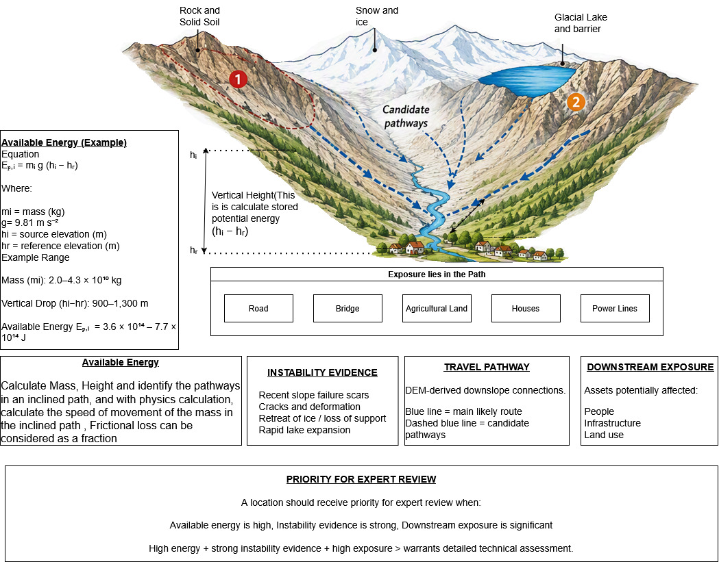
Figure 3. Four-part basis of the screening framework. Available energy represents the possible scale of release; instability evidence records whether conditions are changing; route identifies the broad downslope connection; and exposure records the people, settlements and infrastructure along that connection. The four components remain separate before their relationship is interpreted.

8. Proposed Validation Framework
- Segmentation: class-wise intersection over union, macro F1-score, precision and recall.
- Change detection: change-class F1-score, false-alarm rate and missed-change rate against held-out reference labels.
- Baseline comparison: compare the U-Net class-map difference with spectral-index and direct image differencing under the same geographic split and source-zone rules.
- Energy estimation: error or interval coverage against available field, inventory or published volume estimates.
- Pathway evaluation: for the general screening stage, measure whether the DEM-derived route reaches the correct drainage connection and whether the broad corridor overlaps mapped historical paths. Later runout models must be evaluated separately within each hazard class against observed runout limits, deposit extent, inundation depth or arrival time, depending on the process.
- Ranking evaluation: whether documented event sources appear among the highest-priority zones.
- Controlled removal tests: repeat the ranking without energy change, instability, pathway or exposure information to quantify the contribution of each component.
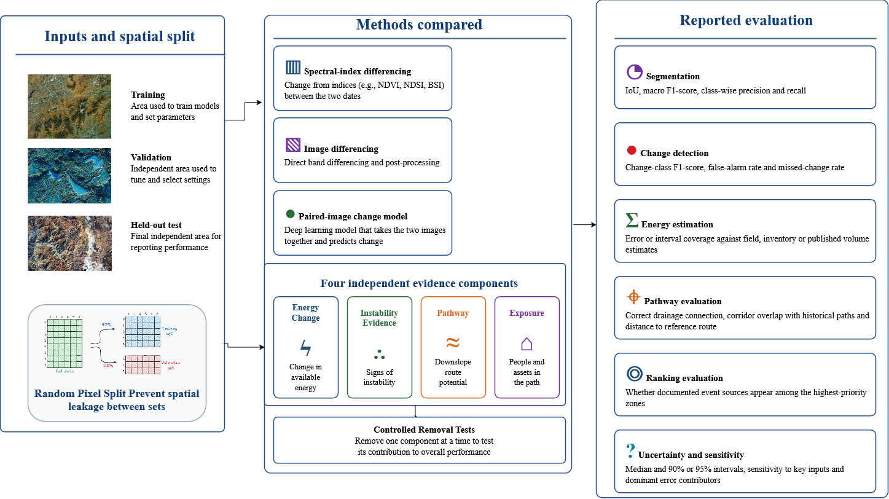
Figure 4. Proposed design for independent evaluation. Development and test areas are geographically separate. Comparison with a simple baseline and removal of individual components are used to determine whether available energy, instability evidence, route and exposure each add useful information.
Figure 4 shows one way to test the method. No dataset has been assembled and no experiment has been performed. Any later claim about accuracy, ranking or practical value should be based on geographically separate test areas, comparison with simpler methods, recorded uncertainty and tests in which one part of the method is removed at a time.

9. Retrospective Demonstration: The 2021 Chamoli Rock–Ice Avalanche
On 7 February 2021, about 27 × 10⁶ m³ of rock and glacier ice detached from the steep north face of Ronti Peak in Chamoli, Uttarakhand. The avalanche entered Ronti Gad, changed into a highly mobile debris flow and continued through the Rishiganga and Dhauliganga valleys. More than 200 people were killed or remained missing, and two hydropower projects were severely damaged. This event was chosen because published satellite and terrain studies provide a source boundary, a volume estimate, pre- and post-event elevation data, movement observations and a documented downstream route. The calculation below is a retrospective screening exercise based on those published measurements, not a new reconstruction of the disaster.
Source delineation and elevation change. The source can be outlined from the fresh detachment scar in post-event imagery and checked against the published collapse polygon. A September 2015 pre-event elevation composite and a 10–11 February 2021 post-event composite are available at 2 m resolution. Their difference identifies source lowering and downstream deposition or scour. Published work reports a collapse volume of about 26.9–27.0 × 10⁶ m³ and more than 10 m of horizontal and vertical movement during the five years before failure. The published volume is used as the central estimate. The interval of 24–30 × 10⁶ m³ is retained only as a provisional sensitivity range; it must not be described as a confidence interval until the original elevation data are reprocessed and their spatial error is propagated.
Approximate mass and energy. The failed mass contained both rock and glacier ice, so no single measured bulk density is available for the whole source. This demonstration therefore uses 2,200–2,600 kg m⁻³ as an explicit sensitivity range for a mixed rock–ice mass rather than as an event measurement. Together with a volume range of 24–30 × 10⁶ m³, it gives a mass range of 5.28 × 10¹⁰ to 7.80 × 10¹⁰ kg. The vertical drop used in the energy calculation is defined as the difference between the mapped source centroid and the first valley-floor reference point on the screening route. A 700–1,000 m sensitivity range is used because that centroid-to-reference measurement has not yet been reproduced from the original elevation files. The corresponding available source energy is about 3.6 × 10¹⁴ to 7.7 × 10¹⁴ J. A middle calculation using 27 × 10⁶ m³, 2,400 kg m⁻³ and 850 m gives about 5.4 × 10¹⁴ J. These values are sensitivity results, not measured event-energy bounds, and they do not represent impact energy, flood energy or energy delivered to either hydropower site.
Route and exposure. A digital elevation model places the source above Ronti Gad and links it downslope to the Rishiganga and then the Dhauliganga. This connection follows the documented event corridor and passes a basic route check, but it remains a screening route because the event changed from a rock–ice avalanche into a debris flow and entrained water and sediment. Exposure will be reported separately as: people or population within the screening corridor; number and type of settlements and facilities; road, bridge and utility length or count; hydropower and other critical assets; and the data date and completeness of each exposure layer. Monetary loss will not be estimated unless a separate, documented valuation method is used.
Uncertainty and interpretation. The example brings together a source boundary, a volume derived from elevation differences, an energy range, a downslope route and a record of exposed assets. It shows that the proposed steps can be completed for one well-documented event. It does not show that the method can detect an unknown source, rank future sites correctly or support a warning. The energy range is controlled mainly by volume, density and the chosen reference elevation. The terrain route cannot reproduce spreading, scour, entrainment or changes in flow behaviour. The case should therefore be treated as a worked example that needs independent reproduction and later testing on events and stable sites that did not shape the method.

10. Potential Application in Disaster Preparedness
If later testing shows that the framework is dependable, the maps could support preparedness review by showing where change has occurred, what evidence supports concern, the possible scale of release, the broad downslope connection and the people or infrastructure in its path. At present, the framework can only identify cases that deserve further technical examination. It cannot recommend evacuation, access restrictions, protective works, infrastructure protection or deployment of emergency resources. Those decisions belong to the responsible authorities and require separate field, engineering, environmental and emergency-management assessments.
The immediate value of the proposed method is a traceable technical record of what changed, why a site was selected, which assumptions were made and what remains uncertain. Remote-sensing specialists, geologists and engineers could review that record before it is passed to public authorities. Decisions about warnings, closures, evacuation, land use or engineering work remain outside this study and with the legally responsible organizations.

11. Review States and Follow-up Actions
Because the framework is unproven, decision levels are limited to three review states. They organize follow-up work and do not authorize warnings, closures, evacuation or engineering action. Movement to a higher state requires independent confirmation, a written uncertainty note and specialist review.
Table 4. Review states, supporting evidence and follow-up actions for routine, uncertain and escalated technical assessments.
Review state | Evidence | Follow-up
Routine | No persistent change, no credible pathway or evidence too weak to interpret | Retain the baseline and continue normal observation
Review | A new or persistent signal is present but remains uncertain | Check another date or sensor, inspect data quality and obtain specialist review
Escalated technical review | Independent observations agree, the pathway and exposure are credible, and conditions are worsening | Increase observation, seek field confirmation where safe and refer the case to the responsible authority

12. Scientific Validation Procedure
- Fix the protocol before testing. Define source classes, dates, exclusions, reference elevation, input ranges, thresholds and evaluation measures before examining outcomes.
- Use independent reference evidence. Build event boundaries, volumes, routes and exposure records from peer-reviewed studies, official inventories, stable data products and field observations. Separate analysts should prepare the reference set where possible.
- Separate development and testing. Select thresholds and processing choices on one set of catchments, then test them without adjustment on geographically separate events and non-events from each hazard class.
- Evaluate every stage. Measure source-boundary overlap, false and missed changes, interval coverage for volume and energy, correct drainage connection, pathway overlap, exposure agreement and ranking of documented sources.
- Test sensitivity and contribution. Repeat the analysis across plausible input ranges and remove energy, instability, pathway and exposure components one at a time. Report which assumptions alter the result and whether each component improves performance over the simple baseline.
- Report failure as well as success. Publish false alarms, missed events, unusable images, inconclusive intervals and cases where terrain routing fails. Practical value should be claimed only after repeated external testing and review by the responsible scientific and public authorities.

13. Requirements Before Operational Use
Before any practical use, the participating organizations would need to agree on data ownership, technical review, legal authority, approval of thresholds, instrument maintenance and the channels used for official communication. Plans would also need to cover communication failure, conflicting evidence and support for people who may need help during evacuation. Exercises should test whether a warning reaches the intended population, is understood and leads to the required action. Review should consider verification time, coverage, completed actions, false alarms, missed events and lessons for the next revision, not only the accuracy of the image analysis.

14. Expected Scientific Contribution
The paper sets out a framework that can be tested; it does not present a proven forecasting method. The Chamoli calculation and the Nepal example show why source conditions, routes and downstream exposure should be considered together, but neither demonstrates that the method is effective. Its scientific value will depend on clearly stated assumptions, transparent uncertainty, dependable reference data and independent tests across several hazard classes, including both past events and stable sites.

15. Limitations
The proposal has not been validated and must not be used to issue warnings, order evacuation, restrict land use or design engineering works. Cloud, shadow and seasonal snow can obscure optical images. Sentinel-2 and Landsat data can outline surface features and visible change, but they do not normally measure lake depth, material thickness, failure-plane depth or reliable vertical change. Volume, mass and energy estimates therefore depend on separate elevation, stereo, photogrammetric, lidar, bathymetric, geotechnical or field evidence. Where only assumed thickness is available, the result must be presented as a scenario interval; if the assumption is not adequately supported, no energy estimate should be reported. An old or low-resolution elevation model may not represent recent terrain change, and differences between elevation models may contain alignment, vegetation and sensor errors. A DEM-derived downslope route is only a screening connection and may miss diversion by local topography, structures or channel change. It is not a final runout or inundation boundary. Glacier or rock avalanches, debris flows, landslides and flood waves require separate models with process-specific inputs and local calibration before velocity, depth, travel time, deposition or inundation can be estimated. Both false alarms and missed detections are possible. Any future map should state the age and source of the data, show the degree of confidence and be checked by the relevant specialists and authorities.

16. Next Steps
The next step is to select a study area and assemble suitable satellite images, terrain data and independent reference material. Assumptions about material thickness, density and elevation should be recorded before calculation. The case study should report its coordinates, image dates, preparation steps, reference labels, geographic separation of development and test areas, model settings and physical constants. Software versions and random seeds should also be preserved. Data and derived maps should be shared where licensing and safety considerations allow.

17. Conclusion
This paper proposes a way to connect observed surface change with stored gravitational energy, terrain, possible travel routes and downstream exposure. Historical events are used to explain the method and show how the calculations may be carried out; they do not establish predictive ability. The next study should repeat the calculations from the original data, carry input uncertainty through every derived quantity and apply a fixed procedure to separate sets of events and stable sites. Claims of practical value should wait until those tests show a clear and repeatable improvement over a simple baseline.

Status of This Paper
This paper records an early research concept and includes one retrospective screening demonstration based on published measurements from the 2021 Chamoli event. No image model has been trained, and the calculation has not been independently reproduced from the original source files. The reported energy interval, route and exposure record are illustrative findings that show how the proposed steps can be connected; they are not a validation of forecasting, runout prediction or operational use.

References
- Ronneberger, O., Fischer, P. and Brox, T. (2015). “U-Net: Convolutional Networks for Biomedical Image Segmentation.” In Medical Image Computing and Computer-Assisted Intervention, Lecture Notes in Computer Science, 9351, 234–241. doi:10.1007/978-3-319-24574-4_28.
- European Space Agency (2015). “Sentinel-2 User Handbook.” Issue 1, Revision 2, 24 July 2015.
- U.S. Geological Survey (2025). “Landsat 8–9 Collection 2 Level-2 Science Product Guide.” Version 6.0, LSDS-1619.
- Crippen, R. et al. (2016). “NASADEM Global Elevation Model: Methods and Progress.” International Archives of the Photogrammetry, Remote Sensing and Spatial Information Sciences, XLI-B4, 125–128. doi:10.5194/isprs-archives-XLI-B4-125-2016.
- Shugar, D. H. et al. (2021). “A Massive Rock and Ice Avalanche Caused the 2021 Disaster at Chamoli, Indian Himalaya.” Science, 373(6552), 300–306. doi:10.1126/science.abh4455.
- Van Wyk de Vries, M. et al. (2022). “Pre-collapse Motion of the February 2021 Chamoli Rock–Ice Avalanche, Indian Himalaya.” Natural Hazards and Earth System Sciences, 22, 3309–3327. doi:10.5194/nhess-22-3309-2022.
- Shean, D., Bhushan, S., Berthier, E., Deschamps-Berger, C., Gascoin, S. and Knuth, F. (2021). “Chamoli Disaster Post-event 2-m DEM Composite (10–11 February 2021) and Difference Map.” Version 1.0, Zenodo. doi:10.5281/zenodo.4558692.
- Maharjan, S. B., Sherpa, T. C. and Shrestha, A. B. (2025). “Thame Valley Glacial Lake Outburst Flood 2024: Causes, Impacts and Future Risks.” International Centre for Integrated Mountain Development, 39 pp.
- World Meteorological Organization (2017). “WMO Guidelines on the Calculation of Climate Normals.” WMO-No. 1203, Geneva.
- Li, C., Wang, Q., Shi, W. and Zhao, S. (2018). “Uncertainty Modelling and Analysis of Volume Calculations Based on a Regular Grid Digital Elevation Model.” Computers & Geosciences, 114, 117–129. doi:10.1016/j.cageo.2018.01.002.
- Cheng, G., Huang, Y., Li, X., Lyu, S., Xu, Z., Zhao, Q. and Xiang, S. (2023). “Change Detection Methods for Remote Sensing in the Last Decade: A Comprehensive Review.” arXiv:2305.05813. doi:10.48550/arXiv.2305.05813.
- Guo, H., Du, B., Wu, C., Han, C. and Zhang, L. (2023). “DeepCL: Deep Change Feature Learning on Remote Sensing Images in the Metric Space.” arXiv:2307.12208. doi:10.48550/arXiv.2307.12208.
- Dahal, A. and Lombardo, L. (2024). “Towards Physics-Informed Neural Networks for Landslide Prediction.” arXiv:2407.06785. doi:10.48550/arXiv.2407.06785.
- Jindgar, K. and Lindsay, G. W. (2024). “Improving Satellite Imagery Segmentation Using Multiple Sentinel-2 Revisits.” arXiv:2409.17363. doi:10.48550/arXiv.2409.17363.
- Chen, H., Qi, Z. and Shi, Z. (2021). “Remote Sensing Image Change Detection with Transformers.” arXiv:2103.00208. doi:10.48550/arXiv.2103.00208.
- Galatola, M., Arnaudo, E., Barco, L., Rossi, C. and Dominici, F. (2023). “Land Cover Segmentation with Sparse Annotations from Sentinel-2 Imagery.” arXiv:2306.16252. doi:10.48550/arXiv.2306.16252.
- Kimura, M. (2019). “Large-Scale Landslides Detection from Satellite Images with Incomplete Labels.” arXiv:1910.07129. doi:10.48550/arXiv.1910.07129.

