Deep Learning for Satellite-Based Mountain Hazard Screening: A Retrospective Failure Analysis on the 2021 Chamoli Rock-Ice Avalanche
Mr. Snigdhajyoti Rakshit,
School of Computing Science and Engineering, VIT Bhopal University, India
Email: snigdhajyotirakshit@gmail.com , snigdhajyoti.23bce11609@vitbhopal.ac.in
ORCID iD: https://orcid.org/0009-0006-8132-5668

Abstract
We built a deep-learning pipeline that screens mountain terrain for possible hazard sources from satellite data, and we tested it on the February 7, 2021, Chamoli rock-ice avalanche in the Indian Himalaya. The pipeline uses 10 Sentinel-2 and terrain channels. A U-Net labels the surface, a change step finds candidate zones, and later steps estimate potential energy by Monte Carlo sampling, trace a steepest-descent (D8) flow route, count exposed assets and rank the zones. U-Net has six classes, but water has no labels, so in practice it learns only five. On a held-out test strip it beat a spectral-rule baseline (macro F1 0.648 against 0.519, with a standard deviation of 0.025 over three seeds, and 0.581 to 0.786 over ten runs), although its F1 for rock and soil stayed near 0.3. The route passed all four documented checkpoints in order, and all three damaged structures lay inside its 250 m corridor. Winter optical change detection, however, missed the source, a northeast-facing face that was 73% shadowed before the event. In follow-up experiments, which were not blind, a published 2 m DEM difference showed up to 183 m of lowering near the source, and the pipeline ranked the best zone within 500 m 14th of 552, while ranking by volume alone put a zone near the source first or second. Energy fell inside an illustrative input range only for a zone chosen after the fact. Because the settings were tuned on the same scene, this is a retrospective test and not an independent one, and it finds a release that has already happened. The main contribution is to show where and why the pipeline fails.
Keywords: deep learning; semantic segmentation; mountain hazard screening; Sentinel-2; U-Net; terrain shadow; change detection; DEM differencing; gravitational potential energy; Chamoli; retrospective evaluation

1. Introduction
High-mountain disasters often originate far above the communities they affect. A rock face, a hanging glacier, a moraine lake or a pile of loose debris in a channel can fail and move down into a valley, sometimes turning into a different kind of flow on the way [1, 2]. On February 7, 2021, about 27 × 10⁶ m³ of rock and glacier ice broke away from Ronti Peak in Chamoli, Uttarakhand [3]. It became a debris flow that destroyed the Rishiganga hydropower project and badly damaged the Tapovan Vishnugad project, and more than 200 people were killed or went missing [3, 4].
Satellites image this kind of terrain repeatedly [5], but visible change alone does not tell us how much material could move, where it would go, or who lives below it. Deep-learning detectors for landslides in Sentinel-2 and SAR imagery [6, 7] produce only a map of changed ground. We test a screening pipeline that expresses different source materials in common physical terms and treats four kinds of evidence separately: the gravitational potential energy available (the possible scale of a release), evidence of instability (whether conditions are changing), the downslope route, and the exposure along it. The pipeline is meant to help prioritize sites for specialist review, not to predict failure. The test is retrospective: the successful source detection uses post-event data (a February 2021 DEM), so it identifies a release that has already occurred and cannot provide advance warning.
This paper evaluates how well the pipeline performs when it is tested against a real event. We ask four questions:
- Does one segmentation model map the surfaces needed for change detection better than spectral rules, on a test area that is geographically separate?
- Does a route traced on the DEM from the documented source reproduce the documented flow path and exposure?
- Is the source detected? If so, where does the pipeline rank the best zone near it among all candidate zones, and does each component contribute?
- Which steps fail, and why?
This paper makes four contributions. First, we implement a minimal screening pipeline with a documented procedure (results vary between training runs; Section 5.2). Second, we run a retrospective check on Chamoli 2021 against a documented reference event, using fixed evaluation rules. Model settings were tuned on the same scene in early runs, so the check is not independent (Section 5.8). Third, we add follow-up analyses: a published 2 m DEM difference for volume, ranking and component-removal tests, a stratified point sample for change accuracy, and ERA5 climate indicators. Fourth, we document where the pipeline fails and why, in particular the conflict between suppressing shadow-induced false change and detecting north-facing sources in winter imagery.

2. Related Work
Shugar et al. [3] reconstructed the event from satellite imagery, seismic records and pre- and post-event DEMs. They put the detachment at about 5,500 m on the steep north face of Ronti Peak (the slope within 1 km of the source faces northeast in the DEM used here; Section 5.4). They estimated a volume of about 26.9 × 10⁶ m³ (95% CI 26.5 to 27.3 × 10⁶) and found that the flow reached the Rishiganga project about 15 km, and Tapovan about 26 km, from the source. Shean et al. [8] released the September 2015 and February 2021 2 m DEM composites that we use. The GEER reconnaissance report [9] documented the damaged sites and their coordinates.
U-Net [10] is a standard encoder-decoder network for dense labeling. It is widely used for Sentinel-2 land cover, including with sparse labels [11] and multi-date inputs [12]. We compare class maps from two dates after classifying each one. This post-classification comparison is simple and easy to interpret, but it adds up the errors from both dates [13]. Spectral indices and change-vector differencing are still common baselines [14].
D8 flow direction [15] gives a single downslope path from each cell. Regional susceptibility tools such as Flow-R instead spread the flow over several downslope neighbors [16]. For DEM-difference volumes, the error has to be estimated with robust statistics on stable terrain, for example the normalized median absolute deviation [17].
The recommended way to estimate the accuracy and area of land-change maps is area-weighted, stratified sampling [18], and we follow it for change detection.
Detecting landslides from satellite data is now commonly treated as a deep-learning segmentation task. Open benchmarks such as Landslide4Sense pair Sentinel-2 bands with DEM and slope layers [6], and SAR-based detectors work in cloud and low light [7]. These studies produce only a map of detected ground change. Susceptibility studies for glacial lakes combine lake inventories with multi-criteria indices [19], but they handle one source type at a time. We did not find a published test that carries one pipeline from change detection through energy, routing and exposure to a ranking of a documented source, with component-removal tests, although our search was not exhaustive. This paper reports one such test for a single event, and its main finding concerns where the optical step fails.

3. Study Area and Data
The scene covers 79.58 to 79.80° E and 30.33 to 30.54° N (about 21 × 23 km), from Ronti Peak to Tapovan, on a 10 m grid in UTM zone 44N (EPSG:32644). These bounds are approximate and were not matched to the published source polygon [3]. The documented source and the downstream checkpoints listed below lie inside them, but anything outside, such as part of the source polygon or a downstream asset, is not seen by the pipeline (Section 7). After masking, 317.8 km² of the scene is usable on both the pre- and post-event images, about 65% of the bounding box (roughly 492 km²). Table 1 lists the data sources and what each is used for.
Table 1: Data sources and their use.
Data | Source | Use
Sentinel-2 L2A, t1 (January 16, 2021) [5, 20] | Microsoft Planetary Computer | pre-event surface map
Sentinel-2 L2A, t2 (February 25, 2021) | Planetary Computer | post-event surface map
Sentinel-2 L2A, t3 (March 12, 2022) | Planetary Computer | persistence (same season)
Copernicus GLO-30 DEM [21] | Planetary Computer; AWS open data (same product) | slope, illumination, routing
2 m DEM difference, September 2015 to February 10 and 11, 2021 | Shean et al. [8], CC BY-NC 4.0 | follow-up source detection, volume
ERA5 daily reanalysis, 1991 to 2021 [22] | Open-Meteo archive API [23] | rainfall and temperature indicators
Settlements, bridges, hydropower | OpenStreetMap (45 features; 0 hydropower) [24] | exposure inventory
Reference event: source, 4 checkpoints, 3 damaged sites | GEER report [9]; Shugar et al. [3] | evaluation
We used bands B02, B03, B04, B08, B11 and B12. B11 and B12 are natively 20 m bands and were resampled to the 10 m grid. For each date we took the least cloudy acquisition day inside a declared window: January 15 to February 6, 2021, for t1, February 8 to March 10, 2021 for t2 and January 15 to March 15, 2022, for t3. Scenes with more than 30% cloud cover were excluded. t1 and t2 come from the same winter, because February 2020 t1 produced mostly inter-annual snow differences.
We digitized labels in QGIS [25] on SWIR false-color (B12-B08-B04) and true-color previews. Each polygon has a class (background, water, snow/ice, rock, soil or debris) and a date (t1, t2 or both). To reduce selection bias in the test strip, rock and soil test labels were placed at randomly generated points (30 on bare ground, then 20 on steep, unshadowed bare ground), and each point was labeled or skipped by eye. The final set has 63 polygons; Table 2 gives the labeled pixels per class and strip.
Table 2: Labeled pixels per class in the training, validation and test strips (t1 and t2 combined).
Strip (t1 + t2 pixels) | background | water | snow/ice | rock | soil | debris
train | 9,126 | 0 | 27,573 | 13,910 | 38,311 | 2,077
validation | 10,208 | 0 | 2,042 | 0 | 5,698 | 0
test | 1,225 | 0 | 11,322 | 1,535 | 5,285 | 0
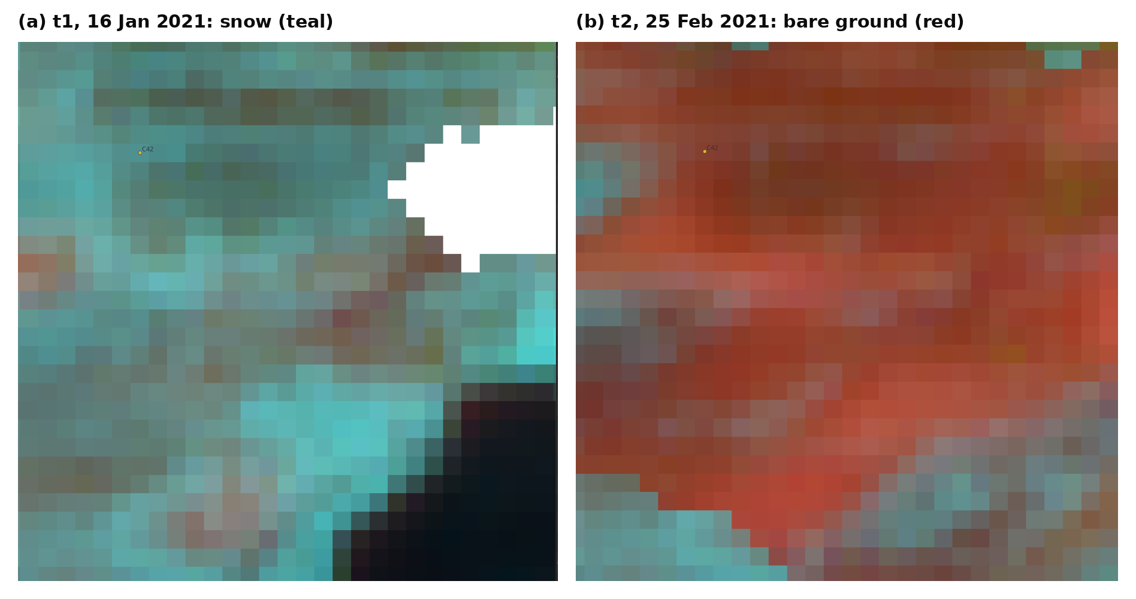
Fig. 1: A labeling example from the blind change-accuracy sample (point C42, 1:1000, SWIR false color B12-B08-B04, one square = one 10 m pixel). (a) Pre-event t1: the pixel is teal (snow). (b) Post-event t2: the same pixel is red (bare ground). The analyst labeled it "change." White areas are masked cloud or no data; near-black areas are terrain shadow, where points were skipped.
We counted a point as "change" only when the material under it differs between the two dates, for example snow turning into bare ground. A difference in shadow or brightness alone does not count. Points that are dark, masked, or on the boundary between two materials on either date were skipped (Fig. 1 shows an example). For polygon labels, the date field records when a surface can be seen: "both" if the same surface shows on both dates, and "t2" if the pre-event image is snow-covered, masked or in shadow.
The reference event has three parts. The source is at 79.716431 E, 30.376403 N, the detachment point on Ronti Peak. There are four checkpoints: Ronti Gad, the Rishiganga plant at about 15 km, the Rishiganga-Dhauliganga confluence, and the Tapovan plant at 26 km. And there are three damaged sites: the Rishiganga plant, Raini bridge and the Tapovan plant.

4. Methods
All thresholds, ranges and rules are declared in one configuration file and archived with each run, together with input hashes, software versions and random seeds. Fig. 2 gives an overview of the six pipeline stages.
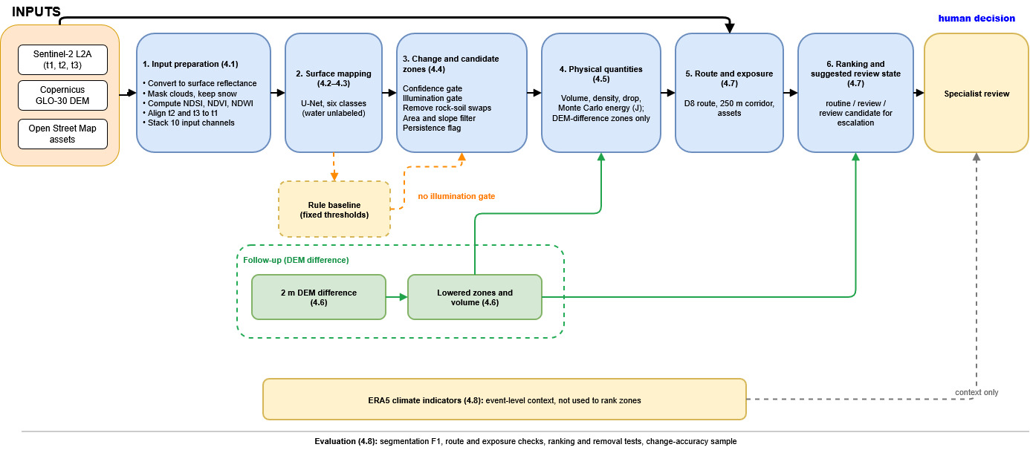
Fig. 2: Overview of screening pipeline. Inputs pass through six stages to a ranked list of zones with a suggested review state; a named specialist makes any escalated review decision.

Fig. 2: Overview of the screening pipeline. The inputs are Sentinel-2 L2A images (t1, t2, t3), the Copernicus GLO-30 DEM and OpenStreetMap assets. They pass through six stages: (1) input preparation (Section 4.1), (2) surface mapping with the U-Net (4.2 and 4.3), (3) change and candidate zones (4.4), (4) physical quantities (4.5), (5) route and exposure (4.7) and (6) ranking with a suggested review state (4.7). The DEM and the asset data also feed stage 5. The rule baseline (dashed orange) replaces the U-Net with fixed thresholds and has no illumination gate. The DEM-difference follow-up (green; Section 4.6) produces lowered zones and their volume, which go into the energy calculation (stage 4) and the ranking (stage 6); energy is calculated only for these zones. ERA5 indicators (4.8, grey) give event-level context only and are not used to rank zones. The software only suggests a review state. An escalated technical review is a human decision that only a named specialist can make. The evaluation (Section 4.8) is summarized at the bottom.

4.1. Input Preparation
Sentinel-2 L2A digital numbers (DN) are converted to surface reflectance R. From processing baseline 04.00 onward, ESA adds an offset of −1000:
R = (DN + O) / 10,000, O = −1000 if baseline ≥ 04.00, otherwise 0 (1)
DN = 0 is treated as no data, and R is clipped to [0, 1.5].
Bright snow is easily mistaken for clouds, so the cloud mask needs an extra rule. Pixels in the scene-classification (SCL) cloud classes [20] are masked, unless they look like snow (NDSI > 0.4 and SWIR1 (B11) < 0.2). SCL cloud shadow is masked only within 3 km of detected cloud, and cloud edges are buffered by 2 pixels. Without this rule, the January image kept only 60% valid pixels, because snow was masked as cloud.
We use three spectral indices, computed from B03 (green), B04 (red), B08 (near infrared) and B11 (shortwave infrared): NDSI [26], NDVI [27] and NDWI [28].
NDSI = (B03 − B11) / (B03 + B11) (2)
NDVI = (B08 − B04) / (B08 + B04) (3)
NDWI = (B03 − B08) / (B03 + B08) (4)
t2 and t3 are co-registered to t1 by phase correlation [29]. Residual shifts above 0.5 px are corrected, and pairs above 2 px are rejected (the t2 residual was 0.52 px and was corrected). Slope and aspect come from the DEM by central differences [30]. The model input is a 10-channel stack: B02, B03, B04, B08, B11, B12, NDWI, NDSI, NDVI and slope. Each channel is standardized with the training strip mean and standard deviation.

4.2. Geographic Split
The scene is cut into vertical strips 64 pixels (640 m) wide. The easternmost 25% of strips form the test area, with one unused gap between it and the development data. 15% at the west edge form the validation area, and the rest is training. Training patches are drawn only from training columns, and any label outside them is masked as "ignore." We moved validation to the west edge after the first runs, because on the east side it covered the 2021 flow channel and removed every debris example from training.

4.3. Surface Mapping
One U-Net [10] (Fig. 3) labels six classes (background, water, snow/ice, rock, soil and debris) on all three dates, using the same weights for each date. We train it with a cross-entropy loss over the labeled pixels, using these class weights:
w_{c} = (1 / √n_{c}) / [ (1 / K) Σ_{k} (1 / √n_{k}) ] (5)
Here n_{c} is the number of training pixels of class c, and K is the number of classes that have training pixels; the sum runs over those classes only. A class with no training pixels gets w = 0. Water has no labeled pixels in any strip, so its weight is 0 and the model is in effect trained on five classes. Water is also not evaluated on the test strip. Table 3 lists the training and inference settings.
Table 3: U-Net training and inference settings.
Setting | Value
Architecture | U-Net, 32 base channels, depth 4 (four downsampling steps)
Input | 10 channels, 128 × 128 patches
Batch size, patches per epoch | 16, 800
Optimizer | AdamW [31], learning rate 10⁻³, weight decay 10⁻⁴
Schedule | cosine annealing [32], up to 30 epochs
Augmentation | random 90° rotations and horizontal flips
Model selection | lowest validation cross-entropy, patience 6
Inference | sliding window, 256 px tiles, 32 px overlap, linear blending
Seeds | 0, 1, 2 (results given as mean +/- sd)
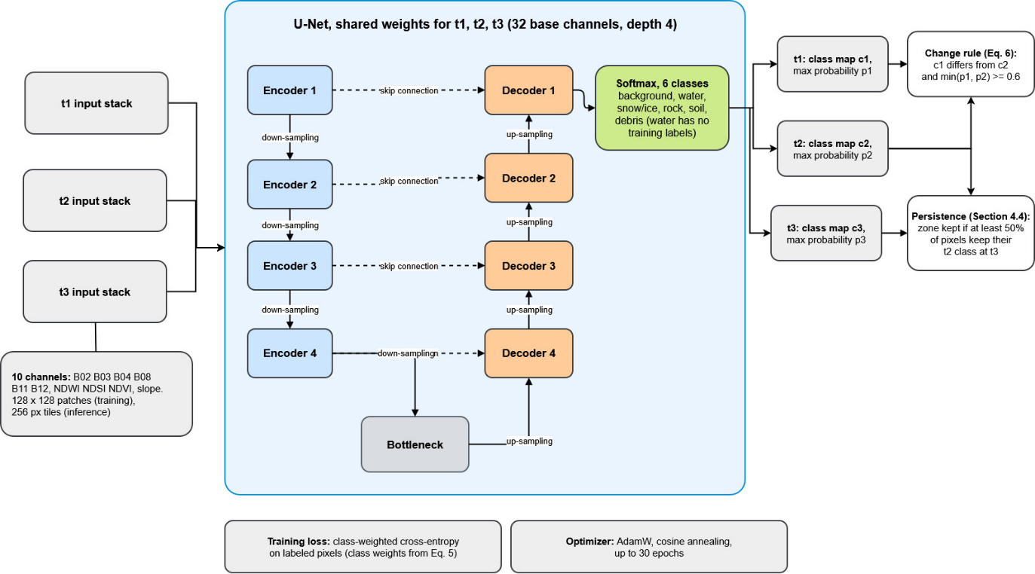
Fig. 3: One U-Net with shared weights maps the surface at t1, t2 and t3; the class maps feed the change rule (Eq. 6) and the persistence check.

Fig. 3: The surface-mapping model (Section 4.3). The t1, t2 and t3 images each go through the same U-Net, so all three dates share one set of weights. Each input is a 10-channel stack (B02, B03, B04, B08, B11, B12, NDWI, NDSI, NDVI and slope), cut into 128 × 128 pixel patches for training and 256 px tiles at inference. The network has 32 base channels and depth 4: four encoder steps that downsample, a bottleneck, and four decoder steps that upsample, with a skip connection from each encoder level to the decoder level at the same depth. A softmax layer gives six class probabilities; water has no training labels, so the model in effect learns five classes. For each date we keep the class map (c1, c2, c3) and the maximum probability (p1, p2, p3). The change rule of Eq. (6) uses the t1 and t2 maps, and the persistence check of Section 4.4 compares the t2 and t3 maps. Training uses a class-weighted cross-entropy loss (weights from Eq. 5) and the AdamW optimizer with cosine annealing. The figure shows the overall structure only, not the channel counts at each level.
The rule baseline uses fixed thresholds to assign the same classes. A pixel is snow/ice where NDSI > 0.40 and green reflectance > 0.25, and water where NDWI > 0.15, NIR < 0.15 and slope < 12°. It is background (vegetated) where NDVI ≥ 0.30. Among the remaining bare pixels, it is rock where slope ≥ 35° and soil where slope < 20° and the 3 × 3 standard deviation of B11 is below 0.025, and everything else is debris. A pixel counts as changed when its rule class differs between the two dates and the change-vector magnitude M [14], taken across the common reflectance bands, exceeds a robust threshold set for the scene: T = median(M) + 2.5 × 1.4826 × MAD(M). Here MAD is the median absolute deviation. The factor 1.4826 scales it to the standard deviation of normally distributed data [47], and the cutoff of 2.5 follows the usual recommendation for median-based outlier rules [48].

4.4. Change and Candidate Zones
At each pixel we have the class maps c₁ and c₂ and the maximum softmax probabilities p₁ and p₂ for the two dates. The pixel counts as changed when
c₁ ≠ c₂ and min(p₁, p₂) ≥ 0.6 (6)
We take the sun's elevation e and azimuth φ from the image metadata. For a pixel with slope β and aspect α, the cosine of the solar incidence angle [33] is
cos i = cos θ × cos β + sin θ × sin β × cos(φ − α), θ = 90° − e (7)
A pixel is shadowed if cos i < 0.15 (self-shadow or grazing light), or if terrain between it and the sun blocks the line of sight (cast shadow, traced up to 8 km toward the sun). We remove changed pixels that are shadowed on one date and lit on the other. We also remove swaps between rock and soil, a rule we added after the first runs produced 324 such zones.
Changed pixels are cleaned with a one-pixel morphological opening, grouped by 8-connectivity and kept if their area is at least 5,000 m². Each zone takes its dominant transition and a source type (water, snow/ice, rock/soil or channel storage). Snow/ice and rock/soil zones also need a median slope of at least 15°. A zone is persistent if at least 50% of its pixels keep their t2 class at t3. Because t3 (March 2022) falls in the same season as t2, it may confirm snow transitions; t3 from another season may not.
Instability indicators are kept in their measured units, together with their uncertainty. A normalized score from 0 to 1 (a linear scale between the 10th and 90th percentiles of the reference values, clipped at the ends; Eq. (17)) is assigned only when at least 30 independent reference values are available. The 30 reference years used for the climate indicators in Section 4.8 meet this minimum. Otherwise, the score stays missing, and a missing value is never filled in. The implementation does not combine the indicators into a single instability index. In the Chamoli test, the only instability evidence for a zone is persistence. The ERA5 climate values are event-level context for the source cell and are not used to rank individual zones.

4.5. Physical Quantities
The mass m and gravitational potential energy E of a source are
m = ρ × V (8)
E = m × g × Δh = ρ × V × g × Δh (9)
Here ρ is the bulk density (kg m⁻³), V the volume (m³), g = 9.80665 m s⁻² and Δh the drop (m) from the source's mass-weighted elevation to a reference elevation h_{ref} on the route. Volume, density and drop are each given as a declared distribution (uniform, normal, triangular or fixed) and sampled N = 20,000 times (Monte Carlo) [34]. We report E as its median and 90% interval (5th to 95th percentile). The share of the output spread due to each input is the normalized squared Spearman rank correlation [35] between that input and E. An interval whose high/low ratio exceeds 10 is reported as inconclusive.
We keep observed change separate from available release volume. DEM differencing gives the volume lost or gained over an observed interval, but it does not tell us how thick the material is that could take part in a future release. We therefore do not treat DEM-derived loss volume as available volume, and we never infer energy from area alone. Energy is calculated only when the volume rests on an independently supported thickness range. None was declared for the optical zones in this case, so no optical zone receives an energy value, and these zones remain area-change records. In follow-up A (Section 4.6), the measured lowering in the DEM difference is used as the volume of an observed release, not as a forecast of a future one. For ranking only, we use the energy index
I = ρ̄ × g × A × Δh (10)
where A is the zone area and ρ̄ the mid-range density. I has units of joules per meter of source thickness, and it orders zones as energy would if all had equal thickness. It is never reported as energy.
Stored gravitational potential energy is a physical screening quantity. It does not measure the probability of failure, runout, impact force or loss, so a ranking by energy or by the energy index should not be read as a forecast of failure or of downstream impact. The implementation can also report the probability that energy exceeds a configured screening threshold. This output is implemented but was not evaluated in this study, so no such result is reported here.

4.6. DEM-Difference Volume and Its Error (Follow-up A)
Take a zone of n lowered pixels with pixel area a and elevation changes dz_{i} (post-event minus pre-event, after bias removal). Its lost volume is
V = a × Σ |dz_{i}| over the n lowered pixels of the zone, defined by Eq. (13) (11)
We estimate the noise on stable terrain, meaning ground that should not have changed between the two DEM dates. A pixel counts as stable if it has valid elevation in both DEMs, lies on gently sloping ground and is not glacier or snow-covered. Steep slopes are excluded because a small horizontal offset between the DEMs shows up there as a large vertical error, and pixels classed as snow/ice in the surface maps of Section 4.3 are excluded as well. The stable-terrain mask is a per-pixel layer on the 10 m grid that combines these three conditions, and the bias and the noise are computed only where it is true. The noise is the normalized median absolute deviation [17] of dz over stable terrain:
NMAD = 1.4826 × median( |dz − median(dz)| ) (12)
A pixel counts as lowered if
dz ≤ −max(5 m, 3 × NMAD) (13)
DEM errors are spatially correlated [36], so the volume uncertainty uses an effective number of independent samples, with zone area A = n × a and correlation length L = 100 m:
σ_{V} = NMAD × A / √n_{eff}, n_{eff} = max(1, A / (π × L²)) (14)
We take the source elevation to be the mass-weighted center of the lost column, z̄ = Σ (z_{i} + ½ d_{i}) × d_{i} / Σ d_{i}. Here z_{i} is the post-event DEM elevation, so z_{i} + ½ d_{i} is the middle of the lost column, and d_{i} = |dz_{i}| is the lowering at pixel i. Density is one range for every zone, 900 to 2,700 kg m⁻³ (glacier ice to dense rock) [37], because elevation change does not identify the material.

4.7. Route, Exposure and Ranking
We first fill depressions in the DEM by morphological reconstruction [38]. Each cell then drains to the steepest of its eight neighbors (D8) [15]. A zone's route starts at its outlet, the zone cell with the largest contributing area, and runs downstream for up to 40 km. The reference elevation h_{ref} is the first route cell on the valley floor (contributing area ≥ 2 km² and slope ≤ 8°), and Δh = z̄ − h_{ref}. A route that crosses a filled depression deeper than 30 m is flagged as a possible lake, dam or DEM artifact.
The screening corridor is every cell within 250 m of the route. Exposure lists the inventory assets (settlements, bridges, hydropower) that fall inside the corridor, with their distance along the route.
Zones are ordered by a fixed key, applied in this order: suggested review state (review candidate for escalation, review, routine), exposure count (more first), energy or energy index (larger first), persistence (persistent first), number of alternative explanations (fewer first) and area (larger first).
The implementation supports screening decisions and is not an operational warning or response system. For each zone it can suggest one of three states. A zone is suggested as routine when the evidence is weak or the route is poor or short, as review when the change is credible but uncertain, and as a review candidate for escalation only when the change is persistent, the route passes exposed assets and at least two independent instability signals agree. In the Chamoli test only persistence is available as an instability signal (Section 4.4), so no zone can reach the review-candidate state. The software cannot set the fourth state, escalated technical review. Only a named specialist can apply it, and the specialist must record a written uncertainty note. A review candidate for escalation is therefore a software suggestion, whereas an escalated technical review is a professional decision. No automated state authorizes a warning, a closure, an evacuation or engineering action.

4.8. Evaluation Protocol
For each class c on the test strip, with true positives TP, false positives FP and false negatives FN [39], we compute precision P, recall R (not the reflectance of Eq. (1)) and F1:
P = TP / (TP + FP), R = TP / (TP + FN), F1 = 2 × P × R / (P + R) (15)
Macro F1 is the mean F1 over the classes present in the test labels: background, snow/ice, rock and soil.
Suppose there are N zones and m of them lie within a given radius of the documented source. If the zones were ordered at random, the expected best rank would be
E[best rank] = (N + 1) / (m + 1) (16)
We use radii of 500 m, 1 km and 2 km.
Follow-up B applies the ranking to the lowered zones of follow-up A (Section 4.6). It then repeats the ranking without energy, without instability (persistence), without exposure, and without the route (which also removes corridor exposure), and compares the results with simple baselines: largest area first, and largest volume or most confident change first. We planned the same tests for the optical zones, but they cannot be interpreted when the source is not detected (Section 5.4).
For the route check, we trace a route from the documented source. A checkpoint counts as reached if the route passes within 250 m of it. We compare along-route distances with the published distances, and we check the documented damaged sites against the corridor and the inventory.
Follow-up C estimates change accuracy. We sample points at random within strata h of known size N_{h} and obtain n_{h} usable labels per stratum. Each labeled point carries the weight W_{h} = N_{h} / n_{h}, and we compute precision, recall and F1 for the class "change" from the weighted confusion counts [18]. Several strata have very few labels with unanimous outcomes, so bootstrapping would not work there. We report per-stratum uncertainty instead as exact (Clopper-Pearson) [40] 95% intervals for the share of change.
The sampling frame is the set of pixels in the held-out test strip that are valid on both dates (678,791 pixels), which is part of the 3.18 million usable pixels of the whole scene. We defined four strata from the change map of the frozen U-Net run (seed 0) and the change map of the rule baseline. The 70 points were drawn at random with seed 29, at least 100 m apart, with planned sizes of 15 (both maps changed), 15 (U-Net only), 15 (rule baseline only) and 25 (neither). The points were given random identifiers C1 to C70, and labeling followed the rules in Section 3. We then scored the same 70 points against all three U-Net seeds (0, 1 and 2), so the three precision and recall pairs share one sampling frame. In this paper "blind" describes only this sample: the points were drawn at random within strata and identified by random labels. The follow-ups themselves are not blind, because we designed them after the optical failure was known (Section 7).
Follow-up D uses climate indicators. For each window of w days ending the day before the event, we take the precipitation total and the mean temperature x [22] and compare them with the same calendar window in each of the 30 years from 1991 to 2020. With P10 and P90 the 10th and 90th percentiles of those reference values, the score is
s = (x − P10) / (P90 − P10), clipped to [0, 1] (17)

4.9. Implementation and Reproducibility
The pipeline is a Python package (Python 3.10 or later) with a command-line interface. It is built on NumPy [41], SciPy [42], scikit-image [43], rasterio, Shapely and PyTorch [44], and uses pystac-client to fetch the data. We ran the experiments on Kaggle notebooks with an NVIDIA Tesla T4 GPU. The code follows the order of the methods above: each stage reads the output of the previous one, and all thresholds and ranges come from the single configuration described in Section 4. All layers sit on one 10 m grid in UTM zone 44N. When the Planetary Computer DEM endpoint fails, the same GLO-30 tile is read from AWS open data (Section 5.8).
Each screening run stores the configuration as used and a manifest. The manifest records the SHA-256 hash of every input, the model hash and metadata, the library versions and the random seeds. The run also stores the class and change maps (GeoTIFF), the zones and routes (GeoJSON and CSV) and a report. For the reported frozen run, these outputs, the reference labels (GeoJSON), the benchmark and event-evaluation outputs, the follow-up protocol and results, and the notebooks we ran are in the code repository (Data and Code Availability). To reproduce the results, run the stages in order: install the package, acquire the data, rasterize the labels, run the benchmark, acquire the OpenStreetMap assets, run the screening and run the event evaluation. A final check re-runs the energy calculation with the illustrative input ranges of Section 5.1 and compares the result with the corner values given there. Acquiring the data needs internet access to the public data services.

5. Results

5.1. Energy Calculation Check
As a first check, we ran the energy layer on Chamoli with illustrative input ranges: volume 24 to 30 × 10⁶ m³, density 2,200 to 2,600 kg m⁻³ and drop 700 to 1,000 m. These values are assumed for this check. The volume range brackets the published volume [3], but the density and drop ranges have no independent source. We sampled each input independently from a uniform distribution over its range, with 20,000 Monte Carlo samples. Table 4 gives the values from Eqs. (8) and (9).
Table 4: Mass and energy for the illustrative input ranges (Eqs. (8) and (9)).
Quantity | Low | Middle | High
Mass, corner values (kg) | 5.28 × 10¹⁰ | 6.48 × 10¹⁰ | 7.80 × 10¹⁰
Energy, corner values (J) | 3.62 × 10¹⁴ | 5.40 × 10¹⁴ | 7.65 × 10¹⁴
Energy, Monte Carlo 90% interval (J) | 4.30 × 10¹⁴ | 5.37 × 10¹⁴ (median) | 6.61 × 10¹⁴
The Monte Carlo interval is narrower than the corner range, because extreme values of all three inputs rarely occur together. The drop accounts for 64% of the output spread, volume for 23% and density for 13%, so the choice of reference elevation matters more than the density assumption. The corner range itself spans a factor of about two (3.62 to 7.65 × 10¹⁴ J), so agreement with it is weak evidence. These are sensitivity ranges for assumed inputs, not measured bounds on the event's energy.

5.2. Segmentation
On the held-out east test strip the U-Net beat the rule baseline overall (macro F1 0.648 +/- 0.025, mean +/- sd over three seeds, against 0.519; Fig. 4). The gain comes from soil (0.311 vs. 0.009) and background (0.982 vs. 0.713). Both methods find snow/ice easily. Neither separates rock from soil well: the U-Net scores about 0.3 on both classes (0.301 for rock, 0.311 for soil), while the baseline reaches 0.354 on rock but only 0.009 on soil. Water and debris have no test-strip labels, so they cannot be evaluated on this split. Overall accuracy was 0.740 +/- 0.020 for the U-Net and 0.695 for the baseline.
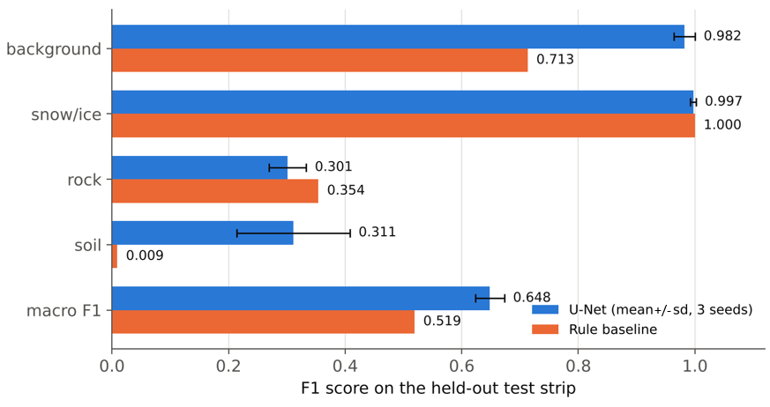
Fig. 4: Per-class F1 on the held-out test strip (test pixels: background 1,225; snow/ice 11,322; rock 1,535; soil 5,285). Blue bars show the U-Net mean over three seeds with +/- 1 standard deviation, and orange bars show the rule baseline.
Training was not bit-reproducible on the GPU we used: the same seed and settings gave a macro F1 of 0.747 in one run and 0.617 in the next. We therefore repeated the three-seed benchmark twice (0.643 +/- 0.078 and 0.705 +/- 0.091). The ten U-Net runs reported here are the three seeds of the frozen benchmark, the three seeds of each of the two repeats, and one additional seed-0 run (3 + 3 + 3 + 1). All ten runs (0.581 to 0.786) beat the baseline, but single runs vary widely, above all for soil (F1 0.015 to 0.755) and rock (0.170 to 0.492), so only means over seeds should be reported (Fig. 5). For seed 2 of the frozen run, the epoch-1 checkpoint was selected as best. This suggests that validation loss is a weak selection signal for rock and debris, because the validation strip contains neither.
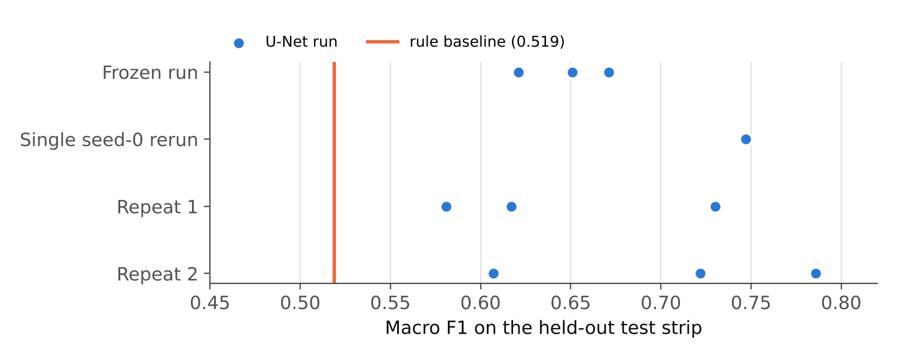
Fig. 5: Macro F1 of every U-Net run (ten runs: the three seeds of the frozen benchmark, the three seeds of each of the two repeats, and one additional seed-0 run). The frozen run is the main result. The two repeats used the same labels and settings after the DEM download source changed (same GLO-30 product). The orange line is the rule baseline.

5.3. Change Mapping
The frozen U-Net run (seed 0) produced 302 candidate zones after 24 were removed by the slope rules (Fig. 6). The illumination gate removed 9.15 km² of class change, and the rule on rock and soil swaps removed 3.17 km². The largest transitions were snow/ice to debris (2.86 km²), background to soil (1.93 km²), snow/ice to soil (1.67 km²), soil to debris (0.99 km²), snow/ice to rock (0.96 km²) and rock to debris (0.68 km²). The zones that changed to debris follow the Rishiganga and Dhauliganga valleys, which fits the 2021 deposits. Zone counts varied strongly between seeds and runs (126 to 371 for the U-Net) and were 434 for the rule baseline, which has no illumination gate.
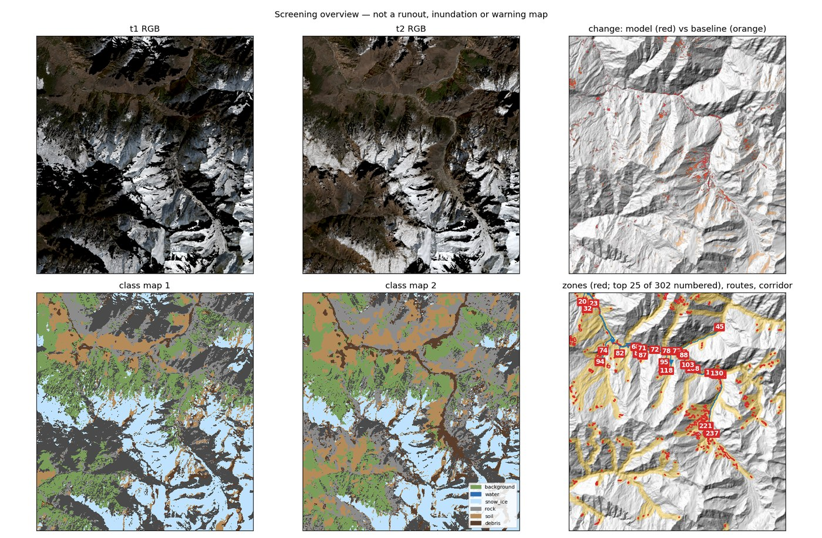
Fig. 6: Screening output of the frozen U-Net run (seed 0): true-color images at t1 (January 16, 2021) and t2 (February 25, 2021), top left and center; changed pixels from the U-Net (red) and the rule baseline (orange) over a hillshade, top right; U-Net class maps for both dates, bottom left and center; candidate zones (red, top 25 of 302 numbered by review order) with their routes (blue) and 250 m corridors (yellow), bottom right. Shadowed north-facing slopes appear black in the January image.

5.4. Event Evaluation with Optical Change
The optical change maps did not detect the source. Within 1 km of the documented source, the face has a slope of 39° and an aspect of 44° (northeast). It was 73% shadowed at t1, 47% at t2 and 47% on both dates. So 26% of the area changed shadow state between the dates and was removed by the illumination gate, and only 27% was lit on both dates. Valid data existed on both dates for 86% of the area, so the loss came from shadow and not from missing data.
Table 5: Optical change near the documented source, by run.
Run | Changed pixels within 1 km, before zone rules | Pixels in zones | Zones within 500 m / 1 km / 2 km
U-Net seed 0 | 112 | 0 | 0 / 0 / 1
U-Net seed 1 | 0 | 0 | 0 / 0 / 0
U-Net seed 2 | 274 | 199 | 0 / 1 / 1
Rule baseline | 763 | 150 | 0 / 1 / 4
As Table 5 shows, no run mapped a zone within 500 m of the source. The zones found between 500 m and 2 km away had changed from debris or soil to snow/ice, so they gained snow. A detachment should instead show a loss of snow and ice and fresh rock appearing. These zones are therefore not detections of the source, and the optical ranking and removal tests cannot be interpreted. For completeness, the nearest zone ranked 6th of 131 zones in the seed 2 run and 12th of 434 for the rule baseline under the full ranking.
The route traced from the documented source follows the documented flow path. It is identical in every run because it depends only on the DEM, and it reached all four checkpoints in order (Table 6, Fig. 7):
Table 6: Route distance to the documented checkpoints (published distances from Shugar et al. [3]).
Checkpoint | Closest approach (m) | Distance along route (km) | Published distance (km)
Ronti Gad | 78 | 2.4 | not given
Rishiganga plant | 28 | 15.6 | about 15
Rishiganga-Dhauliganga confluence | 51 | 17.1 | not given
Tapovan plant | 28 | 23.5 | 26
The route crosses a 34 m filled depression in the gorge. The rule of Section 4.7 flags this as a possible lake, dam or DEM artifact, and we did not investigate its cause. The route falls 2.5 km (about 10%) short of the published distance at Tapovan. This is consistent with a single D8 line cutting across meanders that the real flow followed, but we did not test that explanation.
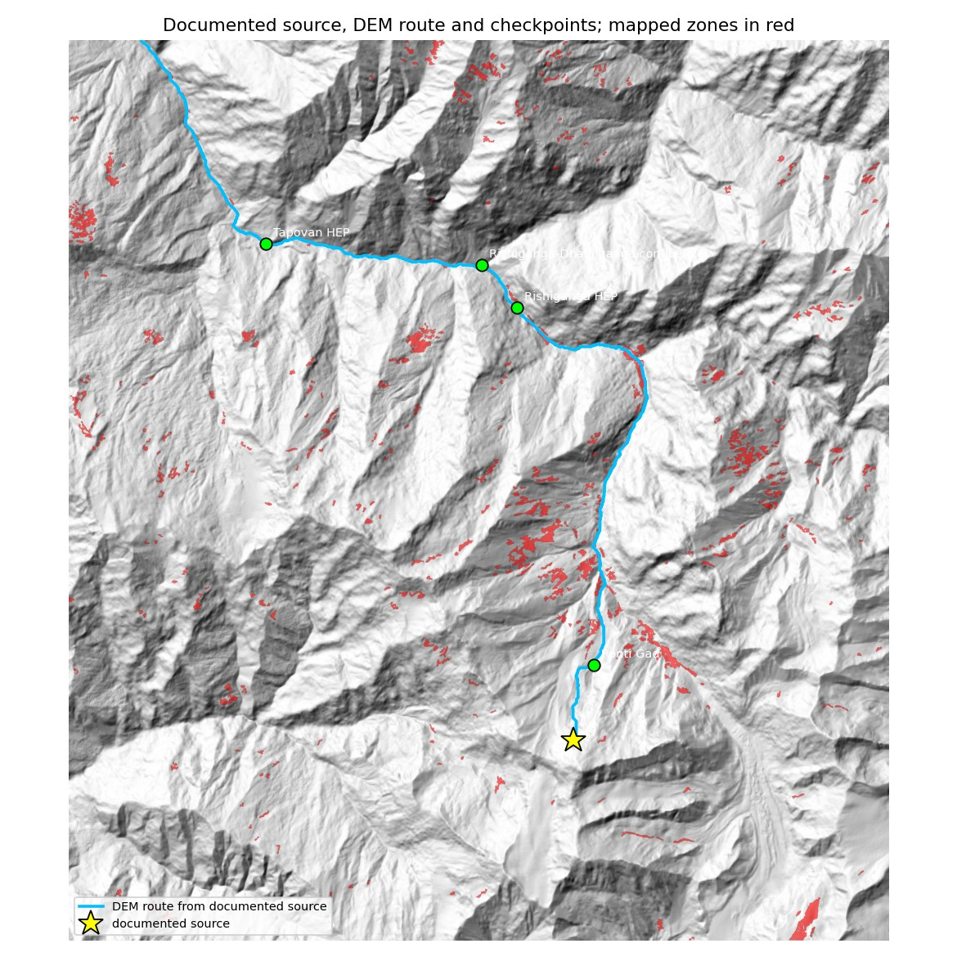
Fig. 7: Route traced from the documented source (blue line) over a hillshade, with the source (star), the four documented checkpoints (green) and the zones mapped by the rule baseline (red).
The corridor contained exposed assets, but the inventory was incomplete. Six OpenStreetMap assets [24] lay in the corridor: Raini bridge (tagged "Destroyed", 16.6 km along the route), Raini village (16.9 km), a Joshimath-Malari road bridge (18.0 km), an unnamed bridge (24.3 km), Garghaniya village (25.0 km) and another unnamed bridge (25.2 km). All three documented damaged sites lie inside the corridor (3/3), but the inventory matched only Raini bridge (1/3). OpenStreetMap contained no hydropower features in the scene, so the two most heavily damaged structures were missing from the exposure list.

5.5. Follow-ups A and B: Detection and Ranking from Elevation Change
The DEM difference identified the source. The 2 m difference [8] covered 67% of the scene. On 576,851 stable-terrain pixels (Section 4.6) the vertical bias was −0.31 m (removed) and the NMAD was 3.24 m, so by Eq. (13) the lowering threshold was 9.73 m (3 × NMAD, with the NMAD rounded to 3.24 m in the text). This gave 552 lowered zones (Fig. 8). Three of them lie within 500 m of the documented source, with up to 183 m of lowering. Elevation change does not depend on illumination, so it found the source that winter optical imagery missed.
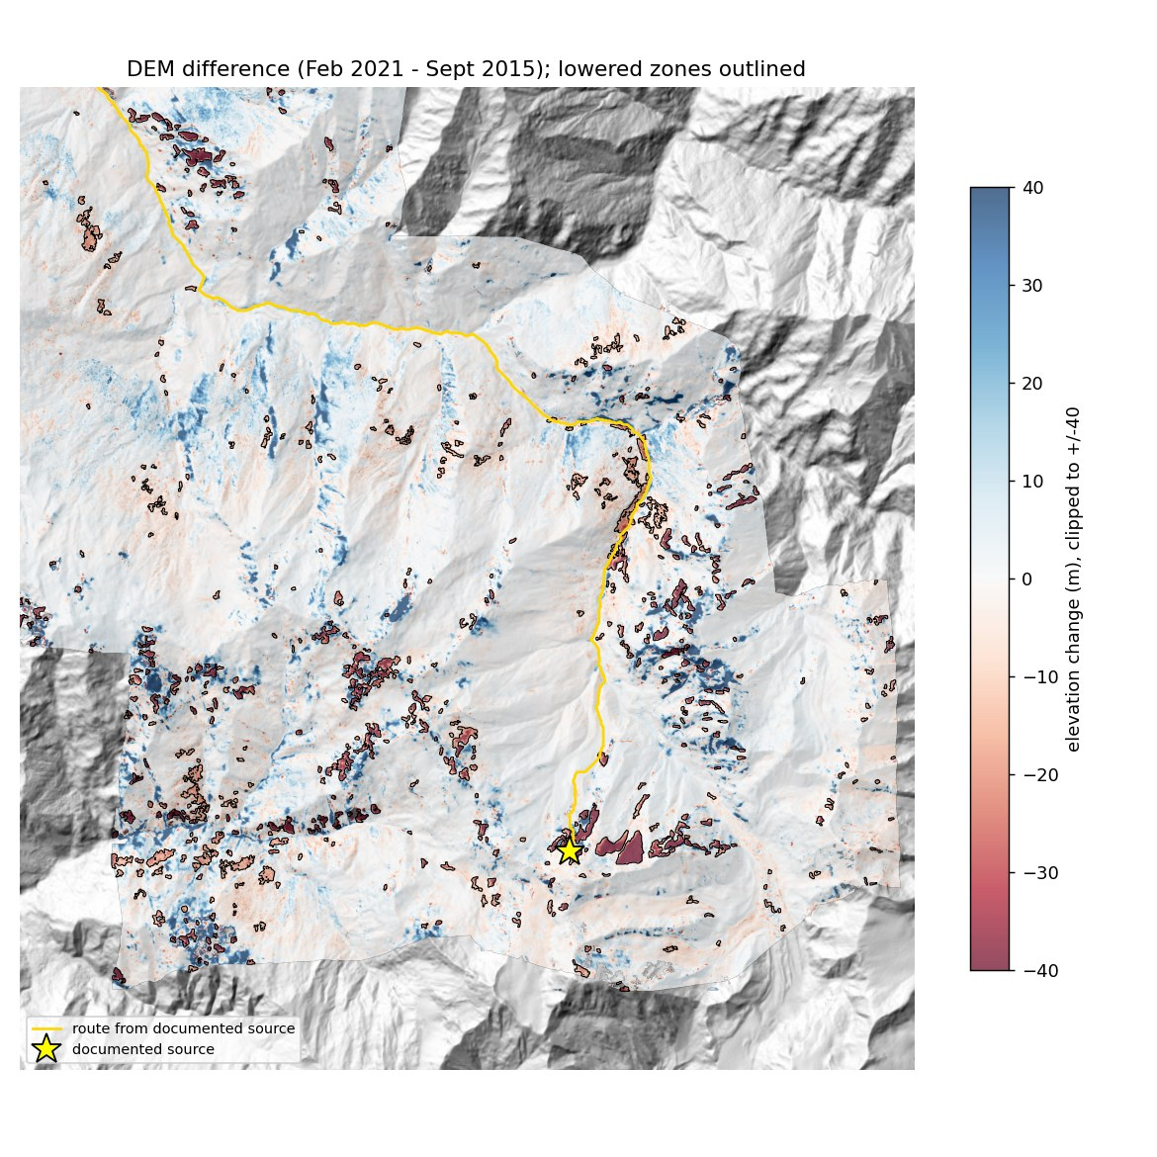
Fig. 8: Elevation change between September 2015 and February 2021 2 m DEMs, resampled to 10 m (red = lowering, blue = raising, clipped at +/-40 m). The 552 lowered zones are outlined, with the documented source (star) and the route traced from it (yellow). The largest lowering lies on the face east of the star.
The declared rule picks the largest-volume zone within 1 km of the documented point. It selected a zone of 291,000 m² with a lost volume of 1.40 × 10⁷ m³ (95% interval 1.33 to 1.46 × 10⁷ m³). This is 0.52 of the published 2.69 × 10⁷ m³ [3], and the published value lies outside the interval. The zone's mass-weighted elevation is 4,963 m (published detachment about 5,500 m), its drop is 1,394 m, and its energy is 3.44 × 10¹⁴ J (90%: 1.89 to 4.98 × 10¹⁴ J).
Post-hoc observation, not a result: a zone 1.5 km east of the documented point on the same face (5,414 m, 307,600 m², mean lowering 85 m) has 2.61 × 10⁷ m³, 97% of the published volume, and an energy of 7.5 × 10¹⁴ J (90%: 4.1 to 10.9 × 10¹⁴ J). This lies inside the corner range of 3.6 to 7.7 × 10¹⁴ J in Section 5.1, near its upper end. At the mid-range density of 1,800 kg m⁻³ it implies a drop of about 1,630 m, more than the 700 to 1,000 m assumed in Section 5.1. The agreement therefore comes from a larger drop combined with a lower density, and it depends on how the reference elevation is set. The zone may be the main scar, with the reference coordinate at its western edge, but we did not compare it with the published source polygon [3]. The published volume was derived from the same DEMs, so the agreement is not an independent validation. The route from the declared source zone again reached all four checkpoints in order (Rishiganga plant at 15.1 km, Tapovan plant at 23.1 km).
With measured energy, the pipeline ranked the best zone within 500 m and within 1 km of the documented point 14th of 552, and the best zone within 2 km 13th. Random ordering would give 138, 50 and 23 (Eq. (16)). This is the top 2.5%. The zone from the post-hoc observation lies 1.5 km from the documented point, so it can only enter the 2 km radius. Removing exposure or the route moved the best zone to 2nd (1st within 2 km), and so did ranking by area or volume alone. Removing energy or instability changed nothing (Fig. 9).
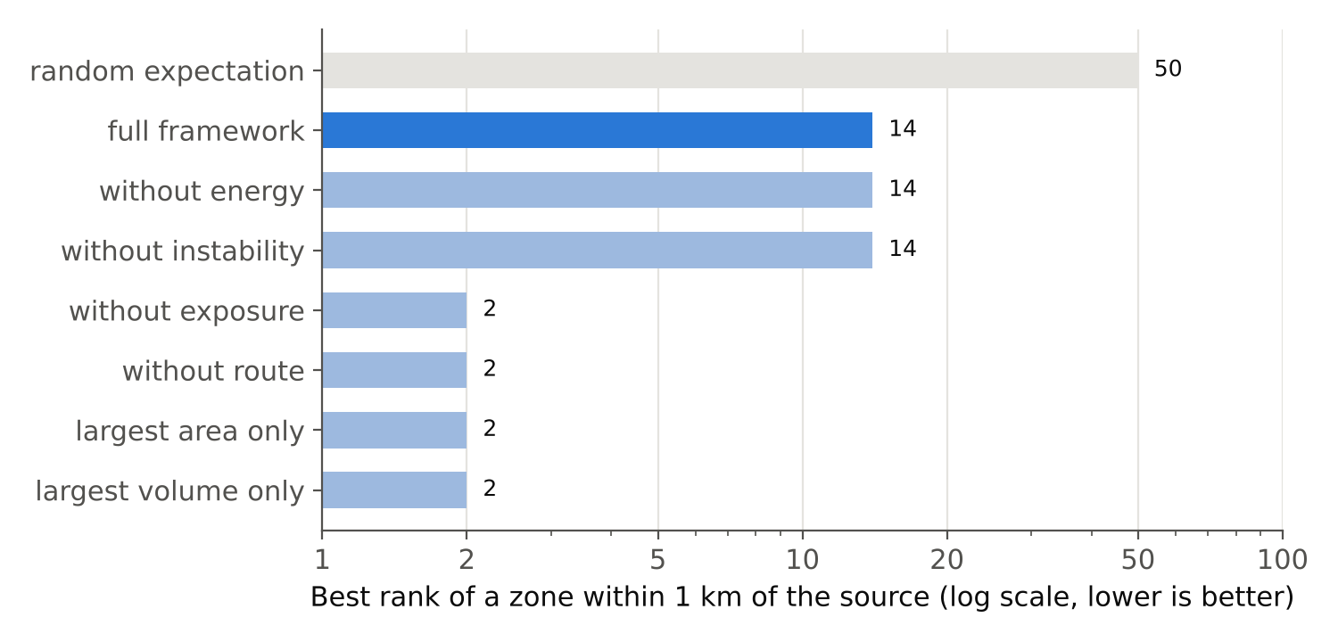
Fig. 9: Best rank of a lowered zone within 1 km of the documented source among 552 zones, for the full pipeline, with one component removed, and for two simple baselines (log scale; lower is better). Gray marks the random expectation.
The thirteen zones ranked above the best zone within 1 km are small lowered patches in the Rishiganga gorge, and their corridors pass seven assets, against six along the route from the documented source (Section 5.4). We did not trace which asset accounts for the difference. It may come from where each route starts, or from assets at the edge of the 250 m corridor. The ranking key orders by exposure count before energy, so a one-asset difference outweighs a roughly 30-fold difference in energy. For the same reason, removing energy changes nothing: energy only breaks ties in exposure. Removing instability changes nothing either, because persistence is not available for DEM zones.

5.6. Follow-up C: Change Accuracy
Of the 70 blind points, 43 (61%) could not be judged, mostly because terrain shadow hid the ground on one or both dates (Table 7).
Table 7: Blind change-accuracy sample, by stratum.
Stratum (pixels) | Labeled / sampled | Change / no change | 95% exact interval, share changed
both maps changed (3,487) | 10 / 15 | 10 / 0 | 0.69 to 1.00
U-Net only (3,692) | 4 / 15 | 0 / 4 | 0.00 to 0.60
rule baseline only (70,276) | 2 / 15 | 2 / 0 | 0.16 to 1.00
neither (601,336) | 11 / 25 | 0 / 11 | 0.00 to 0.28
Where the ground was visible, every labeled change was snow turning into bare ground. The rule baseline flagged all of them, and all four points flagged only by the U-Net were false alarms. The area-weighted point estimates of precision and recall for "change" were 0.49 and 0.05 for U-Net seed 0, 1.00 and 0.51 for seed 1, and 1.00 and 0.04 for seed 2 (all scored on the same 70 points, with strata defined from the seed 0 change map). The baseline scored 1.00 and 1.00. These numbers are imprecise. The baseline-only stratum, which drives recall, rests on two labels, and 0 of 11 in the unchanged stratum still allows up to 28% change there, which would sharply lower every recall. The result is qualitative: most of the change area cannot be checked at 10 m in winter, and on the part that can, the gates in the U-Net pipeline suppress real snow-to-ground change that the rules keep.

5.7. Follow-up D: Weather Before the Event
At the source's ERA5 [22] cell (elevation 5,297 m as returned by the Open-Meteo service, which may differ from the elevation of the native ERA5 cell), the 30 days ending February 6, 2021, had 19.3 mm of precipitation, against a 1991 to 2020 median of 115.7 mm. The mean temperature was 2.16 °C above the 30-year mean. The precipitation total fell below the 10th percentile of the reference years and the temperature rose above the 90th percentile, so both scores sit at the ends of the clipped scale of Eq. (17), at 0.00 and 1.00. The last 1 to 7 days were near normal (Fig. 10). Over 29 winters (December to February), the mean-temperature trend was +0.05 °C per decade. This is context for the event only: one cell of about 31 km cannot rank zones within the scene, and an anomaly is not evidence of cause.
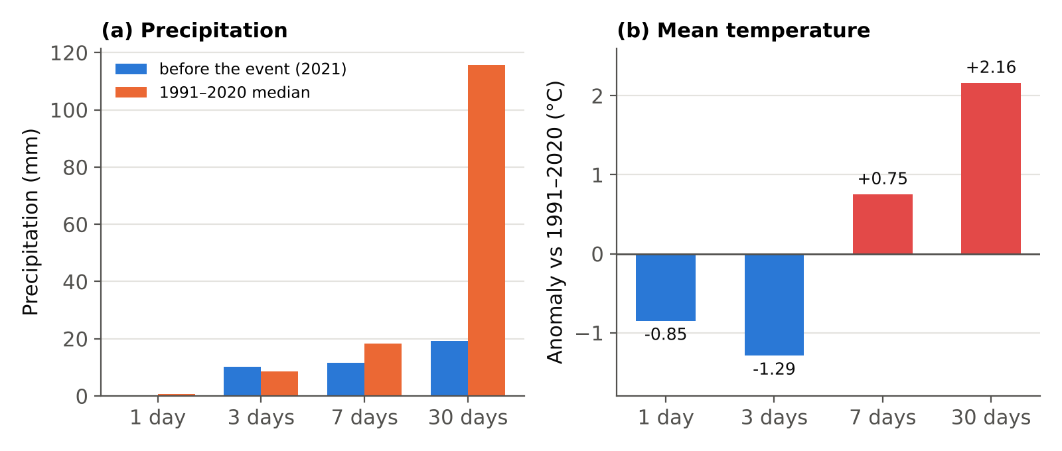
Fig. 10: ERA5 precipitation totals (a) and mean-temperature anomalies (b) at the source's grid cell, for windows of 1, 3, 7 and 30 days ending February 6, 2021, compared with 1991 to 2020.

5.8. Development Log: Failures and Their Fixes
All changes in Table 8 except the last were made in response to early runs on this same scene, and the timing of these changes relative to the frozen benchmark is not independently documented here. Because the development scene and the event scene are the same, the settings were tuned on data that include the event area. The main test is therefore a retrospective check and not an independent one. Only the segmentation test strip is geographically separate from the training and validation strips (Section 4.2). The last change, the source of the DEM download, was made during the repeat runs and altered no threshold.
Table 8: Observations in early runs and the changes made.
Observation in early runs | Change made
The default cloud mask removed snow; the January image kept 60% valid pixels | cloud mask changed to keep snow (Section 4.1)
A February 2020 pre-event image gave about 1,400 zones, mostly year-to-year snow differences | pre-event image moved to the same winter (January 16, 2021)
Low winter sun produced change on slopes lit on only one date | illumination gate, Eq. (7)
An October t3 "confirmed" seasonal snowmelt as persistent | winter t3 (March 2022) and season-aware persistence
The east validation strip held every debris label | validation moved to the west edge
Validation macro F1 was unstable with only two or three classes present | model selection on validation cross-entropy
Swaps between rock and soil produced 324 zones | transitions between rock and soil ignored
The test strip lacked rock and soil labels | random-point labeling round for rock and soil test labels
The Planetary Computer DEM endpoint returned an error in November 2026 | same GLO-30 tile read from AWS open data; benchmark means varied between repeats (Section 5.2)

6. Discussion
Routing worked once the source was given, but the energy check is only partial. Starting from the documented source, a single D8 line traced on free 30 m elevation data passed four documented checkpoints in order. Its 250 m corridor also enclosed all three damaged structures, although the public inventory listed only one of them. Because the route starts at the documented source, this tests routing and exposure, not source detection. The energy check is weaker still. Section 5.1 repeats the calculation with the same inputs, so agreement only shows that the code implements Eqs. (8) and (9) correctly. It does not show that energy is right. The layer does carry uncertainty through the computation instead of adding it afterwards. But with the declared volume rule it recovered only 0.52 of the published volume (Section 5.5). The zone we found after the fact (7.5 × 10¹⁴ J, inside the corner range of Section 5.1) is an observation and not a validation, because it rests on an assumed reference elevation.
Winter optical detection of the source is the weakest step of the pipeline, and the cause is clear. The source is a steep northeast face, mostly in shadow in January and only partly lit in February. We added the illumination gate because low sun created large false changes elsewhere (it removed 9.15 km²). At this source, though, it removed the very pixels where change would show up. Suppressing false alarms therefore also removed the signal from the source. Other north-facing sources may face the same trade-off in winter optical imagery, but a single event cannot establish this. Elevation change does not depend on illumination, and it found the source directly [8]. That detection uses post-event data, so it identifies a release that has already occurred and gives no advance warning. As tested, the pipeline is a retrospective screening tool.
Better surface classification did not lead to better change detection. U-Net outperformed the rules on per-class F1, but on visible ground the rules detected snow-to-ground change that the U-Net missed. The confidence and illumination gates act on the U-Net's change, not on its classes, so segmentation scores alone overstate how well it detects change.
The ranking rule should be redesigned. Because it orders by exposure count before energy, a one-asset difference outweighed a 30-fold difference in energy. Exposure counts from a course, incomplete inventory are a weak primary key. A rule that combines energy and exposure, or ranks by energy within exposure bands, should be declared before the next event is tested. We left the rule unchanged here, because changing it after seeing the result would amount to tuning the method on its own test.
At 10 m in winter, neither method separated rock and soil well (F1 of at most 0.35). Ignoring rock–soil swaps is therefore justified. The cost is that a failure exposing fresh rock on a soil-like surface would not show up in optical imagery.
The public inventory [24] missed the two most heavily damaged structures. Exposure screening is only as complete as its asset data, so hydropower and other critical infrastructure should come from an authoritative register.

7. Limitations
The limitations below are ordered by how much they affect the conclusions. Where the paper addresses a limitation, the bullet points to the section.
- This is one event, one scene and one geographic split, and the settings were tuned on the same scene that contains the event (Section 5.8). The main test is therefore retrospective and not independent. There is no non-event area, so false-alarm rates and generalization are unknown. Testing on a second event and on non-event areas is listed under future work (Section 8).
- Winter optical change detection missed the source, because the illumination gate removed the shadowed pixels where change would appear. One event cannot show how often this happens at other sources. Shadow-insensitive detection, using SAR or multi-date DEMs, is the first item of future work.
- The successful source detection uses post-event DEMs, so the pipeline as tested finds a release that has already happened and gives no advance warning. The follow-up experiments were designed after the optical failure was known, so they are not blind tests (Section 4.8).
- The ranking rule orders zones by exposure count before energy, so a one-asset difference outweighed a 30-fold difference in energy. We did not change the rule after seeing this result (Section 6). Section 8 proposes a rule that weighs energy and exposure together, to be declared before testing.
- The energy estimate was not compared with an independent published estimate for Chamoli. It rests on an assumed reference elevation and on density and drop ranges that have no independent source (Sections 5.1 and 5.5). With the declared volume rule the pipeline recovered 0.52 of the published volume, and the best energy agreement came from a zone chosen after the fact.
- One analyst drew all labels on 10 m imagery, and there is no second labeler. Water has no labels in any strip, so the model is in effect trained on five classes. Debris has no test-strip labels, and the rock test set is small (1,535 pixels). Pixels from the same labeled polygon are not independent, so the spread over seeds understates the uncertainty of the pixel-level F1 values.
- The validation strip has no rock or debris, so model selection cannot favor those classes. For seed 2 of the frozen run, the epoch-1 checkpoint was selected as best. GPU training is not bit-reproducible, so we report means over seeds and the range over ten runs (Section 5.2), and the number of candidate zones varied from 126 to 371 between U-Net runs. The main change maps and candidate zones, and the strata of the point sample, come from the seed 0 run.
- The change-accuracy sample has very few labels in the strata that drive recall, and 61% of the points could not be judged. Its precision and recall values are therefore qualitative (Section 5.6).
- Slope, aspect and shadow come from the 30 m GLO-30 DEM [21], resampled to 10 m, which smooths narrow ridges and gullies. Co-registration is a single global sub-pixel shift, so local misregistration is not corrected. The study area bounds are approximate and were not matched to the published source polygon (Section 3).
- The 2 m DEM difference [8] spans 2015 to 2021, so it includes five years of glacier change, pre-failure movement and snow. The published volume [3] was derived from the same DEMs, so agreement with it is not an independent validation.
- OpenStreetMap [24] was accessed in 2026, five years after the event, and it has no hydropower features, so the two most heavily damaged structures were missing from the exposure list. Exposure counts are only as complete as this inventory. We also did not trace why the corridors of the thirteen higher-ranked DEM zones pass seven assets against six along the route from the documented source (Section 5.5).
- Instability evidence is limited to persistence, so no zone can reach the review candidate state (Section 4.7). ERA5 climate values are event-level context for one cell of about 31 km, are not used to rank zones, and no composite instability index is produced.
- Routes are single D8 lines [15] with a fixed corridor. They are screening connections, not runout, velocity or inundation models [45], and the route fell 2.5 km (about 10%) short of the published distance at Tapovan (Section 5.4).
- Data acquisition depends on internet access to public services that may change or fail. The Planetary Computer DEM endpoint returned an error in November 2026, and the same GLO-30 tile was read from AWS open data instead (Section 5.8).

8. Conclusions and Future Work
On the 2021 Chamoli event, a single D8 route from the documented source passed all four documented checkpoints in order, and its 250 m corridor enclosed all three damaged sites, although the public asset inventory listed only one of them (Raini bridge). Overall, a U-Net improved on spectral rules for surface mapping (macro F1 0.648 against 0.519), but it scored lower on rock, and on visible ground the rules caught real snow-to-ground change that the U-Net missed. With the declared volume rule, the pipeline recovered only 0.52 of the published volume, and the energy estimate fell inside the illustrative range of Section 5.1 only for a zone identified after the fact. Winter Sentinel-2 change detection missed the northeast-facing source, most likely because shadow suppression removed its signal. A 2 m DEM difference detected it, but that detection uses post-event data, so it identifies a release that has already occurred and gives no advance warning. With detection in place, the pipeline ranked the best zone within 1 km of the source 14th of 552 (the top 2.5%), but a simple volume ranking placed a zone near the source first or second, which indicates a flaw in ordering by exposure before energy. This is a single retrospective test with settings tuned on the same scene. It identifies where the pipeline fails, namely source detection in shadowed winter imagery and the ranking rule, but it does not demonstrate that the pipeline works in general.
Next steps, in the order we will take them:
- Add source detection that does not depend on sunlight, using Sentinel-1 SAR backscatter and coherence change [7, 46], or multi-date DEMs where available [8].
- Test whether the source can be flagged before it fails, using only pre-event data such as multi-year DEM or glacier change, so that the pipeline gives advance screening and not only post-event detection.
- Replace the exposure-first ranking with a rule that weighs energy and exposure together and declare it before testing.
- Replace the binary illumination gate with a graded confidence penalty and test it on a separate event.
- Test on a second event and on non-event areas, with change reference labels from a second analyst, to measure false-alarm rates and ranking.
- Add more labeled rock, soil and water examples, since the F1 for rock and soil stays near 0.3 and water has no labels.
- Compare the energy estimate with an independently published estimate for the same event. Also compare the single D8 route with multiple-flow-direction routing [16] and a runout model [45], reporting distance errors at the checkpoints that have published distances (the Rishiganga and Tapovan plants).
- Use an authoritative register of hydropower and critical infrastructure for exposure.

Data and Code Availability
Code, configuration, labels, evaluation outputs, the follow-up protocol and the Kaggle notebooks are at https://github.com/Snigdho2005/mountain-hazard-screening. Sentinel-2 L2A [5, 20] and Copernicus GLO-30 [21] are open data from ESA/Copernicus; the 2 m DEMs are from Shean et al. [8] (CC BY-NC 4.0); ERA5 [22] was accessed through the Open-Meteo archive API [23]; OpenStreetMap [24] data © OpenStreetMap contributors (ODbL).

Author Contributions and Use of AI Tools
The author conceived the study, designed the evaluation, drew all reference labels, ran the experiments and interpreted the results. A generative AI assistant was used to help write code, to draft and revise the text, and to find and format references. The author reviewed and edited all AI-assisted material, checked the references against their sources, and takes full responsibility for the content of this paper, including its text, figures, data and references.

References
[1] O. Hungr, S. Leroueil, and L. Picarelli. The Varnes classification of landslide types, an update. Landslides, 11(2):167-194, 2014. doi:10.1007/s10346-013-0436-y.
[2] A. Kääb, M. Jacquemart, A. Gilbert, S. Leinss, L. Girod, C. Huggel, D. Falaschi, F. Ugalde, D. Petrakov, S. Chernomorets, M. Dokukin, F. Paul, S. Gascoin, E. Berthier, and J. S. Kargel. Sudden large-volume detachments of low-angle mountain glaciers: more frequent than thought? The Cryosphere, 15(4):1751-1785, 2021. doi:10.5194/tc-15-1751-2021.
[3] D. H. Shugar et al. A massive rock and ice avalanche caused the 2021 disaster at Chamoli, Indian Himalaya. Science, 373(6552):300-306, 2021. doi:10.1126/science.abh4455.
[4] A. B. Shrestha, J. Steiner, S. Nepal, S. B. Maharjan, M. Jackson, G. Rasul, and B. Bajracharya. Understanding the Chamoli flood: cause, process, impacts, and context of rapid infrastructure development. ICIMOD, Kathmandu, March 3, 2021. Report.
[5] M. Drusch et al. Sentinel-2: ESA's optical high-resolution mission for GMES operational services. Remote Sensing of Environment, 120:25-36, 2012. doi:10.1016/j.rse.2011.11.026.
[6] O. Ghorbanzadeh, Y. Xu, P. Ghamisi, M. Kopp, and D. Kreil. Landslide4Sense: reference benchmark data and deep learning models for landslide detection. IEEE Transactions on Geoscience and Remote Sensing, 60:1-17, 2022. doi:10.1109/TGRS.2022.3215209.
[7] L. Nava, A. Mondini, K. Bhuyan, C. Fang, O. Monserrat, A. Novellino, and F. Catani. Sentinel-1 SAR-based globally distributed co-seismic landslide detection by deep neural networks. Geoscientific Model Development, 19(1):167-185, 2026. doi:10.5194/gmd-19-167-2026.
[8] D. Shean, S. Bhushan, E. Berthier, C. Deschamps-Berger, S. Gascoin, and F. Knuth. Chamoli disaster post-event 2-m DEM composite (February 10 and 11, 2021) and difference map. Zenodo, 2021. doi:10.5281/zenodo.4558692; and S. Bhushan and D. Shean. Chamoli disaster pre-event 2-m DEM composite: September 2015. Zenodo, 2021. doi:10.5281/zenodo.4554647.
[9] P. Vangla, D. Jindal, A. Sajwan, R. Devrani, J. D. Frost, and G. V. Ramana. Site visit and drone based reconnaissance study of the severely affected infrastructure by February 7th, 2021, Chamoli rock-ice avalanche disaster, Uttarakhand, India. GEER Association Report GEER-074, 2022. doi:10.18118/G6V95B. Report.
[10] O. Ronneberger, P. Fischer, and T. Brox. U-Net: convolutional networks for biomedical image segmentation. In MICCAI 2015, LNCS 9351, pages 234-241, 2015.
[11] M. Galatola, E. Arnaudo, L. Barco, C. Rossi, and F. Dominici. Land cover segmentation with sparse annotations from Sentinel-2 imagery. In IGARSS 2023, pages 6952-6955, 2023. doi:10.1109/IGARSS52108.2023.10281933.
[12] K. Jindgar and G. W. Lindsay. Improving satellite imagery segmentation using multiple Sentinel-2 revisits. arXiv preprint arXiv:2409.17363, 2024. doi:10.48550/arXiv.2409.17363.
[13] D. Lu, P. Mausel, E. Brondízio, and E. Moran. Change detection techniques. International Journal of Remote Sensing, 25(12):2365-2401, 2004. doi:10.1080/0143116031000139863.
[14] R. D. Johnson and E. S. Kasischke. Change vector analysis: a technique for the multispectral monitoring of land cover and condition. International Journal of Remote Sensing, 19(3):411-426, 1998. doi:10.1080/014311698216062.
[15] J. F. O'Callaghan and D. M. Mark. The extraction of drainage networks from digital elevation data. Computer Vision, Graphics, and Image Processing, 28(3):323-344, 1984.
[16] P. Horton, M. Jaboyedoff, B. Rudaz, and M. Zimmermann. Flow-R, a model for susceptibility mapping of debris flows and other gravitational hazards at a regional scale. Natural Hazards and Earth System Sciences, 13(4):869-885, 2013. doi:10.5194/nhess-13-869-2013.
[17] J. Höhle and M. Höhle. Accuracy assessment of digital elevation models by means of robust statistical methods. ISPRS Journal of Photogrammetry and Remote Sensing, 64(4):398-406, 2009.
[18] P. Olofsson, G. M. Foody, M. Herold, S. V. Stehman, C. E. Woodcock, and M. A. Wulder. Good practices for estimating area and assessing accuracy of land change. Remote Sensing of Environment, 148:42-57, 2014.
[19] N. Khadka, X. Chen, Y. Nie, S. Thakuri, G. Zheng, and G. Zhang. Evaluation of glacial lake outburst flood susceptibility using multi-criteria assessment framework in Mahalangur Himalaya. Frontiers in Earth Science, 8:601288, 2021. doi:10.3389/feart.2020.601288.
[20] M. Main-Knorn, B. Pflug, J. Louis, V. Debaecker, U. Müller-Wilm, and F. Gascon. Sen2Cor for Sentinel-2. In Proc. SPIE 10427, Image and Signal Processing for Remote Sensing XXIII, 1042704, 2017. doi:10.1117/12.2278218.
[21] European Space Agency and Airbus. Copernicus DEM. 2022. doi:10.5270/ESA-c5d3d65.
[22] H. Hersbach et al. The ERA5 global reanalysis. Quarterly Journal of the Royal Meteorological Society, 146(730):1999-2049, 2020.
[23] P. Zippenfenig. Open-Meteo.com Weather API. Zenodo, 2023. doi:10.5281/zenodo.7970649.
[24] M. Haklay and P. Weber. OpenStreetMap: user-generated street maps. IEEE Pervasive Computing, 7(4):12-18, 2008. doi:10.1109/MPRV.2008.80.
[25] QGIS Development Team. QGIS Geographic Information System. Open Source Geospatial Foundation Project. https://qgis.org (accessed 2026).
[26] D. K. Hall, G. A. Riggs, and V. V. Salomonson. Development of methods for mapping global snow cover using Moderate Resolution Imaging Spectroradiometer data. Remote Sensing of Environment, 54(2):127-140, 1995.
[27] J. W. Rouse, R. H. Haas, J. A. Schell, and D. W. Deering. Monitoring vegetation systems in the Great Plains with ERTS. In Proceedings of the Third ERTS Symposium, NASA SP-351, volume 1, pages 309-317, 1974.
[28] S. K. McFeeters. The use of the Normalized Difference Water Index (NDWI) in the delineation of open water features. International Journal of Remote Sensing, 17(7):1425-1432, 1996.
[29] M. Guizar-Sicairos, S. T. Thurman, and J. R. Fienup. Efficient subpixel image registration algorithms. Optics Letters, 33(2):156-158, 2008.
[30] L. W. Zevenbergen and C. R. Thorne. Quantitative analysis of land surface topography. Earth Surface Processes and Landforms, 12(1):47-56, 1987.
[31] I. Loshchilov and F. Hutter. Decoupled weight decay regularization. In International Conference on Learning Representations (ICLR), 2019. arXiv:1711.05101.
[32] I. Loshchilov and F. Hutter. SGDR: stochastic gradient descent with warm restarts. In International Conference on Learning Representations (ICLR), 2017. arXiv:1608.03983.
[33] M. Iqbal. An Introduction to Solar Radiation. Academic Press, New York, 1983.
[34] A. Saltelli, M. Ratto, T. Andres, F. Campolongo, J. Cariboni, D. Gatelli, M. Saisana, and S. Tarantola. Global Sensitivity Analysis: The Primer. Wiley, Chichester, 2008.
[35] C. Spearman. The proof and measurement of association between two things. American Journal of Psychology, 15(1):72-101, 1904.
[36] C. Rolstad, T. Haug, and B. Denby. Spatially integrated geodetic glacier mass balance and its uncertainty based on geostatistical analysis: application to the western Svartisen ice cap, Norway. Journal of Glaciology, 55(192):666-680, 2009. doi:10.3189/002214309789470950.
[37] K. M. Cuffey and W. S. B. Paterson. The Physics of Glaciers. Butterworth-Heinemann, Oxford, 4th edition, 2010.
[38] L. Vincent. Morphological grayscale reconstruction in image analysis: applications and efficient algorithms. IEEE Transactions on Image Processing, 2(2):176-201, 1993.
[39] M. Sokolova and G. Lapalme. A systematic analysis of performance measures for classification tasks. Information Processing & Management, 45(4):427-437, 2009.
[40] C. J. Clopper and E. S. Pearson. The use of confidence or fiducial limits illustrated in the case of the binomial. Biometrika, 26(4):404-413, 1934.
[41] C. R. Harris et al. Array programming with NumPy. Nature, 585:357-362, 2020.
[42] P. Virtanen et al. SciPy 1.0: fundamental algorithms for scientific computing in Python. Nature Methods, 17:261-272, 2020.
[43] S. van der Walt, J. L. Schönberger, J. Nunez-Iglesias, F. Boulogne, J. D. Warner, N. Yager, E. Gouillart, T. Yu, and the scikit-image contributors. scikit-image: image processing in Python. PeerJ, 2:e453, 2014.
[44] A. Paszke et al. PyTorch: an imperative style, high-performance deep learning library. In Advances in Neural Information Processing Systems 32, pages 8024-8035, 2019.
[45] M. Mergili, J.-T. Fischer, J. Krenn, and S. P. Pudasaini. r.avaflow v1, an advanced open-source computational framework for the propagation and interaction of two-phase mass flows. Geoscientific Model Development, 10(2):553-569, 2017. doi:10.5194/gmd-10-553-2017.
[46] R. Torres et al. GMES Sentinel-1 mission. Remote Sensing of Environment, 120:9-24, 2012.
[47] P. J. Rousseeuw and C. Croux. Alternatives to the median absolute deviation. Journal of the American Statistical Association, 88(424):1273-1283, 1993. doi:10.1080/01621459.1993.10476408.
[48] C. Leys, C. Ley, O. Klein, P. Bernard, and L. Licata. Detecting outliers: do not use standard deviation around the mean, use absolute deviation around the median. Journal of Experimental Social Psychology, 49(4):764-766, 2013. doi:10.1016/j.jesp.2013.03.013.

