REFERENCE FOR PROJECT-1 (LAFORANT)

Group members:

1. Janson Tan

2. none

3. none

Class : BQ01 – Lab

1. Logo created by Janson Tan using photoshop

2. Website are made using reference from :

* <https://playvalorant.com/en-us/>

Reference of layout, latest news images+content, game agents, game arsenal, game specs, game faqs

some images imported

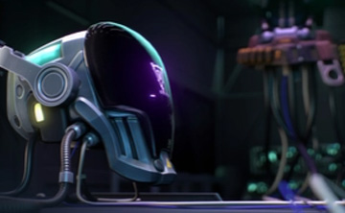

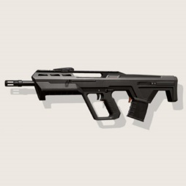

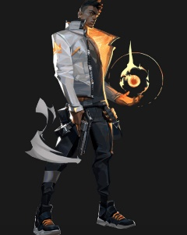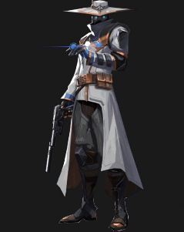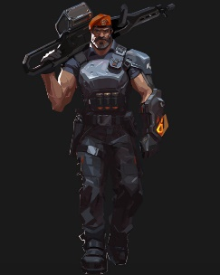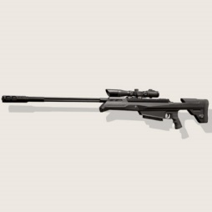

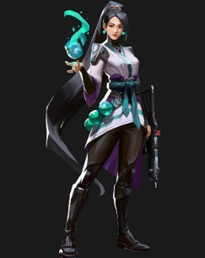

* <https://valorant.fandom.com/wiki/Maps>

Reference for game maps + content

some images imported

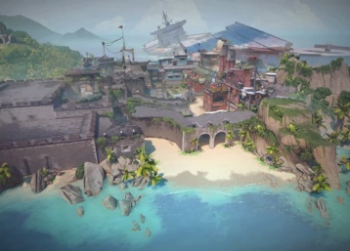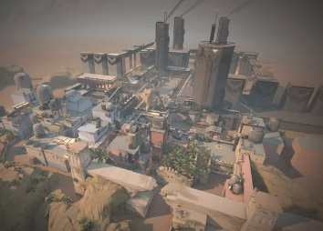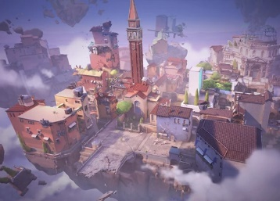

* [https://www.google.com/](https://www.google.com/search?q=valorant&tbm=isch&ved=2ahUKEwilxL7hqanxAhVFXHwKHRwTA5AQ2-cCegQIABAA&oq=valorant&gs_lcp=CgNpbWcQAzIECCMQJzIECCMQJzIHCAAQsQMQQzIECAAQQzIECAAQQzIECAAQQzIECAAQQzIFCAAQsQMyBQgAELEDMgIIADoICAAQsQMQgwFQxxhYrytgni1oAXAAeACAAcQBiAGuBZIBAzcuMpgBAKABAaoBC2d3cy13aXotaW1nwAEB&sclient=img&ei=ctbQYKXDCsW48QOcpoyACQ&rlz=1C1CHBD_enID923ID923&safe=strict)

Reference for slide-image in homePage

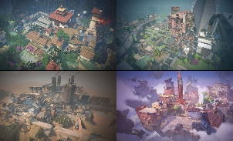some images imported

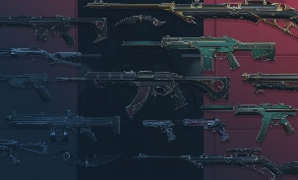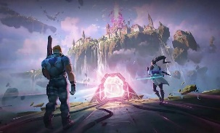



* Downloaded font-icon from websites and youtube suggestions

-font-awesome

-ionicons

-simple-line-icons

-booked-icons

* <https://themeforest.net/category/site-templates?tags=vendor>

-added vendor functions such animation, jquery, theme, icons, bootstrap

* <https://www.youtube.com/watch?v=oYRda7UtuhA>

<https://www.youtube.com/watch?v=qz0aGYrrlhU>

<https://www.w3schools.com/>

Reference for codes css and js

3. Work documentation of Janson Tan



