Report

# Catalogue Shopping Cart System

1. **Use Cases**
2. Administrator
3. Can log into the system.
4. Add item into the catalogue
5. Remove item from the catalogue
6. Update item in the catalogue.
7. View users in the system.
8. Update users in the system.
9. View orders in the system
10. Update orders in the system
11. Customer
12. Log in to the system
13. View items of the catalogue
14. Add items from the catalogue to the cart
15. View shopping cart
16. Update items in the cart
17. Place order for the contents of the cart
18. Deactivate account
19. Anonymous
20. View items of the catalogue
21. Sign up onto the system
22. Deactivated

**Unit Tests:**

1. Admin:
   1. Login test
   2. Add item test
   3. Remove item test
   4. Update item test
   5. Fetch users test
   6. Update user test
   7. Fetch orders test
   8. Update order test
2. Customer
   1. Login test
   2. Fetch items test
   3. Add item to cart test
   4. View cart items test
   5. Update cart items test
   6. Place order test
3. Anonymous
   1. Fetch items
   2. **Model**

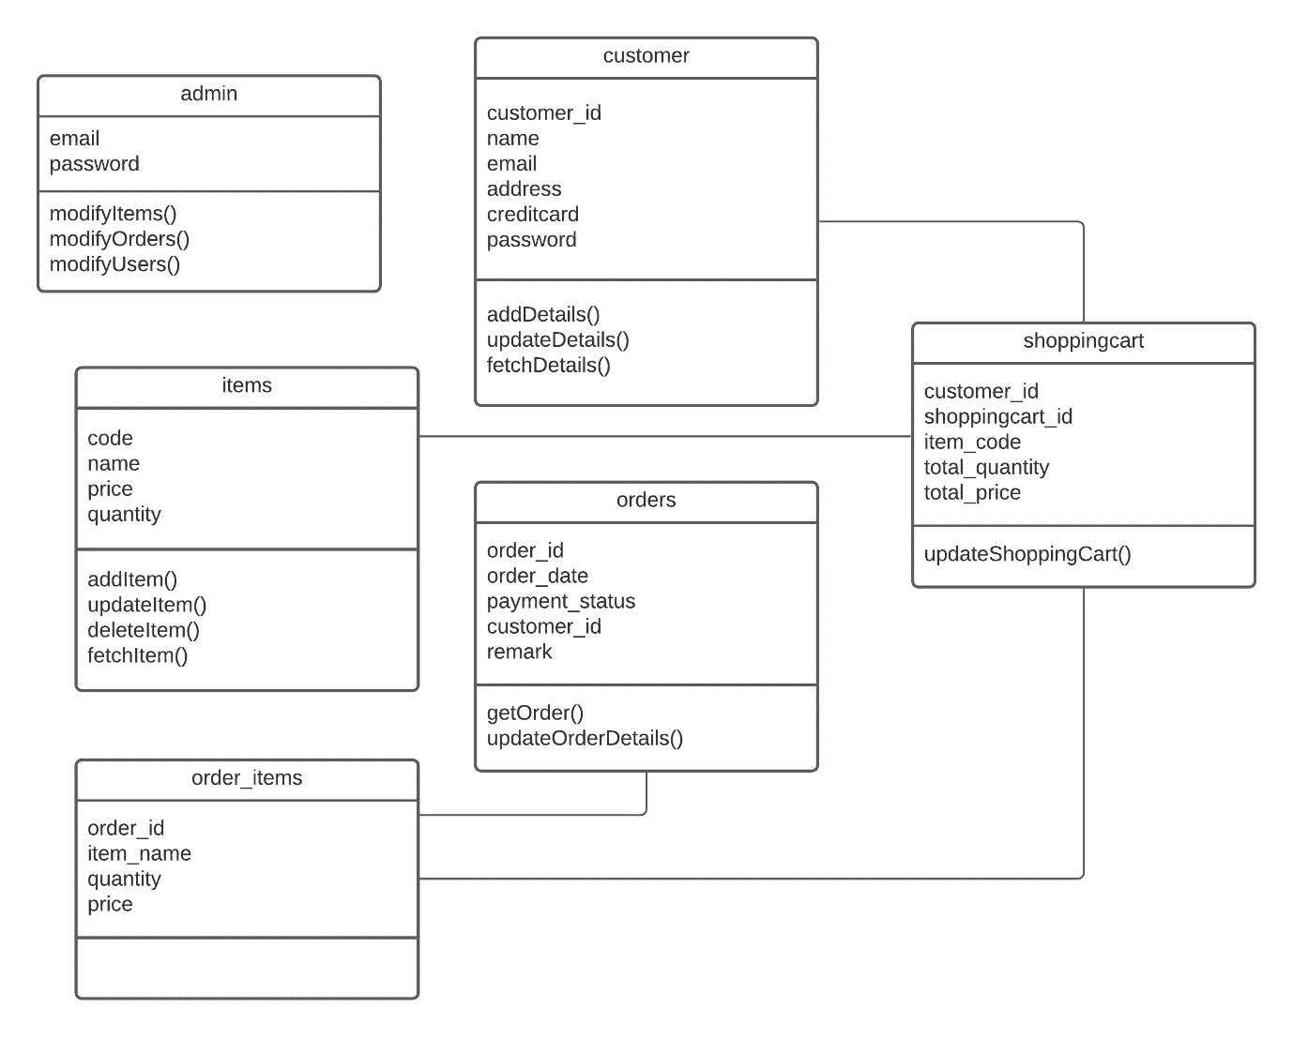

* 1. **Robustness diagram / Sequence Diagrams**

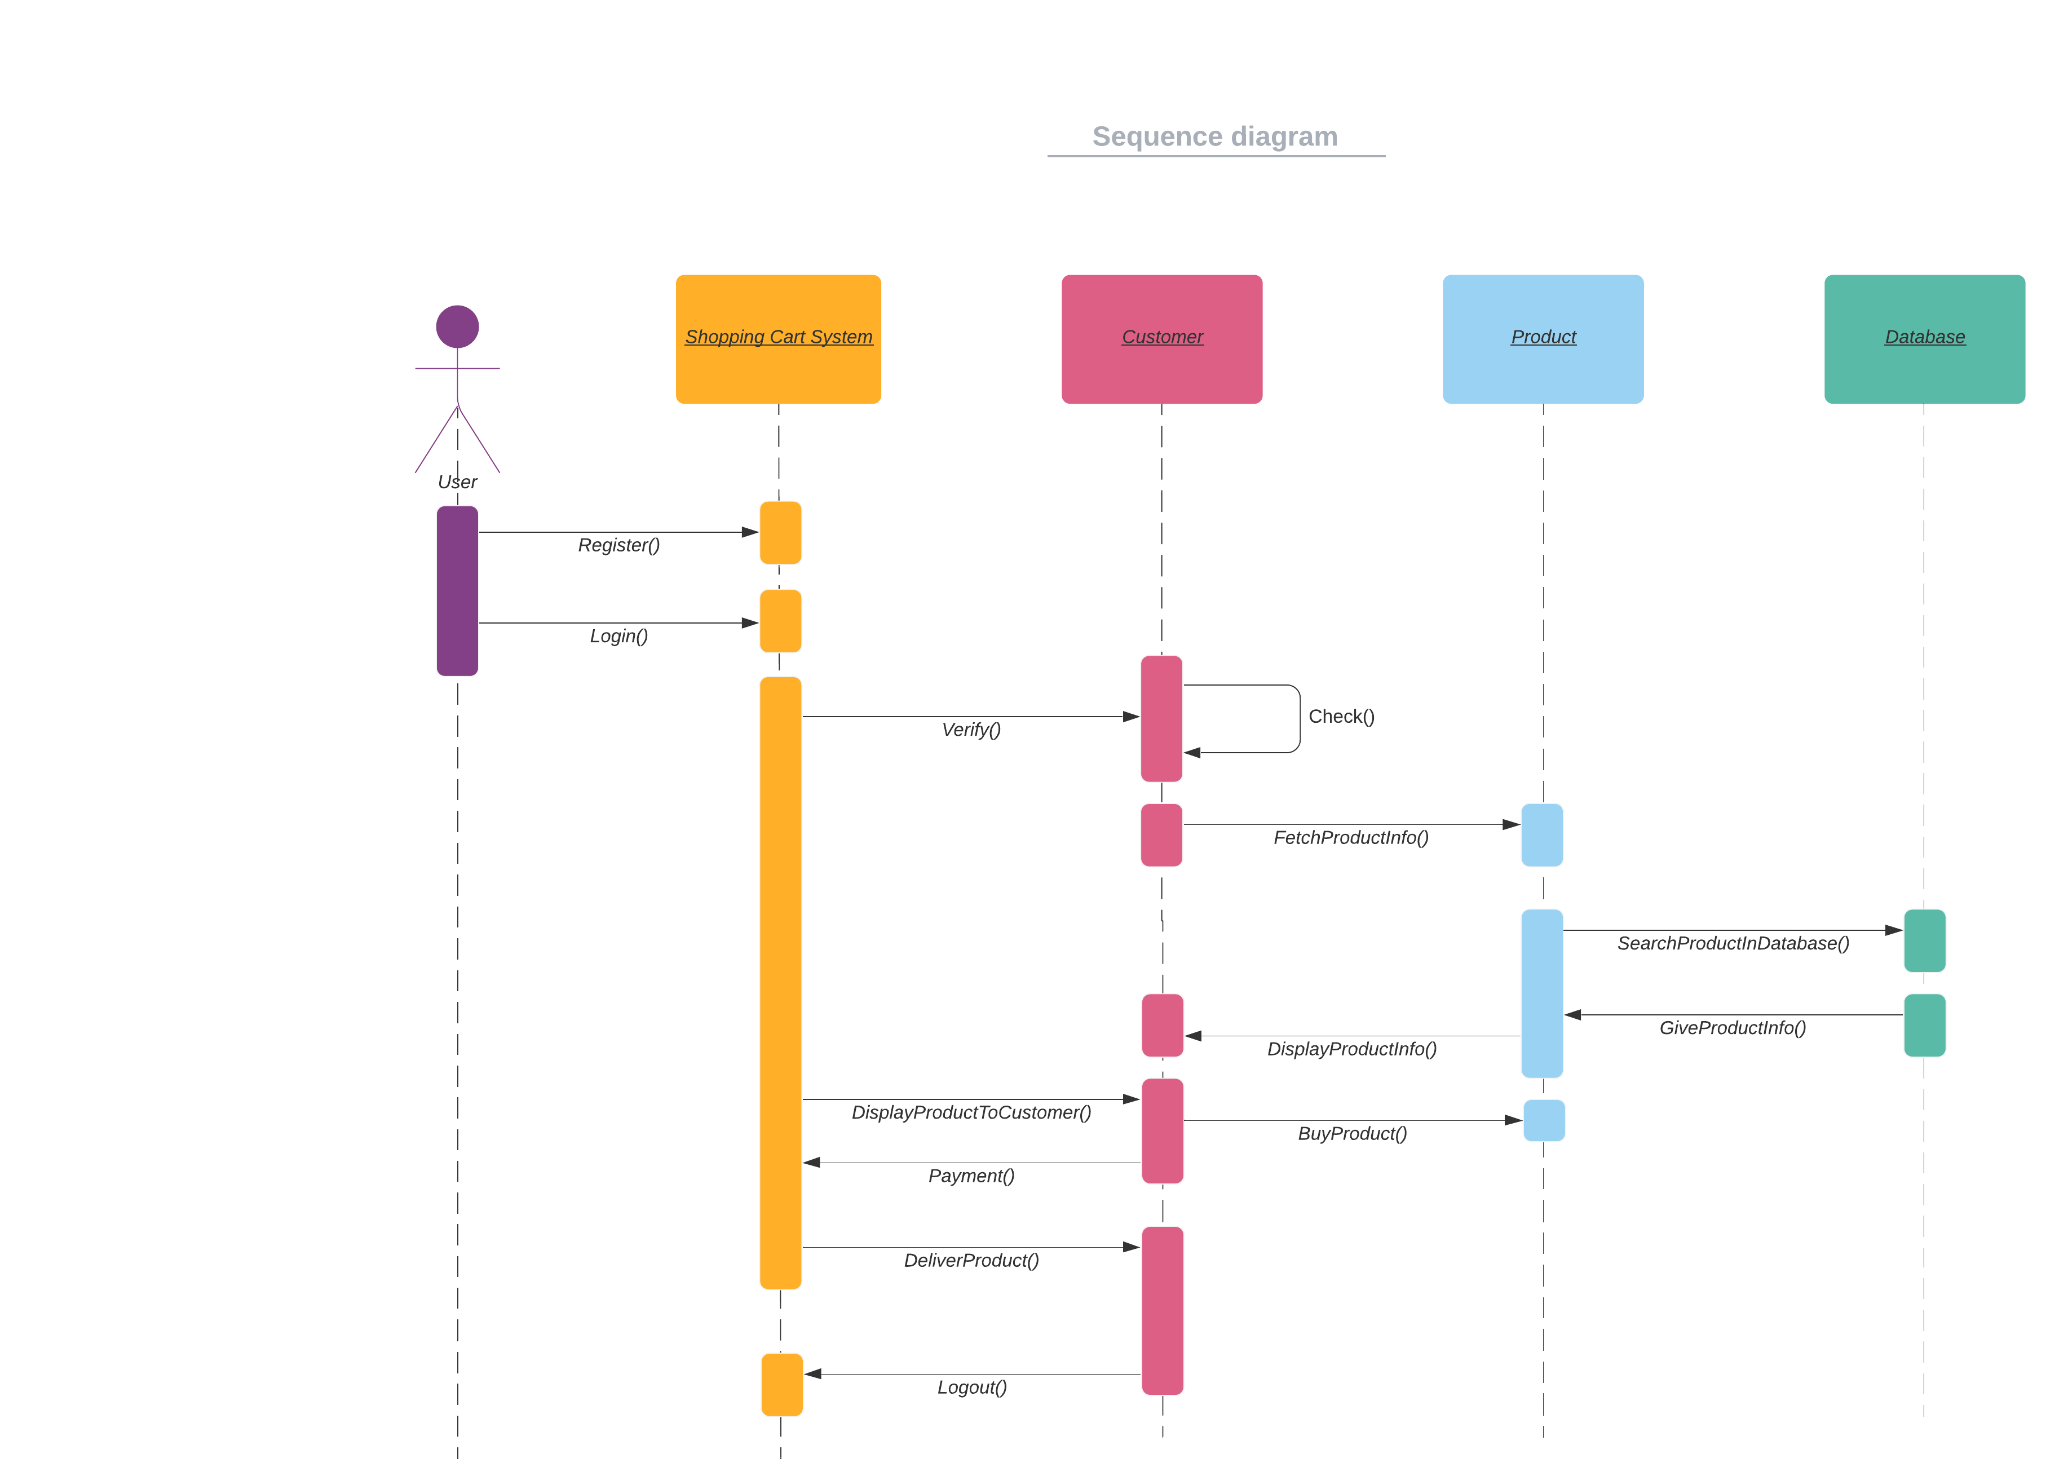

**Sequence Diagram**

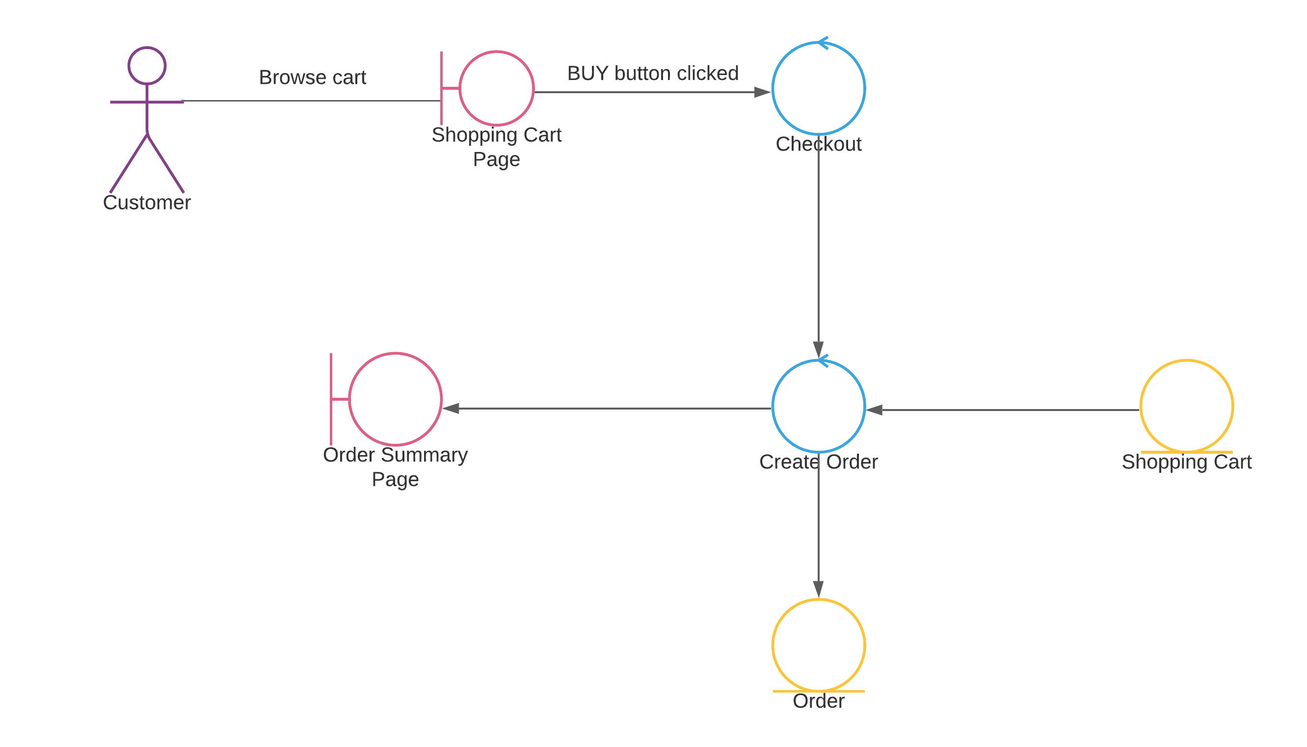

**Robustness Diagram**

* 1. **Implementation**

We followed MVC framework using Spring Boot (Java). We used Postgres SQL as database. We made APIs in order to interact with the database and make system functional.

We made the following APIs:

1. Customer Sign Up
2. Customer Login
3. Admin Login
4. Fetch All items
5. Fetch All Users
6. Fetch All Orders
7. Update User Info
8. Deactivate User
9. Update Order
10. Update Item
11. Add Item
12. Add order
13. Add item to shopping cart
14. Remove item from shopping cart
15. Fetch items of shopping cart
16. Update item of shopping cart