Assignment – 6

Question 1:

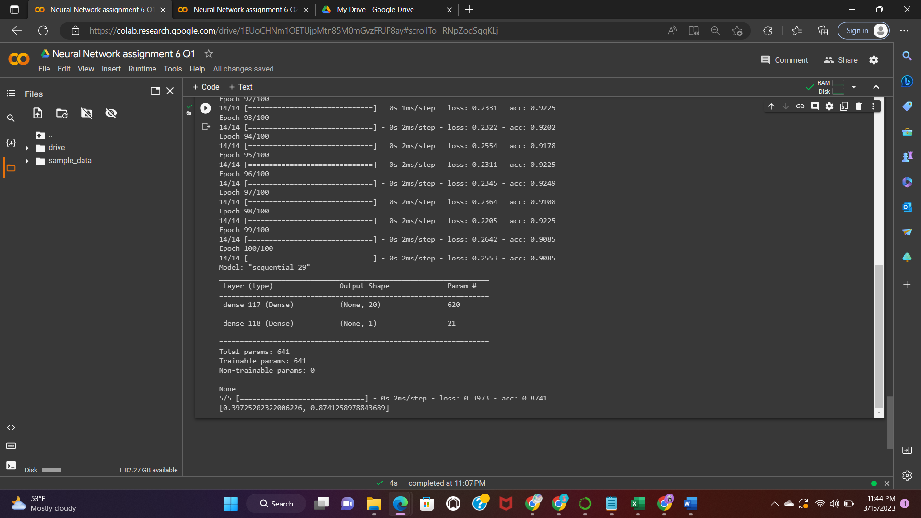

Question2

