Annexe 2 Fiche descriptive de l’entreprise

Project leaders | GOUMZI Clément, HUGOT Antoine, KOLODZIEJSKI Carl
Brand name | La Boule à Zen | 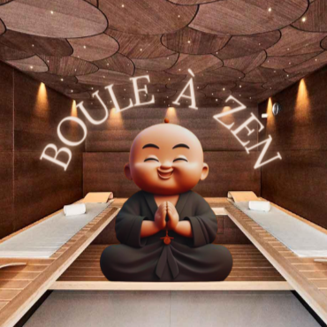
Domain name | www.bouleazen.fr
Its interest for the consumer | The consumer will be able to relax and find deep relaxation. Being able to personalize your treatments according to your needs, providing our consumers with the well-being of a spa salon.
Its technical and commercial characteristics, its operation | - Have a soothing architecture and innovative design to attract our audience, use high-tech equipment, natural and organic products for our customers.  - Being able to allow our customers to have a quick and simple reservation, a prior consultation for suitable care, qualified staff and personalized follow-up.
Advantages | - Unique and memorable experience  - Support for the local community.  - Reduced stress and improved health.  - Suits anyone.
Weaknesses | - Cost sometimes high.  - Competition in the sector  - Limited availability of appointments.  - Frequent maintenance operations needed.  - High customer expectations.

