**GAME DESIGN DOCUMENT**

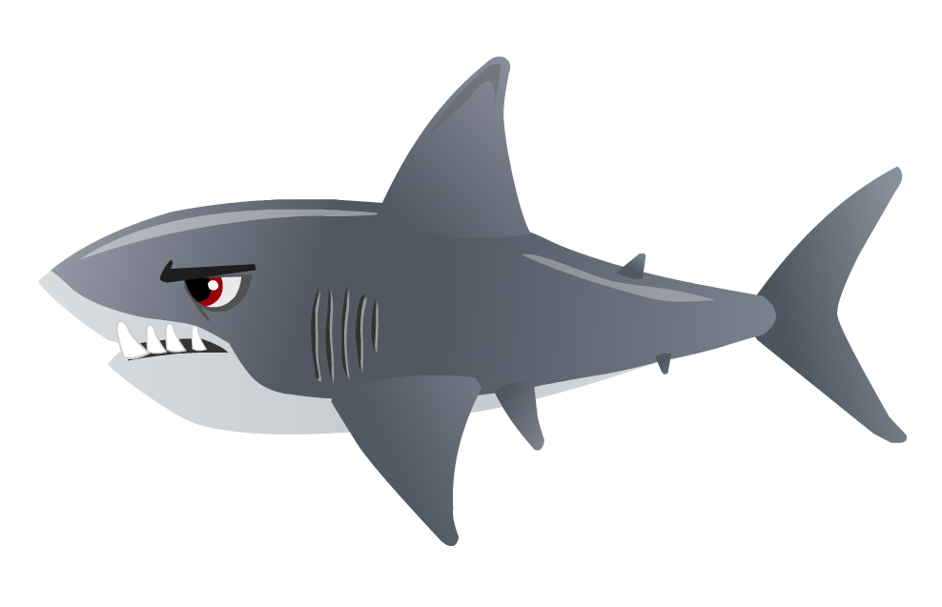

Kenji’s Run

Shark Water

**Last Updated:**

10/24/2018

**Prepared By:**

Josh Cove

Matt Beaton

**TABLE OF CONTENTS**

Game Analysis 3

Mission Statement 3

Genre 3

Platforms 3

Target Audience 3

Storyline & Characters 4

Gameplay 5

Overview of Gameplay 5

Player Experience 5

Gameplay Guidelines 5

Gameplay Mechanics 5

Level Design 6

Control Scheme 7

# Game Analysis

Kenji’s Run is fun game on which the player will be able to

# Mission Statement

Kenji’s Run is a platformer on which the player will have to face fierce sharks jumping for their prey. Kenji is lost and must find his way through these traitorous lands by any means necessary. Collecting as much as possible and killing as many enemies before

# Genre

Platformer.

# Platforms

Pc only.

# Target Audience

This game will target a wide range of players. The game will be animated and unrealistic with death and killing leaving it open to kids and young adults.

# Storyline & Characters

The purple ninja has mastered the art of running and jumping. His sword craft vs the vile zombie is equaled by none.

|  |  |  |  |
| --- | --- | --- | --- |
| Character | Description | Characteristics | Misc. Info |
| Character Name | Describe the character. It is a playable character or NPC. How does this character fit into the story, etc. | Describe the character’s abilities, personality and so forth. | Present any other notes about the character. |

# Gameplay

## Game Objectives & Rewards

This is where you present more details on how the gameplay will motivate the player to progress through the game. Discuss rewards and penalties and the difficulty level. You can use the table below to help break down objectives and rewards.

The objective

|  |  |  |
| --- | --- | --- |
| Rewards | Penalties | Difficulty Levels |
| List ways of how the player is rewarded and when. | Discuss things that hinder the player on progressing | Discuss the difficulty levels within the game |

## Gameplay Mechanics

This is the where you start getting more specific on how some of the systems in the game will work. This includes how characters move in the game, what gameplay actions are available, item inventory and attributes, and how the game progresses from level to level.

|  |  |
| --- | --- |
| **Character Attributes** |  |
| **Character** | **Movement Abilities / Actions Available** |
| Name of character | List the characters abilities & how the player can perform them |
|  |  |
| **Game Modes** |  |
| Game Mode / Difficulty Name | Describe the objectives, hazards in the game mode. And discuss how the player progresses from level to level |
| **Scoring System** |  |
| **Points/Coins/Stars/Grades/Etc.** | **How it’s Awarded & Benefits** |
| List the scoring attribute | Describe how the player obtains this and the benefits. For instance, does getting more points unlock a special level. |

## Level Design

Discuss the levels. How many levels will the game have, what will be included in each level. Include overall look and feel, hazards the level presents, difficulty, objectives, etc.

|  |  |
| --- | --- |
| **Levels** |  |
| Level name and/or pic of it | List or describe the level’s look, difficulty, hazards, and objectives. |

# Control Scheme

Describe the control setup for the game. Does your game use touch input, a controller, or mouse & keyboard? Discuss the functionality of each button/touch. It may help to insert a diagram/pic to help explain the actions.

|  |  |
| --- | --- |
| **Button/ Touch Input** | **Action it Performs** |
| List the button | Describe what functionality the button press has within the game. |