**BeStrong**   
**Report**

All the necessary resources are deployed  
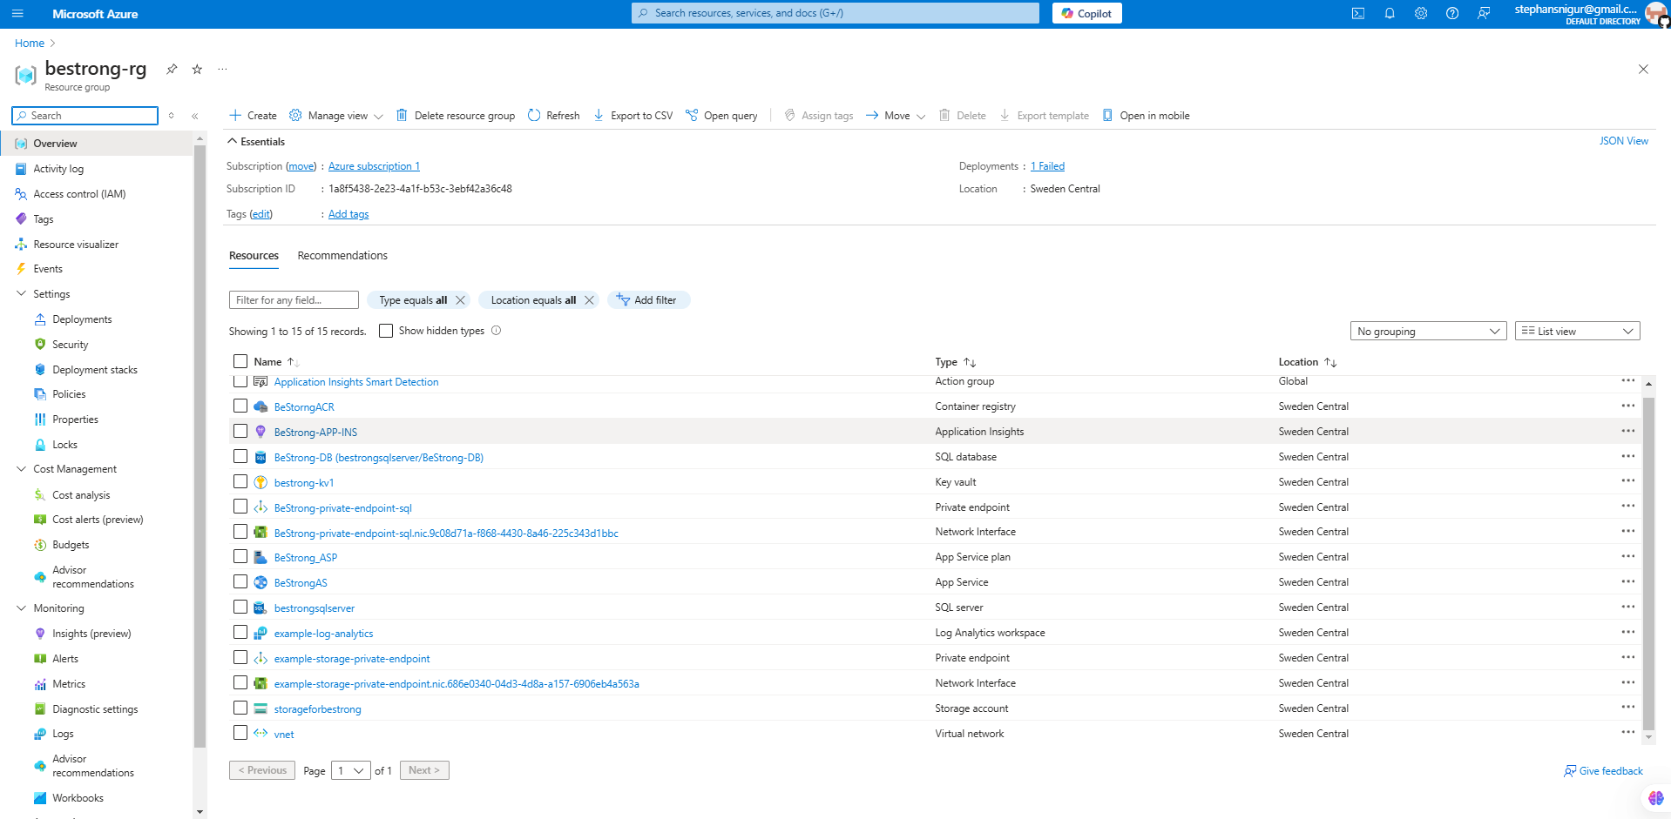

App service with integrated VNet and enabled System Managed Identity

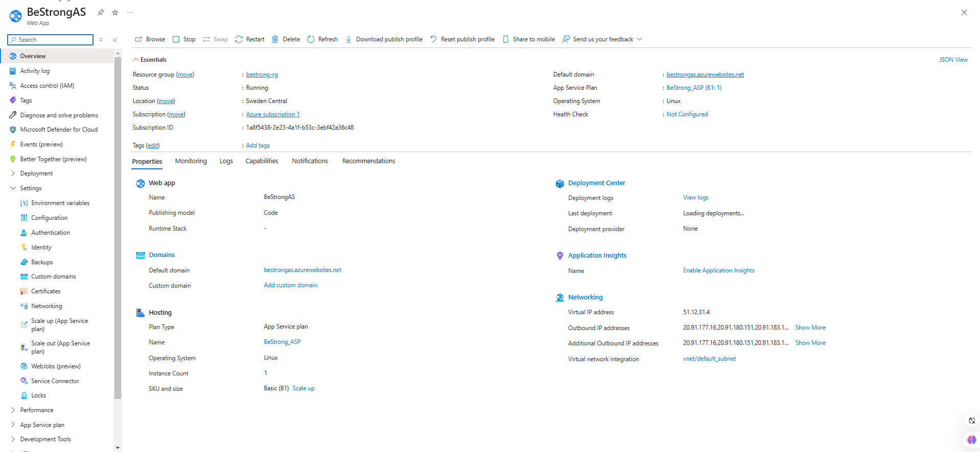

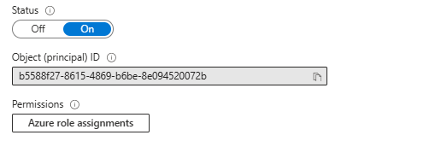

Application insights

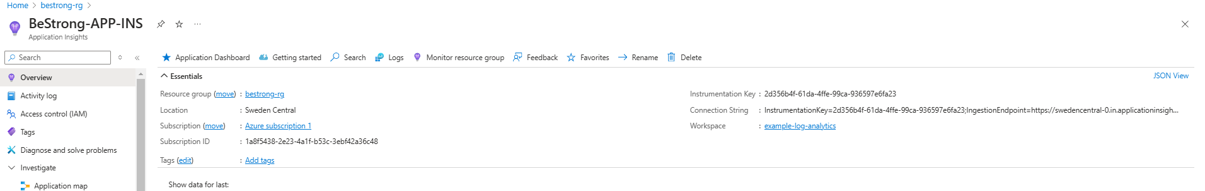

ACR with assigned role

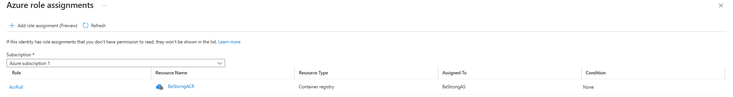

Key vault with integrated VNet and configured access policies

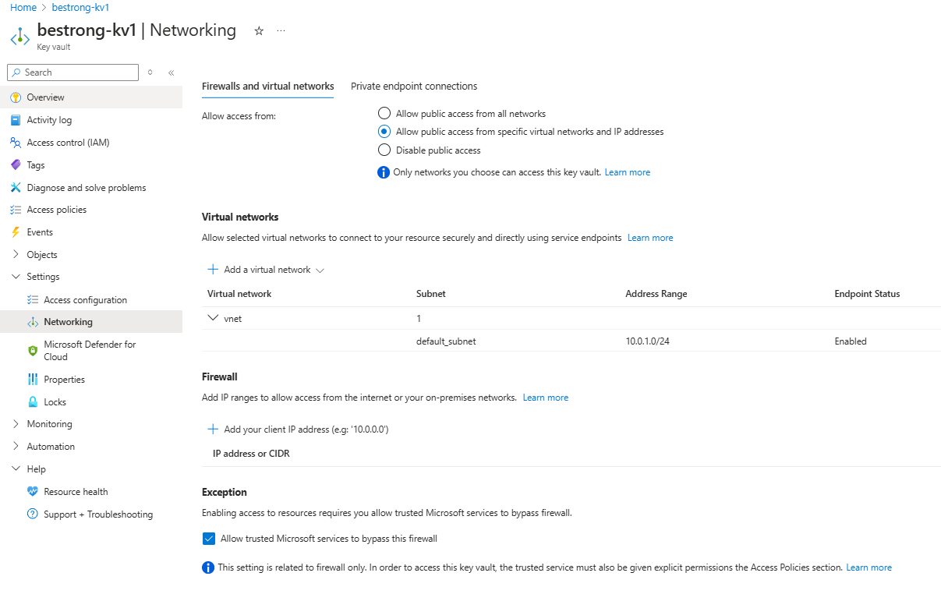

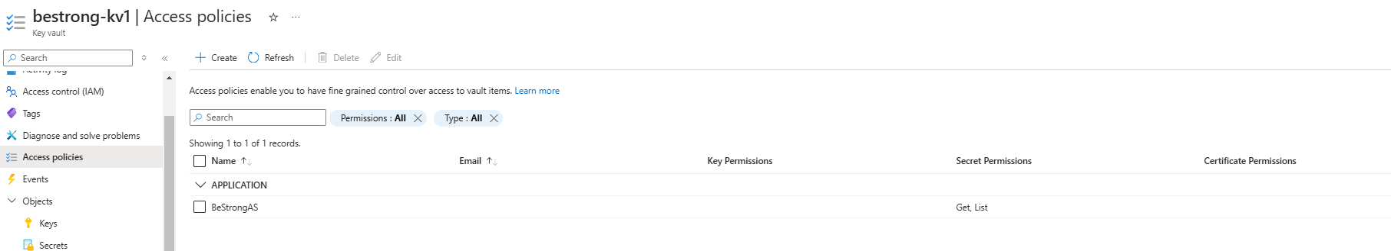

VNet with it`s subnets

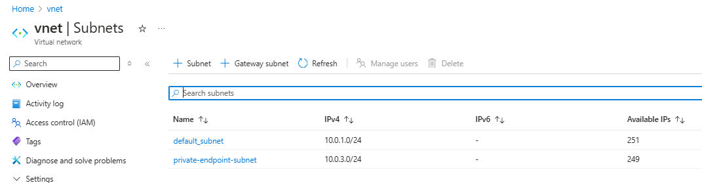

SQL server, DB and private endpoint

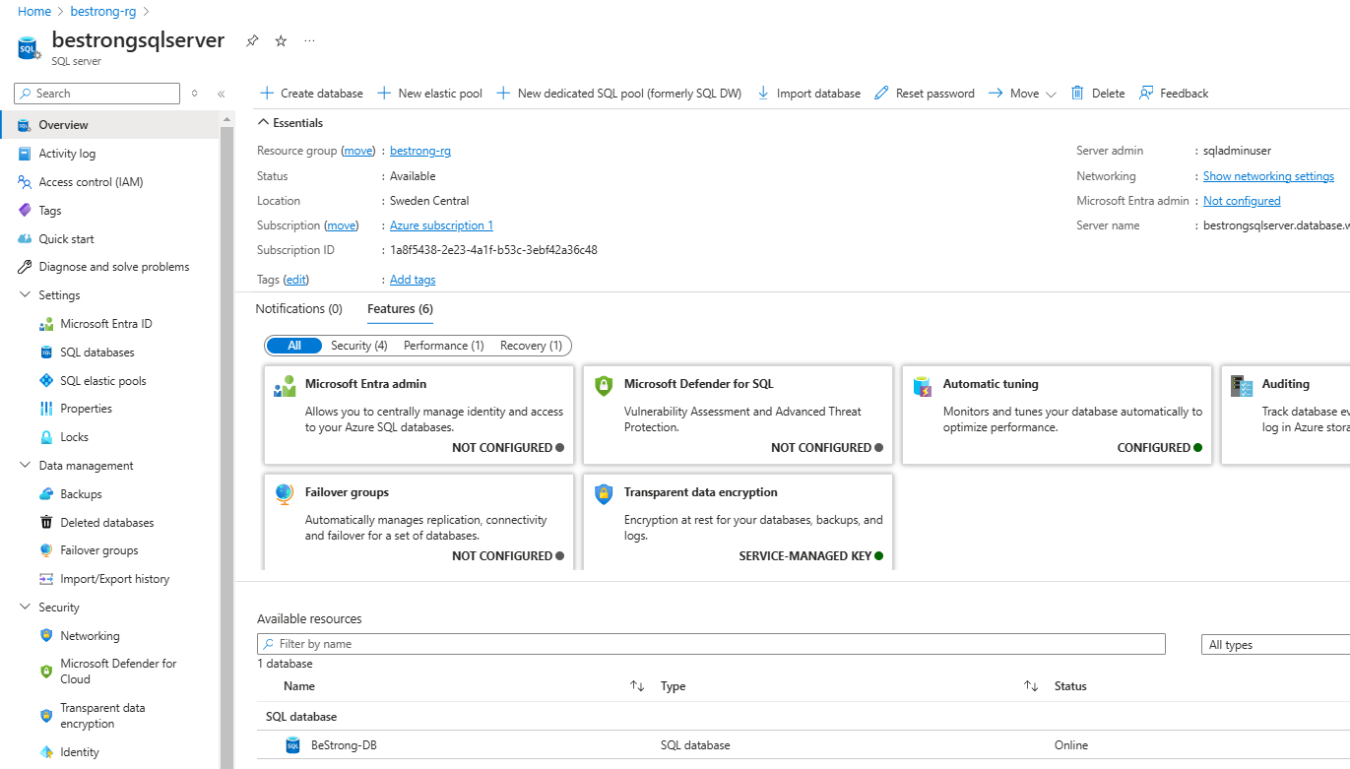

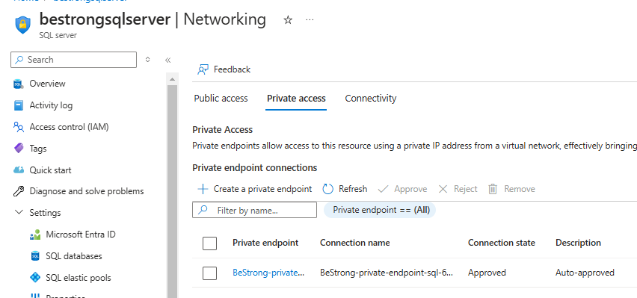

Storage account

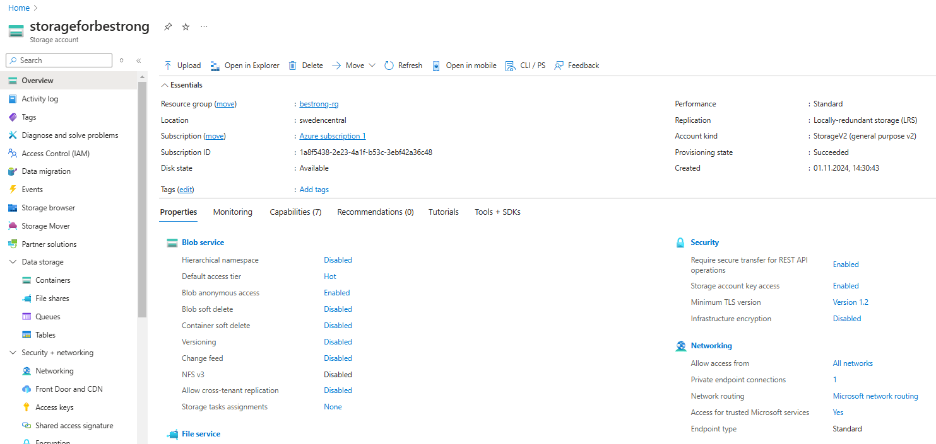

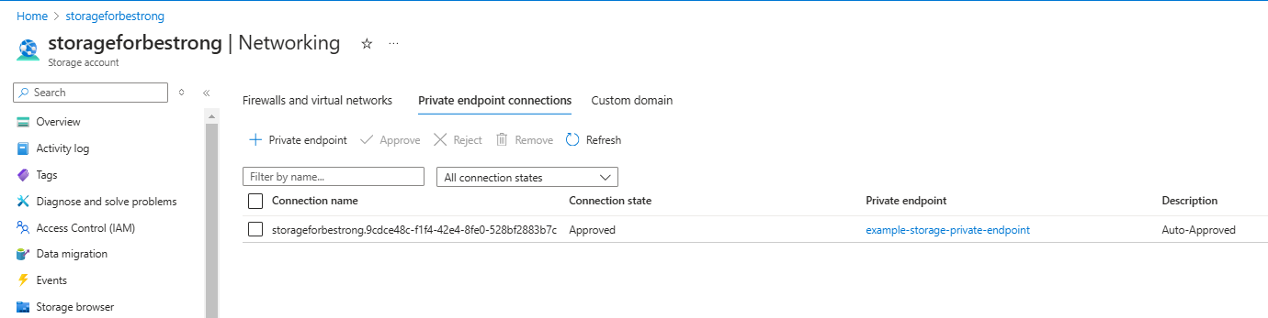

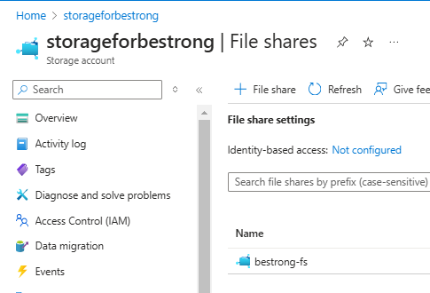

Storage account for Terraform state file

