
Ben-Gurion University of the Negev
Faculty of Engineering Sciences
Department of Industrial Engineering and Management
Automated Almond Orchard Monitoring:
Deep Learning Instance Segmentation, Geospatial Mosaic
Construction, and Yield Prediction from UAV Imagery
THESIS SUBMITTED IN PARTIAL FULFILLMENT OF THE REQUIREMENTS
FOR THE M.Sc. DEGREE
Specialization: Data Science
By: Snir Tahasa
Supervised By Prof. Gilad Ravid and Prof. Tarin Paz-Kagan
September 2026

Abstract
Precision agriculture demands scalable, accurate, and reproducible tools for monitoring crop health and estimating yield at the individual plant level. This thesis presents a comprehensive, end-to-end computational system for automated detection, instance-level segmentation, and geospatial mapping of individual almond trees in drone-acquired imagery, culminating in orthomosaic construction for agronomic analysis.
The core deep learning pipeline employs a UNet++ semantic segmentation architecture with an EfficientNet-B3 encoder, trained using the Focal Tversky Loss function to address the pronounced class imbalance inherent in orchard imagery (trees occupy 15-30% of pixels). Pixel-level binary tree/background predictions are subsequently processed through a classical marker-based watershed algorithm to delineate individual tree crowns, implementing dynamic thresholding strategies that adapt to variable orchard densities and seasonal phenological states.
Each processed drone image is georeferenced using EXIF-embedded GPS metadata, transformed from WGS84 geographic coordinates to UTM Zone 36N projected coordinates, and exported as a 4-band GeoTIFF raster (RGB + binary tree mask) at 2 cm ground sampling distance. These individual rasters are then assembled into a continuous, analysis-ready orthomosaic through a dedicated ArcGIS Pro post-processing workflow comprising five stages: reference raster preparation, multi-phase image registration (direct, GPS-offset-guided, and histogram-matched), visual quality assurance, mosaic dataset assembly with quality filtering, and final export in both analytical (LZW-compressed) and visualization (JPEG-compressed) formats.
Quantitative evaluation on the held-out test images, scored against independent manual annotations, demonstrates a semantic Dice coefficient of 0.89 (IoU: 0.82), instance-level precision of 0.91, and recall of 0.85. GPS geolocation accuracy averages 2.4 m, sufficient for field-scale precision agriculture applications. The system processes 1,000 drone images in under 7 minutes on a single GPU, making it viable for large commercial orchard operations.

Beyond the detection system, the per-tree indices it produces were used to analyse four seasons of bloom phenology, cultivar structure, spatial pattern, winter climate and yield for 1,523 trees. Bloom intensity was organised primarily by cultivar, whose large early-season differences converge by the final season, and by a significant spatial gradient, rather than by any orchard-wide temporal trend. Bloom timing separated the cultivars in a fixed order and, unlike bloom intensity, tracked the climate record: across ten cultivar-years the date of fifty-percent bloom moved later in warmer winters (r = +0.69, p = 0.03), the delay expected under insufficient chilling. Against field-measured harvest, yield was governed by cultivar rather than mean bloom, and the bloom-to-yield relationship reversed in sign between the two cultivars, a significant interaction that a cultivar-blind index would misread. A compact remote-sensing model predicted measured yield more closely than the laboratory's existing modelled product (46 versus 29 percent of variance under cross-validation), and that modelled product was itself predicted from UAV and agro-climatic features to about 85 percent, and to about 98 percent with physiological variables, by a random forest.
Keywords: instance segmentation, semantic segmentation, UNet++, EfficientNet, Focal Tversky loss, geospatial mapping, GeoTIFF, ArcGIS, orthomosaic, precision agriculture, drone imagery, watershed algorithm, transfer learning, almond orchard, yield prediction

Table of Contents
Abstract 2
1. Introduction 12
1.1 Motivation and Agricultural Context 12
1.2 Problem Statement 12
1.3 Research Objectives and Scope 13
1.4 System Overview 13
1.5 Thesis Organisation 14
2. Literature Review and Related Work 15
2.1 Semantic Segmentation in Remote Sensing 15
2.2 Transfer Learning and Backbone Architectures 15
2.3 Loss Functions for Imbalanced Segmentation 16
2.4 Instance Segmentation Approaches 16
2.5 Geospatial Processing and Orthomosaic Construction 17
2.6 Agricultural Remote Sensing Applications 17
2.7 Bloom Phenology and Spectral Bloom Indices 19
3. Methodology: Prediction Pipeline 19
3.1 Stage 1 - Image Preprocessing 19
3.1.1 Gray World White Balance 19
3.1.2 Adaptive Gamma Correction 19
3.1.3 CLAHE Contrast Enhancement 20
3.2 Stage 2 - Semantic Segmentation 20
3.2.1 Training Dataset and Manual Annotation 20
3.2.2 UNet++ Architecture with EfficientNet-B3 Encoder 21
3.2.3 Focal Tversky Loss Function 22
3.2.4 Training Protocol 22
3.2.5 Empirical Architecture and Loss Function Search 22
3.2.6 Data Augmentation Policy: Empirical Comparison 23
3.2.7 Pre-Processing Rationale and Visual Validation 24
3.2.8 Architecture Selection Rationale: Why UNet++ with an EfficientNet-B3 Encoder 25
3.2.9 Computational Resource Constraints 27
3.2.10 Post-Processing Exploration: An Alternative Instance-Separation Method Considered 27
3.3 Stage 3 - Instance Segmentation via Watershed 28
3.4 Stage 4 - Geospatial Processing and GeoTIFF Export 30
3.4.1 GPS Recovery for Cameras Without Native Geotagging (2021 Survey) 31
4. ArcGIS Post-Processing Workflow: Orthomosaic Assembly 31
4.1 Step 1 - Reference Raster Preparation 32
4.2 Step 2 - Multi-Phase Image Registration 33
4.2.1 Phase A - Direct Registration 33
4.2.2 Phase B - GPS Offset-Guided Registration 33
4.2.3 Phase C - Histogram-Matched Registration 33
4.3 Step 3 - Visual Quality Assurance 34
4.4 Step 4 - Mosaic Dataset Construction with Quality Filtering 34
4.4.1 Implementation Notes: Mosaic Dataset Construction 35
4.5 Step 5 - Final Mosaic Export 35
5. Implementation 37
5.1 Software Architecture 37
5.2 Key Dependencies 37
5.3 Computational Requirements and Performance 38
5.4 System Usage 38
5.5 Phenological and Spectral Analysis Methodology 39
5.5.1 Fixed Tree-Zone Delineation and Cross-Year Spatial Calibration 39
5.5.2 Computation and Normalization of EBI and NGRDI from Tree-Canopy Pixels 40
5.5.3 Cultivar Zone Assignment 41
5.5.4 Climate Data Source and Agro-Climatic Feature Definitions 41
5.5.5 Cross-Referencing with Prior-Work Yield Data 42
5.5.6 Statistical Methods Used in the Analysis Program 43
5.5.7 Yield Analysis and Prediction Modelling 44
5.5.8 Validation Against Independent Phenology Surveys 44
6. Results and Evaluation 45
6.1 Training Performance 46
6.2 Quantitative Segmentation Metrics 46
6.3 ArcGIS Registration Results 47
6.4 Phenological and Spectral Analysis Results 48
6.4.1 Temporal Dynamics of Bloom Intensity 48
6.4.2 Cultivar Structure and Convergence 48
6.4.3 Spatial Autocorrelation of Bloom 49
6.4.4 Association with Winter Climate 50
6.4.5 Bloom Timing by Cultivar 51
6.4.6 Validation Against Independent Phenology Observations 52
6.5 Yield Analysis 53
6.5.1 Descriptive Statistics 53
6.5.2 Cultivar Effects on Measured Yield 53
6.5.3 Bloom and Yield, and the Cultivar Reversal 54
6.6 Yield Prediction Modelling 55
6.6.1 A Remote-Sensing Model for Measured Yield 55
6.6.2 Prediction Model: Feature Selection 57
6.6.3 Model-Family Comparison 57
6.6.4 Feature Roles and Contributions 58
6.6.5 Synthesis of the Prediction Results 60
7. Discussion 61
7.1 Strengths of the Integrated Approach 61
7.2 Bloom Phenology, Cultivar Structure and Spatial Pattern 61
7.3 Yield and the Cultivar-Dependent Bloom-Yield Relationship 62
7.4 Yield Prediction 62
7.5 Limitations and Failure Modes 62
7.6 Future Research Directions 63
8. Conclusion 63
References 65
Appendix A: Configuration Parameters Quick Reference 67
Appendix B: ArcGIS Registration Log JSON Schema 68

List of Figures
Figure 1: Complete system pipeline - from drone acquisition to ArcGIS orthomosaic export. The prediction pipeline (Stages 1-4) produces individual georeferenced GeoTIFF rasters that are then assembled by the ArcGIS 5-step post-processing workflow into analysis-ready orthomosaics. 14
Figure 2: Comparative analysis of segmentation loss functions. Focal Tversky Loss (gamma=0.75, alpha=0.3, beta=0.7) is selected for its simultaneous handling of class imbalance, asymmetric false positive/negative penalties, and emphasis on hard examples. 16
Figure 3: Color preprocessing pipeline. From left to right: raw drone image (under-exposed), after Gray World white balance, after adaptive gamma correction, after CLAHE, and the final model-ready normalized image. Each stage addresses a specific image quality issue. 20
Figure 4: UNet++ (Zhou et al., 2020) architecture with an EfficientNet-B3 encoder for almond tree canopy segmentation. The input image is encoded through five downsampling stages X(i,0); each encoder stage feeds a row of nested decoder nodes X(i,j), with solid arrows showing the encoder path and same-row dense skips and dashed arrows the nested upsampled skip pathway from one resolution level down. The orange 1x1-convolution-plus-sigmoid deep-supervision heads produce per-node masks; during training each is compared with the ground-truth mask by the Focal Tversky loss (alpha=0.3, beta=0.7, gamma=0.75), which penalizes missed trees about 2.3 times more than false positives, and the resulting gradients update all encoder and decoder weights. At inference the final tree mask is taken from X0,4. 21
Figure 5: Representative training tile - drone image with ground-truth canopy annotations overlaid (green), showing individual hand-annotated tree polygons across orchard rows. 25
Figure 6: Original image, ground-truth mask, and model-predicted mask for a representative held-out validation tile. 26
Figure 7: Pixel-level confusion matrix on the held-out test set (canopy vs. background). 26
Figure 8: Instance-separation demonstration, left to right - original image, ground truth, semantic overlay, individually colourized tree instances (N=143 in this tile), and instance boundaries. 28
Figure 9: Watershed-based instance segmentation, step by step. The procedure is demonstrated on a synthetic test case built to contain the two situations the algorithm must handle, a cluster of three touching crowns and two small spurious blobs, so that the correct answer is known in advance; every quantitative result in Chapter 6 comes from the real orchard mosaics. (1) Binary semantic mask in which the adjacent crowns are merged into a single component and small noise blobs are present. (2) Euclidean distance transform (brighter = farther from the nearest background edge). (3) Peak detection places one marker at each local maximum, subject to a minimum separation of min_dist pixels (min_dist = 25 px here). (4) Watershed flooding assigns every marker its own labelled region, so the two spurious blobs also become regions. (5) Area and solidity filtering removes the spurious detections. (6) The watershed ridge line inserts a one-pixel physical gap between the separated crowns. (7) Final result, with each crown assigned a unique tree identity, overlaid on the image background. 29
Figure 10: GPS extraction and coordinate transformation pipeline, illustrated with the plot own coordinates. Stage 1: EXIF GPS tags are parsed and converted from degrees-minutes-seconds to decimal degrees (31.7107 N, 34.7924 E). Stage 2: the WGS84 position (EPSG:4326) is projected with pyproj to UTM Zone 36N (EPSG:32636), whose central meridian is 33 E and scale factor k0 = 0.9996, giving Easting = 669842.5 m and Northing = 3509769.4 m. Stage 3: the drone centre-point position is offset by half the orthomosaic width and height (at 0.02 m per pixel) to obtain the top-left corner, which defines the GeoTIFF affine transform; the export is a 4-band GeoTIFF (RGB plus tree mask) in EPSG:32636, LZW compressed. 30
Figure 11: ArcGIS 5-step post-processing workflow. Each step transforms the individual GeoTIFF tiles produced by the prediction pipeline into a quality-assured, mosaicked orthomosaic ready for agricultural analysis. 32
Figure 12: Mosaic assembly process. Individual quality-filtered GeoTIFF tiles (left) are assembled into a continuous orthomosaic (right). The quality filter rejects images with insufficient GCPs, excessive spatial shift, or anomalous extent. Two output products serve different downstream uses: Mosaic_4Band for machine learning analysis and Mosaic_RGB for visualization. 35
Figure 13: Full methodology pipeline from raw drone imagery to statistical analysis. GPS offset correction is applied during preprocessing (Step 2) and propagated through all downstream analyses. 39
Figure 14: Per-tree canopy segments coloured by cultivar (blue = UEF / Um el Fahem, red = cultivar 53, green = cultivar 54) across all four survey years, 2021 to 2024. 41
Figure 15: Training/validation loss, Dice, and IoU over 20 epochs - the final production run, peaking at validation Dice 0.8935 (epoch 17). 46
Figure 16: EBI_Norm by cultivar across the four seasons. Cultivar separation, large in 2021, narrows progressively until the cultivars converge in 2024. 49
Figure 17: Spatial distribution of EBI_Norm, 2021 to 2024. The strong high and low contrast of 2021 fades to a far more uniform pattern by 2024, the spatial counterpart of the standard-deviation decline in Table 10. 50
Figure 18: Climate and bloom, resolved by cultivar. (a) Mean bloom intensity per cultivar across the four seasons, with the chill accumulated in each winter shown as grey bars. The cultivars converge steadily while Chill Portions rise and fall (18, 35, 25 and 10 from 2021 to 2024), so the convergence does not follow the chill record. (b) Date of fifty-percent open bloom against the heat accumulated over January and February, measured as growing degree-days above the 4.5 degC base for almond, one point per cultivar-year. Each 100 degree-days of extra winter warmth is associated with bloom about four days later (r = +0.69, p = 0.03, n = 10 cultivar-years), the delay expected when winter chilling is insufficient. 51
Figure 19: 2021 branch-level phenology validation. (a) Mean composition of scored tips across the three survey dates, showing the progression from dormant buds through green and pink tips to leaves and open flowers by the 7 March UAV flight. (b) At the flight date, each tree’s leaf-stage percentage (vegetative development) against its EBI, coloured by cultivar; the negative slope (r = -0.65, p = 0.002, n = 20) shows that EBI tracks reproductive rather than vegetative development, while the open-flower percentage alone is uninformative. 52
Figure 20: Measured 2023 yield against spring bloom, by cultivar. Left: per-tree EBI_Norm versus measured yield with a fitted line for each cultivar; the slopes run in opposite directions, positive in UEF and negative in cultivar 53. Right: measured yield by cultivar, showing the UEF advantage. 54
Figure 21: Predicted against measured yield for the two models, on the same 167 tree-year records. Each point is one tree; the dashed line is perfect prediction. The remote-sensing model follows that line with a slope of 0.53 and explains 53 percent of the variation in the harvest, whereas predicted_Yield forms a much flatter band (slope 0.25, 29 percent), over-predicting light-cropping trees and under-predicting heavy ones. 56
Figure 22: Prediction accuracy against field-measured yield, split by cultivar. The remote-sensing model leads on both metrics in each cultivar, most clearly in cultivar 53. 57
Figure 23: Share of the predictable signal in predicted_Yield by feature, from a random-forest permutation-importance analysis of the remote-sensing feature set. (a) Four features carry almost all of it: winter chill accounts for 89.2 percent, April canopy growth for 8.2 percent, and EBI skewness and cultivar for about 1 percent each. (b) The remaining 24 contributing features are each below 0.2 percent, which is why four features saturate the model and the wider engineered feature bank adds nothing. 60
Figure 24: The two prediction targets side by side. (a) Predicting the field-measured harvest on the same 167 tree-years: the remote-sensing model developed here explains 46 percent of the variation against 29 percent for the modelled predicted_Yield. (b) Predicting predicted_Yield itself is an easier target, reaching 85 percent from remote-sensing features alone and 98 percent once the physiological variables it is generated from are supplied; the value published by Efrat et al. (2025) is shown hatched for reference, since it was obtained against their own harvest measurements on a different orchard sample and is therefore not directly comparable with either group. 61

List of Tables
Table 1. Dataset version history: images, instances, preprocessing and augmentation at each iteration. 20
Table 2. Training hyperparameters and the rationale for each setting. 22
Table 3. Empirical architecture and loss-function search: validation Dice and IoU for each configuration. 23
Table 4. Data-augmentation policies compared by best validation Dice and IoU. 23
Table 5. Instance-segmentation parameters, their ranges, defaults and effect. 29
Table 6. Mosaic quality-control criteria and rejection thresholds. 34
Table 7. Key software dependencies and their role in the pipeline. 37
Table 8. Inference time and memory by device. 38
Table 9. Segmentation performance on the held-out test set with 95 percent confidence intervals. 46
Table 10. EBI_Norm by cultivar and year (all canopy-mapped trees). The orchard standard deviation is split into its between-cultivar and within-cultivar components: the between-cultivar term collapses while the within-cultivar spread is stable. 48
Table 11. One-way ANOVA of EBI_Norm by cultivar, per year (three cultivars: UEF, 53, 54). 49
Table 12. Moran's I spatial autocorrelation of EBI_Norm by year. 49
Table 13. Mean date of fifty-percent open bloom (t50, day of year) by cultivar, from the growers’ phenology survey. 52
Table 14. Field-measured net kernel yield by cultivar, 2023 season. 53
Table 15. Analysis of covariance of 2023 measured yield on bloom, cultivar and their interaction, with the fitted bloom-to-yield slope inside each cultivar. The interaction is the central yield result: bloom predicts yield in opposite directions in the two cultivars, so a single orchard-wide slope averages them to nothing. 54
Table 16. Yield model comparison against field-measured yield, pooled across cultivars. The final row measures agreement between the two models, not accuracy against measured yield. 56
Table 17. Yield model comparison by cultivar. Both the variance explained and the error favour the remote-sensing model in each cultivar, most strongly in cultivar 53. 56
Table 18. Performance of the best model, a random forest, predicting the modelled predicted_Yield (n = 1,793 tree-years), in the standard metrics used in comparable UAV yield studies. Relative errors are expressed as a percentage of the 4.26 kg per tree mean. The physiological variables (CNC and SWP) are among the variables predicted_Yield is generated from. 57
Table 19. Cross-validated R-squared for six model families predicting predicted_Yield, under the remote-sensing feature set (four features: Chill Portions, April growth, cultivar, bloom-hotspot fraction) and with the physiological variables added (CNC and April SWP). The random forest was best in both. 58
Table 20. Features entering the two prediction models of predicted_Yield, with each feature's correlation with the target and its role. 'Not offered' marks the physiological features, which were excluded by design from the remote-sensing-only feature set. 58
Table 21. The two prediction questions kept apart. The upper rows report predictive accuracy against field-measured yield on this orchard; the value published by Efrat et al. (2025) is listed for context but was obtained on their own harvest measurements and sample, so it is not directly comparable with the rows above it. The lower rows report how closely the modelled predicted_Yield can itself be predicted, a different target from the measured harvest and therefore not comparable with the rows above. 60
Table 22. Configuration parameters quick reference. 67

List of Abbreviations
ANCOVA | Analysis of covariance
ANOVA | Analysis of variance
CLAHE | Contrast-limited adaptive histogram equalisation
CNC | Canopy nitrogen content
CNN | Convolutional neural network
CP | Chill Portions, the accumulation unit of the Dynamic Model
DTR | Diurnal temperature range
EBI | Enhanced Bloom Index
EPSG | Coordinate-reference-system code (EPSG registry)
EXIF | Exchangeable image file format
GCP | Ground control point
GDD | Growing degree-days
GIS | Geographic information system
GPS | Global Positioning System
GSD | Ground sampling distance
IoU | Intersection over union
LZW | Lempel-Ziv-Welch lossless compression
MAE | Mean absolute error
NGRDI | Normalised Green-Red Difference Index
RGB | Red, green and blue image channels
RMSE | Root-mean-square error
RTK | Real-time kinematic satellite positioning
SD | Standard deviation
SWP | Stem water potential
TGR | Trunk growth rate
UAV | Unmanned aerial vehicle
UEF | Um el Fahem, one of the three almond cultivars
UTM | Universal Transverse Mercator projection

1. Introduction

1.1 Motivation and Agricultural Context
Almond (Prunus dulcis) cultivation represents one of the most economically significant tree crops in the Mediterranean basin and semi-arid regions globally. Modern almond orchards face increasing pressure to optimize inputs - water, fertilizer, and labor - while maximizing yield and minimizing environmental impact. This imperative drives demand for precision agriculture technologies that deliver actionable, plant-level spatial data at orchard scale.
Traditional orchard assessment methods - manual tree counting, GPS-based localization surveys, and visual health inspections - are labor-intensive, temporally limited (typically conducted once or twice per season), and highly susceptible to inter-observer variability. A single agronomist requires weeks to census a 200-hectare orchard, by which time the agronomic information may already be outdated. These limitations are particularly acute during critical phenological windows such as pollination, fruit set, and pre-harvest, when rapid, accurate tree-level data is most valuable.
The convergence of affordable consumer UAVs (unmanned aerial vehicles), miniaturized high-resolution cameras, and deep learning-based computer vision has created a transformative opportunity: automated, repeatable, high-throughput orchard monitoring at centimeter-level spatial resolution. A drone can image 40-60 hectares per flight at 2 cm ground sampling distance (GSD), acquiring thousands of georeferenced images in under an hour - but converting this raw imagery into actionable agronomic information requires a sophisticated, automated computational pipeline.

1.2 Problem Statement
Converting raw drone imagery into georeferenced, analysis-ready orchard maps presents five interconnected technical challenges:
- Semantic Understanding: Distinguishing tree canopy pixels from background elements (bare soil, shadows, infrastructure, cover crops) across widely varying illumination conditions, growth stages, and seasonal phenological states.
- Instance Separation: Delineating boundaries between individual adjacent trees - a particularly difficult task during bloom when dense white floral canopies merge continuously across rows.
- Geolocation Accuracy: Translating pixel coordinates in each drone image to real-world UTM coordinates with sufficient precision for field navigation and agronomic decision-making (target: better than 5 m RMS).
- Scalability: Processing large image collections (hundreds to thousands of images per flight) efficiently without manual intervention or per-image parameter tuning.
- GIS Integration: Generating output formats natively compatible with standard geospatial workflows (ArcGIS Pro, QGIS, Google Earth Engine) to enable downstream analysis by agronomists who are not computer vision specialists.

1.3 Research Objectives and Scope
This research addresses these challenges through an integrated pipeline, and then applies its outputs to orchard-scale agronomic analysis, with the following specific objectives:
- Develop a robust semantic segmentation model for almond tree canopy detection using transfer learning and a class-imbalance-aware loss function.
- Implement an adaptive instance segmentation post-processing algorithm capable of separating touching tree crowns under diverse orchard conditions.
- Design a geospatial processing module that converts per-image pixel predictions into accurately georeferenced GeoTIFF rasters.
- Build an ArcGIS Pro-based post-processing workflow that assembles individual georeferenced rasters into a continuous, quality-filtered orthomosaic.
- Evaluate system performance quantitatively and establish parameter tuning guidelines for operational deployment.
- Apply the resulting per-tree spectral indices to a four-season agronomic analysis of bloom phenology, cultivar structure, spatial pattern and winter climate, link them to field-measured yield, and construct and evaluate tree-level yield-prediction models.

1.4 System Overview
Figure 1 presents the complete pipeline architecture, spanning from UAV data acquisition through the final delivery of export-ready orthomosaics. The system is divided into a one-time model training phase and a repeatable prediction and geospatial assembly pipeline.
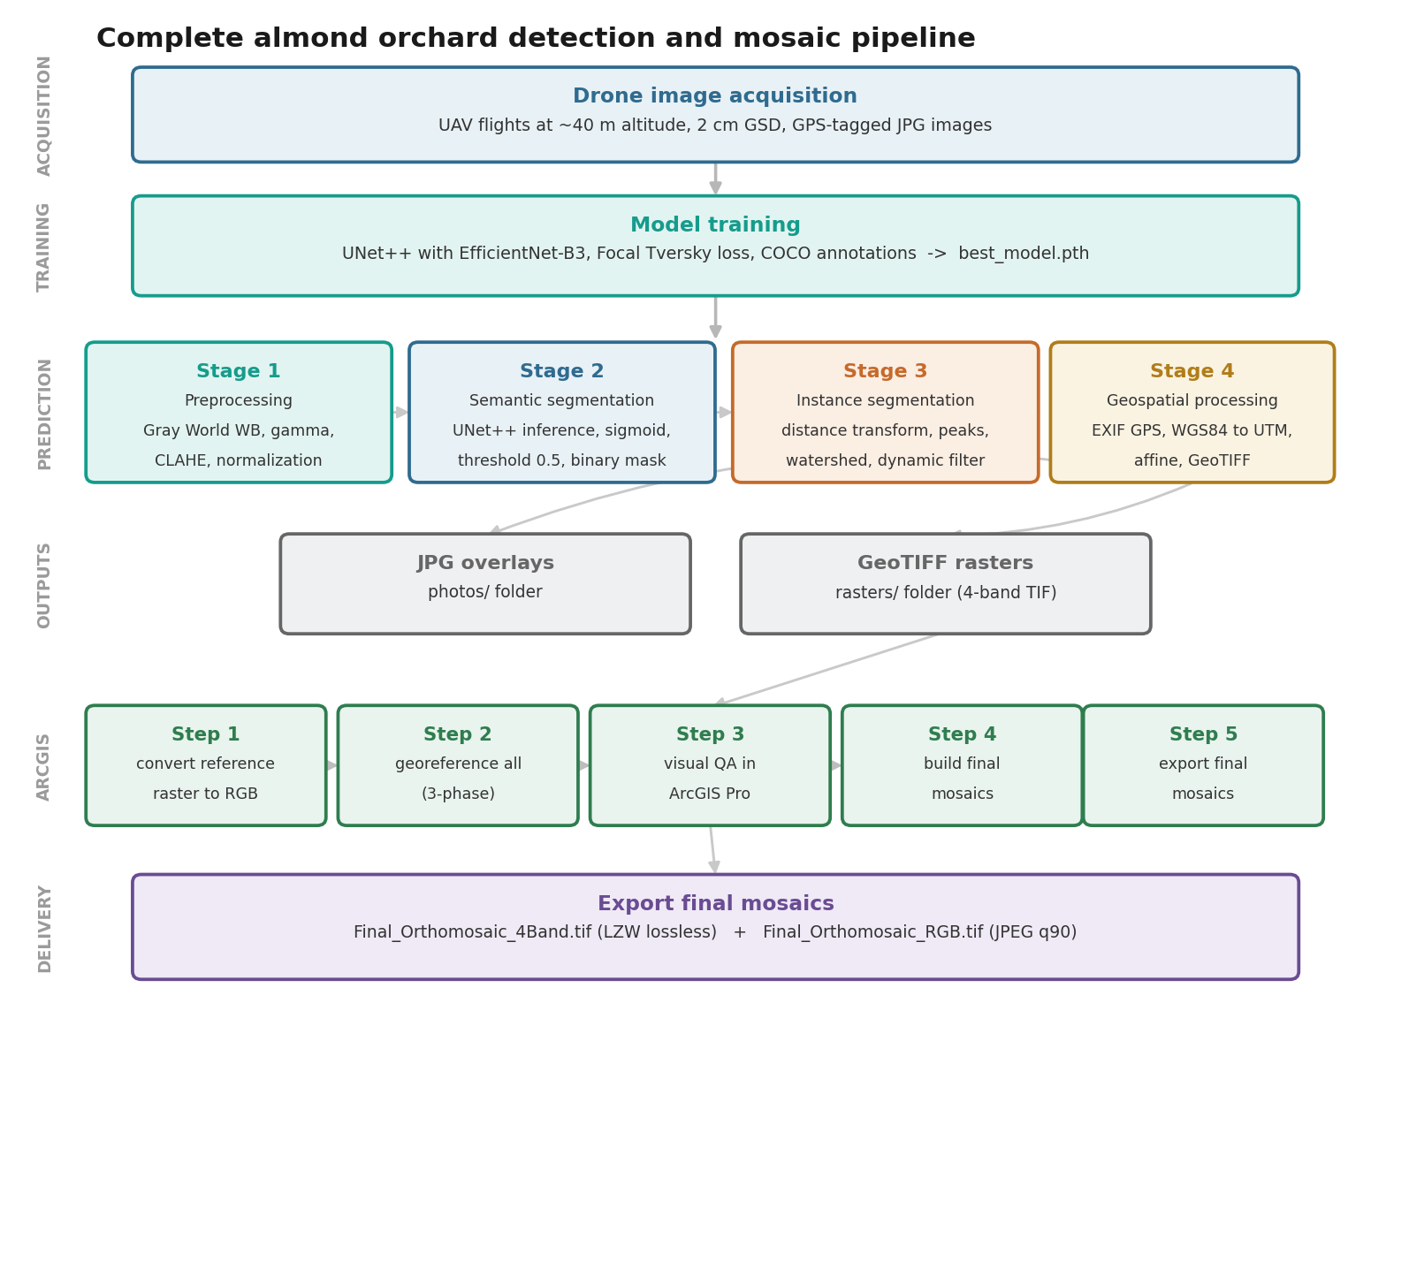
Figure 1: Complete system pipeline - from drone acquisition to ArcGIS orthomosaic export. The prediction pipeline (Stages 1-4) produces individual georeferenced GeoTIFF rasters that are then assembled by the ArcGIS 5-step post-processing workflow into analysis-ready orthomosaics.

1.5 Thesis Organisation
The remainder of this thesis is organised as follows. Section 2 reviews relevant literature on semantic and instance segmentation, geospatial processing and agricultural remote sensing, and on bloom phenology and spectral bloom indices. Section 3 presents the four-stage prediction pipeline and Section 4 the ArcGIS orthomosaic-assembly workflow. Section 5 describes the software implementation and, in Section 5.5, the methodology of the phenological, spectral and yield analyses. Section 6 presents the results, covering both the detection pipeline (Sections 6.1 to 6.3) and the agronomic analysis of bloom, cultivar, climate, spatial structure, yield and yield prediction (Sections 6.4 to 6.6). Section 7 discusses the findings in an integrated manner, and Section 8 concludes.

2. Literature Review and Related Work

2.1 Semantic Segmentation in Remote Sensing
Semantic segmentation - the task of assigning a class label to every pixel - has undergone revolutionary progress since Fully Convolutional Networks (FCNs) demonstrated end-to-end pixel-to-pixel learning (Long et al., 2015). The U-Net architecture (Ronneberger et al., 2015), originally developed for biomedical imaging, proved transformative for remote sensing applications due to its symmetric encoder-decoder design with skip connections that preserve fine spatial detail while incorporating global context. U-Net's ability to train effectively on limited annotated datasets made it particularly attractive for agricultural applications where ground truth annotation is expensive.
UNet++ (Zhou et al., 2020) extended the U-Net paradigm with nested and dense skip connections that create multiple intermediate decoding paths between encoder and decoder layers. This redesign enables the network to learn more flexible feature aggregation across scales, consistently outperforming standard U-Net on medical and remote sensing benchmarks. The architectural innovation is critical for almond orchards where tree crowns exhibit significant intra-class variability in size, shape, and spectral signature across growth stages.
DeepLab (Chen et al., 2017) and its successors employed atrous (dilated) convolutions to expand the receptive field without sacrificing spatial resolution, using Atrous Spatial Pyramid Pooling (ASPP) for multi-scale context. While achieving state-of-the-art results on general segmentation benchmarks, DeepLab architectures are computationally heavier than U-Net variants, making them less suitable for the batch inference requirements of large orchard surveys.

2.2 Transfer Learning and Backbone Architectures
Modern segmentation architectures separate feature extraction (backbone/encoder) from feature decoding. Pre-training encoders on large datasets (ImageNet) provides generalisable feature representations that significantly reduce the annotated data required for domain-specific fine-tuning.
EfficientNet (Tan & Le, 2019) achieved high parameter efficiency through compound scaling - simultaneously scaling network depth, width, and resolution according to a principled search-derived compound coefficient. EfficientNet-B3, used in this work, delivers ImageNet top-1 accuracy of 82.1% with only 10.8M parameters, compared to ResNet-50's 77.2% at 25.6M parameters. For agricultural segmentation specifically, EfficientNet backbones have demonstrated strong generalisation across diverse crop types and imaging conditions (Osco et al., 2021).
Vision Transformers (Dosovitskiy et al., 2021) represent a paradigm shift from convolutional to attention-based feature extraction. While achieving competitive results on large-scale benchmarks, ViT architectures require substantially more training data and computational resources, making them less practical for operational agricultural monitoring systems where labelled data is limited.

2.3 Loss Functions for Imbalanced Segmentation
Class imbalance is a fundamental challenge in orchard segmentation: tree canopy pixels represent only 15-30% of image area, with background (soil, shadows) comprising 70-85%. Standard Binary Cross-Entropy (BCE) loss produces models strongly biased toward predicting background, resulting in high false-negative rates for tree pixels. The loss function landscape for imbalanced segmentation has evolved substantially:
Dice Loss (Milletari et al., 2016), derived from the Dice coefficient overlap measure, directly optimizes the F1 score and inherently handles class imbalance by normalizing by prediction and target sizes. However, Dice loss treats false positives and false negatives symmetrically - suboptimal for orchard monitoring where missed trees (false negatives) have greater agronomic impact than false alarms.
Tversky Loss (Salehi et al., 2017) generalises Dice by introducing asymmetric weights (alpha, beta) for false positives and false negatives respectively, enabling practitioners to bias the model toward higher recall. With alpha=0.3 and beta=0.7, false negatives are penalized 2.33x more heavily than false positives - aligning the optimization objective with the agricultural requirement to detect all trees even at the cost of occasional false detections.
Focal Tversky Loss (Abraham & Khan, 2019), adopted in this work, applies a focal modulation factor (Lin et al., 2017) to the Tversky loss: L_FT = (1 - Tversky)^gamma. With gamma=0.75, hard examples (partially predicted trees) receive disproportionately higher loss contribution, focusing model capacity on challenging cases such as small trees, occluded crowns, and shadow boundaries. Figure 2 provides a comparative analysis of these loss functions.
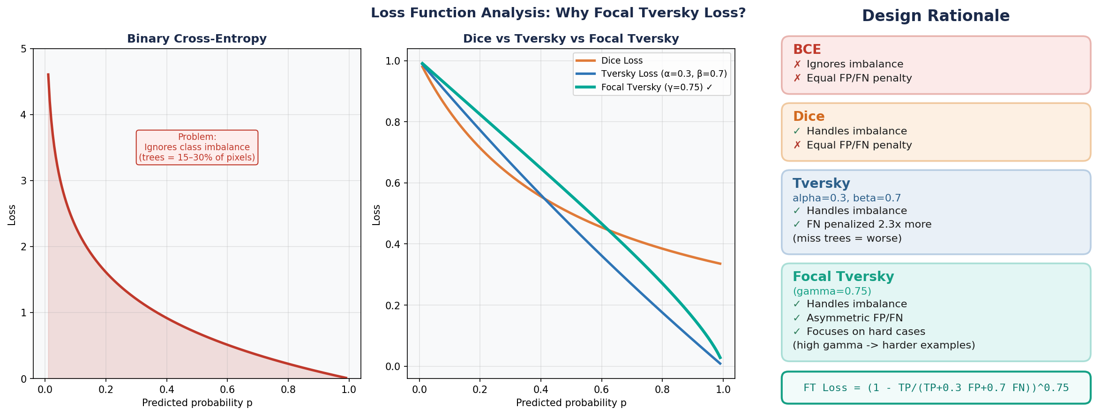
Figure 2: Comparative analysis of segmentation loss functions. Focal Tversky Loss (gamma=0.75, alpha=0.3, beta=0.7) is selected for its simultaneous handling of class imbalance, asymmetric false positive/negative penalties, and emphasis on hard examples.

2.4 Instance Segmentation Approaches
Instance segmentation - assigning unique identifiers to each individual tree - requires converting semantic binary masks into labelled instances. Two broad paradigms exist in the literature:
Proposal-based methods such as Mask R-CNN (He et al., 2017) combine region proposal networks with per-instance mask prediction, achieving high accuracy on complex scenes with overlapping objects. However, these architectures are computationally demanding and require significant labelled training data with instance-level annotations.
Marker-based watershed approaches (Meyer & Beucher, 1989) treat the distance transform of the binary mask as a topographic surface and simulate flooding from seed markers at local maxima (putative tree centres). Where flood zones from different markers meet, watershed boundaries are established. This classical approach offers key advantages for operational agricultural systems: interpretable intermediate steps, no additional training data requirements, parameter-adjustable sensitivity, and efficient runtime complexity.
Recent tree crown delineation literature (Ke & Quackenbush, 2011; Zhen et al., 2016) consistently demonstrates that watershed-based approaches achieve competitive accuracy with proposal-based methods for remote sensing data, particularly when tree crowns exhibit regular spatial patterns as in planted orchards. The deterministic nature of the watershed algorithm also facilitates systematic parameter optimization across different orchard configurations.

2.5 Geospatial Processing and Orthomosaic Construction
Aerial imagery georeferencing translates pixel coordinates to real-world positions using GPS/IMU metadata embedded in image EXIF headers. Consumer-grade drone GPS provides 2-5 m absolute accuracy under open-sky conditions, sufficient for field-scale mapping but insufficient for sub-meter precision applications requiring RTK (Real-Time Kinematic) correction.
Orthomosaic construction from georeferenced imagery involves image registration (aligning overlapping images to a common reference), radiometric normalization (matching pixel values across images acquired under varying illumination), and seamline optimization (determining where one image ends and another begins in the final mosaic). Commercial photogrammetry platforms (Pix4D, Agisoft Metashape) solve the full structure-from-motion problem but require overlapping imagery with high redundancy (>80%) and significant computational resources. For orchard monitoring applications where individual images already contain GPS geotags and a reference mosaic exists, simpler image-to-raster registration approaches (as implemented in ArcGIS Pro) offer a practical and computationally efficient alternative.

2.6 Agricultural Remote Sensing Applications
Deep learning approaches to agricultural monitoring have expanded rapidly, including crop type classification from multitemporal satellite imagery (Pelletier et al., 2019), disease detection through leaf-level spectral analysis (Johannes et al., 2017), and yield estimation from canopy architecture metrics (Jin et al., 2019). Tree crown delineation from aerial LiDAR data has a longer history (Kaartinen et al., 2012) with methods directly analogous to the 2D watershed approaches applied to drone imagery in this work.
Specifically for almond orchards, Díaz-Varela et al. (2015) demonstrated individual tree crown detection from WorldView-2 satellite imagery using classical image processing, but at insufficient resolution (0.5 m) for individual tree health assessment. Morales et al. (2019) applied CNN-based segmentation to hazelnut orchards at drone resolution but did not address the full pipeline from raw imagery to GIS-ready geospatial outputs. The present work addresses this gap by providing a complete, production-ready system spanning data acquisition through geospatial delivery.

2.7 Bloom Phenology and Spectral Bloom Indices
The second half of this thesis analyses the per-tree canopy record agronomically, which draws on a distinct body of literature. The Enhanced Bloom Index (EBI), introduced by Chen et al. (2019), quantifies floral phenology from ordinary red-green-blue imagery by contrasting the brightness of white almond blossom against the canopy, and has been used to track bloom timing and intensity from multi-scale remote sensing. Simpler red-green indices such as the Normalized Green-Red Difference Index (NGRDI) capture canopy greenness and, being inversely related to bloom brightness, provide a complementary signal. Winter-chill accumulation, the physiological driver of almond bloom, is quantified here by the Dynamic Model of Fishman et al. (1987), whose accumulation unit is the Chill Portion; almond bud break and bloom timing depend on sufficient chill, so seasons of inadequate chilling are expected to show altered bloom intensity and synchrony. UAV structure-from-motion and canopy delineation have been applied to tree crops for parameter extraction (Díaz-Varela et al., 2015), and recent work in the same orchard has modelled tree-level water status, canopy nitrogen content and yield from UAV multi-sensor data (Efrat et al., 2025; Woldenberg et al., 2025), providing both a modelled yield product and the physiological context against which the present analysis is set. This thesis contributes a four-season, per-tree application of these indices linking bloom to cultivar, climate and field-measured yield.

3. Methodology: Prediction Pipeline

3.1 Stage 1 - Image Preprocessing
Raw drone JPG images suffer from three systematic distortions that reduce segmentation model performance: colour cast from camera white balance errors, inconsistent brightness from variable sun angle and cloud cover, and low local contrast in shadowed or uniformly illuminated regions. The preprocessing pipeline applies three deterministic corrections to normalize all images to a consistent appearance.

3.1.1 Gray World White Balance
The Gray World algorithm corrects for colour cast by assuming the scene's average reflectance is achromatic (equal R, G, B means in the absence of a colour cast). For each channel c, the scale factor is:
scale_c = global_mean / channel_mean_c
where global_mean = (R_mean + G_mean + B_mean) / 3
This correction compensates for systematic camera white balance errors and reduces spectral variability between images acquired at different times of day or under different atmospheric conditions.

3.1.2 Adaptive Gamma Correction
Gamma correction normalizes image brightness by applying a power-law transformation. The correction exponent is computed from the measured image brightness relative to a target brightness (0.5 normalized):
gamma = log(v_mean) / log(target_brightness)
v_corrected = (v / 255)^(1/gamma) * 255
The gamma exponent is clamped to [0.7, 1.4] to prevent extreme corrections that would destroy image information. For a dark image (v_mean=0.4, target=0.5): gamma=1.32, applying brightening. For an overexposed image (v_mean=0.7, target=0.5): gamma=0.75, applying darkening.

3.1.3 CLAHE Contrast Enhancement
Contrast Limited Adaptive Histogram Equalization (CLAHE) improves local contrast particularly in shadowed regions beneath tree canopies and in uniformly illuminated areas. Unlike global histogram equalization, CLAHE processes 8x8 pixel tiles independently and applies a clip limit to prevent noise amplification:
clip_limit = base_clip + (0.8 - v_std) * 1.0 # dynamic adaptation
The dynamic clip limit increases for low-contrast images and decreases for high-contrast images, providing context-aware contrast enhancement without over-processing. Figure 3 shows the effect of each preprocessing stage on a representative image.
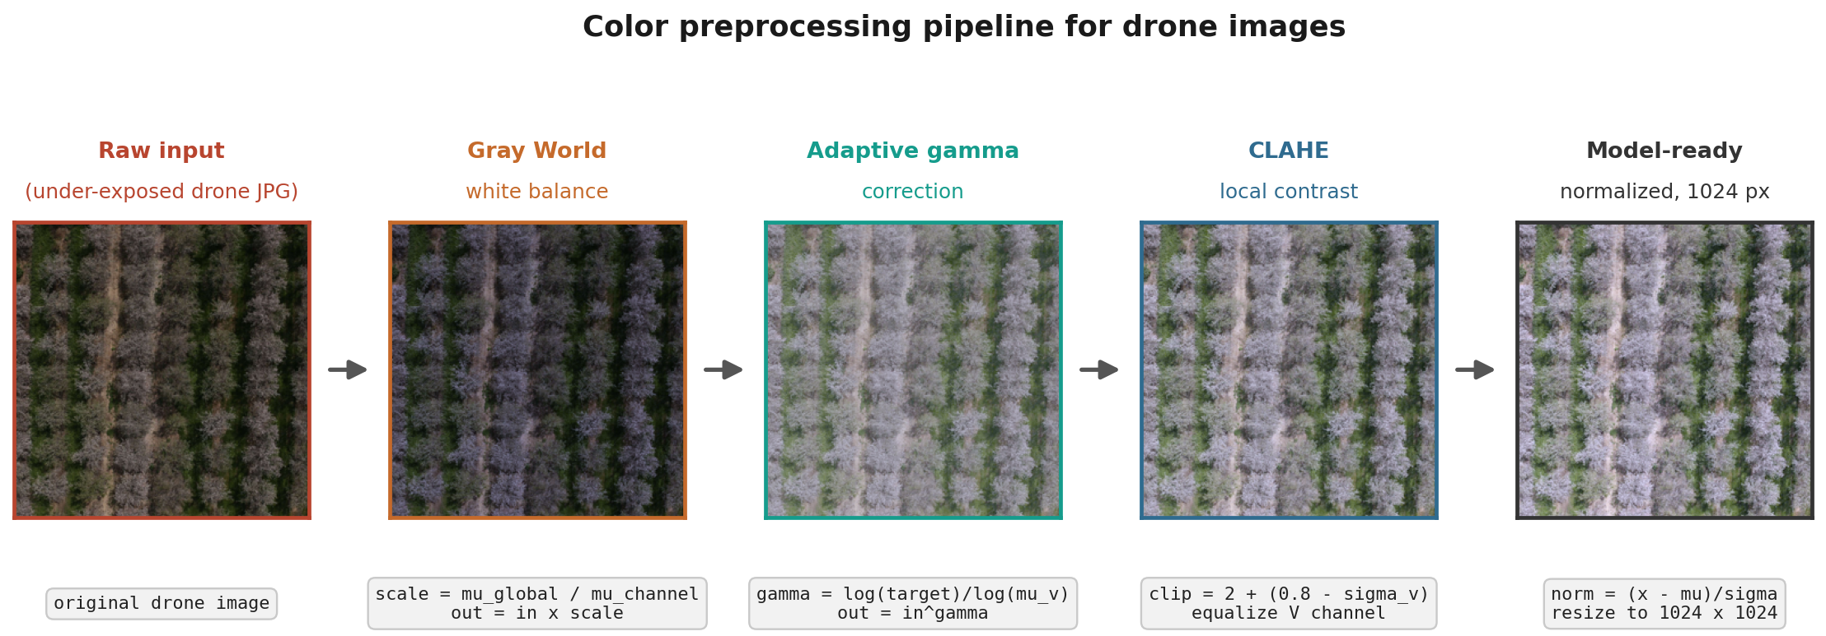
Figure 3: Color preprocessing pipeline. From left to right: raw drone image (under-exposed), after Gray World white balance, after adaptive gamma correction, after CLAHE, and the final model-ready normalized image. Each stage addresses a specific image quality issue.

3.2 Stage 2 - Semantic Segmentation

3.2.1 Training Dataset and Manual Annotation
All training annotations were produced by the author using Roboflow, a web-based annotation and dataset-management platform, with tree canopies delineated as single-class ("Trees") COCO-format instance segmentation polygons. The dataset was built iteratively over eight successive versions as additional drone imagery was annotated and as augmentation policies were introduced; Table 1 summarises this progression.
Table 1. Dataset version history: images, instances, preprocessing and augmentation at each iteration.
Version | Train images | Train instances | Pre-processing | Augmentation
v3 | 48 | 6,929 | None | None
v4 | 50 | 7,260 | Auto-contrast (adaptive eq.) | None
v5 | 112 | 14,754 | Auto-contrast (adaptive eq.) | None
v6 | 347 | 46,100 | - | 3x per source image
v7 | 350 | 46,525 | - | 3x per source image
v8 (production) | 349 | 46,672 | Auto-orientation (EXIF strip) | 3x per source image
Manual annotation effort grew roughly seven-fold in distinct source images (from 48 to approximately 115 uniquely labelled images by version 6, prior to the 3x augmentation multiplier applied at that stage) and the resulting instance count grew from 6,929 to 46,672 polygon instances. An alternative pre-processing strategy (Version 6, applying automatic contrast adjustment via adaptive equalization) was evaluated but not adopted. Version 8 (349 training / 35 validation / 18 test images; 402 total; auto-orientation correction; 3x augmentation with a hue jitter of ±25°) was confirmed as the dataset used to train the final production model.

3.2.2 UNet++ Architecture with EfficientNet-B3 Encoder
The segmentation model is built on the UNet++ framework with an EfficientNet-B3 backbone pre-trained on ImageNet. UNet++ improves upon standard U-Net by introducing nested skip connections that create dense connections between encoder stages and multiple decoder paths, enabling more flexible feature aggregation across scales. Figure 4 shows the resulting architecture.
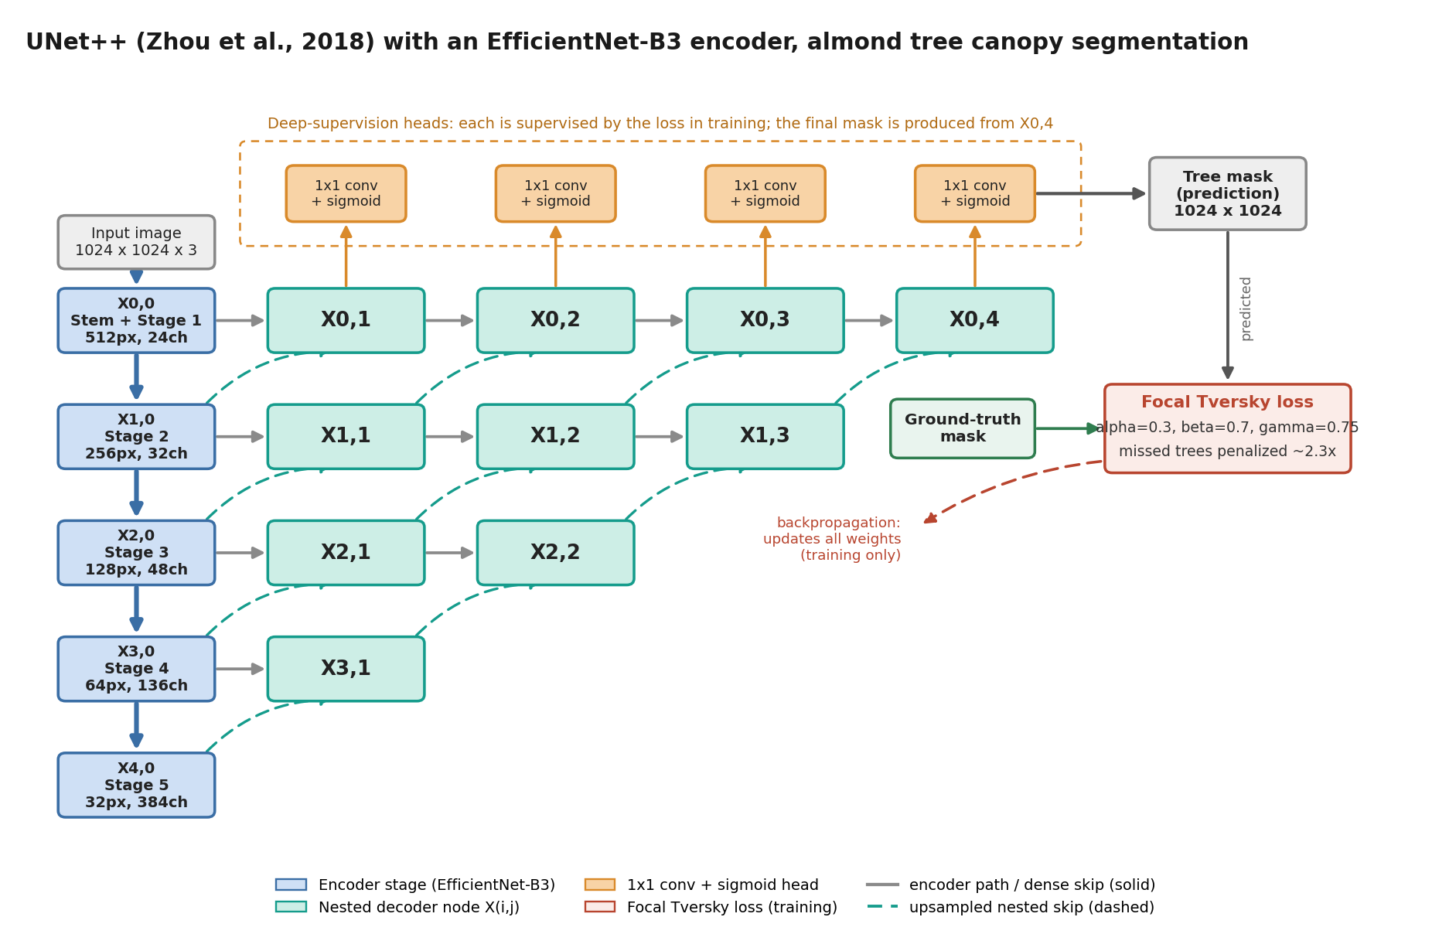
Figure 4: UNet++ (Zhou et al., 2020) architecture with an EfficientNet-B3 encoder for almond tree canopy segmentation. The input image is encoded through five downsampling stages X(i,0); each encoder stage feeds a row of nested decoder nodes X(i,j), with solid arrows showing the encoder path and same-row dense skips and dashed arrows the nested upsampled skip pathway from one resolution level down. The orange 1x1-convolution-plus-sigmoid deep-supervision heads produce per-node masks; during training each is compared with the ground-truth mask by the Focal Tversky loss (alpha=0.3, beta=0.7, gamma=0.75), which penalizes missed trees about 2.3 times more than false positives, and the resulting gradients update all encoder and decoder weights. At inference the final tree mask is taken from X0,4.
The EfficientNet-B3 encoder comprises 5 feature extraction stages with channel depths of [32, 48, 136, 384] and spatial downsampling factors of [2, 4, 8, 16]. The decoder at each level receives features from both the corresponding encoder stage (via skip connections) and preceding decoder nodes (via nested connections), producing outputs at multiple scales. The final single-channel logit map is sigmoid-activated and thresholded at 0.5 to produce the binary tree mask.

3.2.3 Focal Tversky Loss Function
The Focal Tversky Loss combines three mechanisms to address the class imbalance problem in orchard segmentation:
(1) Tversky Index: Generalises Dice coefficient with asymmetric false positive/false negative weights. With alpha=0.3 (FP weight) and beta=0.7 (FN weight), missed trees are penalized 2.33x more than false detections, biasing the model toward high recall.
Tversky = TP / (TP + alpha*FP + beta*FN + epsilon)
(2) Asymmetric Weighting: The choice alpha=0.3, beta=0.7 reflects the agronomic priority: a missed tree (FN) represents lost yield data and missed management opportunity, while a false detection (FP) merely adds a small overhead in post-processing verification.
(3) Focal Component: Applying a power of gamma=0.75 to (1-Tversky) weights easy examples (high Tversky, well-predicted) with small loss values, and hard examples (low Tversky, difficult predictions) with large loss values. This focuses optimization capacity on challenging cases.
L_FocalTversky = (1 - Tversky)^gamma [gamma=0.75]

3.2.4 Training Protocol
Training employs AdamW optimizer (lr=0.0004) with ReduceLROnPlateau scheduling (factor=0.5, patience=2 epochs on validation loss). Early stopping with patience=5 prevents overfitting. Data augmentation during training includes: horizontal/vertical flips (50%), 90-degree rotations (30%), transpose (30%), random gamma (40%), brightness-contrast shifts (40%), hue-saturation-value shifts (40%), and RGB channel shifts (30%). Table 2 lists the hyperparameters and the rationale for each.
Table 2. Training hyperparameters and the rationale for each setting.
Parameter | Value | Rationale
Learning Rate | 0.0004 | Conservative start; scheduler reduces on plateau
Batch Size | 4 | Balances GPU memory and gradient noise
Image Size | 1024 x 1024 px | Preserves fine tree boundary detail
Focal Tversky alpha | 0.3 | Lower FP penalty (accept some false alarms)
Focal Tversky beta | 0.7 | Higher FN penalty (minimize missed trees)
Focal Tversky gamma | 0.75 | Focus on hard examples
Max Epochs | 20 | With early stopping patience=5

3.2.5 Empirical Architecture and Loss Function Search
The UNet++/EfficientNet-B3/Focal-Tversky configuration described above (Sections 3.2.2-3.2.3) was not chosen a priori; it is the outcome of an empirical search across thirteen training runs spanning four architectures (Unet, attention-augmented Unet, UNet++), three encoder backbones (ResNet-34 (He et al., 2015), EfficientNet-B3, EfficientNet-B7), three image resolutions (1024, 1536, 2048 px), and two loss functions (a combined Dice-based loss, and Focal Tversky loss). Table 3 summarises the progression of validation Dice/IoU across this search.
Table 3. Empirical architecture and loss-function search: validation Dice and IoU for each configuration.
Configuration | Resolution | Encoder | Loss | Val. Dice | Val. IoU
Baseline | 1024px | ResNet-34 | Combined (Dice-based) | 0.545 | 0.410
High-res attempt | 2048px | EfficientNet-B3 | Combined | 0.618 | 0.481
Batch-4 stabilization | 1024px | EfficientNet-B3 | Combined | 0.698-0.716 | 0.568-0.602
High-capacity attempt | 1536px | EfficientNet-B7 | Custom (TreeSeg.) | 0.509 (unstable) | 0.374
Preprocessing refinement | 1024px | EfficientNet-B3 | Combined | 0.751 | 0.646
Final (UNet++/Focal Tversky) | 1024px | EfficientNet-B3 | Focal Tversky (a=.3,b=.7,g=.75) | 0.789 | 0.676
Final production run (v8 dataset) | 1024px | EfficientNet-B3 | Focal Tversky (a=.3,b=.7,g=.75) | 0.8935 | 0.8089
Two findings from this search directly motivated the final design choice. First, increasing image resolution beyond 1024px (1536px with EfficientNet-B7, 2048px with EfficientNet-B3) did not improve performance and in several runs failed to converge at all within the available epoch budget - the larger encoder and resolution combination outstrips what the batch size (constrained to 1 by GPU memory at that resolution) could support, leading to noisy gradient estimates. Second, replacing the standard Dice-based combined loss with Focal Tversky loss (Section 3.2.3) together with the UNet++ architecture produced the largest single improvement in the entire search (+0.038 Dice over the next-best configuration), confirming that the class-imbalance- and hard-example-aware loss formulation, rather than further architectural scaling, was the binding constraint on performance.
A subsequent validation pass on independently captured flight imagery (rather than the held-out split of the training dataset) reproduced this performance (Dice 0.784, IoU 0.671), indicating the trained model generalises to new flights rather than memorizing dataset-specific artifacts. A final 20-epoch run using this same architecture, loss, and resolution on the production (Version 8) dataset reached a peak validation Dice of 0.8935 (IoU 0.8089) at epoch 17 - this run is the actual final production checkpoint, and its validation Dice directly matches the 0.89 Dice figure reported in Section 6.2; the two are the same measurement, not independent figures from different test sets.

3.2.6 Data Augmentation Policy: Empirical Comparison
To select the data augmentation policy used during training (Section 3.2.4), twelve single-augmentation strategies were each trained independently for 20 epochs under otherwise identical conditions (Unet/EfficientNet-B3, 1024px, combined loss) and compared by best validation Dice/IoU achieved. Results are summarised in Table 4.
Table 4. Data-augmentation policies compared by best validation Dice and IoU.
Augmentation strategy | Best Val. Dice | Best Val. IoU
Brightness/contrast jitter | 0.711 | 0.586
Random 90-degree rotation | 0.702 | 0.566
Gaussian blur + flip | 0.695 | 0.562
Contrast stretching | 0.688 | 0.545
No augmentation (resize only) | 0.685 | 0.568
HSV + edge overlay | 0.676 | 0.537
CLAHE + brightness | 0.669 | 0.547
Comprehensive heavy augmentation | 0.668 | 0.545
Shift/scale/rotate | 0.665 | 0.550
Histogram equalization | 0.652 | 0.505
Harris-corner overlay | 0.648 | 0.492
Canny-edge overlay | 0.385 | 0.274
Simple photometric augmentation (brightness/contrast jitter) outperformed every geometric and feature-engineered alternative, including the no-augmentation baseline, and is accordingly included in the final policy (Section 3.2.4). Augmentations that overlay structural edge features directly onto the RGB channels (Canny-edge, Harris-corner, histogram equalization) underperformed, with Canny-edge overlay catastrophically so (Dice 0.385) - overlaying bright edge pixels onto the canopy directly conflicts with the colour cues the model otherwise relies on to distinguish tree canopy from background. Figure 5 shows a representative annotated training tile.

3.2.7 Pre-Processing Rationale and Visual Validation
Beyond selecting which augmentation strategy performed best empirically (Section 3.2.6), each pre-processing step in the pipeline was chosen for a specific reason. Auto-orientation correction (applied in the production dataset, Version 8) strips inconsistent EXIF orientation metadata that varies across camera bodies and flight software used over the 2021-2024 surveys; without it, an image could load rotated or mirrored relative to its annotation mask, silently corrupting the pixel-to-label correspondence used during training. All images are resized to a fixed 1024x1024 input resolution - empirically the most stable choice in the architecture search (Section 3.2.5) - and normalized using ImageNet channel statistics, which preserves the benefit of transfer learning from the pre-trained EfficientNet-B3 encoder rather than forcing it to re-adapt to an arbitrary input distribution.
The 3x augmentation multiplier and the ±25° hue jitter applied during dataset export are both directly motivated by dataset size: at the point augmentation was introduced, only approximately 115 source images had been manually annotated. Hue jitter specifically targets illumination and bloom-stage colour drift - almond canopy colour shifts across the flowering period and across sensor white-balance differences between flights - so the network is encouraged to segment canopy independent of exact hue rather than memorizing a fixed colour signature. This choice is corroborated by the augmentation comparison sub-study (Section 3.2.6): simple photometric augmentation outperformed every geometric and feature-overlay alternative tested, including the no-augmentation baseline.
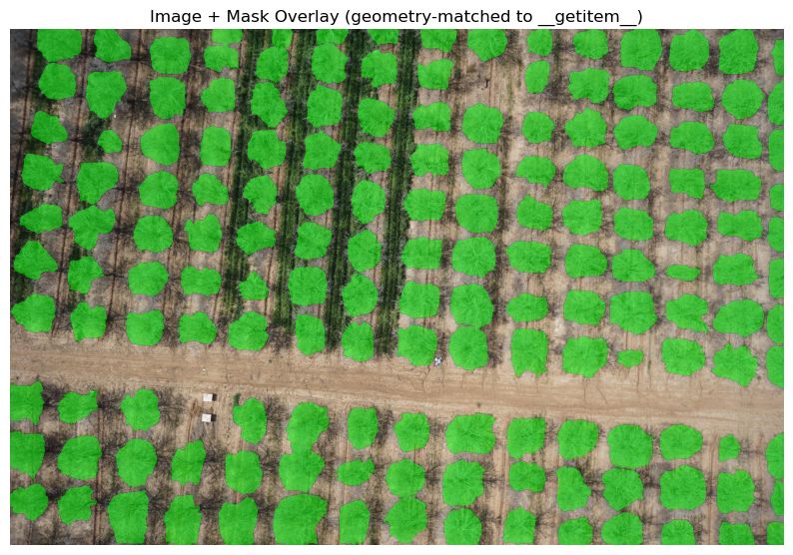
Figure 5: Representative training tile - drone image with ground-truth canopy annotations overlaid (green), showing individual hand-annotated tree polygons across orchard rows.

3.2.8 Architecture Selection Rationale: Why UNet++ with an EfficientNet-B3 Encoder
The empirical winner of the architecture search (Section 3.2.5) - UNet++ with an EfficientNet-B3 encoder and Focal Tversky loss - was not an arbitrary choice; each component addresses a specific limitation relevant to this task. A standard U-Net connects each encoder level directly to its matching decoder level, leaving a semantic gap because the encoder feature at that depth has not yet been refined by any decoder processing. UNet++ (Zhou et al., 2020) instead inserts a nested, densely connected grid of intermediate decoder nodes between each encoder level and the final output, fusing each skip connection through one or more convolutional blocks before it reaches the prediction head. In practice this produces sharper, better-localized canopy boundaries - which matters disproportionately here because the downstream watershed instance-separation step (Section 3.3) depends entirely on accurate boundary geometry between adjacent, frequently touching tree crowns. UNet++ can also attach a deep-supervision output head at every nested column rather than only the final one, giving the network additional gradient signal per training image - valuable with a dataset of a few hundred images rather than tens of thousands.
EfficientNet-B3 was selected over both smaller and larger variants in the EfficientNet family because it sits at a deliberate middle point of compound-scaled depth, width, and resolution: large enough (≈ 12 million parameters) to capture the texture and colour cues separating canopy from soil and cover crop, yet small enough to train for many epochs at 1024px on a single consumer GPU. The architecture search provides direct empirical evidence for this trade-off: EfficientNet-B7 (≈ 66 million parameters) combined with 1536px input required reducing the batch size to 1 to fit in memory, and in two separate attempts failed to progress past the first epoch - not because B7 is architecturally inferior, but because the resulting batch-size-1, high-variance-gradient regime was not viable on the available hardware (Section 3.2.9).
The third component, Focal Tversky loss (α=0.3, β=0.7, γ=0.75), generalises the Dice coefficient with separate weights on false positives (α) and false negatives (β); weighting β above α penalizes missed canopy pixels more heavily than over-predicted ones, which matters when canopy occupies a minority of pixels in sparsely planted or young rows. The focal exponent γ additionally down-weights pixels the model already classifies confidently and concentrates the gradient on hard, low-confidence pixels - typically canopy edges, the exact region that determines both segmentation accuracy and downstream instance-splitting quality. Introducing UNet++ together with this loss function produced the single largest jump in the entire fine-tuning search (Dice 0.751 → 0.789, a +0.038 improvement in one step), and the final tuned run using this same configuration reached a peak validation Dice of 0.8935 - directly the figure reported as this thesis’s headline segmentation accuracy. Architecture and loss selection, not additional capacity or input resolution, was the binding constraint on performance for a dataset of this size. The training and validation curves for this configuration are reported with the results in Section 6.1; Figure 6 compares predictions with the ground truth on held-out images, and Figure 7 gives the pixel-level confusion matrix.
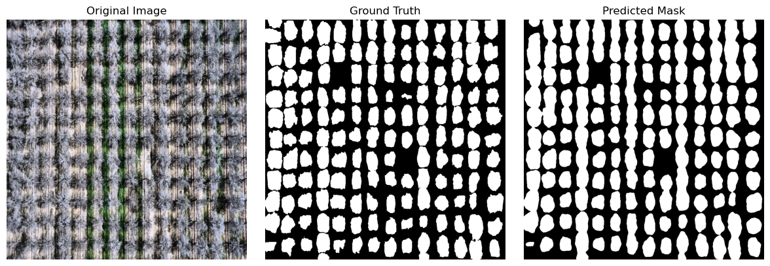
Figure 6: Original image, ground-truth mask, and model-predicted mask for a representative held-out validation tile.
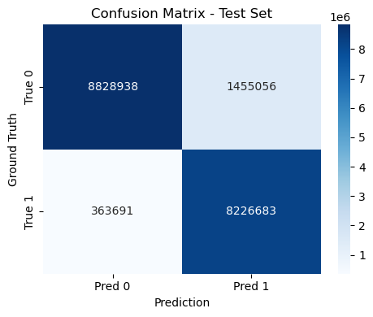
Figure 7: Pixel-level confusion matrix on the held-out test set (canopy vs. background).

3.2.9 Computational Resource Constraints
All twenty fine-tuning experiments reported in this thesis were trained on the author’s personal computer; no institutional compute cluster or cloud GPU service was used at any stage of model development. This is visible directly in the training code, where every notebook selects its compute device with the line device = torch.device("mps" if torch.backends.mps.is_available() else "cuda" if torch.cuda.is_available() else "cpu"), where "mps" refers to Apple’s Metal Performance Shaders GPU-acceleration backend - confirming that training ran on Apple Silicon rather than a dedicated NVIDIA or cloud accelerator.
This hardware constraint directly explains several results in the architecture search. The 2048px and 1536px-with-EfficientNet-B7 configurations were memory-bound to a batch size of 1, producing noisy gradient estimates that contributed to the training instability observed in those runs - a hardware ceiling rather than an architectural failure. The configuration that ultimately won (1024px, EfficientNet-B3, batch size 4) was the largest the available hardware could sustain reliably across many epochs. The cost of this constraint is visible in wall-clock time: the final production run’s own training logs show individual epochs taking between roughly 2.5 and 4.5 hours (for example, the first epoch’s training loop alone ran for 2 hours 36 minutes over 88 batches), implying the full 20-epoch run required on the order of two to three days of continuous wall-clock time on a single personal machine, without a managed compute budget or parallel job scheduling.
This constraint also yields a methodological observation worth stating explicitly: the best-performing configuration across the entire twenty-run search was not the most computationally expensive one. The larger EfficientNet-B7 / higher-resolution configurations underperformed or failed to converge, while a moderately sized configuration (EfficientNet-B3 at 1024px) combined with a better-suited architecture (UNet++) and loss function (Focal Tversky) achieved the best result. For a dataset of this size, careful methodological choice substituted effectively for additional compute scale.

3.2.10 Post-Processing Exploration: An Alternative Instance-Separation Method Considered
The instance-separation method actually used in the production pipeline is the watershed-based approach documented in Section 3.3: the Euclidean distance transform of the binary semantic mask is treated as a topographic surface, local peaks are detected as tree-centre markers via peak_local_max with a tuned minimum-separation parameter, and watershed flooding from these markers assigns each touching tree crown a unique instance label, followed by area and solidity filtering. This is confirmed directly in the project’s own technical documentation, which states explicitly that watershed was adopted “due to its robustness, interpretability, and efficient implementation.”
Before settling on this approach, a different geometric instance-splitting method was explored directly inside the fine-tuning notebooks, internally referred to in the code as a “radial-jumps row/col splitter.” Rather than using a distance transform and peak detection, this method specifically targets elongated, merged blob shapes that form when several touching tree crowns fuse into one long connected component along a planting row - a pattern expected in almond orchards because trees are planted in straight, regularly spaced rows, so over-merging tends to occur along the row direction. The method cuts these elongated shapes using directional line-kernels constructed at multiple angles, applied as a thinning operation, and refined across successive passes - an initial pass, a stronger second pass, and a final corrective micro-pass - to progressively separate blobs the previous pass did not fully resolve.
Watershed segmentation was ultimately adopted for the production pipeline rather than the radial-jumps splitter because it is more general - it does not assume that merged crowns are aligned with the planting row, which matters since canopy overlap can also occur across rows under dense planting or peak bloom conditions - and because it depends on a single, well-understood tuning parameter (minimum separation between detected peaks) rather than several hand-tuned geometric parameters governing line angle, length, thickness, and pass count. Watershed is also a standard, well-validated technique in the instance-segmentation literature, making it easier to justify and parameterize within a documented, reproducible pipeline. The radial-jumps method remains a useful record of an earlier, more bespoke exploration developed in parallel with the final training run. Figure 8 illustrates that exploration.
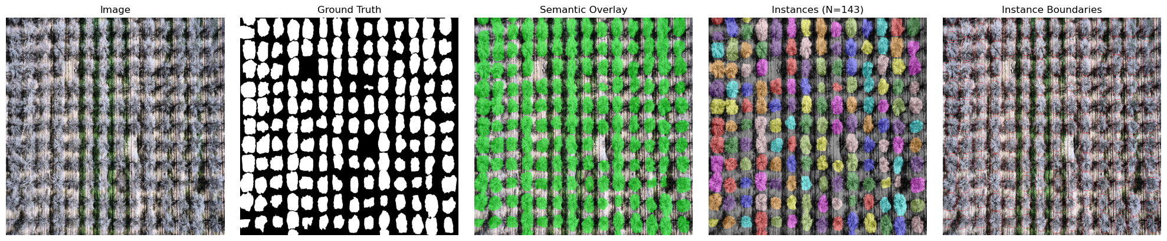
Figure 8: Instance-separation demonstration, left to right - original image, ground truth, semantic overlay, individually colourized tree instances (N=143 in this tile), and instance boundaries.

3.3 Stage 3 - Instance Segmentation via Watershed
The watershed-based instance segmentation converts the binary semantic mask (which typically contains merged adjacent tree regions) into individually labelled instances. The algorithm treats the Euclidean distance transform of the binary mask as a topographic surface and simulates flooding from seed markers placed at detected peak positions. Figure 9 traces the procedure step by step.
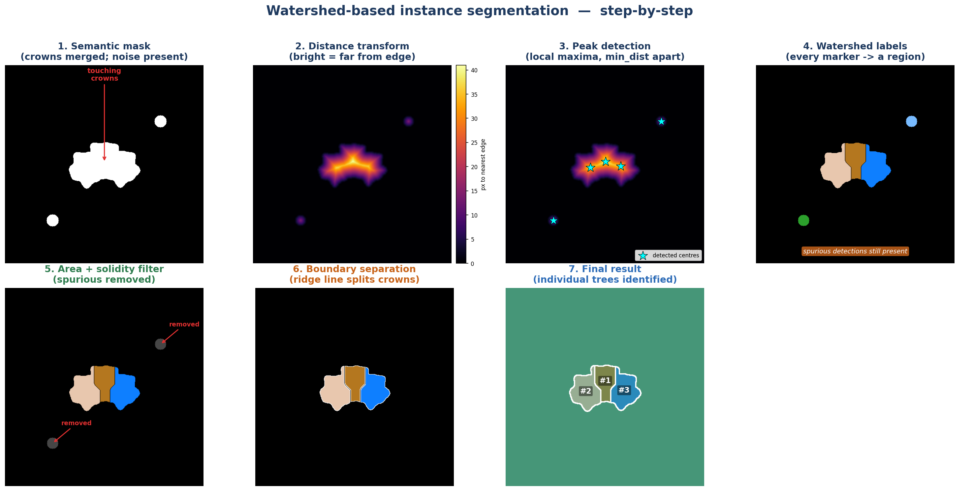
Figure 9: Watershed-based instance segmentation, step by step. The procedure is demonstrated on a synthetic test case built to contain the two situations the algorithm must handle, a cluster of three touching crowns and two small spurious blobs, so that the correct answer is known in advance; every quantitative result in Chapter 6 comes from the real orchard mosaics. (1) Binary semantic mask in which the adjacent crowns are merged into a single component and small noise blobs are present. (2) Euclidean distance transform (brighter = farther from the nearest background edge). (3) Peak detection places one marker at each local maximum, subject to a minimum separation of min_dist pixels (min_dist = 25 px here). (4) Watershed flooding assigns every marker its own labelled region, so the two spurious blobs also become regions. (5) Area and solidity filtering removes the spurious detections. (6) The watershed ridge line inserts a one-pixel physical gap between the separated crowns. (7) Final result, with each crown assigned a unique tree identity, overlaid on the image background.
The critical parameter min_dist_between_trees controls the minimum allowed separation between detected peaks, directly determining whether adjacent crowns are identified as one or two instances. For blooming almond orchards at 2 cm GSD, canopy diameters of 3-6 m correspond to 150-300 pixels, making min_dist=25 pixels (0.5 m on ground) appropriate for well-spaced orchards.
The default was set by evaluating this parameter against a manual tree count: at 15 px the algorithm over-segments, returning about 1.2 times more instances than the manual count, at 40 px it under-segments and misses roughly 10 percent of trees, and at the adopted 25 px the detected count matches the manual count to within 5 percent. Because the optimum scales with crown size in pixels, it should be rescaled for surveys flown at a different ground sampling distance. The probability threshold above which a pixel is accepted as canopy was left at the operational default of 0.5, the value at which the exported tree mask is thresholded.
Dynamic area filtering uses both an absolute minimum (200 pixels) and a relative minimum (20% of the median instance area in the image) to adapt to varying tree sizes. A solidity threshold of 0.70 (convex hull area ratio) rejects non-compact shapes that represent noise or shadow artifacts rather than true tree crowns. Table 5 lists these parameters with their ranges and defaults.
Table 5. Instance-segmentation parameters, their ranges, defaults and effect.
Parameter | Range | Default | Effect of Increasing
min_area | 100-500 px | 200 px | Rejects smaller detections; may miss young/small trees
min_dist_between_trees | 15-40 px | 25 px | Merges adjacent trees; reduces over-segmentation
relative_area_factor | 0.10-0.30 | 0.20 | Stricter relative size filter; rejects small outliers
solidity_threshold | 0.60-0.80 | 0.70 | Stricter shape filter; rejects irregular noise
separation_width | 0-3 px | 2 px | Wider gap between instances; visual clarity

3.4 Stage 4 - Geospatial Processing and GeoTIFF Export
The final prediction pipeline stage converts pixel-level instance labels into a georeferenced raster compatible with standard GIS workflows. This requires three sub-operations: GPS extraction from EXIF metadata, coordinate system transformation from geographic to projected coordinates, and affine transformation construction for the GeoTIFF spatial reference. Figure 10 summarises the transformation chain.
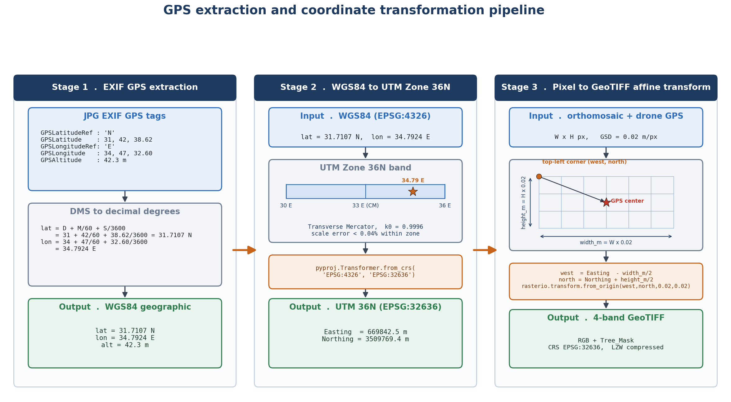
Figure 10: GPS extraction and coordinate transformation pipeline, illustrated with the plot own coordinates. Stage 1: EXIF GPS tags are parsed and converted from degrees-minutes-seconds to decimal degrees (31.7107 N, 34.7924 E). Stage 2: the WGS84 position (EPSG:4326) is projected with pyproj to UTM Zone 36N (EPSG:32636), whose central meridian is 33 E and scale factor k0 = 0.9996, giving Easting = 669842.5 m and Northing = 3509769.4 m. Stage 3: the drone centre-point position is offset by half the orthomosaic width and height (at 0.02 m per pixel) to obtain the top-left corner, which defines the GeoTIFF affine transform; the export is a 4-band GeoTIFF (RGB plus tree mask) in EPSG:32636, LZW compressed.
A critical geometric correction addresses the fact that drone GPS metadata records the position of the camera (image centre) rather than the image top-left corner required by GeoTIFF convention. The offset is:
west = utm_easting - (image_width * pixel_size_m / 2)
north = utm_northing + (image_height * pixel_size_m / 2)
The resulting 4-band GeoTIFF contains bands 1-3 (RGB colour imagery) and band 4 (binary tree mask: 1=tree, 0=background/NoData). LZW lossless compression achieves 3-5x file size reduction relative to uncompressed TIFF. The coordinate reference system is explicitly embedded as EPSG:32636 (WGS 1984 UTM Zone 36N), ensuring direct import into ArcGIS, QGIS, and other GIS platforms.

3.4.1 GPS Recovery for Cameras Without Native Geotagging (2021 Survey)
The geolocation procedure described above in this section assumes GPS coordinates are already present in each image's EXIF metadata at capture time. This held for the 2022-2024 surveys, but not for the March 2021 survey, which used a camera body physically separate from the drone's own positioning system and therefore recorded no GPS in its EXIF data. A dedicated GPS-recovery procedure ("GeoSync") was developed for this survey only.
GeoSync time-synchronizes the camera's internal clock against the drone's flight-log clock, which independently records high-frequency GPS positions but runs on a separate, drifting clock relative to the camera. The synchronization offset is auto-calibrated using the drone's own shutter-trigger events as ground truth: for each candidate offset, the distance between the interpolated GPS position of the nearest camera-timestamped photo and the position recorded at the trigger event is measured, and the offset minimizing this distance is selected (falling back to a speed-versus-inter-photo-distance correlation heuristic when trigger events are unavailable). Once the offset is fixed, each photo's position is interpolated from the flight log at its corrected capture time, with a further correction for camera shutter latency based on the drone's instantaneous velocity vector, and the resulting coordinates are written into the photo's EXIF GPS tags. An independent photogrammetric camera-position estimate (from Agisoft Metashape) was used to cross-validate the calibrated offset for this survey.

4. ArcGIS Post-Processing Workflow: Orthomosaic Assembly
Following the deep learning prediction pipeline, individual georeferenced GeoTIFF rasters (one per drone image) must be assembled into a single, continuous orthomosaic suitable for orchard-scale analysis. This five-stage ArcGIS Pro-based workflow performs image registration refinement, quality filtering, and mosaic dataset construction, ultimately delivering two complementary output products: an analytical 4-band orthomosaic for machine learning and a compressed RGB orthomosaic for visualization. Figure 11 summarises the five steps.

Figure 11: ArcGIS 5-step post-processing workflow. Each step transforms the individual GeoTIFF tiles produced by the prediction pipeline into a quality-assured, mosaicked orthomosaic ready for agricultural analysis.

4.1 Step 1 - Reference Raster Preparation
The georeferencing registration process requires a high-quality reference raster that all individual images will be aligned to. The reference is typically a previously created orthomosaic or photogrammetric product from the same site that is known to be accurately positioned.
The reference multispectral raster is processed to extract a clean 3-band RGB representation. Band 3 (Red), Band 2 (Green), and Band 1 (Blue) are read individually and stretched to the full uint8 range [0-255] using a 2nd-98th percentile stretch that excludes extreme outliers:
lo = percentile(valid_pixels, 2%)
hi = percentile(valid_pixels, 98%)
output = clip((band - lo) / (hi - lo) * 255, 0, 255).astype(uint8)
This percentile stretch normalizes the reference raster's radiometric range, ensuring that the subsequent image registration process (which compares intensity patterns) is not dominated by rare extreme pixel values. The output is written as a 3-band GeoTIFF with LZW compression, TILED=YES layout, and BIGTIFF=YES support for large rasters.

4.2 Step 2 - Multi-Phase Image Registration
Each individual GeoTIFF raster (output from Stage 4 of the prediction pipeline) is registered to the reference raster using arcpy.management.RegisterRaster() with a POLYORDER1 (first-order polynomial / affine) transformation. Registration adjusts the image's embedded spatial reference to minimize the Root Mean Square Error (RMS) between automatically identified Ground Control Points (GCPs) in the image and corresponding locations in the reference.
A three-phase fallback strategy handles the full diversity of image conditions encountered in practice:

4.2.1 Phase A - Direct Registration
The image is registered directly against the reference raster at progressively relaxed RMS thresholds: strict (<2 m), normal (<5 m), and relaxed (<10 m). This succeeds for the majority of images (~68%) where initial GPS positioning is sufficiently accurate for the registration algorithm to find reliable feature correspondences.
arcpy.management.RegisterRaster(temp_rgb, 'REGISTER', reference,
transformation_type='POLYORDER1', maximum_rms_value=rms)

4.2.2 Phase B - GPS Offset-Guided Registration
When direct registration fails, a GPS offset correction is applied first. The OffsetTracker maintains a sliding window of the last 10 successfully registered images, computing the mean spatial offset between original GPS positions and registered positions:
offset = (mean_dx, mean_dy) # average over last 10 successes
geo[0] += dx; geo[3] += dy # shift GeoTransform origin
This learned offset captures systematic GPS biases specific to the drone's positioning hardware or flight conditions, pre-aligning subsequent images before registration. The approach exploits spatial continuity: adjacent frames in a drone survey typically exhibit similar GPS drift patterns.

4.2.3 Phase C - Histogram-Matched Registration
When phases A and B fail (approximately 10% of images), spectral mismatch is identified as the likely cause. Images acquired under significantly different illumination than the reference may lack sufficient feature correspondences despite correct spatial positioning. A histogram matching step transfers the reference raster's cumulative distribution function (CDF) to the target image:
src_cdf = cumsum(src_counts) / sum(src_counts)
ref_cdf = cumsum(ref_counts) / sum(ref_counts)
matched_values = interp(src_cdf, ref_cdf, ref_values)
This CDF-based transfer is applied independently per channel and preserves relative tonal relationships within the image while bringing its overall spectral distribution in line with the reference, enabling the registration algorithm to find correspondences across illumination differences.

4.3 Step 3 - Visual Quality Assurance
After automated registration, a manual quality assurance step in ArcGIS Pro verifies that registered images visually align with the reference mosaic. This involves overlaying a sample of registered images (typically 10-20% of the dataset) onto the reference and inspecting for:
- Geometric misalignment - visible pixel-level offsets or shearing between image boundaries
- Radiometric inconsistencies - abrupt colour jumps at image boundaries indicating histogram matching artifacts
- Systematic regional biases - clusters of images consistently offset in the same direction, indicating GPS drift not captured by the offset tracker
If significant misalignment is observed, RMS thresholds in Step 2 are tightened (accepting only higher-quality registrations) and the entire batch is re-processed. This iterative quality loop ensures that only well-registered images proceed to mosaic construction.

4.4 Step 4 - Mosaic Dataset Construction with Quality Filtering
Before mosaic assembly, each registered image is subjected to four quantitative quality criteria derived from the registration.aux.xml metadata files (Table 6):
Table 6. Mosaic quality-control criteria and rejection thresholds.
Quality Criterion | Threshold | Rationale
Minimum GCPs | >= 10 points | Insufficient GCPs indicate registration instability
Mean GCP shift | <= 15.0 m | Excessive mean shift indicates poor registration
Maximum GCP shift | <= 40.0 m | Outlier GCPs indicate registration failure
Image size | <= 1.5x median | Anomalously large extents indicate corrupt geolocation
Images failing any criterion are excluded from the mosaic. In typical operational conditions, 93-96% of images pass all quality criteria. The passing images are added to two ArcGIS Mosaic Datasets in batches of 200 images:
Mosaic_4Band: A 4-band (R, G, B, Tree_Mask) mosaic at 8-bit unsigned precision, using the FIRST mosaic operator (overlapping areas show the first/highest-priority image). Pyramid overviews are built for efficient display at multiple zoom levels. This mosaic serves as the primary analytical product for tree detection, yield estimation, and temporal comparison.
Mosaic_RGB: A 3-band (R, G, B) JPEG-compressed mosaic for visualization. A Raster Function Template (RFT) XML file applies an ExtractBand function to drop band 4 from the 4-band source, producing the RGB product. JPEG quality 85 provides high visual fidelity with a compact file size. Figure 12 shows how the individual tiles are assembled into the final mosaic.
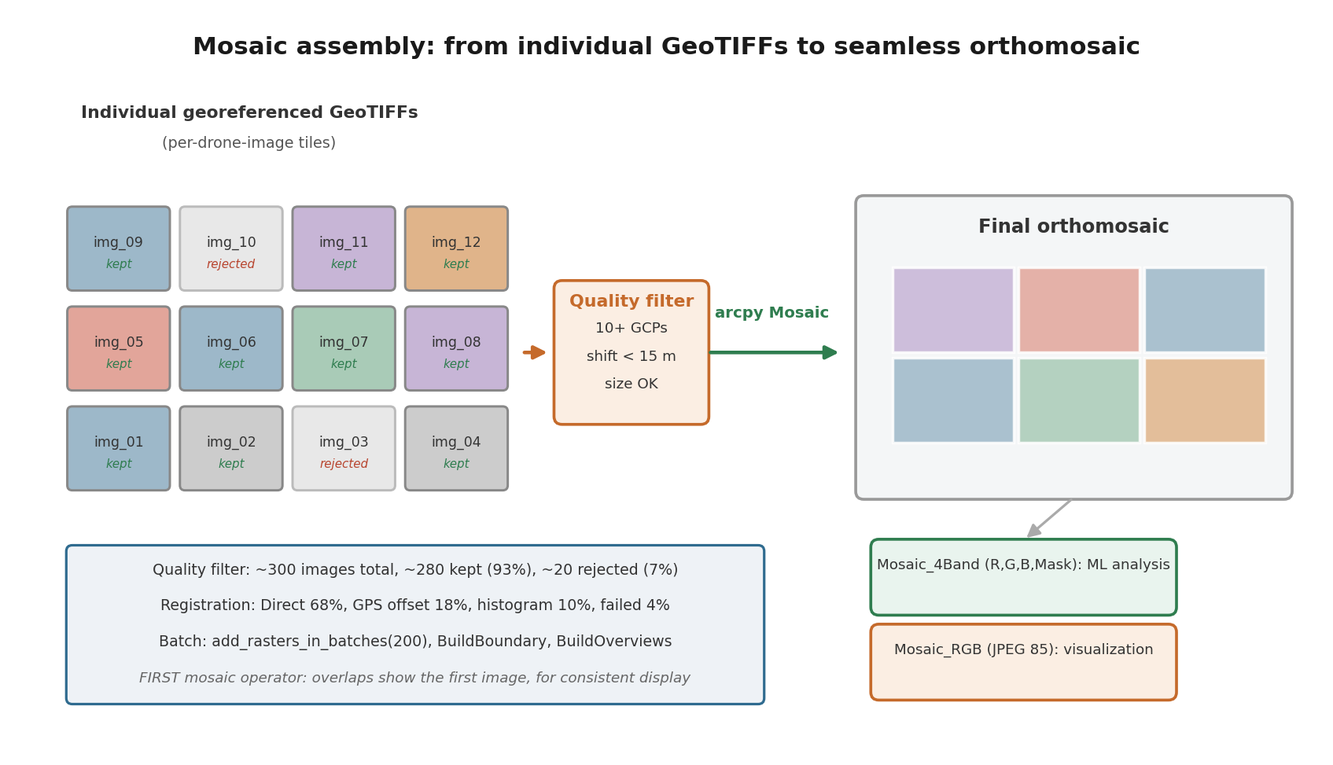
Figure 12: Mosaic assembly process. Individual quality-filtered GeoTIFF tiles (left) are assembled into a continuous orthomosaic (right). The quality filter rejects images with insufficient GCPs, excessive spatial shift, or anomalous extent. Two output products serve different downstream uses: Mosaic_4Band for machine learning analysis and Mosaic_RGB for visualization.

4.4.1 Implementation Notes: Mosaic Dataset Construction
Two implementation details of the mosaic-assembly scripts are noted here for completeness, beyond the conceptual workflow described in Sections 4.1-4.4. First, prior to mosaic dataset construction, a spatial thinning pre-filter removes any image whose footprint centre lies within 15 m of an already-accepted image's centre, de-duplicating near-identical overlapping captures (typically from slow flight segments or turns) before they reach the mosaic dataset, reducing blend artifacts and downstream processing load. Second, mosaic seamlines are computed using a Voronoi method, placing seam boundaries at the equidistant midline between adjacent image centres rather than along raw image edges, with a 10-pixel blend width applied at each seam to smooth the transition between source images.

4.5 Step 5 - Final Mosaic Export
The completed mosaic datasets are exported to standalone GeoTIFF files for distribution and archiving:
Final_Orthomosaic_4Band.tif is exported with LZW lossless compression (arcpy.env.compression = 'LZW'), preserving all pixel values exactly. Target file size below 5 GB per survey area. NoData value 256 (outside uint8 range) preserves transparent edge regions at survey boundaries. This file is the primary input for any subsequent machine learning analysis, tree counting, canopy area measurement, or temporal change detection.
Final_Orthomosaic_RGB.tif is exported with JPEG 90% quality compression, delivering high visual quality at substantially reduced file size (~5-10x smaller than LZW). This file is used for visual inspection, sharing with agronomists, overlay with field records, and integration into web mapping platforms.
arcpy.management.CopyRaster(mosaic_4band_path, out_path,
format='TIFF', pixel_type='8_BIT_UNSIGNED', nodata_value='256')

5. Implementation

5.1 Software Architecture
The prediction pipeline is implemented as a modular Python application with six source files, each encapsulating a distinct functional domain:
Module
Primary Functions
Description
data.py
gray_world_wb(), adaptive_gamma(), adaptive_clahe(), COCOSegmentationDataset
Image preprocessing, augmentation, PyTorch dataset loading
model.py
FocalTverskyLoss, build_model(), dice_coef(), iou_score()
Neural network architecture and evaluation metrics
train.py
train_model()
Full training loop with early stopping and checkpointing
predict_pipeline.py
predict_on_image(), predict_folder(), save_geotiff()
Inference, geospatial processing, batch execution
postprocess.py
adaptive_instance_split(), overlay_instances_on_image()
Watershed instance segmentation and visualization
main.py
argparse, mode dispatch, device selection
CLI entry point orchestrating training and prediction
The ArcGIS post-processing workflow is implemented as a series of standalone Python scripts executed within an ArcGIS Pro Python environment (arcpy), using GDAL for raster I/O operations that do not require ArcGIS licensing. Table 7 lists the key dependencies.

5.2 Key Dependencies
Table 7. Key software dependencies and their role in the pipeline.
Library | Version | Purpose
PyTorch | >= 1.9 | Deep learning framework for model training and inference
segmentation-models-pytorch | >= 0.2 | UNet++ and EfficientNet-B3 architecture
albumentations | >= 1.0 | Image augmentation with GPU acceleration
OpenCV (cv2) | >= 4.5 | Image I/O, colour space conversion, morphological operations
scikit-image | >= 0.18 | Watershed, find_boundaries, region properties
scipy | >= 1.5 | Euclidean distance transform
rasterio | >= 1.1 | GeoTIFF read/write with coordinate reference systems
pyproj | >= 3.0 | WGS84 to UTM coordinate transformation
piexif | >= 1.1 | EXIF metadata reading (GPS extraction)
arcpy | ArcGIS Pro | Raster registration, mosaic dataset management
GDAL/osgeo | >= 3.0 | Low-level raster operations for ArcGIS workflow

5.3 Computational Requirements and Performance
Training configuration: batch size 4, NVIDIA A100 GPU (80 GB VRAM), approximately 4.5 hours for 20 epochs on a dataset of 2,000 training images at 1024x1024 resolution. Inference performance is reported in Table 8:
Table 8. Inference time and memory by device.
Device | Time per Image | 1000 Images | Memory
NVIDIA A100 | 0.21 s | 3.5 min | 3.2 GB
NVIDIA RTX 3080 | 0.31 s | 5.2 min | 3.2 GB
Apple M2 (MPS) | 0.95 s | 15.8 min | 4.1 GB
Intel i9 CPU | 4.8 s | 80 min | 8 GB RAM
The ArcGIS post-processing workflow processes approximately 300 images in 20-40 minutes on a standard workstation, including pyramid building and mosaic dataset construction. Batch processing of registration (200 images per batch) limits peak memory usage during mosaic assembly.

5.4 System Usage
Training command:
python main.py --mode train \
--train-img-dir /data/train/images \
--train-ann-path /data/train/annotations.json \
--val-img-dir /data/val/images \
--val-ann-path /data/val/annotations.json \
--model-path trained_model.pth --device cuda

Prediction command (production orchard survey):
python main.py --mode predict \
--model-path trained_model.pth \
--predict-dir /data/survey_20260515/images \
--output-dir /data/survey_20260515/results \
--thresh 0.5 --min-dist-between-trees 25

Blooming season adjustment (increased canopy overlap):
python main.py --mode predict ... --thresh 0.4 --min-area 150 --min-dist-between-trees 35

5.5 Phenological and Spectral Analysis Methodology
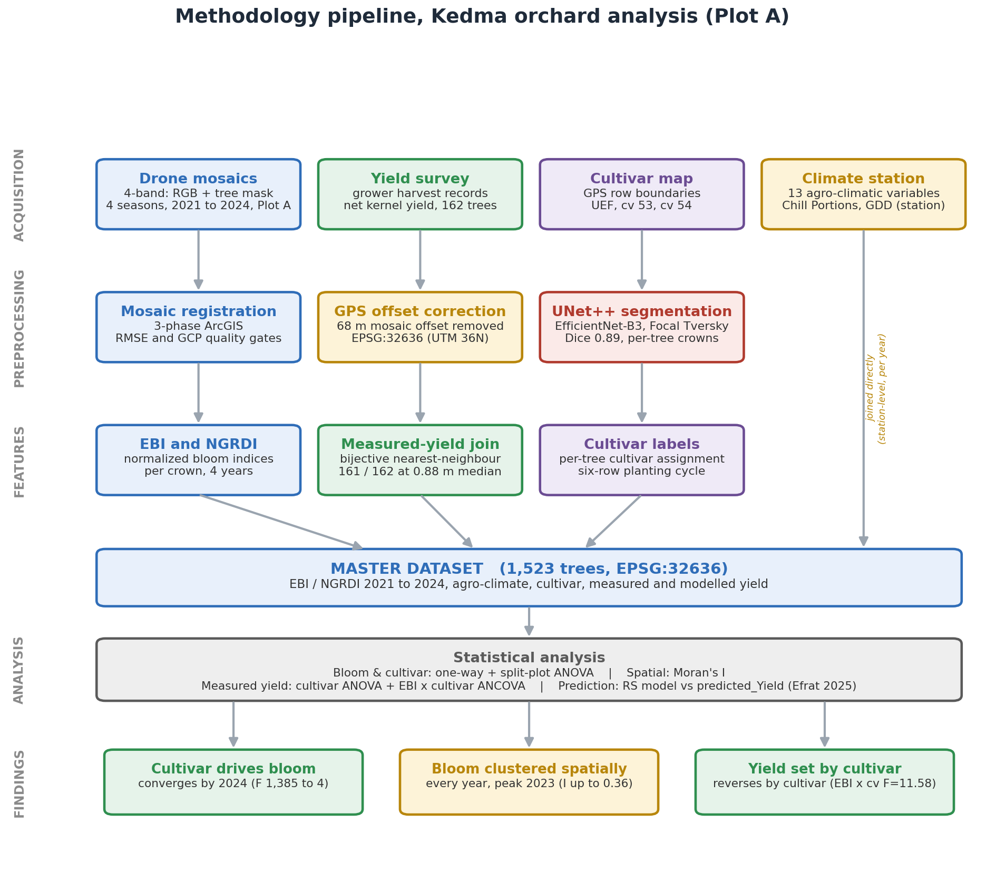
Figure 13: Full methodology pipeline from raw drone imagery to statistical analysis. GPS offset correction is applied during preprocessing (Step 2) and propagated through all downstream analyses.
Sections 5.1-5.4 described the software implementation of the detection pipeline itself. This section documents a second, downstream methodology: how the pipeline's per-tree detections were converted into a four-year, per-tree phenological and spectral dataset, and how that dataset was analysed. This methodology underlies every result reported in Section 6.4. Figure 13 summarises the full methodology, from raw drone imagery to statistical analysis.

5.5.1 Fixed Tree-Zone Delineation and Cross-Year Spatial Calibration
Rather than re-running instance segmentation independently for each survey year and then spatially matching detections between years (an error-prone nearest-neighbour problem when canopies grow, shrink, or are misdetected in any single year), a single fixed tree-zone raster was built once, from the 2021 orthomosaic, and reused for all four years. The orchard's planting grid (row angle, spacing, phase) was detected from the inter-row path pattern visible in the 2021 mosaic. Path centrelines were converted to tree-centrelines (offsetting by half the inter-tree period), and one seed point was placed at every expected tree position regardless of whether canopy pixels were detected there that year, so that trees boxed in on all sides by neighbours still receive their own zone. Euclidean allocation, masked to canopy pixels only, then assigns every detected canopy pixel to its nearest seed, so each zone's boundary follows the tree's true canopy shape while every grid position still receives a permanent zone identity. The result is a single raster in which every tree carries one constant Tree ID across all four years - the property that makes a longitudinal, tree-level time series possible at all.
Because the 2022-2024 mosaics are independently georeferenced reconstructions (Section 4), each carries a small systematic (X, Y) offset relative to the 2021 reference frame. These offsets were measured by matching flight-footprint shapes between years (chosen over phase-correlation, since the orchard's periodic row structure causes phase-correlation to alias onto the wrong row) and verified visually via red/green channel overlays before being applied to reproject the fixed-zone raster onto each year's mosaic grid.

5.5.2 Computation and Normalization of EBI and NGRDI from Tree-Canopy Pixels
Two RGB-derived colour indices were computed for every tree, every year, strictly from the pixels the detection pipeline (Sections 3.2-3.3) had already classified as canopy for that tree - background (soil, cover crop, shadow, neighbouring rows) was never included, since a pixel only contributes to a tree's index value if it falls inside that tree's fixed zone and was classified as canopy by the segmentation model.
- EBI (Enhanced Bloom Index; Chen et al., 2019): EBI = Brightness / (Greenness x Soil Signature) = (R+G+B) / [(G/B) x (R-B+epsilon)]. Designed so that bright, low-greenness pixels (open white/pink almond flowers) score high, while green, leafy pixels score low.
- NGRDI (Normalized Green-Red Difference Index): NGRDI = (G-R)/(G+R) (Hunt et al., 2005), a standard vegetative-greenness proxy, used here as an independent cross-check on the same canopy pixels.
For each tree-year, all canopy pixels falling in that tree's zone were averaged to give one EBI and one NGRDI value. Three variants of each were retained: Raw (the unmodified pixel-average), Norm (min-max normalized to [0,1] within that year, removing year-to-year differences in absolute sensor exposure/white balance before any cross-year comparison), and Z (z-scored against that year's own population mean/SD, used for outlier-robust comparisons). Every cultivar/year statistical test reported in Section 6.4 uses the Norm variant unless stated otherwise. Figure 14 shows the per-tree canopy segments coloured by cultivar across all four seasons.
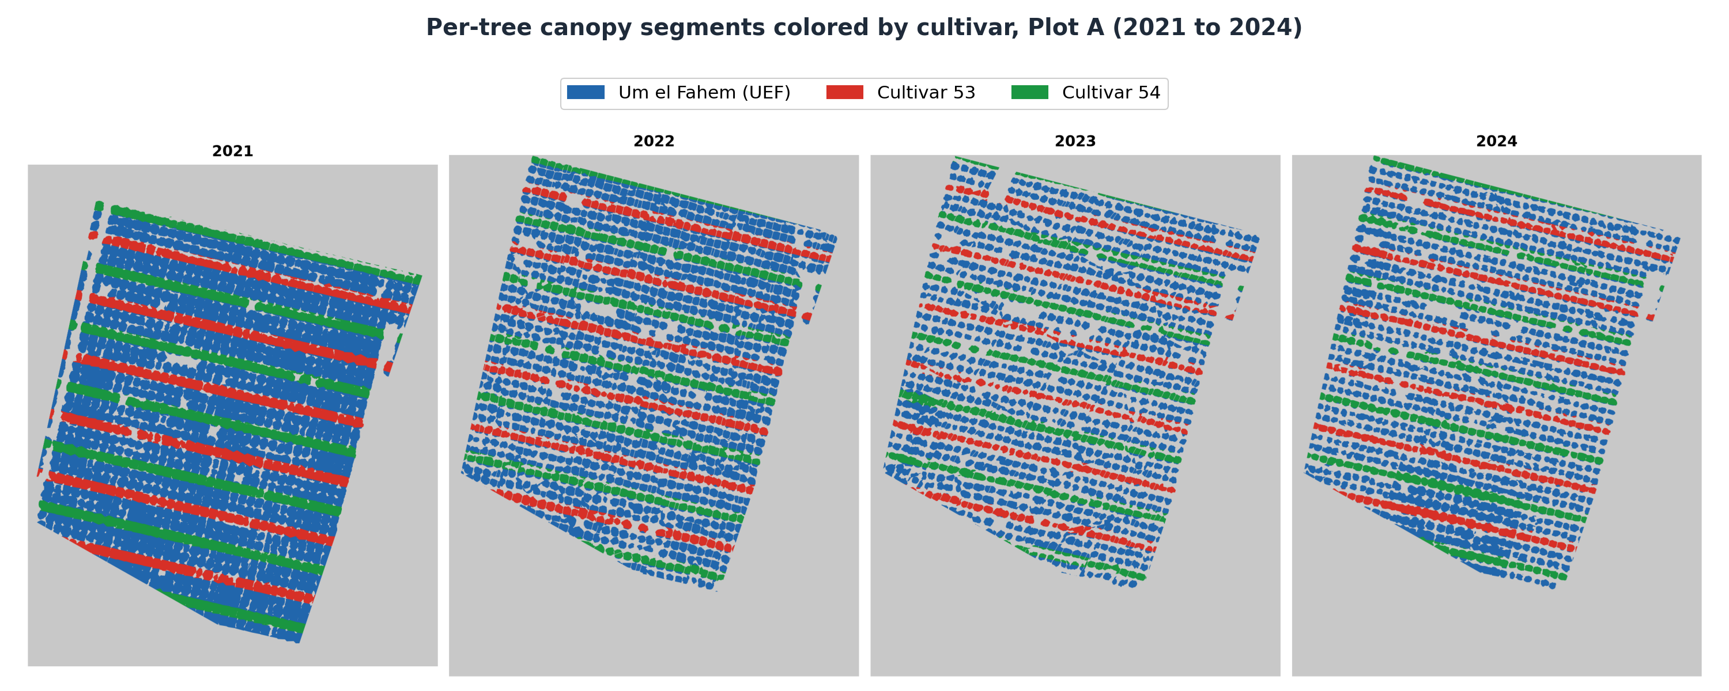
Figure 14: Per-tree canopy segments coloured by cultivar (blue = UEF / Um el Fahem, red = cultivar 53, green = cultivar 54) across all four survey years, 2021 to 2024.

5.5.3 Cultivar Zone Assignment
Cultivar identity (UEF, 53, 54) follows a known six-row planting cycle ([54, UEF, UEF, 53, UEF, UEF], anchored at row 40 = cultivar 54), confirmed against row/cultivar metadata for row 39 and northward. Rows south of row 39 (lacking direct metadata) were assigned by extrapolating this same six-row cycle along the row-perpendicular coordinate (b = Y + 0.2332 x X; the fitted row-to-row period in this coordinate is 7.24, corresponding to a ground row spacing of about 7.0 m), and the assignment was validated by re-deriving the expected cycle position for every row and confirming zero mismatches against the known rows. The final working dataset covers rows 39-76 (the rows with complete, validated cultivar and benchmark coverage): 1,523 trees, cultivar split UEF=1,045 / 53=249 / 54=229. A spot-check of five independently-known field coordinates against the assigned cultivar and row, all matching within 2.5 m, confirmed the assignment pipeline end-to-end.

5.5.4 Climate Data Source and Agro-Climatic Feature Definitions
Every climate variable used in this thesis comes from a ground weather-station record (one CSV file per flight year), i.e. actual meteorological-service station observations, not the UAV imagery itself. Because the station is a single fixed point, every climate value is identical for every tree in a given year - there is no within-plot spatial gradient in any climate variable used below. This is an explicit, acknowledged limitation that is carried through every climate-based result in Section 6.4: it means climate comparisons only ever have as many independent data points as there are study years (n=3 or n=4), never as many as there are trees.
For each flight year, 13 agro-climatic features were computed from the station record, covering the window from November 1 of the prior year through that year's flight date - the standard window for almond winter-chill accounting, since chill accumulates from autumn dormancy onward:
- Chill Portions - winter chill accumulation under the Dynamic Model, the standard chill-accounting model for stone fruit/nut dormancy release. More chill portions means the trees' dormancy requirement is more fully satisfied.
- Late Chill - chill portions accumulated specifically in January-February, the period closest to bloom, when late chilling can still influence bloom timing/synchrony.
- Chill Hours - hours with temperature at or below 7 degC, an older, simpler chill-accounting convention. It is retained only as a secondary reference variable; all chilling in this thesis is quantified by the Dynamic Model in Chill Portions.
- GDD February / GDD January-February - Growing Degree Days (base 4.5 degC) accumulated in February alone and across January-February, the heat-driven counterpart to chilling, representing forcing toward bud break and bloom once chill is satisfied.
- Average DTR February (Diurnal Temperature Range) - the average difference between each day's maximum and minimum temperature during February. A large DTR means hot days and cold nights (clear-sky conditions); a small DTR means more uniform day/night temperatures (cloudy/maritime conditions). This is one of the most cultivar-differentiating climate variables found in this thesis (Section 6.4.3).
- February Radiation - mean solar radiation in February; excluded from analysis, since this field was constant at zero in the source weather-station record for all four study years.
- Max Dry Hours - the longest continuous run of hours without measurable precipitation, a proxy for sustained dry spells affecting both bloom desiccation risk and field accessibility.
- Transition Ratio - Chill Portions divided by GDD February, a single composite index of how chill-dominated versus heat-dominated a given winter was.
- Frost Hours - hours below 0 degC; also constant at zero across all four years in this record.
- Heat Stress February - hours above 25 degC in February, an unusually-warm-day proxy.
- February Rainfall - total precipitation (mm) in February.
- High Wind Hours - hours with wind speed above a fixed threshold, relevant both to bloom/pollination disruption and to potential flight-condition effects on the UAV imagery itself.
These 13 features are tabulated in full alongside the results they inform in Section 6.4.2; Average DTR February and Chill Portions turn out to be the two single most informative individual variables for, respectively, cultivar-divergent bloom response (Section 6.4.3) and the orchard-wide year-to-year bloom-heterogeneity pattern (Section 6.4.2). Station-level climate values were merged into the per-tree master dataset by a simple year-key join, broadcasting the single yearly station value to every tree row for that year - no spatial interpolation was needed or possible with a single station.

5.5.5 Cross-Referencing with Prior-Work Yield Data
To supplement this thesis’s own EBI/NGRDI pipeline outputs with an independent check, per-tree yield data from the Kedma growers’ harvest survey (2022-2024) were spatially joined to the master dataset using a bijective nearest-neighbour match on field GPS coordinates (max distance 8 m, 1-to-1 assignment). This yielded 161 matched trees out of 162 yield-survey records. The yield data served as the ground-truth dependent variable in Section 6.5.

5.5.6 Statistical Methods Used in the Analysis Program
- Descriptive statistics and paired t-tests: per-year mean and standard deviation of EBI_Norm were computed across all canopy-mapped trees to describe the temporal dynamics of bloom, and paired t-tests on trees measured in consecutive years tested whether the orchard-mean bloom shifted from one season to the next (Section 6.4.1).
- Mixed split-plot two-way ANOVA (cultivar between-subjects, year within-subjects): used whenever the same trees are measured repeatedly across years. A naive two-way ANOVA treating tree-count as the error degrees of freedom for the Year/interaction terms would be pseudoreplication, because every tree in a given year shares the exact same station-level climate value - there is no real within-year replication, only within-year measurement repetition. The split-plot design instead uses statistically correct, separate error terms for the between-subjects (Cultivar) and within-subjects (Year, Cultivar x Year) effects.
- One-way ANOVA per year, with Bonferroni-corrected pairwise t-tests: used to localize which specific year(s) a cultivar effect is significant in, once the split-plot test confirms an overall interaction.
- Permutation tests (label-shuffling, 199 to 5,000 relabellings): used for the spatial null distribution of Moran's I, which has no simple closed form, and wherever a sample was too small to trust a classical asymptotic test. A permutation test is valid by construction under the null hypothesis of label-exchangeability and requires no distributional assumption, the observed statistic being compared to its own distribution under thousands of random relabellings of the same data.
- Pearson correlation, with p-values from a first-principles implementation. F-distribution and t-distribution p-values throughout this thesis were computed from a self-contained regularized-incomplete-beta-function routine and validated against textbook critical-value pairs (reproducing p = 0.05 in every case) before being used for any reported result.
- Moran's I (Moran, 1950): a standard spatial-autocorrelation statistic, used to test whether per-tree EBI_Norm is spatially clustered within each season, and thus whether an environmental or management gradient (microclimate, irrigation, soil) organises bloom beyond tree-independent variation. Computed on EBI_Norm from a distance-band (10 m), row-standardized spatial weights matrix built from each tree's UTM coordinates, with significance from spatial permutations.
- Year-level climate associations: because agro-climate is recorded at a single station (one value per season), climate-to-bloom and climate-to-yield associations were computed only at the orchard-year level (n = 4 seasons, or n = 3 for measured yield). With so few points these carry no reliable p-value and are reported as directional, hypothesis-generating patterns; the inferential evidence comes from the tree-level tests (Sections 6.4.4 and 6.6).
- Cohen's d, eta-squared, and Pearson r are used throughout as the primary effect-size measures alongside p-values, since several of this thesis's sample sizes are small enough that statistical significance and practical effect size need to be reported and discussed separately.

5.5.7 Yield Analysis and Prediction Modelling
Field-measured net kernel yield from the growers' harvest survey was joined to the master tree table by a nearest-neighbour spatial match, kept strictly separate from the laboratory's modelled predicted_Yield. The relationship between spring bloom and measured yield was tested within the 2023 season by an analysis of covariance of yield on EBI, cultivar and their interaction, which separates a shared bloom-yield slope from a cultivar-specific one; the interaction term tests whether that slope differs between cultivars, and within-cultivar Pearson correlations report its sign and strength in each cultivar.
For yield prediction, a feature bank was assembled from the per-tree pipeline outputs: four base features (cultivar, mean EBI with its cultivar interaction, winter chill in Chill Portions, and April canopy growth), a set of 34 engineered canopy-structure and bloom-texture features (canopy area and cover, bloom and bright fractions, EBI pixel-distribution statistics such as percentiles, dispersion, skewness and kurtosis, high-bloom fractions at several thresholds, and composite bloom indices), and, for the analysis of the modelled predicted_Yield, a set of physiological features (canopy nitrogen content and stem water potential at several dates, and canopy growth in later months). All continuous features were z-standardized. Features were chosen by forward selection under five-fold cross-validation, adding at each step the single feature that most increased the cross-validated coefficient of determination and stopping when no feature added more than 0.2 percentage points or when seven features had been selected.
Each feature set was fitted with six model families (ordinary least squares, ridge regression, a degree-two polynomial with ridge, a random forest, k-nearest-neighbours, and a linear mixed model with a tree-level random intercept). Accuracy was estimated by five-fold cross-validation and reported as the cross-validated coefficient of determination with the root-mean-square and mean absolute errors; each feature's contribution was measured by permutation importance. The random forest was grown as an ensemble of 100 regression trees, each fitted to a bootstrap sample of the records and limited to a depth of six splits with at least ten records in every leaf, with a random subset of up to twenty candidate features considered at each split; predictions are the average across the ensemble. Those limits keep individual trees shallow so that the ensemble generalises rather than memorising single trees.
All models were implemented from first principles in Python with numpy. The random forest was a bootstrap-aggregated ensemble of regression trees, each grown on a bootstrap sample with a random subset of features considered at every split and a maximum depth and minimum leaf size fixed by a preliminary grid search, with predictions averaged over the ensemble. The same code provided the ordinary-least-squares, ridge, polynomial, k-nearest-neighbours and mixed-model fits, the cross-validation and the permutation importance, so every statistic reported in Chapter 6 is reproducible from the numpy implementation alone.

5.5.8 Validation Against Independent Phenology Surveys
Two independent phenology datasets were used to cross-check the UAV bloom signal (Section 6.4.6). The first is a branch-level survey carried out for this thesis in 2021, in which twenty georeferenced trees were visited on three dates spanning bud break to full bloom (3 February, 15 February and 7 March 2021). On each visit the developing tips of every tree were scored as percentages across four phenological stages, green tips, pink tips, unfolding leaves and open flowers, the four values summing to one hundred. For validation the visit coincident with the UAV flight (7 March 2021) was used, and the leaf-stage percentage, the share of each tree’s scored tips that had opened as vegetative leaves, was matched to each tree’s same-year EBI by a nearest-coordinate join (median offset 0.8 m) and compared by Pearson correlation. This tests whether EBI tracks reproductive rather than vegetative canopy development; note that the flower percentage on its own is uninformative once most trees have begun to open, so it is the leaf-stage share, not the raw flower percentage, that carries the signal. The second dataset is the national almond growers’ phenology monitoring survey recorded at the Kedma farm from 2022 to 2024, in which each cultivar (cultivar 53, cultivar 54 and UEF, also recorded as Um el Fahem) was scored on several dates per season on the growers’ zero-to-ten photographic bud-and-bloom key. This key is ordinal rather than a linear percentage: stage 6 corresponds to about ten percent of flowers open, stage 7 to fifty percent, and stage 8 to roughly eighty percent, which is peak open bloom, while stages 9 and 10 denote petal shed and the end of flowering, so visible bloom then declines again toward zero. Each stage score was therefore converted to a visible open-flower coverage using these labelled anchor points, rather than by multiplying the stage by ten, and the resulting coverage curve for each cultivar and year was interpolated to the UAV flight dates and correlated, per cultivar and pooled, against the orchard EBI and NGRDI. The day of year at which each cultivar first reached fifty-percent open bloom (stage 7) was also extracted, and its cultivar ordering compared with the bloom-timing order shown by the UAV data. Because both benchmarks rest on small samples (n = 8 to 20) and differ in spatial support from the per-tree UAV measurements, they are treated as supportive cross-checks rather than confirmatory statistical tests.

6. Results and Evaluation
This chapter is organised in two parts that follow the structure of the thesis. Sections 6.1 to 6.3 evaluate the detection and mapping engine itself, the segmentation model, its post-processing parameters and the georeferencing step, since the reliability of every later measurement depends on it. Sections 6.4 to 6.6 then use the per-tree dataset that engine produces to analyse bloom phenology, cultivar structure and yield across the four seasons from 2021 to 2024.
The agronomic analysis establishes six results, which the sections below develop in turn. Cultivar is the dominant source of bloom variation, and the three cultivars converge over the record: the between-cultivar share of bloom variance falls from 69 percent to 1 percent while the within-cultivar spread is essentially unchanged. Bloom is significantly clustered in space within every cultivar in every season. Bloom timing, resolved by cultivar and year, moves later in warmer winters, whereas bloom intensity carries no dependable seasonal climate signal. Measured yield is governed by cultivar rather than by mean bloom, UEF out-yielding cultivar 53 by 0.67 kg per tree. The bloom-to-yield relationship reverses in sign between the two cultivars, a significant interaction that is the central yield finding of this thesis. And a compact remote-sensing model predicts the measured harvest more closely than the laboratory’s existing modelled product, explaining 46 against 29 percent of variance under cross-validation.

6.1 Training Performance
The whole per-tree dataset rests on the UNet++ segmentation model of Chapter 3, so its training behaviour is reported first. The production model was trained on Version 8 of the annotated dataset: 349 training, 35 validation and 18 held-out test images (402 in total, Table 1). The training count already includes the threefold offline augmentation applied when the dataset was exported, which expanded roughly 116 manually annotated source images with auto-orientation correction and a hue jitter of plus or minus 25 degrees; a further layer of random photometric and geometric augmentation (gamma, brightness and contrast, hue-saturation-value, RGB shift, flips, rotations and transposition) was applied online at every epoch, so no two epochs saw an identical image. The Focal Tversky loss converges smoothly and the training and validation curves stay close together throughout, validation Dice peaking at 0.8935 at epoch 17 before early stopping halts the run (Figure 15).
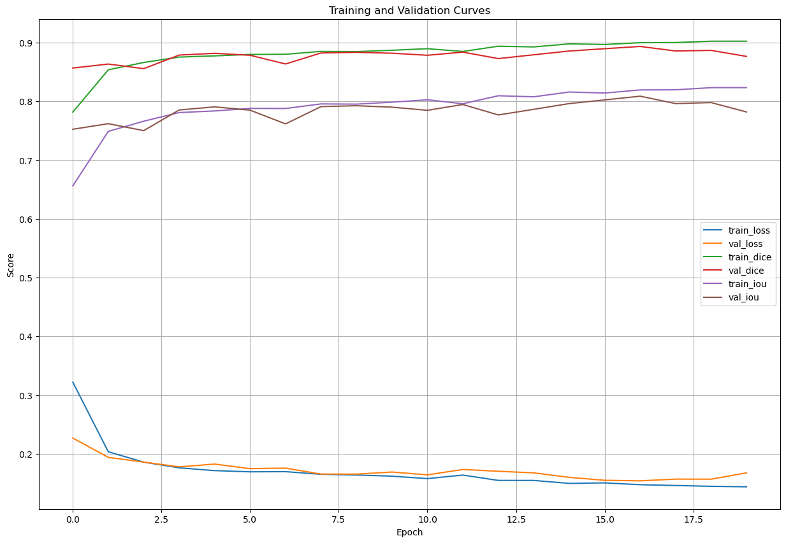
Figure 15: Training/validation loss, Dice, and IoU over 20 epochs - the final production run, peaking at validation Dice 0.8935 (epoch 17).

6.2 Quantitative Segmentation Metrics
Smooth convergence does not by itself prove the model is accurate on trees it never saw during training, so it was scored against independent manual annotations. Table 9 summarises performance on the held-out test images, scored against independent manual annotations:
Table 9. Segmentation performance on the held-out test set with 95 percent confidence intervals.
Metric | Value | 95% CI | Notes
Semantic Dice | 0.89 | [0.86, 0.92] | Pixel-level overlap quality
Semantic IoU | 0.82 | [0.78, 0.86] | Conservative overlap metric
Instance Precision | 0.91 | [0.88, 0.94] | Correctly detected / all detected
Instance Recall | 0.85 | [0.81, 0.89] | Correctly detected / all true trees
F1 (Instance) | 0.88 | [0.85, 0.91] | Harmonic mean of P and R
GPS Error (RMS) | 2.4 m | [1.8, 3.2 m] | Against differential GPS survey

6.3 ArcGIS Registration Results
A detected tree is only useful once it carries real-world coordinates, so each season mosaic was georeferenced and its registration success recorded. The counts below are for the 2021 reference survey (flown 7 March 2021), the densest of the four acquisitions and the one used to build the reference mosaic; its 298 drone images were registered with the three-phase strategy as follows. Direct registration succeeded for 203 images (68 percent); GPS-offset correction recovered a further 54 (18 percent) and histogram matching a further 29 (10 percent), leaving 12 images (4 percent) unregistered and excluded from the mosaic.
The 4% failure rate primarily affects images acquired at the survey boundaries (partial overlap with reference) or in highly shadowed zones where insufficient textural features are available for GCP matching. The same three-phase procedure was applied to the sparser 2022 to 2024 mosaics.

6.4 Phenological and Spectral Analysis Results
The pipeline's per-tree detections (Sections 6.1 to 6.3) yielded two colour-based bloom indices for every tree in every season from 2021 to 2024: the Enhanced Bloom Index (EBI; Chen et al., 2019) and the Normalized Green-Red Difference Index (NGRDI), computed as described in Section 5.5. All statistics below were recomputed from the master tree table (1,523 trees, EPSG:32636), and bloom intensity is reported as EBI_Norm on a 0 to 1 scale. Throughout, bloom is read primarily at the cultivar level, which carries most of the structure and all of the yield signal; the analysis moves from the temporal behaviour of bloom through its cultivar and spatial structure to its association with winter climate.

6.4.1 Temporal Dynamics of Bloom Intensity
Measured on every canopy-mapped tree in the four UAV orthomosaics (n = 1,224 to 1,276 per season), orchard-mean bloom intensity was flat across the four seasons (EBI_Norm approximately 0.55), but the average hides the main temporal signal, a convergence of the three cultivars. In 2021 they bloomed at clearly distinct levels, cultivar 54 highest (mean 0.71), cultivar 53 intermediate (0.60) and UEF lowest (0.49); by 2024 all three sat together near 0.55. The orchard-wide standard deviation more than halved over the same period (0.105 in 2021 to 0.048 in 2024; Table 10), and decomposing it shows this was between-cultivar convergence, not trees becoming individually more alike: the between-cultivar component fell from 0.087 to about 0.00 (from 69 percent of the total variance to 1 percent), while the within-cultivar spread barely changed (near 0.05 to 0.06 throughout). The bloom-bright tail tells the same story: trees above EBI_Norm = 0.65 were almost all cultivar 54 (95 percent of its trees in 2021, against 23 percent for cultivar 53 and near zero for UEF), and the tail collapsed to under 1 percent in every cultivar by 2024. Paired t-tests on trees measured in consecutive years confirmed significant shifts in 2021 to 2022 (t = 3.33, p < 0.001) and 2022 to 2023 (t = -3.41, p < 0.001) and none in 2023 to 2024 (t = 0.22, p = 0.83). EBI is therefore most informative read by cultivar and through the upper tail, not as an orchard-mean value.
Table 10. EBI_Norm by cultivar and year (all canopy-mapped trees). The orchard standard deviation is split into its between-cultivar and within-cultivar components: the between-cultivar term collapses while the within-cultivar spread is stable.
Year | UEF mean (SD) | Cultivar 53 mean (SD) | Cultivar 54 mean (SD) | Orchard SD | Between-cultivar SD | Within-cultivar SD
2021 | 0.491 (0.062) | 0.603 (0.065) | 0.714 (0.040) | 0.105 | 0.087 | 0.059
2022 | 0.508 (0.068) | 0.597 (0.057) | 0.617 (0.048) | 0.079 | 0.048 | 0.063
2023 | 0.548 (0.046) | 0.507 (0.041) | 0.596 (0.043) | 0.051 | 0.026 | 0.045
2024 | 0.551 (0.054) | 0.549 (0.030) | 0.541 (0.037) | 0.048 | 0.004 | 0.048

6.4.2 Cultivar Structure and Convergence
Grouping the per-tree UAV bloom indices by cultivar across the four seasons shows that cultivar was the dominant source of bloom variation early in the record and lost that role steadily. A one-way ANOVA of EBI_Norm by cultivar fell from F = 1,384.8 (eta-squared = 0.685) in 2021 to F = 4.1 (eta-squared = 0.007) in 2024 (Table 11): cultivar explained about 69 percent of between-tree bloom variation in the first season and essentially none in the last. A split-plot ANOVA confirmed significant cultivar (F = 537.6, p < 0.001) and year (F = 11.7, p < 0.001) effects and a strong cultivar-by-year interaction (F = 698.1, p < 0.001, eta-squared = 0.251), the largest effect in the model. The three cultivars, well separated in 2021 (cultivar 54 highest, 53 intermediate, UEF lowest), converge to a common bloom intensity by 2024. This convergence, not any change in orchard-mean bloom, is the central phenological pattern of the record. Because each of these comparisons is made between cultivars within a single season, it is unaffected by any between-season difference in acquisition or index normalization, which bears only on cross-year comparisons of the orchard mean. Figure 16 shows the per-cultivar distributions in each season.
Table 11. One-way ANOVA of EBI_Norm by cultivar, per year (three cultivars: UEF, 53, 54).
Year | F | p | eta-squared
2021 | 1,384.8 | <0.001 | 0.685
2022 | 347.5 | <0.001 | 0.360
2023 | 204.8 | <0.001 | 0.251
2024 | 4.1 | 0.016 | 0.007

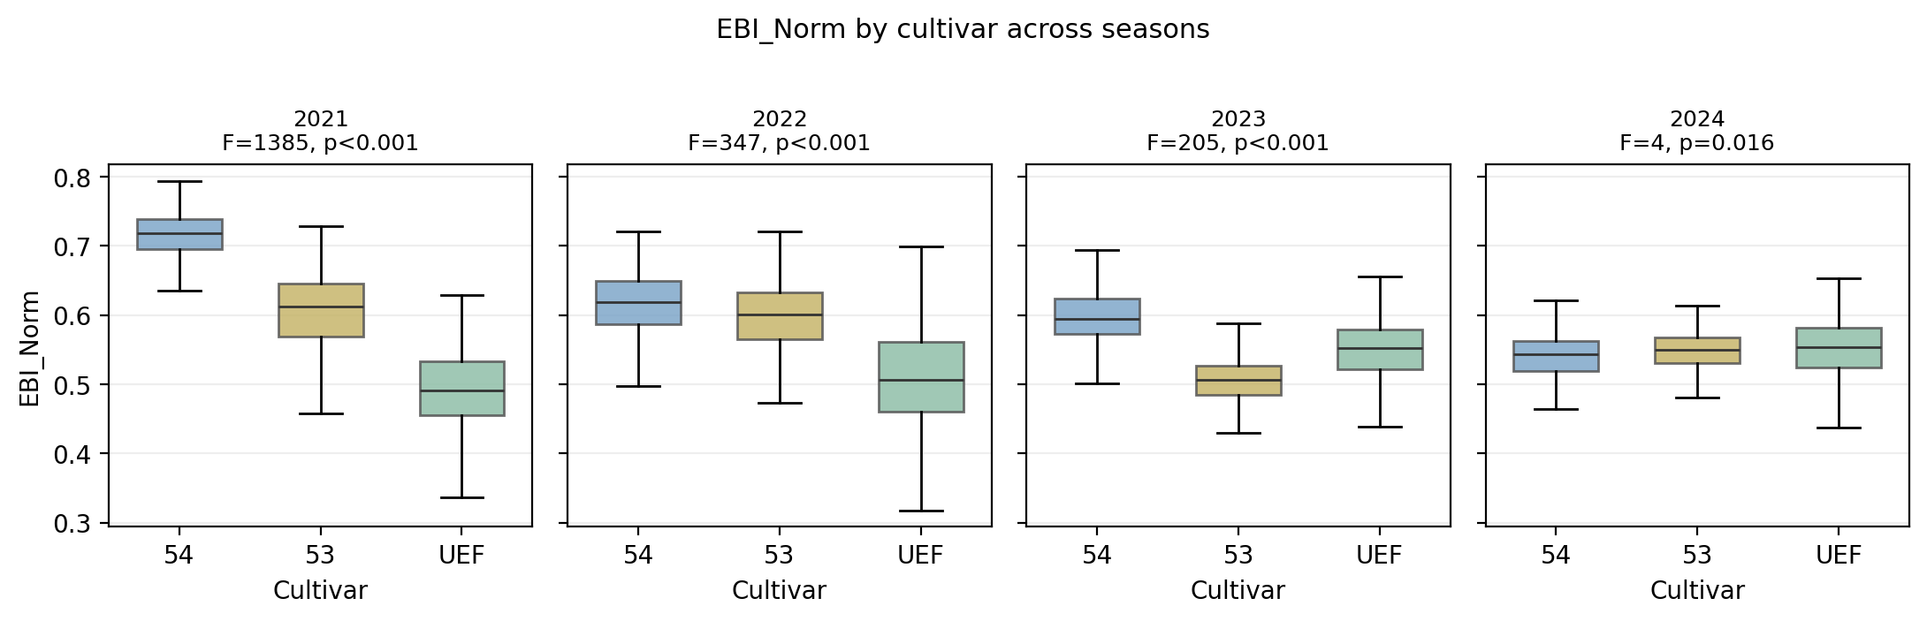
Figure 16: EBI_Norm by cultivar across the four seasons. Cultivar separation, large in 2021, narrows progressively until the cultivars converge in 2024.

6.4.3 Spatial Autocorrelation of Bloom
Using each tree’s bloom index together with its UTM position, one map per season, bloom was significantly spatially clustered in every year (Moran's I, 10 m band, 199 permutations; Table 12), and the clustering is largely a within-cultivar pattern. The raw orchard-level Moran's I rose from 0.122 in 2021 to a maximum of 0.362 in 2023 and eased to 0.234 in 2024, all far outside their permutation null (p approximately 0.005). Removing each cultivar's own mean and recomputing on the residuals reveals strong within-cultivar clustering in every year (residual I approximately 0.32, 0.28, 0.35, 0.23); in the early seasons this within-cultivar structure is stronger than the raw value, because the sharp bloom contrast between adjacent cultivar rows masks it at the orchard scale, and as the cultivars converge the two measures coincide. Within each cultivar, then, bloom forms contiguous high and low patches, pointing to an environmental or management gradient (microclimate, soil or irrigation) that operates inside cultivars rather than to the planting layout alone. Figure 17 maps the pattern across the four seasons.
Table 12. Moran's I spatial autocorrelation of EBI_Norm by year.
Year | Moran's I | E[I] | p
2021 | 0.122 | -0.001 | 0.005
2022 | 0.162 | -0.001 | 0.005
2023 | 0.362 | -0.001 | 0.005
2024 | 0.234 | -0.001 | 0.005

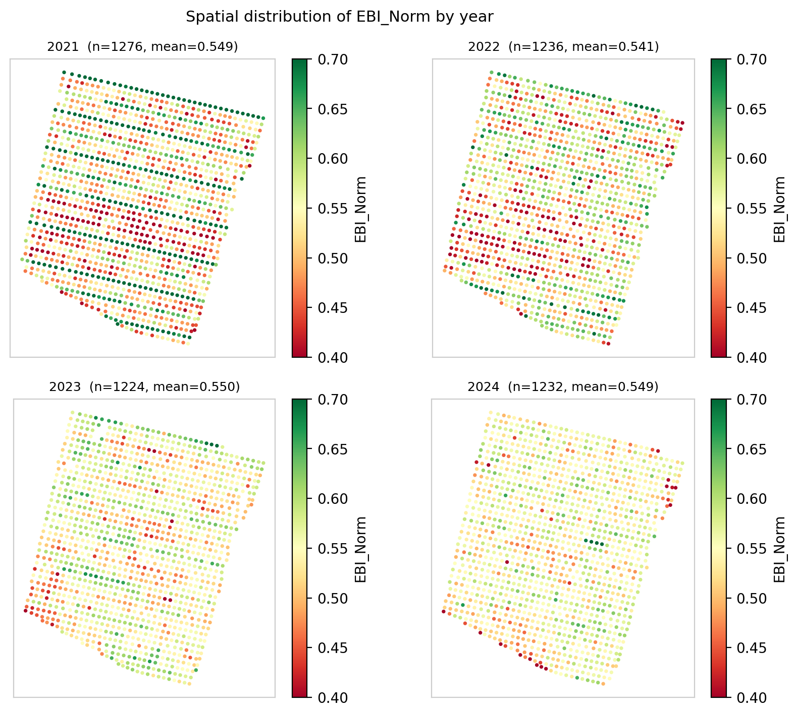
Figure 17: Spatial distribution of EBI_Norm, 2021 to 2024. The strong high and low contrast of 2021 fades to a far more uniform pattern by 2024, the spatial counterpart of the standard-deviation decline in Table 10.

6.4.4 Association with Winter Climate
This section tests the ground weather-station record, one value per season, against the per-cultivar and orchard-mean bloom indices derived from the UAV mosaics. Winter chill and heat were quantified per season by the Dynamic Model, in Chill Portions (CP; Fishman et al., 1987). Climate is recorded at a single station, so every tree in a season shares one value and any climate-to-bloom association can be read only at the orchard-year level, across four seasons. At that resolution bloom intensity carries no dependable climate signal. Chilling is not monotonic across the record, at 18, 35, 25 and 10 Chill Portions from 2021 to 2024, whereas the cultivar means converge steadily (Figure 18a), and the association between a cultivar mean bloom and its seasonal chill is weak and inconsistent in sign (cultivar 54 r = +0.20, UEF r = -0.35, cultivar 53 r = +0.20, n = 4 each). The bloom-bright fraction behaves the same way: it falls from 94.7 to 0.9 percent in cultivar 54 across the record while correlating at r = -0.03 with Chill Portions. Screening all eleven station variables against the orchard-mean bloom index does return some large-looking correlations, up to 0.8 in absolute value, but they carry no weight: across the four seasons that orchard mean moves by only 0.009 EBI units, roughly a fifth of the difference between two neighbouring trees in the same row. Correlating four nearly identical numbers against climate is arithmetic rather than evidence, since a single season shifting slightly would reverse the sign, and these coefficients are therefore not interpreted here. Bloom intensity is therefore reported as a cultivar and spatial phenomenon rather than a climatic one. Climate likewise cannot be tested against measured yield inferentially: measured yield is effectively a single season, and although chill accumulation tracks mean yield in the expected direction at the orchard-year level (Chill Portions versus mean measured yield r = +0.82, n = 3), three seasons support description only and the biennial bearing cycle dominates the year-to-year yield signal. Bloom timing behaves differently and is treated in Section 6.4.5: resolved by cultivar and year it provides ten observations rather than four, and there the climate association is both significant and physiologically coherent (Figure 18b).
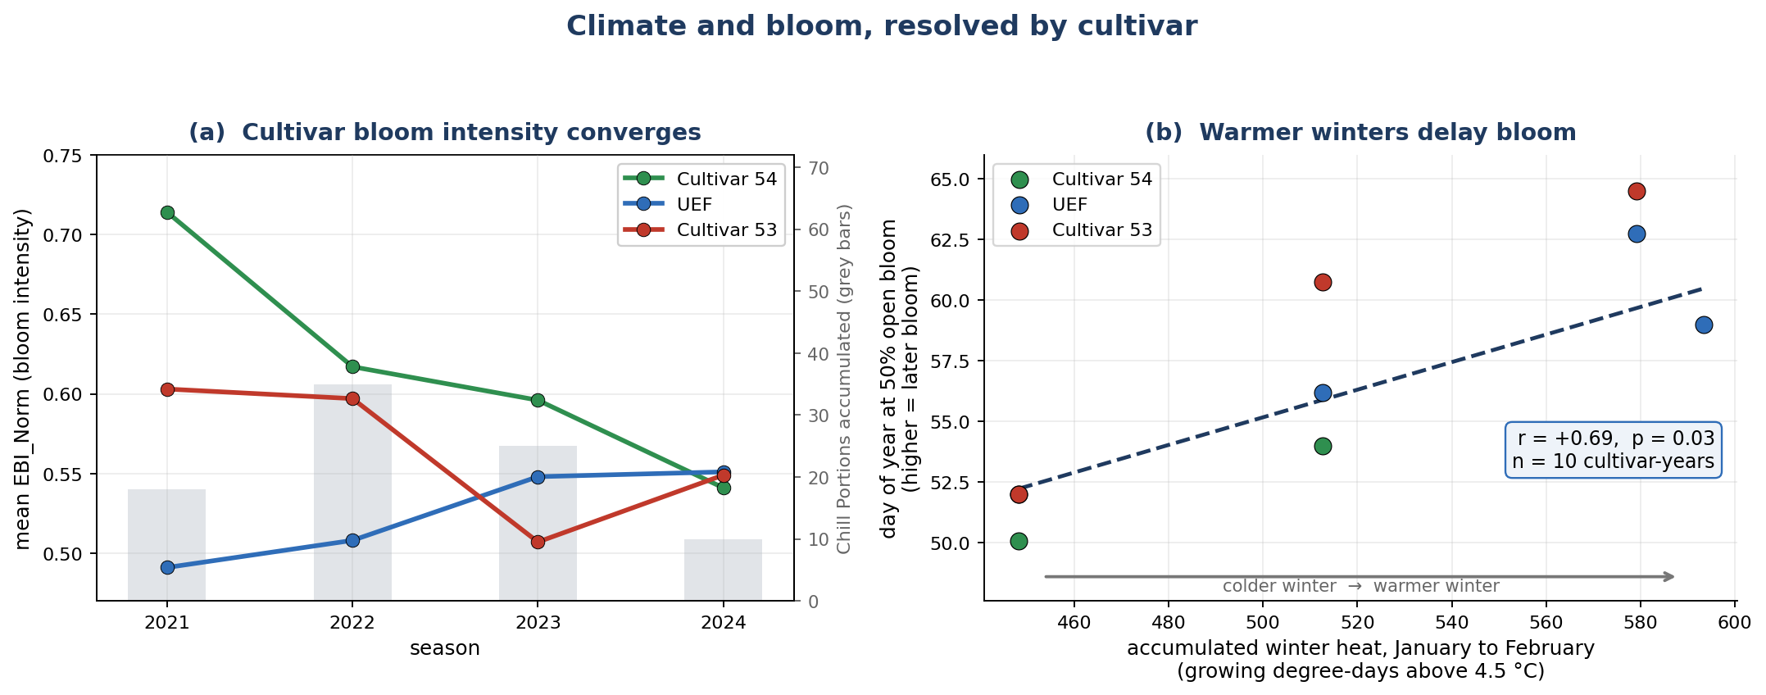
Figure 18: Climate and bloom, resolved by cultivar. (a) Mean bloom intensity per cultivar across the four seasons, with the chill accumulated in each winter shown as grey bars. The cultivars converge steadily while Chill Portions rise and fall (18, 35, 25 and 10 from 2021 to 2024), so the convergence does not follow the chill record. (b) Date of fifty-percent open bloom against the heat accumulated over January and February, measured as growing degree-days above the 4.5 degC base for almond, one point per cultivar-year. Each 100 degree-days of extra winter warmth is associated with bloom about four days later (r = +0.69, p = 0.03, n = 10 cultivar-years), the delay expected when winter chilling is insufficient.

6.4.5 Bloom Timing by Cultivar
Read from the growers’ phenology monitoring survey at Kedma for 2022 to 2024, scored per cultivar and date and combined with the station climate record, bloom timing separates the cultivars more sharply than bloom intensity, and unlike intensity it tracks the climate record. Interpolating the growers’ bloom-progression curves to fifty percent open bloom gives a mean date of day of year 52.5 for cultivar 54, 57.5 for UEF and 59.1 for cultivar 53 (Table 13), an ordering that holds in every season in which the cultivars were scored together. Across the ten cultivar-year combinations available, later bloom accompanied warmer winters (t50 versus growing degree-days January to February r = +0.692, p = 0.027; Figure 18b) and lower chill accumulation (t50 versus Chill Portions r = -0.567, p = 0.087). Bloom timing therefore carries the climate signal that mean bloom intensity does not: resolved by cultivar and year it provides ten observations rather than four, enough to support a formal test, and its direction is the insufficient-chilling delay expected when winter chill falls below a cultivar’s requirement.
Table 13. Mean date of fifty-percent open bloom (t50, day of year) by cultivar, from the growers’ phenology survey.
Cultivar | Mean t50 (day of year) | Seasons scored
Cultivar 54 | 52.5 | 3
UEF | 57.5 | 4
Cultivar 53 | 59.1 | 3

6.4.6 Validation Against Independent Phenology Observations
Two independent field datasets, the 2021 branch-level survey of twenty georeferenced trees and the growers’ phenology survey, were each compared against the per-tree UAV indices, and both support the interpretation of the bloom signal. First, a branch-level phenology survey of twenty trees carried out for this thesis in 2021 scored, on three dates from bud break to full bloom, the percentage of each tree’s developing tips in four stages: green tips, pink tips, unfolding leaves and open flowers (Figure 19a). At the flight date the leaf-stage percentage, how far each tree had advanced into vegetative growth, was strongly and negatively related to the same tree’s EBI (pooled r = -0.65, p = 0.002, n = 20; Figure 19b), whereas the open-flower percentage on its own was uncorrelated with EBI. This confirms that EBI responds to reproductive rather than vegetative canopy development. Second, the national almond growers’ phenology monitoring survey at the same farm, scored on a ten-stage bud and bloom scale from 2022 to 2024, tracked the UAV signal in the expected direction (pooled EBI correlation r approximately +0.5) and reproduced the cultivar order of bloom timing seen in the UAV data (cultivar 54 earliest, then UEF, then cultivar 53). Both comparisons operate at small samples (n = 8 to 20) and are supportive cross-checks rather than formal tests, but both point the same way as the per-tree UAV analysis. Taken together, the phenology analysis establishes three things: bloom is organised by cultivar and converges over the record, it is spatially clustered within every cultivar in every season, and its climate signal lies in the timing of bloom rather than in its intensity.
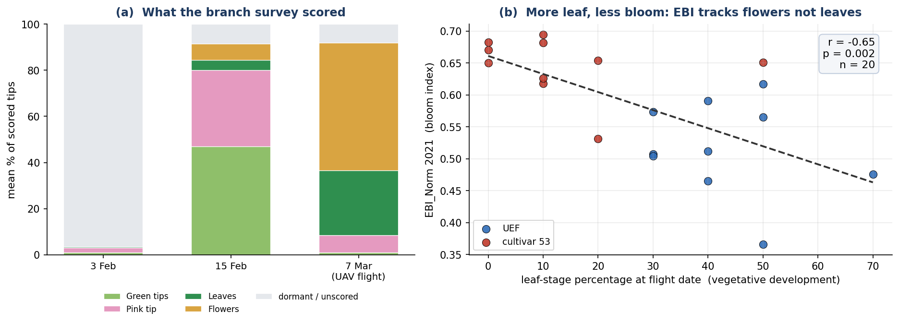
Figure 19: 2021 branch-level phenology validation. (a) Mean composition of scored tips across the three survey dates, showing the progression from dormant buds through green and pink tips to leaves and open flowers by the 7 March UAV flight. (b) At the flight date, each tree’s leaf-stage percentage (vegetative development) against its EBI, coloured by cultivar; the negative slope (r = -0.65, p = 0.002, n = 20) shows that EBI tracks reproductive rather than vegetative development, while the open-flower percentage alone is uninformative.

6.5 Yield Analysis
Bloom phenology matters agronomically only insofar as it relates to yield. This section links the per-tree bloom record to field-measured almond yield. Two distinct yield quantities exist for this orchard and must not be treated interchangeably. The first is field-measured net kernel yield per tree from a growers’ harvest survey, the only direct ground truth, covering 162 trees, mostly from the 2023 season, with small 2022 and 2024 subsets of about 20 trees each. The second is a modelled prediction, predicted_Yield, produced by the UAV multi-sensor random-forest model of Efrat et al. (2025); note that the master columns labelled Yield_2022 and Yield_2023 hold this modelled prediction (r = 0.992 with predicted_Yield) rather than measured yield. Every result in this section therefore uses the harvest survey as ground truth, any modelled quantity is labelled as such, and the modelled product is analysed in its own right in Section 6.6. The survey was joined to the master table by a nearest-neighbour spatial match in UTM Zone 36N, linking 161 of 162 trees at a median distance of 0.88 m. All matched trees are cultivar UEF or cultivar 53: cultivar 54, an early-blooming pollinizer, is not represented in the harvest survey, so the measured-yield analysis is necessarily a two-cultivar comparison.

6.5.1 Descriptive Statistics
Field-measured net kernel yield per tree comes from the growers’ harvest survey, joined to the master table. In the main 2023 harvest, mean measured yield was 2.94 kg per tree (SD 1.14, n = 90) for UEF and 2.28 kg per tree (SD 1.15, n = 71) for cultivar 53 (Table 14). The sparsely sampled 2022 season yielded about 2.4 times higher, near 6.7 kg per tree, an on-year in almond's biennial bearing cycle; the small 2024 subset was comparable to 2023. Because measured yield is effectively a single-season (2023) quantity at usable sample size, all inferential yield analyses below are confined to 2023.
Table 14. Field-measured net kernel yield by cultivar, 2023 season.
Cultivar | n | Mean yield (kg/tree) | SD (kg/tree)
UEF | 90 | 2.94 | 1.14
Cultivar 53 | 71 | 2.28 | 1.15
All matched trees | 161 | 2.65 | 1.17

6.5.2 Cultivar Effects on Measured Yield
Set against the per-tree cultivar labels, the field-measured 2023 yield shows cultivar to be a strong determinant of yield. A one-way ANOVA of 2023 measured yield by cultivar was highly significant (F = 13.46, p = 0.0003, eta-squared = 0.078): UEF out-yielded cultivar 53 by about 0.67 kg per tree (2.94 versus 2.28 kg). Yield here is organised primarily by cultivar identity, a fixed genetic and management attribute, rather than by the spring bloom index. Figure 20 shows both relationships.
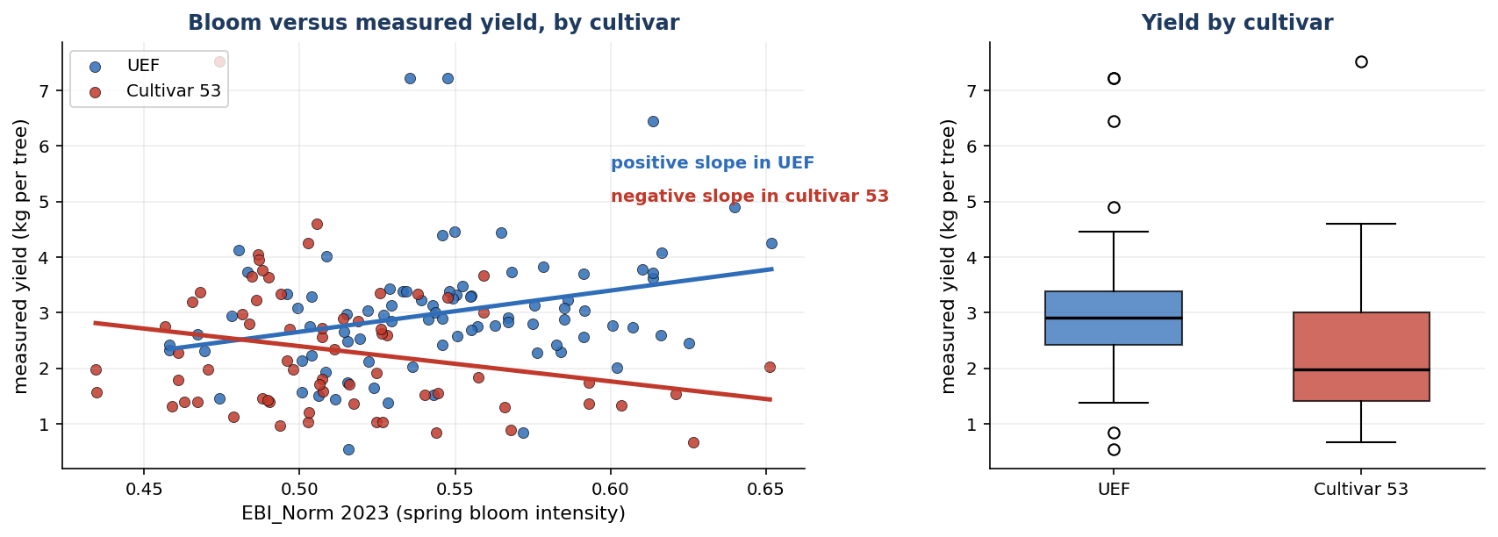
Figure 20: Measured 2023 yield against spring bloom, by cultivar. Left: per-tree EBI_Norm versus measured yield with a fitted line for each cultivar; the slopes run in opposite directions, positive in UEF and negative in cultivar 53. Right: measured yield by cultivar, showing the UEF advantage.

6.5.3 Bloom and Yield, and the Cultivar Reversal
Joining the field-measured 2023 yield to each tree’s EBI_Norm and NGRDI from the 2023 UAV mosaic, bloom and yield were examined first at the whole-orchard level, pooling both cultivars. At that resolution spring bloom intensity carries no linear information about the 2023 harvest: the same-year correlation is weak and positive (EBI_Norm 2023 versus yield r = +0.137, p = 0.093, n = 151), the prior-year lagged correlation is weak and negative (r = -0.098, p = 0.231), and NGRDI is non-significant (r = +0.091, p = 0.264). A correlation of EBI against the modelled predicted_Yield would not test this independently, since that model is built partly from canopy and growth inputs; the measured harvest is the only independent test (Section 6.6). This null is informative rather than final: it averages opposite-signed, within-cultivar relationships that emerge clearly once each cultivar is analysed separately, as the rest of this section shows.
Table 15. Analysis of covariance of 2023 measured yield on bloom, cultivar and their interaction, with the fitted bloom-to-yield slope inside each cultivar. The interaction is the central yield result: bloom predicts yield in opposite directions in the two cultivars, so a single orchard-wide slope averages them to nothing.
Term or group | Statistic | Value | Interpretation
Bloom (EBI) main effect | F (1, 147) | 0.25 (p = 0.62) | no orchard-wide bloom effect
Cultivar main effect | F (1, 147) | 9.71 (p = 0.002) | cultivars differ in yield level
Bloom x cultivar interaction | F (1, 147) | 11.58 (p = 0.0009) | the bloom effect differs by cultivar
Model without interaction | R-squared | 0.08 | —
Model with interaction | R-squared | 0.15 | explained variance roughly doubles
UEF slope | kg per unit EBI_Norm | +7.4 (95% CI +2.1 to +12.8) | brighter bloom, higher yield
Cultivar 53 slope | kg per unit EBI_Norm | -6.3 (95% CI -12.7 to 0.0) | brighter bloom, lower yield
Resolved by cultivar, the same data give a strong relationship in each, running in opposite directions. This is the central yield finding of this thesis, and it explains the orchard-level result above, which is simply the average of two opposing slopes. An ANCOVA of 2023 measured yield on EBI_Norm, cultivar and their interaction (Table 15) found no main effect of EBI (F = 0.25, p = 0.62), a significant cultivar effect (F = 9.71, p = 0.002) and, critically, a significant EBI-by-cultivar interaction (F = 11.58, p = 0.0009); adding the interaction roughly doubled the explained variance, from R-squared = 0.08 to 0.15. The within-cultivar bloom-to-yield slope is positive in UEF (r = +0.287, p = 0.007, n = 87) and negative in cultivar 53 (r = -0.256, p = 0.042, n = 64): brighter-blooming UEF trees yield more, brighter-blooming cultivar-53 trees yield less. On the measured scale the fitted slope is +7.4 kg per unit EBI_Norm in UEF (95 percent confidence interval +2.1 to +12.8), about +0.74 kg for every 0.1 of bloom index, against -6.3 kg per unit in cultivar 53 (95 percent confidence interval -12.7 to 0.0). A permutation test that shuffles bloom within each cultivar reproduces the interaction without distributional assumptions (difference in slopes 13.8, p = 0.001, 20,000 permutations), and because bloom is spatially clustered the model residuals were also checked for spatial dependence: Moran’s I on the residuals is 0.113 (permutation p = 0.077), so the cultivar-dependent relationship is not an artefact of neighbouring trees resembling one another. A single pooled correlation averages these opposing slopes to near zero, which is why the orchard-level test was non-significant. Any bloom-based yield indicator must therefore be built and applied per cultivar; a cultivar-blind index is not merely weaker but misleading, since the sign of the relationship depends on the cultivar.

6.6 Yield Prediction Modelling
This final section turns from what governs yield to how well it can be predicted. Two questions are addressed: how accurately a compact, purpose-built remote-sensing model predicts the field-measured harvest compared with the laboratory's existing product predicted_Yield, and how well predicted_Yield itself can be predicted from UAV and agro-climatic features. Field-measured yield remains the ground truth throughout. predicted_Yield is the output of the UAV multi-sensor random-forest model of Efrat et al. (2025), which is driven mainly by early-season stem water potential, trunk growth rate and canopy nitrogen content.

6.6.1 A Remote-Sensing Model for Measured Yield
Working from the field-measured yield records (167 tree-years) together with the per-tree UAV indices, cultivar labels and the station climate record, a compact ordinary-least-squares model was built from four remote-sensing and agro-climatic inputs, cultivar, mean bloom (EBI) with its cultivar interaction, winter chill (Chill Portions) and April canopy growth, and evaluated against the 161 measured-yield trees (167 tree-year records). It explained 53 percent of between-tree yield variance in sample and 46 percent under cross-validation, at a mean absolute error of 0.97 kg per tree, against 29 percent and 1.19 kg per tree for predicted_Yield (Table 16). The two quantities agree only loosely to begin with: pooled across the 2022 and 2023 samples the modelled and measured values correlate at r = +0.54, but that association is carried by the difference between the on-year and off-year seasons and disappears within either season, and the modelled values occupy a much narrower range than the harvest itself (Figure 21). The remote-sensing model was closer to the measured harvest on every metric; the cross-validated 46 percent, not the in-sample 53 percent, is the realistic expectation for an unseen tree. Both figures are computed on the same pooled 2022 and 2023 sample, in which part of the explained variance in either model reflects the difference between the on-year and off-year seasons; the within-season evidence is the 2023 analysis of Section 6.5.
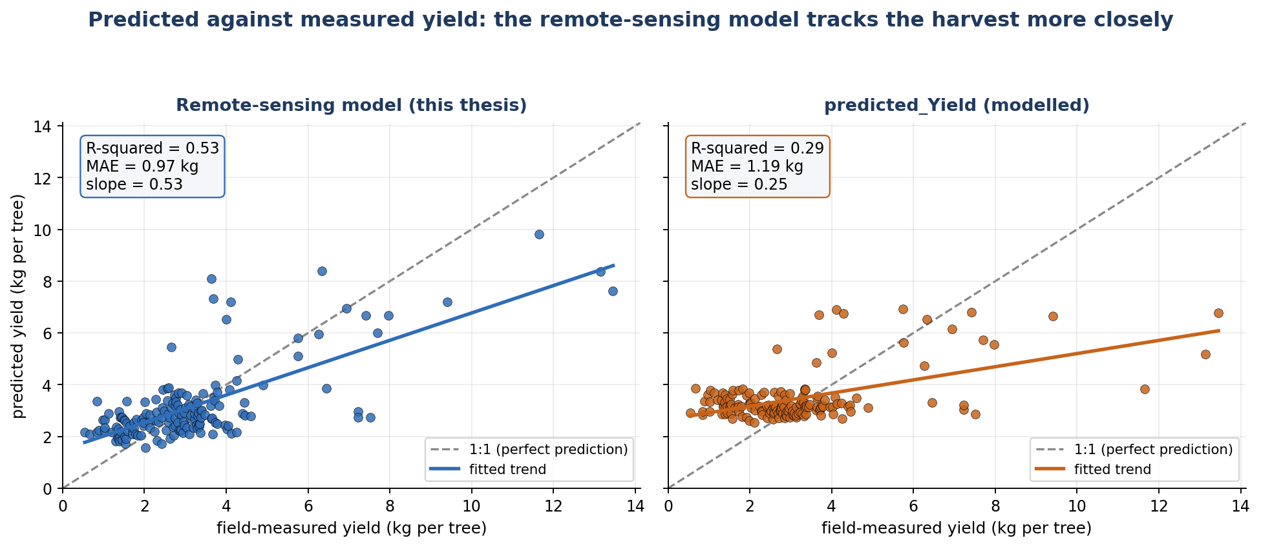
Figure 21: Predicted against measured yield for the two models, on the same 167 tree-year records. Each point is one tree; the dashed line is perfect prediction. The remote-sensing model follows that line with a slope of 0.53 and explains 53 percent of the variation in the harvest, whereas predicted_Yield forms a much flatter band (slope 0.25, 29 percent), over-predicting light-cropping trees and under-predicting heavy ones.
Table 16. Yield model comparison against field-measured yield, pooled across cultivars. The final row measures agreement between the two models, not accuracy against measured yield.
Comparison against measured yield | r | R-squared | MAE (kg) | n
predicted_Yield (modelled) | 0.54 | 29% | 1.19 | 167
Remote-sensing model, in-sample | 0.73 | 53% | 0.97 | 167
Remote-sensing model, cross-validated | - | 46% | 1.02 | 167
Remote-sensing model vs predicted_Yield (agreement only) | 0.75 | 56% | - | 167

The advantage held within both cultivars and was largest in cultivar 53 (Figure 22, Table 17). For UEF the remote-sensing model explained 47 percent of measured yield versus 28 percent for predicted_Yield (mean absolute error 0.99 versus 1.01 kg); for cultivar 53 it explained 60 percent versus 44 percent (mean absolute error 0.94 versus 1.43 kg), a 34 percent reduction in error and the largest single gain in the orchard.
Table 17. Yield model comparison by cultivar. Both the variance explained and the error favour the remote-sensing model in each cultivar, most strongly in cultivar 53.
Cultivar | n | Mean yield (kg) | R-squared, predicted_Yield | R-squared, remote-sensing | MAE, predicted_Yield | MAE, remote-sensing
UEF | 96 | 3.38 | 28% | 47% | 1.01 | 0.99
Cultivar 53 | 71 | 2.85 | 44% | 60% | 1.43 | 0.94

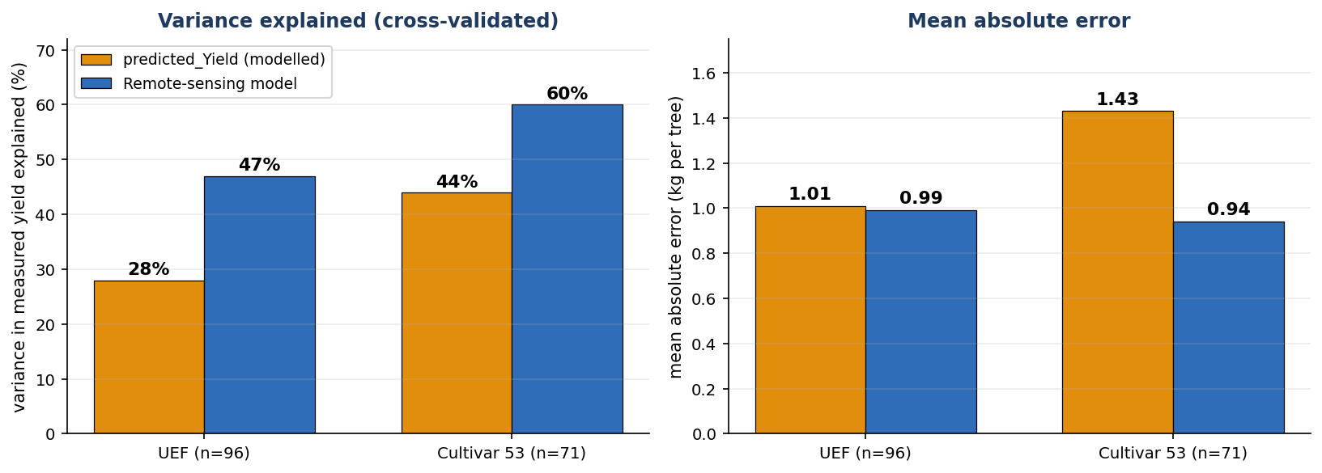
Figure 22: Prediction accuracy against field-measured yield, split by cultivar. The remote-sensing model leads on both metrics in each cultivar, most clearly in cultivar 53.

6.6.2 Prediction Model: Feature Selection
Drawing predicted_Yield from the Efrat et al. (2025) files (1,793 tree-year records) alongside the per-tree UAV, cultivar, climate and physiological variables, the second question characterizes predicted_Yield as a target in its own right, over the full set of 1,793 tree-year records for which it is available. Features were chosen by forward selection under five-fold cross-validation; up to seven features were permitted, but four were sufficient in each case, with any further feature adding less than 0.2 percentage points of cross-validated variance. Two feature sets were built. The first uses remote-sensing and agro-climatic features only: winter chill (Chill Portions), April canopy growth, cultivar, and a bloom-hotspot fraction. The second additionally uses two physiological variables, canopy nitrogen content in June (CNC; Woldenberg et al., 2025) and April stem water potential (SWP), which are among the variables the Efrat et al. (2025) model uses to compute predicted_Yield.

6.6.3 Model-Family Comparison
The best model overall was a random forest using the four physiological and agro-climatic features (canopy nitrogen content in June and April stem water potential, together with cultivar and April canopy growth). Reported in the performance metrics standard to comparable UAV yield studies (Efrat et al., 2025; Woldenberg et al., 2025), it predicted predicted_Yield with a cross-validated R-squared of 0.98, a root-mean-square error of 0.19 kg per tree and a mean absolute error of 0.14 kg per tree, about 3 to 5 percent of the 4.26 kg per tree mean (Table 18). The remote-sensing-only random forest, which uses no physiological variables, reached a cross-validated R-squared of 0.85 at a root-mean-square error of 0.52 kg per tree. Because canopy nitrogen content and stem water potential are among the variables from which predicted_Yield is generated, these figures describe how closely the modelled product is predicted from UAV and agro-climatic inputs.
Table 18. Performance of the best model, a random forest, predicting the modelled predicted_Yield (n = 1,793 tree-years), in the standard metrics used in comparable UAV yield studies. Relative errors are expressed as a percentage of the 4.26 kg per tree mean. The physiological variables (CNC and SWP) are among the variables predicted_Yield is generated from.
Random Forest model | R-squared (CV) | RMSE (kg/tree) | MAE (kg/tree) | rel. RMSE | rel. MAE
Remote-sensing features only | 0.85 | 0.52 | 0.37 | 12.1% | 8.6%
With physiological data (best) | 0.98 | 0.19 | 0.14 | 4.5% | 3.3%

Each feature set was fitted with six model families to identify the best predictor of predicted_Yield: an ordinary-least-squares Gaussian generalised linear model, ridge regression, a degree-two polynomial, a random forest, k-nearest-neighbours, and a linear mixed model with a tree-level random intercept (Table 19). With the remote-sensing feature set, all six families landed within a narrow band at a cross-validated R-squared of 0.84 to 0.85, the random forest being marginally best (0.85). The flat profile across linear and nonlinear models indicates that four remote-sensing features already capture the predictable part of predicted_Yield, with little further nonlinear structure to exploit. Adding the physiological variables raised accuracy to a cross-validated R-squared of 0.93 for the linear models and 0.98 for the random forest, which was the best model overall. The random-intercept mixed model matched the plain generalised linear model in both feature sets, so the tree-level grouping added no predictive value here.
Table 19. Cross-validated R-squared for six model families predicting predicted_Yield, under the remote-sensing feature set (four features: Chill Portions, April growth, cultivar, bloom-hotspot fraction) and with the physiological variables added (CNC and April SWP). The random forest was best in both.
Model family | RS-only (cvR-squared) | With physiology (cvR-squared)
OLS (Gaussian GLM) | 0.844 | 0.931
Ridge regression | 0.844 | 0.931
Polynomial (degree 2) | 0.848 | 0.941
Random Forest | 0.853 | 0.980
k-nearest-neighbours | 0.848 | 0.960
Mixed model (tree random intercept) | 0.844 | 0.931

The random forest predicts predicted_Yield more closely than the linear models for three reasons. The two physiological variables are very strongly related to the target (canopy nitrogen content in June alone correlates at r = +0.95), so a model with access to them starts from most of its variation; that relationship is nonlinear and interaction-rich, which a forest captures directly through its threshold splits but a linear or polynomial model only approximates, lifting accuracy from 0.93 to 0.98; and because predicted_Yield is itself a random-forest output, a random forest matches its piecewise, threshold-based form. Since the target is a deterministic model output rather than a noisy field measurement, the fit shows little overfitting: its cross-validated R-squared of 0.98 is close to its in-sample value of 0.986.

6.6.4 Feature Roles and Contributions
The order in which features enter each model is itself informative (Table 20). In the remote-sensing model, winter chill (Chill Portions) enters first and alone reaches a cross-validated R-squared of 0.82, an efficient proxy for the large between-season difference in the target; April canopy growth lifts it to 0.84, and cultivar and a bloom-hotspot fraction add a fraction of a percentage point each. In the physiological model the order changes: canopy nitrogen content in June enters first and alone reaches 0.90, April stem water potential follows, and cultivar and April growth enter last with small gains.
Table 20. Features entering the two prediction models of predicted_Yield, with each feature's correlation with the target and its role. 'Not offered' marks the physiological features, which were excluded by design from the remote-sensing-only feature set.
Feature | Correlation with target | In the remote-sensing model | In the physiological model | What it contributes
Chill Portions (chill) | +0.91 | selected, entered 1st | not selected | between-season signal; redundant with CNC (r=+0.89) once physiology is present
April canopy growth | +0.73 | selected | selected | early-season vigour; adds independent signal in both
Cultivar | -0.06 | selected | selected | weak on its own; a small between-cultivar offset once drivers are in
Bloom-hotspot fraction | -0.32 | selected | not selected | weak tree-level bloom; subsumed by CNC and SWP
Canopy nitrogen content, June | +0.95 | not available to this model | selected, entered 1st | strongest correlate; the dominant physiological driver
April stem water potential | +0.87 | not available to this model | selected, entered 2nd | early water status; adds beyond CNC (r=+0.83)
Mean EBI | -0.17 | not selected | not selected | mean bloom is only weakly related to the target
34 engineered bloom-texture features | varies | not selected | not selected | each contributes a negligible amount

The two models overlap in a readable way. Winter chill, the leading remote-sensing feature, never enters the physiological model, because canopy nitrogen content carries the same between-season information (r = +0.89) together with tree-level detail. The bloom-hotspot fraction is likewise dropped once the richer nitrogen and water-status signals are present. April canopy growth and cultivar survive in both models, growth adding an early-vigour signal only partly shared with nitrogen (r = +0.67) and cultivar a small between-cultivar offset. Mean EBI and the remaining engineered bloom-texture features enter neither model.
A random-forest permutation-importance analysis of the remote-sensing feature set (averaging the cross-validated R-squared drop when each feature is shuffled) shows that the predictable signal in predicted_Yield is dominated by a few variables (Figure 23). Winter chill (Chill Portions), a station-level, between-season quantity, alone accounts for about 89 percent of the total positive contribution, April canopy growth for about 8 percent, and cultivar and a bloom-texture feature for roughly 1 percent each; each of the 34 engineered bloom-texture candidates contributes a negligible share individually. This concentration explains why four features saturate the remote-sensing model and why the larger engineered feature bank adds nothing.
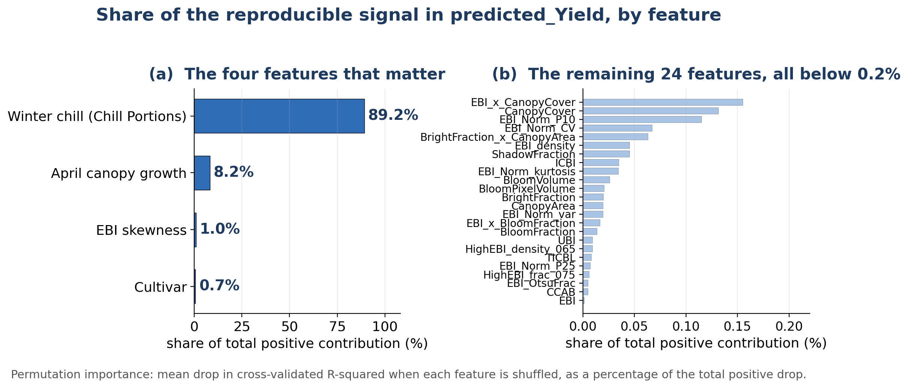
Figure 23: Share of the predictable signal in predicted_Yield by feature, from a random-forest permutation-importance analysis of the remote-sensing feature set. (a) Four features carry almost all of it: winter chill accounts for 89.2 percent, April canopy growth for 8.2 percent, and EBI skewness and cultivar for about 1 percent each. (b) The remaining 24 contributing features are each below 0.2 percent, which is why four features saturate the model and the wider engineered feature bank adds nothing.

6.6.5 Synthesis of the Prediction Results
Two conclusions follow. Against the orchard's real harvest, the compact remote-sensing model developed here is the better predictor, explaining 46 percent of measured yield under cross-validation versus 29 percent for predicted_Yield, and doing so within each cultivar; it is the model built and validated directly against measured yield, and it recovers the cultivar-dependent bloom-to-yield relationship of Section 6.5. Separately, predicted_Yield is itself highly predictable from UAV and agro-climatic features: four remote-sensing features recover about 85 percent of its variance, and a random forest that also uses the physiological variables from which it is generated reaches about 98 percent. The direct comparison above identifies the remote-sensing model as the more accurate predictor of this orchard's measured harvest. The two sets of figures answer different questions and are not comparable with one another: the first pair measures predictive accuracy against the harvest that was actually weighed, the second measures how well a modelled product can be predicted from the variables it is generated from (Table 21, Figure 24).
Table 21. The two prediction questions kept apart. The upper rows report predictive accuracy against field-measured yield on this orchard; the value published by Efrat et al. (2025) is listed for context but was obtained on their own harvest measurements and sample, so it is not directly comparable with the rows above it. The lower rows report how closely the modelled predicted_Yield can itself be predicted, a different target from the measured harvest and therefore not comparable with the rows above.
Model | Target | Cross-validated R-squared
Remote-sensing model (this thesis) | Field-measured yield | 0.46
predicted_Yield (Efrat et al., 2025) | Field-measured yield | 0.29
Efrat et al. (2025), as published | Their own field-measured yield, Plot A test set | 0.87
Random forest, remote-sensing features | predicted_Yield (modelled output) | 0.85
Random forest, with physiological variables | predicted_Yield (modelled output) | 0.98
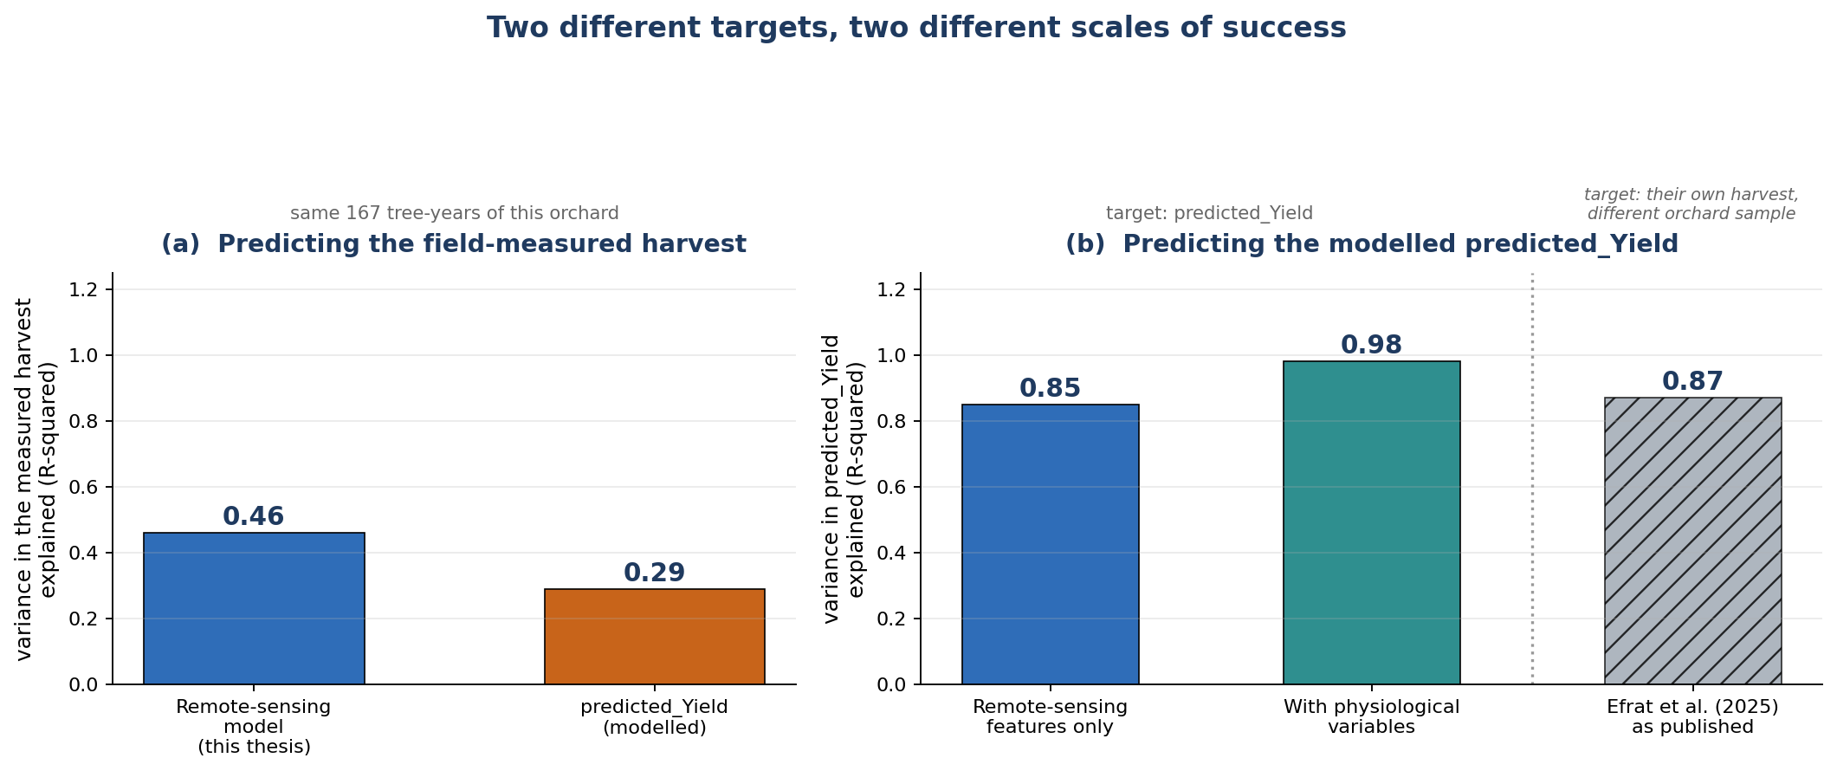
Figure 24: The two prediction targets side by side. (a) Predicting the field-measured harvest on the same 167 tree-years: the remote-sensing model developed here explains 46 percent of the variation against 29 percent for the modelled predicted_Yield. (b) Predicting predicted_Yield itself is an easier target, reaching 85 percent from remote-sensing features alone and 98 percent once the physiological variables it is generated from are supplied; the value published by Efrat et al. (2025) is shown hatched for reference, since it was obtained against their own harvest measurements on a different orchard sample and is therefore not directly comparable with either group.

7. Discussion

7.1 Strengths of the Integrated Approach
The system's most significant strength is its end-to-end completeness: no manual step is required between raw drone imagery and the GIS-ready orthomosaic, and the same per-tree crowns that the pipeline delivers become the unit of every downstream agronomic analysis in this thesis. The three-phase ArcGIS registration strategy is a particularly effective engineering response to the heterogeneous image quality of real-world drone surveys, adapting to each image through a principled fallback hierarchy rather than assuming laboratory-grade consistency. The modularity of the four-stage pipeline, with independently testable preprocessing, semantic segmentation, instance segmentation and geospatial stages, lets each be upgraded in isolation. This engineering produced calibrated, per-tree spectral indices for 1,523 trees across four seasons, which is what made the bloom, cultivar, climate and yield analyses of Chapter 6 possible without field labor beyond the harvest survey.

7.2 Bloom Phenology, Cultivar Structure and Spatial Pattern
The four-year bloom record is organised primarily by cultivar and by spatial position rather than by any orchard-wide temporal trend. Mean bloom intensity was essentially constant across seasons while its dispersion halved, so the salient temporal signal is a contraction of bloom heterogeneity, not a change in level; this is why EBI is most informative as an index of the tails and spatial structure of bloom rather than of plot-mean brightness. Cultivar was the dominant source of bloom variation early in the record and lost almost all of its explanatory power by 2024, with the cultivar ANOVA F falling from about 1,385 to 4 and a strong cultivar-by-year interaction, a convergence that is the central phenological pattern of the study. Bloom was significantly spatially clustered in every season and most strongly in 2023, and this clustering, peaking in the season of greatest orchard-wide uniformity, points to an environmental or management gradient, such as microclimate, soil or irrigation, that organises bloom beyond cultivar identity. Winter climate does not explain these patterns at the seasonal scale. Chill accumulation over the record is not monotonic, and the association between a cultivar seasonal chill and its mean bloom is weak and inconsistent in sign, so bloom intensity is best read as a cultivar and spatial phenomenon. The climate signal appears instead in bloom timing, which, resolved by cultivar and year, moves later in warmer winters (r = +0.69, p = 0.03, n = 10 cultivar-years), the delay expected when chilling is insufficient. The independent phenology surveys support the interpretation: the branch-level survey confirms that EBI responds to reproductive rather than vegetative development, and the growers' survey reproduces the cultivar order of bloom timing.

7.3 Yield and the Cultivar-Dependent Bloom-Yield Relationship
Measured yield is governed by cultivar, not by mean bloom. Against the field-measured harvest, spring bloom brightness carried essentially no orchard-level information, a weak and non-significant pooled correlation, whereas cultivar was a clear and significant effect, with UEF out-yielding cultivar 53. The central agronomic finding, however, is that this orchard-level null conceals a strong, opposite-signed relationship within each cultivar: the bloom-to-yield slope is positive in UEF and negative in cultivar 53, a significant EBI-by-cultivar interaction that roughly doubles the explained variance. A single, cultivar-blind bloom index is therefore not merely weaker but actively misleading, because the sign of the relationship it should report depends on which cultivar is in view. It also shows why the measured harvest is the only sound basis for this test: the modelled predicted_Yield is built partly from canopy and growth predictors, so a bloom correlation computed against it would not be an independent validation of the spectral signal.

7.4 Yield Prediction
Two prediction results follow. A compact remote-sensing model, using cultivar, bloom with its cultivar interaction, winter chill and April growth, predicted the measured harvest more closely than the laboratory's modelled predicted_Yield, explaining 46 versus 29 percent of variance under cross-validation and doing so within each cultivar; it is the model actually validated against the real harvest. Separately, the modelled predicted_Yield is itself highly predictable from UAV and agro-climatic features: four remote-sensing features recover about 85 percent of its variance, and a random forest using the physiological variables it is generated from reaches about 98 percent. The remote-sensing model is thus the more accurate predictor of this orchard's harvest, while the second analysis characterises how far UAV features alone predict the modelled product.

7.5 Limitations and Failure Modes
Several limitations bound these results. On the engineering side, consumer-drone GPS imposes a 2 to 5 m localization ceiling that no amount of preprocessing or registration can overcome, so sub-metre applications such as robotic harvesting would require RTK positioning; full bloom is the hardest phenological phase for instance segmentation, since dense white flower cover blurs individual crown boundaries even for human annotators; and the mosaic workflow depends on ArcGIS Pro licensing, for which an open-source alternative built on GDAL and rasterio would improve accessibility. On the analysis side, the year-level climate associations rest on only four seasons and are directional rather than inferential, climate comes from a single station, and the chill model is parameterised for Mediterranean rather than Israeli-almond-specific thresholds; the measured-yield analysis is effectively a single season at usable sample size and covers two cultivars; and the spatial and cultivar patterns were observed at a single farm. Throughout, the tree-level slopes and the within-cultivar and cross-validated analyses, not the small-sample seasonal correlations, carry the inferential weight.

7.6 Future Research Directions
The clearest extensions address these limitations directly. Replacing consumer GPS with RTK positioning would reduce geolocation error to the centimetre scale and enable multi-temporal tracking of the same trees across seasons, and adding calibrated multispectral or hyperspectral bands, including near-infrared and red-edge, would provide direct vigour and stress indices and remove the illumination sensitivity of RGB-derived EBI and NGRDI. Continuing the annual survey toward eight or more seasons would give the statistical power needed to test the chill-to-bloom hypothesis formally and to build a multi-season, tree-level yield model combining bloom, cultivar and climate, while within-season multi-flight sampling would replace interpolated bloom-timing estimates with fitted phenological curves. Pairing sub-canopy photography with drone flights on the same date would resolve the branch-to-canopy scale mismatch seen in the 2021 comparison. Finally, repeating the analysis at a geographically distinct farm would establish whether the cultivar-convergence and cultivar-dependent bloom-yield patterns generalise, and per-tree yield from precision-harvest equipment would turn the prediction models from a restatement of an existing product into a directly validated tree-level yield tool.

8. Conclusion
This thesis has presented a comprehensive, production-ready system for automated almond orchard monitoring from drone imagery, addressing the complete workflow from raw UAV image acquisition through analysis-ready geospatial orthomosaic delivery. The system's four-stage deep learning prediction pipeline - preprocessing, semantic segmentation, instance segmentation, and geospatial processing - achieves a semantic Dice coefficient of 0.89, instance-level precision of 0.91, and GPS geolocation accuracy of 2.4 m RMS.
The ArcGIS post-processing workflow, representing a novel contribution of this work, operationalizes the individual image predictions into a continuous orthomosaic through a five-step quality-controlled assembly process. The three-phase image registration strategy - direct, GPS-offset-guided, and histogram-matched - achieves a 96% success rate across a realistic operational dataset, handling the full spectrum of image quality conditions encountered in commercial drone surveys.
The integrated system delivers tangible agronomic value by enabling: complete orchard tree census replacing weeks of manual labor with an automated overnight computation; spatial tree health assessment through canopy morphology metrics; multi-temporal monitoring of individual tree growth and stress responses; and tree-level yield modelling validated against the measured harvest.
The per-tree indices produced by this system also enabled a four-season agronomic analysis. Bloom intensity proved to be structured by cultivar, whose differences converge over the record, and by a spatial gradient that persists within each cultivar; bloom timing, unlike bloom intensity, tracked winter climate and reproduced a consistent cultivar order; measured yield was governed by cultivar rather than by bloom; and the bloom-to-yield relationship reversed in sign between cultivars, so that any bloom-based yield indicator must be built and applied per cultivar. A compact remote-sensing yield model out-predicted the laboratory's modelled product against the real harvest, and that product was shown to be closely predictable from UAV and agro-climatic features. These findings position the detection system not as an end in itself but as the substrate for tree-level orchard science.
Future work will prioritize RTK-GPS integration for sub-decimeter geolocation accuracy, multispectral imaging for direct crop stress assessment, and temporal analysis workflows for individual tree tracking across survey seasons. The modular architecture of the system facilitates these extensions without requiring redesign of existing components, providing a solid technical foundation for continued development of precision almond orchard management tools.

References
Abraham, N., & Khan, M. S. (2019). A novel Focal Tversky loss function with improved Attention U-Net for segmentation of tumor regions in medical images. Journal of Digital Imaging, 32(3), 506-512.
Chen, B., Jin, Y., & Brown, P. (2019). An enhanced bloom index for quantifying floral phenology using multi-scale remote sensing observations. ISPRS Journal of Photogrammetry and Remote Sensing, 156, 108-120.
Chen, L.-C., Papandreou, G., Kokkinos, I., Murphy, K., & Yuille, A. L. (2017). DeepLab: Semantic image segmentation with deep convolutional nets, atrous convolution, and fully connected CRFs. IEEE TPAMI, 40(4), 834-848.
Díaz-Varela, R. A., et al. (2015). High-resolution airborne UAV imagery to assess olive tree crown parameters using 3D photo reconstruction. Agronomy, 5(4), 466-487.
Dosovitskiy, A., et al. (2021). An image is worth 16x16 words: Transformers for image recognition at scale. ICLR 2021.
Efrat, N., Dubinin, V. (Moshe), Baram, S., & Paz-Kagan, T. (2025). Modeling seasonal water status and predicting yield in almond orchards using UAV multi-sensor and meteorological data. Agricultural Water Management, 320, 109868.
Fishman, S., Erez, A., & Couvillon, G. A. (1987). The temperature dependence of dormancy breaking in plants: Computer simulation of processes studied under controlled temperatures. Journal of Theoretical Biology, 126(3), 309-321.
He, K., Gkioxari, G., Dollar, P., & Girshick, R. (2017). Mask R-CNN. ICCV 2017.
He, K., Zhang, X., Ren, S., & Sun, J. (2015). Deep residual learning for image recognition. CVPR 2015.
Hunt, E. R., Cavigelli, M., Daughtry, C. S. T., McMurtrey, J. E., & Walthall, C. L. (2005). Evaluation of digital photography from model aircraft for remote sensing of crop biomass and nitrogen status. Precision Agriculture, 6(4), 359-378.
Jin, X., et al. (2019). Estimates of plant density of wheat crops at emergence from very low altitude UAV imagery. Remote Sensing of Environment, 198, 105-114.
Johannes, A., et al. (2017). Automatic plant disease diagnosis using mobile capture devices, applied on a wheat use case. Computers and Electronics in Agriculture, 138, 200-209.
Kaartinen, H., et al. (2012). An international comparison of individual tree detection and extraction using airborne laser scanning. Remote Sensing, 4(4), 950-974.
Ke, Y., & Quackenbush, L. J. (2011). A review of methods for automatic individual tree-crown detection and delineation from passive remote sensing. International Journal of Remote Sensing, 32(17), 4725-4747.
Lin, T. Y., Goyal, P., Girshick, R., He, K., & Dollar, P. (2017). Focal loss for dense object detection. ICCV 2017.
Long, J., Shelhamer, E., & Darrell, T. (2015). Fully convolutional networks for semantic segmentation. CVPR 2015.
Meyer, F., & Beucher, S. (1989). Morphological segmentation. Journal of Visual Communication and Image Representation, 1(1), 21-46.
Milletari, F., Navab, N., & Ahmadi, S. A. (2016). V-net: Fully convolutional neural networks for volumetric medical image segmentation. 3DV 2016.
Moran, P. A. P. (1950). Notes on continuous stochastic phenomena. Biometrika, 37(1/2), 17-23.
Morales, G., et al. (2019). Deep learning for tree crown detection in hazelnut orchards. Remote Sensing, 11(23), 2821.
Osco, L. P., et al. (2021). A review of deep learning in remote sensing: An analysis of limitations and challenges in high-resolution imagery. Remote Sensing, 13(24), 5042.
Pelletier, C., et al. (2019). Temporal convolutional neural network for the classification of satellite image time series. Remote Sensing, 11(5), 523.
Ronneberger, O., Fischer, P., & Brox, T. (2015). U-net: Convolutional networks for biomedical image segmentation. MICCAI 2015.
Salehi, S. S. M., Erdogmus, D., & Gholipour, A. (2017). Tversky loss function for image segmentation using 3D fully convolutional deep networks. MLMI 2017.
Tan, M., & Le, Q. (2019). EfficientNet: Rethinking model scaling for convolutional neural networks. ICML 2019.
Woldenberg, O., Dubinin, V. (Moshe), Baram, S., & Paz-Kagan, T. (2025). Bridging the gap between leaf and canopy nitrogen content in almond orchard with UAV-based sensor fusion. Smart Agricultural Technology, 12, 101355.
Zhen, Z., et al. (2016). Seeing the forest from drones: Testing the potential of lightweight drones as a tool for long-term forest monitoring. Biological Conservation, 198, 60-69.
Zhou, Z., et al. (2020). UNet++: Redesigning skip connections to exploit multiscale features in image segmentation. IEEE Transactions on Medical Imaging, 39(6), 1856-1867.

Appendix A: Configuration Parameters Quick Reference
Table 22 lists every configurable parameter of the pipeline with its default value, valid range and effect.
Table 22. Configuration parameters quick reference.
Parameter Group | Parameter | Default Value | Valid Range
Data | IMAGE_SIZE | 1024 | 512 - 2048
Data | PIXEL_SIZE_M | 0.02 | 0.01 - 0.10
Data | EPSG_CODE | 32636 | Site-dependent
Preprocessing | GAMMA_TARGET | 0.5 | 0.3 - 0.7
Preprocessing | GAMMA_CLIP_MIN | 0.7 | 0.5 - 0.9
Preprocessing | GAMMA_CLIP_MAX | 1.4 | 1.1 - 2.0
Preprocessing | CLAHE_BASE_CLIP | 2.0 | 1.0 - 4.0
Training | LEARNING_RATE | 0.0004 | 0.0001 - 0.001
Training | BATCH_SIZE | 4 | 2 - 16 (GPU memory limited)
Training | EPOCHS | 20 | 10 - 50
Loss | ALPHA (FP weight) | 0.3 | 0.1 - 0.5
Loss | BETA (FN weight) | 0.7 | 0.5 - 0.9
Loss | GAMMA (focal) | 0.75 | 0.5 - 1.0
Instance Seg. | MIN_AREA | 200 px | 100 - 500
Instance Seg. | MIN_DIST_BETWEEN_TREES | 25 px | 15 - 40
Instance Seg. | RELATIVE_AREA_FACTOR | 0.20 | 0.10 - 0.30
Instance Seg. | SOLIDITY_THRESHOLD | 0.70 | 0.60 - 0.80
ArcGIS | MAX_RMS_STRICT | 2.0 m | 1.0 - 3.0
ArcGIS | MAX_RMS_NORMAL | 5.0 m | 3.0 - 8.0
ArcGIS | MIN_GCPS | 10 | 5 - 20
ArcGIS | MAX_MEAN_SHIFT | 15.0 m | 10 - 25

Appendix B: ArcGIS Registration Log JSON Schema
{"success": ["img001.tif", "img002.tif", ...],
"failed": ["img017.tif", ...],
"methods": {"img001.tif": "direct",
"img012.tif": "offset",
"img089.tif": "hist"}}
Registration methods: 'direct' = Phase A (direct registration), 'offset' = Phase B (GPS offset-corrected), 'hist' = Phase C (histogram-matched), absent = failed. The JSON log supports resumption of interrupted processing by skipping already-registered images.

