
Ben-Gurion University of the Negev
Faculty of Engineering Sciences
Department of Industrial Engineering and Management
An Integrated UAV Framework for Individual-Tree Mapping, Bloom Phenology Monitoring, and Yield Prediction in Almond Orchards

THESIS SUBMITTED IN PARTIAL FULFILLMENT OF THE REQUIREMENTS
FOR THE M.Sc. DEGREE
Specialization: Data Science
By: Snir Tahasa
Supervised By Prof. Gilad Ravid and Prof. Tarin Paz-Kagan
September 2026

Abstract

Accurate individual-tree monitoring is essential for translating UAV imagery into actionable orchard-management information. However, existing studies often address canopy segmentation, geospatial mapping, bloom monitoring, and yield prediction as separate tasks, with limited integration into a reproducible tree-level workflow. This thesis developed and evaluated an end-to-end framework for automated almond-tree delineation, geospatial mosaic assembly, multiseason bloom analysis, and yield prediction using RGB UAV imagery integrated with environmental, physiological, and management data.
Tree canopies were identified using a UNet++ semantic-segmentation model with an EfficientNet-B3 encoder and Focal Tversky loss. Individual crowns were subsequently separated using an adaptive marker-based watershed procedure. Image-level predictions were georeferenced and registered against a reference raster to generate GIS-ready mosaics and consistent per-tree analytical units. The final segmentation model was trained using 349 images containing 46,672 annotated tree instances and evaluated on independently annotated test images. On the held-out leaf-on test images it achieved a semantic Dice coefficient of 0.894 (95% CI 0.867 to 0.918) and an intersection-over-union score of 0.809 (0.767 to 0.848), while the crown-separation stage achieved instance-level precision of 0.916 (0.875 to 0.947) and recall of 0.899 (0.870 to 0.926); dormant-season imagery was excluded from the analytical scope, since leafless canopies provide no reliable crown boundary. Geolocation error was 2.4 m RMS, and 1,000 images were processed in about sixteen minutes on a consumer laptop GPU. The resulting tree objects were used to analyse bloom phenology and spatial variability for 1,523 trees over four seasons. Bloom intensity was structured primarily by cultivar and spatial location, whereas bloom timing was associated with winter thermal conditions. Across ten cultivar-year observations, the date of 50% bloom occurred later following warmer winters (r = 0.69, p = 0.03), consistent with delayed flowering under insufficient chilling. Field-measured yield differed significantly between cultivars, while mean bloom intensity alone was not a consistent orchard-wide predictor of yield. Instead, the bloom-yield relationship reversed in direction between the two principal cultivars, revealing a significant cultivar interaction that would be obscured by a cultivar-blind model. A compact remote-sensing model combining cultivar, bloom, winter climate, and canopy-development variables explained 46% of the variability in measured yield under cross-validation, compared with 29% explained by the laboratory’s existing modelled yield product. In a separate surrogate-modelling analysis, this modelled product could be reproduced from UAV and agro-climatic features with approximately 85% explained variance, increasing to approximately 98% when physiological variables used in its original derivation were included.
The study demonstrates the value of integrating hybrid semantic-to-instance segmentation, geospatial individual-tree mapping, and agronomic analysis within a unified UAV-monitoring framework. It further shows that bloom-based yield assessment should account explicitly for cultivar, because similar bloom intensities may translate into different, and even opposite, yield responses among cultivars. Nevertheless, validation across additional orchards, cultivars, seasons, imaging conditions, and positioning systems is required before broad operational deployment.
Keywords: instance segmentation, semantic segmentation, UNet++, EfficientNet, Focal Tversky loss, geospatial mapping, GeoTIFF, ArcGIS, registered mosaic, precision agriculture, drone imagery, watershed algorithm, transfer learning, almond orchard, yield prediction

Table of Contents
Abstract 2
1. Introduction 13
1.1 Motivation and Agricultural Context 13
1.2 Problem Statement 14
1.3 Research Objectives and Scope 14
1.4 System Overview 14
1.5 Research Gaps, Questions and Hypotheses 15
1.6 Thesis Organization 16
2. Literature Review and Related Work 17
2.1 Semantic Segmentation in Remote Sensing 17
2.2 Transfer Learning and Backbone Architectures 18
2.3 Loss Functions for Imbalanced Segmentation 18
2.4 Instance Segmentation Approaches 20
2.5 Geospatial Processing and Mosaic Construction 21
2.6 Agricultural Remote Sensing Applications 22
2.7 Bloom Phenology and Spectral Bloom Indices 24
2.8 Synthesis: Six Strands and Where This Thesis Sits 25
3. Methodology: Prediction Pipeline 26
3.1 Stage 1 - Image Preprocessing 26
3.1.1 Gray World White Balance 26
3.1.2 Adaptive Gamma Correction 27
3.1.3 CLAHE Contrast Enhancement 27
3.2 Stage 2 - Semantic Segmentation 27
3.2.1 Training Dataset and Manual Annotation 28
3.2.2 Architecture Selection Rationale: Why UNet++ with an EfficientNet-B3 Encoder 29
3.2.3 Computational Resource Constraints 30
3.2.4 Empirical Architecture and Loss Function Search 31
3.2.5 Data Augmentation Policy: Empirical Comparison 32
3.2.6 Pre-Processing Rationale and Visual Validation 33
3.2.7 UNet++ Architecture with EfficientNet-B3 Encoder 33
3.2.8 Focal Tversky Loss Function 34
3.2.9 Training Protocol 35
3.2.10 Post-Processing Exploration: An Alternative Instance-Separation Method Considered 35
3.3 Stage 3 - Instance Segmentation via Watershed 36
3.4 Stage 4 - Geospatial Processing and GeoTIFF Export 38
3.4.1 GPS Recovery for Cameras Without Native Geotagging (2021 Survey) 40
4. ArcGIS Post-Processing Workflow: Mosaic Assembly 40
4.1 Step 1 - Reference Raster Preparation 42
4.2 Step 2 - Multi-Phase Image Registration 43
4.2.1 Phase A - Direct Registration 43
4.2.2 Phase B - GPS Offset-Guided Registration 43
4.2.3 Phase C - Histogram-Matched Registration 43
4.3 Step 3 - Visual Quality Assurance 44
4.4 Step 4 - Mosaic Dataset Construction with Quality Filtering 44
4.4.1 Implementation Notes: Mosaic Dataset Construction 45
4.5 Step 5 - Final Mosaic Export 45
5. Implementation 47
5.1 Software Architecture 47
5.2 Key Dependencies 47
5.3 Computational Requirements and Performance 47
5.4 System Usage 48
5.5 Phenological and Spectral Analysis Methodology 49
5.5.1 Fixed Tree-Zone Delineation and Cross-Year Spatial Calibration 50
5.5.2 Computation and Normalization of EBI and NGRDI from Tree-Canopy Pixels 51
5.5.3 Cultivar Zone Assignment 51
5.5.4 Climate Data Source and Agro-Climatic Feature Definitions 52
5.5.5 Cross-Referencing with Prior-Work Yield Data 53
5.5.6 Statistical Methods Used in the Analysis Program 53
5.5.7 Yield Analysis and Prediction Modelling 55
5.5.8 Validation Against Independent Phenology Surveys 55
6. Results and Evaluation 57
6.1 Training Performance 57
6.2 Quantitative Segmentation Metrics 58
6.3 ArcGIS Registration Results 60
6.4 Phenological and Spectral Analysis Results 60
6.4.1 Temporal Dynamics of Bloom Intensity 60
6.4.2 Cultivar Structure and Convergence 61
6.4.3 Spatial Autocorrelation of Bloom 62
6.4.4 Association with Winter Climate 63
6.4.5 Bloom Timing by Cultivar 65
6.4.6 Validation Against Independent Phenology Observations 66
6.5 Yield Analysis 67
6.5.1 Descriptive Statistics 67
6.5.2 Cultivar Effects on Measured Yield 68
6.5.3 Bloom and Yield, and the Cultivar Reversal 68
6.6 Yield Prediction Modelling 69
6.6.1 A Remote-Sensing Model for Measured Yield 70
6.6.2 Prediction Model: Feature Selection 71
6.6.3 Model-Family Comparison 72
6.6.4 Feature Roles and Contributions 73
6.6.5 Synthesis of the Prediction Results 74
7. Discussion 75
7.1 Overview of the Main Findings 76
7.2 Technical Contribution: An Integrated Individual-Tree Monitoring Framework 77
7.3 Biological Interpretation of Bloom Dynamics 77
7.4 Bloom-Yield Relationships and Cultivar Dependence 78
7.5 Implications for UAV-Based Yield Prediction 79
7.6 Implications for Precision Orchard Management 80
7.7 Limitations 81
7.8 Future Research Directions 82
8. Conclusion 83
References 84
Appendix A: Configuration Parameters Quick Reference 87
Appendix B: ArcGIS Registration Log JSON Schema 88

List of Figures
Figure 1: Complete system pipeline - from drone acquisition to ArcGIS registered mosaic export. The prediction pipeline (Stages 1-4) produces individual georeferenced GeoTIFF rasters that are then assembled by the ArcGIS 5-step post-processing workflow into analysis-ready registered mosaics. 15
Figure 2: Loss behaviour under the class imbalance of orchard imagery. Left, binary cross-entropy, which weights every pixel equally and is therefore dominated by the background majority. Right, the three overlap losses evaluated at a canopy fraction of 22 percent: Dice, Tversky with alpha = 0.3 and beta = 0.7, and the Focal Tversky variant with gamma = 0.75 adopted here, in which a missed tree costs 2.3 times a false alarm and the exponent below one compresses the loss range so that nearly correct crowns still generate a substantial gradient. All curves are computed from the published loss definitions rather than reproduced from any source; the script that generates this figure is included in the repository. 20
Figure 3: Colour preprocessing pipeline. From left to right: raw drone image (under-exposed), after Gray World white balance, after adaptive gamma correction, after CLAHE, and the final model-ready normalized image. Each stage addresses a specific image quality issue. 27
Figure 4: Original image, ground-truth mask, and model-predicted mask for a representative held-out validation tile. 30
Figure 5: Pixel-level confusion matrix on the held-out test set (canopy vs. background). 30
Figure 6: Representative training tile - drone image with ground-truth canopy annotations overlaid (green), showing individual hand-annotated tree polygons across orchard rows. 33
Figure 7: UNet++ (Zhou et al., 2020) architecture with an EfficientNet-B3 encoder for almond tree canopy segmentation. The input image is encoded through five downsampling stages X(i,0); each encoder stage feeds a row of nested decoder nodes X(i,j), with solid arrows showing the encoder path and same-row dense skips and dashed arrows the nested upsampled skip pathway from one resolution level down. The orange 1x1-convolution-plus-sigmoid deep-supervision heads produce per-node masks; during training, each is compared with the ground-truth mask by the Focal Tversky loss (alpha=0.3, beta=0.7, gamma=0.75), which penalizes missed trees about 2.3 times more than false positives, and the resulting gradients update all encoder and decoder weights. At inference, the final tree mask is taken from X0,4. 34
Figure 8: Instance-separation demonstration, left to right - original image, ground truth, semantic overlay, individually colourized tree instances (N=143 in this tile), and instance boundaries. 36
Figure 9: Watershed-based instance segmentation, step by step. The procedure is demonstrated on a synthetic test case designed to include the two situations the algorithm must handle: a cluster of three touching crowns and two small spurious blobs, so that the correct answer is known in advance. Every quantitative result in Chapter 6 comes from the real orchard mosaics. (1) Binary semantic mask in which the adjacent crowns are merged into a single component and small noise blobs are present. (2) Euclidean distance transform (brighter = farther from the nearest background edge). (3) Peak detection places one marker at each local maximum, subject to a minimum separation of min_dist pixels (min_dist = 25 px here). (4) Watershed flooding assigns every marker its own labelled region, so the two spurious blobs also become regions. (5) Area and solidity filtering removes the spurious detections. (6) The watershed ridge line inserts a one-pixel physical gap between the separated crowns. (7) Final result, with each crown assigned a unique tree identity, overlaid on the image background. 37
Figure 10: GPS extraction and coordinate transformation pipeline, illustrated with the plot own coordinates. Stage 1: EXIF GPS tags are parsed and converted from degrees-minutes-seconds to decimal degrees (31.7107 N, 34.7924 E). Stage 2: the WGS84 position (EPSG:4326) is projected with pyproj to UTM Zone 36N (EPSG:32636), whose central meridian is 33 E and scale factor k0 = 0.9996, giving Easting = 669842.5 m and Northing = 3509769.4 m. Stage 3: the drone centre-point position is offset by half the registered mosaic width and height (at 0.02 m per pixel) to obtain the top-left corner, which defines the GeoTIFF affine transform; the export is a 4-band GeoTIFF (RGB plus tree mask) in EPSG:32636, LZW compressed. 38
Figure 11: ArcGIS 5-step post-processing workflow. Each step transforms the individual GeoTIFF tiles produced by the prediction pipeline into a quality-assured, mosaicked registered mosaic ready for agricultural analysis. 42
Figure 12: Mosaic assembly process. Individual quality-filtered GeoTIFF tiles (left) are assembled into a continuous registered mosaic (right). The quality filter rejects images with insufficient GCPs, excessive spatial shift, or anomalous extent. Two output products serve different downstream uses: Mosaic_4Band for machine learning analysis and Mosaic_RGB for visualization. 45
Figure 13: Full methodology pipeline from raw drone imagery to statistical analysis. Rows on the left give the processing stage, and colour identifies the data stream each box belongs to: blue for the UAV imagery and the bloom indices derived from it, green for the field-measured harvest, purple for cultivar identity, amber for the climate record and for the coordinate correction applied to the mosaics, red for the segmentation model, and grey for the statistical layer and the pooled master dataset. GPS offset correction is applied during preprocessing and propagated through all downstream analyses. 49
Figure 14: Per-tree canopy segments coloured by cultivar (blue = UEF / Um el Fahem, red = cultivar 53, green = cultivar 54) across all four survey years, 2021 to 2024. 51
Figure 15: Training/validation loss, Dice, and IoU over 20 epochs - the final production run, peaking at validation Dice 0.8935 (epoch 17). 58
Figure 16: EBI_Norm by cultivar across the four seasons. Cultivar separation, large in 2021, narrows progressively until the cultivars converge in 2024. 62
Figure 17: Spatial distribution of EBI_Norm, 2021 to 2024. The strong high- and low-contrast of 2021 fades to a far more uniform pattern by 2024, the spatial counterpart to the standard-deviation decline in Table 13. 63
Figure 18: Climate and bloom, resolved by cultivar. (a) Mean bloom intensity per cultivar across the four seasons, with the chill accumulated in each winter shown as grey bars. The cultivars converge steadily while Chill Portions rise and fall (18, 35, 25 and 10 from 2021 to 2024), so the convergence does not follow the chill record. (b) Date of fifty percent open bloom against the heat accumulated over January and February, measured as growing degree-days above the 4.5 degC base for almond, one point per cultivar-year. Each 100 degree-days of extra winter warmth is associated with bloom about four days later (r = +0.69, p = 0.03, n = 10 cultivar-years), the delay expected when winter chilling is insufficient. 65
Figure 19: Three chill models against observed bloom timing. Each panel plots the accumulation to 28 February computed from the station's 10-minute temperature record against the field date of fifty percent bloom, one point per season. Chill Portions from the Dynamic Model orders the seasons most consistently with observed bloom (r = -0.87), ahead of Utah Chill Units (r = -0.81) and Chill Hours (r = -0.54). With four seasons none of the associations is significant, so the comparison is directional and ranks the models rather than testing them. 65
Figure 20: 2021 branch-level phenology validation. (a) Mean composition of scored tips across the three survey dates, showing the progression from dormant buds through green and pink tips to leaves and open flowers by the 7 March UAV flight. (b) At the flight date, each tree’s leaf-stage percentage (vegetative development) against its EBI, coloured by cultivar; the negative slope (r = -0.65, p = 0.002, n = 20) shows that EBI tracks reproductive rather than vegetative development, while the open-flower percentage alone is uninformative. 66
Figure 21: Measured 2023 yield against spring bloom, by cultivar. Left: per-tree EBI_Norm versus measured yield with a fitted line for each cultivar; the slopes run in opposite directions, positive in UEF and negative in cultivar 53. Right: measured yield by cultivar, showing the UEF advantage. 68
Figure 22: Predicted against measured yield for the two models, on the same 167 tree-year records. Each point is one tree; the dashed line is perfect prediction. The remote-sensing model follows that line with a slope of 0.53 and explains 53 percent of the variation in the harvest in sample, 46 percent under cross-validation, whereas predicted Yield forms a much flatter band (slope 0.25, 29 percent), over-predicting light-cropping trees and under-predicting heavy ones. 70
Figure 23: Prediction accuracy against field-measured yield, split by cultivar. The remote-sensing model leads on both metrics in each cultivar, most clearly in cultivar 53. 71
Figure 24: Share of the predictable signal in predicted_Yield by feature, from a random-forest permutation-importance analysis of the remote-sensing feature set. (a) Four features carry almost all of it: winter chill accounts for 89.2 percent, April canopy growth for 8.2 percent, and EBI skewness and cultivar for about 1 percent each. (b) The remaining 24 contributing features are each below 0.2 percent, which is why four features saturate the model and the wider engineered feature bank adds nothing. 74
Figure 25: The two prediction targets side by side. (a) Predicting the field-measured harvest on the same 167 tree-years: the remote-sensing model developed here explains 46 percent of the variation against 29 percent for the modelled predicted_Yield. (b) Predicting predicted_Yield itself is an easier target, reaching 85 percent from remote-sensing features alone and 98 percent once the physiological variables it is generated from are supplied; the value published by Efrat et al. (2025) is shown hatched for reference, since it was obtained against their own harvest measurements on a different orchard sample and is therefore not directly comparable with either group. 75

List of Tables
Table 1. The six research strands reviewed in this chapter, what each has established, what each leaves open, and how this thesis responds. 25
Table 2. Dataset version history: images, instances, preprocessing and augmentation at each iteration. 28
Table 3. Empirical architecture and loss-function search: validation Dice and IoU for each configuration. 31
Table 4. Data-augmentation policies compared by best validation Dice and IoU. 32
Table 5. Training hyperparameters and the rationale for each setting. 35
Table 6. Instance-segmentation parameters, their ranges, defaults, and effect. 38
Table 7. Mosaic quality-control criteria and rejection thresholds. 44
Table 8. Key software dependencies and their role in the pipeline. 47
Table 9. Measured inference time and memory for the machine used throughout this work, an Apple Silicon laptop running the model through the Metal Performance Shaders backend. 48
Table 10. UAV bloom-season acquisitions. Image counts are the distinct source frames referenced by each season's mosaic metadata, after the quality filtering described in Section 4.4. Camera models are read from the image metadata. 50
Table 11. Segmentation performance on the held-out leaf-on test images (10 images, 1,233 annotated crowns), with 95 percent confidence intervals obtained by bootstrapping over source images. 58
Table 12. Detection recall by stratum on the held-out test set, at an overlap threshold of 0.50. Canopy condition covers all 18 test images; the remaining strata are computed within leaf-on imagery only, since detection fails on dormant imagery and pooling it would make the comparisons uninterpretable. The three season rows sum to 1,070 of the 1,109 leaf-on detections because one leaf-on frame carries no acquisition date in its metadata and is not assigned to a season. 59
Table 13. EBI_Norm by cultivar and year (all canopy-mapped trees). The orchard standard deviation is split into its between-cultivar and within-cultivar components: the between-cultivar term collapses while the within-cultivar spread is stable. 61
Table 14. One-way ANOVA of EBI_Norm by cultivar, per year (three cultivars: UEF, 53, 54). 62
Table 15. Moran's I spatial autocorrelation of EBI_Norm by year. 63
Table 16. Mean date of fifty percent open bloom (t50, day of year) by cultivar, from the growers’ phenology survey. 66
Table 17. Sample flow for the measured-yield analysis, from the raw harvest survey to the modelling sample. Each row reports the records and distinct trees remaining after the stated step. 67
Table 18. Field-measured net kernel yield by cultivar, 2023 season. 68
Table 19. Analysis of covariance of 2023 measured yield on bloom, cultivar and their interaction, with the fitted bloom-to-yield slope inside each cultivar. The interaction is the central yield result: bloom predicts yield in opposite directions in the two cultivars, so a single orchard-wide slope averages them to nothing. 69
Table 20. Yield model comparison against field-measured yield, pooled across cultivars. The final row measures agreement between the two models, not accuracy against measured yield. 71
Table 21. Yield model comparison by cultivar. Both the variance explained and the error favour the remote-sensing model in each cultivar, most strongly in cultivar 53. 71
Table 22. Performance of the best model, a random forest, predicting the modelled predicted_Yield (n = 1,793 tree-years), in the standard metrics used in comparable UAV yield studies. Relative errors are expressed as a percentage of the 4.26 kg per tree mean. The physiological variables (CNC and SWP) are among the variables predicted_Yield is generated from. 72
Table 23. Cross-validated R-squared for six model families predicting predicted_Yield, under the remote-sensing feature set (four features: Chill Portions, April growth, cultivar, bloom-hotspot fraction) and with the physiological variables added (CNC and April SWP). The random forest was best in both. 73
Table 24. Features entering the two prediction models of predicted_Yield, with each feature's correlation with the target and its role. 'Not offered' denotes the physiological features that were excluded by design from the remote-sensing-only feature set. 73
Table 25. The two prediction questions kept apart. The upper rows report predictive accuracy against field-measured yield for this orchard; the value published by Efrat et al. (2025) is listed for context but was obtained from their own harvest measurements and sample, so it is not directly comparable to the rows above it. The lower rows report how closely the modelled predicted_Yield can itself be predicted, a different target from the measured harvest and therefore not comparable with the rows above. 75
Table 26. Configuration parameters quick reference. 87

List of Abbreviations
ANCOVA | Analysis of covariance
ANOVA | Analysis of variance
CI | Confidence interval
CLAHE | Contrast-limited adaptive histogram equalization
CNC | Canopy nitrogen content
CNN | Convolutional neural network
CP | Chill Portions, the accumulation unit of the Dynamic Model
CPU | Central processing unit
DTR | Diurnal temperature range
EBI | Enhanced Bloom Index
EPSG | Coordinate-reference-system code (EPSG registry)
EXIF | Exchangeable image file format
GCP | Ground control point
GDD | Growing degree-days
GIS | Geographic information system
GNSS | Global navigation satellite system
GPS | Global Positioning System
GPU | Graphics processing unit
GSD | Ground sampling distance
IoU | Intersection over union
LZW | Lempel-Ziv-Welch lossless compression
MAE | Mean absolute error
NGRDI | Normalized Green-Red Difference Index
RGB | Red, green and blue image channels
RMS | Root mean square
RMSE | Root-mean-square error
RTK | Real-time kinematic satellite positioning
SD | Standard deviation
SWP | Stem water potential
TGR | Trunk growth rate
UAV | Unmanned aerial vehicle
UEF | Um el Fahem, one of the three almond cultivars
UTM | Universal Transverse Mercator projection

1. Introduction

1.1 Motivation and Agricultural Context
Modern orchard agriculture faces increasing pressure to optimize water, fertilizer, labour, and other management inputs while maintaining high productivity and reducing environmental impacts. Meeting these demands requires precision agriculture technologies that monitor individual trees rather than treating orchards as homogeneous management units. Tree-level information enables growers to identify spatial variability in crop performance, detect stress at an early stage, optimize resource allocation, and improve yield prediction and management decisions. Traditional orchard assessment methods, including manual tree inventories, GPS-based localization surveys, and visual health inspections, are labour-intensive, time-consuming, and often limited to one or two observations per growing season. They are also susceptible to observer bias and cannot easily capture the spatial and temporal variability that characterizes modern orchards. As a result, critical phenological stages such as flowering, fruit set, and pre-harvest development are frequently under-sampled, limiting the ability to support timely management decisions. The rapid development of affordable unmanned aerial vehicles (UAVs), high-resolution imaging sensors, and deep learning has created new opportunities for high-throughput orchard monitoring at centimeter-level spatial resolution. A single UAV flight can acquire thousands of georeferenced images covering tens of hectares within less than an hour. However, acquiring imagery is no longer the primary bottleneck. The fundamental challenge is transforming these large image collections into accurate, georeferenced, and persistent individual-tree datasets that can be consistently analysed across seasons and linked to agronomic processes, including phenology, spatial variability, and yield.
Although numerous studies have demonstrated deep learning for canopy segmentation, geospatial mapping, bloom monitoring, or yield prediction individually, these components are typically developed as independent workflows. Consequently, there remains a lack of integrated frameworks that convert raw UAV imagery into persistent GIS-ready individual-tree objects suitable for both operational orchard management and scientific analysis. Bridging this gap requires combining computer vision, geospatial processing, and agronomic modelling into a unified and reproducible workflow. This thesis addresses this challenge by developing an end-to-end framework that integrates semantic segmentation, instance-level tree delineation, geospatial mosaic construction, and multiseason agronomic analysis. Rather than considering tree detection as the final objective, the proposed framework establishes individual-tree mapping as the foundation for quantifying bloom phenology, investigating cultivar-specific responses, and improving tree-level yield prediction. Almond (Prunus dulcis) was selected as the study crop because it is one of the most economically important tree crops in Mediterranean and semi-arid regions and provides an excellent testbed due to its distinct canopy structure, pronounced flowering period, cultivar-dependent phenology, and strong sensitivity to winter chilling, making it well suited for developing and evaluating advanced UAV-based monitoring methodologies.

1.2 Problem Statement
Converting raw drone imagery into georeferenced, analysis-ready orchard maps presents five interconnected technical challenges:
- Semantic Understanding: Distinguishing tree canopy pixels from background elements (bare soil, shadows, infrastructure, cover crops) across widely varying illumination conditions, growth stages, and seasonal phenological states.
- Instance Separation: Delineating boundaries between individual adjacent trees - a particularly difficult task during bloom when dense white floral canopies merge continuously across rows.
- Geolocation Accuracy: Translating pixel coordinates in each drone image to real-world UTM coordinates with sufficient precision for field navigation and agronomic decision-making (target: better than 5 m RMS).
- Scalability: Processing large image collections (hundreds to thousands of images per flight) efficiently without manual intervention or per-image parameter tuning.
- GIS Integration: Generating output formats natively compatible with standard geospatial workflows (ArcGIS Pro, QGIS, Google Earth Engine) to enable downstream analysis by agronomists who are not computer vision specialists.

1.3 Research Objectives and Scope
This thesis has two complementary objectives: (i) to develop an integrated computational framework for generating persistent, georeferenced individual-tree datasets from UAV imagery, and (ii) to demonstrate how these datasets enable biological and agronomic analyses that are not readily achievable using conventional image-processing workflows. Specifically, the study aims to:
- Develop an end-to-end framework that integrates semantic segmentation, instance-level tree delineation, geospatial mapping, and GIS-ready data generation from RGB UAV imagery.
- Quantitatively evaluate the framework's accuracy, robustness, and computational performance for operational orchard monitoring.
- Establish individual-tree geospatial objects as a common analytical unit for investigating multiseason bloom phenology, cultivar effects, spatial variability, and climate responses.
- Determine how tree-level bloom characteristics relate to productivity and evaluate whether integrating UAV-derived features with environmental and management data improves yield prediction.

1.4 System Overview
Figure 1 presents the complete pipeline architecture, spanning from UAV data acquisition through the final delivery of export-ready registered mosaics. The system is divided into a one-time model-training phase and a repeatable prediction and geospatial-assembly pipeline.
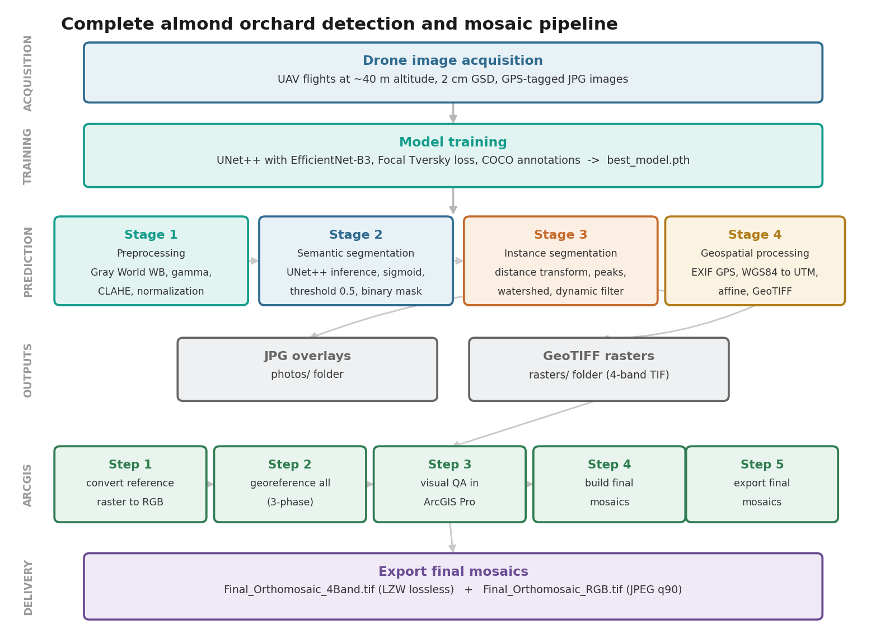
Figure 1: Complete system pipeline - from drone acquisition to ArcGIS registered mosaic export. The prediction pipeline (Stages 1-4) produces individual georeferenced GeoTIFF rasters that are then assembled by the ArcGIS 5-step post-processing workflow into analysis-ready registered mosaics.

1.5 Research Gaps, Questions and Hypotheses
Four gaps motivate the work, and they are of different kinds. The technical gap is that canopy segmentation and crown separation are usually demonstrated on curated image sets and reported as pixel-level accuracy, with no requirement that the resulting objects survive beyond the frame in which they were computed. The geospatial and operational gap is that converting those masks into georeferenced objects with stable identities, from imagery carrying only single-point geotags and no camera attitude, is treated as an implementation detail rather than as a problem with its own failure modes and error budget. The agronomic gap is that bloom, cultivar and yield have almost always been studied at plot or orchard scale, so relationships that differ between cultivars or vary across an orchard are averaged away before they can be observed. The validation gap is that remotely sensed yield work is frequently assessed against modelled yield products rather than against a measured harvest, which tests agreement with a model rather than accuracy against the crop.
These gaps translate into four questions. Can individual almond crowns be delineated accurately and georeferenced consistently enough, from consumer UAV imagery, to serve as a persistent analytical unit across several seasons? Given such a unit, how is bloom organized, by cultivar, by position in the orchard, or by year? Does bloom intensity or bloom timing carry the orchard's response to winter climate? And does tree-level bloom, combined with cultivar and environment, predict the measured harvest better than the modelled yield product currently available for this orchard?
Five hypotheses follow. Each is stated so that it can fail, with the outcome that would refute it, and each is tested in Chapter 6.
H1. Marker-controlled watershed separation applied to a semantic canopy mask recovers individual crowns without becoming the limiting step in the workflow: instance-level accuracy does not fall substantially below the pixel-level accuracy of the mask it is derived from. The hypothesis fails if crown separation, rather than canopy detection, is where accuracy is lost.
H2. Per-tree bloom intensity is organized by cultivar and by position within the orchard. The null is that, once cultivar is accounted for, bloom is distributed at random in space, in which case Moran's I would be indistinguishable from zero in every season.
H3. Winter thermal accumulation acts on the timing of bloom rather than on its intensity. The null is that both respond in comparable degree, or that intensity responds more strongly; the test is whether the date of fifty percent bloom and mean bloom intensity track chill and heat accumulation equally.
H4. The sign of the bloom-to-yield relationship depends on cultivar. What was already established before this study is that bloom-based indicators carry yield information when estimated within a single cultivar, which is how the published almond work is designed. What had not been tested is whether a relationship fitted in one cultivar transfers to another in the same orchard, because that requires per-tree measurements in more than one cultivar against a measured harvest. The null here is a common slope across cultivars, under which the bloom-by-cultivar interaction term is not significant.
H5. A model combining cultivar, bloom with its cultivar interaction, winter chill and early canopy growth predicts field-measured yield more closely than bloom alone or than a cultivar-blind alternative, under cross-validation on the same trees. The hypothesis fails if the simpler models match it.
The boundaries of the study should be clear from the outset. All observations come from a single orchard, Plot A at Kedma in southern Israel, comprising 1,523 trees of three cultivars. Bloom is observed over four consecutive seasons, one flight per season, so seasonal climate comparisons rest on four points and are directional rather than inferential. Measured harvest is available for 162 trees and is effectively a single well-sampled season, covering two of the three cultivars. The imagery is RGB throughout, and a different camera was flown in each of the four seasons: a Sony ILCE-6000 in 2021, a Canon EOS 6D in 2022, a DJI Zenmuse L1 in 2023 and a DJI Zenmuse H20T in 2024. Nothing in what follows constitutes multi-site validation, and the term almond orchards should be read as this orchard unless stated otherwise; the framework is offered as generalisable, the agronomic findings as specific until tested elsewhere.

1.6 Thesis Organization
The remainder of this thesis is organized as follows. Chapter 2 reviews relevant literature on semantic and instance segmentation, geospatial processing and agricultural remote sensing, and on bloom phenology and spectral bloom indices. Chapter 3 presents the four-stage prediction pipeline, and Chapter 4 presents the ArcGIS registered mosaic assembly workflow. Chapter 5 describes the software implementation and, in Section 5.5, the methodology of the phenological, spectral, and yield analyses. Chapter 6 presents the results, covering both the detection pipeline (Sections 6.1 to 6.3) and the agronomic analysis of bloom, cultivar, climate, spatial structure, yield, and yield prediction (Sections 6.4 to 6.6). Chapter 7 discusses the findings in an integrated manner, and Chapter 8 concludes.

2. Literature Review and Related Work

2.1 Semantic Segmentation in Remote Sensing
Semantic segmentation - the task of assigning a class label to every pixel - has undergone revolutionary progress since Fully Convolutional Networks (FCNs) demonstrated end-to-end pixel-to-pixel learning (Long et al., 2015). The U-Net architecture (Ronneberger et al., 2015), originally developed for biomedical imaging, proved transformative for remote sensing applications due to its symmetric encoder-decoder design with skip connections that preserve fine spatial detail while incorporating global context. U-Net's ability to train effectively on limited annotated datasets makes it particularly attractive for agricultural applications, where ground-truth annotation is expensive.
UNet++ (Zhou et al., 2020) extended the U-Net paradigm with nested and dense skip connections that create multiple intermediate decoding paths between encoder and decoder layers. This redesign enables the network to learn more flexible feature aggregation across scales, consistently outperforming standard U-Net on medical and remote sensing benchmarks. The architectural innovation is critical for almond orchards where tree crowns exhibit significant intra-class variability in size, shape, and spectral signature across growth stages.
DeepLab (Chen et al., 2017) and its successors employed atrous (dilated) convolutions to expand the receptive field without sacrificing spatial resolution, using Atrous Spatial Pyramid Pooling (ASPP) for multi-scale context. While achieving state-of-the-art results on general segmentation benchmarks, DeepLab architectures are computationally heavier than U-Net variants, making them less suitable for the batch inference requirements of large orchard surveys.
What is established is that encoder-decoder networks with dense skip connections segment high-resolution aerial imagery reliably, and that the choice among the leading architectures matters less than the quality and quantity of annotation. What remains unresolved is how such networks behave when the target class has no coherent surface, as with a leafless canopy, and how well a model trained on one sensor transfers to another. This thesis adopts UNet++ as a settled choice and reports the transfer question empirically, including a condition in which the network fails outright.

2.2 Transfer Learning and Backbone Architectures
Modern segmentation architectures separate feature extraction (backbone/encoder) from feature decoding. Pre-training encoders on large datasets (e.g., ImageNet) provides generalizable feature representations that significantly reduce the amount of annotated data required for domain-specific fine-tuning.
EfficientNet (Tan & Le, 2019) achieved high parameter efficiency through compound scaling - simultaneously scaling network depth, width, and resolution according to a principled search-derived compound coefficient. EfficientNet-B3, used in this work, reaches an ImageNet top-1 accuracy of about 81.6 percent with 12 million parameters, against 76.3 percent for ResNet-50 with 25.6 million (Tan & Le, 2019). Specifically for agricultural segmentation, EfficientNet backbones have demonstrated strong generalization across diverse crop types and imaging conditions (Osco et al., 2021).
Vision Transformers (Dosovitskiy et al., 2021) represent a paradigm shift from convolutional to attention-based feature extraction. While achieving competitive results on large-scale benchmarks, ViT architectures require substantially more training data and computational resources, making them less practical for operational agricultural monitoring systems with limited labelled data.
The judgement that attention-based models were impractical here should be stated narrowly, since as a general claim it no longer holds. It applies to training a transformer from scratch on a few hundred annotated orchard images with a single consumer GPU, which was the situation in this work. It does not apply to lightweight hierarchical transformers, to encoders pre-trained on large corpora and fine-tuned on small agricultural datasets, or to promptable foundation models such as the Segment Anything Model (Kirillov et al., 2023), which produce usable masks with little or no task-specific training. The evidence on foundation models for this particular task is not yet one-sided: Teng et al. (2025) report that SAM applied out of the box, even with well-designed prompts, does not outperform a purpose-trained Mask R-CNN for tree crown instance segmentation in drone imagery, although further tuning and the addition of surface-model elevation both improve it. The practical reading is that a supervised architecture trained on task-specific annotations remains competitive, while foundation models offer the more promising route where annotation is scarce, which is precisely the leafless canopy condition on which the present network fails.
What is established is that ImageNet-pretrained encoders make small agricultural datasets tractable and that compound-scaled convolutional backbones give the best accuracy per parameter at this data scale. What remains unresolved is where the crossover to attention-based and foundation models lies for orchard imagery, and how much annotation each route actually needs. This thesis fixes EfficientNet-B3 by empirical search under a stated hardware constraint and treats the alternatives as the most likely source of future improvement rather than as settled against.

2.3 Loss Functions for Imbalanced Segmentation
Class imbalance is a fundamental challenge in orchard segmentation: tree canopy pixels represent only 15-30% of the image area, while background (soil, shadows) comprises 70-85%. Standard Binary Cross-Entropy (BCE) loss produces models that are strongly biased toward predicting the background, resulting in high false-negative rates for tree pixels. The loss function landscape for imbalanced segmentation has evolved substantially:
Dice Loss (Milletari et al., 2016), derived from the Dice coefficient overlap measure, directly optimizes the F1 score and inherently handles class imbalance by normalizing by the sizes of the predictions and targets. However, Dice loss treats false positives and false negatives symmetrically - suboptimal for orchard monitoring where missed trees (false negatives) have greater agronomic impact than false alarms.
Tversky Loss (Salehi et al., 2017) generalises Dice by introducing asymmetric weights (alpha, beta) for false positives and false negatives respectively, enabling practitioners to bias the model toward higher recall. With alpha=0.3 and beta=0.7, false negatives are penalized 2.33x more heavily than false positives - aligning the optimization objective with the agricultural requirement to detect all trees even at the cost of occasional false detections.
Focal Tversky Loss (Abraham & Khan, 2019), adopted in this work, applies a focal modulation factor (Lin et al., 2017) to the Tversky loss: L_FT = (1 - Tversky) ^gamma. With gamma=0.75 the exponent lies below one, which compresses the loss range and keeps a meaningful gradient on crowns that are already close to correct, favouring boundary refinement over concentration on the worst cases such as small trees, occluded crowns, and shadow boundaries. Figure 2 provides a comparative analysis of these loss functions.
The weights are not free choices, and the values adopted here follow published practice for two of the three. Salehi et al. (2017), introducing the Tversky loss, tested a range of settings and reported alpha = 0.3 with beta = 0.7 as the best-performing combination for lesion segmentation, the same asymmetry adopted in this work and for the same reason, that a missed positive is costlier than a false alarm. Abraham and Khan (2019) retained alpha = 0.3 and beta = 0.7 for the focal variant. They set the focal exponent to gamma = 4/3, above one, whereas the value used here is 0.75, below one. The two regimes behave differently and the distinction matters: with the exponent above one a nearly correct prediction contributes little and the gradient concentrates on the worst-segmented objects, while with the exponent below one the loss range is compressed and a prediction that is already close still produces a large gradient, so emphasis shifts toward refining crowns that are nearly right rather than toward the hardest cases. At a Tversky index of 0.5 against 0.9, the loss ratio is 8.5 at gamma = 4/3, 5.0 at gamma = 1 and 3.3 at gamma = 0.75. The exponent was chosen for balance rather than by search. Weighting beta above alpha pushes the model toward recall, and an exponent above one would compound that pressure by concentrating the gradient on the worst-segmented crowns, which in this imagery are the marginal and ambiguous ones; the cheapest way for a model to reduce that loss is to label more marginal pixels as canopy, at the cost of precision. Setting the exponent below one damps the focusing, so recall pressure comes from the asymmetric weights alone. The reported precision and recall, 0.916 and 0.899 on the held-out leaf-on images, are consistent with that intention. The value was nonetheless held fixed at 0.75 in every run reported here rather than compared against alternatives, so it is a reasoned choice and not an optimized one, and a sweep of the exponent is noted as future work.
What is established is that overlap-based losses handle the class imbalance of canopy segmentation better than pixel-wise cross-entropy, and that asymmetric weighting can bias a model toward recall. What remains unresolved is how the weighting should be chosen for a given operational cost of a missed versus a spurious crown, which is rarely stated explicitly. This thesis adopts Focal Tversky with recall weighted above precision, on the reasoning that a missed tree removes a record from every downstream analysis whereas a spurious one is detectable by area and shape filtering.
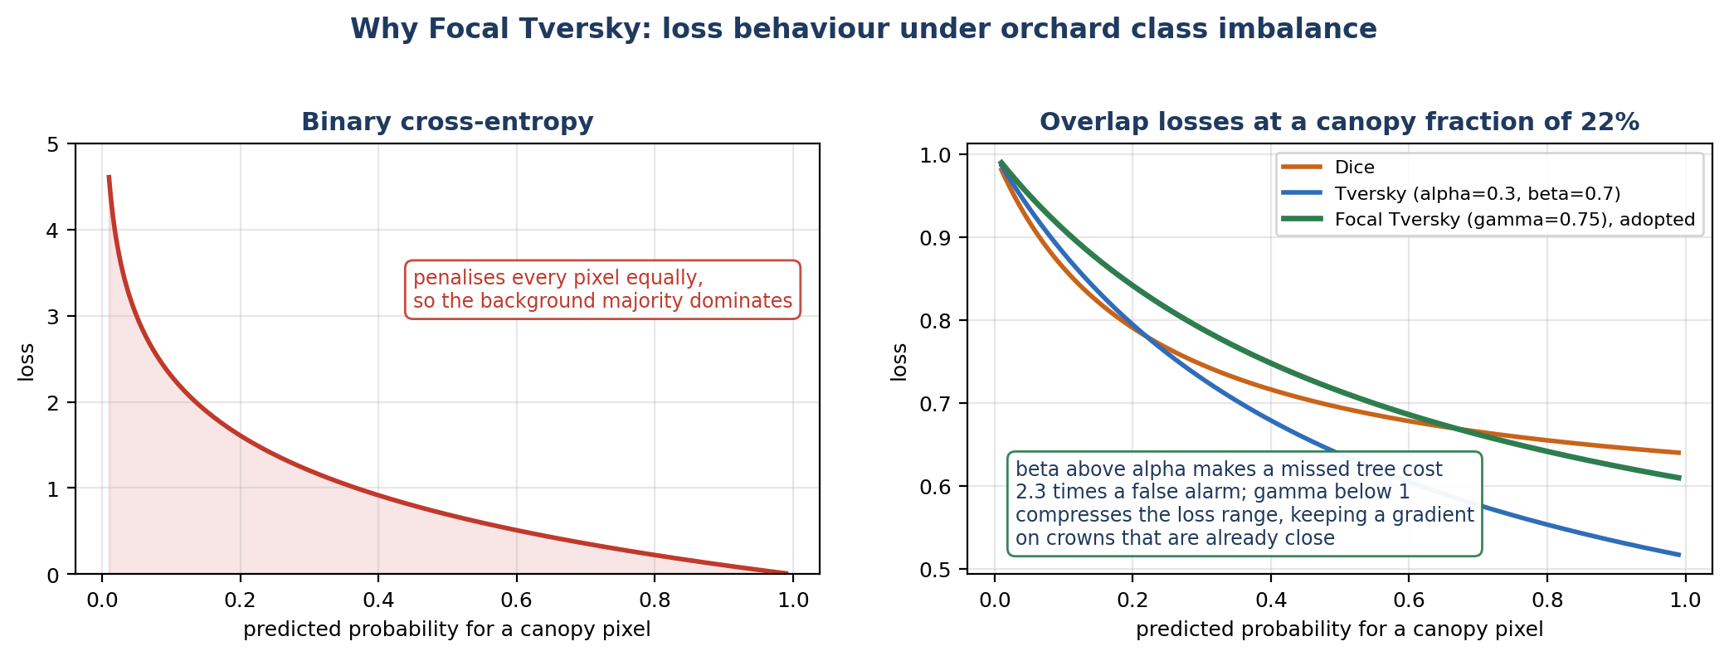
Figure 2: Loss behaviour under the class imbalance of orchard imagery. Left, binary cross-entropy, which weights every pixel equally and is therefore dominated by the background majority. Right, the three overlap losses evaluated at a canopy fraction of 22 percent: Dice, Tversky with alpha = 0.3 and beta = 0.7, and the Focal Tversky variant with gamma = 0.75 adopted here, in which a missed tree costs 2.3 times a false alarm and the exponent below one compresses the loss range so that nearly correct crowns still generate a substantial gradient. All curves are computed from the published loss definitions rather than reproduced from any source; the script that generates this figure is included in the repository.

2.4 Instance Segmentation Approaches
Instance segmentation - assigning unique identifiers to each individual tree - requires converting semantic binary masks into labelled instances. Two broad paradigms exist in the literature:
Proposal-based methods, such as Mask R-CNN (He et al., 2017), combine region proposal networks with per-instance mask prediction, achieving high accuracy in complex scenes with overlapping objects. However, these architectures are computationally demanding and require significant labelled training data with instance-level annotations.
Marker-based watershed approaches (Meyer & Beucher, 1989) treat the distance transform of the binary mask as a topographic surface and simulate flooding from seed markers at local maxima (putative tree centres). Where flood zones from different markers meet, watershed boundaries are established. This classical approach offers key advantages for operational agricultural systems: interpretable intermediate steps, no additional training data requirements, parameter-adjustable sensitivity, and efficient runtime complexity.
Recent tree crown delineation literature (Ke & Quackenbush, 2011; Zhen et al., 2016) consistently demonstrates that watershed-based approaches achieve competitive accuracy with proposal-based methods for remote sensing data, particularly when tree crowns exhibit regular spatial patterns as in planted orchards. The deterministic nature of the watershed algorithm also facilitates systematic parameter optimization across different orchard configurations.
The paradigms should be distinguished more carefully than the literature usually does, because they fail differently. Semantic segmentation labels pixels by class and does not separate touching objects at all. Connected-component labelling separates them only where they are physically disjoint, which fails as soon as canopies touch. Marker-controlled watershed imposes separation geometrically from a distance transform and depends on crown size and spacing priors. Proposal-based instance segmentation, such as Mask R-CNN, learns object extent directly and handles overlap, at the cost of substantially more annotation. Panoptic approaches unify the semantic and instance tasks, and centre-point or boundary-aware networks learn crown centres or edges explicitly as an auxiliary target. What is established is that in orchards, where trees are planted on a regular grid at known spacing, geometric separation is competitive with learned instance methods at a fraction of the labelling cost. What remains unresolved is how far that holds at full bloom, when crown boundaries blur. This thesis uses the geometric route, reports its parameter sensitivity, and quantifies the divided and merged crowns it produces rather than reporting detection counts alone.

2.5 Geospatial Processing and Mosaic Construction
Five operations are often grouped under the heading of mosaic construction, and the distinction between them determines what a resulting product can legitimately be called. Georeferencing assigns real-world coordinates to an image, typically from onboard GNSS metadata. Image registration aligns one image to another or to a reference raster, usually through an affine or polynomial transform fitted to matched control points. Mosaicking merges overlapping georeferenced images into a single continuous raster, resolving seams and radiometric differences. Orthorectification removes the geometric displacement caused by terrain relief and camera perspective, so that every pixel is viewed as if from directly overhead. Structure-from-motion reconstruction estimates camera poses and a three-dimensional surface from overlapping images, and is the route by which photogrammetric software produces a true orthomosaic. A product that has been georeferenced, registered and mosaicked, but not orthorectified, is a registered mosaic; it is planimetrically correct only to the extent that the terrain is flat and the view close to vertical, since both relief and off-nadir viewing displace features from their true ground position by amounts that no two-dimensional transform can remove.
Aerial imagery georeferencing translates pixel coordinates to real-world positions using GPS/IMU metadata embedded in image EXIF headers. Consumer-grade drone GPS provides 2-5 m absolute accuracy under open-sky conditions, sufficient for field-scale mapping but insufficient for sub-metre precision applications requiring RTK (Real-Time Kinematic) correction.
The two sources of position used in this thesis are of different quality and should not be confused. Field measurements, comprising the surveyed tree coordinates and the harvest records, were collected with RTK GNSS and are accurate to the centimetre scale; they serve as the ground reference against which the imagery is assessed. The drone imagery carries only consumer-grade single-point geotags, and the 2.4 m root-mean-square figure reported in Chapter 6 measures the imagery against that RTK reference rather than any uncertainty in the reference itself.
Mosaic construction from georeferenced imagery involves image registration (aligning overlapping images to a common reference), radiometric normalization (matching pixel values across images acquired under varying illumination), and seamline optimization (determining where one image ends and another begins in the final mosaic). Commercial photogrammetry platforms (Pix4D, Agisoft Metashape) solve the full structure-from-motion problem but require high-redundancy, overlapping imagery (>80%) and significant computational resources. For orchard monitoring applications where, individual images already contain GPS geotags, and a reference mosaic exists, simpler image-to-raster registration approaches (as implemented in ArcGIS Pro) offer a practical and computationally efficient alternative.
What is established is that georeferencing from onboard GNSS metadata, followed by registration to a reference raster, produces mosaics adequate for many agricultural purposes at a small fraction of the cost of full photogrammetric reconstruction. What remains unresolved is how the resulting positional error propagates into per-tree measurements, and how identities are maintained between surveys flown months apart with different equipment. This thesis treats both as first-order problems rather than implementation details, reporting the registration success rate by fallback phase, the residual join distance to the ground survey, and the fixed-zone strategy used to hold tree identity constant across four seasons.

2.6 Agricultural Remote Sensing Applications
Deep learning approaches to agricultural monitoring have expanded rapidly, including crop type classification from multitemporal satellite imagery (Pelletier et al., 2019), disease detection through leaf-level spectral analysis (Johannes et al., 2017), and yield estimation from canopy architecture metrics (Jin et al., 2019). Tree crown delineation from aerial LiDAR data has a longer history (Kaartinen et al., 2012) with methods directly analogous to the 2D watershed approaches applied to drone imagery in this work.
Specifically for almond orchards, Díaz-Varela et al. (2015) demonstrated individual tree crown detection from WorldView-2 satellite imagery using classical image processing, but at insufficient resolution (0.5 m) for individual tree health assessment. Morales et al. (2019) applied CNN-based segmentation to hazelnut orchards at drone resolution but did not address the full pipeline from raw imagery to GIS-ready geospatial outputs. The present work addresses this gap by providing a complete, production-ready system spanning data acquisition through geospatial delivery.
Two recent studies address almond specifically at the tree level and together define what this thesis has to add. Chakraborty et al. (2023) mapped bloom density from aerial RGB imagery and used it to forecast crop load per tree, establishing that bloom brightness carries yield-relevant information early in the season. Tang et al. (2023) took the opposite end of the season, estimating tree-level yield from summer multispectral imagery with a convolutional network and reporting an R-squared of 0.96 against individually harvested trees. The contrast between them is instructive. Tang et al. predict close to harvest, when developing fruit is present in the canopy, and validate against roughly two thousand individually weighed trees of a single cultivar; the task is well posed and the accuracy is correspondingly high. Chakraborty et al. predict months earlier from flowers alone, which is far more useful for planning and far less determined, because the path from flower to kernel runs through pollination, fruit set and resource competition.
Three limitations run through this body of work and motivate the present study. Almost all of it treats a single cultivar, so the possibility that the bloom-to-yield relationship differs between cultivars has not been tested and would be invisible by construction. Almost all of it covers a single season, so nothing is established about whether the relationship is stable, and the individual tree is rarely tracked from one year to the next, which requires geolocation that survives between flights rather than only within one. And validation is frequently against a modelled yield product rather than a measured harvest, which tests agreement with a model rather than accuracy against the crop. This thesis is positioned in that space: it works from bloom rather than from developing fruit, across four seasons rather than one, on three cultivars with measured harvest for two, using tree objects that persist between years. Its accuracy against the measured crop is accordingly far below the figure reported by Tang et al., and the comparison is not like for like: predicting a harvest from flowers is a different and harder question than estimating it from fruit already on the tree.

2.7 Bloom Phenology and Spectral Bloom Indices
Bloom phenology is one of the most critical developmental stages in deciduous fruit production because it determines pollination success, fruit set, and ultimately yield. In almond orchards, bloom timing and intensity are highly sensitive to winter chilling and spring temperatures, making bloom an important indicator of cultivar adaptation, climate variability, and future productivity. Consequently, accurate, spatially explicit monitoring of bloom has become increasingly important as warming winters threaten adequate chill accumulation in many almond-growing regions.
The second half of this thesis analyses the per-tree canopy record agronomically, which draws on a distinct body of literature. The Enhanced Bloom Index (EBI), introduced by Chen et al. (2019), quantifies floral phenology from ordinary red-green-blue imagery by contrasting the brightness of white almond blossom against the canopy, and has been used to track bloom timing and intensity from multi-scale remote sensing. Simpler red-green indices, such as the Normalized Green-Red Difference Index (NGRDI), capture canopy greenness and, because they are inversely related to bloom brightness, provide a complementary signal. Winter-chill accumulation, the physiological driver of almond bloom, is quantified here using the Dynamic Model of Fishman et al. (1987), in which the accumulation unit is the Chill Portion. Almond bud break and bloom timing depend on sufficient chill, so seasons of inadequate chilling are expected to show altered bloom intensity and synchrony. UAV structure-from-motion and canopy delineation have been applied to tree crops for parameter extraction (Díaz-Varela et al., 2015), and recent work in the same orchard has modelled tree-level water status, canopy nitrogen content, and yield from UAV multi-sensor data (Efrat et al., 2025; Woldenberg et al., 2025), providing both a modelled yield product and the physiological context against which the present analysis is set. This thesis presents a four-season, per-tree application of these indices that links bloom to cultivar, climate, and field-measured yield.
Despite these advances, most previous studies have focused on orchard- or plot-level bloom characterization, while relatively few have consistently examined bloom dynamics at the individual-tree level across multiple growing seasons. Furthermore, bloom monitoring, geospatial tree mapping, and yield prediction have generally been investigated independently, limiting our understanding of how tree-level bloom variability interacts with cultivar, spatial location, climatic conditions, and productivity. The biological significance of remotely sensed bloom indices for explaining yield variability also remains insufficiently understood, particularly under contrasting climatic conditions and among different cultivars.
Recent work conducted in the same orchard demonstrated that UAV multisensor observations can successfully estimate tree-level water status, canopy nitrogen content, and modelled yield (Efrat et al., 2025; Woldenberg et al., 2025), providing important physiological context for interpreting bloom dynamics. However, these studies relied primarily on physiological and structural indicators and did not investigate how multiseason bloom phenology itself relates to climate variability and field-measured yield at the individual-tree level.

Motivated by these knowledge gaps, this thesis extends previous work by integrating persistent individual-tree delineation with four years of bloom observations to investigate the relationships among bloom phenology, cultivar-specific responses, spatial variability, winter climate, and field-measured yield. Rather than using bloom indices solely for phenological monitoring, the study evaluates their biological and agronomic significance and their potential to improve tree-level yield prediction within an integrated UAV-based monitoring framework.
What is established is that colour indices computed from RGB imagery track floral display in almond, and that bloom phenology is a determinant of yield. What remains unresolved is whether the relationship between bloom and yield is a general property or a cultivar-specific one, since the question requires per-tree measurements in more than one cultivar with a measured harvest, and whether bloom intensity or bloom timing carries the climate response. This thesis addresses both directly, and the answers, that the bloom-to-yield relationship reverses between cultivars and that timing rather than intensity tracks winter warmth, are the principal agronomic results reported in Chapter 6.

2.8 Synthesis: Six Strands and Where This Thesis Sits
Table 1. The six research strands reviewed in this chapter, what each has established, what each leaves open, and how this thesis responds.
Research strand | What is established | What is left open | This thesis
Orchard tree detection | Crowns are located reliably from UAV imagery, across species and planting systems | Each survey is analysed on its own. The detected trees are not given lasting identities, so the same tree cannot be followed to the next flight | Detections become georeferenced tree objects that keep the same identity across four seasons
Canopy segmentation | Encoder-decoder networks segment high-resolution aerial imagery accurately | Accuracy is measured on images held out from the same collection, not on a later independent flight | Scored on a held-out set and reported separately by canopy condition, including the condition in which the model fails
Almond bloom mapping | Colour indices and flower detection track floral display, and bloom density can be measured for each tree | Nearly all studies cover a single cultivar in a single season | Three cultivars followed at tree level over four consecutive seasons
Tree-level yield prediction | Accurate when imagery is taken close to harvest and checked against individually weighed trees | Much weaker when predicting early in the season, and often checked against a modelled yield rather than a real harvest | Predicted from bloom, months before harvest, and checked only against the measured crop
UAV mosaic generation | Photogrammetric reconstruction is the standard way to build an orthomosaic | Assembly by registering images to a reference raster is treated as a second-best option, and its positional error is rarely quantified | Registered mosaic, with the registration success rate and the residual distance to the ground survey both reported
Multitemporal tree matching | Little is settled. Most studies avoid the problem by analysing each season separately | How to hold one tree's identity between flights months apart, taken with different cameras and carrying metre-scale position error | Tree zones defined once and reprojected onto each season, so identity is fixed by construction
The work reviewed above falls into six strands, and setting them side by side (Table 1) shows what each has settled and what none has joined up. Orchard tree detection is mature: crowns are located reliably from UAV imagery in a range of species and planting systems, but detection is usually the endpoint and the detected objects rarely outlive the survey. Canopy segmentation is likewise well developed and is typically validated on curated image sets at pixel level, with accuracy reported for the split rather than for a subsequent operational flight. Almond bloom mapping has moved from plot-level indices to per-flower detection and per-tree bloom density, most directly in Chakraborty et al. (2023), but almost always within a single cultivar and a single season. Tree-level yield prediction has reached high accuracy where imagery is acquired close to harvest and validated against individually weighed trees, as in Tang et al. (2023), and much lower accuracy where prediction is attempted early in the season. UAV mosaic generation is dominated by photogrammetric reconstruction, with registration-based assembly treated as a lesser alternative rather than as a method with a characterized error budget. Multitemporal tree matching is the least developed of the six: the problem of holding a tree's identity across surveys flown months apart, with different sensors and metre-scale positional error, is usually solved informally or avoided by analysing each season separately.
Read together, these strands share a boundary rather than a gap in any one of them. Each is competent within its own scope, and the missing element is the join: a workflow in which detection produces objects that persist, persistence makes multiseason comparison possible, and multiseason comparison exposes relationships, such as a cultivar-dependent link between bloom and yield, that are invisible to any single-season or plot-level treatment. That join is what this thesis constructs, and the chapters that follow are ordered accordingly: Chapters 3 and 4 build the objects, Chapter 5 defines the measurements taken on them, and Chapter 6 uses them to ask the agronomic questions that the objects make answerable.

3. Methodology: Prediction Pipeline

3.1 Stage 1 - Image Preprocessing
Raw drone JPG images suffer from three systematic distortions that reduce segmentation model performance: colour cast due to camera white-balance errors, inconsistent brightness from variable sun angle and cloud cover, and low local contrast in shadowed or uniformly illuminated regions. The preprocessing pipeline applies three deterministic corrections to normalize all images to a consistent appearance.

3.1.1 Gray World White Balance
The Gray World algorithm corrects for colour cast by assuming the scene's average reflectance is achromatic (equal R, G, B means in the absence of a colour cast). For each channel c, the scale factor is:
scale_c = global_mean / channel_mean_c
where global_mean = (R_mean + G_mean + B_mean) / 3
This correction compensates for systematic camera white-balance errors and reduces spectral variability between images acquired at different times of day or under varying atmospheric conditions.

3.1.2 Adaptive Gamma Correction
Gamma correction normalizes image brightness by applying a power-law transformation. The correction exponent is computed from the measured image brightness relative to a target brightness (0.5 normalized):
gamma = log(v_mean) / log(target_brightness)
v_corrected = (v / 255)^(1/gamma) * 255
The gamma exponent is clamped to [0.8, 1.3] in the production pipeline, to prevent extreme corrections that would destroy image information. For a slightly dark image (v_mean=0.45, target=0.5) the exponent is 1.15 and the image is brightened; for a slightly bright one (v_mean=0.55) it is 0.86 and the image is darkened. Values outside the clamp are truncated to it, so an image at v_mean=0.7 would compute 0.51 and be applied as 0.8.

3.1.3 CLAHE Contrast Enhancement
Contrast Limited Adaptive Histogram Equalization (CLAHE) improves local contrast particularly in shadowed regions beneath tree canopies and in uniformly illuminated areas. Unlike global histogram equalization, CLAHE processes 8x8 pixel tiles independently and applies a clip limit to prevent noise amplification:
clip_limit = base_clip + (0.8 - v_std) * 1.0 # dynamic adaptation
The clip limit is itself constrained to [1.5, 3.0]. It increases for low-contrast images and decreases for high-contrast images, providing context-aware contrast enhancement without over-processing. Figure 3 shows the effect of each preprocessing stage on a representative image.
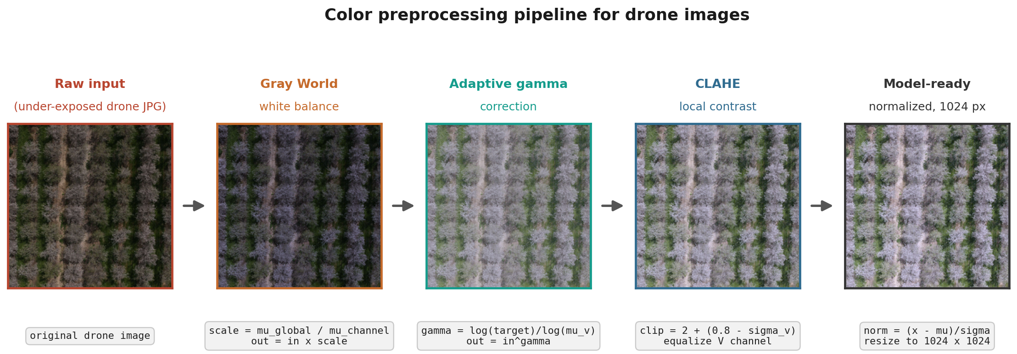
Figure 3: Colour preprocessing pipeline. From left to right: raw drone image (under-exposed), after Gray World white balance, after adaptive gamma correction, after CLAHE, and the final model-ready normalized image. Each stage addresses a specific image quality issue.

3.2 Stage 2 - Semantic Segmentation
This section is presented in the order in which the design decisions were actually made. It begins with the training data, then sets out the reasoning that pointed to a particular architecture, encoder and loss, together with the hardware limits that bounded the search space. It then reports the empirical comparisons that tested those choices, covering architecture and loss, augmentation policy and pre-processing. Only afterwards is the adopted configuration specified in full, followed by the training protocol and by one alternative instance-separation method that was explored and set aside.

3.2.1 Training Dataset and Manual Annotation
All training annotations were produced by the author using Roboflow, a web-based annotation and dataset management platform, with tree canopies delineated as single-class ("Trees") COCO-format instance-segmentation polygons. The dataset was built iteratively over eight successive versions as additional drone imagery was annotated and as augmentation policies were introduced; Table 2 summarises this progression.
The annotation protocol was as follows. A single annotator, the author, delineated every tree instance as a closed polygon following the outer edge of the visible canopy, with each crown labelled as one instance regardless of how far it overlapped its neighbours, and crowns truncated by the image border retained rather than discarded. Successive dataset versions (Table 2) reflect re-annotation of earlier images alongside the addition of new ones. Using one annotator gives internal consistency, but it also means that annotation uncertainty is not quantified: no subset was annotated twice, and no inter-annotator or intra-annotator agreement statistic was computed. The segmentation accuracies of Chapter 6 should therefore be read as agreement with one interpretation of where a crown ends, which is itself ambiguous at full bloom where adjacent canopies merge.
The independence of the training, validation and test splits was verified directly, since manual annotation was the limiting effort and augmented duplicates were therefore generated from the annotated frames rather than from new ones. Version 8 contains 169 distinct source frames: 116 in training, expanded to 349 images by threefold offline augmentation with auto-orientation and a hue jitter of plus or minus 25 degrees, together with 35 validation and 18 test frames, neither of which is augmented. Checking the source identifier of every image confirms that no frame contributes to more than one split, so every augmented copy of an annotated image stays with its original and no augmented duplicate of a training image appears in validation or test. One qualification remains. The split is random at the level of the frame rather than grouped by flight, date or orchard block, and because mapping flights are flown with substantial forward and lateral overlap, frames assigned to different splits can view the same ground and therefore the same physical trees from different positions. The reported segmentation accuracy should accordingly be read as an upper estimate of performance on a genuinely new flight, and grouped splitting by flight or block is the stronger design for any future evaluation.
Table 2. Dataset version history: images, instances, preprocessing and augmentation at each iteration.
Version | Train images | Train instances | Pre-processing | Augmentation
v3 | 48 | 6,929 | None | None
v4 | 50 | 7,260 | Auto-contrast (adaptive eq.) | None
v5 | 112 | 14,754 | Auto-contrast (adaptive eq.) | None
v6 | 347 | 46,100 | - | 3x per source image
v7 | 350 | 46,525 | - | 3x per source image
v8 (production) | 349 | 46,672 | Auto-orientation (EXIF strip) | 3x per source image
Manual annotation effort grew roughly seven-fold in distinct source images (from 48 at version 3 to 112 by version 5, the last version exported without augmentation, and 116 in the production version 8) and the resulting instance count grew from 6,929 to 46,672 polygon instances. An alternative pre-processing strategy (Version 6, applying automatic contrast adjustment via adaptive equalization) was evaluated but not adopted. Version 8 (349 training / 35 validation / 18 test images; 402 total; auto-orientation correction; 3x augmentation with a hue jitter of ±25°) was confirmed as the dataset used to train the final production model.

3.2.2 Architecture Selection Rationale: Why UNet++ with an EfficientNet-B3 Encoder
The configuration adopted in this study, UNet++ with an EfficientNet-B3 encoder and Focal Tversky loss, was reasoned about before it was tested, and the search that confirms it is reported in Section 3.2.4. Each component addresses a specific limitation relevant to this task. A standard U-Net connects each encoder level directly to its corresponding decoder level, leaving a semantic gap because the encoder features at that depth have not yet been refined by any decoder processing. UNet++ (Zhou et al., 2020) instead inserts a nested, densely connected grid of intermediate decoder nodes between each encoder level and the final output, fusing each skip connection through one or more convolutional blocks before it reaches the prediction head. In practice, this produces sharper, better-localized canopy boundaries - which matters disproportionately here because the downstream watershed instance-separation step (Section 3.3) depends entirely on accurate boundary geometry between adjacent, frequently touching tree crowns. UNet++ can also attach a deep-supervision output head at every nested column rather than only the final one, giving the network additional gradient signal per training image - valuable with a dataset of a few hundred images rather than tens of thousands.
EfficientNet-B3 was selected over both smaller and larger variants in the EfficientNet family because it sits at a deliberate middle point of compound-scaled depth, width, and resolution: large enough (≈ 12 million parameters) to capture the texture and colour cues separating canopy from soil and cover crop, yet small enough to train for many epochs at 1024px on a single consumer GPU. The architecture search provides direct empirical evidence for this trade-off: EfficientNet-B7 (≈ 66 million parameters) combined with 1536px input required reducing the batch size to 1 to fit in memory, and in two separate attempts failed to progress past the first epoch - not because B7 is architecturally inferior, but because the resulting batch-size-1, high-variance-gradient regime was not viable on the available hardware (Section 3.2.3).
The third component, Focal Tversky loss (α=0.3, β=0.7, γ=0.75), generalizes the Dice coefficient with separate weights on false positives (α) and false negatives (β); weighting β above α penalizes missed canopy pixels more heavily than over-predicted ones, which matters when canopy occupies a minority of pixels in sparsely planted or young rows. The focal exponent γ, set below one here, compresses the loss range so that crowns the model already segments well continue to generate a substantial gradient, which sustains pressure on boundary refinement rather than concentrating the gradient on the worst-segmented objects as an exponent above one would - typically canopy edges, the exact region that determines both segmentation accuracy and downstream instance-splitting quality. Introducing UNet++ together with this loss function produced the single largest jump in the entire fine-tuning search (Dice 0.751 → 0.789, a +0.038 improvement in one step), and the final tuned run using this same configuration reached a peak validation Dice of 0.8935 - directly the figure reported as this thesis’s headline segmentation accuracy. Architecture and loss selection, not additional capacity or input resolution, was the binding constraint on performance for a dataset of this size. The training and validation curves for this configuration are reported with the results in Section 6.1; Figure 4 compares predictions with the ground truth on held-out images, and Figure 5 gives the pixel-level confusion matrix.
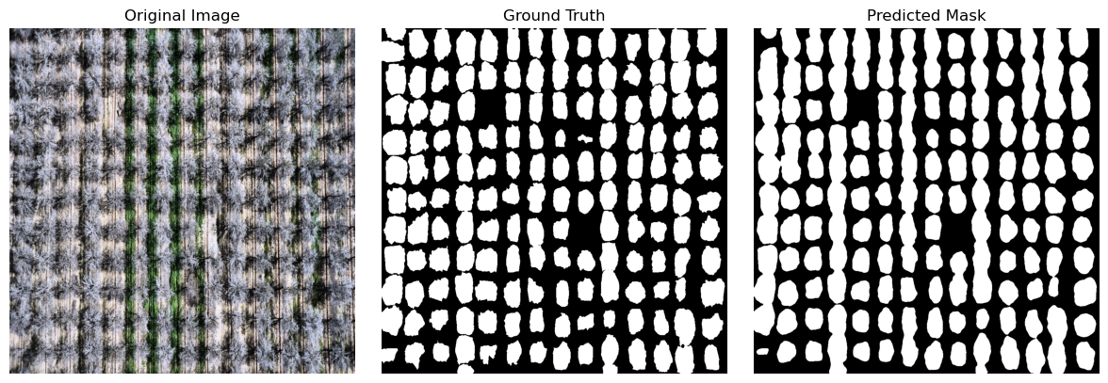
Figure 4: Original image, ground-truth mask, and model-predicted mask for a representative held-out validation tile.
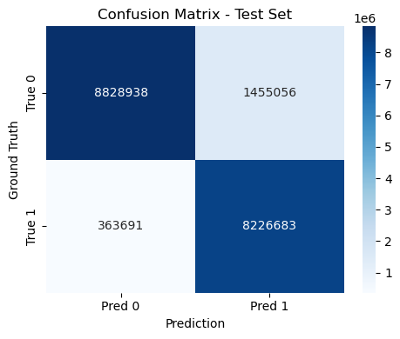
Figure 5: Pixel-level confusion matrix on the held-out test set (canopy vs. background).

3.2.3 Computational Resource Constraints
All twenty fine-tuning experiments reported in this thesis were trained on the author’s personal computer; no institutional compute cluster or cloud GPU service was used at any stage of model development. This is visible directly in the training code, where every notebook selects its compute device with the line device = torch.device("mps" if torch.backends.mps.is_available() else "cuda" if torch.cuda.is_available() else "cpu"), where "mps" refers to Apple’s Metal Performance Shaders GPU-acceleration backend - confirming that training ran on Apple Silicon rather than a dedicated NVIDIA or cloud accelerator.
This hardware constraint directly explains several results of the architecture search reported in Section 3.2.4. The 2048px and 1536px-with-EfficientNet-B7 configurations were memory-bound to a batch size of 1, producing noisy gradient estimates that contributed to the training instability observed in those runs - a hardware ceiling rather than an architectural failure. The configuration that ultimately won (1024px, EfficientNet-B3, batch size 4) was the largest that the available hardware could reliably sustain across many epochs. The cost of this constraint is visible in wall-clock time: the final production run’s own training logs show individual epochs taking between roughly 2.5 and 4.5 hours (for example, the first epoch’s training loop alone ran for 2 hours 36 minutes over 88 batches), implying the full 20-epoch run required on the order of two to three days of continuous wall-clock time on a single personal machine, without a managed compute budget or parallel job scheduling.
This constraint also yields a methodological observation worth stating explicitly: the best-performing configuration across the entire twenty-run search was not the most computationally expensive one. The larger EfficientNet-B7 / higher-resolution configurations underperformed or failed to converge, while a moderately sized configuration (EfficientNet-B3 at 1024px) combined with a better-suited architecture (UNet++) and loss function (Focal Tversky) achieved the best result. For a dataset of this size, careful methodological choices effectively substituted for additional compute scale.

3.2.4 Empirical Architecture and Loss Function Search
The UNet++/EfficientNet-B3/Focal-Tversky configuration adopted here, and specified in full in Sections 3.2.7 to 3.2.9, was not chosen a priori; it is the outcome of an empirical search across thirteen training runs spanning four architectures (Unet, attention-augmented Unet, UNet++), three encoder backbones (ResNet-34 (He et al., 2015), EfficientNet-B3, EfficientNet-B7), three image resolutions (1024, 1536, 2048 px), and two loss functions (a combined Dice-based loss, and Focal Tversky loss). Table 3 summarises the progression of validation Dice/IoU across this search.
Table 3. Empirical architecture and loss-function search: validation Dice and IoU for each configuration.
Configuration | Resolution | Encoder | Loss | Val. Dice | Val. IoU
Baseline | 1024px | ResNet-34 | Combined (Dice-based) | 0.545 | 0.410
High-res attempt | 2048px | EfficientNet-B3 | Combined | 0.618 | 0.481
Batch-4 stabilization | 1024px | EfficientNet-B3 | Combined | 0.698-0.716 | 0.568-0.602
High-capacity attempt | 1536px | EfficientNet-B7 | Custom (TreeSeg.) | 0.509 (unstable) | 0.374
Preprocessing refinement | 1024px | EfficientNet-B3 | Combined | 0.751 | 0.646
Final (UNet++/Focal Tversky) | 1024px | EfficientNet-B3 | Focal Tversky (α=0.3, β=0.7, γ=0.75) | 0.789 | 0.676
Final production run (v8 dataset) | 1024px | EfficientNet-B3 | Focal Tversky (α=0.3, β=0.7, γ=0.75) | 0.8935 | 0.8089
Two findings from this search directly motivated the final design choice. First, increasing image resolution beyond 1024px (1536px with EfficientNet-B7, 2048px with EfficientNet-B3) did not improve performance and, in several runs, failed to converge at all within the available epoch budget - the larger encoder and resolution combination outstrips what the batch size (constrained to 1 by GPU memory at that resolution) could support, leading to noisy gradient estimates. Second, replacing the standard Dice-based combined loss with Focal Tversky loss (Section 3.2.8) together with the UNet++ architecture produced the largest single improvement in the entire search (+0.038 Dice over the next-best configuration), confirming that the class-imbalance- and hard-example-aware loss formulation, rather than further architectural scaling, was the binding constraint on performance.
One caveat applies to the whole search and should be stated before the results are read as a controlled comparison. The configurations differ simultaneously in architecture, encoder, input resolution, loss function, preprocessing and, in several cases, dataset version, because the search was conducted iteratively as the dataset itself was being built rather than as a factorial experiment. An improvement between two rows therefore cannot be attributed to any single component. The search should be read as a record of how the final configuration was arrived at in practice, and the two findings above as the strongest regularities visible across it, not as isolated effects. A controlled comparison, holding the split, dataset version, augmentation and resolution fixed while varying one component at a time, would be needed to attribute the gains and is the appropriate design for any follow-up study.
A subsequent validation pass on independently captured flight imagery (rather than the held-out split of the training dataset) reproduced this performance (Dice 0.784, IoU 0.671), indicating the trained model generalizes to new flights rather than memorizing dataset-specific artifacts. A final 20-epoch run using this same architecture, loss, and resolution on the production (Version 8) dataset reached a peak validation Dice of 0.8935 (IoU 0.8089) at epoch 17 - this run is the actual final production checkpoint. Its peak validation Dice of 0.8935 is close to the 0.894 reported for the held-out leaf-on test images in Section 6.2, but the two are independent measurements on different image sets, and their agreement is evidence that the model does not overfit the validation split rather than a restatement of one figure.

3.2.5 Data Augmentation Policy: Empirical Comparison
To select the data augmentation policy used during training (Section 3.2.9), twelve single-augmentation strategies were each trained independently for 20 epochs under otherwise identical conditions (Unet/EfficientNet-B3, 1024px, combined loss) and compared based on the best validation Dice/IoU achieved. Results are summarized in Table 4.
Table 4. Data-augmentation policies compared by best validation Dice and IoU.
Augmentation strategy | Best Val. Dice | Best Val. IoU
Brightness/contrast jitter | 0.711 | 0.586
Random 90-degree rotation | 0.702 | 0.566
Gaussian blur + flip | 0.695 | 0.562
Contrast stretching | 0.688 | 0.545
No augmentation (resize only) | 0.685 | 0.568
HSV + edge overlay | 0.676 | 0.537
CLAHE + brightness | 0.669 | 0.547
Comprehensive heavy augmentation | 0.668 | 0.545
Shift/scale/rotate | 0.665 | 0.550
Histogram equalization | 0.652 | 0.505
Harris-corner overlay | 0.648 | 0.492
Canny-edge overlay | 0.385 | 0.274
Simple photometric augmentation (brightness/contrast jitter) outperformed all geometric and feature-engineered alternatives, including the no-augmentation baseline, and is therefore included in the final policy (Section 3.2.9). Augmentations that overlay structural edge features directly onto the RGB channels (Canny-edge, Harris-corner, histogram equalization) underperformed, with Canny-edge overlay catastrophically so (Dice 0.385) - overlaying bright edge pixels onto the canopy directly conflicts with the colour cues the model otherwise relies on to distinguish tree canopy from background. Figure 6 shows a representative annotated training tile.

3.2.6 Pre-Processing Rationale and Visual Validation
Beyond selecting which augmentation strategy performed best empirically (Section 3.2.5), each pre-processing step in the pipeline was chosen for a specific reason. Auto-orientation correction (applied in the production dataset, Version 8) strips inconsistent EXIF orientation metadata that varies across camera bodies and flight software used over the 2021-2024 surveys; without it, an image could load rotated or mirrored relative to its annotation mask, silently corrupting the pixel-to-label correspondence used during training. All images are resized to a fixed 1024x1024 input resolution - empirically the most stable choice in the architecture search (Section 3.2.4) - and normalized using ImageNet channel statistics, which preserves the benefit of transfer learning from the pre-trained EfficientNet-B3 encoder rather than forcing it to re-adapt to an arbitrary input distribution.
The 3x augmentation multiplier and the ±25° hue jitter applied during dataset export are both directly motivated by dataset size: at the point augmentation was introduced, only 112 source images had been manually annotated (Table 2, version 5). Hue jitter specifically targets illumination and bloom-stage colour drift - almond canopy colour shifts across the flowering period and across sensor white-balance differences between flights - so the network is encouraged to segment canopy independent of exact hue rather than memorizing a fixed colour signature. This choice is corroborated by the augmentation comparison sub-study (Section 3.2.5): simple photometric augmentation outperformed every geometric and feature-overlay alternative tested, including the no-augmentation baseline.
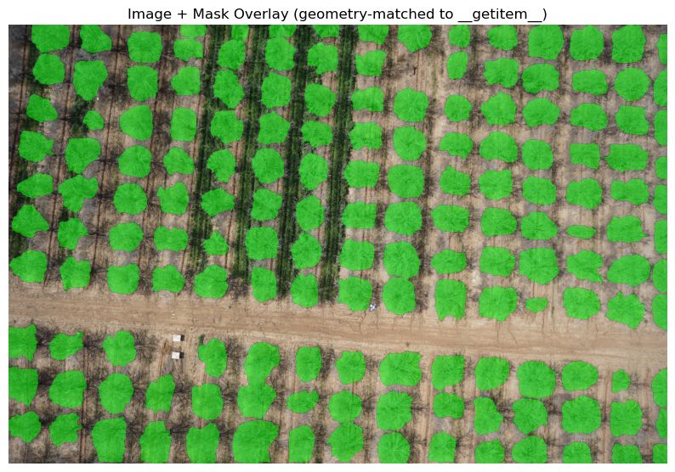
Figure 6: Representative training tile - drone image with ground-truth canopy annotations overlaid (green), showing individual hand-annotated tree polygons across orchard rows.

3.2.7 UNet++ Architecture with EfficientNet-B3 Encoder
The segmentation model is built on the UNet++ framework with an EfficientNet-B3 backbone pre-trained on ImageNet. UNet++ improves upon standard U-Net by introducing nested skip connections that create dense connections between encoder stages and multiple decoder paths, enabling more flexible feature aggregation across scales. Figure 7 shows the resulting architecture.
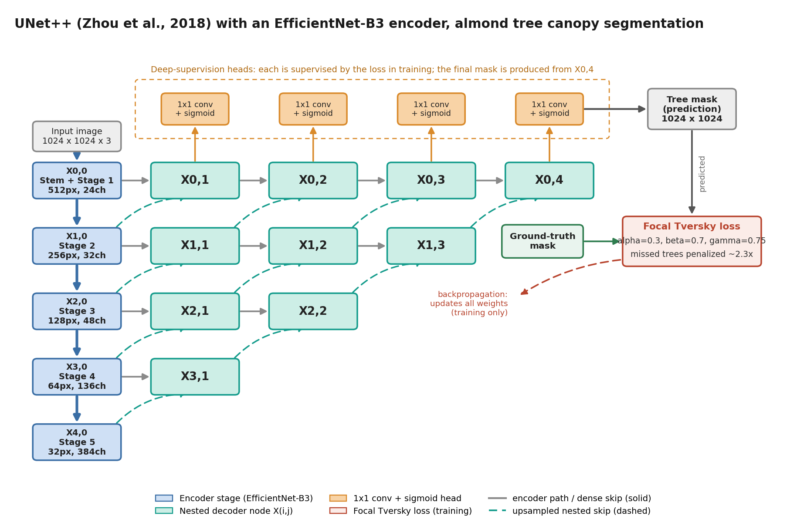
Figure 7: UNet++ (Zhou et al., 2020) architecture with an EfficientNet-B3 encoder for almond tree canopy segmentation. The input image is encoded through five downsampling stages X(i,0); each encoder stage feeds a row of nested decoder nodes X(i,j), with solid arrows showing the encoder path and same-row dense skips and dashed arrows the nested upsampled skip pathway from one resolution level down. The orange 1x1-convolution-plus-sigmoid deep-supervision heads produce per-node masks; during training, each is compared with the ground-truth mask by the Focal Tversky loss (alpha=0.3, beta=0.7, gamma=0.75), which penalizes missed trees about 2.3 times more than false positives, and the resulting gradients update all encoder and decoder weights. At inference, the final tree mask is taken from X0,4.
The EfficientNet-B3 encoder comprises 5 feature extraction stages with channel depths of [32, 48, 136, 384] and spatial downsampling factors of [2, 4, 8, 16]. The decoder at each level receives features from both the corresponding encoder stage (via skip connections) and preceding decoder nodes (via nested connections), producing outputs at multiple scales. The final single-channel logit map is sigmoid-activated and thresholded at 0.5 to produce the binary tree mask.

3.2.8 Focal Tversky Loss Function
The Focal Tversky Loss combines three mechanisms to address the class imbalance problem in orchard segmentation:
(1) Tversky Index: Generalizes the Dice coefficient with asymmetric false positive/false negative weights. With alpha=0.3 (FP weight) and beta=0.7 (FN weight), missed trees are penalized 2.33x more than false detections, biasing the model toward high recall.
Tversky = TP / (TP + alpha*FP + beta*FN + epsilon)
(2) Asymmetric Weighting: The choice alpha=0.3, beta=0.7 reflects the agronomic priority: a missed tree (FN) represents lost yield data and missed management opportunity, while a false detection (FP) merely adds a small overhead in post-processing verification.
(3) Focal Component: the loss is raised to a power of gamma=0.75. Because this exponent is below one, it compresses the range of the loss: a crown the model already segments well still returns a loss, and therefore a gradient, that is a substantial fraction of the loss returned by a poorly segmented one. Optimization pressure is thereby kept on boundary refinement across all crowns rather than concentrated on the worst-segmented objects, which is the behaviour an exponent above one would produce.
L_FocalTversky = (1 - Tversky)^gamma [gamma=0.75]

3.2.9 Training Protocol
Training employs the AdamW optimizer (lr=0.0004) with ReduceLROnPlateau scheduling (factor=0.5, patience=2 epochs on validation loss). Early stopping with patience=5 prevents overfitting. Data augmentation during training includes: horizontal/vertical flips (50%), 90-degree rotations (30%), transpose (30%), random gamma (40%), brightness-contrast shifts (40%), hue-saturation-value shifts (40%), and RGB channel shifts (30%). Table 5 lists the hyperparameters and their rationale.
These values were not tuned jointly. The three that govern the loss, alpha, beta and gamma, were set from the asymmetry argument given in Section 2.3 and then held fixed, and the input resolution, encoder and loss family were chosen by the empirical comparison reported in Section 3.2.4 rather than assumed. The remainder are conventional defaults for this optimiser and schedule, adopted unchanged: the learning rate, the plateau scheduler's factor and patience, and the early-stopping patience. Batch size was set by the memory available on the training hardware (Section 3.2.3) rather than by search. No exhaustive hyperparameter optimization was performed, which is a limitation of the training protocol rather than a claim of optimality.
Table 5. Training hyperparameters and the rationale for each setting.
Parameter | Value | Rationale
Learning Rate | 0.0004 | Conservative start; scheduler reduces on plateau
Batch Size | 4 | Balances GPU memory and gradient noise
Image Size | 1024 x 1024 px | Preserves fine tree boundary detail
Focal Tversky alpha | 0.3 | Lower FP penalty (accept some false alarms)
Focal Tversky beta | 0.7 | Higher FN penalty (minimize missed trees)
Focal Tversky gamma | 0.75 | Below one: compresses the loss range and sustains gradient on crowns already close to correct
Max Epochs | 20 | With early stopping patience=5

3.2.10 Post-Processing Exploration: An Alternative Instance-Separation Method Considered
The instance-separation method actually used in the production pipeline is the watershed-based approach documented in Section 3.3: the Euclidean distance transform of the binary semantic mask is treated as a topographic surface, local peaks are detected as tree-centre markers via peak_local_max with a tuned minimum-separation parameter, and watershed flooding from these markers assigns each touching tree crown a unique instance label, followed by area and solidity filtering. This is confirmed directly in the project’s own technical documentation, which states explicitly that watershed was adopted “due to its robustness, interpretability, and efficient implementation.”
Before settling on this approach, a different geometric instance-splitting method was explored directly inside the fine-tuning notebooks, internally referred to in the code as a “radial-jumps row/col splitter.” Rather than using a distance transform and peak detection, this method specifically targets elongated, merged blob shapes that form when several touching tree crowns fuse into one long connected component along a planting row - a pattern expected in almond orchards because trees are planted in straight, regularly spaced rows, so over-merging tends to occur along the row direction. The method cuts these elongated shapes using directional line-kernels constructed at multiple angles, applied as a thinning operation, and refined across successive passes - an initial pass, a stronger second pass, and a final corrective micro-pass - to progressively separate blobs the previous pass did not fully resolve.
Watershed segmentation was ultimately adopted for the production pipeline rather than the radial-jumps splitter because it is more general - it does not assume that merged crowns are aligned with the planting row, which matters since canopy overlap can also occur across rows under dense planting or peak bloom conditions - and because it depends on a single, well-understood tuning parameter (minimum separation between detected peaks) rather than several hand-tuned geometric parameters governing line angle, length, thickness, and pass count. Watershed is also a standard, well-validated technique in the instance-segmentation literature, making it easier to justify and parameterize within a documented, reproducible pipeline. The radial-jumps method remains a useful record of an earlier, more bespoke exploration developed in parallel with the final training run. Figure 8 illustrates that exploration.
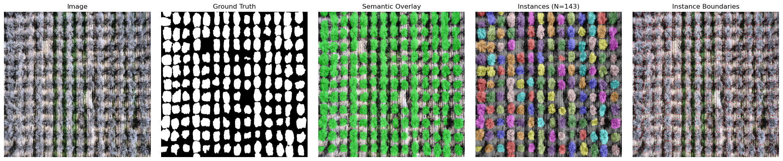
Figure 8: Instance-separation demonstration, left to right - original image, ground truth, semantic overlay, individually colourized tree instances (N=143 in this tile), and instance boundaries.

3.3 Stage 3 - Instance Segmentation via Watershed
The watershed-based instance segmentation converts the binary semantic mask (which typically contains merged adjacent tree regions) into individually labelled instances. The algorithm treats the Euclidean distance transform of the binary mask as a topographic surface and simulates flooding from seed markers placed at detected peak positions. Figure 9 traces the procedure step by step.
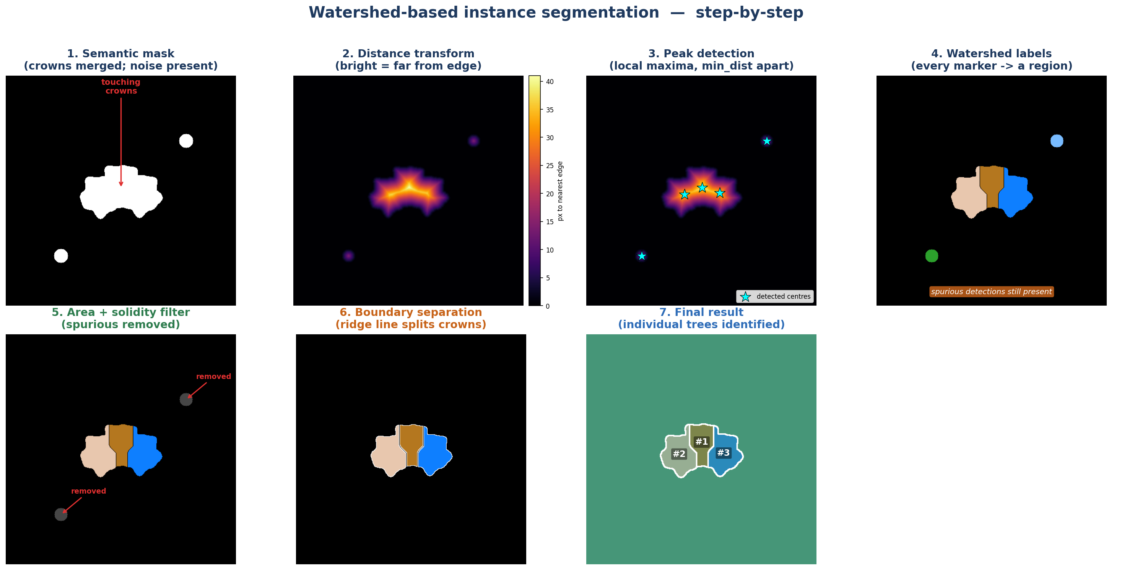
Figure 9: Watershed-based instance segmentation, step by step. The procedure is demonstrated on a synthetic test case designed to include the two situations the algorithm must handle: a cluster of three touching crowns and two small spurious blobs, so that the correct answer is known in advance. Every quantitative result in Chapter 6 comes from the real orchard mosaics. (1) Binary semantic mask in which the adjacent crowns are merged into a single component and small noise blobs are present. (2) Euclidean distance transform (brighter = farther from the nearest background edge). (3) Peak detection places one marker at each local maximum, subject to a minimum separation of min_dist pixels (min_dist = 25 px here). (4) Watershed flooding assigns every marker its own labelled region, so the two spurious blobs also become regions. (5) Area and solidity filtering removes the spurious detections. (6) The watershed ridge line inserts a one-pixel physical gap between the separated crowns. (7) Final result, with each crown assigned a unique tree identity, overlaid on the image background.
The critical parameter min_dist_between_trees controls the minimum allowed separation between detected peaks, directly determining whether adjacent crowns are identified as a single or a double instance. For blooming almond orchards at 2 cm GSD, canopy diameters of 3-6 m correspond to 150-300 pixels, making min_dist=25 pixels (0.5 m on ground) appropriate for well-spaced orchards.
The default was set by evaluating this parameter against a manual tree count: at 15 px the algorithm over-segments, returning about 1.2 times more instances than the manual count, at 40 px its under-segments and misses roughly 10 percent of trees, and at the adopted 25 px the detected count matches the manual count to within 5 percent. Because the optimum scales with crown size in pixels, it should be rescaled for surveys flown at a different ground sampling distance. The probability threshold above which a pixel is accepted as canopy was left at the operational default of 0.5, the value used to threshold the exported tree mask.
Dynamic area filtering uses both an absolute minimum (200 pixels) and a relative minimum (20% of the median instance area in the image) to adapt to varying tree sizes. A solidity threshold of 0.70 (convex hull area ratio) rejects non-compact shapes that represent noise or shadow artifacts rather than true tree crowns. Table 6 lists these parameters with their ranges and defaults.
Table 6. Instance-segmentation parameters, their ranges, defaults, and effect.
Parameter | Range | Default | Effect of Increasing
min_area | 100-500 px | 200 px | Rejects smaller detections; may miss young/small trees
min_dist_between_trees | 15-40 px | 25 px | Merges adjacent trees; reduces over-segmentation
relative_area_factor | 0.10-0.30 | 0.20 | Stricter relative size filter; rejects small outliers
solidity_threshold | 0.60-0.80 | 0.70 | Stricter shape filter; rejects irregular noise
separation_width | 0-3 px | 2 px | Wider gap between instances; visual clarity

3.4 Stage 4 - Geospatial Processing and GeoTIFF Export
The final prediction pipeline stage converts pixel-level instance labels into a georeferenced raster compatible with standard GIS workflows. This requires three sub-operations: GPS extraction from EXIF metadata, coordinate system transformation from geographic to projected coordinates, and construction of an affine transformation for the GeoTIFF spatial reference. Figure 10 summarises the transformation chain.
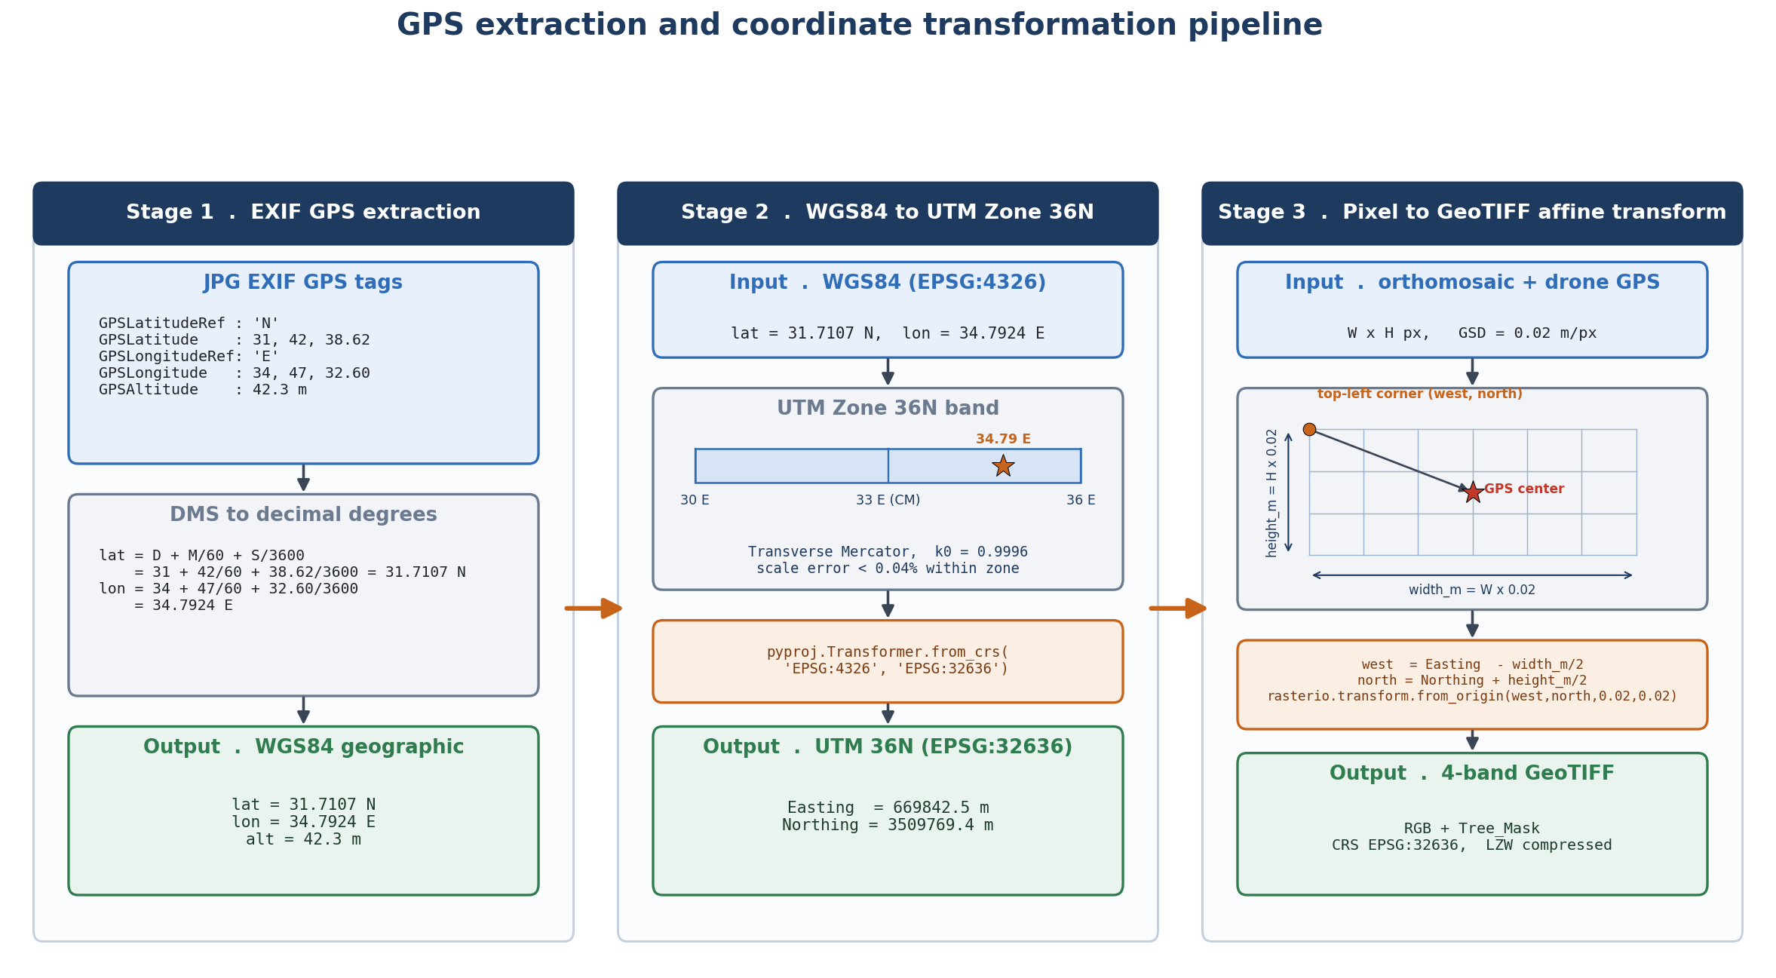
Figure 10: GPS extraction and coordinate transformation pipeline, illustrated with the plot own coordinates. Stage 1: EXIF GPS tags are parsed and converted from degrees-minutes-seconds to decimal degrees (31.7107 N, 34.7924 E). Stage 2: the WGS84 position (EPSG:4326) is projected with pyproj to UTM Zone 36N (EPSG:32636), whose central meridian is 33 E and scale factor k0 = 0.9996, giving Easting = 669842.5 m and Northing = 3509769.4 m. Stage 3: the drone centre-point position is offset by half the registered mosaic width and height (at 0.02 m per pixel) to obtain the top-left corner, which defines the GeoTIFF affine transform; the export is a 4-band GeoTIFF (RGB plus tree mask) in EPSG:32636, LZW compressed.
A critical geometric correction addresses the fact that drone GPS metadata records the position of the camera (image centre) rather than the image top-left corner required by GeoTIFF convention. The offset is:
west = utm_easting - (image_width * pixel_size_m / 2)
north = utm_northing + (image_height * pixel_size_m / 2)
The resulting 4-band GeoTIFF contains bands 1-3 (RGB colour imagery) and band 4 (binary tree mask: 1=tree, 0=background/NoData). LZW lossless compression achieves 3-5x file size reduction relative to uncompressed TIFF. The coordinate reference system is explicitly embedded as EPSG:32636 (WGS 1984 UTM Zone 36N), ensuring direct import into ArcGIS, QGIS, and other GIS platforms.

3.4.1 GPS Recovery for Cameras Without Native Geotagging (2021 Survey)
The geolocation procedure described above in this section assumes that GPS coordinates are already present in each image's EXIF metadata at the time of capture. This held for the 2022-2024 surveys, but not for the March 2021 survey, which used a camera body physically separate from the drone's own positioning system and therefore recorded no GPS in its EXIF data. A dedicated GPS-recovery procedure ("GeoSync") was developed for this survey only.
GeoSync time-synchronizes the camera's internal clock against the drone's flight-log clock, which independently records high-frequency GPS positions but runs on a separate, drifting clock relative to the camera. The synchronization offset is auto-calibrated using the drone's own shutter-trigger events as ground truth: for each candidate offset, the distance between the interpolated GPS position of the nearest camera-timestamped photo and the position recorded at the trigger event is measured, and the offset minimizing this distance is selected (falling back to a speed-versus-inter-photo-distance correlation heuristic when trigger events are unavailable). Once the offset is fixed, each photo's position is interpolated from the flight log at its corrected capture time, with an additional correction for camera shutter latency based on the drone's instantaneous velocity vector, and the resulting coordinates are written to the photo's EXIF GPS tags. An independent photogrammetric camera-position estimate (from Agisoft Metashape) was used to cross-validate the calibrated offset for this survey.
Positions recovered in this way are not equivalent to native geotags and are treated separately throughout. Their accuracy depends on the quality of the clock synchronization and on the interpolation between logged track points, so their uncertainty is larger than, and not directly comparable with, the 2.4 m figure reported for natively geotagged imagery. Because the 2021 survey is the reference frame onto which the fixed tree zones were built, any systematic error in these recovered positions propagates to all four seasons as a common offset rather than as year-specific noise, which is why the cross-year alignment of Section 5.5.1 was verified against flight-footprint shapes and by visual channel overlay rather than assumed from the metadata.

4. ArcGIS Post-Processing Workflow: Mosaic Assembly
Following the deep learning prediction pipeline, individual georeferenced GeoTIFF rasters (one per drone image) must be assembled into a single, continuous registered mosaic suitable for orchard-scale analysis. This five-stage ArcGIS Pro-based workflow performs image registration refinement, quality filtering, and mosaic dataset construction, ultimately delivering two complementary output products: an analytical 4-band registered mosaic for machine learning and a compressed RGB registered mosaic for visualization. Figure 11 summarises the five steps.
The product of this workflow is a registered mosaic in the sense defined in Section 2.5. Each frame carries a single centre coordinate from onboard GNSS metadata, with no record of camera attitude, and the frames vary in heading, in off-nadir angle and consequently in scale. A centre point alone fixes only where an image sits, not how it is turned or how far across the ground it reaches, so the registration must recover translation, rotation and scale for every image by matching it to the reference raster; this is why alignment is driven by image content rather than by metadata alone, and why the three-phase fallback of Section 4.2 is necessary at all. What the procedure does not do is estimate camera pose, model the terrain, or remove the perspective and relief displacement that off-nadir viewing introduces. The result is therefore not a photogrammetrically orthorectified product, and residual displacement remains largest for the most oblique frames and for tall canopy viewed away from the image centre. The orchard is close to flat, which limits relief displacement, and the accuracy that matters here is at tree-crown rather than sub-metre scale; the residual join error reported in Section 5.5 quantifies how far the approximation holds. The contribution claimed is accordingly not a new registration algorithm but a reproducible, quality-controlled operational workflow for heterogeneous orchard UAV imagery, with an explicit fallback hierarchy and a per-image audit trail.
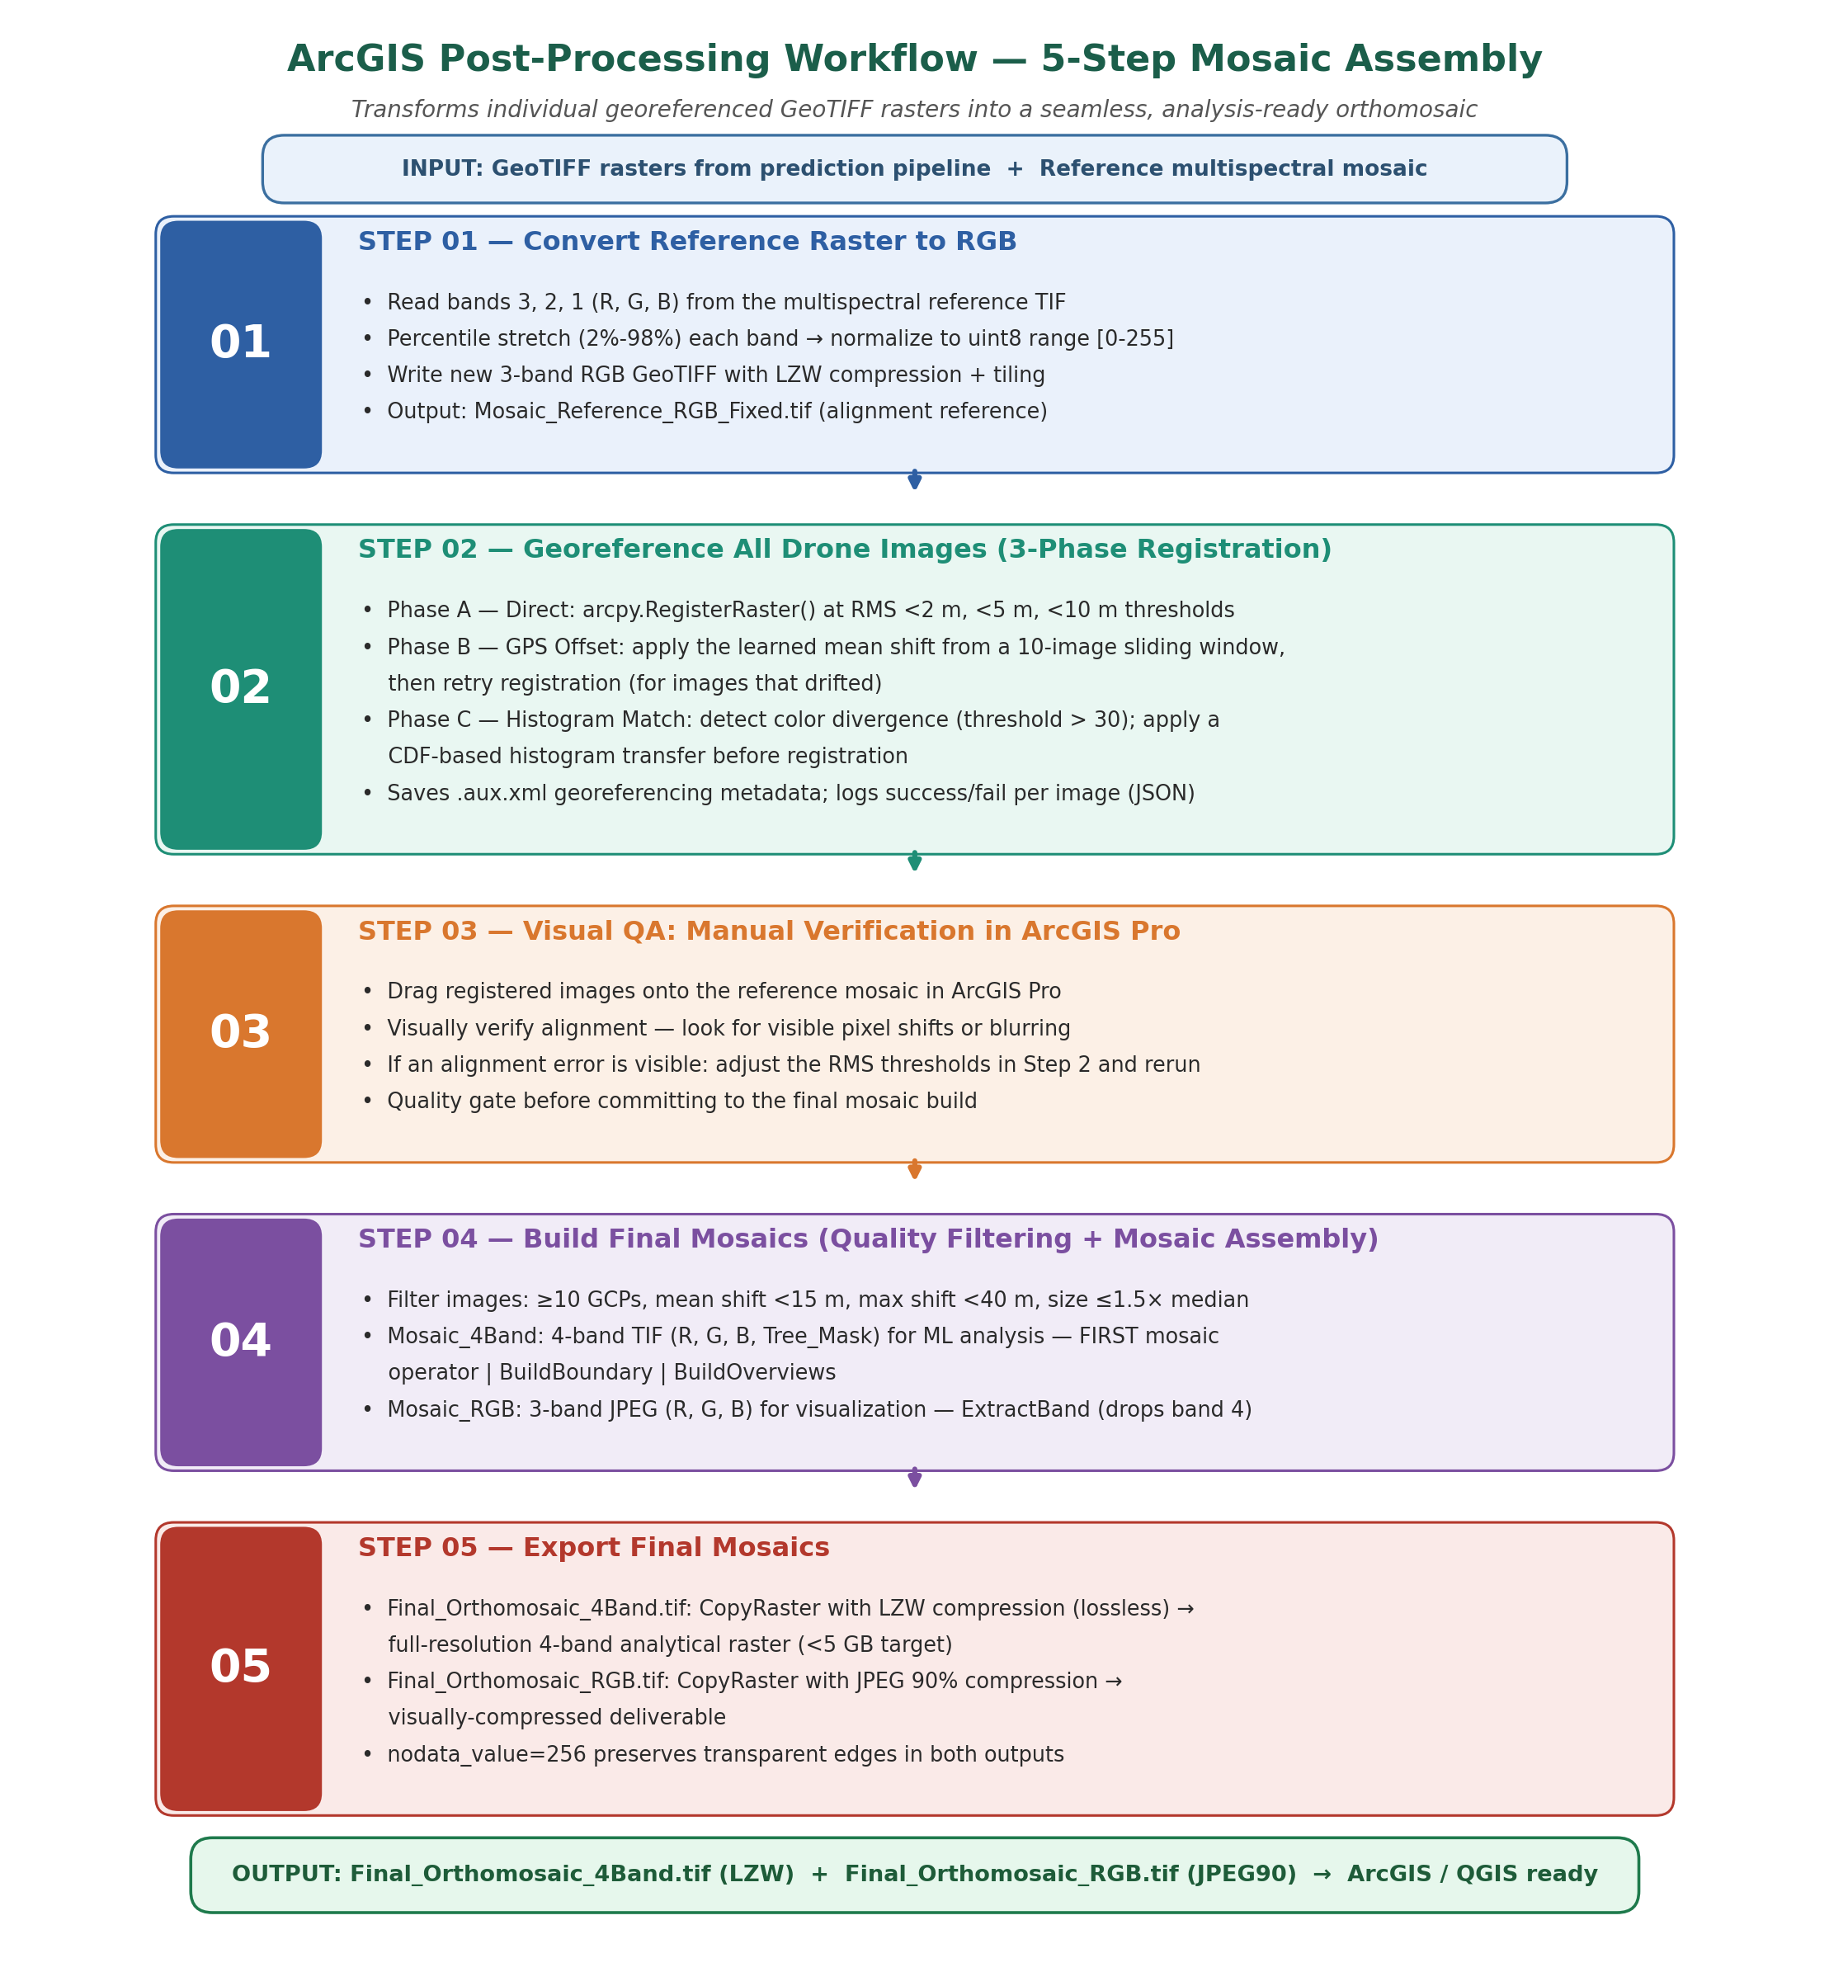
Figure 11: ArcGIS 5-step post-processing workflow. Each step transforms the individual GeoTIFF tiles produced by the prediction pipeline into a quality-assured, mosaicked registered mosaic ready for agricultural analysis.

4.1 Step 1 - Reference Raster Preparation
The georeferencing registration process requires a high-quality reference raster to which all individual images will be aligned. The reference is typically a previously created registered mosaic or photogrammetric product from the same site, known to be accurately positioned.
The reference multispectral raster is processed to extract a clean 3-band RGB representation. Band 3 (Red), Band 2 (Green), and Band 1 (Blue) are read individually and stretched to the full uint8 range [0-255] using a 2nd-98th percentile stretch that excludes extreme outliers:
lo = percentile(valid_pixels, 2%)
hi = percentile(valid_pixels, 98%)
output = clip((band - lo) / (hi - lo) * 255, 0, 255).astype(uint8)
This percentile stretch normalizes the reference raster's radiometric range, ensuring that the subsequent image registration process (which compares intensity patterns) is not dominated by rare extreme pixel values. The output is written as a 3-band GeoTIFF with LZW compression, TILED=YES layout, and BIGTIFF=YES support for large rasters.

4.2 Step 2 - Multi-Phase Image Registration
Each individual GeoTIFF raster (output from Stage 4 of the prediction pipeline) is registered to the reference raster using arcpy.management.RegisterRaster() with a POLYORDER1 (first-order polynomial/affine) transformation. Registration adjusts the image's embedded spatial reference to minimize the Root Mean Square Error (RMS) between automatically identified Ground Control Points (GCPs) in the image and corresponding locations in the reference.
A three-phase fallback strategy handles the full diversity of image conditions encountered in practice:

4.2.1 Phase A - Direct Registration
The image is registered directly against the reference raster at progressively relaxed RMS thresholds: strict (<2 m), normal (<5 m), and relaxed (<10 m). This succeeds for most images (~68%) where initial GPS positioning is sufficiently accurate for the registration algorithm to find reliable feature correspondences.
arcpy.management.RegisterRaster(temp_rgb, 'REGISTER', reference,
transformation_type='POLYORDER1', maximum_rms_value=rms)

4.2.2 Phase B - GPS Offset-Guided Registration
When direct registration fails, a GPS offset correction is applied first. The OffsetTracker maintains a sliding window of the last 10 successfully registered images, computing the mean spatial offset between original GPS positions and registered positions:
offset = (mean_dx, mean_dy) # average over last 10 successes
geo[0] += dx; geo[3] += dy # shift GeoTransform origin
This learned offset captures systematic GPS biases specific to the drone's positioning hardware or flight conditions, pre-aligning subsequent images before registration. The approach exploits spatial continuity: adjacent frames in a drone survey typically exhibit similar GPS drift patterns.

4.2.3 Phase C - Histogram-Matched Registration
When phases A and B fail (approximately 10% of images), spectral mismatch is identified as the likely cause. Images acquired under significantly different illumination than the reference may lack sufficient feature correspondences despite correct spatial positioning. A histogram matching step transfers the reference raster's cumulative distribution function (CDF) to the target image:
src_cdf = cumsum(src_counts) / sum(src_counts)
ref_cdf = cumsum(ref_counts) / sum(ref_counts)
matched_values = interp(src_cdf, ref_cdf, ref_values)
This CDF-based transfer is applied independently per channel and preserves relative tonal relationships within the image while aligning its overall spectral distribution with the reference, enabling the registration algorithm to find correspondences across illumination differences.

4.3 Step 3 - Visual Quality Assurance
After automated registration, a manual quality-assurance step in ArcGIS Pro verifies that the registered images visually align with the reference mosaic. This involves overlaying a sample of registered images (typically 10-20% of the dataset) onto the reference and inspecting for:
- Geometric misalignment - visible pixel-level offsets or shearing between image boundaries
- Radiometric inconsistencies - abrupt colour jumps at image boundaries indicating histogram matching artifacts
- Systematic regional biases - clusters of images consistently offset in the same direction, indicating GPS drift not captured by the offset tracker
If significant misalignment is observed, RMS thresholds in Step 2 are tightened (accepting only higher-quality registrations), and the entire batch is re-processed. This iterative quality loop ensures that only well-registered images proceed to mosaic construction.

4.4 Step 4 - Mosaic Dataset Construction with Quality Filtering
Before mosaic assembly, each registered image is subjected to four quantitative quality criteria derived from the registration.aux.xml metadata files (Table 7):
Table 7. Mosaic quality-control criteria and rejection thresholds.
Quality Criterion | Threshold | Rationale
Minimum GCPs | >= 10 points | Insufficient GCPs indicate registration instability
Mean GCP shift | <= 15.0 m | Excessive mean shift indicates poor registration
Maximum GCP shift | <= 40.0 m | Outlier GCPs indicate registration failure
Image size | <= 1.5x median | Anomalously large extents indicate corrupt geolocation
Images failing any criterion are excluded from the mosaic. Under typical operating conditions, 93-96% of images meet all quality criteria. The passing images are added to two ArcGIS Mosaic Datasets in batches of 200 images:
Mosaic_4Band: A 4-band (R, G, B, Tree_Mask) mosaic at 8-bit unsigned precision, using the FIRST mosaic operator (overlapping areas show the first/highest-priority image). Pyramid overviews are built for efficient display at multiple zoom levels. This mosaic serves as the primary analytical product for tree detection, yield estimation, and temporal comparison.
Mosaic_RGB: A 3-band (R, G, B) JPEG-compressed mosaic for visualization. A Raster Function Template (RFT) XML file applies an ExtractBand function to drop band 4 from the 4-band source, producing the RGB product. JPEG quality 85 provides high visual fidelity with a compact file size. Figure 12 shows how the individual tiles are assembled into the final mosaic.
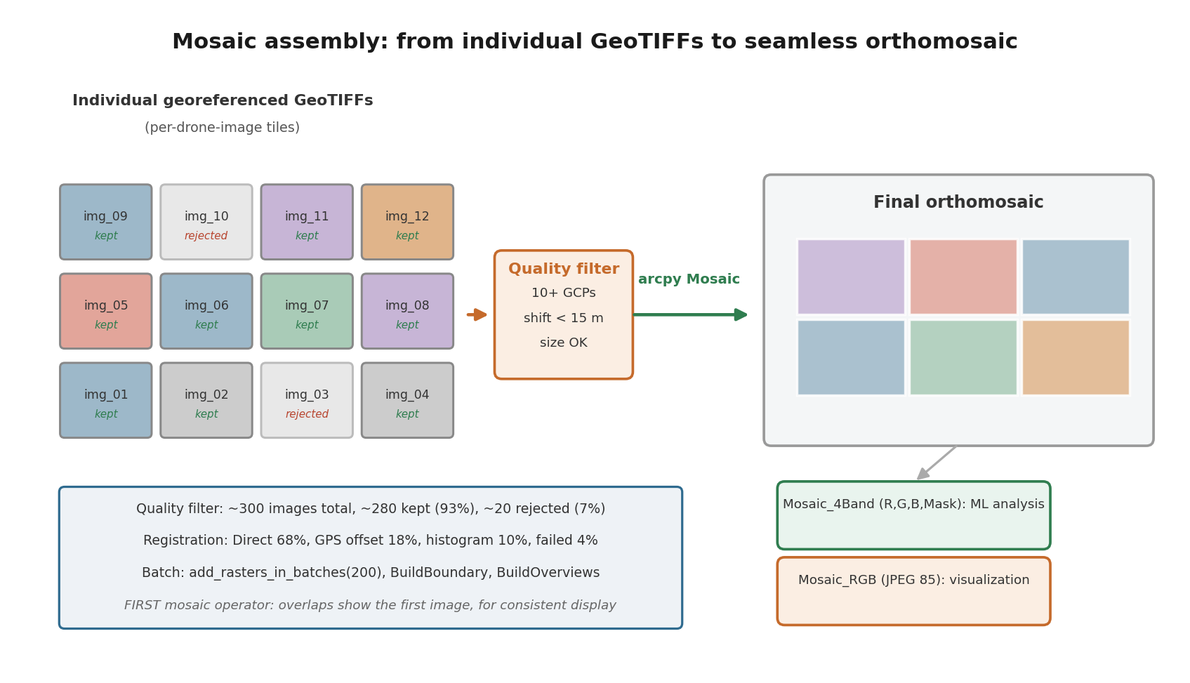
Figure 12: Mosaic assembly process. Individual quality-filtered GeoTIFF tiles (left) are assembled into a continuous registered mosaic (right). The quality filter rejects images with insufficient GCPs, excessive spatial shift, or anomalous extent. Two output products serve different downstream uses: Mosaic_4Band for machine learning analysis and Mosaic_RGB for visualization.

4.4.1 Implementation Notes: Mosaic Dataset Construction
Two implementation details of the mosaic-assembly scripts are noted here for completeness, in addition to the conceptual workflow described in Sections 4.1-4.4. First, prior to mosaic dataset construction, a spatial thinning pre-filter removes any image whose footprint centre lies within 15 m of an already-accepted image's centre, de-duplicating near-identical overlapping captures (typically from slow flight segments or turns) before they reach the mosaic dataset, reducing blend artifacts and downstream processing load. Second, mosaic seamlines are computed using a Voronoi method, placing seam boundaries at the equidistant midlines between adjacent image centres rather than along the raw image edges, with a 10-pixel blend width applied to each seam to smooth the transition between source images.

4.5 Step 5 - Final Mosaic Export
The completed mosaic datasets are exported to standalone GeoTIFF files for distribution and archiving:
Final_Orthomosaic_4Band.tif is exported with LZW lossless compression (arcpy.env.compression = 'LZW'), preserving all pixel values exactly. Target file size below 5 GB per survey area. NoData value 256 (outside uint8 range) preserves transparent edge regions at survey boundaries. This file is the primary input for any subsequent machine learning analysis, tree counting, canopy area measurement, or temporal change detection.
Final_Orthomosaic_RGB.tif is exported with JPEG compression at 90% quality, delivering high visual quality while substantially reducing file size (~5-10x smaller than LZW). This file is used for visual inspection, sharing with agronomists, overlay with field records, and integration into web mapping platforms.
arcpy.management.CopyRaster(mosaic_4band_path, out_path,
format='TIFF', pixel_type='8_BIT_UNSIGNED', nodata_value='256')

5. Implementation

5.1 Software Architecture
The prediction pipeline is implemented as a modular Python application in which preprocessing and data loading, the network and its loss, the training loop, inference with geospatial export, watershed post-processing, and the command-line entry point are separated into independent modules, each testable on its own. The module-level documentation is maintained with the source code rather than reproduced here.
The ArcGIS post-processing workflow is implemented as a series of standalone Python scripts executed in ArcGIS Pro (arcpy) using GDAL for raster I/O operations that do not require ArcGIS licensing. Table 8 lists the key dependencies.
All code, the trained model weights and the analysis scripts are openly available at https://github.com/Snir5/almond-uav-phenology-yield. The repository contains the four-stage prediction pipeline, the ArcGIS post-processing scripts, the statistical analysis programs that generate every reported result, and a self-contained inference package holding the trained weights, a single prediction script, and pinned dependency versions, so that detection can be reproduced on new imagery without the rest of the repository. Library versions are pinned because the checkpoint depends on a specific segmentation-library layout. The raw and mosaicked imagery, the growers' harvest and phenology records and the climate station files are not redistributed, as they belong to the orchard operator and the collaborating laboratory.

5.2 Key Dependencies
Table 8. Key software dependencies and their role in the pipeline.
Library | Version | Purpose
PyTorch | >= 2.0 | Deep learning framework for model training and inference
segmentation-models-pytorch | >= 0.3.3, < 0.4 | UNet++ and EfficientNet-B3 architecture
albumentations | >= 1.3, < 2.0 | Image augmentation with GPU acceleration
OpenCV (cv2) | >= 4.7 | Image I/O, colour space conversion, morphological operations
scikit-image | >= 0.20 | Watershed, find_boundaries, region properties
scipy | >= 1.10 | Euclidean distance transform
rasterio | >= 1.3 | GeoTIFF read/write with coordinate reference systems
pyproj | >= 3.5 | WGS84 to UTM coordinate transformation
piexif | >= 1.1 | EXIF metadata reading (GPS extraction)
arcpy | ArcGIS Pro | Raster registration, mosaic dataset management
GDAL/osgeo | >= 3.0 | Low-level raster operations for ArcGIS workflow

5.3 Computational Requirements and Performance
Training configuration: batch size 4 at 1024 x 1024 resolution on the 349-image training split, run on the author's Apple Silicon machine through the Metal Performance Shaders backend, no discrete NVIDIA or cloud accelerator being available (Section 3.2.3). Individual epochs took between roughly 2.5 and 4.5 hours, so the full 20-epoch run required on the order of two to three days of continuous wall-clock time. Inference performance on the same machine is reported in Table 9.
Table 9. Measured inference time and memory for the machine used throughout this work, an Apple Silicon laptop running the model through the Metal Performance Shaders backend.
Device | Time per Image | 1000 Images | Memory
Apple M2 (MPS) | 0.95 s | 15.8 min | 4.1 GB
The ArcGIS post-processing workflow processes approximately 300 images in 20-40 minutes on a standard workstation, including pyramid building and mosaic dataset construction. Batch processing of registration (200 images per batch) limits peak memory usage during mosaic assembly.
The throughput figures above are reported for a defined configuration and should not be read as hardware-independent. Inference was timed on the same Apple Silicon machine used for training, on 4000-pixel-wide JPG frames resized to 1024 by 1024, processed one image at a time; the quoted time includes preprocessing, the forward pass, watershed separation and GeoTIFF writing, and excludes the ArcGIS registration and mosaic assembly, which are reported separately and run on CPU. Storage was local SSD. No discrete NVIDIA or server-class accelerator was available at any point in this work, so throughput on such hardware was not measured; it would be substantially higher than the figures given here. The pipeline is also defined for the cases that occur in operational surveys: an unreadable or corrupt image is skipped with a logged error and processing continues; an image without GPS EXIF is still segmented and its overlay and mask written, but no georeferenced raster is produced; an image in which the model returns no canopy yields an empty instance label image rather than a failure; and registration failures are recorded per image in the log described in Appendix B, with the image excluded from the mosaic.

5.4 System Usage
Training command:
python main.py --mode train \
--train-img-dir /data/train/images \
--train-ann-path /data/train/annotations.json \
--val-img-dir /data/val/images \
--val-ann-path /data/val/annotations.json \
--model-path trained_model.pth --device mps

Prediction command (production orchard survey):
python main.py --mode predict \
--model-path trained_model.pth \
--predict-dir /data/survey_20260515/images \
--output-dir /data/survey_20260515/results \
--thresh 0.5 --min-dist-between-trees 25

Blooming season adjustment (increased canopy overlap):
python main.py --mode predict ... --thresh 0.4 --min-area 150 --min-dist-between-trees 35

5.5 Phenological and Spectral Analysis Methodology
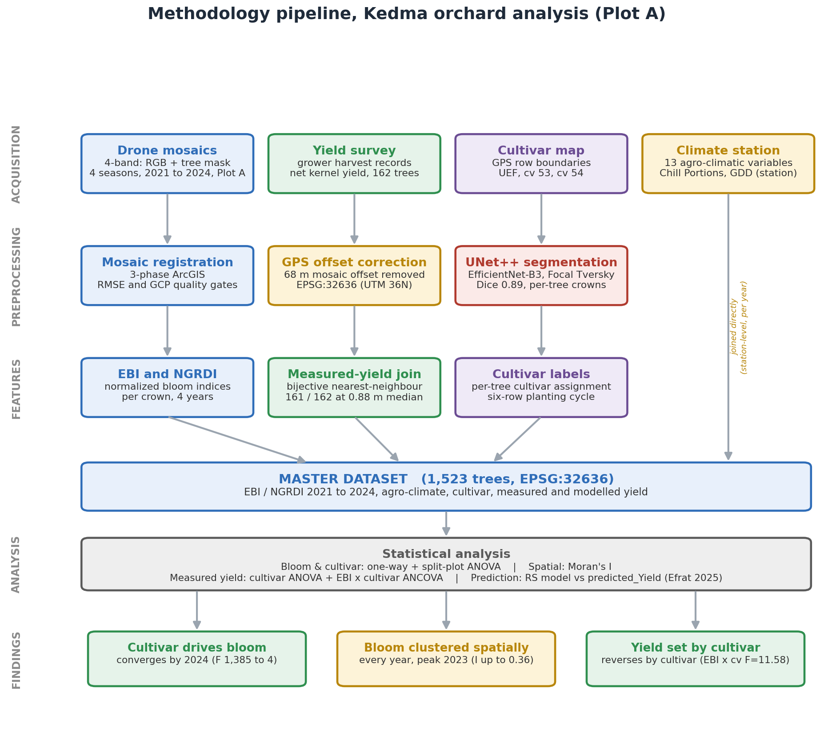
Figure 13: Full methodology pipeline from raw drone imagery to statistical analysis. Rows on the left give the processing stage, and colour identifies the data stream each box belongs to: blue for the UAV imagery and the bloom indices derived from it, green for the field-measured harvest, purple for cultivar identity, amber for the climate record and for the coordinate correction applied to the mosaics, red for the segmentation model, and grey for the statistical layer and the pooled master dataset. GPS offset correction is applied during preprocessing and propagated through all downstream analyses.
Sections 5.1-5.4 described the software implementation of the detection pipeline itself. This section documents a second, downstream methodology: how the pipeline's per-tree detections were converted into a four-year, per-tree phenological and spectral dataset, and how that dataset was analysed. This methodology underlies every result reported in Section 6.4. Figure 13 summarises the full methodology, from raw drone imagery to statistical analysis.
The per-tree record rests on four bloom-season acquisitions, one per year, and these differ in sensor and in the detail recorded about them. Table 10 lists them. A different camera was flown in each season, identified from the image metadata: a Sony ILCE-6000 in 2021, a Canon EOS 6D in 2022, a DJI Zenmuse L1 in 2023 and a DJI Zenmuse H20T in 2024. The first two are handheld camera bodies, which is why the 2021 survey carries no GPS and required the recovery procedure of Section 3.4.1. This change of instrument between seasons is a design constraint rather than a choice, and its consequences for the multiseason comparison are examined directly in Section 6.4.2.
Table 10. UAV bloom-season acquisitions. Image counts are the distinct source frames referenced by each season's mosaic metadata, after the quality filtering described in Section 4.4. Camera models are read from the image metadata.
Flight date | Source images | Sensor | Acquisition window
7 March 2021 | 172 | Sony ILCE-6000 (no GPS recorded) | not recorded
2 March 2022 | 746 | Canon EOS 6D | not recorded
1 March 2023 | 386 | DJI Zenmuse L1 | 14:12 to 14:41
29 February 2024 | 659 | DJI Zenmuse H20T | 14:19 to 15:04

5.5.1 Fixed Tree-Zone Delineation and Cross-Year Spatial Calibration
Rather than re-running instance segmentation independently for each survey year and then spatially matching detections between years (an error-prone nearest-neighbour problem when canopies grow, shrink, or are misdetected in any single year), a single fixed tree-zone raster was built once, from the 2021 registered mosaic, and reused for all four years. The orchard's planting grid (row angle, spacing, phase) was detected from the inter-row path pattern visible in the 2021 mosaic. Path centrelines were converted to tree-centrelines (offsetting by half the inter-tree period), and one seed point was placed at every expected tree position regardless of whether canopy pixels were detected there that year, so that trees boxed in on all sides by neighbours still receive their own zone. Euclidean allocation, masked to canopy pixels only, then assigns every detected canopy pixel to its nearest seed, so each zone's boundary follows the tree's true canopy shape while every grid position still receives a permanent zone identity. The result is a single raster in which every tree carries one constant Tree ID across all four years - the property that makes a longitudinal, tree-level time series possible at all.
Because the 2022-2024 mosaics are independently georeferenced reconstructions (Section 4), each carries a small systematic (X, Y) offset relative to the 2021 reference frame. These offsets were measured by matching flight-footprint shapes between years (chosen over phase-correlation, since the orchard's periodic row structure causes phase-correlation to alias onto the wrong row) and verified visually via red/green channel overlays before being applied to reproject the fixed-zone raster onto each year's mosaic grid.
It is worth stating plainly what this design does and does not require, because tree identity across years is usually the weakest link in multiseason orchard analysis. No nearest-neighbour matching between seasons is performed at any point, and no maximum displacement threshold is applied, because no cross-year matching takes place: identity is fixed once by the zone raster and then reprojected, so a tree cannot be confused with its neighbour by a positional error smaller than the reprojection residual. This matters because consumer geotags carry metre-scale error while trees stand roughly seven metres apart, which would make year-by-year matching fragile. A tree not detected in a given season is handled the same way: its seed and zone exist regardless, so it simply contributes no canopy pixels that year and yields a missing index value rather than being matched to a different tree, which is why the per-year sample sizes in Chapter 6 fall between 1,224 and 1,276 of the 1,523 trees rather than varying in composition. The residual risk therefore lies entirely in the per-year offset correction rather than in the matching, and that correction was verified by visual channel overlay; the independent check is the harvest survey join, which links 161 of 162 surveyed trees at a median distance of 0.88 m.

5.5.2 Computation and Normalization of EBI and NGRDI from Tree-Canopy Pixels
Two RGB-derived colour indices were computed for every tree, every year, strictly from the pixels the detection pipeline (Sections 3.2-3.3) had already classified as canopy for that tree - background (soil, cover crop, shadow, neighbouring rows) was never included, since a pixel only contributes to a tree's index value if it falls inside that tree's fixed zone and was classified as canopy by the segmentation model.
- EBI (Enhanced Bloom Index; Chen et al., 2019): EBI = Brightness / (Greenness x Soil Signature) = (R+G+B) / [(G/B) x (R-B+epsilon)]. Designed so that bright, low-greenness pixels (open white/pink almond flowers) score high, while green, leafy pixels score low.
- NGRDI (Normalized Green-Red Difference Index): NGRDI = (G-R)/(G+R) (Hunt et al., 2005), a standard vegetative-greenness proxy, used here as an independent cross-check on the same canopy pixels.
For each tree-year, all canopy pixels falling in that tree's zone were averaged to give one EBI and one NGRDI value. Three variants of each were retained: Raw (the unmodified pixel-average), Norm (min-max normalized to [0,1] within that year, removing year-to-year differences in absolute sensor exposure/white balance before any cross-year comparison), and Z (z-scored against that year's own population mean/SD, used for outlier-robust comparisons). Every cultivar/year statistical test reported in Section 6.4 uses the Norm variant unless stated otherwise. Figure 14 shows the per-tree canopy segments coloured by cultivar across all four seasons.
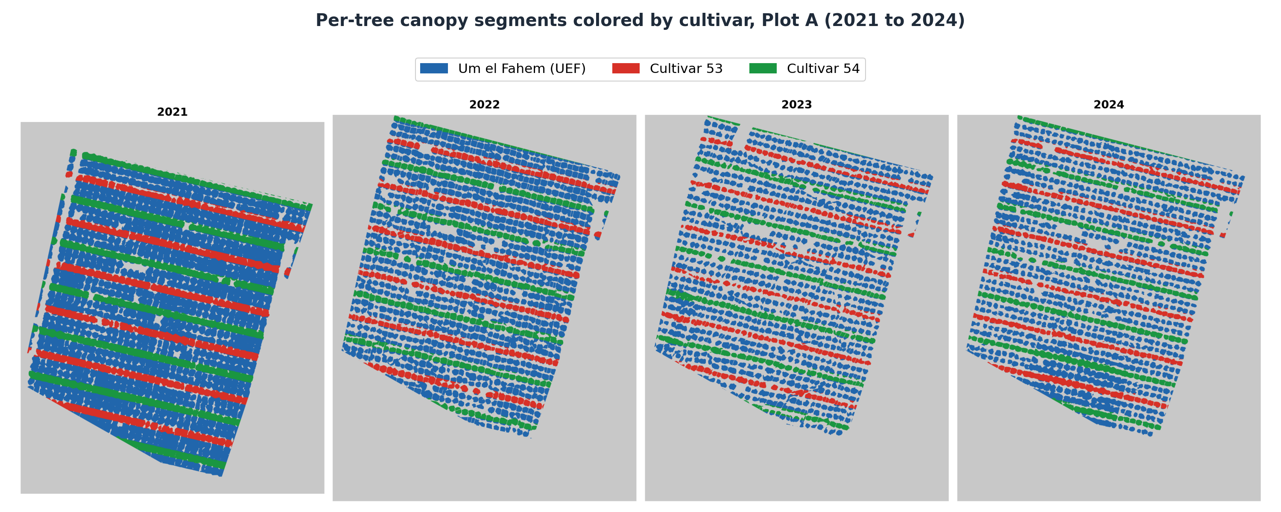
Figure 14: Per-tree canopy segments coloured by cultivar (blue = UEF / Um el Fahem, red = cultivar 53, green = cultivar 54) across all four survey years, 2021 to 2024.

5.5.3 Cultivar Zone Assignment
Cultivar identity (UEF, 53, 54) follows a known six-row planting cycle ([54, UEF, UEF, 53, UEF, UEF], anchored at row 40 = cultivar 54), confirmed against row/cultivar metadata for row 39 and northward. Rows south of row 39 (lacking direct metadata) were assigned by extrapolating this same six-row cycle along the row-perpendicular coordinate (b = Y + 0.2332 x X; the fitted row-to-row period in this coordinate is 7.24, corresponding to a ground row spacing of about 7.0 m), and the assignment was validated by re-deriving the expected cycle position for every row and confirming zero mismatches against the known rows. The final working dataset covers rows 39-76 (the rows with complete, validated cultivar and benchmark coverage): 1,523 trees, cultivar split UEF=1,045 / 53=249 / 54=229. A spot-check of five independently known field coordinates against the assigned cultivar and row, all matching within 2.5 m, confirmed the assignment pipeline end-to-end.

5.5.4 Climate Data Source and Agro-Climatic Feature Definitions
Every climate variable used in this thesis comes from a ground weather-station record (one CSV file per flight year), i.e. actual meteorological-service station observations, not the UAV imagery itself. Because the station is a single fixed point, every climate value is identical for every tree each year - there is no within-plot spatial gradient in any climate variable used below. This is an explicit, acknowledged limitation that carries through to every climate-based result in Section 6.4: it means climate comparisons have at most as many independent data points as there are study years (n=3 or n=4), never as many as there are trees.
For each flight year, 13 agro-climatic features were computed from the station record, covering the window from November 1 of the prior year through that year's flight date - the standard window for almond winter-chill accounting, since chill accumulates from autumn dormancy onward:
- Chill Portions - winter chill accumulation under the Dynamic Model, the standard chill-accounting model for stone fruit/nut dormancy release. More chill portions mean the trees' dormancy requirement is more fully satisfied.
- Late Chill - chill portions accumulated specifically in January-February, the period closest to bloom, when late chilling can still influence bloom timing/synchrony.
- Chill Hours - hours with temperature at or below 7 degC, an older, simpler chill-accounting convention. It is retained only as a secondary reference variable; all chilling in this thesis is quantified by the Dynamic Model in Chill Portions.
- GDD February / GDD January-February - Growing Degree Days (base 4.5 degC) accumulated in February alone and across January-February, the heat-driven counterpart to chilling, representing forcing toward bud break and bloom once chill is satisfied.
- Average DTR February (Diurnal Temperature Range) - the average difference between each day's maximum and minimum temperature during February. A large DTR means hot days and cold nights (clear-sky conditions); a small DTR means more uniform day/night temperatures (cloudy/maritime conditions). Its association with bloom is examined in Section 6.4.4.
- February Radiation - mean solar radiation in February; excluded from analysis, since this field was constant at zero in the source weather-station record for all four study years.
- Max Dry Hours - the longest continuous run of hours without measurable precipitation, a proxy for sustained dry spells affecting both bloom desiccation risk and field accessibility.
- Transition Ratio - Chill Portions divided by GDD February, a single composite index of how chill-dominated versus heat-dominated a given winter was.
- Frost Hours - hours below 0 degC; also constant at zero across all four years in this record.
- Heat Stress February - hours above 25 degC in February, an unusually-warm-day proxy.
- February Rainfall - total precipitation (mm) in February.
- High Wind Hours - hours with wind speed above a fixed threshold, relevant both to bloom/pollination disruption and to potential flight-condition effects on the UAV imagery itself.
These features are screened against the bloom record in Section 6.4.4, where the single-station design is shown to limit them to four orchard-year observations; Chill Portions is the one carried forward, as the chill metric used throughout this thesis. Station-level climate values were merged into the per-tree master dataset by a simple year-key join, broadcasting the single yearly station value to every tree row for that year - no spatial interpolation was needed or possible with a single station.

5.5.5 Cross-Referencing with Prior-Work Yield Data
To supplement this thesis’s own EBI/NGRDI pipeline outputs with an independent check, per-tree yield data from the Kedma growers’ harvest survey (2022-2024) were spatially joined to the master dataset using a bijective nearest-neighbour match on field GPS coordinates (max distance 8 m, 1-to-1 assignment). This matched 161 of the 162 trees in the yield survey; Table 17 reconciles the record counts that follow from it. The yield data served as the ground-truth dependent variable in Section 6.5.

5.5.6 Statistical Methods Used in the Analysis Program
- Descriptive statistics and paired t-tests: per-year mean and standard deviation of EBI_Norm were computed across all canopy-mapped trees to describe the temporal dynamics of bloom, and paired t-tests on trees measured in consecutive years tested whether the orchard-mean bloom shifted from one season to the next (Section 6.4.1).
- Mixed split-plot two-way ANOVA (cultivar between-subjects, year within-subjects): used whenever the same trees are measured repeatedly across years. A naive two-way ANOVA treating tree-count as the error degrees of freedom for the Year/interaction terms would be pseudoreplication, because every tree each year shares the exact same station-level climate value - there is no real within-year replication, only within-year measurement repetition. The split-plot design instead uses statistically correct, separate error terms for the between-subjects (Cultivar) and within-subjects (Year, Cultivar x Year) effects.
- One-way ANOVA per year, with Bonferroni-corrected pairwise t-tests: used to localize which specific year(s) a cultivar effect is significant in, once the split-plot test confirms an overall interaction.
- Permutation tests (label-shuffling, 199 to 20,000 relabellings): used for the spatial null distribution of Moran's I, which has no simple closed form, and wherever a sample was too small to trust a classical asymptotic test. A permutation test is valid by construction under the null hypothesis of label-exchangeability and requires no distributional assumption, the observed statistic being compared to its own distribution under thousands of random relabellings of the same data.
- Pearson correlation, with p-values from a first-principles implementation. F-distribution and t-distribution p-values throughout this thesis were computed from a self-contained regularized-incomplete-beta-function routine and validated against textbook critical-value pairs (reproducing p = 0.05 in every case) before being used for any reported result.
- Moran's I (Moran, 1950): a standard spatial-autocorrelation statistic, used to test whether per-tree EBI_Norm is spatially clustered within each season, and thus whether an environmental or management gradient (microclimate, irrigation, soil) organises bloom beyond tree-independent variation. Computed on EBI_Norm from a binary distance-band spatial weights matrix, in which two trees are neighbours if they lie within 10 m of one another in UTM coordinates, with significance from spatial permutations.
- Year-level climate associations: because agro-climate is recorded at a single station (one value per season), climate-to-bloom and climate-to-yield associations were computed only at the orchard-year level (n = 4 seasons, or n = 3 for measured yield). With so few points these carry no reliable p-value and are reported as directional, hypothesis-generating patterns; the inferential evidence comes from the tree-level tests (Sections 6.4.4 and 6.6).
- Cohen's d, eta-squared, and Pearson r are used throughout as the primary effect-size measures alongside p-values, since several of this thesis's sample sizes are small enough that statistical significance and practical effect size need to be reported and discussed separately.

5.5.7 Yield Analysis and Prediction Modelling
Field-measured net kernel yield from the growers' harvest survey was joined to the master tree table via a nearest-neighbour spatial match and kept strictly separate from the laboratory's modelled predicted_Yield. The relationship between spring bloom and measured yield was tested within the 2023 season by an analysis of covariance of yield on EBI, cultivar and their interaction, which separates a shared bloom-yield slope from a cultivar-specific one; the interaction term tests whether that slope differs between cultivars, and within-cultivar Pearson correlations report its sign and strength in each cultivar.
For yield prediction, a feature bank was assembled from the per-tree pipeline outputs: four base features (cultivar, mean EBI with its cultivar interaction, winter chill in Chill Portions, and April canopy growth), a set of 34 engineered canopy-structure and bloom-texture features (canopy area and cover, bloom and bright fractions, EBI pixel-distribution statistics such as percentiles, dispersion, skewness and kurtosis, high-bloom fractions at several thresholds, and composite bloom indices), and, for the analysis of the modelled predicted_Yield, a set of physiological features (canopy nitrogen content and stem water potential at several dates, and canopy growth in later months). All continuous features were z standardized. Features were chosen by forward selection under five-fold cross-validation, adding at each step the single feature that most increased the cross-validated coefficient of determination, and stopping either when no additional feature increased the cross-validated coefficient of determination by more than 0.2 percentage points or when seven features had been selected.
Each feature set was fitted with six model families (ordinary least squares; ridge regression, Hoerl & Kennard, 1970; a degree-two polynomial with ridge; a random forest, Breiman, 2001; k-nearest-neighbours, Fix & Hodges, 1951; and a linear mixed model with a tree-level random intercept, Laird & Ware, 1982). Accuracy was estimated via five-fold cross-validation and reported as the cross-validated coefficient of determination, along with the root-mean-square error and mean absolute error; each feature's contribution was measured using permutation importance (Breiman, 2001). The random forest was grown as an ensemble of 100 regression trees, each fitted to a bootstrap sample of the records and limited to a depth of six splits with at least ten records in every leaf, with a random subset of up to twenty candidate features considered at each split; predictions are the average across the ensemble. Those limits keep individual trees shallow so that the ensemble generalizes rather than memorizing single trees.
All models were implemented from first principles in Python with numpy. The random forest was a bootstrap-aggregated ensemble of regression trees, each grown on a bootstrap sample with a random subset of features considered at every split and a maximum depth and minimum leaf size fixed by a preliminary grid search, with predictions averaged over the ensemble. The same code provided the ordinary least squares, ridge, polynomial, k-nearest-neighbours, and mixed-model fits, the cross-validation, and the permutation importance, so every statistic reported in Chapter 6 is reproducible from the numpy implementation alone.

5.5.8 Validation Against Independent Phenology Surveys
Two independent phenology datasets were used to cross-check the UAV bloom signal (Section 6.4.6). The first is a branch-level survey conducted for this thesis in 2021, in which 20 georeferenced trees were visited on three dates spanning bud break to full bloom (3 February, 15 February, and 7 March 2021). On each visit, the developing tips of every tree were scored as percentages across four phenological stages: green tips, pink tips, unfolding leaves, and open flowers, with the four values summing to 100%. For validation, the visit coincident with the UAV flight (7 March 2021) was used, and the leaf-stage percentage, the share of each tree’s scored tips that had opened as vegetative leaves, was matched to each tree’s same-year EBI by a nearest-coordinate join (median offset 0.8 m) and compared by Pearson correlation. This tests whether EBI tracks reproductive rather than vegetative canopy development; note that the flower percentage on its own is uninformative once most trees have begun to open, so it is the leaf-stage share, not the raw flower percentage, that carries the signal. The second dataset is the national almond growers’ phenology monitoring survey recorded at the Kedma farm from 2022 to 2024, in which each cultivar (cultivar 53, cultivar 54 and UEF, also recorded as Um el Fahem) was scored on several dates per season on the growers’ zero-to-ten photographic bud-and-bloom key. This key is ordinal rather than a linear percentage: stage 6 corresponds to about ten percent of flowers open, stage 7 to fifty percent, and stage 8 to roughly eighty percent, which is peak open bloom, while stages 9 and 10 denote petal shed and the end of flowering, so visible bloom then declines again toward zero. Each stage score was therefore converted to a visible open-flower coverage using these labelled anchor points, rather than by multiplying the stage by ten, and the resulting coverage curve for each cultivar and year was interpolated to the UAV flight dates and correlated, per cultivar and pooled, against the orchard EBI and NGRDI. The day of year at which each cultivar first reached fifty percent open bloom (stage 7) was also extracted, and its cultivar ordering compared with the bloom-timing order shown by the UAV data. Because both benchmarks rest on small samples (n = 8 to 20) and differ in spatial support from the per-tree UAV measurements, they are treated as supportive cross-checks rather than confirmatory statistical tests.

6. Results and Evaluation
This chapter is organized in two parts that follow the structure of the thesis. Sections 6.1 to 6.3 evaluate the detection and mapping engine itself, the segmentation model, its post-processing parameters, and the georeferencing step, as the reliability of all subsequent measurements depends on these components. Sections 6.4 to 6.6 then use the per-tree dataset produced by the engine to analyse bloom phenology, cultivar structure, and yield across the four seasons from 2021 to 2024.
The agronomic sections that follow are ordered from the behaviour of bloom itself to its agronomic consequences. Section 6.4 reports the temporal, cultivar and spatial structure of bloom and its association with winter climate, together with the two independent phenology cross-checks. Section 6.5 sets the per-tree bloom record against the field-measured harvest, and Section 6.6 reports the yield prediction models. Interpretation of these findings, and their relation to the literature, is deferred to Chapter 7.

6.1 Training Performance
The entire per-tree dataset is based on the UNet++ segmentation model from Chapter 3, so its training behaviour is reported first. The production model was trained on Version 8 of the annotated dataset: 349 training images, 35 validation images, and 18 held-out test images (402 in total; Table 2). The training count already includes the threefold offline augmentation applied when the dataset was exported, which expanded roughly 116 manually annotated source images with auto-orientation correction and a hue jitter of plus or minus 25 degrees; a further layer of random photometric and geometric augmentation (gamma, brightness and contrast, hue-saturation-value, RGB shift, flips, rotations and transposition) was applied online at every epoch, so no two epochs saw an identical image. The Focal Tversky loss converges smoothly, and the training and validation curves stay close together throughout, validation Dice peaking at 0.8935 at epoch 17 before early stopping halts the run (Figure 15).
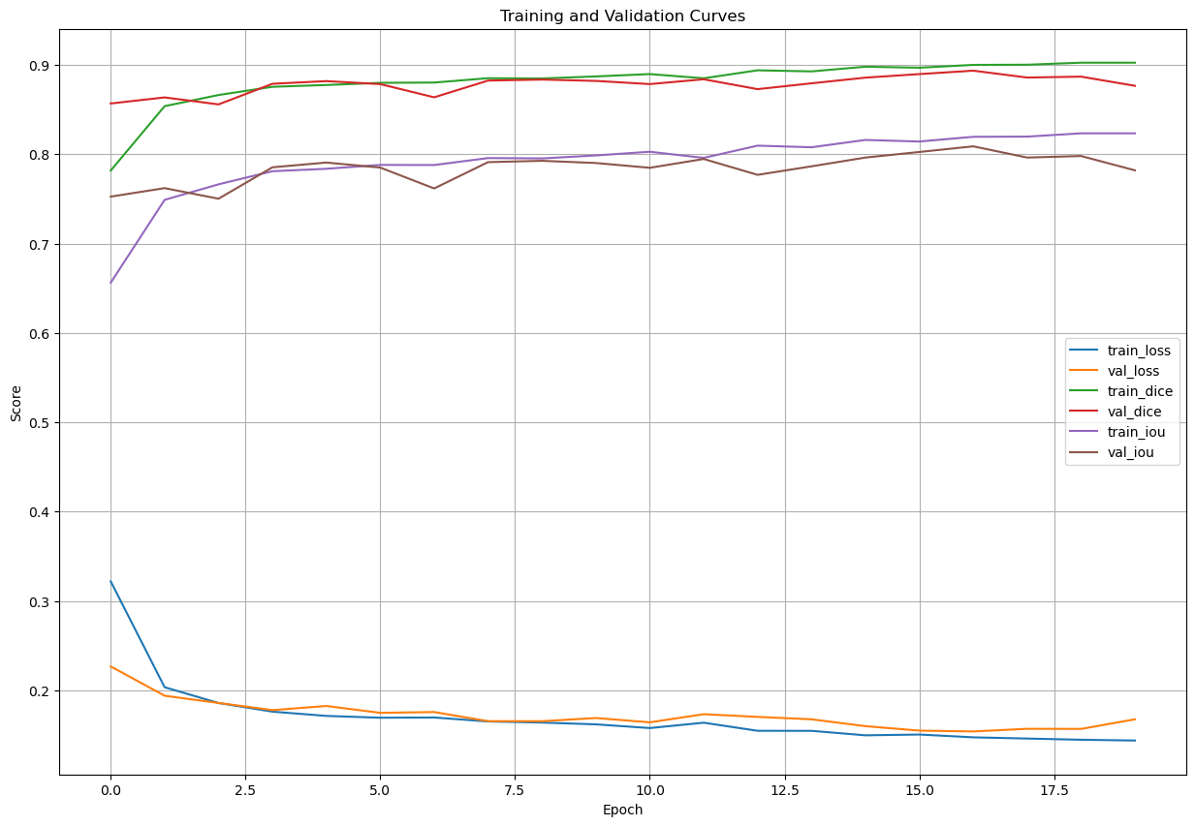
Figure 15: Training/validation loss, Dice, and IoU over 20 epochs - the final production run, peaking at validation Dice 0.8935 (epoch 17).

6.2 Quantitative Segmentation Metrics
Smooth convergence does not by itself establish that the model is accurate on trees it never saw during training, so the trained network was scored against the independent manual annotations of the held-out test split. Evaluation is confined to leaf-on imagery, matching the operating scope adopted after training: dormant-season acquisitions were excluded from the analytical pipeline because leafless canopies provide no reliable crown boundary, and every per-tree index in this thesis is derived from leaf-on and bloom-period flights. The reported sample is therefore the ten leaf-on test images and their 1,233 annotated crowns. Table 11 gives the result.
Table 11. Segmentation performance on the held-out leaf-on test images (10 images, 1,233 annotated crowns), with 95 percent confidence intervals obtained by bootstrapping over source images.
Metric | Value | 95% CI | Notes
Semantic Dice | 0.894 | [0.867, 0.918] | Pixel-level overlap with the annotations
Semantic IoU | 0.809 | [0.767, 0.848] | Conservative overlap metric
Instance Precision | 0.916 | [0.875, 0.947] | Correctly detected / all detected crowns
Instance Recall | 0.899 | [0.870, 0.926] | Correctly detected / all annotated crowns
F1 (Instance) | 0.908 | [0.877, 0.933] | Harmonic mean of precision and recall
GPS Error (RMS) | 2.4 m | [1.8, 3.2 m] | Against differential GPS survey
The evaluation protocol is stated explicitly so that the figures can be reproduced. A predicted crown counts as a true positive when its intersection over union with an unused annotated crown reaches 0.50; predictions and annotations are matched one to one, highest overlap first; predicted objects below 200 pixels are discarded; and crowns truncated by the image border are retained. Confidence intervals resample the ten source images, not pixels or individual crowns, because crowns within one frame share illumination, exposure and canopy condition and are not independent; pixel-level resampling would yield intervals several times narrower than the data support. Across the leaf-on set the workflow returned 1,211 crowns against 1,233 annotated, with 33 crowns divided between two predictions and 50 predictions spanning more than one crown.
Detection quality degrades gradually as the matching criterion tightens, from an F1 of 0.91 at an overlap threshold of 0.50 to 0.73 at 0.70 and 0.50 at 0.80, which reflects the intrinsic ambiguity of crown boundaries in a closed orchard canopy rather than missed trees. Two parameters were examined directly. The binary probability threshold proved immaterial: across the range 0.3 to 0.7 the semantic Dice moves by less than 0.001, so the conventional value of 0.5 is adopted without loss. The watershed separation distance is the parameter that matters, trading the two error types against each other: raising it from 15 to 35 pixels reduces divided crowns from 127 to 42 while increasing spanned crowns from 55 to 92 over the full eighteen-image test set, with the best balance at the adopted value of 25.
Pooled figures conceal where the workflow actually fails, so detection was resolved for every annotated crown and broken down by acquisition and by crown geometry (Table 12). Three patterns emerge. Canopy condition dominates everything else: recall is 0.899 on leaf-on imagery and 0.001 on dormant imagery, which is the operating boundary of the workflow and the reason dormant acquisitions are excluded from the analytical scope. Within leaf-on imagery, performance is stable across seasons and sensors, 0.897 in 2022, 0.875 in 2023 and 0.922 in 2024, despite a different camera in each of the three, a Canon EOS 6D followed by two different DJI Zenmuse payloads; this is direct evidence that a change of instrument does not by itself degrade detection, and it supports the interpretation of the multiseason bloom comparison in Section 6.4.2. What does vary is crown geometry. Crowns cut by the frame border are detected at 0.703 against 0.963 for crowns lying wholly inside it, because a truncated crown often fails to reach the overlap threshold, and small crowns are detected at 0.831 against 0.968 for large ones, reflecting the minimum-area and dynamic-area filters that remove small objects. The headline recall of 0.899 is therefore a conservative figure: for a fully visible, average-sized crown in leaf-on imagery the workflow detects better than nineteen trees in twenty.
Table 12. Detection recall by stratum on the held-out test set, at an overlap threshold of 0.50. Canopy condition covers all 18 test images; the remaining strata are computed within leaf-on imagery only, since detection fails on dormant imagery and pooling it would make the comparisons uninterpretable. The three season rows sum to 1,070 of the 1,109 leaf-on detections because one leaf-on frame carries no acquisition date in its metadata and is not assigned to a season.
Stratum | Detected | Crowns | Recall
Leaf-on imagery | 1,109 | 1,233 | 0.899
Dormant imagery | 1 | 1,233 | 0.001
2022 season imagery | 384 | 428 | 0.897
2023 season imagery | 258 | 295 | 0.875
2024 season imagery | 428 | 464 | 0.922
Crown wholly inside the frame | 898 | 933 | 0.963
Crown cut by the frame border | 211 | 300 | 0.703
Crown larger than the image median | 599 | 619 | 0.968
Crown smaller than the image median | 510 | 614 | 0.831
The contribution of each preprocessing stage was quantified by scoring the same images with the colour correction removed and reinstated one stage at a time. Raw imagery, Gray World white balance alone, adaptive gamma alone, CLAHE alone and the full chain all produce a Dice between 0.876 and 0.901 on leaf-on imagery, a spread of 0.024 that is smaller than the width of the confidence interval on any single estimate. The preprocessing chain therefore stabilises appearance without measurably changing segmentation accuracy. This also settles a question that matters for the agronomic chapters: because the colour transformations leave the segmentation unchanged and the spectral indices are computed from the mosaic radiometry rather than from the network inputs, EBI and NGRDI are not affected by the enhancement applied before inference.

6.3 ArcGIS Registration Results
A detected tree is only useful once it carries real-world coordinates, so each season mosaic was georeferenced and its registration success recorded. The counts below are for the 2021 reference survey (flown 7 March 2021), the densest of the four acquisitions and the one used to build the reference mosaic; its 298 drone images were registered with the three-phase strategy as follows. Direct registration succeeded for 203 images (68 percent); GPS-offset correction recovered a further 54 (18 percent) and histogram matching a further 29 (10 percent), leaving 12 images (4 percent) unregistered and excluded from the mosaic.
The 4% failure rate primarily affects images acquired at survey boundaries (with partial overlap with the reference) or in highly shadowed zones where insufficient textural features are available for GCP matching. The same three-phase procedure was applied to the sparser 2022-2024 mosaics.

6.4 Phenological and Spectral Analysis Results
The pipeline's per-tree detections (Sections 6.1 to 6.3) yielded two colour-based bloom indices for every tree in every season from 2021 to 2024: the Enhanced Bloom Index (EBI; Chen et al., 2019) and the Normalized Green-Red Difference Index (NGRDI), computed as described in Section 5.5. All statistics below were recomputed from the master tree table (1,523 trees, EPSG:32636), and bloom intensity is reported as EBI_Norm on a 0-1 scale. Throughout, bloom is read primarily at the cultivar level, which carries most of the structure and all the yield signals; the analysis moves from the temporal behaviour of bloom through its cultivar and spatial structure to its association with winter climate.

6.4.1 Temporal Dynamics of Bloom Intensity
Measured on every canopy-mapped tree in the four UAV registered mosaics (n = 1,224 to 1,276 per season), orchard-mean bloom intensity was flat across the four seasons (EBI_Norm approximately 0.55), but the average hides the main temporal signal, a convergence of the three cultivars. In 2021, they bloomed at clearly distinct levels: cultivar 54 was highest (mean 0.71), cultivar 53 intermediate (0.60), and UEF lowest (0.49); by 2024, all three sat together near 0.55. The orchard-wide standard deviation more than halved over the same period (0.105 in 2021 to 0.048 in 2024; Table 13) and decomposing it shows this was between-cultivar convergence, not trees becoming individually more alike: the between-cultivar component fell from 0.087 to about 0.00 (from 69 percent of the total variance to 1 percent), while the within-cultivar spread barely changed (near 0.05 to 0.06 throughout). The bloom-bright tail tells the same story: trees above EBI_Norm = 0.65 were almost all cultivar 54 (95 percent of its trees in 2021, against 23 percent for cultivar 53 and near zero for UEF), and the tail collapsed to under 1 percent in every cultivar by 2024. Paired t-tests on trees measured in consecutive years confirmed significant shifts in 2021 to 2022 (t = 3.33, p < 0.001) and 2022 to 2023 (t = -3.41, p < 0.001), and none in 2023 to 2024 (t = 0.22, p = 0.83). EBI is therefore most informative when read by cultivar and through the upper tail, not as an orchard-mean value.
Table 13. EBI_Norm by cultivar and year (all canopy-mapped trees). The orchard standard deviation is split into its between-cultivar and within-cultivar components: the between-cultivar term collapses while the within-cultivar spread is stable.
Year | UEF mean (SD) | Cultivar 53 mean (SD) | Cultivar 54 mean (SD) | Orchard SD | Between-cultivar SD | Within-cultivar SD
2021 | 0.491 (0.062) | 0.603 (0.065) | 0.714 (0.040) | 0.105 | 0.087 | 0.059
2022 | 0.508 (0.068) | 0.597 (0.057) | 0.617 (0.048) | 0.079 | 0.048 | 0.063
2023 | 0.548 (0.046) | 0.507 (0.041) | 0.596 (0.043) | 0.051 | 0.026 | 0.045
2024 | 0.551 (0.054) | 0.549 (0.030) | 0.541 (0.037) | 0.048 | 0.004 | 0.048

6.4.2 Cultivar Structure and Convergence
Grouping the per-tree UAV bloom indices by cultivar across the four seasons shows that cultivar was the dominant source of bloom variation early in the record and lost that role steadily. A one-way ANOVA of EBI_Norm by cultivar fell from F = 1,384.8 (eta-squared = 0.685) in 2021 to F = 4.1 (eta-squared = 0.007) in 2024 (Table 14): cultivar explained about 69 percent of between-tree bloom variation in the first season and essentially none in the last. A split-plot ANOVA confirmed significant cultivar (F = 537.6, p < 0.001) and year (F = 11.7, p < 0.001) effects and a strong cultivar-by-year interaction (F = 698.1, p < 0.001, eta-squared = 0.251), the largest effect in the model. The three cultivars, well separated in 2021 (cultivar 54 highest, 53 intermediate, UEF lowest), converge to a common bloom intensity by 2024. This convergence, not any change in orchard-mean bloom, is the central phenological pattern of the record. Because each of these comparisons is made between cultivars within a single season, it is unaffected by any between-season difference in acquisition or index normalization, which bears only on cross-year comparisons of the orchard mean. Figure 16 shows the per-cultivar distributions in each season.
Because a different camera was flown in each of the four seasons, a Sony ILCE-6000, a Canon EOS 6D and then two different DJI Zenmuse payloads, the convergence was tested against the possibility that it reflects the instrument rather than the orchard. Decomposing the EBI_Norm variance separates the two possibilities directly. A radiometric cause would compress the whole distribution, reducing the spread within cultivars and between them together. What is observed instead is that the within-cultivar standard deviation is essentially unchanged across the record (0.059, 0.063, 0.045 and 0.048 from 2021 to 2024) while the between-cultivar standard deviation falls by a factor of twenty (0.087, 0.048, 0.026 and 0.004). Individual trees remain as variable as they ever were; it is the cultivar means that come together. The coefficient of variation, which is insensitive to any pure change of scale between sensors, halves over the same period, from 19.1 to 8.8 percent.
A second test uses NGRDI as an internal control. It is computed from the same pixels of the same images through a different band combination, so any radiometric artifact common to a camera should appear in both indices, and none does. The between-cultivar share of NGRDI variance moves in the opposite direction over the same four seasons, rising from 8.2 to 28.0 percent while the EBI share falls from 68.5 to 0.7 percent. Two indices drawn from identical imagery cannot diverge in opposite directions through a shared instrumental effect, so the collapse of cultivar separation is a property of the bloom signal rather than of the sensors. Consistent with this, the change of camera between 2021 and 2022, from a Sony ILCE-6000 to a Canon EOS 6D, left the tree-level ordering of bloom intensity largely intact (Spearman rho = 0.78), showing that a change of instrument does not by itself disturb the measurement.
One qualification follows from the same analysis. Tree-level agreement between seasons is high only for the first pair; from 2022 onward the ordering of trees by bloom intensity is weakly preserved (Spearman rho = 0.18 for 2022 against 2023 and 0.14 for 2023 against 2024). Individual trees therefore do not hold a fixed position in the bloom distribution from year to year, even though the spatial clustering of bloom persists in every season (Section 6.4.3). The convergence result is accordingly a statement about cultivar means, not a claim that particular trees behave consistently across the record.
Table 14. One-way ANOVA of EBI_Norm by cultivar, per year (three cultivars: UEF, 53, 54).
Year | F | p | eta-squared
2021 | 1,384.8 | <0.001 | 0.685
2022 | 347.5 | <0.001 | 0.360
2023 | 204.8 | <0.001 | 0.251
2024 | 4.1 | 0.016 | 0.007

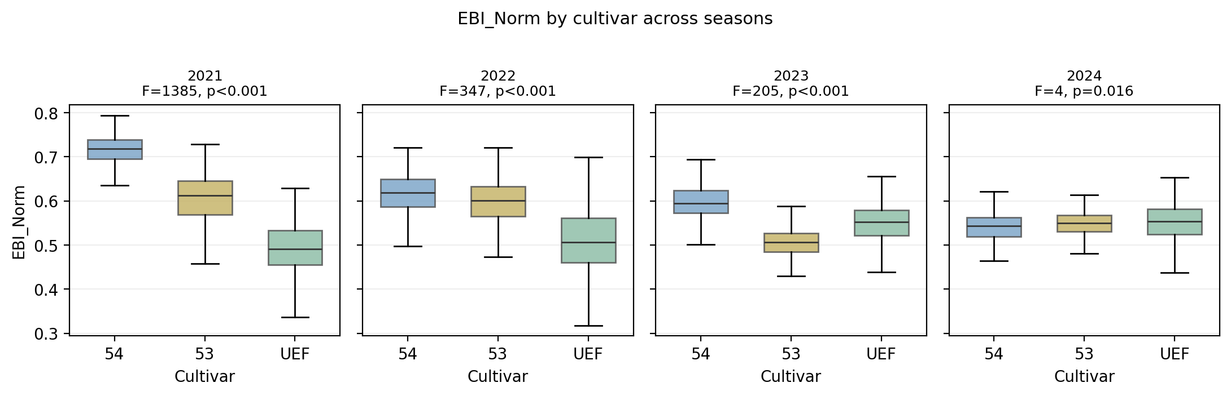
Figure 16: EBI_Norm by cultivar across the four seasons. Cultivar separation, large in 2021, narrows progressively until the cultivars converge in 2024.

6.4.3 Spatial Autocorrelation of Bloom
Using each tree’s bloom index together with its UTM position, one map per season, bloom was significantly spatially clustered in every year (Moran's I, 10 m band, 199 permutations; Table 15), and the clustering is largely a within-cultivar pattern. The raw orchard-level Moran's I rose from 0.122 in 2021 to a maximum of 0.362 in 2023 and eased to 0.234 in 2024, all far outside their permutation null (p approximately 0.005). Removing each cultivar's own mean and recomputing on the residuals reveals strong within-cultivar clustering in every year (residual I approximately 0.32, 0.28, 0.35, 0.23); in the early seasons this within-cultivar structure is stronger than the raw value, because the sharp bloom contrast between adjacent cultivar rows masks it at the orchard scale, and as the cultivars converge the two measures coincide. Within each cultivar, then, bloom forms contiguous high and low patches, pointing to an environmental or management gradient (microclimate, soil or irrigation) that operates inside cultivars rather than to the planting layout alone. Figure 17 maps the pattern across the four seasons.
Table 15. Moran's I spatial autocorrelation of EBI_Norm by year.
Year | Moran's I | E[I] | p
2021 | 0.122 | -0.001 | 0.005
2022 | 0.162 | -0.001 | 0.005
2023 | 0.362 | -0.001 | 0.005
2024 | 0.234 | -0.001 | 0.005

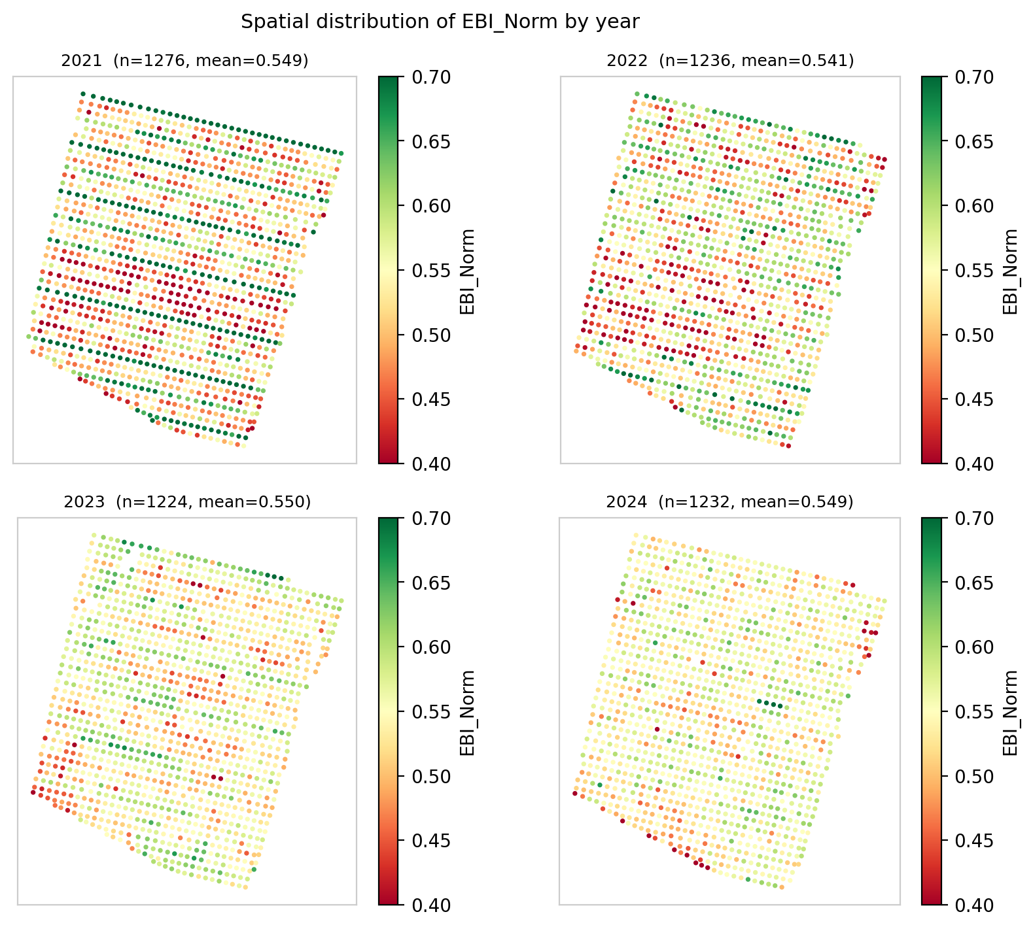
Figure 17: Spatial distribution of EBI_Norm, 2021 to 2024. The strong high- and low-contrast of 2021 fades to a far more uniform pattern by 2024, the spatial counterpart to the standard-deviation decline in Table 13.

6.4.4 Association with Winter Climate
This section tests the ground weather-station record, one value per season, against the per-cultivar and orchard-mean bloom indices derived from the UAV mosaics. Winter chill and heat were quantified per season by the Dynamic Model, in Chill Portions (CP; Fishman et al., 1987). Climate is recorded at a single station, so every tree in a season shares a single value, and any climate-to-bloom association can be read only at the orchard-year level across four seasons. At that resolution, bloom intensity carries no dependable climate signal. Chilling is not monotonic across the record, at 18, 35, 25 and 10 Chill Portions from 2021 to 2024, whereas the cultivar means converge steadily (Figure 18a), and the association between a cultivar mean bloom and its seasonal chill is weak and inconsistent in sign (cultivar 54 r = +0.20, UEF r = -0.35, cultivar 53 r = +0.20, n = 4 each). The bloom-bright fraction behaves the same way: it falls from 94.7 to 0.9 percent in cultivar 54 across the record while correlating at r = -0.03 with Chill Portions. Screening all eleven station variables against the orchard-mean bloom index does return some large-looking correlations, up to 0.8 in absolute value, but they carry no weight: across the four seasons that orchard mean moves by only 0.009 EBI units, roughly a fifth of the difference between two neighbouring trees in the same row. Correlating four nearly identical numbers with climate is arithmetic rather than evidence, since a single season shifting slightly would reverse the sign; therefore, these coefficients are not interpreted here. Bloom intensity is therefore reported as a cultivar and spatial phenomenon rather than a climatic one. Climate likewise cannot be tested against measured yield inferentially: measured yield is effectively a single season, and although chill accumulation tracks mean yield in the expected direction at the orchard-year level (Chill Portions versus mean measured yield r = +0.82, n = 3), three seasons support description only and the biennial bearing cycle dominates the year-to-year yield signal. Bloom timing behaves differently and is treated in Section 6.4.5: resolved by cultivar and year, it provides ten observations rather than four, and there the climate association is both significant and physiologically coherent (Figure 18b).
Because the choice of chill model is not neutral in a warm winter climate, all three of the models in common use were computed from the same 10-minute temperature record and evaluated against the field bloom dates (Figure 19). Chill Portions from the Dynamic Model orders the four seasons most consistently with observed bloom (r = -0.87), ahead of Utah Chill Units (r = -0.81) and well ahead of Chill Hours (r = -0.54). The Utah model additionally returns negative accumulations in every season, from -417 units in 2022 to -1,136 in 2024, because its high-temperature penalties dominate under Mediterranean winter conditions, so its totals are not interpretable as chill accumulated even where they rank the seasons correctly. Chill Hours, which counts hours at or below seven degrees and applies no penalty at all, is the least informative of the three. This is the expected ordering, since the Dynamic Model was developed precisely for climates in which warm spells reverse partially accumulated chill, and it supports the use of Chill Portions as the chill metric throughout this thesis. The three models were recomputed here to a common 28 February cut-off so that they could be compared on equal terms, which gives totals slightly different from the seasonal Chill Portions values reported elsewhere in this chapter, most noticeably in 2024. With four seasons none of the three associations reaches significance, so the comparison ranks the models rather than testing them.
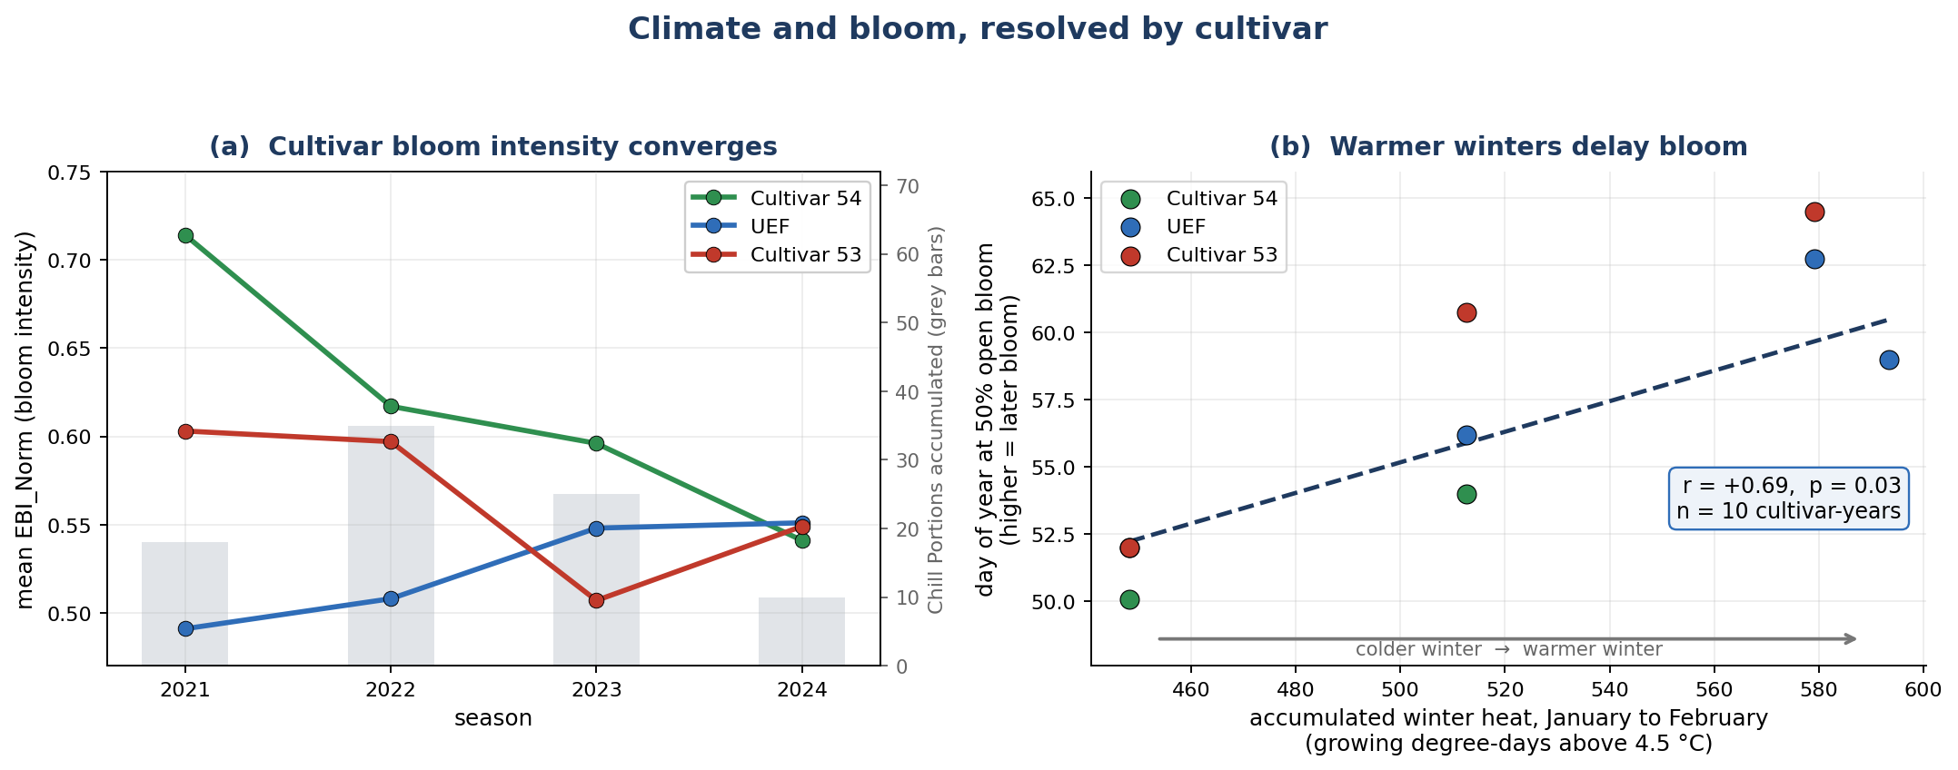
Figure 18: Climate and bloom, resolved by cultivar. (a) Mean bloom intensity per cultivar across the four seasons, with the chill accumulated in each winter shown as grey bars. The cultivars converge steadily while Chill Portions rise and fall (18, 35, 25 and 10 from 2021 to 2024), so the convergence does not follow the chill record. (b) Date of fifty percent open bloom against the heat accumulated over January and February, measured as growing degree-days above the 4.5 degC base for almond, one point per cultivar-year. Each 100 degree-days of extra winter warmth is associated with bloom about four days later (r = +0.69, p = 0.03, n = 10 cultivar-years), the delay expected when winter chilling is insufficient.
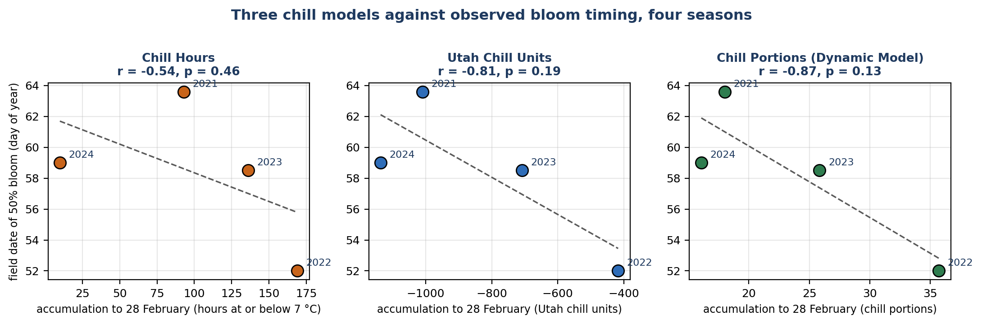
Figure 19: Three chill models against observed bloom timing. Each panel plots the accumulation to 28 February computed from the station's 10-minute temperature record against the field date of fifty percent bloom, one point per season. Chill Portions from the Dynamic Model orders the seasons most consistently with observed bloom (r = -0.87), ahead of Utah Chill Units (r = -0.81) and Chill Hours (r = -0.54). With four seasons none of the associations is significant, so the comparison is directional and ranks the models rather than testing them.

6.4.5 Bloom Timing by Cultivar
Read from the growers’ phenology monitoring survey at Kedma for 2022 to 2024, scored per cultivar and date and combined with the station climate record, bloom timing separates the cultivars more sharply than bloom intensity, and unlike intensity it tracks the climate record. Interpolating the growers’ bloom-progression curves to fifty percent open bloom gives a mean date of day of year 52.5 for cultivar 54, 57.5 for UEF and 59.1 for cultivar 53 (Table 16), an ordering that holds in every season in which the cultivars were scored together. Across the ten cultivar-year combinations available, later bloom accompanied warmer winters (t50 versus growing degree-days January to February r = +0.692, p = 0.027; Figure 18b) and lower chill accumulation (t50 versus Chill Portions r = -0.567, p = 0.087). Bloom timing therefore carries the climate signal that mean bloom intensity does not: resolved by cultivar and year it provides ten observations rather than four, enough to support a formal test, and its direction is the insufficient-chilling delay expected when winter chill falls below a cultivar’s requirement.
Table 16. Mean date of fifty percent open bloom (t50, day of year) by cultivar, from the growers’ phenology survey.
Cultivar | Mean t50 (day of year) | Seasons scored
Cultivar 54 | 52.5 | 3
UEF | 57.5 | 4
Cultivar 53 | 59.1 | 3

6.4.6 Validation Against Independent Phenology Observations
Two independent field datasets, the 2021 branch-level survey of twenty georeferenced trees and the growers’ phenology survey, were each compared against the per-tree UAV indices, and both support the interpretation of the bloom signal. First, a branch-level phenology survey of twenty trees, carried out for this thesis in 2021, recorded, on three dates from bud break to full bloom, the percentage of each tree’s developing tips in four stages: green tips, pink tips, unfolding leaves, and open flowers (Figure 20a). At the flight date, the leaf-stage percentage, how far each tree had advanced into vegetative growth, was strongly and negatively related to the same tree’s EBI (pooled r = -0.65, p = 0.002, n = 20; Figure 20b), whereas the open-flower percentage on its own was uncorrelated with EBI. This confirms that EBI responds to reproductive rather than vegetative canopy development. Second, the national almond growers’ phenology monitoring survey at the same farm, scored on a ten-stage bud and bloom scale from 2022 to 2024, tracked the UAV signal in the expected direction (pooled EBI correlation r approximately +0.5) and reproduced the cultivar order of bloom timing seen in the UAV data (cultivar 54 earliest, then UEF, then cultivar 53). Both comparisons operate on small samples (n = 8 to 20) and serve as supportive cross-checks rather than formal tests, but both point in the same direction as the per-tree UAV analysis. Taken together, the phenological analysis establishes three things: bloom is organized by cultivar and converges across the record; it is spatially clustered within each cultivar in every season; and its climate signal lies in the timing of bloom rather than in its intensity.
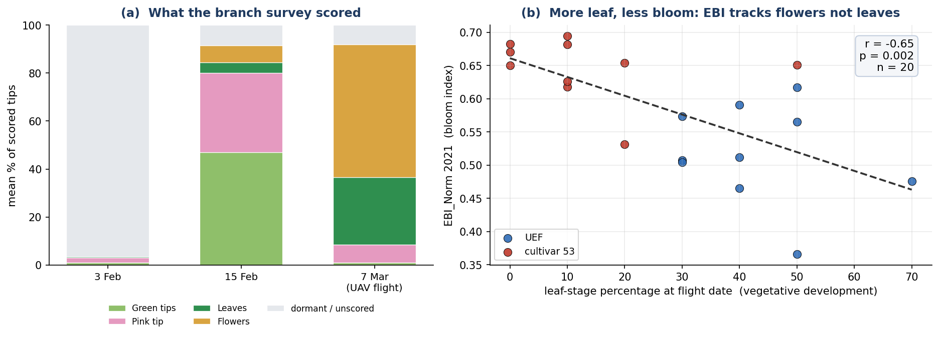
Figure 20: 2021 branch-level phenology validation. (a) Mean composition of scored tips across the three survey dates, showing the progression from dormant buds through green and pink tips to leaves and open flowers by the 7 March UAV flight. (b) At the flight date, each tree’s leaf-stage percentage (vegetative development) against its EBI, coloured by cultivar; the negative slope (r = -0.65, p = 0.002, n = 20) shows that EBI tracks reproductive rather than vegetative development, while the open-flower percentage alone is uninformative.

6.5 Yield Analysis
Bloom phenology matters agronomically only insofar as it relates to yield. This section links the per-tree bloom record to field-measured almond yield. Two distinct yield quantities exist for this orchard and must not be treated interchangeably. The first is field-measured net kernel yield per tree from a growers’ harvest survey, the only direct ground truth, covering 162 trees, mostly from the 2023 season, with small 2022 and 2024 subsets of about 20 trees each. The second is a modelled prediction, predicted_Yield, produced by the UAV multi-sensor random-forest model of Efrat et al. (2025); note that the master columns labelled Yield_2022 and Yield_2023 hold this modelled prediction (r = 0.992 with predicted_Yield) rather than measured yield. Every result in this section therefore uses the harvest survey as ground truth; any modelled quantity is labelled as such, and the modelled product is analysed in its own right in Section 6.6. The survey was joined to the master table by a nearest-neighbour spatial match in UTM Zone 36N, linking 161 of 162 trees at a median distance of 0.88 m. All matched trees are cultivar UEF or cultivar 53: cultivar 54, an early-blooming pollinizer, is not represented in the harvest survey, so the measured-yield analysis is necessarily a two-cultivar comparison.
The counts quoted through this section and the next differ because successive joins and quality filters remove records, and Table 17 reconciles them. The growers' survey holds 202 harvest records on 162 trees across three seasons. Restricting to the two seasons with matching bloom imagery leaves 182 records; the spatial join to the master table matches 181 at a median distance of 0.88 m; the cultivar-consistency filter, which drops trees whose master cultivar disagrees with the nearest crown polygon, removes two more; and requiring complete values for every model input leaves 167 tree-years on 149 distinct trees, of which 18 appear in two seasons. Analyses reported for a single season use the 2023 subset, which is the only season sampled at usable size: of the 202 records, 162 are from 2023 against 20 each from 2022 and 2024. The 2022 and 2024 records are retained only where a pooled sample is explicitly stated.
Table 17. Sample flow for the measured-yield analysis, from the raw harvest survey to the modelling sample. Each row reports the records and distinct trees remaining after the stated step.
Step | Records | Trees | Note
Raw harvest records | 202 | 162 | all measured years
Seasons 2022 and 2023 | 182 | 162 | 2024 has 20 records and no matching bloom season
Matched to a master tree within 8 m | 181 | 161 | greedy one-to-one; median distance 0.88 m
Cultivar-consistency filter | 179 | 159 | master cultivar must agree with the crown polygon
Complete cases, cultivars UEF and 53 | 167 | 149 | the modelling sample; 18 trees appear in two years

6.5.1 Descriptive Statistics
Field-measured net kernel yield per tree is derived from the growers’ harvest survey and joined to the master table. In the main 2023 harvest, mean measured yield was 2.94 kg per tree (SD 1.14, n = 90) for UEF and 2.28 kg per tree (SD 1.15, n = 71) for cultivar 53 (Table 18). The sparsely sampled 2022 season yielded about 2.4 times higher, near 6.7 kg per tree, an on year in almond's biennial bearing cycle; the small 2024 subset was comparable to 2023. Because measured yield is effectively a single-season (2023) quantity at usable sample size, all inferential yield analyses below are confined to 2023.
Table 18. Field-measured net kernel yield by cultivar, 2023 season.
Cultivar | n | Mean yield (kg/tree) | SD (kg/tree)
UEF | 90 | 2.94 | 1.14
Cultivar 53 | 71 | 2.28 | 1.15
All matched trees | 161 | 2.65 | 1.19

6.5.2 Cultivar Effects on Measured Yield
Set against the per-tree cultivar labels, the field-measured 2023 yield shows that cultivar is a strong determinant of yield. A one-way ANOVA of 2023 measured yield by cultivar was highly significant (F = 13.46, p = 0.0003, eta-squared = 0.078): UEF out-yielded cultivar 53 by about 0.67 kg per tree (2.94 versus 2.28 kg). Yield here is organized primarily by cultivar identity, a fixed genetic and management attribute, rather than by the spring bloom index. Figure 21 shows both relationships.
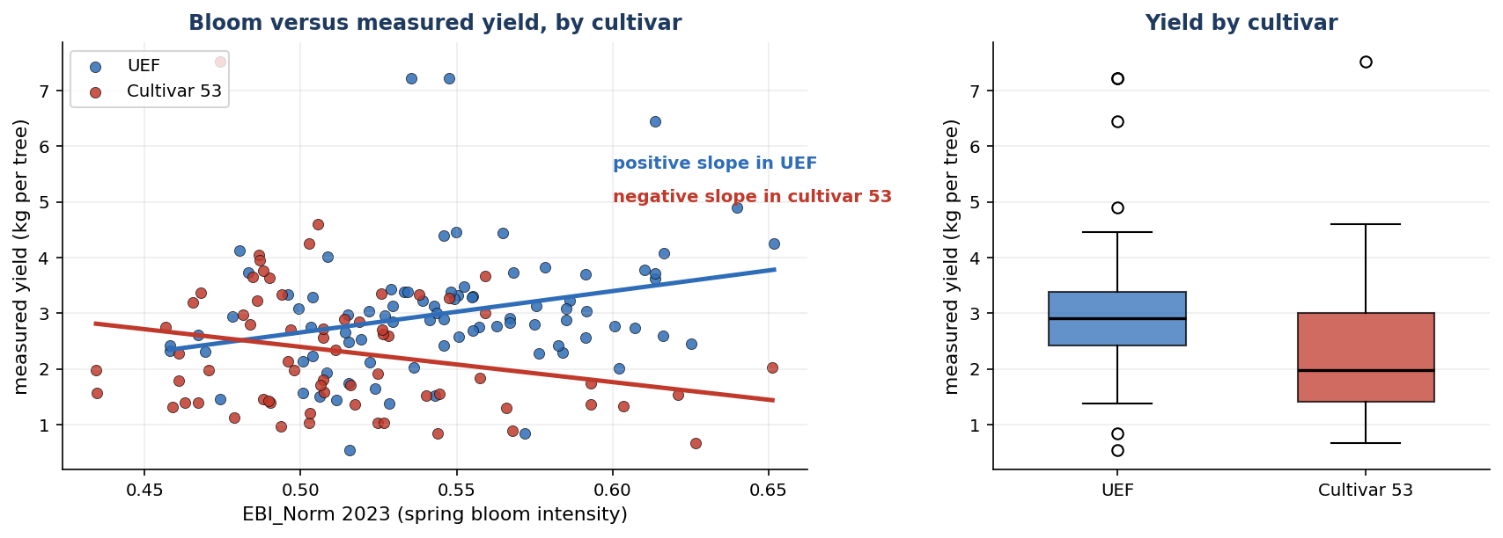
Figure 21: Measured 2023 yield against spring bloom, by cultivar. Left: per-tree EBI_Norm versus measured yield with a fitted line for each cultivar; the slopes run in opposite directions, positive in UEF and negative in cultivar 53. Right: measured yield by cultivar, showing the UEF advantage.

6.5.3 Bloom and Yield, and the Cultivar Reversal
Joining the field-measured 2023 yield to each tree’s EBI_Norm and NGRDI from the 2023 UAV mosaic, bloom and yield were examined first at the whole-orchard level, pooling both cultivars. At that resolution spring bloom intensity carries no linear information about the 2023 harvest: the same-year correlation is weak and positive (EBI_Norm 2023 versus yield r = +0.137, p = 0.093, n = 151), the prior-year lagged correlation is weak and negative (r = -0.098, p = 0.231), and NGRDI is non-significant (r = +0.091, p = 0.264). A correlation of EBI against the modelled predicted_Yield would not test this independently, since that model is built partly from canopy and growth inputs; the measured harvest is the only independent test (Section 6.6). This null is informative rather than final: it averages opposite-signed, within-cultivar relationships that emerge clearly once each cultivar is analysed separately, as the rest of this section shows.
Table 19. Analysis of covariance of 2023 measured yield on bloom, cultivar and their interaction, with the fitted bloom-to-yield slope inside each cultivar. The interaction is the central yield result: bloom predicts yield in opposite directions in the two cultivars, so a single orchard-wide slope averages them to nothing.
Term or group | Statistic | Value | Interpretation
Bloom (EBI) main effect | F (1, 147) | 0.25 (p = 0.62) | no orchard-wide bloom effect
Cultivar main effect | F (1, 147) | 9.71 (p = 0.002) | cultivars differ in yield level
Bloom x cultivar interaction | F (1, 147) | 11.58 (p = 0.0009) | the bloom effect differs by cultivar
Model without interaction | R-squared | 0.08 | —
Model with interaction | R-squared | 0.15 | explained variance roughly doubles
UEF slope | kg per unit EBI_Norm | +7.6 (95% CI +2.1 to +13.1) | brighter bloom, higher yield
Cultivar 53 slope | kg per unit EBI_Norm | -6.8 (95% CI -13.3 to -0.3) | brighter bloom, lower yield

Resolved by cultivar, the same data show a strong relationship in each, with opposite directions. This is the central yield finding of this thesis, and it explains the orchard-level result above, which is simply the average of two opposing slopes. An ANCOVA of 2023 measured yield on EBI_Norm, cultivar and their interaction (Table 19) found no main effect of EBI (F = 0.25, p = 0.62), a significant cultivar effect (F = 9.71, p = 0.002) and, critically, a significant EBI-by-cultivar interaction (F = 11.58, p = 0.0009); adding the interaction roughly doubled the explained variance, from R-squared = 0.08 to 0.15. The within-cultivar bloom-to-yield slope is positive in UEF (r = +0.287, p = 0.007, n = 87) and negative in cultivar 53 (r = -0.256, p = 0.042, n = 64): brighter-blooming UEF trees yield more, brighter-blooming cultivar-53 trees yield less. On the measured scale the fitted slope is +7.6 kg per unit EBI_Norm in UEF (95 percent confidence interval +2.1 to +13.1), about +0.76 kg for every 0.1 of bloom index, against -6.8 kg per unit in cultivar 53 (95 percent confidence interval -13.3 to -0.3). A permutation test that shuffles bloom within each cultivar reproduces the interaction without distributional assumptions (difference in slopes 14.4, p = 0.0006, 20,000 permutations), and because bloom is spatially clustered the model residuals were also checked for spatial dependence: Moran’s I on the residuals of the interaction model is 0.099 (permutation p = 0.068, 999 permutations), weak and not significant at the five percent level, so the cultivar-dependent relationship is unlikely to be an artefact of neighbouring trees resembling one another, although a modest residual spatial dependence cannot be excluded. A single pooled correlation averages these opposing slopes to near zero, which is why the orchard-level test was non-significant. Any bloom-based yield indicator must therefore be built and applied per cultivar; a cultivar-blind index is not merely weaker but misleading, since the sign of the relationship depends on the cultivar.

6.6 Yield Prediction Modelling
This final section turns from what governs yield to how well it can be predicted. Two questions are addressed: how accurately a compact, purpose-built remote-sensing model predicts the field-measured harvest compared with the laboratory's existing product predicted_Yield, and how well predicted_Yield itself can be predicted from UAV and agro-climatic features. Field-measured yield remains the ground truth throughout. predicted_Yield is the output of the UAV multi-sensor random-forest model of Efrat et al. (2025), which is driven mainly by early-season stem water potential, trunk growth rate and canopy nitrogen content.

6.6.1 A Remote-Sensing Model for Measured Yield
Working from the field-measured yield records (167 tree-years) together with the per-tree UAV indices, cultivar labels and the station climate record, a compact ordinary-least-squares model was built from four remote-sensing and agro-climatic inputs, cultivar, mean bloom (EBI) with its cultivar interaction, winter chill (Chill Portions) and April canopy growth, and evaluated against the 161 measured-yield trees (167 tree-year records). It explained 53 percent of between-tree yield variance in the sample and 46 percent under cross-validation, at a mean absolute error of 0.97 kg per tree, against 29 percent and 1.19 kg per tree for predicted_Yield (Table 20). The two quantities agree only loosely to begin with: pooled across the 2022 and 2023 samples, the modelled and measured values correlate at r = +0.54, but that association is carried by the difference between the on-year and off-year seasons and disappears within either season, and the modelled values occupy a much narrower range than the harvest itself (Figure 22). The remote-sensing model was closer to the measured harvest on every metric; the cross-validated 46 percent, not the in-sample 53 percent, is the realistic expectation for an unseen tree. Both figures are computed on the same pooled 2022 and 2023 sample, in which part of the explained variance in either model reflects the difference between the on-year and off-year seasons; the within-season evidence is provided by the 2023 analysis in Section 6.5.
Because 18 trees contribute a record in each of two seasons, the cross-validation was repeated with the folds grouped by tree identity, so that no tree appears in both training and testing. The result is essentially unchanged: grouping the folds by tree alters the cross-validated coefficient of determination by less than 0.01, whether the folds are drawn once or averaged over several random partitions. The reported accuracy therefore does not depend on the same tree appearing in both training and testing. Holding out an entire season is a different matter and fails: the model returns a negative coefficient of determination on either held-out year. The reason is structural rather than a deficiency of fit, since winter chill takes one value for every tree in a season, so a model trained on a single year cannot identify its coefficient and extrapolates blindly. The model should therefore be understood as interpolating between trees within the seasons sampled, not as predicting an unseen season.
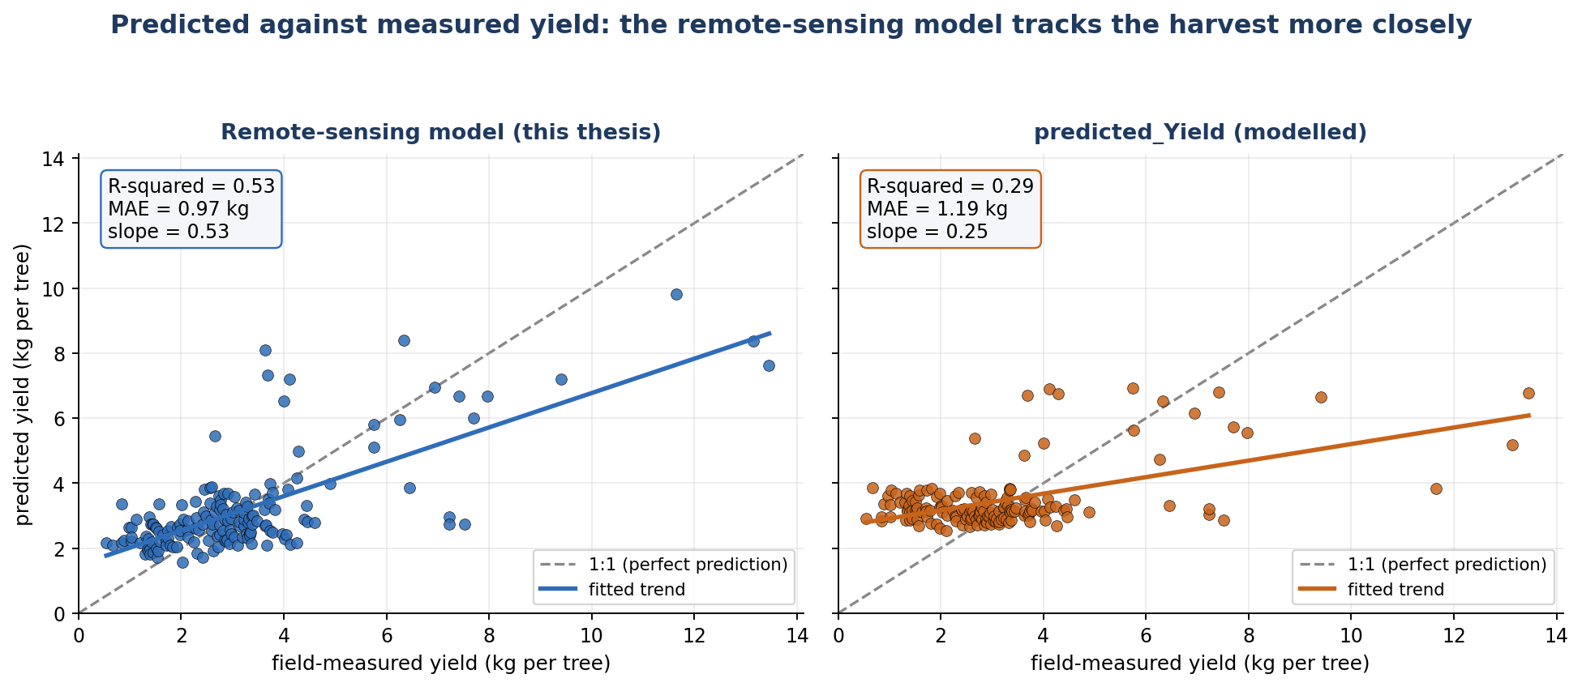
Figure 22: Predicted against measured yield for the two models, on the same 167 tree-year records. Each point is one tree; the dashed line is perfect prediction. The remote-sensing model follows that line with a slope of 0.53 and explains 53 percent of the variation in the harvest in sample, 46 percent under cross-validation, whereas predicted Yield forms a much flatter band (slope 0.25, 29 percent), over-predicting light-cropping trees and under-predicting heavy ones.
Table 20. Yield model comparison against field-measured yield, pooled across cultivars. The final row measures agreement between the two models, not accuracy against measured yield.
Comparison against measured yield | r | R-squared | MAE (kg) | n
predicted_Yield (modelled) | 0.54 | 29% | 1.19 | 167
Remote-sensing model, in-sample | 0.73 | 53% | 0.97 | 167
Remote-sensing model, cross-validated | - | 46% | 1.02 | 167
Remote-sensing model vs predicted_Yield (agreement only) | 0.75 | 56% | - | 167

The advantage held within both cultivars and was largest in cultivar 53 (Figure 23, Table 21). For UEF the remote-sensing model explained 47 percent of measured yield versus 28 percent for predicted_Yield (mean absolute error 0.99 versus 1.01 kg); for cultivar 53 it explained 60 percent versus 44 percent (mean absolute error 0.94 versus 1.43 kg), a 34 percent reduction in error and the largest single gain in the orchard.
Table 21. Yield model comparison by cultivar. Both the variance explained and the error favour the remote-sensing model in each cultivar, most strongly in cultivar 53.
Cultivar | n | Mean yield (kg) | R-squared, predicted_Yield | R-squared, remote-sensing | MAE, predicted_Yield | MAE, remote-sensing
UEF | 96 | 3.38 | 28% | 47% | 1.01 | 0.99
Cultivar 53 | 71 | 2.85 | 44% | 60% | 1.43 | 0.94

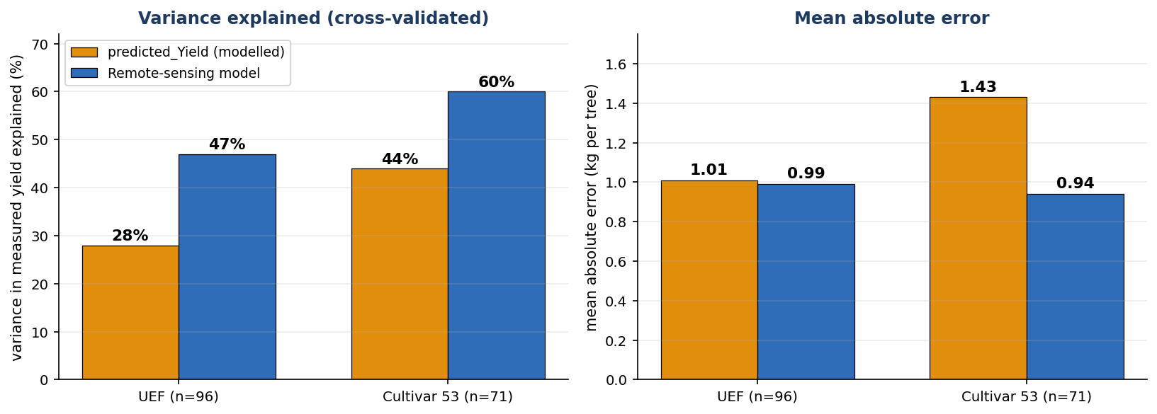
Figure 23: Prediction accuracy against field-measured yield, split by cultivar. The remote-sensing model leads on both metrics in each cultivar, most clearly in cultivar 53.

6.6.2 Prediction Model: Feature Selection
Drawing predicted_Yield from the Efrat et al. (2025) files (1,793 tree-year records) alongside the per-tree UAV, cultivar, climate and physiological variables, the second question characterizes predicted_Yield as a target in its own right, over the full set of 1,793 tree-year records for which it is available. Features were chosen by forward selection under five-fold cross-validation; up to seven features were permitted, but four were sufficient in each case, with any further feature adding less than 0.2 percentage points of cross-validated variance. Two feature sets were built. The first uses only remote sensing and agro-climatic features: winter chill (Chill Portions), April canopy growth, cultivar, and a bloom-hotspot fraction. The second additionally uses two physiological variables, canopy nitrogen content in June (CNC; Woldenberg et al., 2025) and April stem water potential (SWP), which are among the variables the Efrat et al. (2025) model uses to compute predicted_Yield.
The two modelling efforts differ in scope and should not be read as competing versions of the same analysis. The published product was developed across the laboratory's wider orchard dataset and multiple sensing modalities, and is designed to generalize across sites; the model reported here is fitted to one plot, from RGB-derived bloom indices, cultivar and station climate, and is validated against that plot's measured harvest. The comparison in this section is therefore local: it establishes which model better describes the harvest of Plot A, not which approach is superior in general, and the single-plot model would have to be refitted, not merely applied, to be used elsewhere.

6.6.3 Model-Family Comparison
The best model overall was a random forest using the four physiological and agro-climatic features (canopy nitrogen content in June and April stem water potential, together with cultivar and April canopy growth). Reported in the performance metrics standard to comparable UAV yield studies (Efrat et al., 2025; Woldenberg et al., 2025), it predicted predicted_Yield with a cross-validated R-squared of 0.98, a root-mean-square error of 0.19 kg per tree, and a mean absolute error of 0.14 kg per tree, about 3 to 5 percent of the 4.26 kg per tree mean (Table 22). The remote-sensing-only random forest, which uses no physiological variables, reached a cross-validated R-squared of 0.85 at a root-mean-square error of 0.52 kg per tree. Because canopy nitrogen content and stem water potential are among the variables from which predicted_Yield is generated, these figures describe how closely the modelled product is predicted from UAV and agro-climatic inputs.

Table 22. Performance of the best model, a random forest, predicting the modelled predicted_Yield (n = 1,793 tree-years), in the standard metrics used in comparable UAV yield studies. Relative errors are expressed as a percentage of the 4.26 kg per tree mean. The physiological variables (CNC and SWP) are among the variables predicted_Yield is generated from.
Random Forest model | R-squared (CV) | RMSE (kg/tree) | MAE (kg/tree) | rel. RMSE | rel. MAE
Remote-sensing features only | 0.85 | 0.52 | 0.37 | 12.1% | 8.6%
With physiological data (best) | 0.98 | 0.19 | 0.14 | 4.5% | 3.3%

Each feature set was fitted with six model families to identify the best predictor of predicted_Yield: an ordinary-least-squares Gaussian generalized linear model, ridge regression, a degree-two polynomial, a random forest, k-nearest-neighbours, and a linear mixed model with a tree-level random intercept (Table 23). With the remote-sensing feature set, all six families landed within a narrow band at a cross-validated R-squared of 0.84 to 0.85, with the random forest marginally the best (0.85). The flat profile across linear and nonlinear models indicates that four remote-sensing features already capture the predictable part of predicted_Yield, with little further nonlinear structure to exploit. Adding the physiological variables raised accuracy to a cross-validated R-squared of 0.93 for the linear models and 0.98 for the random forest, which was the best model overall. The random-intercept mixed model matched the plain generalized linear model in both feature sets, so the tree-level grouping added no predictive value here.
Table 23. Cross-validated R-squared for six model families predicting predicted_Yield, under the remote-sensing feature set (four features: Chill Portions, April growth, cultivar, bloom-hotspot fraction) and with the physiological variables added (CNC and April SWP). The random forest was best in both.
Model family | RS-only (cvR-squared) | With physiology (cvR-squared)
OLS (Gaussian GLM) | 0.844 | 0.931
Ridge regression | 0.844 | 0.931
Polynomial (degree 2) | 0.848 | 0.941
Random Forest | 0.853 | 0.980
k-nearest-neighbours | 0.848 | 0.960
Mixed model (tree random intercept) | 0.844 | 0.931

The random forest predicts predicted_Yield more closely than the linear models for three reasons. The two physiological variables are very strongly related to the target (canopy nitrogen content in June alone correlates at r = +0.95), so a model with access to them starts from most of its variation; that relationship is nonlinear and interaction-rich, which a forest captures directly through its threshold splits but a linear or polynomial model only approximates, lifting accuracy from 0.93 to 0.98; and because predicted_Yield is itself a random-forest output, a random forest matches its piecewise, threshold-based form. Since the target is a deterministic model output rather than a noisy field measurement, the fit shows little overfitting: its cross-validated R-squared of 0.98 is close to its in-sample value of 0.986.

6.6.4 Feature Roles and Contributions
The order in which features enter each model is informative in itself (Table 24). In the remote-sensing model, winter chill (Chill Portions) enters first and alone reaches a cross-validated R-squared of 0.82, an efficient proxy for the large between-season difference in the target; April canopy growth lifts it to 0.84, and cultivar and a bloom-hotspot fraction add a fraction of a percentage point each. In the physiological model, the order changes: canopy nitrogen content in June enters first and alone reaches 0.90, April stem water potential follows, and cultivar and April growth enter last with small gains.
Table 24. Features entering the two prediction models of predicted_Yield, with each feature's correlation with the target and its role. 'Not offered' denotes the physiological features that were excluded by design from the remote-sensing-only feature set.
Feature | Correlation with target | In the remote-sensing model | In the physiological model | What it contributes
Chill Portions (chill) | +0.91 | selected, entered 1st | not selected | between-season signal; redundant with CNC (r=+0.89) once physiology is present
April canopy growth | +0.73 | selected | selected | early-season vigour; adds independent signal in both
Cultivar | -0.06 | selected | selected | weak on its own; a small between-cultivar offset once drivers are in
Bloom-hotspot fraction | -0.32 | selected | not selected | weak tree-level bloom; subsumed by CNC and SWP
Canopy nitrogen content, June | +0.95 | not available to this model | selected, entered 1st | strongest correlate; the dominant physiological driver
April stem water potential | +0.87 | not available to this model | selected, entered 2nd | early water status; adds beyond CNC (r=+0.83)
Mean EBI | -0.17 | not selected | not selected | mean bloom is only weakly related to the target
34 engineered bloom-texture features | varies | not selected | not selected | each contributes a negligible amount

The two models overlap in a readable way. Winter chill, the leading remote-sensing feature, is never included in the physiological model because canopy nitrogen content carries the same between-season information (r = +0.89) alongside tree-level detail. The bloom-hotspot fraction is likewise dropped once the richer nitrogen and water-status signals are present. April canopy growth and cultivar survive in both models, growth adding an early-vigour signal only partly shared with nitrogen (r = +0.67) and cultivar a small between-cultivar offset. Mean EBI and the remaining engineered bloom-texture features enter neither model.
A random-forest permutation-importance analysis of the remote-sensing feature set (averaging the cross-validated R-squared drop when each feature is shuffled) shows that the predictable signal in predicted_Yield is dominated by a few variables (Figure 24). Winter chill (Chill Portions), a station-level, between-season quantity, alone accounts for about 89 percent of the total positive contribution; April canopy growth for about 8 percent; and cultivar and a bloom-texture feature for roughly 1 percent each. Each of the 34 engineered bloom-texture candidates contributes a negligible share individually. This concentration explains why four features saturate the remote-sensing model and why the larger engineered feature bank adds nothing.
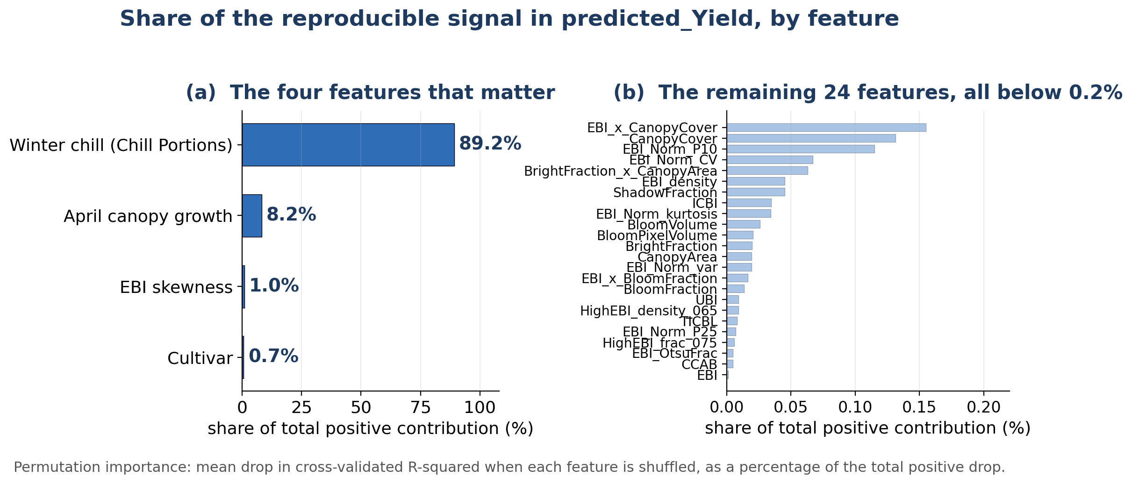
Figure 24: Share of the predictable signal in predicted_Yield by feature, from a random-forest permutation-importance analysis of the remote-sensing feature set. (a) Four features carry almost all of it: winter chill accounts for 89.2 percent, April canopy growth for 8.2 percent, and EBI skewness and cultivar for about 1 percent each. (b) The remaining 24 contributing features are each below 0.2 percent, which is why four features saturate the model and the wider engineered feature bank adds nothing.

6.6.5 Synthesis of the Prediction Results
The two prediction analyses reported above answer different questions and are set out together in Table 25 and Figure 25. Against the field-measured harvest, the compact remote-sensing model explains 46 percent of the variance under cross-validation and predicted_Yield 29 percent, and the advantage holds within each cultivar. Against the modelled predicted_Yield as target, four remote-sensing features recover about 85 percent of its variance, and a random forest that is additionally supplied with the physiological variables from which that product is generated reaches about 98 percent. The first pair measures accuracy against a harvested weight; the second measures how closely a modelled quantity can be reproduced from its own inputs. They are therefore not comparable, and only the first describes yield prediction.
Table 25. The two prediction questions kept apart. The upper rows report predictive accuracy against field-measured yield for this orchard; the value published by Efrat et al. (2025) is listed for context but was obtained from their own harvest measurements and sample, so it is not directly comparable to the rows above it. The lower rows report how closely the modelled predicted_Yield can itself be predicted, a different target from the measured harvest and therefore not comparable with the rows above.
Model | Target | Cross-validated R-squared
Remote-sensing model (this thesis) | Field-measured yield | 0.46
predicted_Yield (Efrat et al., 2025) | Field-measured yield | 0.29
Efrat et al. (2025), as published | Their own field-measured yield, Plot A test set | 0.87
Random forest, remote-sensing features | predicted_Yield (modelled output) | 0.85
Random forest, with physiological variables | predicted_Yield (modelled output) | 0.98
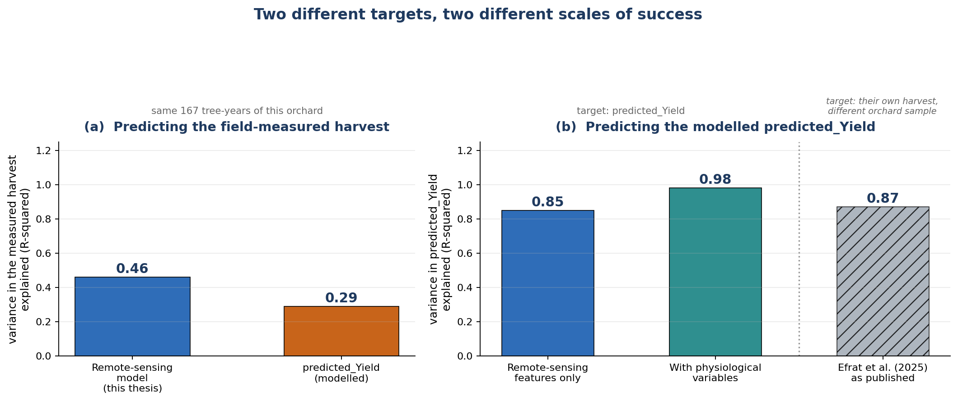
Figure 25: The two prediction targets side by side. (a) Predicting the field-measured harvest on the same 167 tree-years: the remote-sensing model developed here explains 46 percent of the variation against 29 percent for the modelled predicted_Yield. (b) Predicting predicted_Yield itself is an easier target, reaching 85 percent from remote-sensing features alone and 98 percent once the physiological variables it is generated from are supplied; the value published by Efrat et al. (2025) is shown hatched for reference, since it was obtained against their own harvest measurements on a different orchard sample and is therefore not directly comparable with either group.

7. Discussion
This study addressed two complementary research objectives: first, to develop an integrated UAV-based framework capable of generating accurate, persistent, georeferenced individual-tree objects from RGB imagery; and second, to demonstrate how these tree-level datasets can support biological and agronomic analyses beyond conventional image segmentation. The proposed framework successfully combined semantic segmentation, adaptive instance delineation, geospatial processing, and GIS-based data integration into a unified workflow, achieving high segmentation accuracy and efficient large-scale processing. The resulting individual-tree dataset enabled four seasons of bloom phenology analysis and revealed that bloom intensity is primarily governed by cultivar and spatial location, whereas bloom timing is more closely associated with winter climatic conditions. Furthermore, the study demonstrated that bloom-yield relationships differ fundamentally between cultivars and that integrating remotely sensed tree characteristics with environmental information improves tree-level yield prediction. These findings highlight the importance of treating individual trees as the fundamental analytical unit for precision orchard monitoring and provide new insights into linking computer vision, phenology, and productivity within a single operational framework.

7.1 Overview of the Main Findings
Four findings carry the thesis, and the sections that follow take them in turn. The first is technical: semantic segmentation, adaptive crown separation and geospatial registration can be combined into a single workflow that turns raw drone frames into persistent, georeferenced individual-tree objects, at an accuracy sufficient for agronomic use and at a throughput that makes whole-orchard surveys practical on consumer hardware. The second is biological: across four seasons, bloom intensity is organized by cultivar and by position in the orchard rather than by year, and the cultivars converge steadily, while bloom timing behaves differently and tracks winter warmth. The third is agronomic and is the central result: the relationship between bloom and yield reverses in sign between cultivars, so that the same bloom brightness implies more fruit in one cultivar and less in another. The fourth is operational: a compact model combining cultivar, bloom, winter chill and early canopy growth predicts the measured harvest better than the modelled product currently available for this orchard.
These four results are connected by a single methodological commitment. Once the individual tree, rather than the image or the plot, becomes the unit of analysis, questions that cannot be posed at coarser resolution become answerable: whether cultivars differ in the way bloom translates into yield, whether bloom clusters in space within a cultivar, whether a tree that bloomed brightly last season does so again. The segmentation and registration machinery of Chapters 3 and 4 is therefore not the end of the work but its precondition, and the value of the framework is best judged by the biological questions it opens rather than by its Dice coefficient alone.
The five hypotheses set out in Section 1.5 can now be answered. H1 holds: on leaf-on imagery the instance-level F1 of 0.908 sits at the level of the semantic Dice of 0.894 from which it is derived, so crown separation is not where accuracy is lost, although the mask itself fails on dormant canopy and the claim is confined to the leaf-on scope. H2 holds: bloom is structured by cultivar in every season and, once each cultivar's own mean is removed, remains significantly clustered in space in all four (residual Moran's I 0.23 to 0.35, p = 0.005), so the random-in-space null is rejected. H3 holds: the date of fifty percent bloom tracks winter warmth across ten cultivar-years (r = +0.69, p = 0.03) while mean bloom intensity carries no dependable climate signal, which is the asymmetry the hypothesis predicted. H4 holds and is the central result: the common-slope null is rejected by a significant bloom-by-cultivar interaction (F = 11.58, p = 0.0009), with slopes of opposite sign in the two cultivars. H5 holds within the seasons sampled: the compact model reaches a cross-validated R-squared of 0.46 against the measured harvest, where bloom alone carries no orchard-wide signal and the cultivar-blind specification explains roughly half as much, but the model does not extrapolate to an unseen season, since winter chill takes one value per year.

7.2 Technical Contribution: An Integrated Individual-Tree Monitoring Framework
The system's most significant strength is its end-to-end completeness: no manual step is required between raw drone imagery and the GIS-ready registered mosaic, and the same per-tree crowns that the pipeline delivers become the unit of every downstream agronomic analysis in this thesis. The three-phase ArcGIS registration strategy is a particularly effective engineering response to the heterogeneous image quality of real-world drone surveys, adapting to each image through a principled fallback hierarchy rather than assuming laboratory-grade consistency. The modularity of the four-stage pipeline, with independently testable preprocessing, semantic segmentation, instance segmentation, and geospatial stages, allows each stage to be upgraded in isolation. This engineering produced calibrated, per-tree spectral indices for 1,523 trees across four seasons, which made the bloom, cultivar, climate, and yield analyses in Chapter 6 possible without field labour beyond the harvest survey.
None of the individual components is new. UNet++, Focal Tversky loss, marker-controlled watershed separation and affine raster registration are all established, and the contribution claimed here lies in closing the chain between them. Most UAV orchard studies stop at one of two places: a segmentation mask that exists only for the frame it was computed in, or a plot-level aggregate that dissolves the individual tree. Neither product can answer a question about a particular tree over several seasons. What this framework adds is persistence. Every crown becomes a georeferenced object with a stable identity, so the same tree can be revisited, joined to a harvest record, compared with its neighbours, and followed as conditions change. The analytical chapters of this thesis are the demonstration of that claim, since none of the cultivar, spatial or yield results could have been obtained from image-level masks.
The operating envelope should be stated as plainly as the capability. The workflow assumes leaf-on canopy, near-flat terrain and accuracy requirements at crown rather than sub-metre scale, and it delivers within those limits using consumer drone imagery, single-point geotags and no photogrammetric reconstruction. That is what makes it deployable: the barrier to tree-level orchard monitoring has rarely been the imaging, which is now cheap and routine, but the labour of converting images into records that can be analysed. Because the four stages are independently testable, the segmentation stage can be replaced as better architectures appear without disturbing the geospatial and analytical layers built on top of it, and the ArcGIS dependency of the mosaic stage is similarly a substitution rather than a redesign.

7.3 Biological Interpretation of Bloom Dynamics
The four-year bloom record is organized primarily by cultivar and by spatial position rather than by any orchard-wide temporal trend. Mean bloom intensity was essentially constant across seasons while its dispersion halved, so the salient temporal signal is a contraction of bloom heterogeneity, not a change in level; this is why EBI is most informative as an index of the tails and spatial structure of bloom rather than of plot-mean brightness. Cultivar was the dominant source of bloom variation early in the record and lost almost all its explanatory power by 2024, with the cultivar ANOVA F falling from about 1,385 to 4 and a strong cultivar-by-year interaction, a convergence that is the central phenological pattern of the study. Bloom was significantly spatially clustered in every season and most strongly in 2023, and this clustering, peaking in the season of greatest orchard-wide uniformity, points to an environmental or management gradient, such as microclimate, soil or irrigation, that organizes bloom beyond cultivar identity. Winter climate does not explain these patterns at the seasonal scale. Chill accumulation over the record is not monotonic, and the association between a cultivar seasonal chill and its mean bloom is weak and inconsistent in sign, so bloom intensity is best read as a cultivar and spatial phenomenon. The climate signal appears instead in bloom timing, which, resolved by cultivar and year, moves later in warmer winters (r = +0.69, p = 0.03, n = 10 cultivar-years), the delay expected when chilling is insufficient. The independent phenology surveys support the interpretation: the branch-level survey confirms that EBI responds to reproductive rather than vegetative development, and the growers' survey reproduces the cultivar order of bloom timing.
That cultivar should dominate bloom intensity is expected, since cultivar fixes the chilling and heat requirements that set both the date of flowering and its synchrony, and an image captures a moment in that schedule rather than a season-long total. A cultivar photographed close to its peak appears bright; one photographed while still opening, or already dropping petals, appears dimmer at identical flowering effort. Much of the large early separation is therefore likely to be phenological advancement at the moment of the flight rather than a difference in the quantity of bloom, which is why bloom timing and bloom intensity behave so differently in this record and why the timing signal is the one that tracks climate. The convergence admits two readings that the present data cannot fully separate: a genuine biological synchronization, in which declining winter chill compresses differences that chill requirement would otherwise spread apart, or a narrowing of the phenological gap at the flight date. Both are consistent with the observation that within-cultivar variability is unchanged while only the cultivar means approach one another.
The spatial result is the more surprising of the two and the harder to attribute. Bloom is significantly clustered within every cultivar in every season, which excludes cultivar layout as the cause and points to a gradient in the growing environment, most plausibly in soil depth, water availability or the microclimate of the plot. The clustering is strongest in 2023, the season in which the cultivars are most alike, so the spatial gradient becomes more visible precisely as the genetic signal recedes. Two observations sharpen the interpretation. The gradient persists even though individual trees do not hold their rank between seasons, which means the structure is a property of location rather than of particular trees, exactly what a soil or water gradient would produce and not what tree vigour alone would produce. And the gradient is invisible to any plot-mean summary, which is the clearest illustration in this study of why the tree rather than the plot has to be the unit of analysis.

7.4 Bloom-Yield Relationships and Cultivar Dependence
Measured yield is governed by cultivar, not by mean bloom. Against the field-measured harvest, spring bloom brightness carried essentially no orchard-level information, a weak and non-significant pooled correlation, whereas cultivar was a clear and significant effect, with UEF out-yielding cultivar 53. The central agronomic finding, however, is that this orchard-level null conceals a strong, opposite-signed relationship within each cultivar: the bloom-to-yield slope is positive in UEF and negative in cultivar 53, a significant EBI-by-cultivar interaction that roughly doubles the explained variance. A single, cultivar-blind bloom index is therefore not merely weaker but actively misleading, because the sign of the relationship it should report depends on which cultivar is in view. It also shows why the measured harvest is the only sound basis for this test: the modelled predicted_Yield is built partly from canopy and growth predictors, so a bloom correlation computed against it would not be an independent validation of the spectral signal.
Why the slopes should point in opposite directions is the question the result poses and does not answer, and several mechanisms are plausible. The first is source and sink balance. Almond is prone to alternate bearing, and a tree that flowers and sets heavily draws on reserves that limit kernel filling, so beyond some threshold additional bloom buys fruit number at the cost of kernel weight; if one cultivar in this orchard sits below that threshold and the other above it, the same additional bloom raises yield in one and depresses it in the other. The second is fruit set efficiency. Bloom brightness measures flowers, not fruit, and cultivars differ in how reliably a flower becomes a kernel, which depends on pollination, on the proximity and synchrony of compatible pollinizers, and on the weather during the short receptive window. Where set is limiting, more flowers help; where set is already saturated, more flowers mostly compete. The third is observational rather than biological: if the flight caught one cultivar before its peak and the other after, brightness would be reading advancement in one and retention in the other, and these need not relate to yield in the same direction.
Distinguishing these requires measurements this study did not make, and stating them defines the experiment that would settle it. Flower counts on tagged branches would separate flower number from canopy brightness; fruit set counts on the same branches would establish where in the flower-to-kernel chain the cultivars diverge; and flights timed to each cultivar's own peak rather than to a single calendar date would remove the phenological confound. Until then the reversal should be read as a robust description of this orchard, established on measured harvest with a significant interaction and reproduced within each cultivar, rather than as an established cultivar mechanism that other orchards will reproduce. Its practical force does not depend on resolving the mechanism: whatever its cause, a bloom index applied without regard to cultivar will average two opposing relationships and report that bloom does not predict yield, which is the wrong conclusion drawn from correct data.

7.5 Implications for UAV-Based Yield Prediction
Two prediction results follow. A compact remote-sensing model, using cultivar, bloom with its cultivar interaction, winter chill and April growth, predicted the measured harvest more closely than the laboratory's modelled predicted_Yield, explaining 46 versus 29 percent of variance under cross-validation and doing so within each cultivar; it is the model actually validated against the real harvest. Separately, the modelled predicted_Yield is itself highly predictable from UAV and agro-climatic features: four remote-sensing features recover about 85 percent of its variance, and a random forest using the physiological variables it is generated from reaches about 98 percent. The remote-sensing model is thus the more accurate predictor of this orchard's harvest, while the second analysis characterizes how far UAV features alone predict the modelled product.
The composition of the model matters more than its coefficient of determination. Cultivar enters first and carries the largest share, which is the same result the yield analysis produced by a different route. Bloom enters only through its interaction with cultivar, consistent with the reversal described above and with the finding that bloom alone has no orchard-wide signal. Winter chill contributes at the level of the season rather than the tree, since every tree in a year shares one value, so its coefficient absorbs whatever distinguishes an on year from an off year. April canopy growth is the one genuinely tree-level physiological input, and its contribution is readily interpretable: a tree that expands its canopy early has the resources to fill kernels later. The model is therefore not a black box fitted to spectral noise but a compact statement that yield in this orchard follows genotype, early vigour and the cultivar-specific way bloom converts to fruit.
Two boundaries on transferability follow from the same structure. Because chill is constant within a season, holding out an entire year leaves its coefficient unidentified, and the model does not extrapolate to an unseen season; what it does reliably is interpolate across trees within the seasons sampled. Grouping the cross-validation by tree identity, so that no tree appears in both training and testing, changes the result very little, which shows the performance does not rest on repeated observations of the same trees. The second analysis, in which a random forest recovers about 98 percent of the modelled predicted_Yield, should be read as an emulation exercise rather than as evidence about harvest accuracy: the model is supplied with the physiological variables from which its target was generated, and reproducing a model from its own inputs is a different and much easier task than predicting a harvest. The honest comparison against the measured crop is the 46 percent against 29 percent, and it is the only one of these numbers that describes yield prediction.

7.6 Implications for Precision Orchard Management
The practical consequence of the cultivar-dependent bloom-yield relationship is that bloom-based decision support cannot be deployed orchard-wide. A single bloom index applied across a mixed planting averages two opposing relationships and returns approximately nothing, which is precisely what the pooled correlation shows. Any operational use of bloom imagery for yield expectation, thinning, or harvest logistics must therefore be built and calibrated per cultivar, and the cultivar map must be maintained as carefully as the imagery. This is a demanding requirement in commercial orchards, where cultivar boundaries are often approximate and pollinizer rows interleave with the main variety, and it is an argument for treating cultivar identity as core orchard data rather than as an annotation.
The persistence of the tree objects is what makes the framework operationally useful beyond a single survey. Because every tree retains its identity and coordinates between seasons, the same records accumulate year on year and can be joined to irrigation, fertilization, harvest and phenology data as those become available. That is the substrate a digital twin of an orchard requires, and it is reached here without specialized positioning hardware or photogrammetric reconstruction, using consumer drone imagery and a registration workflow. The limiting factor for adoption is not the imaging but the ground truth: the yield records that anchor any predictive model remain the scarcest input, and the analysis here rests on a single well-sampled harvest season.

7.7 Limitations
The limitations fall into three groups, and each bounds the conclusions in a specific way. The technical limits come from the imaging and the pipeline. Positions derive from single-point consumer GNSS geotags with no attitude record, giving a localization ceiling of two to five metres that registration improves but cannot remove, so the tree objects are reliable at crown scale and unsuitable as they stand for sub-metre tasks such as robotic harvesting. The mosaics are registered rather than orthorectified, and because the frames vary in heading and off-nadir angle, residual displacement is largest for oblique views and tall canopy away from the image centre. The segmentation model is reliable only on leaf-on canopy: on dormant, leafless imagery it labels the entire frame as canopy, which is why the analytical scope is restricted to leaf-on and bloom-period flights and why no dormant-season index appears in this thesis. Full bloom remains the hardest phase for crown separation, since dense white flower cover blurs boundaries that human annotators also find ambiguous. The mosaic stage depends on ArcGIS Pro licensing, which limits reproduction by others more than it limits the result, and no benchmark was run against established photogrammetric software such as Agisoft Metashape, Pix4D or OpenDroneMap, so the registered mosaic is characterized by its own error budget rather than relative to an alternative reconstruction. Finally, the acquisitions were not radiometrically controlled: no reflectance panels or calibration targets were flown, exposure was left to the camera, and flight altitude and time of day were held only approximately constant, so absolute index values are comparable within a flight with more confidence than between flights.
The experimental limits come from the design of the survey. All observations are from one orchard at one farm, so nothing here establishes that the patterns generalize; three cultivars are represented in the bloom analysis but only two carry measured yield, so the reversal is demonstrated on a single cultivar pair. Four bloom seasons is a short record for a climate question, and the harvest survey is effectively one well-sampled season, which is why the yield results are strongest as between-tree comparisons within 2023 and weakest as statements about years. A different camera was flown in each season, which is a genuine confound for any multi-season comparison; the variance decomposition and the NGRDI control in Section 6.4.2 argue against an instrumental explanation for the convergence, but they do not remove the design flaw. The annotations were produced by a single annotator, which gives internal consistency but leaves annotation uncertainty unmeasured, and the training, validation and test images were divided at random rather than grouped by flight, so overlapping frames may be radiometrically and spatially similar across the split and the reported segmentation accuracy should be read as an upper estimate for genuinely new flights.
The statistical limits follow from the structure of the data. Climate is recorded at one station and takes a single value per season, so the seasonal climate associations rest on four observations, or ten cultivar-years for bloom timing, and are directional rather than inferential; the chill model is also parameterized for Mediterranean conditions rather than for Israeli almond specifically. Because chill is constant within a season, a model trained on one year cannot identify its coefficient, and leave-one-year-out validation accordingly fails: the yield model interpolates between trees within the seasons sampled and should not be expected to predict an unseen season. Bloom is spatially autocorrelated in every season, so nearby trees are not independent observations, and tree-level rank agreement between seasons is weak after 2022, which limits claims about the consistency of individual trees to the cultivar means rather than the trees themselves. No external validation set exists, since every result comes from the same orchard and the same four flights. Throughout, the inferential weight rests on the tree-level slopes and the within-cultivar and cross-validated analyses, not on the small-sample seasonal correlations.

7.8 Future Research Directions
The clearest extensions address these limitations directly. The ground reference data, the surveyed tree positions and the harvest records, were collected with RTK GNSS, so the positional uncertainty in this work lies entirely on the imaging side. Carrying that accuracy into the imagery, by flying an RTK-tagged platform or by recording camera attitude alongside position, would remove the metre-scale registration residual and make multi-temporal tracking of the same crowns exact rather than approximate. Adding calibrated multispectral or hyperspectral bands, including near-infrared and red-edge, would provide direct vigour and stress indices and remove the illumination sensitivity of RGB-derived EBI and NGRDI. Continuing the annual survey for eight or more seasons would provide the statistical power needed to formally test the chill-to-bloom hypothesis and to build a multi-season, tree-level yield model that combines bloom, cultivar, and climate, while within-season multi-flight sampling would replace interpolated bloom-timing estimates with fitted phenological curves. Pairing sub-canopy photography with drone flights on the same date would resolve the branch-to-canopy-scale mismatch observed in the 2021 comparison. Finally, repeating the analysis at a geographically distinct farm would establish whether the cultivar-convergence and cultivar-dependent bloom-yield patterns generalize, and per-tree yield from precision-harvest equipment would turn the prediction models from a restatement of an existing product into a directly validated tree-level yield tool.
On the model side, the segmentation stage is the component most likely to be superseded soon. Lightweight vision transformers and promptable foundation models for segmentation have reduced the annotation burden substantially since this work began, and they are the natural route to the dormant-canopy case that defeats the present network, where the informative structure is thin branch geometry rather than a coloured surface. Because the pipeline is modular, such a model can be substituted at the segmentation stage without touching the geospatial or analytical layers. Structural sensing would complement it: LiDAR or photogrammetric canopy height would supply the volume and architecture that a two-dimensional index cannot, and would let canopy size be separated from bloom density in the yield models, where the two are currently entangled. A cheaper experiment than any of these would be to sweep the focal exponent of the loss, which was reasoned to 0.75 and then held fixed in every run reported here. Values above one shift gradient toward the worst-segmented crowns and would trade precision for recall, which may nonetheless suit the full-bloom condition where boundaries are hardest and missed trees are the dominant error.
On the agronomic side, the reversal in the bloom-to-yield relationship is the finding most worth pursuing, and the experiment that would resolve it is modest: tagged branches counted for flowers and again for set fruit, in both cultivars, with flights timed to each cultivar's own peak rather than to a common calendar date. Extending the harvest survey to several seasons and to more cultivars would convert the single-season result into a multi-year, tree-level model, and per-tree weights from precision-harvest equipment would remove the dependence on a manual survey altogether. Repeating the whole analysis at a geographically distinct orchard remains the decisive test of generality. Taken together, these extensions point toward a persistent tree-level record updated each season and joined to irrigation, nutrition and harvest data, which is the practical form a digital twin of an orchard would take and for which the framework developed here supplies the underlying spatial object.

8. Conclusion
This thesis developed and evaluated an integrated UAV-based framework for individual-tree orchard monitoring that combines deep-learning semantic segmentation, adaptive instance delineation, geospatial processing, and agronomic analysis within a unified workflow. The framework generated persistent GIS-ready individual-tree objects from RGB UAV imagery and demonstrated how these products can support multiseason analyses of bloom phenology, cultivar variability, spatial structure, and tree-level yield prediction. The principal findings show that (i) individual-tree mapping can be achieved with high segmentation and geospatial accuracy, (ii) bloom intensity is primarily structured by cultivar and spatial location, whereas bloom timing is more closely associated with winter climatic conditions, (iii) bloom-yield relationships are cultivar dependent rather than universal, and (iv) integrating remotely sensed tree characteristics with environmental information improves tree-level yield prediction. Together, these findings demonstrate that accurate individual-tree mapping provides a valuable foundation for linking computer vision with biological interpretation and precision orchard management. From a technical perspective, the proposed four-stage framework, comprising image preprocessing, semantic segmentation, adaptive instance delineation and geospatial processing, achieved a semantic Dice coefficient of 0.894, an instance-level precision of 0.916 and a recall of 0.899 on held-out leaf-on imagery, together with a geolocation accuracy of 2.4 m RMS. The ArcGIS-based post-processing workflow transformed individual image predictions into a quality-controlled GIS-ready registered mosaic using a robust three-stage image registration strategy, achieving a 96% registration success rate across heterogeneous operational imagery. Beyond its computational performance, the framework substantially reduces the effort required for orchard inventories while enabling repeatable tree-level monitoring over large commercial orchards.
The persistent individual-tree dataset generated by this framework enabled biological and agronomic analyses that extend well beyond image segmentation. Four years of observations showed that bloom intensity is primarily determined by cultivar and spatial location, whereas bloom timing is more responsive to interannual winter climatic variability. Most importantly, the relationship between bloom and yield differed fundamentally between cultivars, demonstrating that generalized bloom-based yield indicators may obscure cultivar-specific responses. Integrating UAV-derived bloom characteristics with environmental variables improved tree-level yield prediction compared with the laboratory's existing modelled product, highlighting the importance of combining phenological, climatic, and structural information for orchard productivity assessment. These findings position individual-tree mapping not as the final objective of UAV image analysis, but as the enabling foundation for quantitative orchard science. Although the proposed framework was evaluated under realistic operational conditions, further validation across additional orchards, cultivars, climatic regions, and growing seasons is required to establish its broader applicability. Future integration of higher-accuracy positioning systems, multisensor UAV observations, and advanced physiological measurements could further improve both tree delineation and predictive performance. More broadly, this work demonstrates how integrating artificial intelligence, geospatial technologies, and agronomic knowledge can transform UAV imagery into biologically meaningful information, providing a scalable foundation for precision orchard management, digital twins, and next-generation decision-support systems.
Two conclusions follow for yield prediction specifically. Against this orchard's real harvest the compact remote-sensing model developed here is the better predictor, explaining 46 percent of measured yield under cross-validation against 29 percent for the existing modelled product, and doing so within each cultivar; it is the model built and validated directly against the measured crop, and it recovers the cultivar-dependent bloom-to-yield relationship that is the central agronomic finding of this work. Separately, that modelled product proves highly predictable from UAV and agro-climatic features, which characterises how far remote sensing can reproduce it but says nothing about accuracy against a harvest. Keeping these two questions apart is necessary for any honest account of what UAV imagery can currently deliver for tree-level yield.

References
Abraham, N., & Khan, M. S. (2019). A novel Focal Tversky loss function with improved Attention U-Net for segmentation of tumor regions in medical images. Journal of Digital Imaging, 32(3), 506-512.
Breiman, L. (2001). Random forests. Machine Learning, 45(1), 5-32.
Chakraborty, M., Pourreza, A., Zhang, X., Jafarbiglu, H., Shackel, K. A., & DeJong, T. (2023). Early almond yield forecasting by bloom mapping using aerial imagery and deep learning. Computers and Electronics in Agriculture, 212, 108063.
Chen, B., Jin, Y., & Brown, P. (2019). An enhanced bloom index for quantifying floral phenology using multi-scale remote sensing observations. ISPRS Journal of Photogrammetry and Remote Sensing, 156, 108-120.
Chen, L.-C., Papandreou, G., Kokkinos, I., Murphy, K., & Yuille, A. L. (2017). DeepLab: Semantic image segmentation with deep convolutional nets, atrous convolution, and fully connected CRFs. IEEE TPAMI, 40(4), 834-848.
Díaz-Varela, R. A., et al. (2015). High-resolution airborne UAV imagery to assess olive tree crown parameters using 3D photo reconstruction. Agronomy, 5(4), 466-487.
Dosovitskiy, A., et al. (2021). An image is worth 16x16 words: Transformers for image recognition at scale. ICLR 2021.
Efrat, N., Dubinin, V. (Moshe), Baram, S., & Paz-Kagan, T. (2025). Modeling seasonal water status and predicting yield in almond orchards using UAV multi-sensor and meteorological data. Agricultural Water Management, 320, 109868.
Fishman, S., Erez, A., & Couvillon, G. A. (1987). The temperature dependence of dormancy breaking in plants: Computer simulation of processes studied under controlled temperatures. Journal of Theoretical Biology, 126(3), 309-321.
Fix, E., & Hodges, J. L. (1951). Discriminatory analysis: Nonparametric discrimination, consistency properties. USAF School of Aviation Medicine, Randolph Field, Texas.
He, K., Gkioxari, G., Dollar, P., & Girshick, R. (2017). Mask R-CNN. ICCV 2017.
He, K., Zhang, X., Ren, S., & Sun, J. (2015). Deep residual learning for image recognition. CVPR 2015.
Hoerl, A. E., & Kennard, R. W. (1970). Ridge regression: Biased estimation for nonorthogonal problems. Technometrics, 12(1), 55-67.
Hunt, E. R., Cavigelli, M., Daughtry, C. S. T., McMurtrey, J. E., & Walthall, C. L. (2005). Evaluation of digital photography from model aircraft for remote sensing of crop biomass and nitrogen status. Precision Agriculture, 6(4), 359-378.
Jin, X., et al. (2019). Estimates of plant density of wheat crops at emergence from very low altitude UAV imagery. Remote Sensing of Environment, 198, 105-114.
Johannes, A., et al. (2017). Automatic plant disease diagnosis using mobile capture devices, applied on a wheat use case. Computers and Electronics in Agriculture, 138, 200-209.
Kaartinen, H., et al. (2012). An international comparison of individual tree detection and extraction using airborne laser scanning. Remote Sensing, 4(4), 950-974.
Ke, Y., & Quackenbush, L. J. (2011). A review of methods for automatic individual tree-crown detection and delineation from passive remote sensing. International Journal of Remote Sensing, 32(17), 4725-4747.
Kirillov, A., Mintun, E., Ravi, N., Mao, H., Rolland, C., Gustafson, L., Xiao, T., Whitehead, S., Berg, A. C., Lo, W.-Y., Dollar, P., & Girshick, R. (2023). Segment Anything. IEEE/CVF International Conference on Computer Vision (ICCV), 4015-4026.
Laird, N. M., & Ware, J. H. (1982). Random-effects models for longitudinal data. Biometrics, 38(4), 963-974.
Lin, T. Y., Goyal, P., Girshick, R., He, K., & Dollar, P. (2017). Focal loss for dense object detection. ICCV 2017.
Long, J., Shelhamer, E., & Darrell, T. (2015). Fully convolutional networks for semantic segmentation. CVPR 2015.
Meyer, F., & Beucher, S. (1989). Morphological segmentation. Journal of Visual Communication and Image Representation, 1(1), 21-46.
Milletari, F., Navab, N., & Ahmadi, S. A. (2016). V-net: Fully convolutional neural networks for volumetric medical image segmentation. 3DV 2016.
Morales, G., et al. (2019). Deep learning for tree crown detection in hazelnut orchards. Remote Sensing, 11(23), 2821.
Moran, P. A. P. (1950). Notes on continuous stochastic phenomena. Biometrika, 37(1/2), 17-23.
Osco, L. P., et al. (2021). A review of deep learning in remote sensing: An analysis of limitations and challenges in high-resolution imagery. Remote Sensing, 13(24), 5042.
Pelletier, C., et al. (2019). Temporal convolutional neural network for the classification of satellite image time series. Remote Sensing, 11(5), 523.
Ronneberger, O., Fischer, P., & Brox, T. (2015). U-net: Convolutional networks for biomedical image segmentation. MICCAI 2015.
Salehi, S. S. M., Erdogmus, D., & Gholipour, A. (2017). Tversky loss function for image segmentation using 3D fully convolutional deep networks. MLMI 2017.
Tan, M., & Le, Q. (2019). EfficientNet: Rethinking model scaling for convolutional neural networks. ICML 2019.
- Tang, M., Sadowski, D. L., Peng, C., Vougioukas, S. G., Klever, B., Khalsa, S. D. S., Brown, P. H., & Jin, Y. (2023). Tree-level almond yield estimation from high resolution aerial imagery with convolutional neural network. Frontiers in Plant Science, 14, 1070699.
Teng, M., Ouaknine, A., Laliberte, E., Bengio, Y., Rolnick, D., & Larochelle, H. (2025). Assessing SAM for tree crown instance segmentation from drone imagery. ICLR 2025 Machine Learning for Remote Sensing Workshop. arXiv:2503.20199.
Woldenberg, O., Dubinin, V. (Moshe), Baram, S., & Paz-Kagan, T. (2025). Bridging the gap between leaf and canopy nitrogen content in almond orchard with UAV-based sensor fusion. Smart Agricultural Technology, 12, 101355.
Zhen, Z., et al. (2016). Seeing the forest from drones: Testing the potential of lightweight drones as a tool for long-term forest monitoring. Biological Conservation, 198, 60-69.
Zhou, Z., et al. (2020). UNet++: Redesigning skip connections to exploit multiscale features in image segmentation. IEEE Transactions on Medical Imaging, 39(6), 1856-1867.

Appendix A: Configuration Parameters Quick Reference
Table 26 lists every configurable parameter of the pipeline with its default value, valid range and effect.
Table 26. Configuration parameters quick reference.
Parameter Group | Parameter | Default Value | Valid Range
Data | IMAGE_SIZE | 1024 | 512 - 2048
Data | PIXEL_SIZE_M | 0.02 | 0.01 - 0.10
Data | EPSG_CODE | 32636 | Site-dependent
Preprocessing | GAMMA_TARGET | 0.5 | 0.3 - 0.7
Preprocessing | GAMMA_CLIP_MIN | 0.8 | 0.5 - 0.9
Preprocessing | GAMMA_CLIP_MAX | 1.3 | 1.1 - 2.0
Preprocessing | CLAHE_BASE_CLIP | 2.0 | 1.0 - 4.0
Training | LEARNING_RATE | 0.0004 | 0.0001 - 0.001
Training | BATCH_SIZE | 4 | 2 - 16 (GPU memory limited)
Training | EPOCHS | 20 | 10 - 50
Loss | ALPHA (FP weight) | 0.3 | 0.1 - 0.5
Loss | BETA (FN weight) | 0.7 | 0.5 - 0.9
Loss | GAMMA (focal) | 0.75 | 0.5 - 1.0
Instance Seg. | MIN_AREA | 200 px | 100 - 500
Instance Seg. | MIN_DIST_BETWEEN_TREES | 25 px | 15 - 40
Instance Seg. | RELATIVE_AREA_FACTOR | 0.20 | 0.10 - 0.30
Instance Seg. | SOLIDITY_THRESHOLD | 0.70 | 0.60 - 0.80
ArcGIS | MAX_RMS_STRICT | 2.0 m | 1.0 - 3.0
ArcGIS | MAX_RMS_NORMAL | 5.0 m | 3.0 - 8.0
ArcGIS | MIN_GCPS | 10 | 5 - 20
ArcGIS | MAX_MEAN_SHIFT | 15.0 m | 10 - 25

Appendix B: ArcGIS Registration Log JSON Schema
{"success": ["img001.tif", "img002.tif", ...],
"failed": ["img017.tif", ...],
"methods": {"img001.tif": "direct",
"img012.tif": "offset",
"img089.tif": "hist"}}
Registration methods: 'direct' = Phase A (direct registration), 'offset' = Phase B (GPS offset-corrected), 'hist' = Phase C (histogram-matched), absent = failed. The JSON log supports resumption of interrupted processing by skipping already-registered images.

