Power query

Renaming Unclear Columns
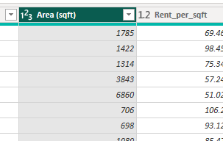
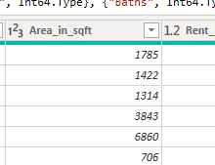

My first step was to change variable names I started from changing the area variable name I did the same for several others for example I changed ‘Age_of_Listing_in_days’ to ‘Listing Age (days)’.

Correcting data types
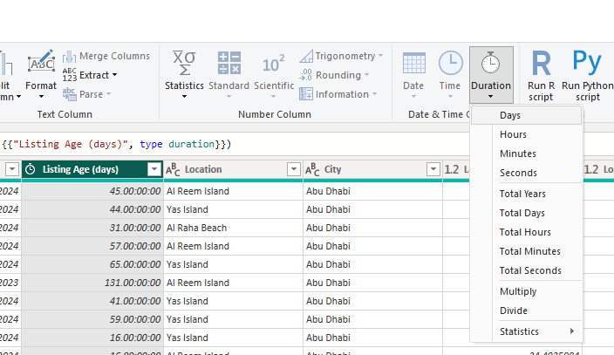
The only data type I had to correct was changing Listing age to a duration data type in days.

Removing blank row and duplicates
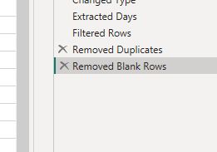
The next steps was removing duplicate and blank rows.

Formatting
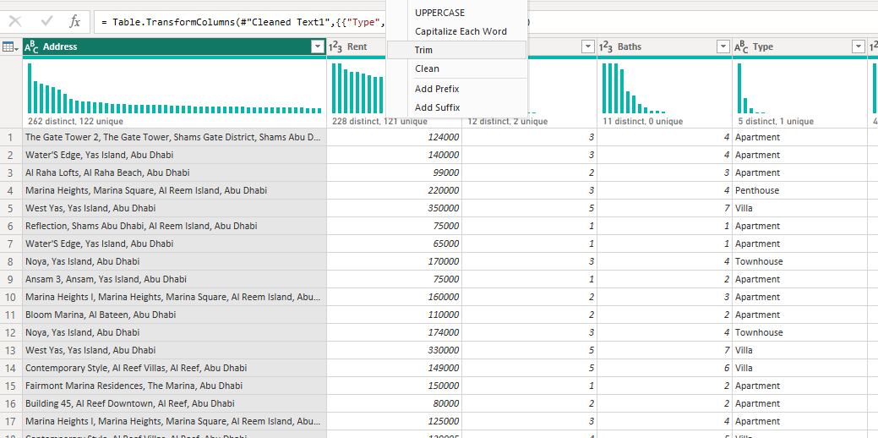
I formatted All text fields by capitalizing by trimming cleaning and capitalizing each word.

Replacing inconsistent values
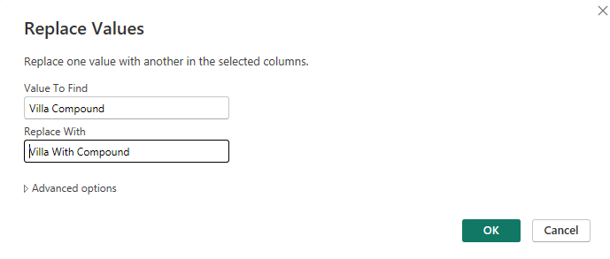
I replaced ‘villa compound’ to ‘villa with compound’.

Handling missing values
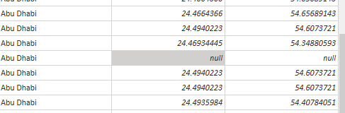
The only missing values we had were longitude and latitude values this was not a big deal as this variable will only be used for map visualization.

Removing unnecessary columns

Splitting columns
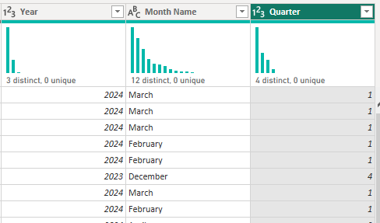
I Then split the posted date column into year, month and quarter.

Custom columns
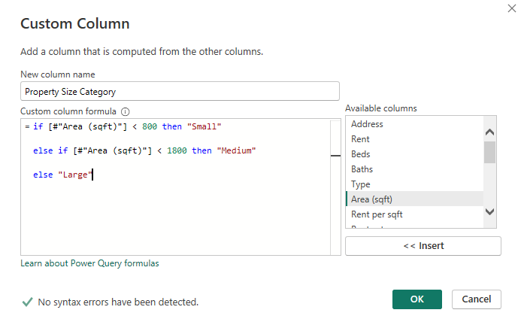
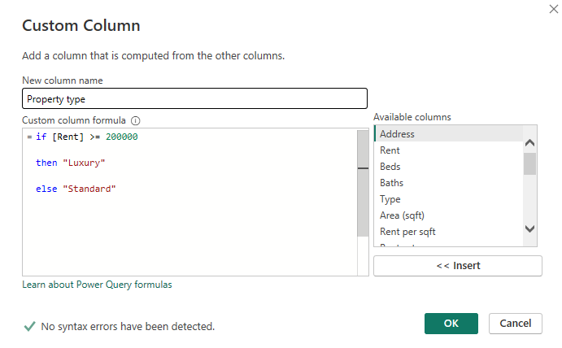
I created two new columns showing size and luxury categories.

Advanced Power query

Creating a date table
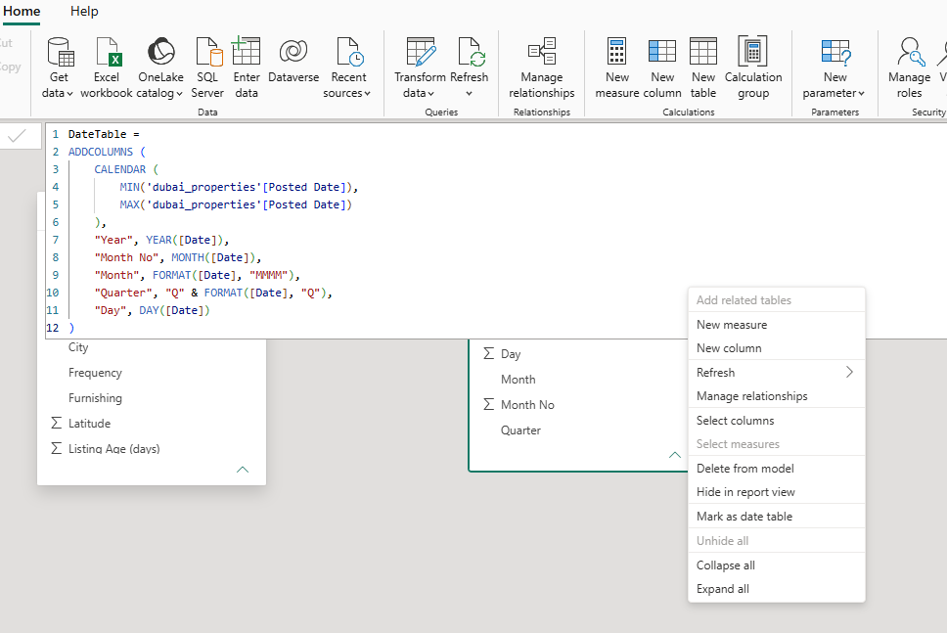
I created this date table with the above dax code to enable time-based analysis such as monthly, quarterly, and yearly trends. It also supports DAX time intelligence functions like YTD, MTD, and previous month comparisons, while providing a consistent calendar for reporting.

Reference Query
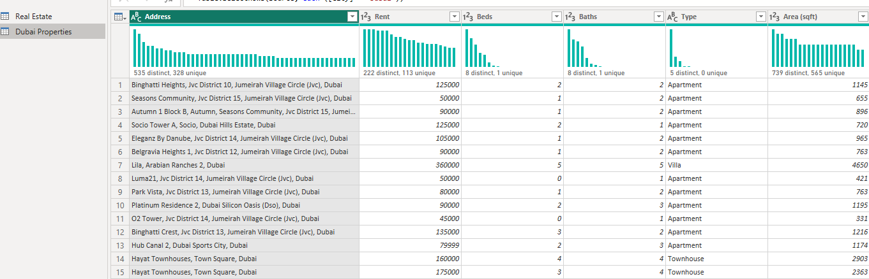
I added a Dubai reference table to create separate analysis tables (e.g., Dubai and Abu Dhabi properties) without duplicating the original dataset.

Group by with multiple aggregations
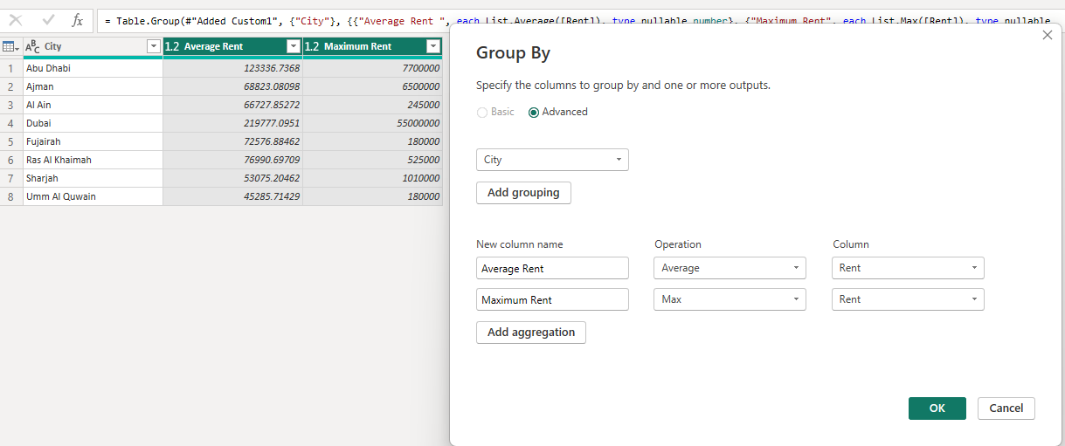
I used the group by feature to create a table to summarize detailed property records into meaningful business metrics such as average rent and maximum rent by location or property type. This improves reporting and supports executive-level insights.

