STUDENT PERFORMANCE
ANALYTICS SYSTEM
Project Documentation Report
EWB Courses | Python with AI Internship
Student Name: Shanaboina Nivas
Roll Number: 23K81A66G8
Department / College: CSE(AI&ML)/ St.Martin’s Engineering College
Submission Date: 16-10-2026

1. Project Title
Student Performance Analytics System

2. Objective
The objective of this project is to build a Python-based system that reads student records and analyzes academic performance. It calculates total and average marks, assigns grades, identifies pass/fail results, summarizes subject-wise performance, identifies top-performing students, analyzes attendance, and saves processed results to a CSV file.

3. Technologies Used
- Python — program logic, conditions, loops, and functions.
- NumPy — numerical calculations on subject marks.
- Pandas — CSV reading, DataFrame operations, filtering, grouping, and analysis.
- CSV — storage of input student records and output results.
- Visual Studio Code — development environment.
- GitHub — repository hosting and project submission.

4. Dataset Description
The input dataset is stored in students.csv and contains 20 sample student records. Fields include Student_ID, Name, Department, Python marks, AI marks, Mathematics marks, and Attendance. The program uses the three subject-mark columns to calculate totals, averages, grades, and results.
Note: Confirm that the dataset and record count in this report match the final version of students.csv before submission.

5. Implementation
- Load the dataset: Pandas reads students.csv into a DataFrame.
- Calculate totals and averages: The program calculates total marks for each student and uses NumPy to calculate average marks.
- Assign grades: A reusable function assigns grades according to the average-mark thresholds defined in the code.
- Determine pass/fail: A student passes when every subject mark is at least 40; otherwise, the student is marked as Fail.
- Analyze class performance: The program calculates the number of students, class average, highest average, and lowest average.
- Analyze subjects: The program calculates the average for each subject and identifies the highest- and lowest-average subjects.
- Identify top performers: Pandas selects the five students with the highest average marks.
- Analyze attendance and departments: The program lists students with attendance below 75% and calculates average performance by department.
- Save output: The final processed DataFrame is written to student_results.csv.

6. Key Features
- Loads student records from a CSV dataset.
- Calculates total marks and average marks.
- Assigns grades using defined thresholds.
- Identifies pass/fail status using a per-subject minimum.
- Reports overall class performance.
- Calculates subject-wise averages.
- Displays the top five performers.
- Identifies students with attendance below 75%.
- Compares average performance by department.
- Exports processed data to student_results.csv.

7. Output / Screenshots
These are files in folder:
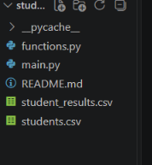

In below screen short shows that main.py and how to run in vs code terminal:

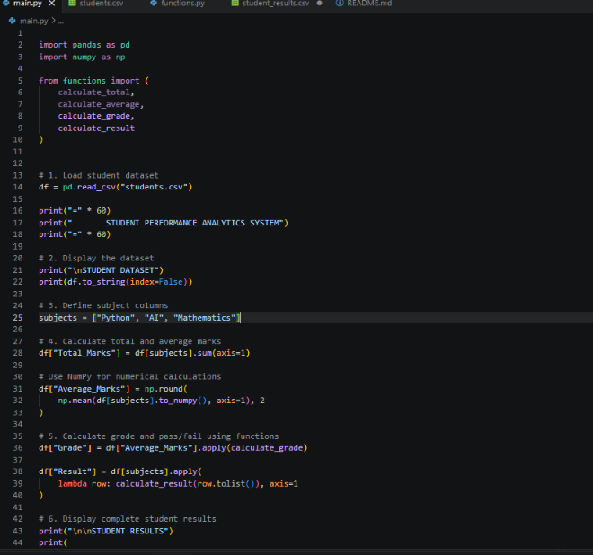

STUDENT DATASET:

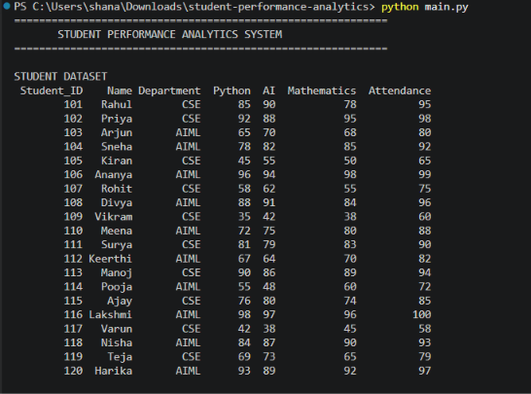

STUDENT RESULTS:

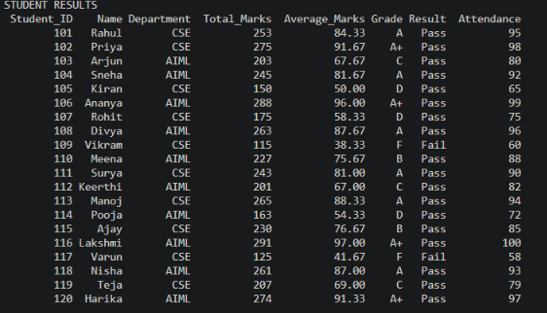

Here we can see that Overall Class Analysis, Pass/Fail Statistics, Student-Wise Averages, Top 5 Performing Students, Attendance Analysis and Department-Wise Average

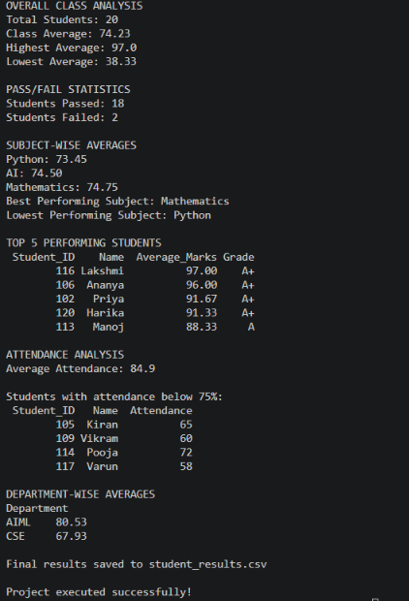

Student_result.csv

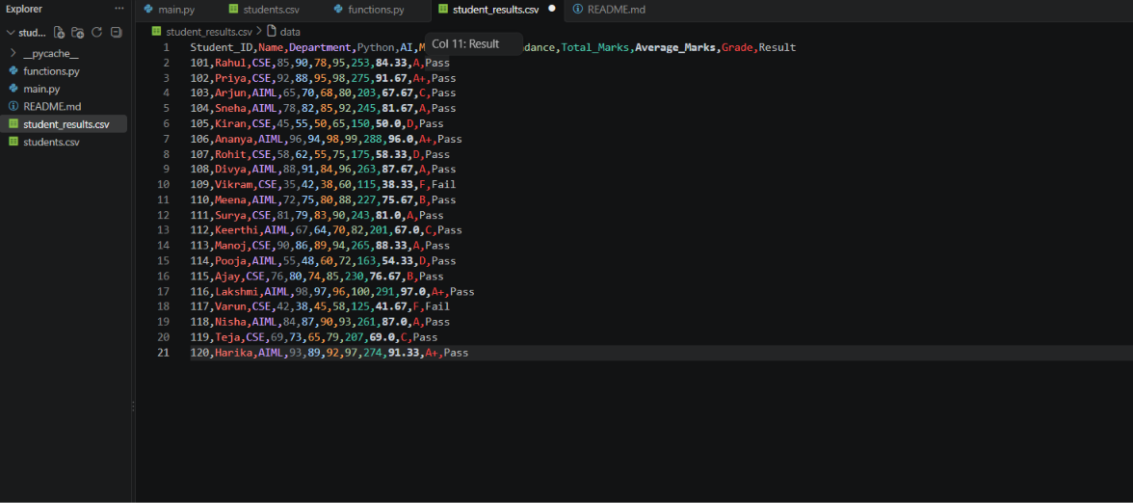

8. Final Outcome
The project demonstrates how Python, NumPy, and Pandas can be used to analyze student academic records. The program generates summaries for marks, grades, pass/fail status, subject performance, top performers, attendance, and department-wise averages, then saves the results in a separate CSV file. Verify the output against the final run before submission.

9. Challenges & Learning
During setup, the program initially could not run because main.py had not been created in the project directory. The required files were then created in the correct folder, and the program was run successfully. This helped reinforce file organization, saving Python files, running programs from the VS Code terminal, and working with CSV data.
Learning outcomes include Python functions and conditions, loops, NumPy numerical operations, Pandas DataFrames, CSV file handling, filtering, grouping, and basic data analysis.

10. GitHub Repository
Repository URL: https://github.com/Snivas1/student-performance-analytics

Final Checklist
☐ Project runs successfully.
☐ Input dataset is included.
☐ NumPy and Pandas are used.
☐ Functions, loops, and conditions are demonstrated.
☐ README.md is included.
☐ Actual output screenshots are inserted.
☐ GitHub repository URL is added.
☐ Repository is checked and the Google Form is submitted.

