BluetoothRC Manual

Android – Arduino Communication
When connected and one of the button pressed and pushed or change becomes in accelerometer values. Aplication starts sending data. Application will send: X,Y<br>
Where: <br>
X = values of x axis. X accepts positive and negative values. <br>
Y = values of y axis. Y also accets positive and negative values.<br>
The Y value is used to control the speed, also positive values is to go forward and negative is to go backward.<br>
The X value is used to control the left and right turns, positive value is to turn right and negative is to turn left.<br>
You can check the application by downloading the .apk file.

User ροη...
As soon as the application starts
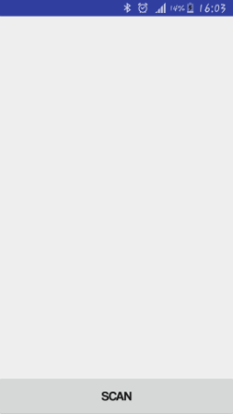
![sd](/Screenshots/Screenshot1.png)<br>BluetoothRC searches for available Bluetooth devices,
connects to selected Bluetooth device,
![alt tag](/Screenshots/Screenshot2.png)<br> pops up a menu to select the accelerometer or the joystick controller<br>
![alt tag](/Screenshots/Screenshot3.png)<br>and your selected controller starts.<br>
![alt tag](/Screenshots/Screenshot4.png)<br>
![alt tag](/Screenshots/Screenshot5.png)<br>
Application tested with Bluetooth HC-05 and Arduino nano.

