One of the big challenges I face with Inventor is getting the numbers from McMaster-Carr and the design tools of Inventor to match. The following is a page from the McMaster-Carr catalog for gears.

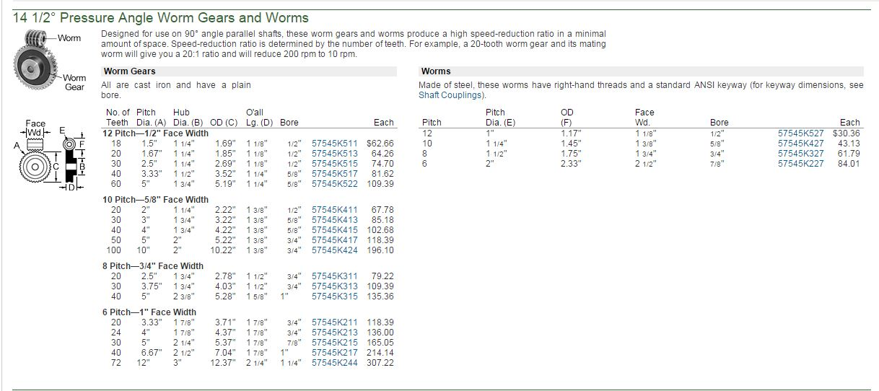

Just about all of the dimensions from this sheet above have a corresponding input on the Inventor Design input, shown below. For some reasons if you click on the Size Type Module and then back again to Circular Pitch it changes the input to ‘Circular Pitch’. This input needs to be calculated as $\frac{pi}{pitch}$. Ptich is the value from the McMaster-Carr catalog sheet. The rest of the numbers, gear ratio, pressure angle, worm length called face width in the Master-Carr spec, can be obtained directly from the catalog. The dimensions of the drawing should match the McMaster-Carr catalog.

The screen shot from Inventor for the worm gear specifics:

