Creation of Threads for Nuts & Bolts

- I began looking into creating plastic parts for items for telescope that require threads but very little load capability. That has expanded into other applications.
  - I would not try creating nuts and bolts with threads less than 3/8x11 – but I have not experimented with small thread sizes yet.
- As an experiment I created a nut and bolt with 5/8x11 threads.
  - For thread definition I used the web site: Theoritical Machinist. This link calculates the parameters for creating threads. For creating a sample using 5/8x11 1A and 1B threads. Here is a summary of the values I used for the thread creation.

Bolt with External Threads

- For the dimensions of the thread cutting

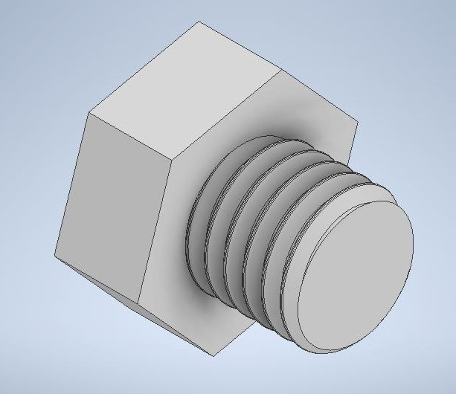
Here is the sketch I used for creating the threads using the coil command and removing the material for the threads.

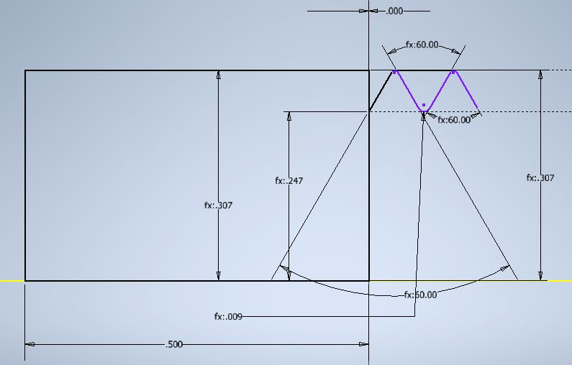
Used the average value for the thread profile.

- I would recommend not using non-standard threads, but whenever possible using standard threads. This leaves open the possiblity of mating with purchased nuts and bolts.
- Also, I also embed a text string with the thread specifcation on the part, such a 1 1/4(1.250)x10.
  - This is especially important when using non-standard threads.

- BrakeStopAndOuterHousing-V02 NUT
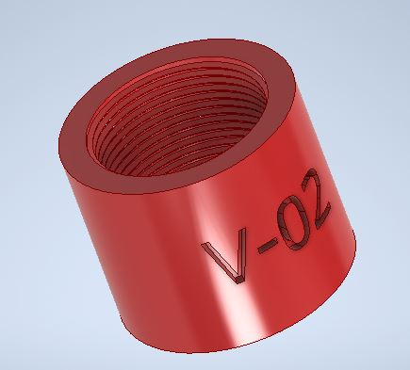
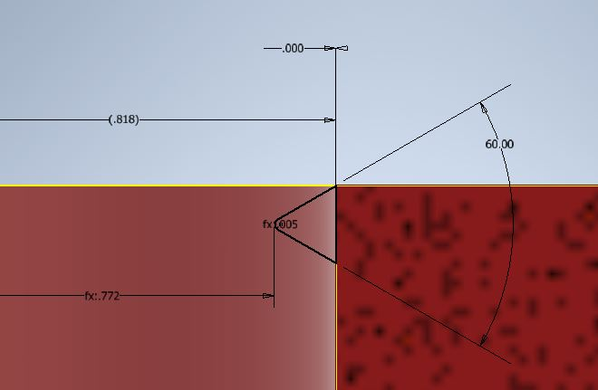
  - d12
    - hole for nut
    - b1MajorDiameterAvg
    - 1.6368
  - d17
    - b1RootRadiusAvg
    - 0.00450
  - d18
    - tip of root radius average
    - b1MinorDiameterAvg / 2 ul
    - 0.7719
  - b1MinorDiameterAvg
    - 1.5438
  - d59
    - Base of triangle
    - b1MajorDiameterAvg/2
    - 0.8184
  - Coil is created by adding material to the model

- BrakeHandle-V03 BOLT
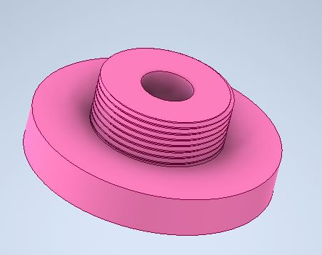
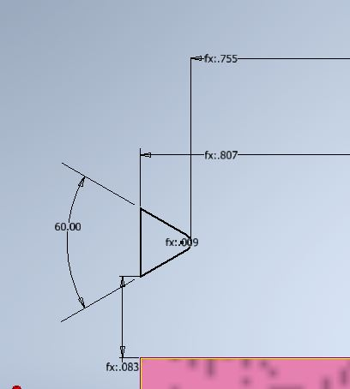
  - d1
    - shaft diameter
    - a1MajorDiameterAvg
    - 1.614650
  - d42
    - Base of triangle
    - a1MajorDiameterAvg / 2 ul
    - 0.807325
  - d39
    - Root radius
    - 0.0088
  - d52
    - Tip of root radius
    - a1MinorDiameterAvg / 2 ul
    - 0.75545
  - a1MinorDiameterAvg
    - 1.5109
  - Coil is created by removing material from the bolt

