Database Systems Project Proposal

Project Name
IS CAP : Influencer Sponsorship & Campaign Analytics Platform

Roles & Members

Role | Member
Project Lead | Mitchel Vore
Database Designer | Ethan Childs
Query Engineer | Nolan Jones

Problem Statement
Too often there are difficulties with bringing new products to market. Whether the product is sold by a big corporation with millions budgeted for advertising or by an individual with $500 in savings and genuinely innovative useful product. Our mission is to create a service which will accurately match companies big and small with reputable individuals or groups in order to facilitate the dissemination of products to those individuals which will most readily benefit.

Using systems such as excel, sheets or other manual systems tends to lead to system failures, either creating duplicates that shouldn’t exist or bad information being placed due to user error. constraints such as contract per accepted application, tracking multiple deliverables per contract, monitoring engagement metrics over time, and ensuring accurate financial reporting become impossible to enforce and evaluate consistently and very difficult to correct once a mistake has been made.
This project proposes a relational database system that models the full lifecycle of influencer marketing campaigns. The system will enforce meaningful constraints, maintain data integrity, and support advanced analytical queries to evaluate campaign effectiveness, influencer performance, and return on investment.

Requirements and Target Use
Brands: Create and manage sponsorship campaigns, review influencer applications, issue contracts, track deliverables, and monitor campaign performance metrics.
Influencers: Create profiles, apply to campaigns, manage active contracts, submit deliverables, and track earnings and engagement statistics.
Administrators: Oversee platform activity, resolve disputes, and monitor overall system health.
Core functional requirements include:
- Ability for brands to create campaigns with defined budgets, timelines, and objectives.
- Influencers can apply to multiple campaigns, and brands can review multiple applications.
- Accepted applications generate formal contracts with defined deliverables.
- Contracts may include multiple deliverables (e.g., posts, videos, stories).
- Engagement metrics (views, clicks, likes, conversions) must be recorded over time.
- Payments must be tracked and linked to contracts.
- The database must support analytical queries such as ROI calculation, top-performing influencers, and campaign performance trends.

Diagrams and Tables
ER Diagram
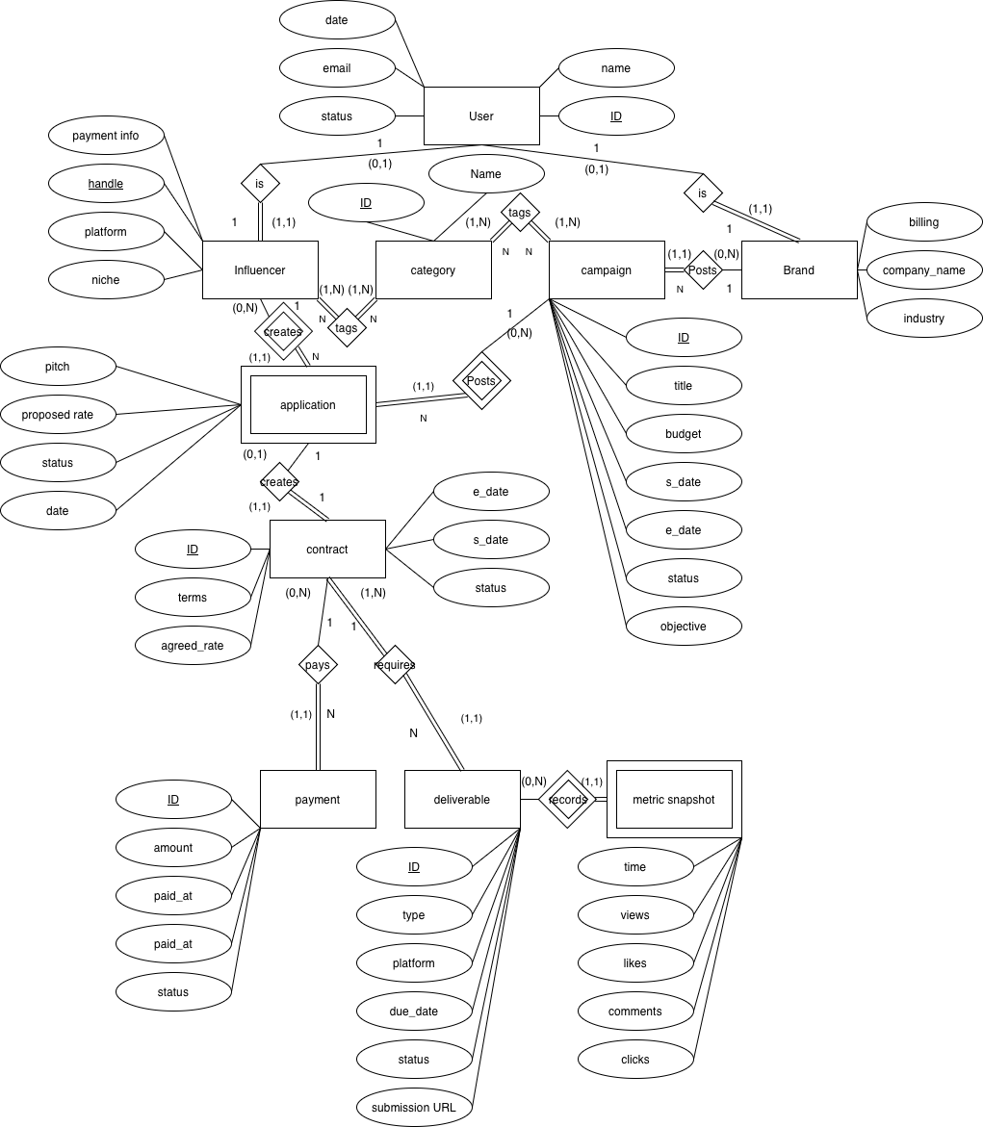

EER Diagram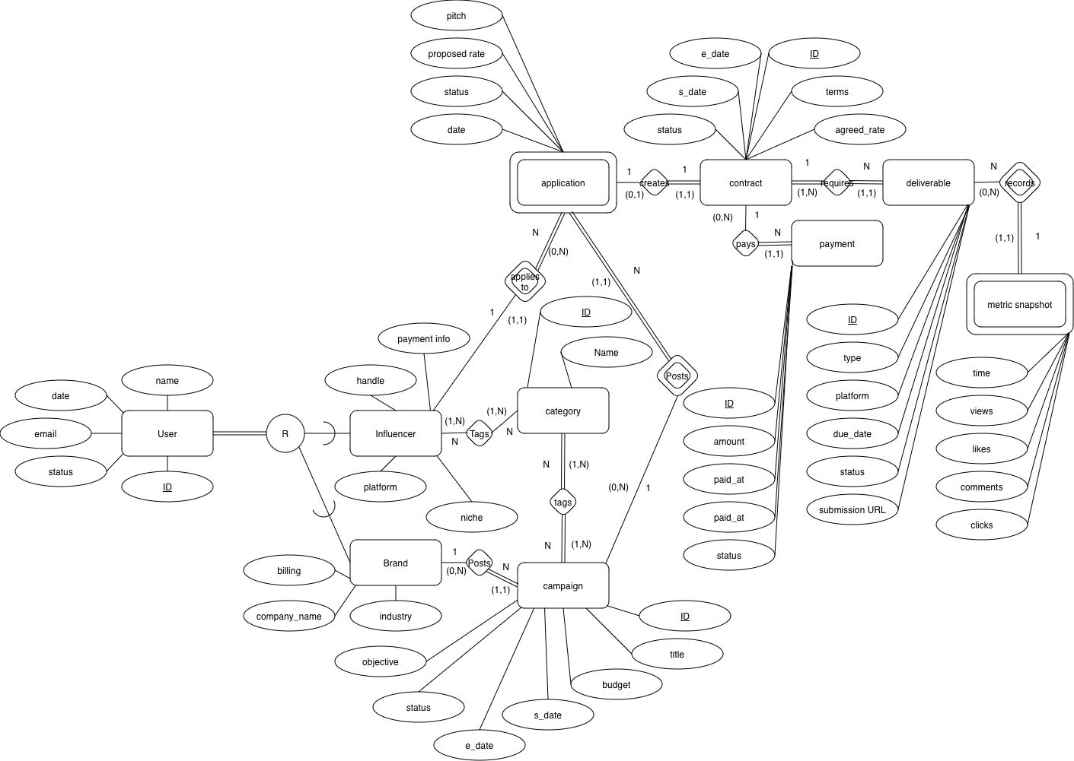

Tables
User
User ID | name | start_date | email | account_status | user_type
Primary Keys : User_ID
Justification: Chosen primary key

User_ID : ID for the user : hex : auto increment : non-null
name : First and Last Name : string : no default : non-null
start_date : date users account was created : integer/Date : current date : non-null
email : users email : string : no default : non-null
account_status : if account is activated, banned, locked… : int : 0 : non-null
user_type : will be used to identify as as influencer or brand exclusively : Object : no default : non-null

Influencer
User ID | handle | payment_info | niche | platform
Primary Keys : handle platform, User_ID
Foreign Keys : User_ID
Inherits User ID from user because its a sub class.

handle : stored the users platform handle : string : no default : non-null
payment_info : bank account routing num : long long : no default : non-null
niche : influencers niche : string : null : allows-null

Brand
User ID | company_name | account_to_bill | industry
Primary Keys : User_ID
Foreign Keys : User_ID
Justification: Inherits User ID from user because its a sub class.

company_name : the companies name : string : no default : non-null
account_to_bill : company bank acct to bill : long long : no default : non-null
industry : primary industry the company is in : string : no default : non-null

Category
Category ID | name
Primary Keys : Category_ID
Justification: Chosen Primary Key

Category ID : ID for the category : hex : auto increment : non-null
name : category name : string : no default : non-null

Campaign
Campaign ID | title | budget | start_date | end_date | status | objective | Brand_ID
Primary Keys : Category_ID
Foreign Keys : Brand_ID
Justification: Chosen Primary Key and it Connects brand to a campaign.

Campaign ID : ID for the campaign : hex : auto increment : non-null
title : campaign title : string : no default : non-null
budget : budget : float : no default : non-null
start_date : planned start date of campaign : int/Date : no default : non-null
end_date : planned end date of campaign : int/Date : no default : non-null
status : numerical stage representation : int : 0 : non-null
objective : ultimate goal of campaign : string : no default : allows-null

Application
User ID | Campaign ID | pitch | proposed_rate | status | date
Primary Keys : User_ID Campaign_ID
Foreign Keys : User_ID, Campaign_ID
Justification: Inherits Primary keys from User_ID and Campaign_ID because those two entities create an application, they’re also foreign because its a weak entity.

pitch : what the company wants advertised possibly step by step : string : no default : non-null
proposed_rate : the amount the company wishes to pay individual : float : no default : non-null
status : application status : int : 0 : non-nul
date : date of application submission : int/Date : current date : non-null

Contract
Contract ID | terms | agreed_rate | start_date | end_date | status | iUser_ID | bUser_ID
Primary Keys : Contract_ID
Foreign Keys : iUser_ID, bUser_ID
Justification: Chosen Primary Key, Foreign Keys are brought from Application to identify the user and brand which are participating in the contract.

terms : terms and conditions : string : no-default : non-null
agreed_rate : payment rate per completed activity : float : no-default : non-null
start_date : date of first commitment : int/Date : no default : non-null
end_date : date of last commitment : int/Date : no default : non-null
status : contract terminations / has ended : 0 : non-null
Payment
Payment ID | amount | paid_at | method | status | Contract_ID
Primary Keys : Payment_ID
Foreign Keys : Contract_ID
Justification: Chosen Primary Key, Foreign Key relates payment to contract

Payment ID : ID for the payment : hex : auto increment : non-null
amount : quantity paid : float : no-default : non-null
paid_at : date of payment : int\Date : no-default : non-null
method : how funds were transferred : string : direct-deposit : non-null
status : unpaid, processing, paid: int : 0 : non-null

Deliverable
Deliverable ID | type | platform | due_date | status | submission_URL | Contract_ID
Primary Keys : Deliverable ID
Foreign Keys : Contract_ID
Justification: Chosen Primary Key, Foreign Key relates deliverable to contract

Deliverable_ID : ID for the deliverable : hex : auto increment : non-null
type : type of deliverable image, video, url : string : no default : non-null
platform : which platform to complete on : string : no default : non-null
due_date : date to complete by/on : int/Date : no default : non-null
status : completed/missed/tbd : int : 0 ; non-null;
submission_URL : location to upload proof of completion : string : null : allows-null

Metric snapshots
Deliverable ID | time | views | likes | comments | clicks
Primary Keys : Deliverable_ID time
Foreign Keys : Deliverable_ID
Justification: Chosen Primary Key should be unique, Foreign Key inherits from Deliverable because its a weak entity

time : date/time of snapshot : int/Date : current time : non-null
views : number of views : int : no default : non-null
likes : number of likes : int : no default : non-null
comments : number of comments : int : no default : non-null
clicks : number of interactions with comments : int : no default : non-null

Influencer_Tags
User ID | Category ID
Primary Keys : User_ID Category_ID
Foreign Keys : User_ID, Category_ID
Justification: combination of User and Category is Primary Key (N to N relationship) as such they’re both foreign

Campaign_Tags
Campaign ID | Category ID
Primary Keys : User_ID Campaign_ID
Foreign Keys : User_ID, Campaign_ID
Justification: combination of Campaign and Category is Primary Key (N to N relationship) as such they’re both foreign

Relation Table Justifications
Foreign keys are typically added based upon the previous entity/s which caused the existence of the current one. With a rare exception of contract inheriting foreign keys from a previous layer due to application being a Weak entity. These keys have been added to illustrate the relationships between entities as described in the ER/EER diagrams. Only Many to Many relationships and sub classes spawn new tables. All other place the extra information in new columns belonging to a/the entity which was “one” (not many) in the relationship

Campaign_Tags
Campaign and Category share a many to many relationship
As many campaign_ID’s can have many Categorie_ID’s
Influencer_Tags
Influencers and Category share a many to many relationship
As many User_ID can add many Category_ID’s
Deliverable
Deliverables are Parts of Contracts where one Contract_ID can many Deliverable_IDs
Payment
Payments are Parts of Contracts where one Contract_ID can many Payments
Metric Snapshots
Are based upon Deliverables and there could be several snapshots for a Deliverable_ID over a small span of time.
Contract
Based upon an application where a contract can have one User_ID and one Brand_ID per Contract_ID.
Payment
Are based upon Contract_ID where one Contract_ID can have many Payment_ID’s
Application
Each Campaign only accepts one Application per User as such no Application should contain the same exact User_ID and Campaign_ID
Campaigns
Each Brand can have many campaigns but campaigns cannot have multiple brands only one
Influencer / Brand
Both are sub classes of User as such they receive the User_ID as a primary key
User
User is a superclass and could exclusively be of either type Influencer or of type Brand as such it contains an identifier to specify which the account is. It is assumed that an account cannot be both an Influencer and Brand account

Data
We will be generating synthetic data and then manually facilitating some data interactions and creation via interfacing.

