Technical Exercise: AI-Forward Engineering
Candidate: Snobin Antony
This submission is not a paper-only design. It is how I actually used AI agents to turn the three interview problems into a running local demo: requirements first, explicit assumptions, a written plan, agent guides, then build, test, and debug.

How I work with AI (this is the method)
The exercise asks how I would work with Codex, Claude Code, or similar agents. Below is the sequence I used in this repo — not a hypothetical workflow.
- 1. Read the interviewer problems and write a requirements list (README.md). Separate ship-now vs defer vs blocked-by-missing-config.
- 2. State local assumptions: no Azure credentials, mock LLM, header auth, filesystem blobs, Redis as queue.
- 3. Switch to Plan mode. Produce plan.md and a structured MVP plan (epics 0 → 3 → 1 → 2).
- 4. Write AGENTS.md and CLAUDE.md before generating application code — so the agent cannot silently own auth, tenancy, or the job state machine.
- 5. Switch to Agent/build mode. Implement the local demo against the plan.
- 6. Test the development implementation. When a customer-style incident appeared (false failed + duplicates), switch to Debug mode, reproduce with logs, then fix with tests.
- 7. Capture screenshots of the three problem UIs from the running demo.
I treat the agent as a fast mid-level pair programmer. I decide architecture, tenancy, and state machines. The agent drafts boilerplate, tests, and library syntax. I stop it after two failed fix attempts, or if it touches auth/tenancy/state machines without approval.

Part 0 — AGENTS.md (AI interaction protocol)
Full file in the repo: AGENTS.md. Claude-specific rules: CLAUDE.md. Summary:

Philosophy
AI agents are excellent at pattern matching, boilerplate, localized tests, and framework syntax. They lack holistic system context and have no inherent sense of security or domain risk. I define architecture; the agent implements mechanics under review.

What the AI should explore and draft
- Scaffolding: CRUD, ORM models, React shells, TypeScript interfaces from a schema I provide.
- Test drafts for pure functions and isolated components.
- Library syntax (FastAPI deps, TanStack Query keys, SQLAlchemy, Redis/Azure clients).

What the AI must not decide alone
- Where data lives (Postgres vs Redis vs blob vs queue).
- Org vs workspace authorization and tenancy filters.
- Job lifecycle, lease, idempotency, DLQ.
- Which security/integration tests are required.

Verification / when to stop
- Review for missing auth, N+1 queries, useEffect data fetching, hardcoded tenant IDs, swallowed errors.
- I write tenancy and concurrency tests myself as invariants.
- Stop the agent after two failed attempts, or if it proposes cross-workspace queries or skipping the storage facade.

Project conventions enforced in this demo
Area | Rule
Tenancy | Every query filters org_id or workspace_id
Job status | Postgres is truth; Redis is UI cache + queue
Usage | API reads daily_usage_rollup, not raw events by default
Frontend | TanStack Query; URL params for document filters
IndexedDB | DocumentRepository facade only (API-only in this MVP)
Cost | DECIMAL in Postgres; computed at event write in the worker

Requirements, assumptions, and plan
Source files: README.md (requirements + how to run), plan.md, and .cursor/plans/local_demo_mvp_5bb6db1c.plan.md.

This is a development implementation
The interview stack names Azure Blob/Queue and real OpenAI / Vertex providers. I do not have those credentials in this environment, so I did not pretend to call them. I built a local replica that keeps the same boundaries: durable store, cache, queue, blob keyed by job_id, tenancy.
Production (exercise) | Local demo assumption | Status
Azure Blob | data/blobs/{job_id}.json | Shipped
Azure Queue | Redis list BRPOP/LPUSH + DLQ list | Shipped
Real LLM APIs | Mock worker delay + optional failure rate | Shipped (mock)
IdP / JWT | X-User-Id header + seeded users | Shipped (mock)
Org usage UI / billing recon | Org API exists; UI deferred | Deferred
Encrypted IndexedDB / density | API-first DocumentRepository | Deferred
Top workflows by cost | Not in MVP chart | Deferred
Provider picker in UI | API supports 3 providers; UI defaults openai/gpt-4o-mini | Partial — data model ready

Build order I locked in Plan mode
- Epic 0 — Platform: Docker Postgres + Redis, FastAPI auth/tenancy, Vite shell.
- Epic 3 — Jobs + worker first (Problems 1 and 3 depend on a real job pipeline).
- Epic 1 — Usage dashboard from worker-emitted events.
- Epic 2 — Document Insights on the same job pipeline.
Figure A — Local demo architecture from Plan mode (Vite React → FastAPI → Postgres/Redis; worker → blobs + usage events)
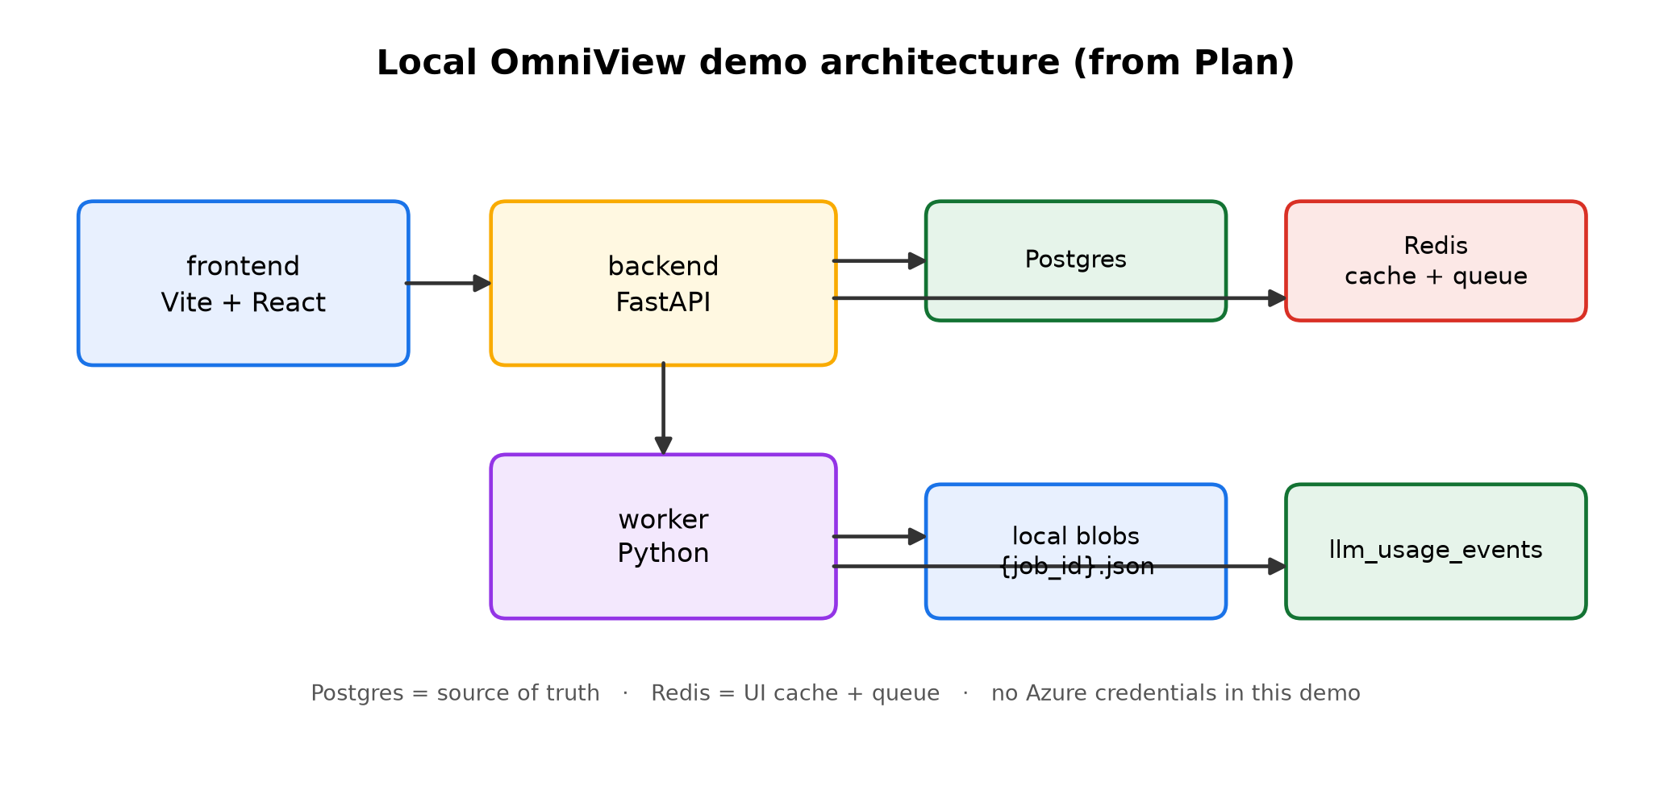

Problem 1 — Usage & Cost Admin View

What I would ask the agent vs what I verify
- Ask agent: SQLAlchemy models for llm_usage_events; SQL for daily_usage_rollup; Recharts layout from JSON.
- I decide: cost at write time from a versioned pricing table; DECIMAL; org owner vs workspace admin; MV not raw table for the dashboard.
- I verify: 403 across workspaces; rollup matches hand-calculated sample events.

Data / API / auth
- Append-only llm_usage_events: org_id, workspace_id, provider, model, tokens, cost_usd DECIMAL, status, workflow_name.
- Pricing rows seeded for openai/gpt-4o-mini, vertex_gemini/gemini-1.5-flash, vertex_anthropic/claude-3-haiku.
- GET /api/v1/workspaces/{id}/analytics/usage — workspace admin or org owner of that workspace.
- GET /api/v1/orgs/{id}/analytics/usage — org owner; per-workspace summaries (org UI deferred).
- Chart: X = provider/model, Y = cost USD (and failed series). Daily spend and failed count are cards. Top workflows deferred.
Figure 1 — Usage data flow (worker event → Postgres → rollup → API → dashboard)
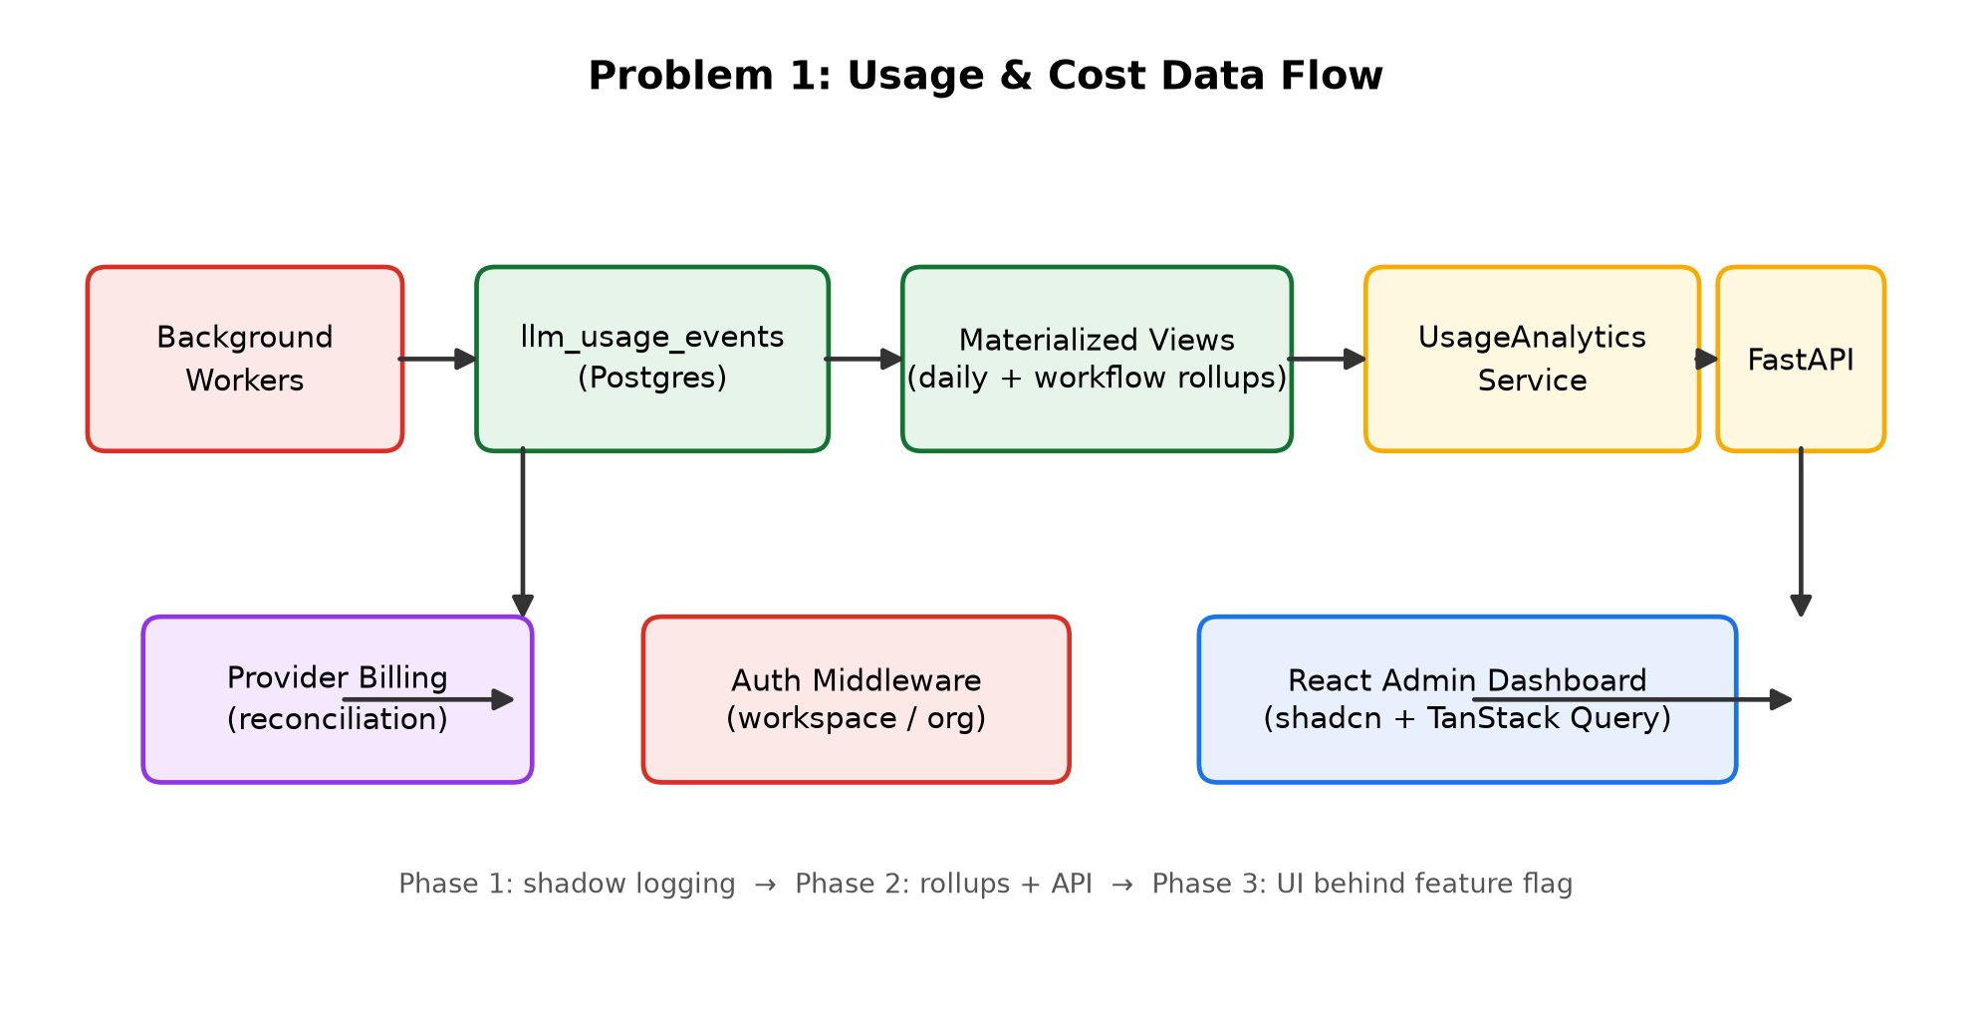

Figure 2 — Running demo: Usage admin page (workspace daily spend, failed count, provider/model chart)
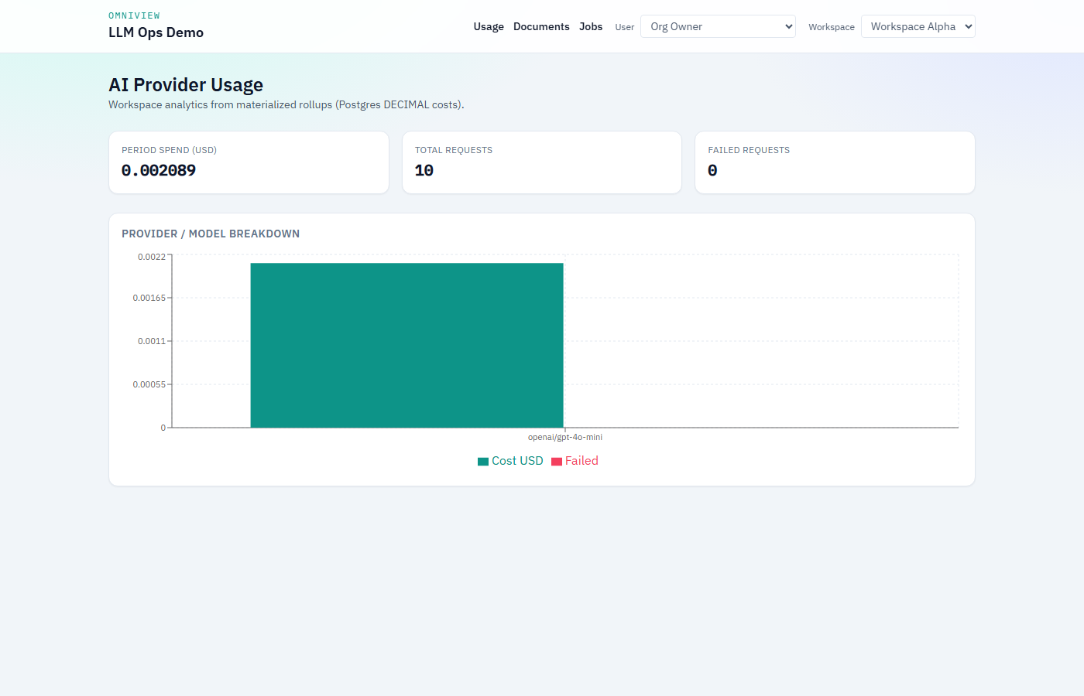

The screenshot may show one model bar because the UI enqueue path currently defaults to openai/gpt-4o-mini. The rollup and chart are grouped by provider and model; more bars appear when jobs are created with other seeded providers. That is sample data, not a one-model design.

Ship first vs defer
- Shipped: shadow-style event write from worker, workspace spend, failed count, provider/model breakdown, tenancy tests.
- Deferred: org-level UI, top workflows table, billing-file reconciliation, provider picker in the Jobs UI.

Tests (Problem 1)
- test_workspace_admin_cannot_read_other_workspace_usage → 403
- test_workspace_admin_can_read_own_workspace_usage → 200
- test_org_owner_can_access_org_usage → 200
- test_workspace_admin_cannot_access_org_route → 403
- test_rollup_matches_hand_calculated_events — DECIMAL spend and failed count

Problem 2 — Frontend Architecture & AI Review

What I would ask the agent vs what I reject
- Ask agent: useInfiniteQuery + @tanstack/react-virtual boilerplate; filter chips bound to URL search params.
- Reject: useEffect to sync props into state; fetch-in-useEffect; IndexedDB imports in page components; 15-level prop drilling.

Design shipped in the demo
- DocumentInsightsPage + filters in URL (?status=&doc=) + virtualized list + details panel.
- Query key includes workspace_id so cache cannot leak across workspaces.
- DocumentRepository facade — API only in MVP (IndexedDB deferred).
- Loading skeletons, empty + clear filters, error + retry, details-panel errors isolated.
- Analyze enqueues a job on the same worker pipeline.
Figure 3 — Running demo: Document Insights (virtualized list, status filters, insights JSON panel)
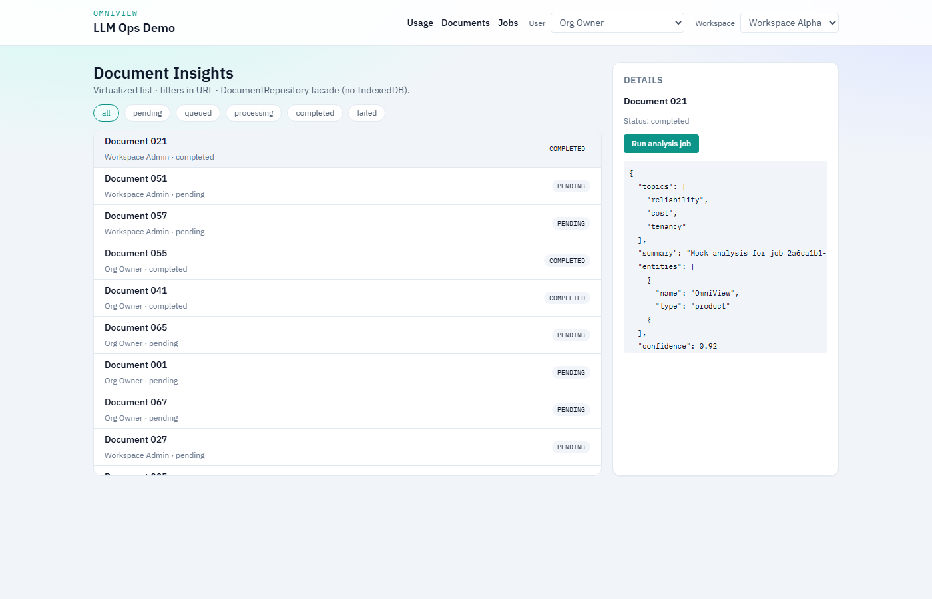

Ship first vs defer
- Shipped: list, status, URL filters, details, analyze-from-API.
- Deferred: encrypted IndexedDB, compact/comfortable density, owner/date filter chips (API already accepts owner_id).

Problem 3 — Worker Reliability Incident
Customer report: long jobs sometimes show failed in the UI while the result later appears in storage; other times duplicates appear. I treated this as an incident on the demo, not only a design essay.

What I inspect first
- Lease duration vs mock LLM duration (visibility timeout analogue).
- Whether two worker_ids claimed the same job_id.
- Postgres status vs Redis cache vs blob existence for that job_id.

Failure modes we reproduced
- False failed: blob written, then an error before Postgres completed; list poll did not reconcile (only GET-by-id did).
- Duplicates: no lease heartbeat, so a second worker could claim after lease expiry while the first was still in the LLM sleep.
- Retries re-queued while status stayed failed, so claim (queued | expired processing) often skipped them.

Fix I shipped (Debug mode → tests)
- Postgres is truth. Redis cache is updated after durable writes.
- Blob path = job_id (idempotent overwrite).
- If blob exists, mark completed — do not leave failed; skip duplicate success usage events.
- Heartbeat renews lease while the mock LLM runs.
- Transient retry re-queues as queued.
- list_jobs (UI poll every 2s) now reconciles the same way GET /jobs/{id} does.
Figure 4 — Job status state machine (lease, retry, DLQ, reconcile)
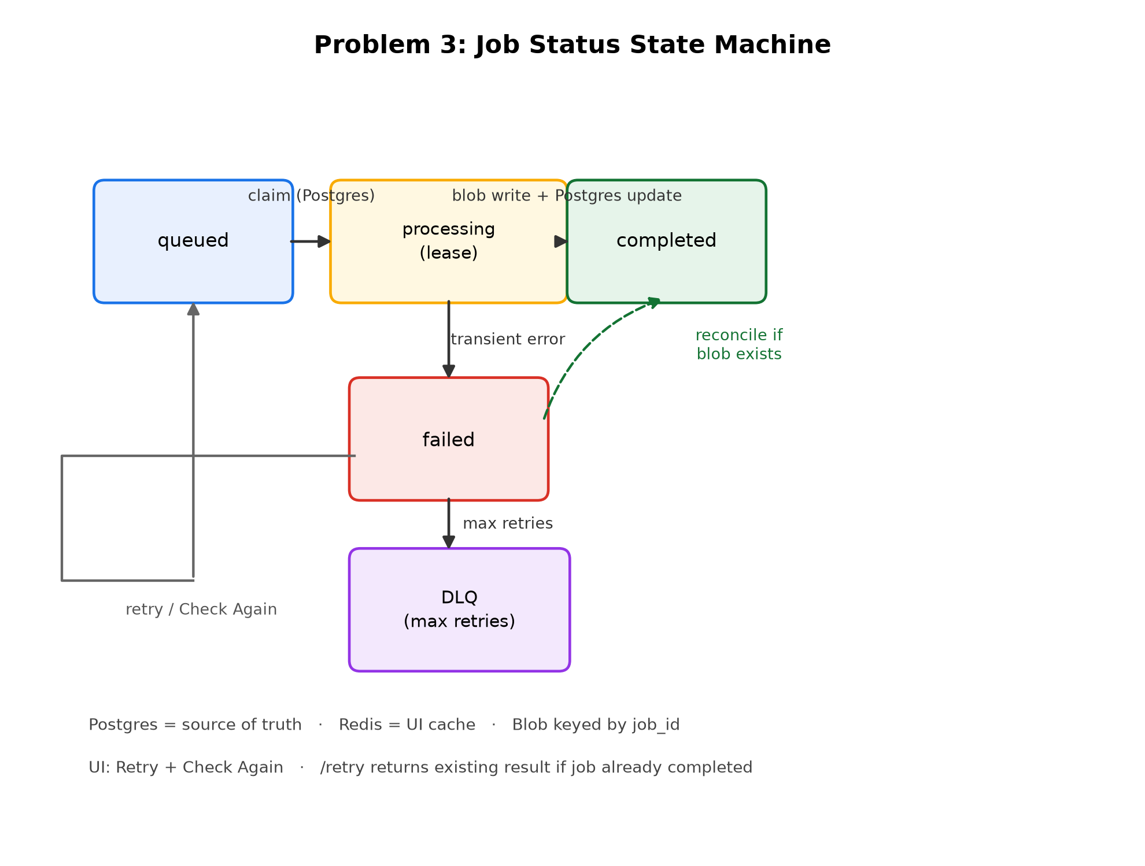

Figure 5 — Running demo: Jobs page (poll queued → processing → completed; Retry / Check again)
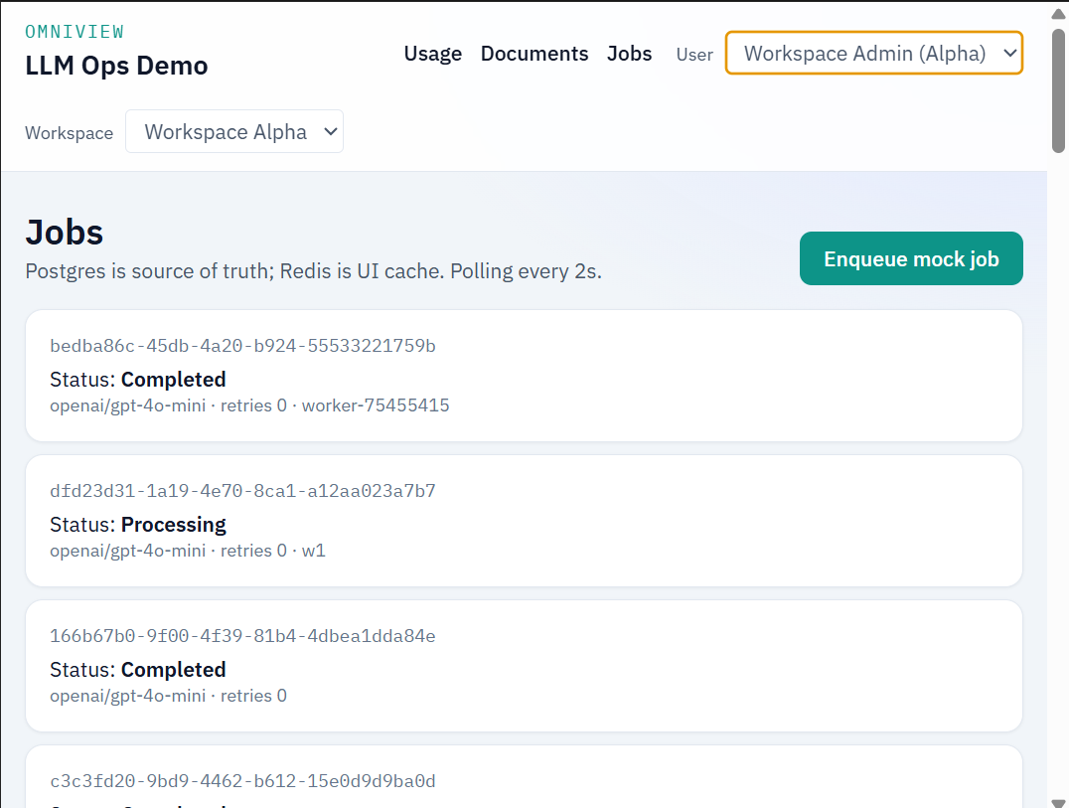

AI during the incident
- I did not let the agent invent a new architecture. I used it to instrument, draft tests, and implement the heartbeat/reconcile patch I specified.
- I required runtime evidence: list_jobs log showed status=failed and blob=true; GET then reconciled. After the fix, list heals that row; worker with a pre-existing blob marks completed without a second LLM.

Tests (Problem 3)
- test_duplicate_claim_only_one_wins — two concurrent claims, one winner
- test_fresh_lease_blocks_second_worker_claim
- test_reconcile_when_blob_exists_but_status_failed
- test_list_jobs_reconciles_failed_when_blob_exists — UI poll path
- test_retry_returns_existing_when_completed — /retry idempotency

What the interviewer asked vs this demo
Interviewer ask | In this implementation
AGENTS.md / how you work with AI | AGENTS.md + CLAUDE.md written before app code; process documented above
Usage: daily spend, provider/model, failures | Usage page + MV + DECIMAL events
Org owner vs workspace admin | Header mock users; 403 tests
Document list, filters, details, virtualization | Documents page screenshot
No useEffect fetch; storage facade | TanStack Query; DocumentRepository
False failed + duplicates | Reproduced and fixed; tests listed
Lease, DLQ, retry idempotency | Worker heartbeat, DLQ, /retry
Complete production Azure/OIDC | Explicitly out of scope for this local dev replica

Code repository (share this)
The GitHub repo is the running project (not the interview PDF). Clone, follow README, run the demo.
- Repository: https://github.com/Snobin-Antony/omniview-ai-dashboard-for-llm-ops-assessment
- Clone: git clone https://github.com/Snobin-Antony/omniview-ai-dashboard-for-llm-ops-assessment.git
- README (how to run): https://github.com/Snobin-Antony/omniview-ai-dashboard-for-llm-ops-assessment#readme
- Local UI after start: http://localhost:5173
- Local API docs: http://localhost:8000/docs
Setup: Docker Desktop, then scripts/setup.ps1, then API + worker + frontend (three terminals).
- Org Owner id: cccccccc-cccc-cccc-cccc-ccccccccccc1
- Workspace Admin id: cccccccc-cccc-cccc-cccc-ccccccccccc2 (Alpha only)

