Interim report (Week 2)

Followings are the researches I have conducted so far:
- National Reimbursement Drug List (NRDL) and Group Purchasing Organization (GPO):
  - Since its establishment in May 2018, China’s National Healthcare Security Administration(NHSA) has launched a centralized bulk procurement programmme, also known as the Group Purchasing Organization (GPO), to obtain the best prices for selected drugs and medical equipments.
  - The distinctive feature of GPO is that only a limited number of pharmaceutical companies will be chosen to supply one kind of drug or device listed on NRDL while other procurement procedures will allow several suppliers for one kind of drug or device.
  - To be qualified in GPO, pharmaceutical companies need to bid with very low price, and in exchange, the winning bidder will get access to vast number of patients and much quicker reimbursement.
  - The initiative leads to a significant price-cut in China’s healthcare industry (see table 1):

Table 1
Date | Range | Scale | Max. winners | Avg Price Cut | Implemented
2018.8 | 11 Pilot Cities | 25 | 1 | 52% | 2019.2
2019.3 | National | 25 | 3 | 25% | 2019.12
2020.1 | National | 33 | 6 | 53% | 2020.4
2020.7 | National | 56 | 8 | 72% | 2020.10

  - The coronary stents are covered in the GPO of July 2020. The tender results are disruptive, with the average price of the ten stent products that won the national tender dropped from 13,000 RMB to 700 RMB (more than 90% drop).
  - The eight winning bidders include two international players, Boston Scientific and Medtronic, and six Chinese companies (JWMS, Essen Technology, MicroPort, Lepu Medical, Kindly Medical and Medfavour Medical). Noticablely Abbott Vascular, which was a dominant player in the high-end stent market, is not on the list.
  - The bidding results show that any stents which are priced above 700RMB, regardless of its manufacturer, lost the bid, significantly limiting the range of stents that the patients in public hospitals can get access to (see table 2):
  - The volume of this centralized procurement was 1.07 million stents over 31 provinces, which is calculated as around 75% of the consolidated demand estimated by the public hospitals in China.
  - The centralized procurements is likely to expand to other “High-Price Consumables” including intravascular interventional devices, non-vascular interventional devices, orthopedic implants, neurosurgical implants, electrophysiological catheters, pacemakers, extracorporeal blood circuit/blood purification devices, ophthalmic implants, dental implants, and others.
- Market research:
  - Competitor research: I have obtained a list of all hospitals registered in Kunming by developing a Python-based web-crawler (Please see annex 1). The information contained in the list include names, addresses, specielites, and the number of beds. After Chinese new year holiday, I plan to visit some of these hopistals.
  - Market-sizing research: I have collected three-year’s sales data from one of largest cardiology device distributors in Kunming, and conducted some preliminary analysis on these figures. Followings are what I have found:
    - Five types of operations are most dominant in Yunnan province: Drug-eluting stent (DES), Electrophysiology, Percutaneous transluminal coronary angioplasty (PTCA), Congenital heart defect (CHD), and Pacemaker. Figure 1 shows their revenues over past three years:
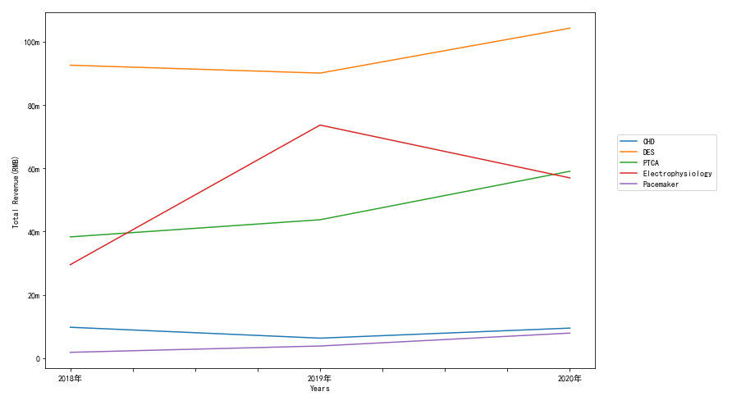
Figure 1

    - There are 6 manufacturers for DES: MicroPort, LePu, JWMS, Essen, Boston Scientific Corporation, Abbott Vascular. Figure 2 shows their revenues over past three years and Table 2 shows their gross margin over past three years:
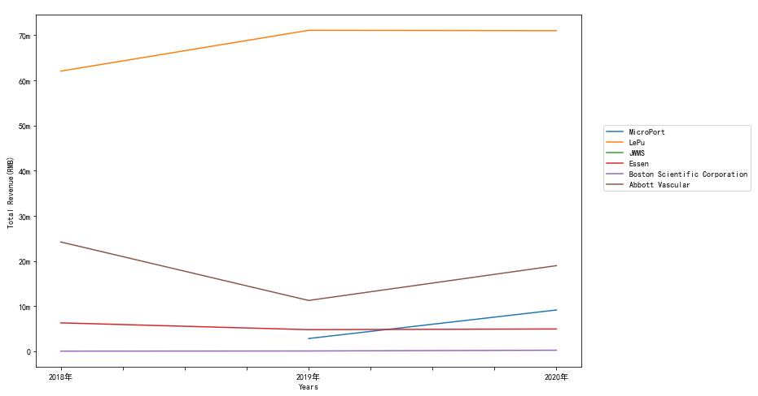
Figure 2
Table 2
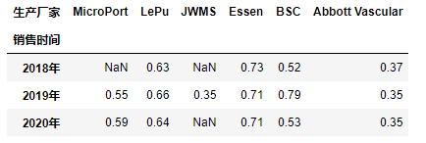

    - There are 6 manufacturers for PTCA: MicroPort, Braun Melsungen, BSC, Terumo Coroporation, Abbott Vascular, LePu, APT Medical, Yinyi Biotech. Figure 3 shows their revenues over past three years and Table 3 shows their gross margin over past three years:
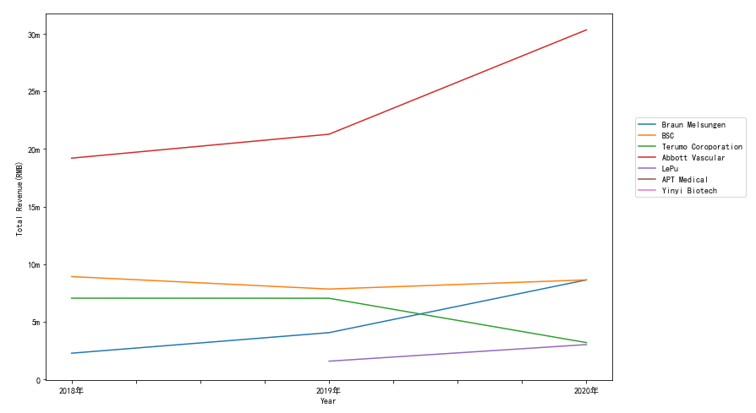
Figure 3
Table 3
