Interim report (Week 4)
Week 3 (from Feb 15 to Feb 21）is the Chinese new year holidays, so I did not do much of the work. In week 4 (from Feb 22 to Feb 26), my co-worker and I visited several hospitals and clinics in Shanghai and Kunming. Followings are the summary of these visits:

- Shanghai United Family Hospital (UFH)
- United Family Hospital is one of the leading private healthcare providers offering comprehensive premium healthcare services in China. It was firstly founded in Beijing in 1997, and now it operates in all four tier-one cities in China. The one we visited is located in Shanghai west, and it had just been renewed in 2020.
- The hospital's size has been expanded to around 20000 sqm from 6000 sqm, alongside the number of beds increased to 80 from 40.
- The differentiation from the public hospitals is obvious, as UFH’s environment and services are far better. Also, its prices are much higher and it only accepts national medical insurance for very limited service.
- Among several medical services, including cardiology, dermatology, endocrinology and so on, provided by the hospital, the obstetrics&gynecology department is most reputable and profitable. For example, the cost of standardized labouring service in UFH is 66,000RMB, while it is only around 4,000RMB in public hospitals.
- UFH currently is making losses, and one of the reasons is that its contracted wage expenses are so high, taking up to 58% of its revenues.
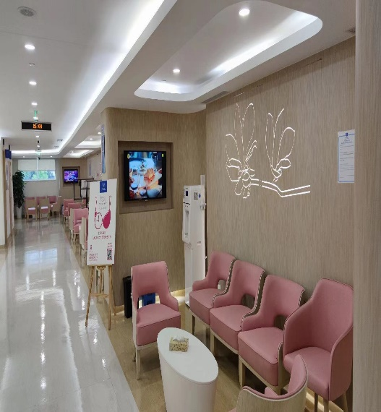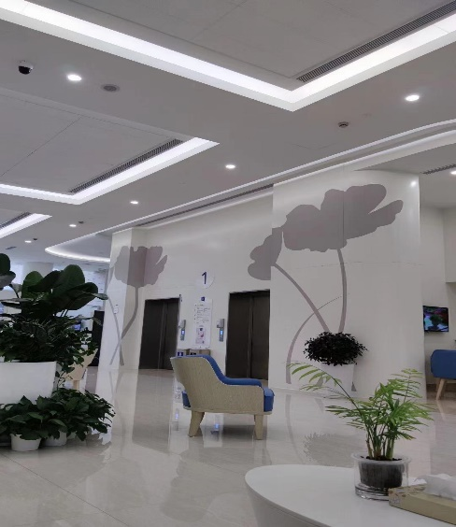
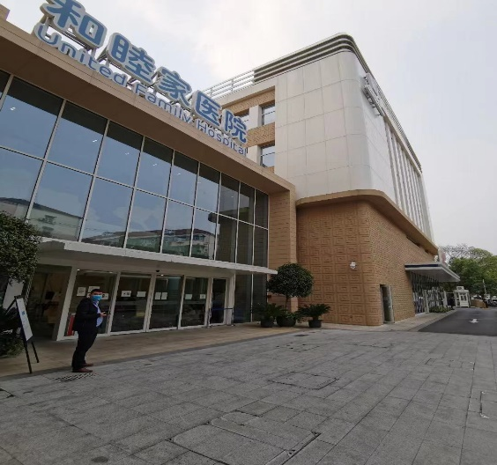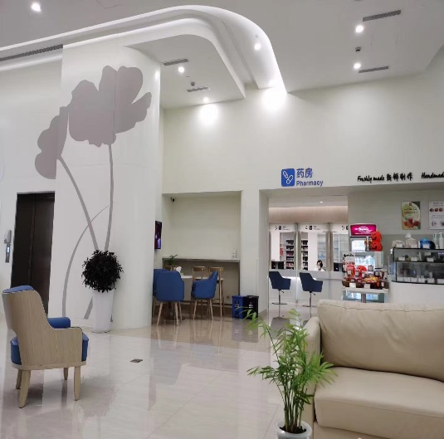

- Shanghai DeltaHealth Hospital (DHH)
  - DHH is a foreign-funded hospital focusing on cardiovascular treatment.
  - The hospital's size is approximately 50000 sqm, and there are 500 beds. The hospital is constructed with three floors, of which the first floor is dedicated to ordinary patients with national medical insurance while the other two are dedicated to VIPs.
  - DHH hires doctors quite different from UFH, as DHH, rather than paying doctors a fixed amount of wages, shares the revenues generated by patients with doctors. From the hospital's perspective, this business model is sufficient, as it significantly lowers the operating leverage; from the doctors' perspective, this business model is relatively fair, as they get paid based on their workloads.
  - As one of Fidelity's major investments in China, DHH can cooperate with some world-class cardiovascular hospitals (e.g. Columbia Heart Source) and partner with some best cardiovascular experts in China. The reputation has attracted a lot of patients, especially the rich ones.

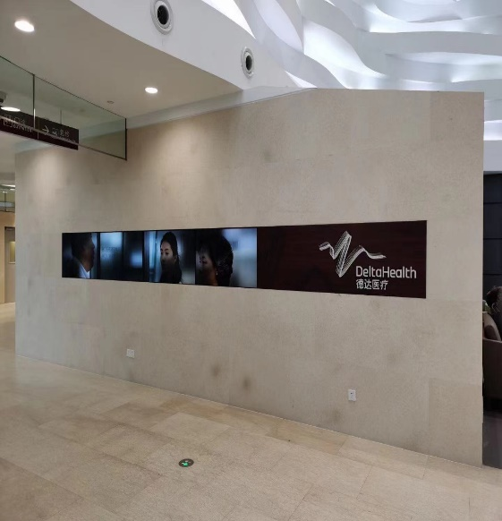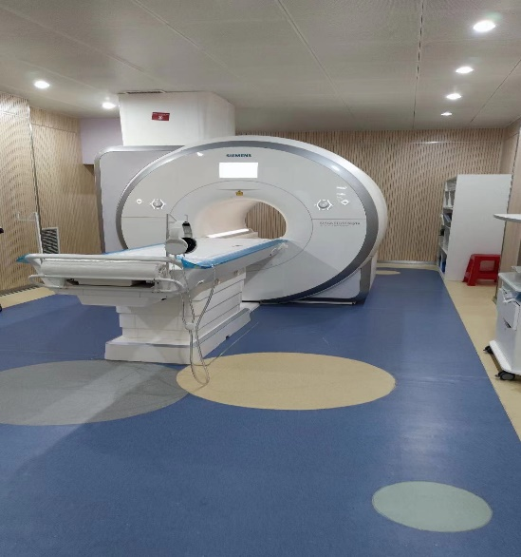

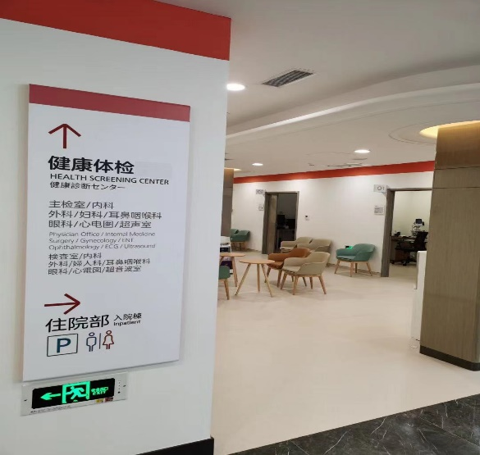
- Yunnan First People Provincial Hospital (YFPPH)
  - The hospital is one of the best public hospitals providing comprehensive treatments in Yunnan province.
  - The hospital’s cardiovascular department has two operating floors, the size of 1800 sqm and 120 beds.
  - The recent centralized bulk procurement programme has significantly impacted the department, as the average cost of cardiovascular operation has been lowered to around 2,000RMB from 10,000RMB.
  - In Yunnan, people still trust public hospitals much more than private ones, and given the price decent, the number of patients increases by almost 40% this year. The ward is full of patients, as some extra beds are added.
  - We also visited a small private clinic that focuses on cardiac vascular health-check and post-operation rehabilitation. The price of these services is not that high. For instance, a CT cardiac vascular health check costs 320RMB, which is 30% higher than the public one. Although the clinic keeps a good partnership with YFPPH, patients seem still reluctant to pay for these private services.

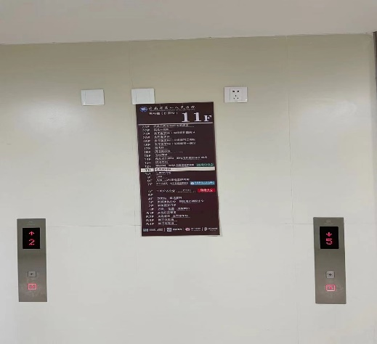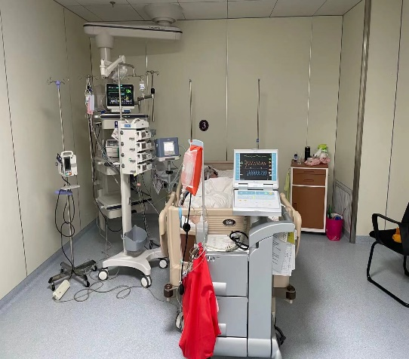

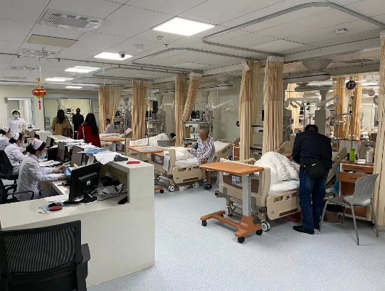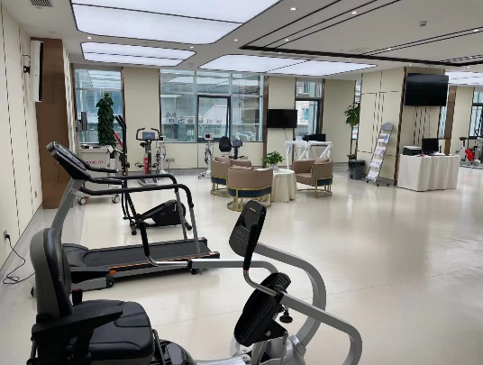
- Qilin Traditional Medicine Hospital (QTMH)
  - The hospital is a private one located in Qujing, a five-tier city that is a two-hour drive from Kunming.
  - The hospital is constructed as part of real estate development, and it has been given a public brand. This kind of mix provides the hospital with a competitive edge in the market. It can utilize the brand to attract patients but not necessarily be compliant with all the public hospital regulations.
  - The hospital has just finished building, and most of the significant medical instruments have newly been installed.
  - The hospital is expected to enter a trial operation in July 2021.
  - The management of QTMH is seeking cooperation with YFPPH’s cardiac vascular department.
  - Recently, many hospitals have been built or designed because many residential developments are required to include the construction of community hospitals. However, due to the business risk associated with private hospitals, only a small fraction of these community hospitals are operating.
