Interim report (Week 6)
Following last week 4’s visits to different hospitals, I continued the healthcare industry research, focusing on regulatory overview, the current situation and future prospectus of the industry, and the strategic comparison between public and private hospitals.

- Regulatory overview
- Categories of medical institutions in China
Medical institutions in China can be broadly categorized into three: public not-for-profit, private not-for-profit and private for-profit medical institutions. Both public not-for-profit and private not-for-profit medical institutions are required to charge service fees within a range authorized by government regulatory body and to retain the profits for future development, while private for-profit ones are permitted to charge fees freely and distribute the profits to their shareholders.Also, both taxation and accounting regulations applied on for-profit and not-for-profit ones are different accordingly.

In parallel, medical institutions are ranked into three classes: Class I, II and III, with Class-III being the highest class. Within each class, there are three sub-grades (A,B and C, with Grade A being the highest grade). Among various criteria for the ranking assessment, the number of beds is the most import one. For instance, for any hospital that is qualified for Class III, it should have at least 500 beds, while for Class I it should at least have 20 beds.

- Guidances on encouraging private capitals to invest in medical institutions
Several guidances and opinions have been issued by various level of Chinese government to stimulate private investment,including foreign capitals, in the healthcare system. For instance, Chinese State Council issued “Opinion on Innovating the Investment and Financing Mechanisms in Key Areas and Encouraging Social Investment” to encourage private capitals to participate in all kinds of healthcare investments. In the document, the state council also specified the implementation of preferential tax policies on private medical institutions and the exemption policies of administrative and institutional fees on the construction and operation of medical institutions.

Among many obstacles hindering the development of private hospitals, hiring reputable medical practitioners probably is the greatest one, as most of doctors in China like to work in the public institutions. To tackle this problem, the regulatory body issued “Administrative Measures for the Registration of Medical Practitioners” to confirm that medical practitioners can work in multiple institutions as long as they follow certain registration measures.

- Regulations on Handling Medical Malpractice
As medical accident is one of the most critical operational risks faced by medical institutions, specifying the rights and obligations of medical institutions during the medical services and clearifying the procedures of defining medical malpractice at legislative level are vital to the industry. The regulations on Handling Medical Malpratice promulgated by the State Council in 2002 provides detailed provisions regarding the prevention, disposition, technical identification, administrative disposition and supervision and compensation of medical malpractice.

- Regulations on Medical Insurance Coverage and Reimbursement
The national medical insurance program (NMIP) was first adopted in 1999, under which all employers in urban cities are required to enroll their employees in the basic medical insurance program and the insurance premium is jointly contributed by the employers and employees. NMIP is undoubtedly NO.1 payment program in China’s healthcare sector, as more than 50% of public hospitals’ revenues are paid through NMIP. Despite the its high coverage, NMIP is only designed for basic medical needs, and therefore, the problems like high co-pay requirements, drug and medical services exclusions, low caps for total reimbursement and inflexible plans undermine its values.

In 2019, the NHC issued “The Opinion on Promoting the Sustainable, Healthy and Regulated Development of Private Medical Institutions” to strengthen the support for private medical institutions, including encouraging private medical institutions to participate in NMIP by simplifying the administrative criteria and approval processes.

- Laws and Regulation on Prices of Medical Services and Medicine
The Notice of Issues Related to the Implementation of Market Price Adjustment by Non-Publiuc Healthcare Institutions, promulgated and implemented by State Council and the Ministry of Human Resources and Social Security, confirmed that private for-profit healthcare institutions can set their own prices for medical services but the reasonable prices shall be formulated under the principles of fairness, lawfulness and faithfulness and maintained the relatively stable price level within a specific period. The system of explicitly specifying the price and the breakdown list of medicine costs shall be executed as required. The prices of medical services and medicine shall be displayed to the patients publicly through various means.

- Regulations on the Management of Medical Waste and its Implementation Measures
The regulations and the Implementation Measures of the Management of Medical Waste stipulates that medical institutions must timely deliver medical waste to a specially designated location for centralized disposal of medical waste and categorize the medical waste in accordance with the Classified Catalog of Medical Waste. Sewage generated by any medical institution and excretion of its patients or patients suspected of infectious diseases must be sterilized in accordance with the relevant laws, rules and regulations, and must not be discharged into sewage until the relevant standards are met.

- The current situation and future prospectus of the healthcare industry
- Industry Revenue Generation
According to Frost & Sullivan, from 2014 to 2018, the revenue of China’s healthcare institutions grew from RMB 2,634.5 billion to RMB 4,111.2 billion, representing a CAGR of 11.7%. This trend of strong growth is very likely to persist. Frost & Sullivan predicts that to 2023 the revenue of China’s healthcare institutions will reach RMB 6,376.9 billion.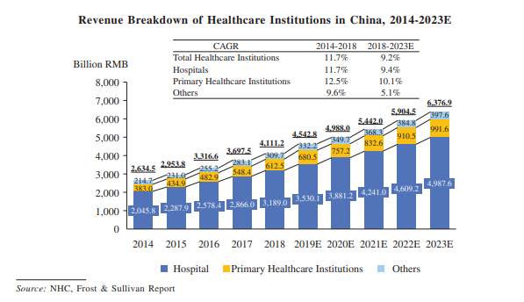
- Drivers for the Industry Growth
- The aging population and longer life expectancy
The Chinese population is aging fast. According to WHO’s report, in the next 20 years, the percentage of people age at 60 or over is expected to morethan double, from 12.4%(168 million people) in 2010 to 28% (402 million) in 2040. In 2050, this number is expected to reach 39% of the total population.
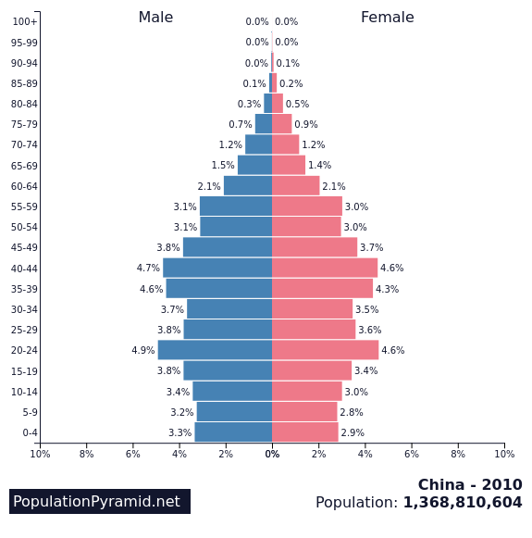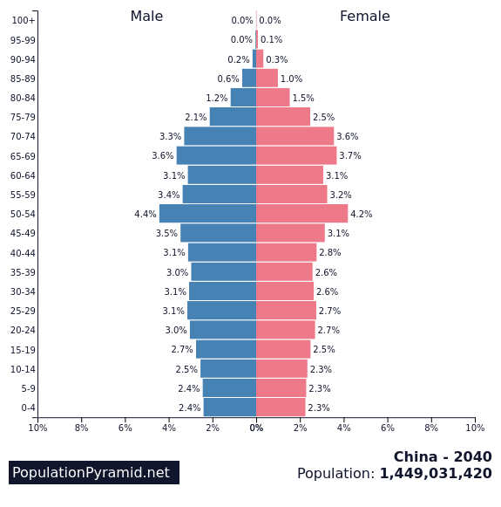
Moreover, a person who reaches age 60 in China can expect to live longer. In 2013, there were 22.6 million people aged 80 or over, and by 2050 the number is expected to increase fourfold to 90.4 million.
- The expansion of social insurance coverage
Universal insurance coverage is a key component of the government’s effort to address the increasing burden of healthcare costs for individuals and families, and it really has made some amazing achievements. Within less than 10 years, approximately 900 million people were enrolled in various public health insurance schemes, extentding coverage to morethan 95% of Chinese citizens.
- The rise in incidence of chronic diseases due to unhealthy lifestyle and pollutions
According to National Health Commission (NHC), China has over 180 million elderly citizens suffering from chronic , of whom 75% have more than one. The average life expectancy of Chinese citizens is 77 in 2018, but the healthy life expectancy was 68.7 years, indicating that people have more than 8 years to live with chronic diseases.almost 80%. Among several diseases, the most burdensome ones are Ischemic Heart Disease, Stroke, Chronic Obstructive Pulmonary Disease (COPD), and Type 2 Diabetes.

- The growth of annual disposable income per capita
Alongside with the economic growth, Chinese annual disposable income per capita has increased significantly. In 2020 the average of disposable income per capita has reached RMB43,000, more than doubled than 10 years ago. According to Morgan Stanley, this figure is expected to be doubled again in 2030, growing to RMB 82,000. This means that private consumption growth would be sustained at 7.9% annually over the next decade, pivoting more towards service consumption.

国内医院政策汇总
老龄化，尤其是心血管疾病人士的未来趋势
其他种类私立医院趋势
高端私立医院的竞争优势
高端私立医院的风险
中国医院体系：社区医院，市级医院，重点医院
私立医院（医保）：一般都处于中国三四线非省会城市
私立医院（非医保）：集中于北上广深一线城市
公立医院
运营模拟

