**Start**

Move forward by hitting "d" trying to hit as **many platforms as** possible before getting to the end

Hit'W'

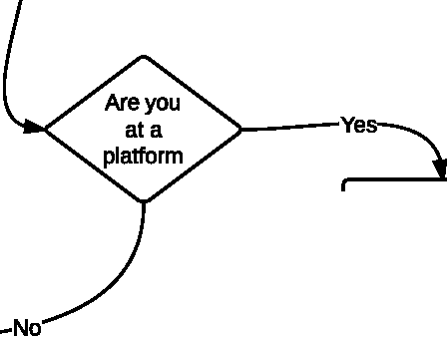

N 1Point gets added to your **final score and**

you land on

**Continue on**

forward

ANYTHING BELOW THIS POINT WAS INTENDED BUT NOT ACTUALLY IMPLEMENTED

top of platform

>---INOI--...-j

**Game is over.** Score will be calculated.

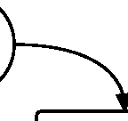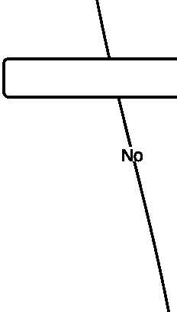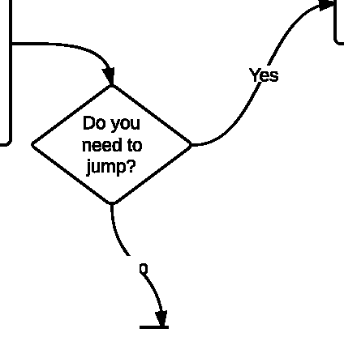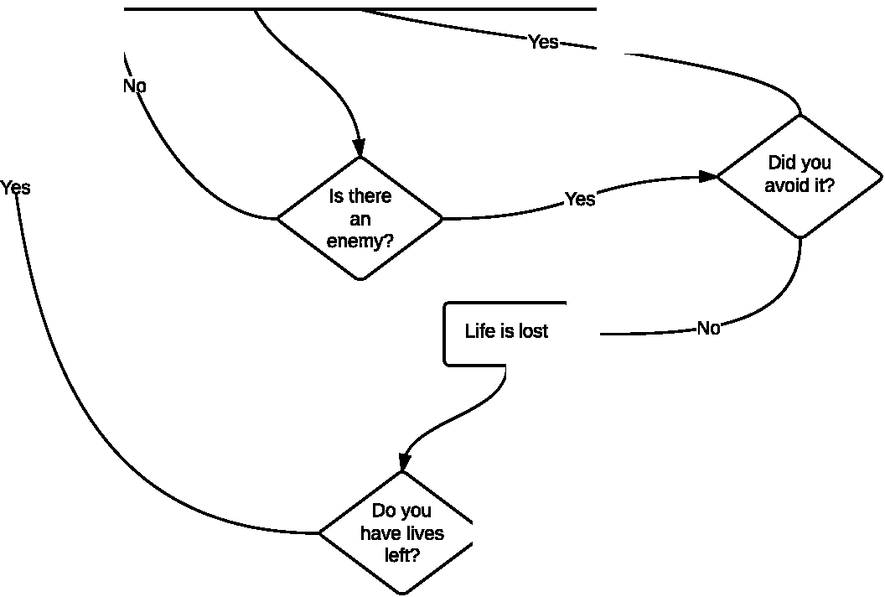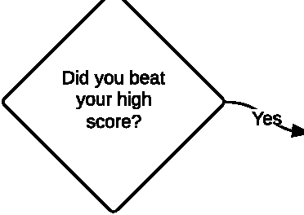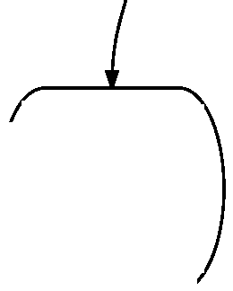

**ROCK ON!!!!**

**Game is over, score is the sum of however many platforms you** landed on, and how **many seconds are left on the clock**