Exercise 1:

To start with, I decided to use a multi-layer perceptron (MLP) with the structure shown below. This achieved very good results, with it achieving 100% validation accuracy at its peak performance. After 500 epochs, the model had achieved: loss: 0.0395 - acc: 0.9868 - val_loss: 0.0441 - val_acc: 0.9825, where the loss function used was binary crossentropy, and RMSProp was used to train the model.
_________________________________________________________________
Layer (type) Output Shape Param #
=================================================================
dense_121 (Dense) (None, 64) 1984
_________________________________________________________________
dropout_20 (Dropout) (None, 64) 0
_________________________________________________________________
dense_122 (Dense) (None, 64) 4160
_________________________________________________________________
dropout_21 (Dropout) (None, 64) 0
_________________________________________________________________
dense_123 (Dense) (None, 1) 65
=================================================================
Total params: 6,209
Trainable params: 6,209
Non-trainable params: 0

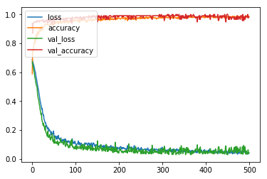
I then created some plots of the data (see below for an example; for all the graiphs see Pair_Plot.png in the Dataset 1 folder of the Git repository), which showed that the pairwise relationships of all the parameters look quite separable by a linear fit, which shouts out to me as an implementation for a support vector machine (SVM). Unfortunately, I don't have much experience with Scikit Learn, and I did not have enough time to learn to use it, or write an SVM from scratch. Given more time and knowledge, I would like to try to implement this to find out how it compares to the MLP. This also indicates that the features extracted are very well chosen.

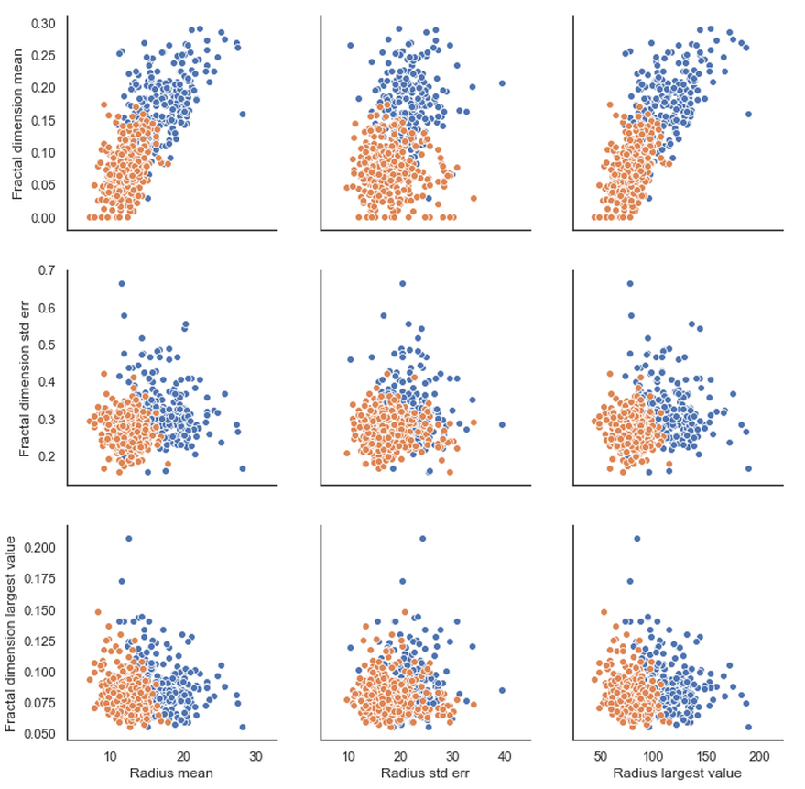

Exercise 2:

This was a much harder problem to train. The data importing was a bit more difficult since the labels and images are loaded in in different order, but this was solved with pandas easily enough. I started off using a CNN based on VGG, however after playing around with it for a while I could just not get it to train successfully. I looked at how many parameters were being trained and realised that there were over 200,000,000. The images only contain 5,120,000 pixels before the validation split, so there was no way this was going to train successfully. After playing about for a while longer I finally settled on the following structure:

Layer (type) Output Shape Param #
=================================================================
conv2d_104 (Conv2D) (None, 398, 638, 64) 640
_________________________________________________________________
max_pooling2d_90 (MaxPooling (None, 79, 127, 64) 0
_________________________________________________________________
dropout_138 (Dropout) (None, 79, 127, 64) 0
_________________________________________________________________
conv2d_105 (Conv2D) (None, 77, 125, 64) 36928
_________________________________________________________________
max_pooling2d_91 (MaxPooling (None, 15, 25, 64) 0
_________________________________________________________________
dropout_139 (Dropout) (None, 15, 25, 64) 0
_________________________________________________________________
flatten_41 (Flatten) (None, 24000) 0
_________________________________________________________________
dense_81 (Dense) (None, 32) 768032
_________________________________________________________________
dropout_140 (Dropout) (None, 32) 0
_________________________________________________________________
dense_82 (Dense) (None, 2) 66
=================================================================
Total params: 805,666
Trainable params: 805,666
Non-trainable params: 0

The pooling works in 5x5 regions, the Dense layer has been reduced in size, but the network is still a bit deep, as this improved the power of the network without requiring as many parameters. I would have made it deeper, but that makes it much more difficult to train. After training for 100 epochs, the results were: loss: 0.0154 - categorical_accuracy: 1.0000 - val_loss: 0.0165 - val_categorical_accuracy: 1.0000, where the loss was categorical crossentropy and the optimizer used was adam with a learning rate of 0.0005 (this gave the best convergence I could find).

Since the dataset is so small, I tried using data augmentation techniques: I used Keras' ImageDataGenerator to apply random rotations, flips and scaling to the images. This did not improve the convergence, so I removed the width and height scaling in case the data is sensitive to distortion, but it still did not help, as the loss curves below show. This is interesting and could imply that my net has been overfitting, since rotations and horizontal flips should not affect the data, or it could mean that my data generator was not implemented properly.
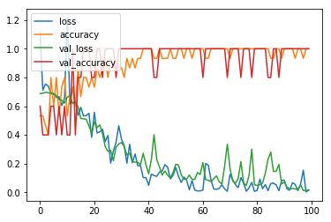
Training graph from the non-augmented data set
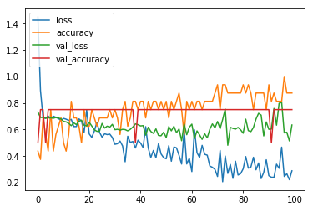
Training graph from the augmented set

In terms of comparison to each other, in theory the CNN would perform better if the same number of cases were used, since it could learn all the features extracted for the other data set, but also pick out other things that may not have been thought of. However, this is much, much more computationally expensive to do. I was very impressed by the success of the feature based method, and believe that this is a more effective method as it allows many more cases to be used, creating a more general model (4 images is not enough for a validation set). That is assuming there is enough data to make it worth it. In this case, 569 images is not prohibitively large and it would be interesting to see how successful a CNN would be, and how long it would take to train. I would also like to see an SVM working, as I think this has the potential to be very powerful.

In conclusion, if I had huge amounts of data, I would use feature extraction and either an SVM or an MLP to train the model, but if the amount of data was more moderate, I would stick with a CNN, as it can pick out many more features, it just requires more training.

