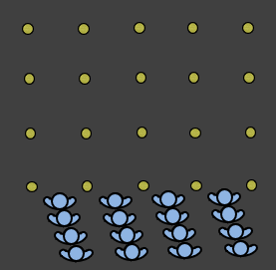

Warmup
Rules/explanation | Passing activation
Groups of 5 or 6  Going through all dynamic movements.  Swing arms.  Over the fence.  Sideways at each cone around opposite player.  Knees up.  Heels up.  Raise knee, kick leg out.  Jog to first cone, then accelerate.  2 footed jumps.  Shoulder to shoulder | 3 different combinations  Follow the diagrams below.
Progressions | Coaching points

Players | Size | Timing
All players. | 4 cones per line.  5m (6 steps apart) | 15mins
Scoring | Intensity
 | Warmup

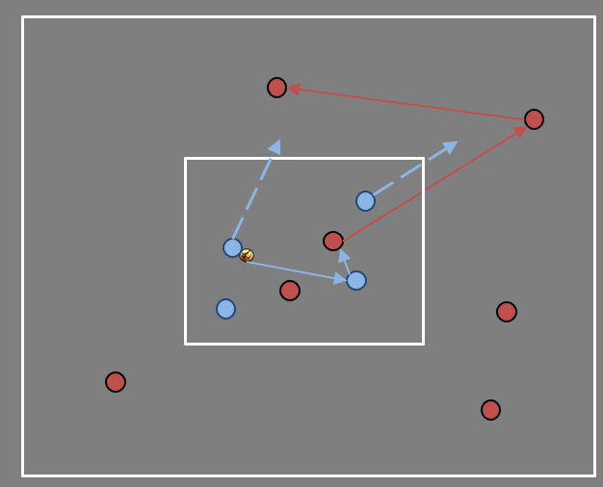

Introduction
Rules/explanation | Coaching messages
2 teams of 11.  2 squares setup, 7v4 in each.  Rotate often.  Start with the 4v2, when ball is won or goes out of square it becomes 7v4.  8 is the magic number.  If the 4 get 8 passes, a new pair defends. If the 7 get 8 then it’s a goal. | How quickly will we react.  BP>BPO, can we close the ball quickly.  BPO>BP, can we slow the tempo, and build passes.  Are we supporting, or just tired standing behind people.
Progressions | Coaching points
Change the magic number if it’s too hard or too easy.

Players | Size | Timing
All | 10x10m  25x25m | 15mins
Scoring | Intensity
 | Low-med

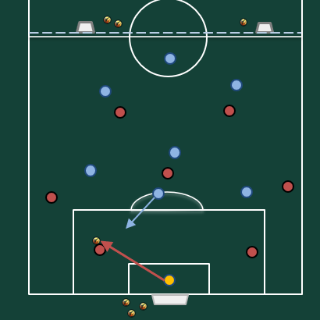

Main part
Rules/explanation | Tasks
2 teams. 6v6 or 7v7.  1-2-1-3 for attackers.  4-1-2 for defenders.  Attacking team v defending team.  Key is +1 at back for defenders, so attackers have to jump to make 1v1 everywhere.  Restarts happen from anywhere.  Attackers dont allow CBs to have open-ball or time and space. | Focus is on attackers pressing decisions.  Need the 10 to jump in game moments and for goal-kicks.  CBs can’t have time to play a pass or drive.
Progression | Coaching point

Players | Size | Timing
Players and GK | 45x50m | 20-25mins.
Scoring | Intensity
Score in goals | Med-High.

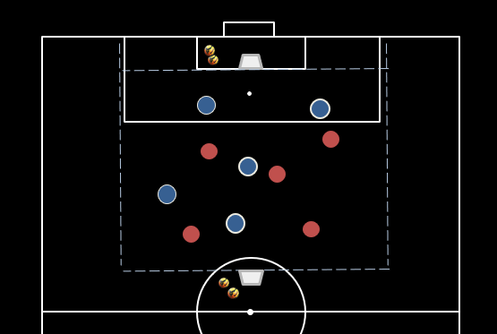

End game
Rules/explanation | Tasks
SMALL GAMES

30m x 40m. 6v6

1 game (3 teams)

5mins play, 3mins rest.
5mins play, 4mins rest.

Vary the rules/conditions of the game.

Whatever the theme was for the session.

Players | Size | Timing
All | Less than half field. | 12-15mins total
Scoring | Intensity
Goals | Med-High

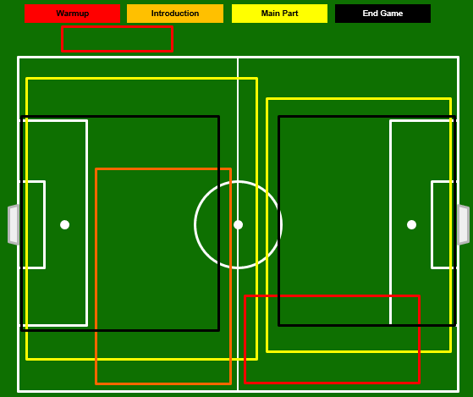

Comments
- McKellar Sunday

24 players
2 (GK training)
26 total likely.

1 | GK | Matilde
2 | CB | Ailish
3 | CB | Rhi | Ankle
4 | CB | Emily | Away
5 | FB | Bronte
6 | FB | Maja
7 | FB | Stefi
8 | FB | EJ
9 | CM | Izzy
10 | CM | Anneke
11 | CM | Leila
12 | CM | Alex | Rest
13 | F | Alina | Away
14 | F | Hattie | Likely away
15 | F | DC
16 | F | Skelly
17 | GK | Claire
18 | CB | Gemma
19 | CB | Sage
20 | FB | Ariana
21 | FB | Sarah
22 | FB | Molly
23 | CM | Isla
24 | CM | Issey
25 | CM | Siena
26 | CM | Dani | Away
27 | CM | Sammy
28 | CM | Eden
29 | F | Lily
30 | F | Scarlett
 |  | Keira
 |  | Ella
 |  | Alex M
 |  | Elfin
 |  | ET

