Target organization: UPC
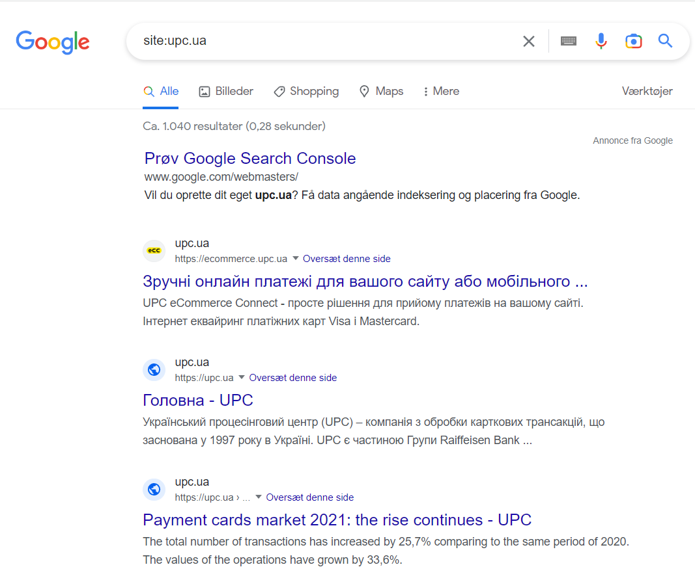
1. Google search engine.
General information about target
Summary: UPC – is the payment cards processing company which has additional business e-commerce and the company is the leader on the market.

2. Google search engine. Specific search I
Let’s try to find some open documents related with our target organization.
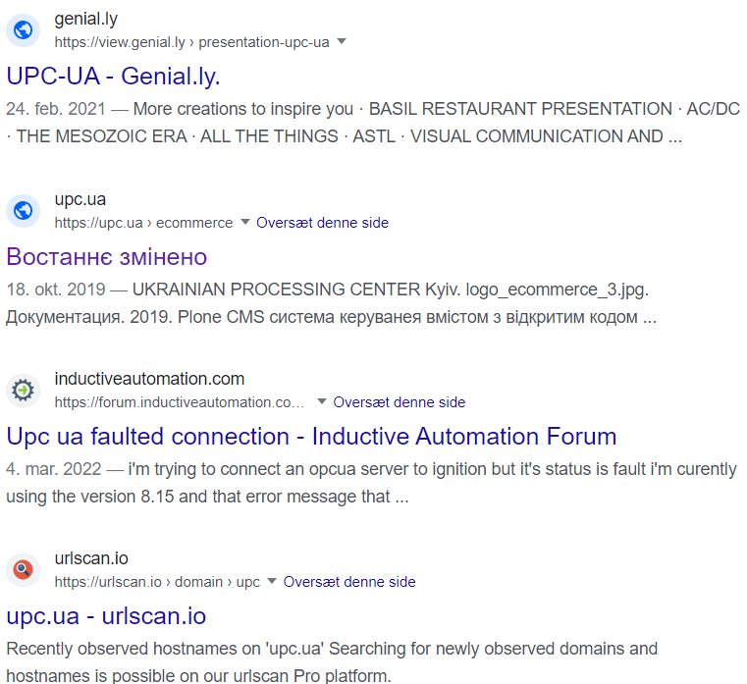
intitle:"upc.ua" -filetype:"PDF"
Summary: I was lucky. I have managed to find some information related with title of target organization, but
without any PDF.
intitle:"upc.ua" -filetype:"jpeg"
Also return nothing, I mean documents, but the query returns information about target organization which has the word “UPC” in its title.

3. Google search engine. Specific search II
Let’s try to find specific word in the target URL.
Try to find the snippet like: “gotivki-za-rik”
from the link: “https://upc.ua/pokupka-iz-vidacheyu-gotivki-za-rik-oboroti-zbilshilis-u-41-raz-a-kilkst-operatsiy-u-11-raziv/”
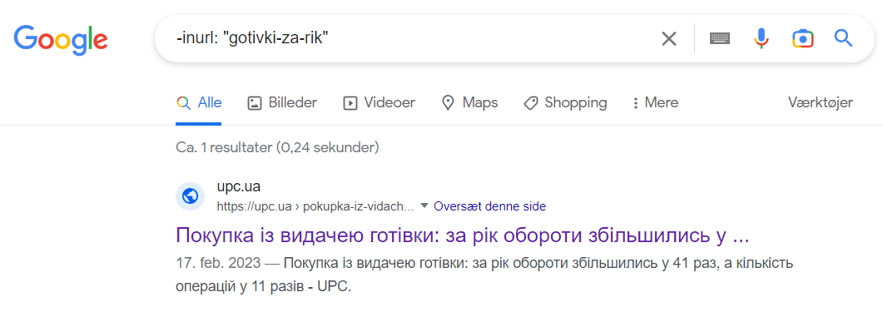
Summary: Perfect. Only one URL in our result.
4. Email harvesting
Try to find e-mails related with target organization using “theHarvester” app from Kali distrib using Bing, Yahoo.
Does not support Google search engine :(
All support search engine is available by command:
theHarvester -h

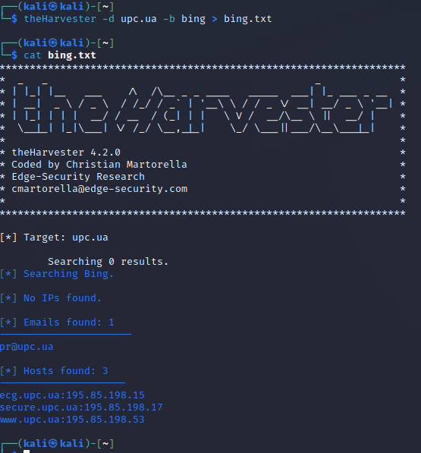
Bing search result:
theHarvester -d upc.ua -b bing > bing.txt

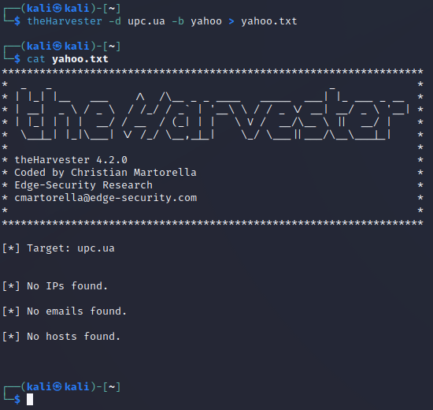
Summary: Found one public email ”pr@upc.ua”
and 3 hosts.
Yahoo search result:
theHarvester -d upc.ua -b yahoo > yahoo.txt

Summary: no any result, maybe target organization does not indexing by Yahoo.

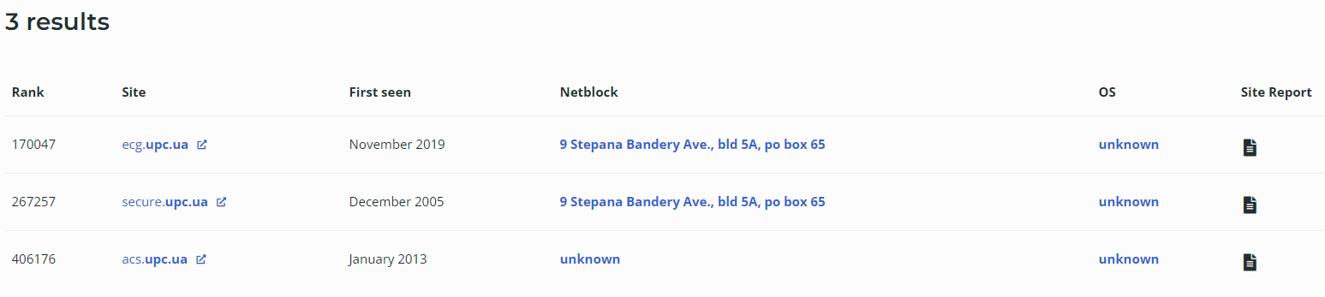
5. WEB GUI tools. Netcraft.
I have found 3 public hosts:

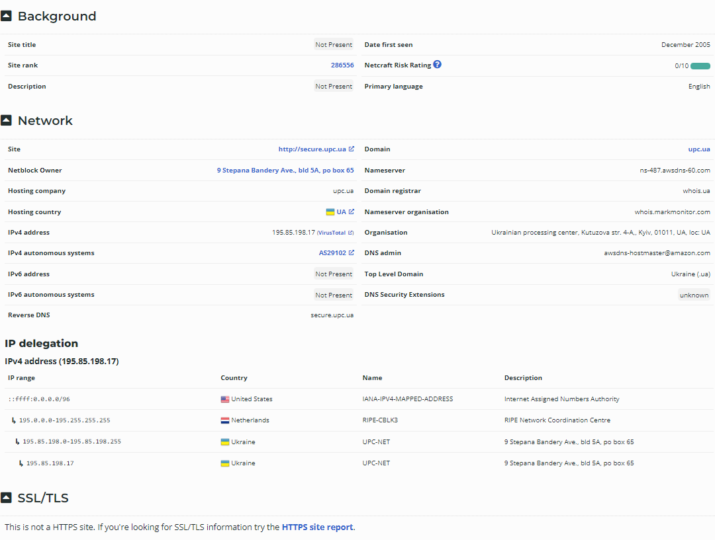
Detailed information about one of them

6. WHOIS
The most popular tools.
whois upc.ua

