

**O’ZBEKISTON RESPUBLIKASI AXBOROT TEXNOLOGIYALARI VA KOMMUNIKATSIYALARINI RIVOJLANTIRISH VAZIRLIGI**

**MUHAMMAD AL-XORAZMIY NOMIDAGI TOSHKENT AXBOROT TEXNOLOGIYALARI UNIVERSITETI**

**SAMARQAND FILIALI**

**“KOMPYUTER INJINIRINGI”**

**FAKULTETI**

**“KOMPYUTER INJINIRING” KAFEDRASI**

INDIVIDUAL LOYIHA ISHI

**Mavzu:** “Online shop” internet do’konni ishlab chiqish

Bajardi: 104-19-guruh talabasi

Tohirov. A

Rahbar:__________________

SAMARQAND – 2022

**Reja**

1. Kirish.
2. Asosiy qism.
3. Dasturlash texnologiyasi va ishchi holatga tayyorlash.
4. “OnlineShop.uz” internet do’konini interfeysini yaratish.
5. Foydalanuvchilarga qo’llanma.

Foydalanilgan adabiyotlar

**Kirish**

Hozirgi kunda dunyo aholisining deyarli 90 % internet tarmog’idan foydalanmoqda. Bu holat esa aksariyat foydalanuvchilar ko’plab o’zlariga kerakli narsalarni uydan turib **Online shop**lardan buyurtma qilishni va online holatda sotib olishni xohlashadi.

Jamiyatning moliyaviy ahvoli ma'lum darajada texnikalar va oziq-ovqatga bo'lgan talab bilan belgilanadi va bu tadqiqot natijalari bilan tasdiqlangan haqiqatdir. Iqtisodchilarning ta'kidlashicha, mintaqa yoki shahar qanchalik boy bo'lsa, jon boshiga shunchalik ko'p narsa bo’yimlar sotiladi. Ammo shunga qaramay, ushbu bayonotni yuz foiz deb atash mumkin emas, chunki bu masalada mentalitet rol o'ynaydi.

Bizning internet do’konimizning qulayliklardan biri bu asosan qulay interfeys foydalanish mumkinligidir. Biz taklif qilayotgan xizmatlar ko’pchilik foydalanuvchilarga maqul bo’lib, ularning vaqtlari pullarini tejashga imkon beradi. Biz asosiy e’tiborni sifatga qaratamiz. Eng asosiysi siz bizning do’konga shaxsan tashrif buyurishingiz shart emas. Biz masofaviy to’lovlarni click, pyme, oson va bir qator shu kabi ilovalar orqali to’lashni yo’lga qo’yganmiz. Bulardan tashqari, UZCARD, HUMO, VISA CARD plastic kartalari orqali ham to’lov qilish mumkin. Bizning yetkazib berish xizmatimiz butun O’zbekiston bo’yicha yo’lga qo’yilgan.

Internetdagi savdo maydonchamizda siz O'zbekiston bo'yicha taklif qilingan texnika va oziq-ovqatlarni kategoriyasidagi mahsulotlarni tez, oson va qulay sotib olishingiz mumkin. Saytda xarid qilish uchun maqbul shartlarga ega eng yaxshi takliflar mavjud. O'zbekiston bo'yicha texnika va oziq-ovqatlarni kategoriyasidagi mahsulotlarini sotadigan kompaniyalar arzon narxlar, tezkor yetkazib berish va xaridorga foydali bo'lgan boshqa imkoniyatlarni taklif qiladi.

Bu yerda siz O'zbekiston bo'yichagi texnika va oziq-ovqatlarni uchun eng maqbul narxni topasiz, bu sizning xarajatlaringizni iloji boricha kamaytiradi. Bundan tashqari, izohlarning mavjudligi va fotosurat bilan O'zbekiston bo'yicha kategoriya qisqacha tavsifi sizga taklif qilinayotgan mahsulot haqida to'liq tasavvurga ega bo'lishga imkon beradi.

**OnlineShop.uz** onlayn-savdo markazi O'zbekiston bo'yichagi Sun'iy gullar kategoriyasidan biron narsani sotmoqchi bo'lganlar uchun qulay va foydalidir.

**Asosiy qism.**

1. Dasturiy taminotni yartish uchun bizga text editor kerak bo’ladi. Har bir dasturchining o’z editorlari (o’ziga qulay bo’lgan va o’zi doimiy foydalanadigan editorlari) mavjud bo’ladi. Dasturlash nuqtai nazaridan vaqtni tejash maqsadida text editorimiz standart kodlarni o’zi zoyib beradigan (падсказка)li qilib yaratilgan bo’lishi kerak. Shu nuqtai nazardan men loyiham uchun Visual Studio Code text editoridan foydalanaman. Hozzirgi kunda bu text editor boshqa shu kabi editorlar ichida eng samaradori va keng qo’llanilaotganini ham takidlab o’tish kerak. Bulardan tashqari ushbu editor keng imkoniyatlarga ega. Word, image, audio, video va boshqa bir qancha fayllar bilan ishlay oladi. Shu birga bu editordan foydalanish judayam oson va qulay.

HTML **H**yper**t**ext **M**arkup **L**anguage (Gipermatnli belgilash tili) degan ma’noni anglatadi va asosan Web sahifalar asosini yozishda foydalaniladi.  
**CSS (CASCADING STYLE SHEETS – STILLARNING KASKADLI JADVALI). HTML VA CSS**

Html elementlariga stillar 3 hil usulda beriladi:  
Inline style – Html elementi bilan bir chiziqda  
External style sheet – alohida tashqi faylda  
Internal style sheet – Html sahifaning aynan oʼzida

**CSS** – bu stillar bilan ishlay oladigan **kaskadli stillar majmuasi**dir. Web sahifalarga har xil stillar berish uchun ishlatiladi. HTML xujjat ichida teglar bilan birga foydalaniladi. CSS kodlarini kompilyastiya qilish uchun qandaydir kompillyatorlar, qandaydir dasturlar, va bu kod tushuna oladigan qandaydir redaktorlar kerak bo’lmaydi. Bu kodlarni HTML singari web brauzerning o’zi kompilyastiya qiladi va natijani chiqarib beradi. Bu stillar jadvali(CSS) to’liq holatda **1997** yilda tashkil topib, **“WWW Consorcium”** ida qo’llab quvvatlangan va foydalanishga taqdim etilgan. O’sha paytlarda **HTML ning 3** versiyasi ommabop edi. CSS ni dastlab **Netscape Navigator 4.0** va **Internet Explorer 4.0** brouzerlarida ko’rish mumkin bo’lgan. Hozirda barcha brouzerlar css da yozilgan kodlarni tushuna oladi. Bu stillarga oid dasturlash tilini o’rganish sodda bo’lib, yangi stillar qo’shilishi natijasida kengayib bormoqda.  
CSS ni HTML xujjati ichida ishlatilishini birin ketin ko’rib o’tamiz: 1. Web sahifada ishlatiladigan CSS kodlari orqali hosil qilinadigan stillarni hammasini bitta  
faylga yozib, uni serverda saqlaymiz. So’ng, sahifadan, serverdagi saqlab qo’yilgan faylga murojaat qilib, kerakli stilni olamiz. Bu usul katta hajmdagi web sahifalar yaratishda foydali hisoblanadi. Faylga murojaat, **<head>** tegi ichida amalga oshiriladi va quyidagi ko’rinishga ega bo’ladi.

<LINK REL=STYLESHEET TYPE="text/css" HREF="URL">

**<link>** tegi sahifa biror faylga murojaatni amalga oshirmoqda degani, **REL**– fayl qandaydir stillardan iborat degani, **TYPE** - stillar css kodlaridan iborat va fayl joylashgan manzil yoziladi. 1. CSS kodlar veb sahifa ichidagi <head> tegi orasida beriladi. Bunda yaratilgan stillar shu sahifaga tegishli bo’ladi, bu degani faqat shu sahifada ishlatilish mumkindir. <head>< STYLE TYPE="text/css"> <!-- A {text-decoration:none; } --> </--STYLE></head> 2. Navbatdagi turi, bu har bir element uchun alohida teg ichida stil berib chiqishdan iborat. Misol uchun, “p” tegi ichida biror matn yozilsa, shu matn uchun teg ichida alohida stil beriladi va bu stil shu teg uchun xususiy bo’ladi. Bu usuldan foydalanishni maslahat bermiman, chunki bu usul kodlarni chalkash va tushunarsiz bo’lishiga olib keladi. Shoshilinch vaziyatlarda yoki stil qay tartibda namoyon bo’lishni ko’rib olish uchun bu usuldan foydalanishni maslahat beraman. Undan tashqari <style> tegi orqali css faylni import qilish mumkin bo’ladi.

Quyida biz Visual Studio Code dasturini ishga tushuramiz (1-rasm).

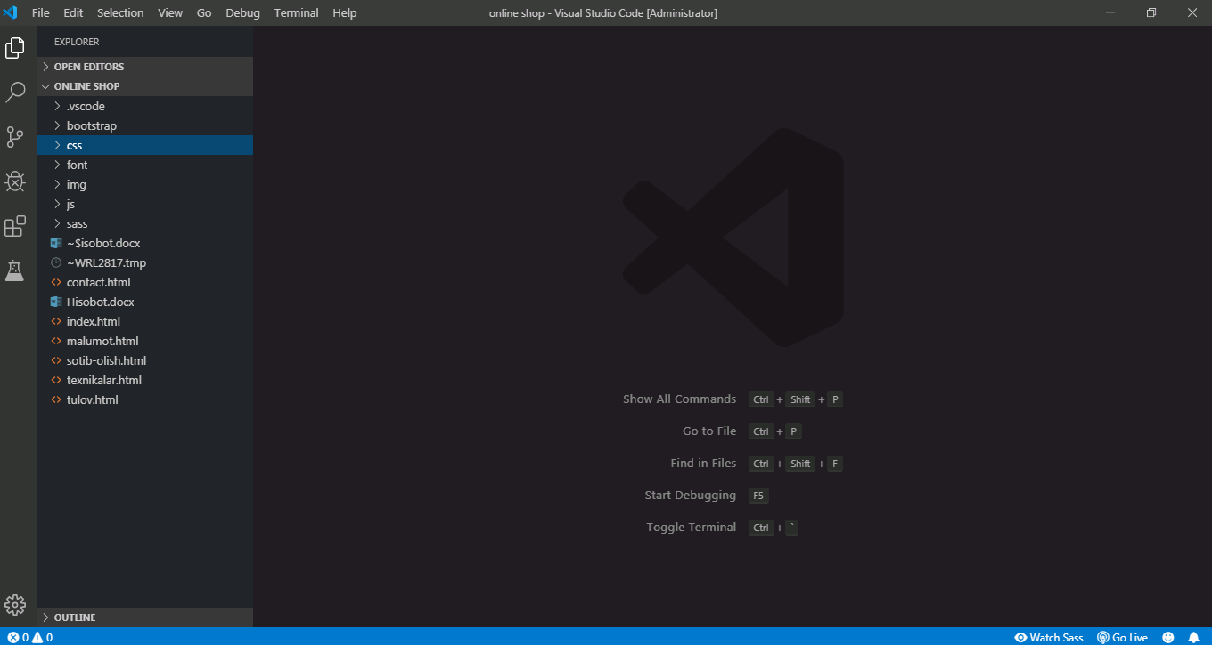

Bizning ishchi oynamiz hozzircha bo’sh turibdi. Chap tomonda esa biz yaratgan fayllar menyusi joylashgan. Bu bo’limda katalog(Online shop papkasi) fayllar bilan ishlash mumkin.

Men bu yerda bootstrap, img, css, js, font, sass kataloglarini va index.html, contact.html, malumot.html,sotib-olish.html, texnikalar.html, tulov.html fayllarini yaratdim. Bulardan tashqari, js katalogi joylashgan bo’lib, unda java script fayllari joylashgan. Buni quyidagi rasmlarda ham ko’rish mumkin:

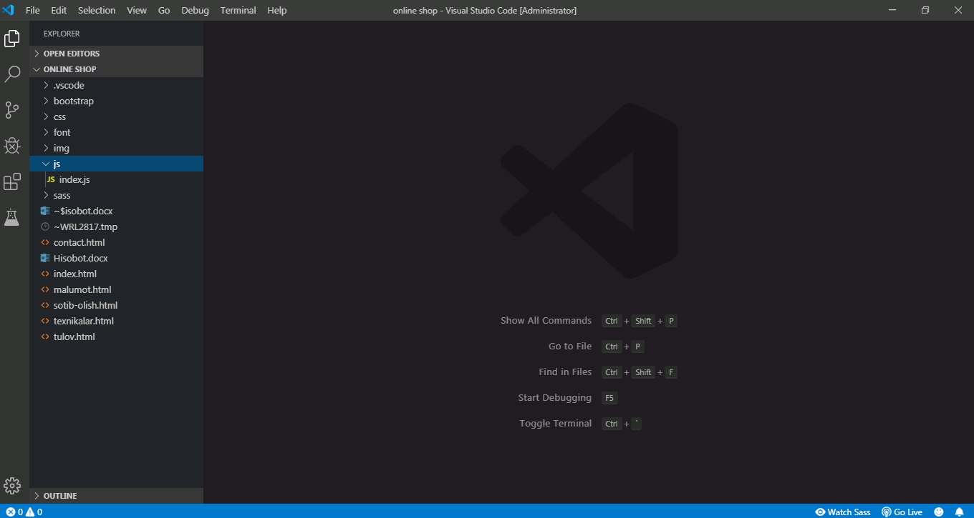

1.Index.html faylidagi kodlar.

<!DOCTYPE html>

<html lang="en">

<head>

    <meta charset="UTF-8">

    <meta name="viewport" content="width=device-width, initial-scale=1.0">

    <meta http-equiv="X-UA-Compatible" content="ie=edge">

    <link rel="stylesheet" href="bootstrap/css/bootstrap.css">

    <link rel="stylesheet" href="css/index.css">

    <link rel="stylesheet" href="css/kirish.css">

    <title>Online shop | Home page</title>

</head>

<body>

    <div class="container-fluid">

        <div class="bosh-menu">

            <div class="menu">

                <div class="logo">

                    <img src="img/logo.jpg" alt="logo">

                </div>

                <div class="menu-bar">

                    <div class="menu-search">

                        <input type="text" name="Search" placeholder="Search . . ." id="search">

                        <img src="img/search.svg" alt="search">

                    </div>

                    <div class="menu-name">

                        <ul>

                            <li><img src="img/uy.jpg" alt=""><a href="index.html">Home</a></li>

                            <li><img src="img/texnika.jpg" alt=""><a href="texnikalar.html">Texnikalar</a></li>

                            <li><img src="img/oziq-ovqat.jpg" alt=""><a href="#">Oziq-ovqatlar</a></li>

                            <li><img src="img/atir.jpg" alt=""><a href="#">Buyumlar</a></li>

                            <li><img src="img/pochta.jpg" alt=""><a href="contact.html">Contact</a></li>

                        </ul>

                    </div>

                </div>

                <div class="menu-lang">

                    <div id="login-btn" class="kirish">Kirish</div>

                    <select class="form-select" aria-label="Default select example">

                        <option selected>Uzbek</option>

                        <option value="1">English</option>

                        <option value="2">Rus</option>

                      </select>

                </div>

            </div>

        </div>

        <div class="login-form-container">

            <button id="close-login-btn" type="button" class="btn-close" aria-label="Close"></button>

            <form>

                <div class="mb-3">

                  <label for="exampleInputEmail1" class="form-label">Email address</label>

                  <input type="email" class="form-control" id="exampleInputEmail1" aria-describedby="emailHelp">

                  <div id="emailHelp" class="form-text">We'll never share your email with anyone else.</div>

                </div>

                <div class="mb-3">

                  <label for="exampleInputPassword1" class="form-label">Password</label>

                  <input type="password" class="form-control" id="exampleInputPassword1">

                </div>

                <div class="mb-3 form-check">

                  <input type="checkbox" class="form-check-input" id="exampleCheck1">

                  <label class="form-check-label" for="exampleCheck1">Check me out</label>

                </div>

                <button type="submit" class="btn btn-primary">Submit</button>

            </form>

        </div>

        <div class="reklama">

            <h2>Reklama</h2>

                <div class="box-left"></div>

                <div class="box-middle">

                    <div class="box-1"></div>

                    <div class="box-2"></div>

                </div>

                <div class="box-right"></div>

        </div>

        <div class="clr"></div>

        <div class="produkt">

            <div class="box-1">

                <div class="maxsulot-rasm">

                </div>

                <div class="belgi">+</div>

                <div class="maxsulot-nomi">

                        Maxsulot nomi

                </div>

                <div class="narx">

                    <del>100 $</del> | <span>narxi 80$</span>

                </div>

                <div class="malumot">

                    <div class="box1">

                        <a href="#">Malumot</a>

                    </div>

                    <div class="box2">

                        <a href="sotib-olish.html">Sotib olish</a>

                    </div>

                </div>

            </div>

            <div class="box-1">

                    <div class="maxsulot-rasm"></div>

                    <div class="belgi">+</div>

                    <div class="maxsulot-nomi">

                            Maxsulot nomi

                    </div>

                    <div class="narx">

                        <del>100 $</del> | <span>narxi 80$</span>

                    </div>

                    <div class="malumot">

                        <div class="box1">

                            <a href="#">Malumot</a>

                        </div>

                        <div class="box2">

                            <a href="#">Sotib olish</a>

                        </div>

                    </div>

            </div>

            <div class="box-1">

                    <div class="maxsulot-rasm"></div>

                    <div class="belgi">+</div>

                    <div class="maxsulot-nomi">

                            Maxsulot nomi

                    </div>

                    <div class="narx">

                        <del>100 $</del> | <span>narxi 80$</span>

                    </div>

                    <div class="malumot">

                        <div class="box1">

                            <a href="#">Malumot</a>

                        </div>

                        <div class="box2">

                            <a href="#">Sotib olish</a>

                        </div>

                    </div>

            </div>

            <div class="box-1">

                    <div class="maxsulot-rasm"></div>

                    <div class="belgi">+</div>

                    <div class="maxsulot-nomi">

                            Maxsulot nomi

                    </div>

                    <div class="narx">

                        <del>100 $</del> | <span>narxi 80$</span>

                    </div>

                    <div class="malumot">

                        <div class="box1">

                            <a href="#">Malumot</a>

                        </div>

                        <div class="box2">

                            <a href="#">Sotib olish</a>

                        </div>

                    </div>

            </div>

            <div class="box-1">

                    <div class="maxsulot-rasm"></div>

                    <div class="belgi">+</div>

                    <div class="maxsulot-nomi">

                            Maxsulot nomi

                    </div>

                    <div class="narx">

                        <del>100 $</del> | <span>narxi 80$</span>

                    </div>

                    <div class="malumot">

                        <div class="box1">

                            <a href="#">Malumot</a>

                        </div>

                        <div class="box2">

                            <a href="#">Sotib olish</a>

                        </div>

                    </div>

            </div>

            <div class="box-1">

                    <div class="maxsulot-rasm"></div>

                    <div class="belgi">+</div>

                    <div class="maxsulot-nomi">

                            Maxsulot nomi

                    </div>

                    <div class="narx">

                        <del>100 $</del> | <span>narxi 80$</span>

                    </div>

                    <div class="malumot">

                        <div class="box1">

                            <a href="#">Malumot</a>

                        </div>

                        <div class="box2">

                            <a href="#">Sotib olish</a>

                        </div>

                    </div>

            </div>

            <div class="box-1">

                    <div class="maxsulot-rasm"></div>

                    <div class="belgi">+</div>

                    <div class="maxsulot-nomi">

                            Maxsulot nomi

                    </div>

                    <div class="narx">

                        <del>100 $</del> | <span>narxi 80$</span>

                    </div>

                    <div class="malumot">

                        <div class="box1">

                            <a href="#">Malumot</a>

                        </div>

                        <div class="box2">

                            <a href="#">Sotib olish</a>

                        </div>

                    </div>

            </div>

            <div class="box-1">

                    <div class="maxsulot-rasm"></div>

                    <div class="belgi">+</div>

                    <div class="maxsulot-nomi">

                            Maxsulot nomi

                    </div>

                    <div class="narx">

                        <del>100 $</del> | <span>narxi 80$</span>

                    </div>

                    <div class="malumot">

                        <div class="box1">

                            <a href="#">Malumot</a>

                        </div>

                        <div class="box2">

                            <a href="#">Sotib olish</a>

                        </div>

                    </div>

            </div>

            <div class="box-1">

                    <div class="maxsulot-rasm"></div>

                    <div class="belgi">+</div>

                    <div class="maxsulot-nomi">

                            Maxsulot nomi

                    </div>

                    <div class="narx">

                        <del>100 $</del> | <span>narxi 80$</span>

                    </div>

                    <div class="malumot">

                        <div class="box1">

                            <a href="#">Malumot</a>

                        </div>

                        <div class="box2">

                            <a href="#">Sotib olish</a>

                        </div>

                    </div>

            </div>

            <div class="box-1">

                    <div class="maxsulot-rasm"></div>

                    <div class="belgi">+</div>

                    <div class="maxsulot-nomi">

                            Maxsulot nomi

                    </div>

                    <div class="narx">

                        <del>100 $</del> | <span>narxi 80$</span>

                    </div>

                    <div class="malumot">

                        <div class="box1">

                            <a href="#">Malumot</a>

                        </div>

                        <div class="box2">

                            <a href="#">Sotib olish</a>

                        </div>

                    </div>

            </div>

        </div>

        <div class="adress">

            <div class="box-left">

                <div class="box-store">

                    <div class="app-store">

                        <img src="img/ios.png" alt="ios">

                        App Store

                    </div>

                    <div class="meta">

                        <img src="img/meta.svg" alt="meta">

                    </div>

                </div>

                <br>

                <div class="box-store">

                    <div class="app-store">

                        <img src="img/play-market.png" alt="ios">

                            App Market

                    </div>

                    <div class="meta">

                            <img src="img/meta.svg" alt="meta">

                    </div>

                </div>

            </div>

            <div class="box-right">

                <div class="box-1">

                    <p>Call Markaz</p>

                    <p>+998 99 959 98 11</p>

                </div>

                <div class="box-2">

                    <p>Manzil</p>

                    <p>Qashqadaryo vil, Shahrisabz tumani, Bog'ishamol MFY, uch uyli ko'chasi 28-uy</p>

                </div>

                <div class="box-3">

                    <p>Yetkazib berish</p>

                    <ul>

                        <li>Samalyod</li>

                        <li>Pochta</li>

                        <li>Poyizd</li>

                    </ul>

                </div>

            </div>

        </div>

    </div>

    <script src="js/index.js"></script>

</body>

</html>

2.texnikalar.html faylidagi kodlar.

<!DOCTYPE html>

<html lang="en">

<head>

    <meta charset="UTF-8">

    <meta name="viewport" content="width=device-width, initial-scale=1.0">

    <meta http-equiv="X-UA-Compatible" content="ie=edge">

    <link rel="stylesheet" href="bootstrap/css/bootstrap.css">

    <link rel="stylesheet" href="css/index.css">

    <link rel="stylesheet" href="css/kirish.css">

    <link rel="stylesheet" href="css/texnikalar.css">

    <title>Texnikalar | Online shop</title>

</head>

<body>

    <div class="container-fluid">

        <div class="bosh-menu">

            <div class="menu">

                <div class="logo">

                    <img src="img/logo.jpg" alt="logo">

                </div>

                <div class="menu-bar">

                    <div class="menu-search">

                        <input type="text" name="Search" placeholder="Search . . ." id="search">

                        <img src="img/search.svg" alt="search">

                    </div>

                    <div class="menu-name">

                        <ul>

                            <li><img src="img/uy.jpg" alt=""><a href="index.html">Home</a></li>

                            <li><img src="img/texnika.jpg" alt=""><a href="texnikalar.html">Texnikalar</a></li>

                            <li><img src="img/oziq-ovqat.jpg" alt=""><a href="#">Oziq-ovqatlar</a></li>

                            <li><img src="img/atir.jpg" alt=""><a href="#">Buyumlar</a></li>

                            <li><img src="img/pochta.jpg" alt=""><a href="contact.html">Contact</a></li>

                        </ul>

                    </div>

                </div>

                <div class="menu-lang">

                    <div id="login-btn" class="kirish">Kirish</div>

                    <select class="form-select" aria-label="Default select example">

                        <option selected>Uzbek</option>

                        <option value="1">English</option>

                        <option value="2">Rus</option>

                      </select>

                </div>

            </div>

        </div>

        <div class="login-form-container">

            <button id="close-login-btn" type="button" class="btn-close" aria-label="Close"></button>

            <form>

                <div class="mb-3">

                  <label for="exampleInputEmail1" class="form-label">Email address</label>

                  <input type="email" class="form-control" id="exampleInputEmail1" aria-describedby="emailHelp">

                  <div id="emailHelp" class="form-text">We'll never share your email with anyone else.</div>

                </div>

                <div class="mb-3">

                  <label for="exampleInputPassword1" class="form-label">Password</label>

                  <input type="password" class="form-control" id="exampleInputPassword1">

                </div>

                <div class="mb-3 form-check">

                  <input type="checkbox" class="form-check-input" id="exampleCheck1">

                  <label class="form-check-label" for="exampleCheck1">Check me out</label>

                </div>

                <button type="submit" class="btn btn-primary">Submit</button>

            </form>

        </div>

        <div class="content">

                <div class="list-last">

                        <h3 class="m-2">Brend</h3>

                        <div class="form-check mt-2">

                            <input class="form-check-input" type="checkbox" value="" id="flexCheckIndeterminate">

                            <label class="form-check-label" for="flexCheckIndeterminate">

                              Artel

                            </label>

                        </div>

                        <div class="form-check mt-2">

                            <input class="form-check-input" type="checkbox" value="" id="flexCheckIndeterminate">

                            <label class="form-check-label" for="flexCheckIndeterminate">

                              SAMSUNG

                            </label>

                        </div>

                        <div class="form-check mt-2">

                            <input class="form-check-input" type="checkbox" value="" id="flexCheckIndeterminate">

                            <label class="form-check-label" for="flexCheckIndeterminate">

                              Apple

                            </label>

                        </div>

                        <div class="form-check mt-2">

                            <input class="form-check-input" type="checkbox" value="" id="flexCheckIndeterminate">

                            <label class="form-check-label" for="flexCheckIndeterminate">

                              ACER

                            </label>

                        </div>

                        <div class="form-check mt-2">

                            <input class="form-check-input" type="checkbox" value="" id="flexCheckIndeterminate">

                            <label class="form-check-label" for="flexCheckIndeterminate">

                              SHIVAKI

                            </label>

                        </div>

                        <h3 class="m-2">Saralash</h3>

                        <div class="form-check form-switch mt-2">

                            <input class="form-check-input" type="checkbox" id="flexSwitchCheckDefault">

                            <label class="form-check-label" for="flexSwitchCheckDefault">Qimmat</label>

                        </div>

                        <div class="form-check form-switch mt-2">

                            <input class="form-check-input" type="checkbox" id="flexSwitchCheckDefault">

                            <label class="form-check-label" for="flexSwitchCheckDefault">Arzon</label>

                        </div>

                        <div class="form-check form-switch mt-2">

                            <input class="form-check-input" type="checkbox" id="flexSwitchCheckDefault">

                            <label class="form-check-label" for="flexSwitchCheckDefault">A - Z</label>

                        </div>

                        <div class="form-check form-switch mt-2">

                            <input class="form-check-input" type="checkbox" id="flexSwitchCheckDefault">

                            <label class="form-check-label" for="flexSwitchCheckDefault">Z - A</label>

                        </div>

                        <div class="form-check form-switch mt-2">

                            <input class="form-check-input" type="checkbox" id="flexSwitchCheckDefault">

                            <label class="form-check-label" for="flexSwitchCheckDefault">Yangi</label>

                        </div>

                </div>

            <div class="list-right">

                <div class="box-1">

                    <div class="maxsulot-rasm">

                    </div>

                    <div class="belgi">+</div>

                    <div class="maxsulot-nomi">

                        Maxsulot nomi

                    </div>

                    <div class="narx">

                        <del>100 $</del> | <span>narxi 80$</span>

                    </div>

                    <div class="malumot">

                        <div class="box1">

                            <a href="#">Malumot</a>

                        </div>

                        <div class="box2">

                            <a href="sotib-olish.html">Sotib olish</a>

                        </div>

                    </div>

                </div>

                <div class="box-1">

                        <div class="maxsulot-rasm">

                        </div>

                        <div class="belgi">+</div>

                        <div class="maxsulot-nomi">

                            Maxsulot nomi

                        </div>

                        <div class="narx">

                            <del>100 $</del> | <span>narxi 80$</span>

                        </div>

                        <div class="malumot">

                            <div class="box1">

                                <a href="#">Malumot</a>

                            </div>

                            <div class="box2">

                                <a href="sotib-olish.html">Sotib olish</a>

                            </div>

                        </div>

                </div>

                <div class="box-1">

                        <div class="maxsulot-rasm">

                        </div>

                        <div class="belgi">+</div>

                        <div class="maxsulot-nomi">

                            Maxsulot nomi

                        </div>

                        <div class="narx">

                            <del>100 $</del> | <span>narxi 80$</span>

                        </div>

                        <div class="malumot">

                            <div class="box1">

                                <a href="#">Malumot</a>

                            </div>

                            <div class="box2">

                                <a href="sotib-olish.html">Sotib olish</a>

                            </div>

                        </div>

                </div>

                <div class="box-1">

                        <div class="maxsulot-rasm">

                        </div>

                        <div class="belgi">+</div>

                        <div class="maxsulot-nomi">

                            Maxsulot nomi

                        </div>

                        <div class="narx">

                            <del>100 $</del> | <span>narxi 80$</span>

                        </div>

                        <div class="malumot">

                            <div class="box1">

                                <a href="#">Malumot</a>

                            </div>

                            <div class="box2">

                                <a href="sotib-olish.html">Sotib olish</a>

                            </div>

                        </div>

                </div>

                <div class="box-1">

                        <div class="maxsulot-rasm">

                        </div>

                        <div class="belgi">+</div>

                        <div class="maxsulot-nomi">

                            Maxsulot nomi

                        </div>

                        <div class="narx">

                            <del>100 $</del> | <span>narxi 80$</span>

                        </div>

                        <div class="malumot">

                            <div class="box1">

                                <a href="#">Malumot</a>

                            </div>

                            <div class="box2">

                                <a href="sotib-olish.html">Sotib olish</a>

                            </div>

                        </div>

                </div>

                <div class="box-1">

                            <div class="maxsulot-rasm">

                            </div>

                            <div class="belgi">+</div>

                            <div class="maxsulot-nomi">

                                Maxsulot nomi

                            </div>

                            <div class="narx">

                                <del>100 $</del> | <span>narxi 80$</span>

                            </div>

                            <div class="malumot">

                                <div class="box1">

                                    <a href="#">Malumot</a>

                                </div>

                                <div class="box2">

                                    <a href="sotib-olish.html">Sotib olish</a>

                                </div>

                            </div>

                </div>

                <div class="box-1">

                            <div class="maxsulot-rasm">

                            </div>

                            <div class="belgi">+</div>

                            <div class="maxsulot-nomi">

                                Maxsulot nomi

                            </div>

                            <div class="narx">

                                <del>100 $</del> | <span>narxi 80$</span>

                            </div>

                            <div class="malumot">

                                <div class="box1">

                                    <a href="#">Malumot</a>

                                </div>

                                <div class="box2">

                                    <a href="sotib-olish.html">Sotib olish</a>

                                </div>

                            </div>

                </div>

                <div class="box-1">

                            <div class="maxsulot-rasm">

                            </div>

                            <div class="belgi">+</div>

                            <div class="maxsulot-nomi">

                                Maxsulot nomi

                            </div>

                            <div class="narx">

                                <del>100 $</del> | <span>narxi 80$</span>

                            </div>

                            <div class="malumot">

                                <div class="box1">

                                    <a href="#">Malumot</a>

                                </div>

                                <div class="box2">

                                    <a href="sotib-olish.html">Sotib olish</a>

                                </div>

                            </div>

                </div>

            </div>

        </div>

        <div class="adress">

            <div class="box-left">

                <div class="box-store">

                    <div class="app-store">

                        <img src="img/ios.png" alt="ios">

                        App Store

                    </div>

                    <div class="meta">

                        <img src="img/meta.svg" alt="meta">

                    </div>

                </div>

                <br>

                <div class="box-store">

                    <div class="app-store">

                        <img src="img/play-market.png" alt="ios">

                            App Market

                    </div>

                    <div class="meta">

                            <img src="img/meta.svg" alt="meta">

                    </div>

                </div>

            </div>

            <div class="box-right">

                <div class="box-1">

                    <p>Call Markaz</p>

                    <p>+998 99 959 98 11</p>

                </div>

                <div class="box-2">

                    <p>Manzil</p>

                    <p>Qashqadaryo vil, Shahrisabz tumani, Bog'ishamol MFY, uch uyli ko'chasi 28-uy</p>

                </div>

                <div class="box-3">

                    <p>Yetkazib berish</p>

                    <ul>

                        <li>Samalyod</li>

                        <li>Pochta</li>

                        <li>Poyizd</li>

                    </ul>

                </div>

            </div>

        </div>

    </div>

    <script src="js/index.js"></script>

</body>

</html>

3.malumot.html faylidagi kodlar.

<!DOCTYPE html>

<html lang="en">

<head>

    <meta charset="UTF-8">

    <meta name="viewport" content="width=device-width, initial-scale=1.0">

    <meta http-equiv="X-UA-Compatible" content="ie=edge">

    <link rel="stylesheet" href="bootstrap/css/bootstrap.css">

    <link rel="stylesheet" href="css/malumot.css">

    <title>Produkt haqida malumot</title>

</head>

<body>

    <div class="wrapper">

        <div class="box-1">

            <div class="card" style="width: 18rem;">

                <img src="img/6.png" class="card-img-top" alt="...">

                <div class="card-body">

                  <h5 class="card-title">Maxsulot nomi</h5>

                  <p class="card-text">Some quick example text to build on the card title and make up the bulk of the card's content.</p>

                  <a href="sotib-olish.html" class="btn btn-primary">Sotib olish</a>

                </div>

            </div>

        </div>

        <div class="box-2"></div>

        <div class="box-3">

            <ol class="list-group list-group-numbered">

                <li class="list-group-item d-flex justify-content-between align-items-start">

                    <div class="ms-2 me-auto">

                    <div class="fw-bold">Subheading</div>

                    Cras justo odio

                    </div>

                    <span class="badge bg-primary rounded-pill">14</span>

                </li>

                <li class="list-group-item d-flex justify-content-between align-items-start">

                    <div class="ms-2 me-auto">

                    <div class="fw-bold">Subheading</div>

                    Cras justo odio

                    </div>

                    <span class="badge bg-primary rounded-pill">14</span>

                </li>

                <li class="list-group-item d-flex justify-content-between align-items-start">

                    <div class="ms-2 me-auto">

                    <div class="fw-bold">Subheading</div>

                    Cras justo odio

                    </div>

                    <span class="badge bg-primary rounded-pill">14</span>

                </li>

            </ol>

            <br>

            <div class="mb-3">

                <label for="exampleFormControlTextarea1" class="form-label">Call markazga xabar junatish</label>

                <textarea class="form-control" id="exampleFormControlTextarea1" rows="3"></textarea>

            </div>

            <button type="button" class="btn btn-primary">Submit</button>

        </div>

    </div>

    <script src="bootstrap/js/bootstrap.js"></script>

</body>

</html>

4.sotib-olish.html faylidagi kodlar.

<!DOCTYPE html>

<html lang="en">

<head>

    <meta charset="UTF-8">

    <meta name="viewport" content="width=device-width, initial-scale=1.0">

    <meta http-equiv="X-UA-Compatible" content="ie=edge">

    <link rel="stylesheet" href="bootstrap/css/bootstrap.css">

    <link rel="stylesheet" href="css/sotib-olish.css">

    <title>Sotib olish</title>

</head>

<body>

    <div class="wrapper">

        <div class="block">

            <div class="box-1">

                <div class="name1"><span>1</span>Maxsulot jadvali</div>

                <div class="name2"><span>2</span>Buyurtmaga tulov</div>

            </div>

        </div>

        <div class="block-2">

            <div class="box-left">

                <div class="box-1">

                </div>

                <div class="box-2">

                </div>

                <div class="box-3">

                </div>

            </div>

            <div class="box-right">

                <div class="box">

                    <div class="max-img">

                        <img src="img/5.png" alt="">

                    </div>

                    <div class="max-nomi">

                        <h4>Maxsulot nomi</h4>

                        <p>Hajmi</p>

                    </div>

                    <div class="max-soni">

                        <p>-</p>

                        <p>5</p>

                        <p>+</p>

                    </div>

                    <div class="max-narx">

                        R$ 20.97

                    </div>

                </div>

                <div class="box">

                    <div class="max-img">

                        <img src="img/5.png" alt="">

                    </div>

                    <div class="max-nomi">

                        <h4>Maxsulot nomi</h4>

                        <p>Hajmi</p>

                    </div>

                    <div class="max-soni">

                        <p>-</p>

                        <p>5</p>

                        <p>+</p>

                    </div>

                    <div class="max-narx">

                        R$ 20.97

                    </div>

                </div>

                <div class="box">

                    <div class="max-img">

                        <img src="img/5.png" alt="">

                    </div>

                    <div class="max-nomi">

                        <h4>Maxsulot nomi</h4>

                        <p>Hajmi</p>

                    </div>

                    <div class="max-soni">

                        <p>-</p>

                        <p>5</p>

                        <p>+</p>

                    </div>

                    <div class="max-narx">

                        R$ 20.97

                    </div>

                </div>

                <div class="box">

                    <div class="max-img">

                        <img src="img/5.png" alt="">

                    </div>

                    <div class="max-nomi">

                        <h4>Maxsulot nomi</h4>

                        <p>Hajmi</p>

                    </div>

                    <div class="max-soni">

                        <p>-</p>

                        <p>5</p>

                        <p>+</p>

                    </div>

                    <div class="max-narx">

                        R$ 20.97

                    </div>

                </div>

                <div class="box">

                    <div class="max-img">

                        <img src="img/5.png" alt="">

                    </div>

                    <div class="max-nomi">

                        <h4>Maxsulot nomi</h4>

                        <p>Hajmi</p>

                    </div>

                    <div class="max-soni">

                        <p>-</p>

                        <p>5</p>

                        <p>+</p>

                    </div>

                    <div class="max-narx">

                        R$ 20.97

                    </div>

                </div>

            </div>

        </div>

        <div class="d-grid gap-2 mt-5 button">

            <button class="btn " type="button"><a class="link" href="tulov.html">Tulovni amalga oshirish</a></button>

        </div>

    </div>

    <script src="./bootstrap/js/bootstrap.js"></script>

</body>

</html>

5.tulov.html faylidagi kodlar.

<!DOCTYPE html>

<html lang="en">

<head>

    <meta charset="UTF-8">

    <meta name="viewport" content="width=device-width, initial-scale=1.0">

    <meta http-equiv="X-UA-Compatible" content="ie=edge">

    <link rel="stylesheet" href="bootstrap/css/bootstrap.css">

    <link rel="stylesheet" href="css/tulov.css">

    <title>Tulovni bajarish</title>

</head>

<body>

    <div class="container-fluid">

        <div class="row">

            <div class="col-3">

                <p class="text-secondary fs-4 mt-3">Kuponni kiritish</p>

                <div class="input-group mb-2" style="width: 18rem;">

                    <button class="btn btn-outline-secondary dropdown-toggle" type="button" data-bs-toggle="dropdown" aria-expanded="false">Kupon</button>

                    <ul class="dropdown-menu">

                      <li><a class="dropdown-item" href="#">Kupon turi</a></li>

                      <li><a class="dropdown-item" href="#">Kupon turi</a></li>

                      <li><a class="dropdown-item" href="#">Kupon turi</a></li>

                    </ul>

                    <input type="text" class="form-control" aria-label="Text input with dropdown button">

                </div>

                <div class="card" style="width: 18rem;">

                    <img src="img/6.png" class="card-img-top" alt="...">

                    <div class="card-body">

                        <h5 class="card-title">Card title</h5>

                        <p class="card-text">Some quick example text to build on the card title and make up the bulk of the card's content.</p>

                        <a href="#" class="btn btn-primary">Go somewhere</a>

                    </div>

                </div>

            </div>

            <div class="col-6">

                <h4 class="mt-3">Tulovni bajarish</h4>

                    <div class="input-group mb-3">

                        <label class="input-group-text" for="inputGroupSelect01">Tulov turi</label>

                        <select class="form-select" id="inputGroupSelect01">

                            <option selected>Choose...</option>

                            <option value="1">Click</option>

                            <option value="2">Payme</option>

                            <option value="3">Paynet</option>

                        </select>

                    </div>

                    <div class="input-group mb-3">

                        <label class="input-group-text" for="inputGroupSelect01">Tulov puli</label>

                        <select class="form-select" id="inputGroupSelect01">

                            <option selected>Choose...</option>

                            <option value="1">USA</option>

                            <option value="2">Yevro</option>

                            <option value="3">Sum</option>

                        </select>

                    </div>

                    <div class="input-group mb-3">

                        <label class="input-group-text" for="inputGroupSelect01">Maxshulot soni</label>

                        <select class="form-select" id="inputGroupSelect01">

                            <option selected>Choose...</option>

                            <option value="1">1</option>

                            <option value="2">2</option>

                            <option value="3">3</option>

                            <option value="4">....</option>

                            <option value="5">n</option>

                        </select>

                    </div>

                    <div class="input-group mb-3">

                        <label class="input-group-text" for="inputGroupSelect01">Manzil</label>

                        <input type="text" class="form-control" placeholder="" aria-label="Example text with button addon" aria-describedby="button-addon1">

                    </div>

                    <div class="card mt-2">

                        <h5 class="card-header">Xarid qiymati</h5>

                        <div class="card-body">

                            <h5 class="card-title">Jami qiymat</h5>

                            <p class="card-text">xxx xxx sum</p>

                        </div>

                    </div>

                    <div class="d-grid gap-2  mt-5">

                        <button class="btn btn-primary" type="button">Tastiqlash</button>

                    </div>

            </div>

            <div class="col-3">

                    <h4 class="mt-3">Karta qo'shish</h4>

                    <div class="input-group mb-3 mt-3">

                        <label class="input-group-text" for="inputGroupSelect01">Karta raqami</label>

                        <input type="text" class="form-control" placeholder="" aria-label="Example text with button addon" aria-describedby="button-addon1">

                    </div>

                    <div class="input-group mb-3">

                        <label class="input-group-text" for="inputGroupSelect01">Karta muddati</label>

                        <input type="text" class="form-control" placeholder="" aria-label="Example text with button addon" aria-describedby="button-addon1">

                    </div>

                    <div class="input-group mb-3">

                        <label class="input-group-text" for="inputGroupSelect01">Karta egasi</label>

                        <input type="text" class="form-control" placeholder="" aria-label="Example text with button addon" aria-describedby="button-addon1">

                    </div>

                    <p class="mt-4" style="background-image: url('../img/7.jpg'); background-repeat: no-repeat; background-size: cover; width: 20rem; height: 12rem;" >

                        <span class="ms-4 mt-4">xxx xxx xxx xxx</span><br>

                        <span>muddati: 5/23</span><br>

                        <span>Karta egasi</span>

                    </p>

                    <div class="d-grid gap-2  mt-4">

                        <button class="btn btn-primary" type="button">Karta qo'shish</button>

                    </div>

            </div>

        </div>

    </div>

    <script src="bootstrap/js/bootstrap.js"></script>

</body>

</html>

6.contact.html faylidagi kodlar.

<!DOCTYPE html>

<html lang="en">

<head>

    <meta charset="UTF-8">

    <meta name="viewport" content="width=device-width, initial-scale=1.0">

    <title>Online shop | Contact</title>

    <link rel="stylesheet" href="css/contact.css">

</head>

<body>

    <div class="wrapper">

        <h1>Bizning jamoa</h1>

        <div class="block">

            <div class="box">

                <div class="rasm">

                    <div class="belgi"></div>

                    <img src="img/Ellipse.png" alt="">

                </div>

                <div class="content">

                    <h3>Brandon Richards</h3>

                    <p>Fotograf, Bosh dizayner</p>

                </div>

            </div>

            <div class="box">

                <div class="rasm">

                    <div class="belgi"></div>

                    <img src="img/Ellipse-1.png" alt="">

                </div>

                <div class="content">

                    <h3>Beth Mckinney</h3>

                    <p>Mizlar bilan ishlash bo'lim boshlig'i</p>

                </div>

            </div>

            <div class="box">

                <div class="rasm">

                    <div class="belgi"></div>

                    <img src="img/Ellipse-2.png" alt="">

                </div>

                <div class="content">

                    <h3>Dianne Fisher</h3>

                    <p>Mizlar bilan ishlash menejeri</p>

                </div>

            </div>

        </div>

        <div class="fon">

            <img src="img/Rectangle 6.7.png" alt="">

        </div>

    </div>

</body>

</html>

7.index.css kodlari:

@font-face {

  font-family: 'menu-bold';

  src: url("../font/OpenSans-Bold.ttf") format("truetype");

}

* {

  margin: 0;

  padding: 0;

  -webkit-box-sizing: border-box;

          box-sizing: border-box;

}

* body .container-fluid .bosh-menu {

  width: 100%;

  height: 178px;

}

* body .container-fluid .bosh-menu .menu {

  display: -webkit-box;

  display: -ms-flexbox;

  display: flex;

  -ms-flex-pack: distribute;

      justify-content: space-around;

}

* body .container-fluid .bosh-menu .menu .logo {

  width: 20%;

  margin: 37px 10px 89px 20px;

  margin-top: 37px;

  margin-bottom: 89px;

  padding-left: 20px;

}

* body .container-fluid .bosh-menu .menu .menu-bar {

  width: 60%;

}

* body .container-fluid .bosh-menu .menu .menu-bar .menu-search {

  margin: 10px 160px;

}

* body .container-fluid .bosh-menu .menu .menu-bar .menu-search img {

  width: 30px;

  height: 30px;

  margin-left: 10px;

}

* body .container-fluid .bosh-menu .menu .menu-bar .menu-search input {

  border: none;

  border-bottom: 1px solid #ff751a;

  width: 300px;

  height: 40px;

  outline: none;

}

* body .container-fluid .bosh-menu .menu .menu-bar .menu-name {

  width: 100%;

  border-top: 1px solid #555555;

  border-bottom: 1px solid #555555;

}

* body .container-fluid .bosh-menu .menu .menu-bar .menu-name ul {

  list-style-type: none;

  display: -webkit-box;

  display: -ms-flexbox;

  display: flex;

  -webkit-box-pack: justify;

      -ms-flex-pack: justify;

          justify-content: space-between;

  padding-left: 0px;

}

* body .container-fluid .bosh-menu .menu .menu-bar .menu-name ul li {

  padding-top: 20px;

}

* body .container-fluid .bosh-menu .menu .menu-bar .menu-name ul li img {

  width: 30px;

  height: 30px;

  margin: 5px 0;

}

* body .container-fluid .bosh-menu .menu .menu-bar .menu-name ul li a {

  text-decoration: none;

  color: #555555;

  font-family: "menu-bold", sans-serif;

  font-size: 18px;

}

* body .container-fluid .bosh-menu .menu .menu-bar .menu-name ul li:nth-child(1) img {

  padding: 0 0 5px 0;

}

* body .container-fluid .bosh-menu .menu .menu-bar .menu-name ul li:nth-child(2) img {

  padding: 0 0 7px 0;

}

* body .container-fluid .bosh-menu .menu .menu-bar .menu-name ul li:nth-child(3) img {

  padding: 0 0 7px 0;

}

* body .container-fluid .bosh-menu .menu .menu-lang {

  width: 20%;

  padding: 20px 60px;

}

* body .container-fluid .bosh-menu .menu .menu-lang .kirish {

  border: 1px solid #E5E5E5;

  border-radius: 3px;

  padding: 8px 16px;

  font-family: 'menu-bold', sans-serif;

  margin-bottom: 1rem;

}

* body .container-fluid .reklama {

  width: 100%;

  height: 250px;

  background-image: url("../img/bg.png");

  background-repeat: no-repeat;

  background-position: top center;

  position: relative;

}

* body .container-fluid .reklama h2 {

  text-align: center;

  padding-top: 2rem;

  color: #E5E5E5;

}

* body .container-fluid .reklama .box-left {

  width: 180px;

  height: 250px;

  background-image: url("../img/1.png");

  background-size: cover;

  position: absolute;

  top: 120px;

  left: 300px;

}

* body .container-fluid .reklama .box-middle {

  width: 320px;

  height: 250px;

  position: absolute;

  top: 120px;

  left: 500px;

}

* body .container-fluid .reklama .box-middle .box-1, * body .container-fluid .reklama .box-middle .box-2 {

  margin-top: 14px;

  width: 100%;

  height: 100px;

}

* body .container-fluid .reklama .box-middle .box-1 {

  background-image: url("../img/2.png");

  background-size: cover;

}

* body .container-fluid .reklama .box-middle .box-2 {

  background-image: url("../img/3.png");

  background-size: cover;

}

* body .container-fluid .reklama .box-right {

  width: 180px;

  height: 250px;

  background-image: url("../img/4.png");

  background-size: cover;

  position: absolute;

  top: 120px;

  right: 300px;

}

* body .container-fluid .clr {

  width: 100%;

  height: 170px;

}

* body .container-fluid .produkt {

  display: -webkit-box;

  display: -ms-flexbox;

  display: flex;

  -ms-flex-pack: distribute;

      justify-content: space-around;

  -webkit-box-align: start;

      -ms-flex-align: start;

          align-items: flex-start;

  -ms-flex-wrap: wrap;

      flex-wrap: wrap;

  background-color: #E5E5E5;

}

* body .container-fluid .produkt .box-1 {

  width: 18%;

  height: 250px;

  position: relative;

  border: 1px solid #555555;

  border-top-left-radius: 10px;

  border-top-right-radius: 10px;

  margin-right: 1rem;

  margin-bottom: 1rem;

}

* body .container-fluid .produkt .box-1 .maxsulot-rasm {

  width: 100%;

  height: 150px;

  background-image: url("../img/6.png");

  background-size: cover;

  border-top-left-radius: 7px;

  border-top-right-radius: 7px;

}

* body .container-fluid .produkt .box-1 .belgi {

  position: absolute;

  top: 0;

  left: 10px;

  width: 30px;

  height: 30px;

  background-color: #ff751a;

  color: #fff;

  text-align: center;

  font-family: 'menu-bold', sans-serif;

  font-size: 24px;

}

* body .container-fluid .produkt .box-1 .maxsulot-nomi {

  width: 100%;

  height: 40px;

  color: #555555;

  text-align: center;

  font-family: 'menu-bold';

  font-size: 20px;

  border-bottom: 1px solid black;

}

* body .container-fluid .produkt .box-1 .narx {

  width: 100%;

  height: 30px;

  font-family: 'menu-bold', sans-serif;

  font-size: 16px;

  border-bottom: 1px solid black;

}

* body .container-fluid .produkt .box-1 .narx del {

  margin: 0 30px;

  color: red;

}

* body .container-fluid .produkt .box-1 .narx span {

  margin-left: 25px;

  color: green;

}

* body .container-fluid .produkt .box-1 .malumot {

  width: 100%;

  height: 30px;

  display: -webkit-box;

  display: -ms-flexbox;

  display: flex;

}

* body .container-fluid .produkt .box-1 .malumot .box1, * body .container-fluid .produkt .box-1 .malumot .box2 {

  width: 50%;

}

* body .container-fluid .produkt .box-1 .malumot .box1 a, * body .container-fluid .produkt .box-1 .malumot .box2 a {

  text-decoration: none;

  color: black;

  margin-top: 5px;

  margin-left: 20px;

}

* body .container-fluid .adress {

  width: 100%;

  height: 150px;

  display: -webkit-box;

  display: -ms-flexbox;

  display: flex;

  -webkit-box-pack: justify;

      -ms-flex-pack: justify;

          justify-content: space-between;

  background-color: #46160E;

}

* body .container-fluid .adress .box-left {

  width: 40%;

  height: 100%;

  padding-top: 25px;

}

* body .container-fluid .adress .box-left .box-store {

  display: -webkit-box;

  display: -ms-flexbox;

  display: flex;

  -ms-flex-pack: distribute;

      justify-content: space-around;

}

* body .container-fluid .adress .box-left .box-store .app-store {

  width: 40%;

  height: 40px;

  background-color: #555;

  border-radius: 8px;

  font-family: 'menu-bold', sans-serif;

  font-size: 20px;

  padding-top: 5px;

  color: #fff;

}

* body .container-fluid .adress .box-left .box-store .app-store img {

  padding: 0 15px 5px 15px;

}

* body .container-fluid .adress .box-left .box-store .meta {

  width: 100px;

  height: 40px;

  background-color: #555;

  border-radius: 8px;

}

* body .container-fluid .adress .box-left .box-store .meta img {

  width: 90px;

  padding-left: 5px;

  padding-top: 10px;

}

* body .container-fluid .adress .box-right {

  width: 60%;

  height: 100%;

  display: -webkit-box;

  display: -ms-flexbox;

  display: flex;

  -webkit-box-pack: justify;

      -ms-flex-pack: justify;

          justify-content: space-between;

}

* body .container-fluid .adress .box-1 {

  width: 30%;

  padding: 25px 0 0 10px;

  color: #fff;

}

* body .container-fluid .adress .box-1 p {

  font-family: sans-serif;

  font-size: 16px;

}

* body .container-fluid .adress .box-2 {

  width: 40%;

  padding: 25px 0 0 10px;

  color: #fff;

}

* body .container-fluid .adress .box-2 p {

  font-family: sans-serif;

  font-size: 16px;

}

* body .container-fluid .adress .box-3 {

  width: 30%;

  color: #fff;

}

* body .container-fluid .adress .box-3 p {

  font-family: sans-serif;

  font-size: 16px;

  padding-top: 25px;

}

* body .container-fluid .adress .box-3 ul {

  list-style-type: none;

}

* body .container-fluid .adress .box-3 ul li {

  font-family: sans-serif;

  font-size: 14px;

}

/*# sourceMappingURL=index.css.map */

Endilikda dastur dizaynini kurib chiqamiz

Index.html yani boshlang’ich oyna

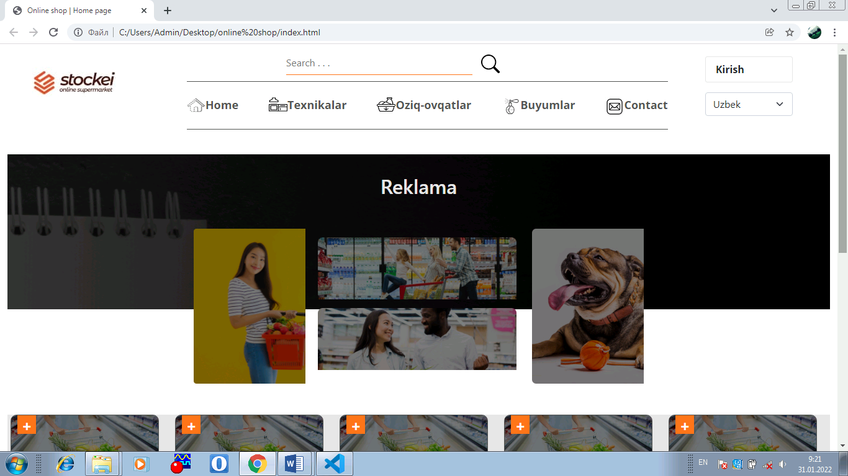

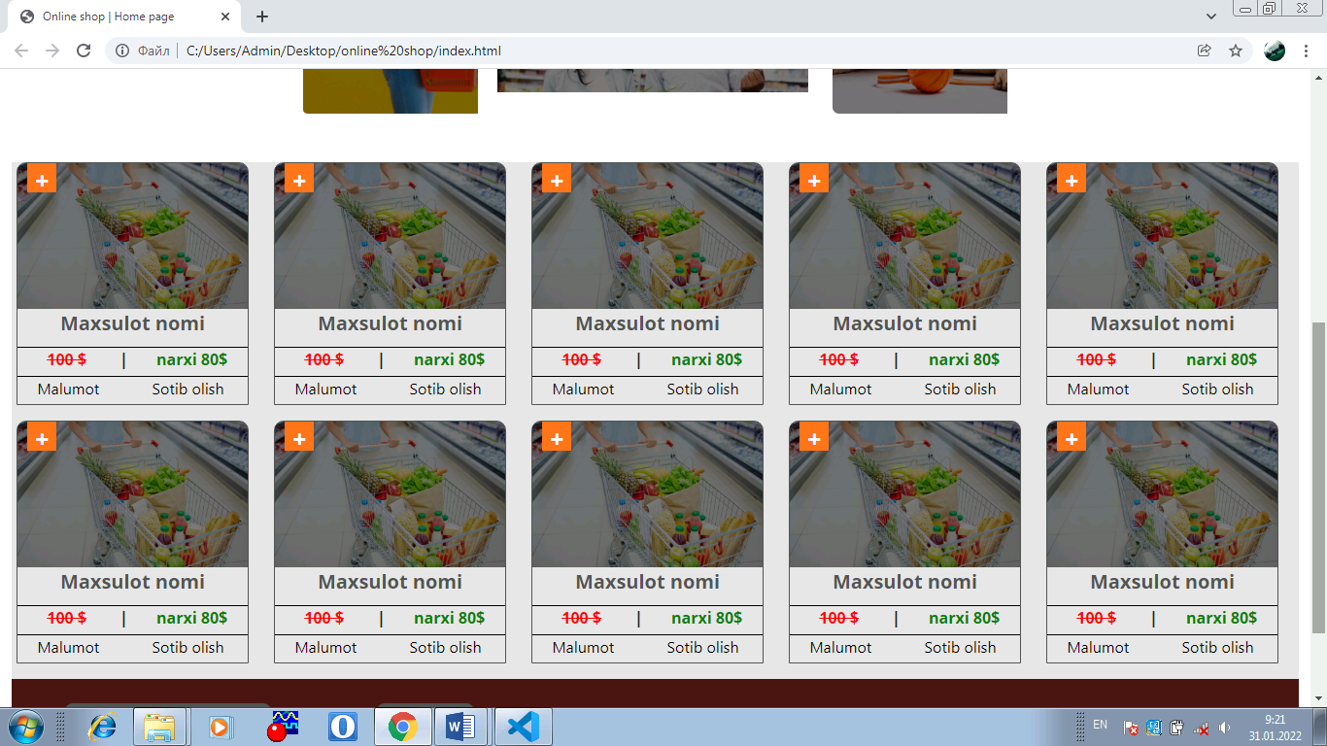

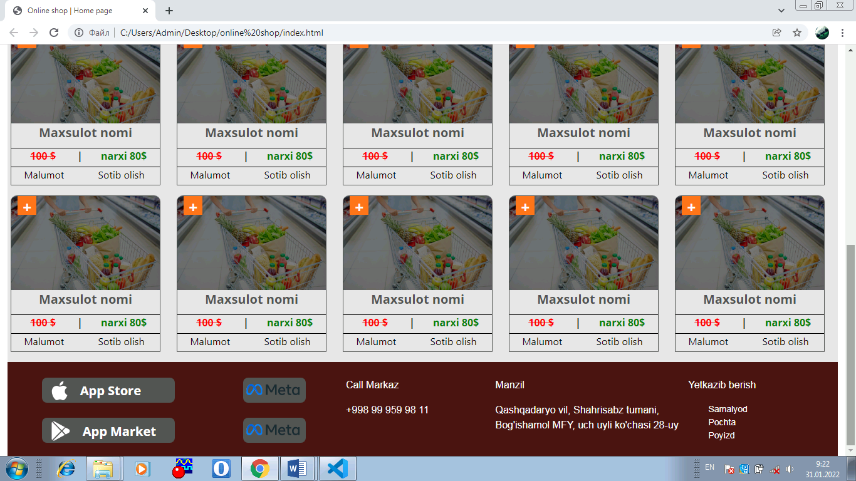

Kirish yani ruyxattan o’tish bulmi

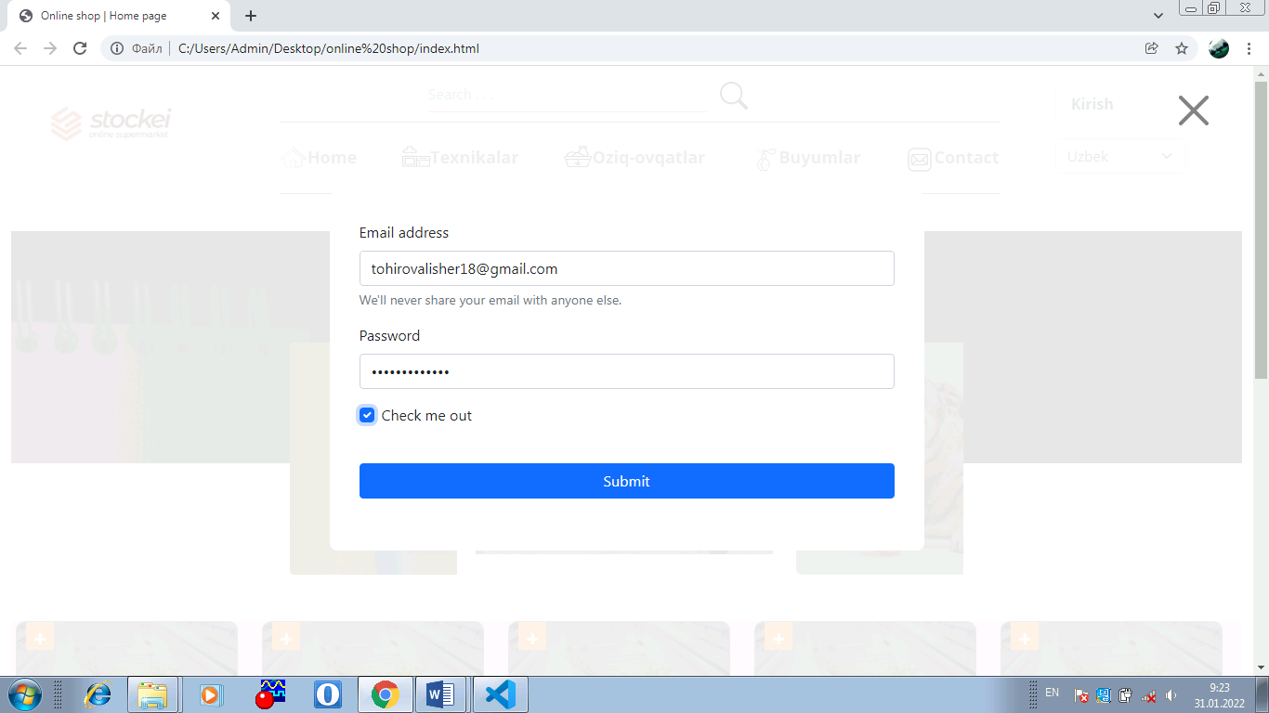

Maxsulotdan sotib olish tugmasi

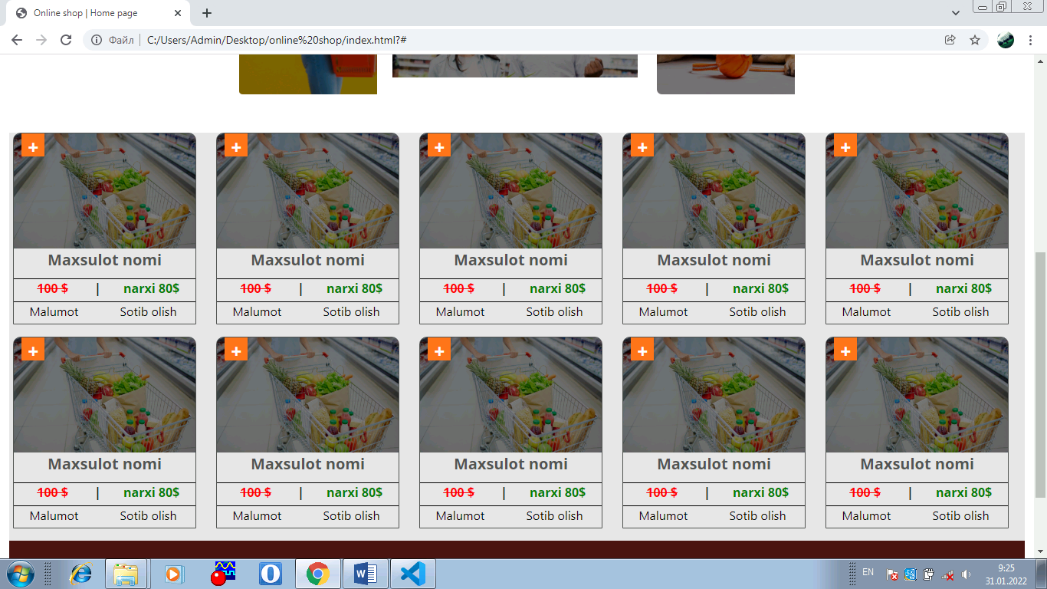

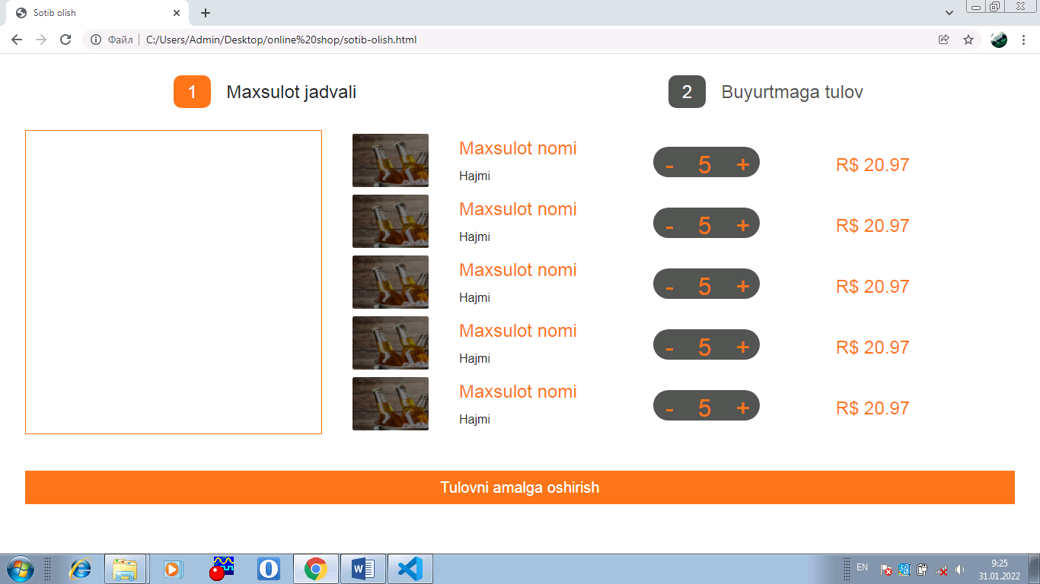

Tulovni amalga oshirish tugmasi

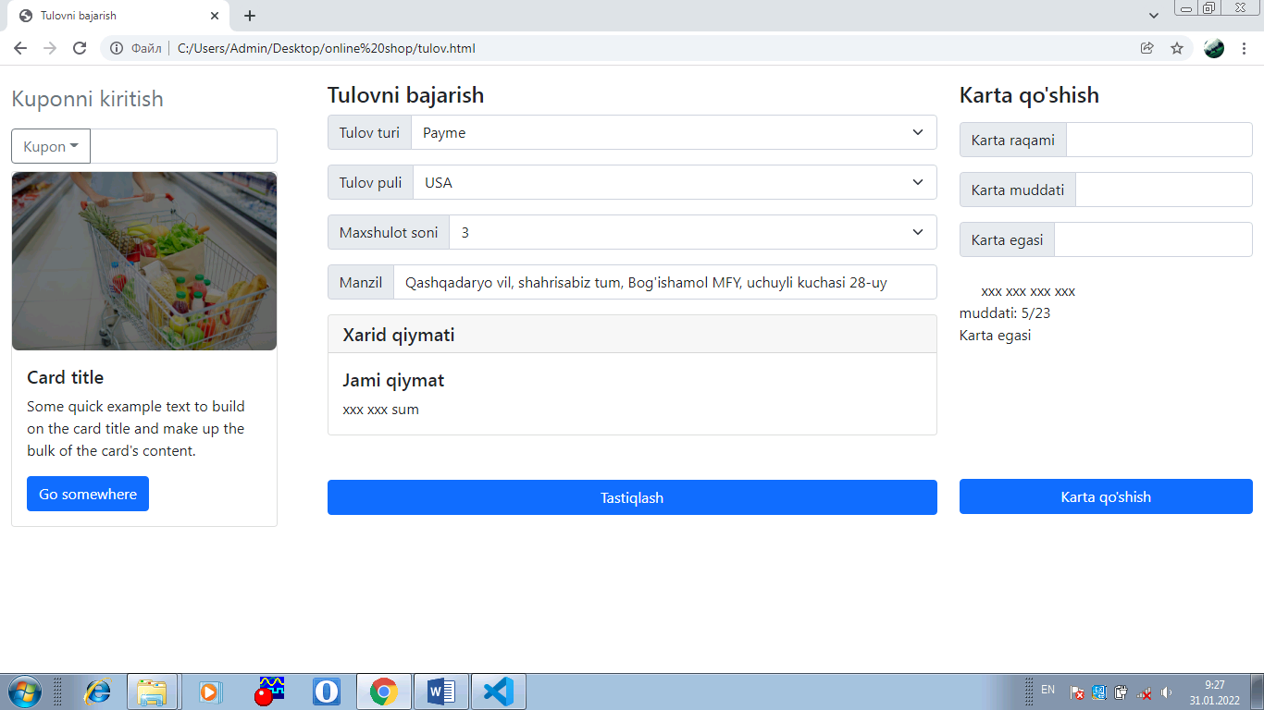

Texnikalar bulmi:

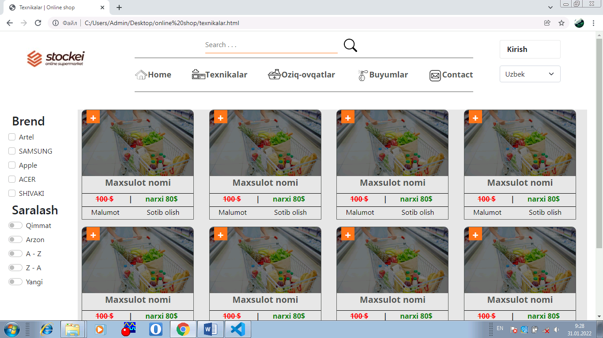

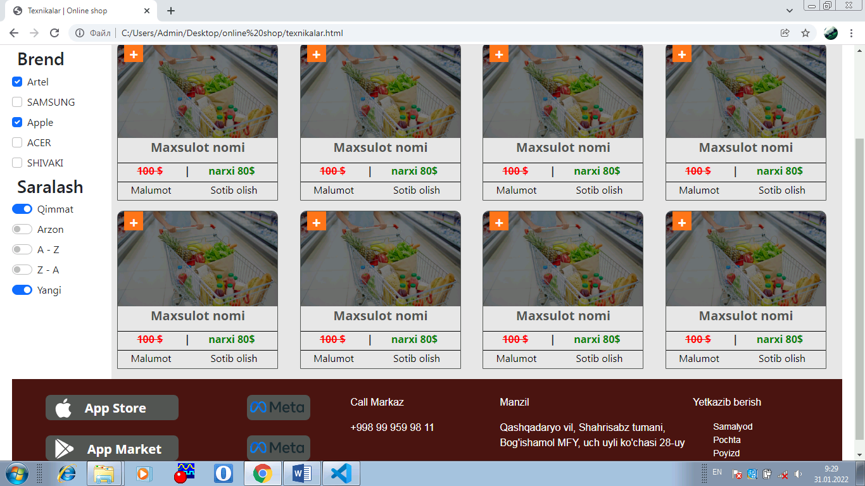

Contact bulmi:

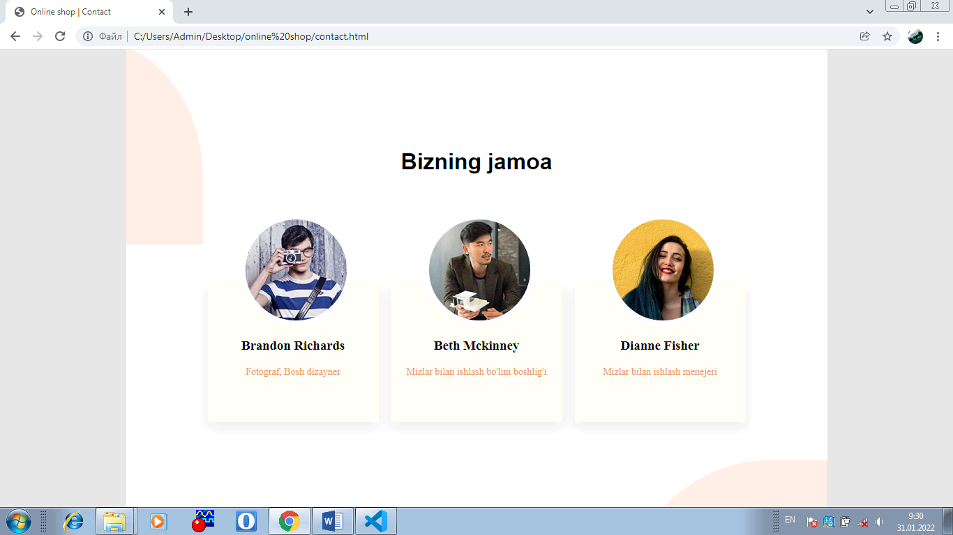

**Xulosa**

Ushbu individual loyiha ishi “Online Shop” internet do’koni orqali foydalanuvchilarga sifatli va hamyonbop narxlarda texnika va oziq-ovqat maxsulotlarini sotib olishga va yetkazishga qaratilgan.

Individual loyiha ishini bajarishda quyidagilarni ishlarni bajardim:

* Online shoplar haqida ko’plab malumotlar o’rgandim.
* Web sayt strukturalari va web sahifalarning bir-biri bilan bog’lanishi;
* CSS va JavaScript fayllari bilan ishlash;
* CSS va Java Script fayllarini html fayllariga bog’lash;
* Web dizaynlar bilan ishlash;

**Foydalanilgan adabiyotlar.**

1. Dars ishlanma;
2. PDP IT academy ma’ruza matnlari.
3. [www.pdp.uz](http://www.pdp.uz)
4. <https://Wikipediya.org.com>
5. <https://w3school.com>
6. <https://htmlbook.ru>
7. <https://webref.ru>