The Challenges

Challenge 1 – Puzzle Boxes

Box a: Draw lines to indicate where the 10kΩ and 330Ω resistor is, labelling each.

Box b: Draw lines to indicate where the two resistors are, labelling each.

Box c:

i. The resistance through the LDR in light conditions is about **_____** Ω.

ii. The resistance through the LDR is dark conditions is about **_____** Ω.

iii. The other component is a **____** Ω resistor.

Box d: Draw two arrows to indicate where the 2 diodes are connected, and their polarity.

Box e: Draw lines to indicate how the 3 components are connected up.

The value of the resistor is **____** Ω.

Box f: With my multimeter set to **__**V DC, I got these readings:

i. There is a potential difference of **__** volts between the 0V and 12V terminals.

ii. There is a PD of **__** volts between 0V and the terminal where the two 1k resistors meet.

iii. There is a PD of **__** volts between 0V and bottom of the right-hand 1k resistor.

Box g: With my multimeter set to 20V DC, I got these readings:

(*Use the answer from the indicated part of the question to get the next answer in Qiii and Qiv*)

i. I got a reading of ***__***V between the 0V and 12V terminals.

ii. I measured **__**V between 0V and the cathode (negative) side of the diode.

iii. Therefore, the diode is using i - ii =**__**V of the voltage in my circuit.

iv. I measured ***__***V between 0V and the positive leg of the LED.

Therefore, the resistor is dissipating ii – iii= **__**V of the voltage in the circuit.

v. I measured ***__***V between the 0V terminal and the negative leg of the LED.

Therefore the LED is using iv – v = **__**V in the circuit.

Box h:

i. The resistance between pins 1 and 3 is **__** Ω.

ii. With the dial facing pin 2, the resistance between pin 1 and pin 2 is **__** Ω, and between 2 and 3 is **__** Ω. Added together, these equal **__** Ω.

iii. With the dial facing the left-hand mark, the resistance between pin 1 and 2 is **__** Ω.

iii. With the dial facing the right-hand mark the resistance between pin 1 and 2 is **__** Ω.

Box i: Draw a thick line to represent the thermistor, and a thinner line to represent the

resistor on the circles opposite.

i. The value of the fixed resistor is **__** Ω.

ii. At room temperature, the resistance of the thermistor is **__** Ω.

iii. When my finger has been on it for about 20s, the thermistor’s resistance is **__** Ω.

Multimeter Summary

1. Three things a multimeter can measure are ______, ______ and ______.

2. Imagine you’re an engineer maintaining an Antarctic research station’s heating system, and need to replace a resistor on a circuit board. Unfortunately, the coloured bands have rubbed off and you can’t tell what value it is any more. Write a short paragraph explaining how to find the resistance of the component.

3. Imagine you’re working on a lighting rig at a music festival, and some of the DC motors that make the dancer’s podiums spin aren’t working. You think the power is on (its running at 500V), but don’t really want to touch it with your hands to find out. How could a multimeter help?

Challenge 2 – Programming Boxes

Screenshot, then paste and crop your solutions to the problems in the spaces below. Extra credit awarded where Genie BASIC is used (*as long as you comment and tidy the code a little, so it’s clear you understand it).*

a – Bike light program

b – Momentary LED torch

c – Toggle switched LED torch

d – Morse code transmitter

e – Night light

f – Night light Mk. II

g – Music Box

h – Music Box Mk. II

i – Personal Alarm

j – Book alarm

k – Free choice. My program works as follows:

l - Final Challenge

Challenge 3 – Stripboard Circuits

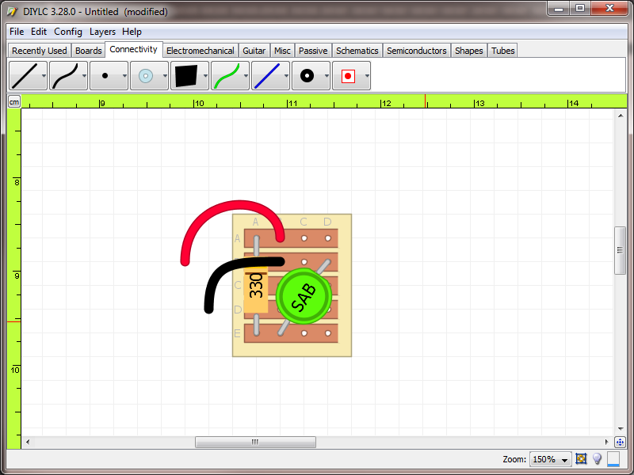

a – LED light pt. 1 a –

(*this* e*xample is done for you;*

*replace it with your own work*)

LED light pt. 2

b – LDR / Transistor circuit

i. When run, the LED illuminates when…

ii. The way the circuit works is…

iii. My stripboard design is shown below.

<YOUR DESIGN HERE>

iv. My soldered, working circuit is shown below.

<PHOTO OF YOUR CIRCUIT HERE>

c – 555 timer circuit

i. When the circuit is energised, what happens?

ii. My stripboard circuit design is shown below:

<YOUR DESIGN HERE>

iii. My soldered, working circuit is shown below:

<PHOTO OF YOUR CIRCUIT HERE>

Evaluation

Which of the tasks did you find hardest, and why?

Which did you find easiest?

Which did you enjoy the most?

Which did you enjoy the least?

If you were going to attempt the strip-board tasks again, would you do anything differently to improve the end product?