18-645: How to write fast code, Spring 2014
HW #2 – Manycore Programming Infrastructure
Due: February 17, 11:00pm EDT, 8:00pm PDT

Submission:

To submit your homework, you must carefully follow these instructions:

1. Use the text-based answer template for filling in your answers. You can find it at:

Module 2 Homework 2: hw2_answer_sheet.txt

2. To get credit for the homework, please submit your completed answer sheet, save it as: hw2_<yourFirstName>_<yourLastName>.txt on Acatar website under Module 2 Homework 2.

Note: Completing HW2 and submitting it as instructed is required to stay in the course.

As you start the homework project, you will realize that the homework is designed to help you get started on the project.

Introduction
This homework includes a CUDA installation tutorial. CUDA stands for “Compute Unified Device Architecture”. It is a general-purpose programming model for programming the NVIDIA graphics processing unit (GPU) platform. The CUDA programming model allows users to kick off batches of thousands of threads on the GPU, thereby utilizing the vast amount of parallelism the hardware provides. With the CUDA programming model, the GPU-based platform can allow computation to take place on a single GPU card at a throughput of TeraFLOPS (10^12 FLoating-point Operations Per Second), which is as fast as a TOP500 Supercomputing Center just 6 years ago. Today, manycore processors are used in 3 of the 5 fastest supercomputers in the world!

This document provides a guide to help you setting up a CUDA programming environment on the ghcXX.ghc.andrew.cmu.edu , XX = {52,…,80} cluster machines. By the end of this setup, you will have an environment to start programming in CUDA.

Background
To understand what we are setting up, we must first understand a bit about the underlying system infrastructure. The GPUs are acceleration cards that plugs into a computer system.

In a standard PC, the CPU (top of Figure 1) runs the operating system, and the GPU is attached through the PCI Express bus on the North Bridge (82925X MCH in Figure 1), which gives the CPU access to peripherals with high bandwidth requirements.
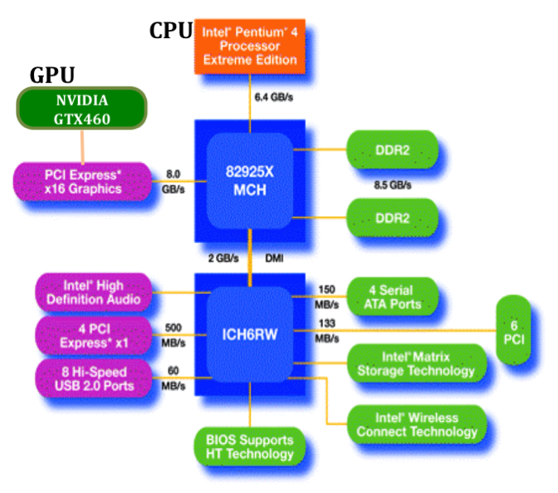
Figure 1. The system architecture for using a GPU in a PC
From a PC system builder’s perspective, we are plugging a GPU graphics card on to the motherboard. Figure 2 illustrates where a GPU can be plugged into a motherboard, and how a completely assembled system looks like. The GPU is circled in the photo of the completely assembled system.

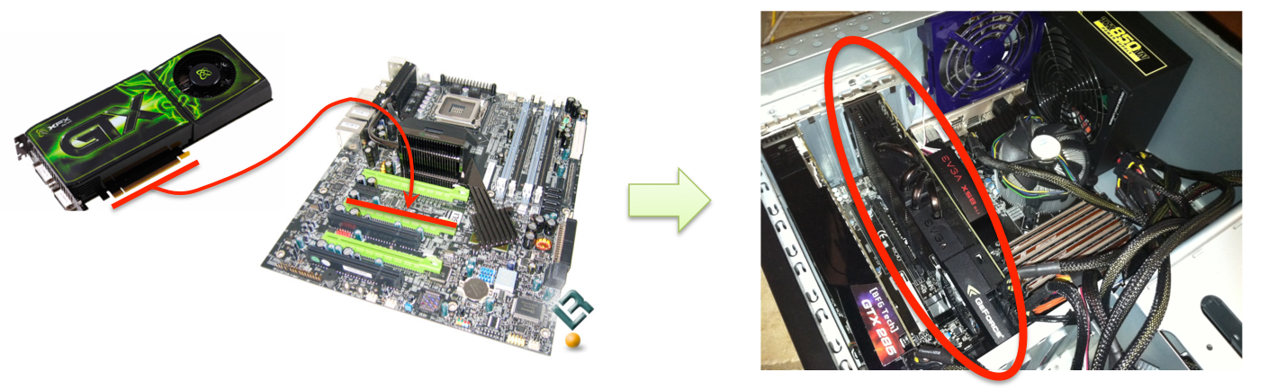
Figure 2. Illustrating how a GPU can be plugged into a motherboard to result in a completely assembled system

The ghc cluster consists of 30 machines, the majority of which are fitted with GPU cards. To use a machine with a GPU, you should choose a machine with the least number of teams logged in. There are a few machines in the 30 that don’t appear to have a functional GPU—if you run into problems, try a different machine in the cluster.

Setting up of the CUDA environment involves three steps: installing the CUDA developer driver, installing the CUDA toolkit, and installing the CUDA software development kit (SDK).

- The developer driver provides a set of interfaces for the operating system to talk to the GPU subsystem.

- The CUDA toolkit provides a compiler, a debugger, a performance profiler, and a set of pre-optimized CUDA libraries.

- The CUDA SDK provides an infrastructure and examples to help users quickly get start on using the CUDA infrastructure.

The CUDA developer driver and CUDA toolkit has already been installed on the ISL cluster. In this tutorial, you will be setting up the CUDA SDK in your personal PROJECTS directory.

Let the fun begin!

Tasks

There are three tasks in this tutorial. The first task provides guidelines for installing the CUDA SDK. The second task will provide steps to profile your CUDA program. The third one gets you started in looking at the CUDA programs.

Task 1: CUDA SDK Installation

Step 1: Setting up the CUDA environment

After logging into any ghcXX.ghc.andrew.cmu.edu, set the following environment variables.

If you`re using bash shell,
export CUDA_HOME=/usr/local/cuda
export PATH=$PATH:/usr/local/depot/gcc-4.7.3/bin:/usr/local/cuda-5.5.22/bin
export LD_LIBRARY_PATH=$LD_LIBRARY_PATH:$CUDA_HOME/lib64:$CUDA_HOME/lib:$HOME/cppunit/lib
If you’re using csh shell,

Setenv CUDA_HOME “/usr/local/cuda-5.5.22”
setenv PATH /usr/local/depot/gcc-4.7.3/bin:/usr/local/cuda-5.5.22/bin:${PATH}
setenv LD_LIBRARY_PATH
setenv LD_LIBRARY_PATH "${LD_LIBRARY_PATH}:${HOME}/cppunit/lib:$CUDA_HOME/lib64:$CUDA_HOME/lib"

Step 2: Installing SDK & Building executables
2a. We will install GPU Computing SDK under ~/645 directory:
cd /usr/local/cuda-5.5.22/bin
./cuda-install-samples-5.5.sh ~/645

You will see message, similar to the one below:

2b. Once you install, you need to compile tools that we require in this homework:
cd ~/645/NVIDIA_CUDA-5.5_Samples/
cd 1_Utilities/deviceQuery
make
cd ../bandwidthTest/
make

Step 3: Run Tests

4a. Go to the path ~/645/NVIDIA_CUDA-5.5_Samples/1_Utilities/deviceQuery
4b. Run the executable deviceQuery
./deviceQuery

On success, it should display the following screen:

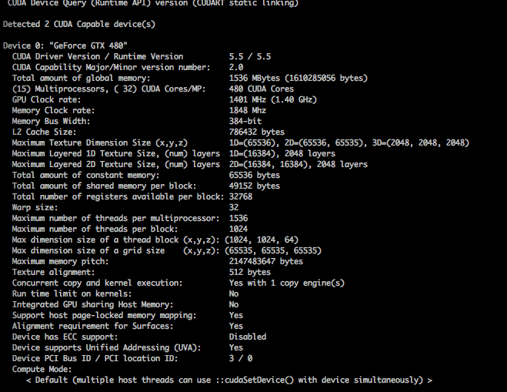
4c. Go to the path ~/645/NVIDIA_CUDA-5.5_Samples/1_Utilities/bandwidthTest
4d. Run the executable bandwidthTest
./bandwidthTest

On success, it should display the following screen:
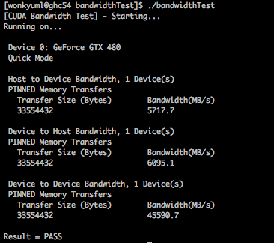

Question 1:
- What is the Host to Device bandwidth you observe on your cluster machine?
- What is the Device to Host bandwidth you observe on your cluster machine?
- What is the Device to Device bandwidth you observe on your cluster machine?

Task 2: Get information about the GPU and Run the CUDA Visual Profiler

Step 1: Running the CUDA Visual Profiler

The purpose of this task is to learn how to run the CUDA Visual Profiler.

1.a. First you need to connect to any of the cluster machines through X. For detailed instructions on connecting to the cluster using X, look at Task 1

Warning! Your local machine needs a X server. Linux should have it by default, OS X probably needs XQuartz and Windows users can look at Xming or Cygwin.

1.b. On successful connection you should be able to see the prompt on your screen.
<your ID>@ghcYY:~$

Where XX is your team id and YY is the cluster machine.

1.c. Go to the CUDA Visual Profiler directory
<your ID>@ghcYY:~$ cd /usr/local/cuda/bin/
<your ID>@ghcYY:/usr/local/cuda/bin$

1.d. Run the visual profiler
teamXX@ghcYY:/usr/local/cuda/bin$ ./computeprof &

Now you should be able to see the following screen pop up

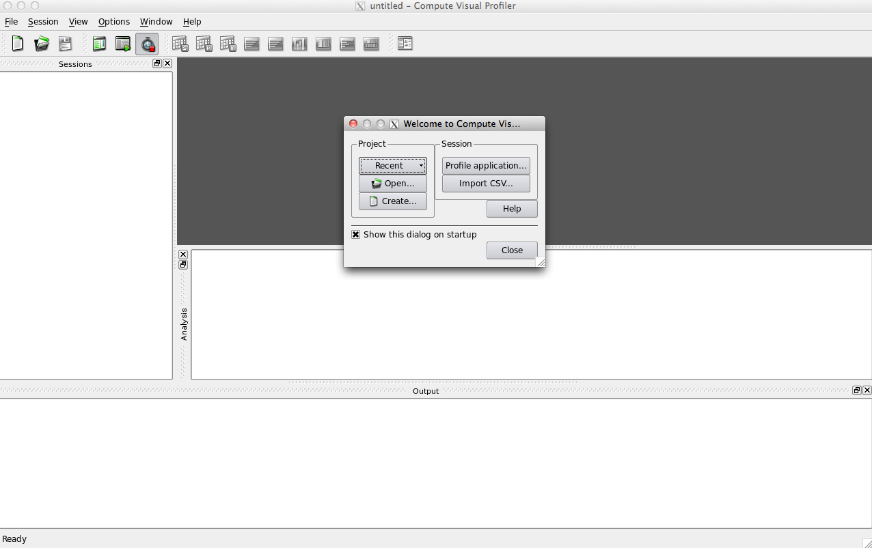

1.e. If you see the following message
computeprof: cannot connect to X server localhost:11.0

logout and login again using X

ssh –X <your_user_name>@ghcXX.ghc.andrew.cmu.edu

If on Windows, you’ll need to install a program like Xming and configure Putty to enable X11 tunneling.

Step 2: Questions on CUDA and GPUs

Please answer the following questions about the GPU device (GTX 460) on any of cluster machines

You may find the CUDA Programming Guide very useful for answering these questions:
http://docs.nvidia.com/cuda/pdf/CUDA_C_Programming_Guide.pdf

Question 1:
- What is the maximum number of threads per block?
- How many threads are in a warp?
- What is the maximum number of threads per Streaming Multiprocessor?
- What is the maximum number of warps per block?
- What is the maximum number of warps per Streaming Multiprocessor?

Question 2:
- What is the size of the register file per Streaming Multiprocessor?
- The shared memory is divided into 16 memory banks, true or false?
- What is the size of the global memory on the device?
- What is the total amount of shared memory per block?

Question 3:
- What is the maximum number of floating point operations per thread per cycle?
- One day, you read a paper where the authors claim that they have implemented an amazingly fast Matrix to Matrix Multiplication algorithm in CUDA for the GPU devices installed on the cluster machines. The paper claims that the fast algorithm can achieve performance of 1.5 Teraflop/s for multiplying many couples of 32x32 element matrices of single precision floating point numbers on a single GTX460 GPU. Unfortunately they won’t share the code. Could can you tell if what the paper is claim is possible or not?
- What is the peak perfromance of a single GTX460 GPU?

Question 4:
- What is the total amount of L2 cache?
- The total amount of shared memory is bigger than the total amount of register file on the GPU, true or false?
- The number of blocks that can executed simultaneously on one Streaming Multiprocessor is restricted only by the amount of shared memory each block allocates, true or false?

Task 3: Getting Started on the CUDA Matrix Multiply

In the code repository, you will find a set of files, of which you will only optimize a few of the CUDA files.

matrix_mul:
Makefile
cuda
Makefile
matrix_mul.cu <<== To optimize
matrix_mul.h
tests.cpp
omp
Makefile
matrix_mul.cpp
matrix_mul.h
tests.cpp
sequential
Makefile
matrix_mul.cpp
matrix_mul.h
tests.cpp
tests
testutil.h

kmeans
LICENSE
Makefile
README
benchmark.sh
cuda_io.cu
cuda_kmeans.cu <<== To optimize
cuda_main.cu
cuda_wtime.cu
file_io.c
gmon.out
go
kmeans.h
omp_kmeans.c
omp_main.c
sample.output
seq_kmeans.c
seq_main.c
wtime.c
Image_data

Question 1:
- In your matrix_mul_01.dat test file for CUDA, add one more test case for matrices of size 33x33. Then compile and run the code. Does the code execute normally for this test case? If yes, what kind of performance do you get for this test case? If not, explain why the code fails in this case.

