18-645: How to write fast code, Spring 2014
Project #1 – Multicore Optimization

Due: February 5, 2014, 11:00pm EDT, 8:00pm PDT

The goal of this project is to use your understanding of parallel computing resources in a multicore microprocessor to optimize two fully functional applications. The applications are Matrix Multiple and K-means Clustering.

For a functional description of the applications, please refer to:

http://en.wikipedia.org/wiki/Matrix_multiplication

http://en.wikipedia.org/wiki/K-means

The code optimization techniques you may want to consider are explained in Module 1 and Module 2 which includes:

- Cache blocking
- OpenMP pragma-based optimizations
  - omp parallel
  - omp for
  - omp atomic
  - omp reduction
- Intrinsics Programming

Step 1: Cloning a git repository

You can get the initial version of the code using (already done if HW1 is complete):
cp /afs/andrew.cmu.edu/course/18/645/spring_2014/18645_spring_14.tar.gz .

The structure of the project

matrix_mul:
Makefile
matrix_mul_01.dat
matrix_mul_02.dat
cuda
Makefile
matrix_mul.cu
matrix_mul.h
tests.cpp
omp
Makefile
matrix_mul.cpp <<== To optimize
matrix_mul.h
tests.cpp
sequential
Makefile
matrix_mul.cpp
matrix_mul.h
tests.cpp
tests
testutil.h

kmeans
LICENSE
Makefile
README
benchmark.sh
cuda_io.cu
cuda_kmeans.cu
cuda_main.cu
cuda_wtime.cu
file_io.c
gmon.out
go
kmeans.h
omp_kmeans.c <<== To optimize
omp_main.c
sample.output
seq_kmeans.c
seq_main.c
wtime.c
Image_data

Step 2: Code optimization

For project “matrix_mul” OpenMP implementations, please apply your optimization only to the content of the “matrix_multiplication” function in the file “matrix_mul.cpp”.

For project “kmeans” OpenMP implementations, please make your changes only to the content of the “omp_kmeans” functions in files “omp_kmeans.c”. Testing data for kmeans can be downloaded from below:

http://fast645.info/course/data/kmeans01.dat
http://fast645.info/course/data/kmeans02.dat
http://fast645.info/course/data/kmeans03.dat
http://fast645.info/course/data/kmeans04.dat

NOTE: Please DO NOT add kmeans testing data (kmeans01.dat ~ kmeans04.dat) to your git repository. They bloat the repository.

NOTE: It is crucial that your DO NOT change the interface. Any changes in the interface could result in your work not testable by our test infrastructure and you will receive no credit.

To compile the code, simply type “Make” in the project directory.

To run the code and see runtime:

For kmeans:

./omp_main –i kmeans01.dat –n 3 -o

For matrix_mul:

./matrix_mul –i ../matrix_mul_02.dat

Commit your code frequently to your local repository by doing:
git commit –a -m “description”

Step 3: Push your changes to the server

To share your optimizations with us, you will need to “push” the changes to the remote repository.
git push origin master

http://www.kernel.org/pub/software/scm/git/docs/everyday.html

Step 4: Look at Jenkins

Visit http://fast645.info/jenkins

User: student
Password: 18645

Check the Jenkins website to see if your project ran through properly. Make sure you are looking at your team’s project!

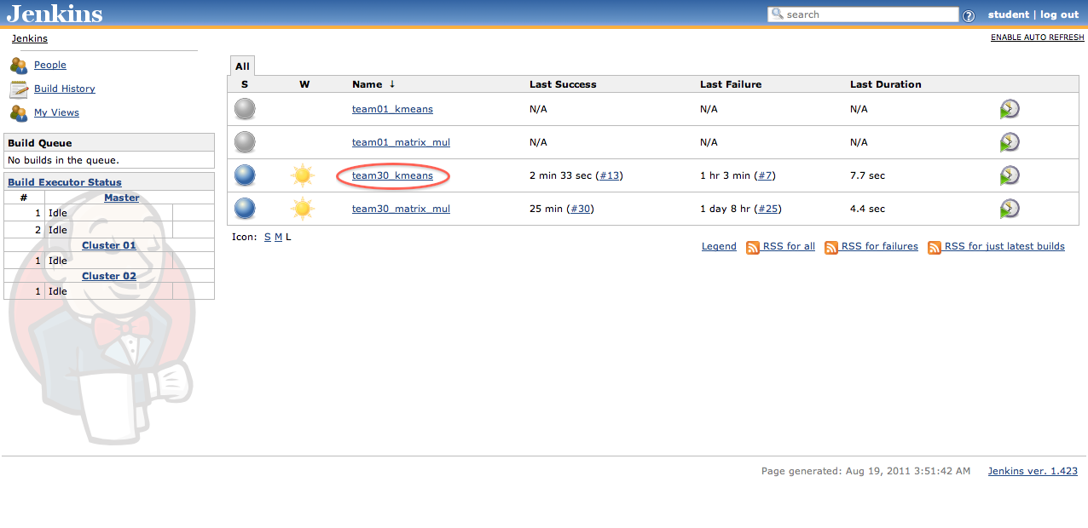
Then, click on a successful build:

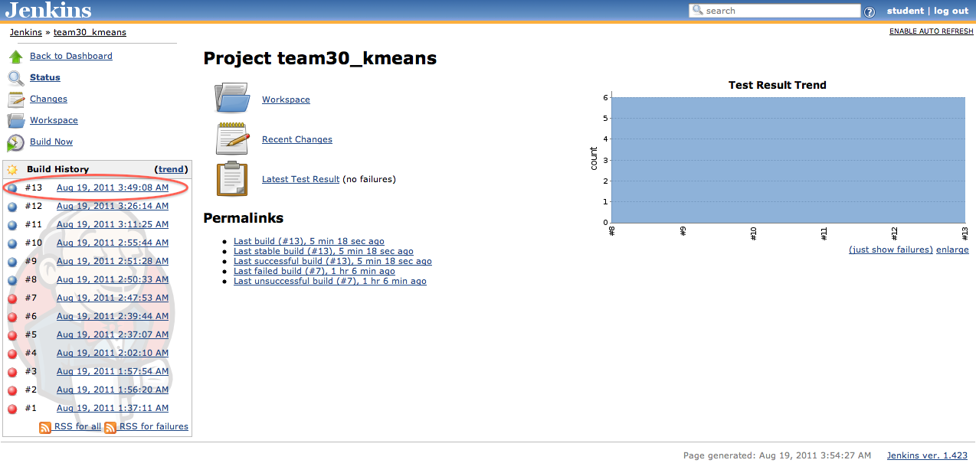

To view the performance, use the Console Output link:

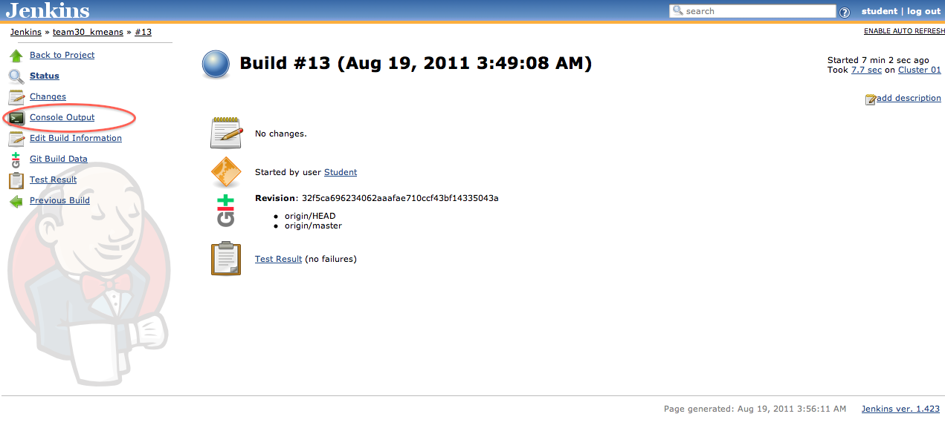

The performance would then be available:

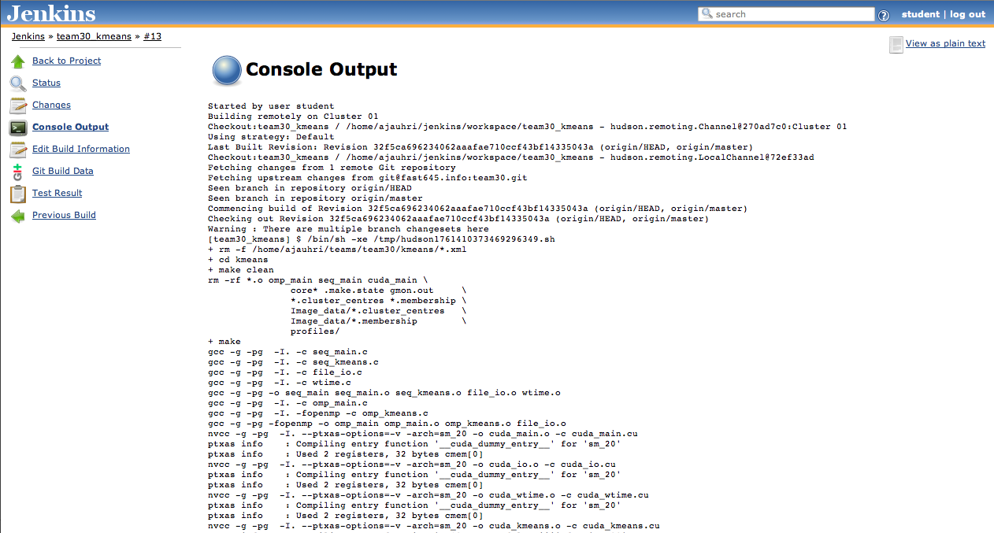

Step 5: Is the performance good enough?

If yes, look at the other application. If no, go back to step 2 and try another optimization. You are expected to try at least 3 optimizations per application.

Grading criteria
- 30% - Correctness - Correctness of the results (program output)
- 30% - Performance –
  - MatrixMultiply:
For OpenMP version, achieving at least 5X speed up compared to sequential version (SUM of all the testcases – matrix_mul_02.dat)
  - K-means:
For OpenMP version, achieving at least 1.5x speedup compared to current OpenMP version (SUM of all the tests)
- 30% - Write up – Clearly describing, for each performance optimization,
  - how the speed up works
  - what is the expected speed up
  - what is the observed speed up
  - an explanation of any difference between the expected and observed speed ups
- 10% - Code quality - Good coding practices and well commented code

Guidelines for the write up:

Minimum of one 8.5x11 page write-up for each optimization. The write up should include:

- Optimization goal:
  - Hardware resources being optimized toward?
(cache? SIMD? multicore?)
  - What is the specification of the hardware you are optimizing for?
- Optimization process:
  - Data considerations
  - Parallelization considerations
- Optimization results:
  - Performance before optimization
  - Performance after optimization

Two teams with the fastest project in the class will be asked to do a 10min presentation each on what they tried.

We will look at the code of the slowest two implementations as a class. The class will discuss why their code is slow.

