Snow Explorer

Help File

Brigham Young University

Civil Engineering 594R – By Jiri Kadlec and William Garner

Contents

Introduction and Purpose: 1

Downloading: 1

Restrictions and Licensing: 1

Requirements and Restrictions 1

Licensing 1

User Interface 2

Get Snow Data 3

Draw Polygon 4

Calculate Snow Volume 4

Open File 5

HELP 5

Technical Support? 5

Background Information

# Introduction and Purpose:

Snow data is essential for farmers, planners, and engineers. With accurate snow data draughts and floods can be predicted. Easily, figuring the amount of how much water will come from a certain area is vital. In an effort to make this snow data more accessible and easier to find SnowExplorer was created.

SnowExplorer is a standalone program designed to calculate the snow-water-equivalent volume (m3) and snow coverage area (m2) of any polygon in the United States. It allows the user to draw any polygon and calculate the volume and snow coverage for that area. Snow data models from the National Snow and Ice Center (NSIDC), 1993-2015 are used. This data can be found at <http://nsidc.org/data/docs/noaa/g02158_snodas_snow_cover_model/index.html>.

## Downloading:

SnowExlporer can be download from GitHub at <https://github.com/SnowMappers/SnowExplorer>. To download the software click releases and download SnowExplorer.V1.0.zip. Once the file is unzipped, open the SnowExplorer folder and click SnowExplorer.exe.

# Restrictions and Licensing:

## Requirements and Restrictions

The program requires all snow data rasters to be .bgd file formats. The program is restricted to polygons shapefiles drawn through the program interface. Other polygons added directly may not calculate the volume and area correctly. In further version we anticipate fixings these problems and improving the programs adaptability.

## Licensing

This program is licensed according to the MIT License developed by the open Source initiative. It contains the following license agreement.

The MIT License (MIT)

Copyright © <2015> <Jiri Kadlec and William Garner>

Permission is hereby granted, free of charge, to any person obtaining a copyof this software and associated documentation files (the "Software"), to dealin the Software without restriction, including without limitation the rightsto use, copy, modify, merge, publish, distribute, sublicense, and/or sell copies of the Software, and to permit persons to whom the Software isfurnished to do so, subject to the following conditions:

The above copyright notice and this permission notice shall be included in all copies or substantial portions of the Software.

THE SOFTWARE IS PROVIDED "AS IS", WITHOUT WARRANTY OF ANY KIND, EXPRESS OR IMPLIED, INCLUDING BUT NOT LIMITED TO THE WARRANTIES OF MERCHANTABILITY, FITNESS FOR A PARTICULAR PURPOSE AND NONINFRINGEMENT. IN NO EVENT SHALL THE AUTHORS OR COPYRIGHT HOLDERS BE LIABLE FOR ANY CLAIM, DAMAGES OR OTHER LIABILITY, WHETHER IN AN ACTION OF CONTRACT, TORT OR OTHERWISE, ARISING FROM, OUT OF OR IN CONNECTION WITH THE SOFTWARE OR THE USE OR OTHER DEALINGS IN THE SOFTWARE

Program Use

# User Interface

The User Interface is divided into several sections. This interface is shown in figure 1. The main section is the map. For reference, this section contains a shapefiles of the U.S States and U.S Lakes. It also contains zoom and pan buttons. To the right of the map view there is a legend and a results box. The legend displays the current layers loaded into the map. The results box will contain the calculated volume and area. Above the map view there are several buttons. A description of each button and its use is listed below.

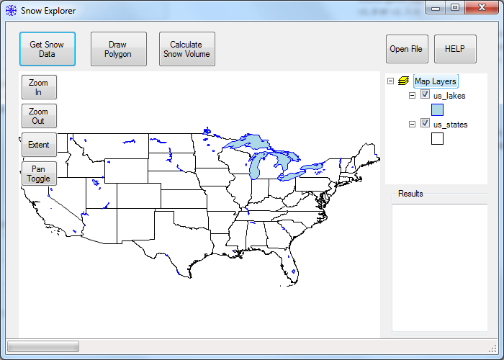

Figure : User Interface

Get Snow Data**:** Clicking the Get Snow Data button will bring up the Get Snow Data interface, shown in Figure 2. This interface will be used to upload snow data to the map. The snow data can be uploaded in two ways. Frist, the data can be directly downloaded internet. To do this simply select a date and then click Get Date From Internet. This will automatically download data from the NSDIC website and upload it to the map. It may take several minutes to download and add the snow data to the map. Second, a snow raster can be uploaded from the computer hard drive by clicking Get Data From File. These file must be in .bgd file type. An example Snow Raster is located in SnowExplorer/bin/Debug/Snow_Data/ExSnowRaster.bgd.

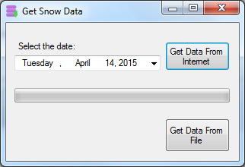

Figure Get Snow Data Interface

Draw Polygon**:** The draw polygon button is used to draw a polygon on the map interface. Once the button is clicked a dialog will pop up instructing on how to draw the polygon. Left click to add more points and double left click to terminate the polygon. This will add a polygon layer to the map, as shown in figure 3.

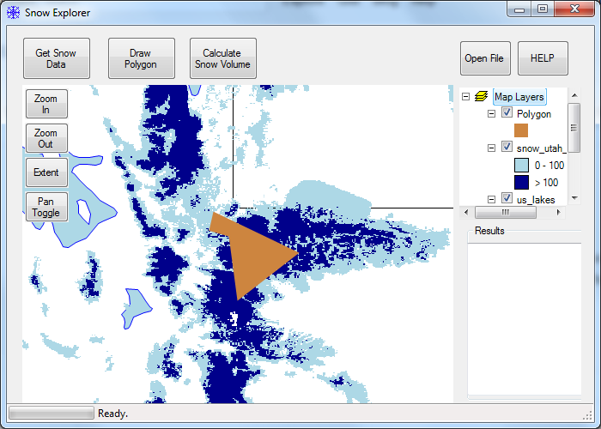

Figure 3 Map with Drawn Polygon

Calculate Snow Volume**:** Once the Snow Raster is uploaded to the map and the polygon is drawn click the Calculate Snow Volume button. This will clip the Snow Raster and the find the Volume and snow covered area of the raster. The results will be displayed in the lower right hand corner, as shown in Figure 4. It may take several minutes for the calculation to be performed. These results can be copied and pasted to any text file for further studies.

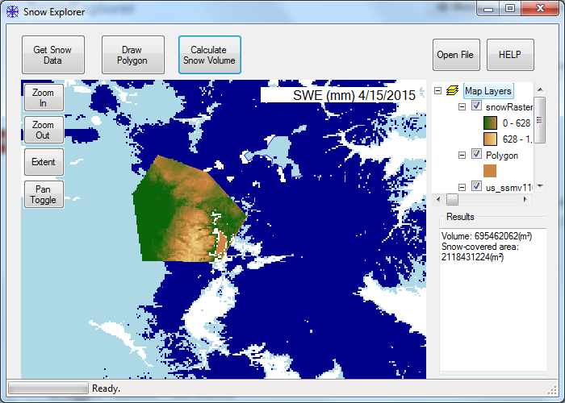

Figure Calculation Results

Figure 5 Basic Web Interface

Open File**:** Open file allows you to add a layer to map interface through a system dialog box

HELP**:** The help button will bring up this user document and the technical documentation for the program.

# Technical Support?

Thank you for using SnowExplorer. If this document did not answer your questions or if further help is needed please contact Jiri at jirikadlec2@gmail.com or Will at will.j.garner@gmail.com.