Technical Specifications

# Introduction:

What’s Shakin’, Baby is a script designed to run with ESRI’s ArcMap application. It takes in elevation and earthquake intensity data and creates a hazard map according to slope and peak ground acceleration.

# Background:

## How its Built

The script was programed using a combination of ArcMap’s model build, python, and Notepad++. A geoprocessing model was first developed in ArcMap’s model builder to find the slope, create an interpolated intensity terrain, and multiply these two items together. This model was than exported to a Python Script and this script was looped through the earthquake intensity data.

## Who Built it

What’s Shakin’, Baby was designed as part of a Brigham Young University Civil Engineering class project. The primary programmers were Ryan Moore and William Garner.

# Software and Hardware Requirements

The software is designed for use with ArcMap version 10.2. Software and Hardware requirements are the same as ArcMap Version 10.2 and can be found on the ESRI website at <http://resources.arcgis.com/en/help/system-requirements/10.2/index.html#//015100000002000000>.

# Licensing

This program is licensed according to the MIT License developed by the open Source initiative.

Copyright © <2014> <Ryan Moore and William Garner>

Permission is hereby granted, free of charge, to any person obtaining a copyof this software and associated documentation files (the "Software"), to dealin the Software without restriction, including without limitation the rightsto use, copy, modify, merge, publish, distribute, sublicense, and/or sell copies of the Software, and to permit persons to whom the Software isfurnished to do so, subject to the following conditions:

The above copyright notice and this permission notice shall be included in all copies or substantial portions of the Software.

THE SOFTWARE IS PROVIDED "AS IS", WITHOUT WARRANTY OF ANY KIND, EXPRESS OR IMPLIED, INCLUDING BUT NOT LIMITED TO THE WARRANTIES OF MERCHANTABILITY, FITNESS FOR A PARTICULAR PURPOSE AND NONINFRINGEMENT. IN NO EVENT SHALL THE AUTHORS OR COPYRIGHT HOLDERS BE LIABLE FOR ANY CLAIM, DAMAGES OR OTHER LIABILITY, WHETHER IN AN ACTION OF CONTRACT, TORT OR OTHERWISE, ARISING FROM, OUT OF OR IN CONNECTION WITH THE SOFTWARE OR THE USE OR OTHER DEALINGS IN THE SOFTWARE

# Installation

Minimum installation requires the installation ArcMap 10.2 and the download of a selected folders.

# Distribution and Technical Support– Where can I get one?

For technical support and to obtain a copy please contact William Garner at [will.j.garner@gmail.com](mailto:will.j.garner@gmail.com) or Ryan Moore at [leroytheotter@gmail.com](mailto:leroytheotter@gmail.com).

Software Design

# Purpose

Earthquakes cause significant damage and loss of life. These damages can be mitigated by construction in areas less hazardous to earthquakes What’s Shakin’, Baby is a script designed define the hazard level of a location of interest and thus providing a safer area for construction.

# Structure

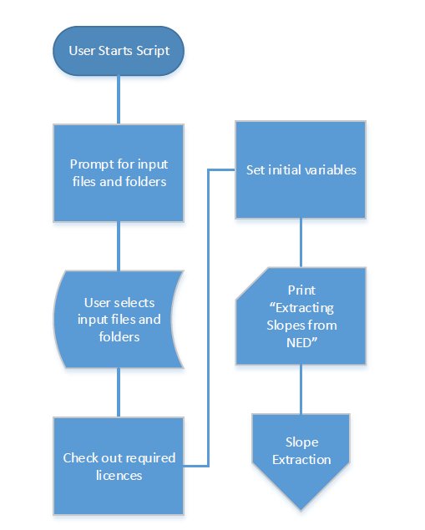

Figure 1: Script Setup and Initialization

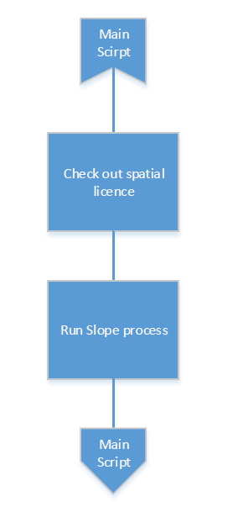

Figure 2: Slope Extraction Function

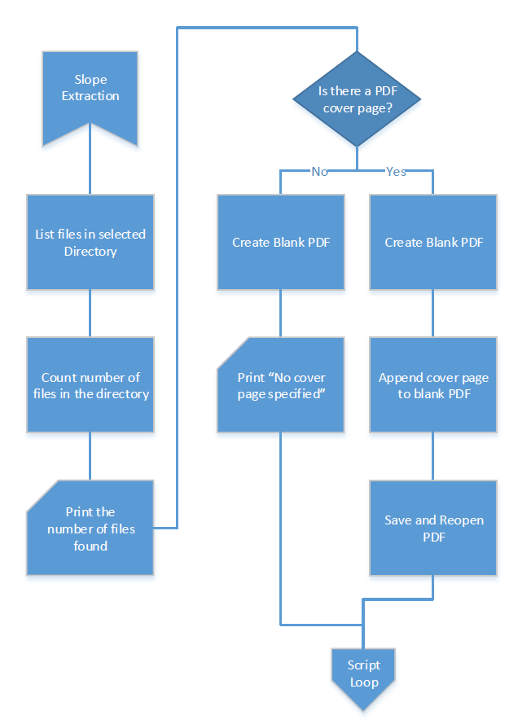

Figure 3: File Location and PDF Output Setup

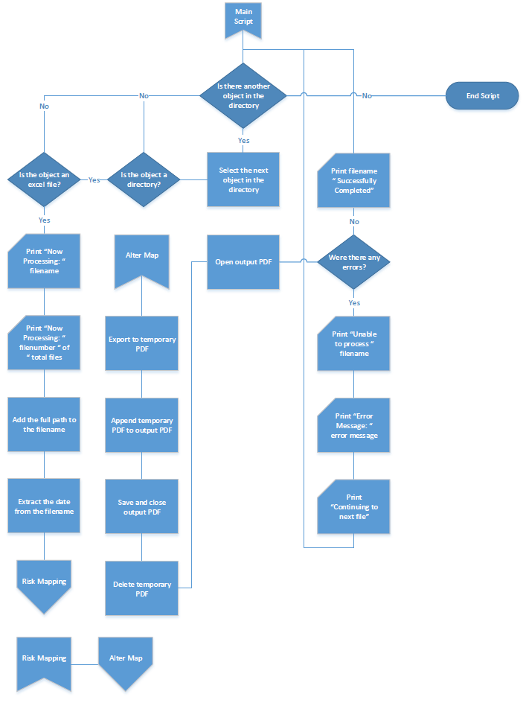

Figure 4: Main Loop

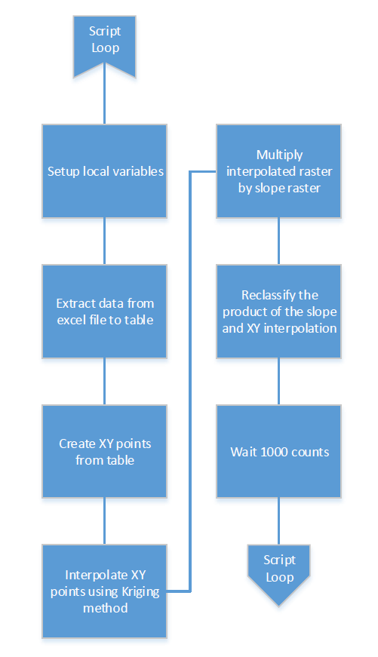

Figure 5: Risk Mapping Function

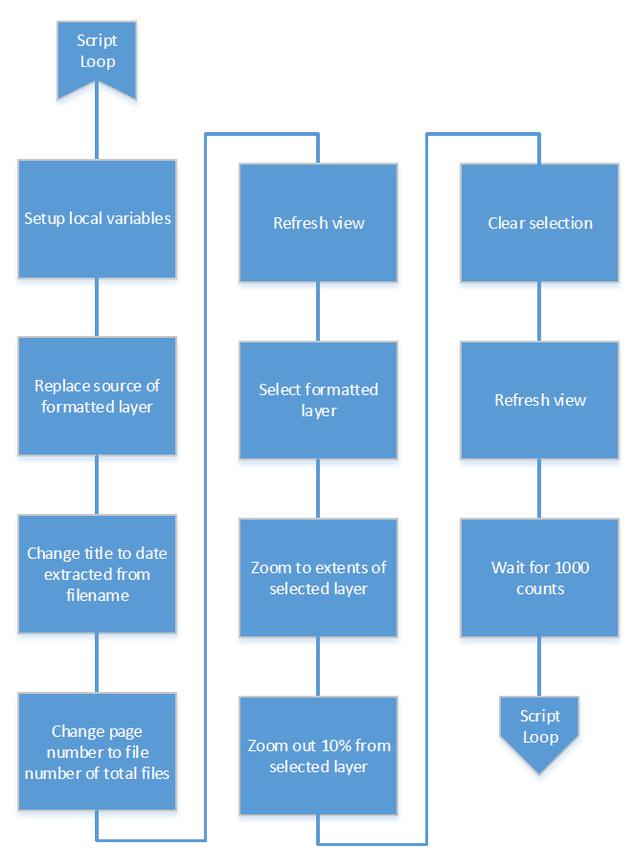

Figure 6: Alter Map Function

## Main Files

## Classes and Functions

UML Class Diagram

## Why is it structured this way?

# Interface Elements

UML Sequence diagram