## 贵州茅台

训练集 mt_space_1d_rate_20d_12-21_pre

测试集 mt_space_1d_rate_20d_22-22_pre

模型 model_mt_c2_s0.1_b16_lr0.001_d0.5_e60.pth

精确率 tensor([0.4615, 0.3333])

准确率 tensor(0.3871)

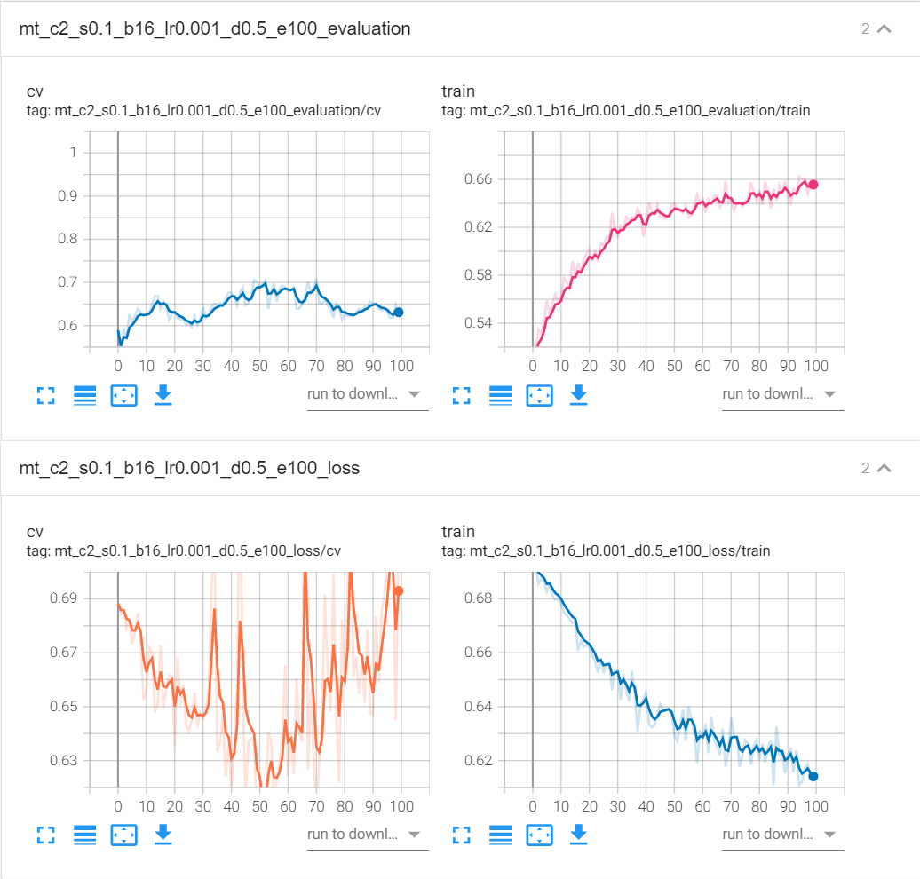

## 五粮液

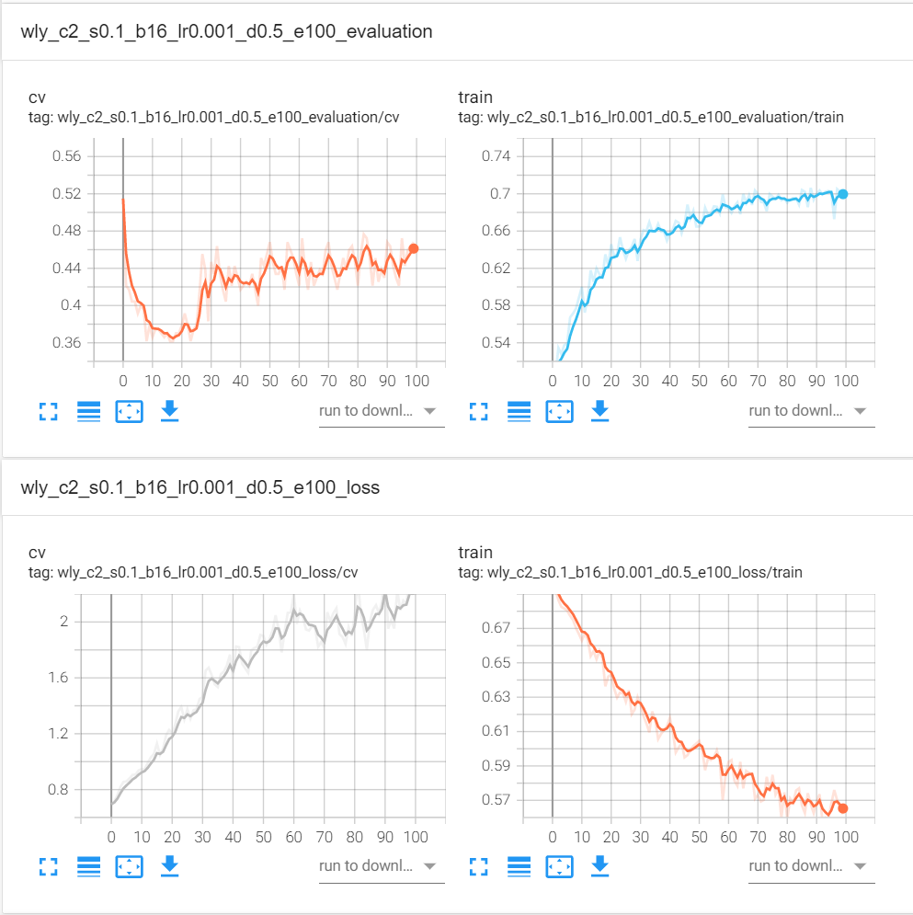

## 平安银行

训练集 pa_space_1d_rate_20d_12-21_pre

测试集 pa_space_1d_rate_20d_22-22_pre

模型 model_pa_c2_s0.1_b16_lr0.001_d0.5_e30.pth

精确率 tensor([0.5333, 0.4375])

准确率 tensor(0.4839)

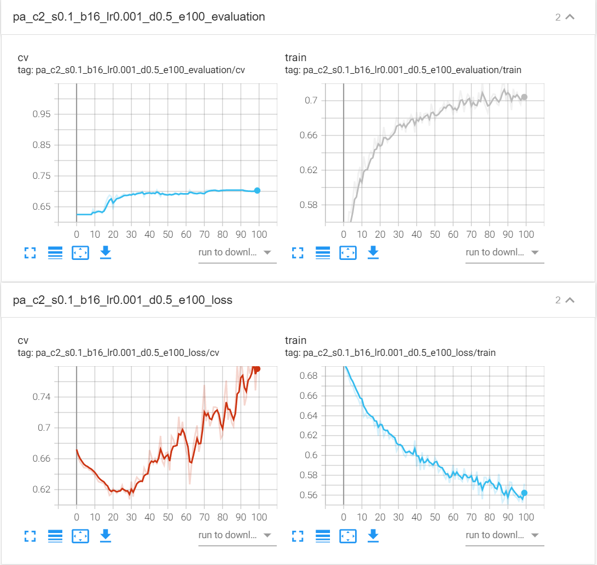

## 招商银行

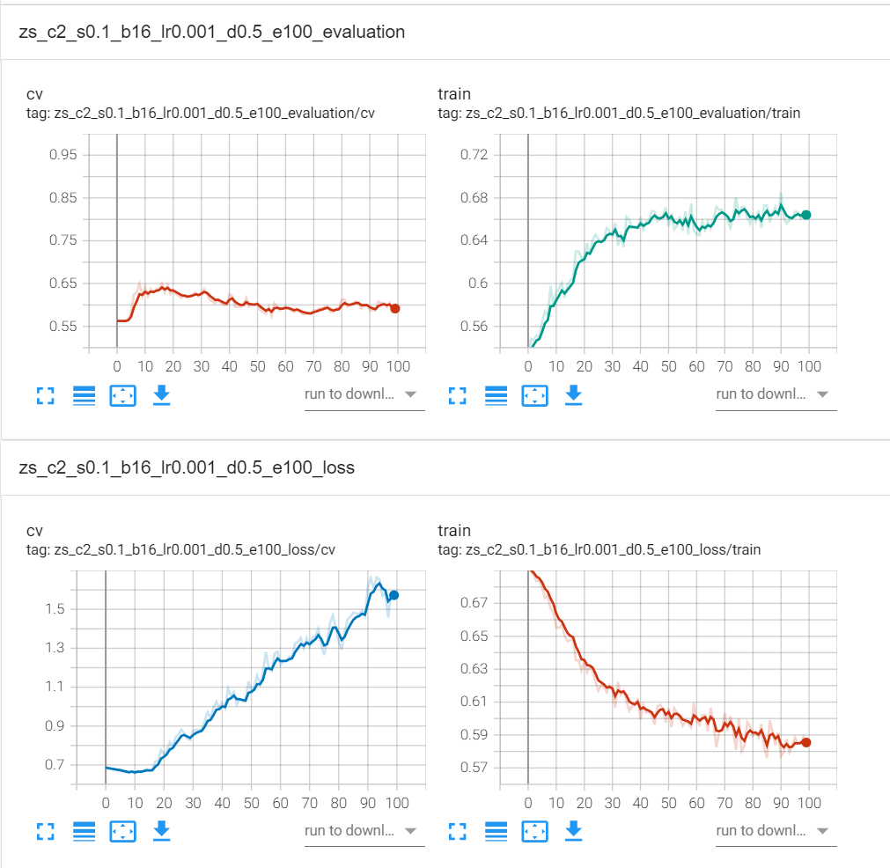

## 上汽集团

训练集 sq_space_1d_rate_20d_12-21_pre

测试集 sq_space_1d_rate_20d_22-22_pre

模型 model_sq_c2_s0.1_b16_lr0.001_d0.5_e20.pth

精确率 tensor([0.5000, 0.7059])

准确率 tensor(0.6129)

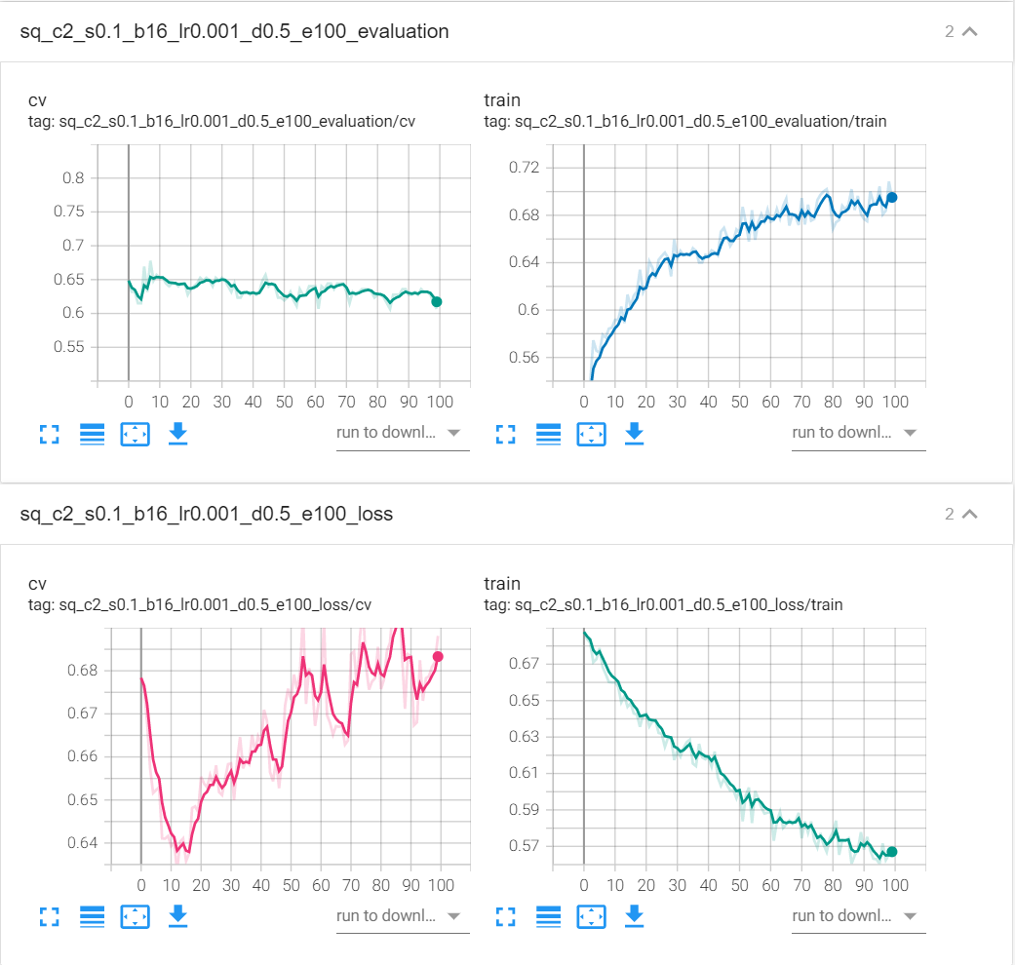

## 宇通客车

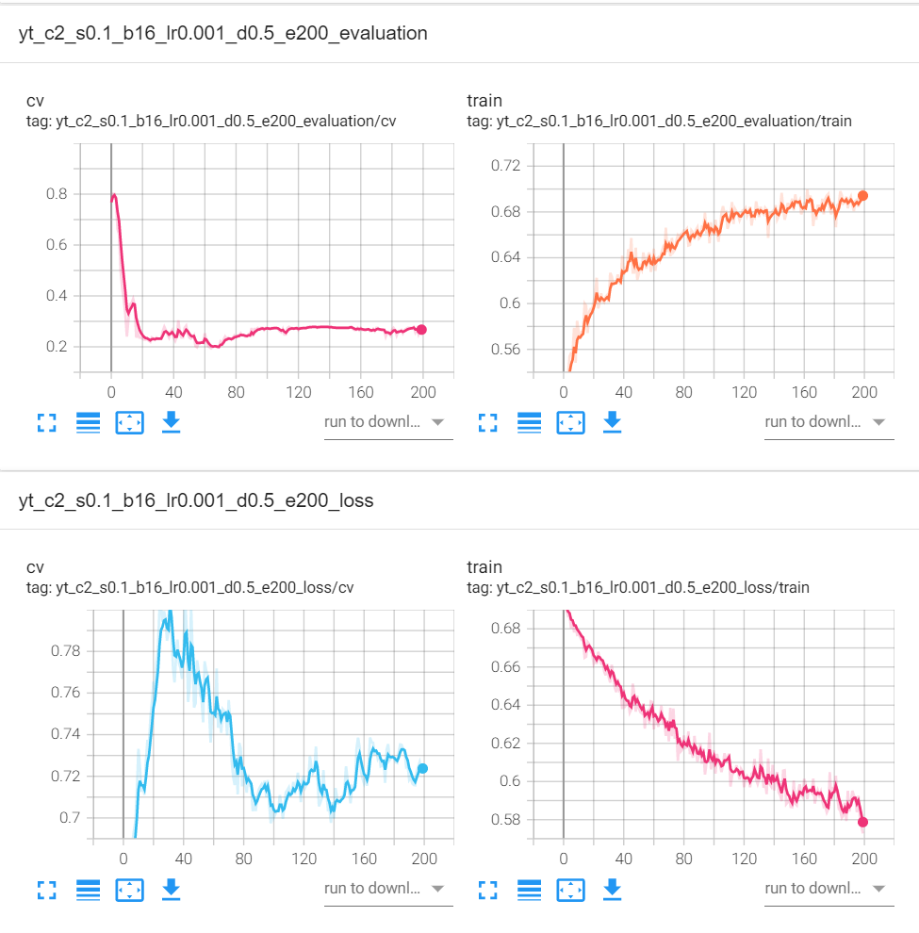

## 同仁堂

训练集 trt_space_1d_rate_20d_12-21_pre

测试集 trt_space_1d_rate_20d_22-22_pre

模型 model_trt_c2_s0.1_b16_lr0.001_d0.5_e40.pth

精确率 tensor([0.6667, 0.5909])

准确率 tensor(0.6129)

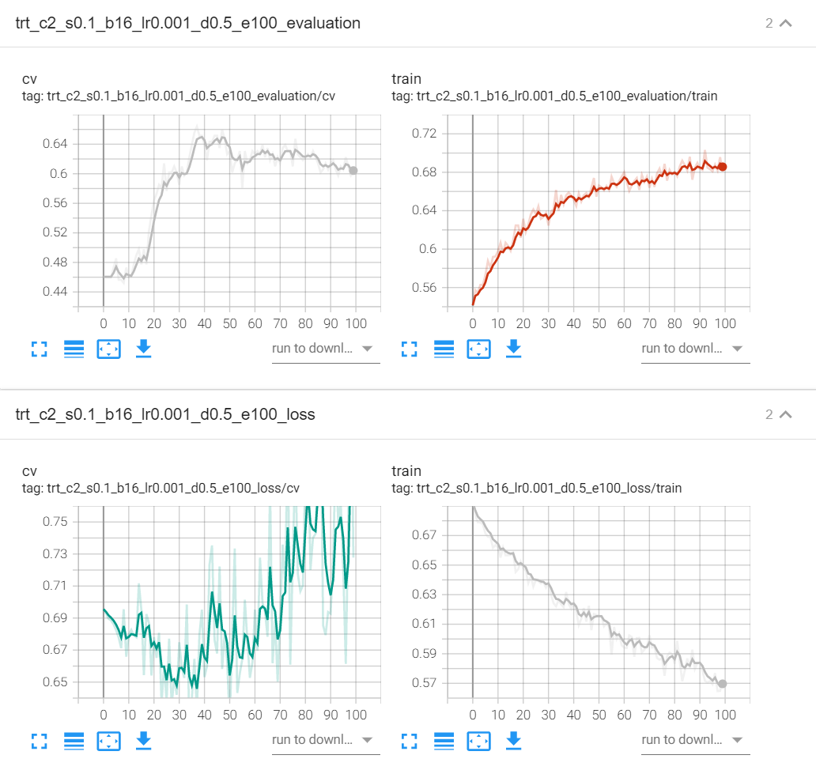

## 恒瑞医药

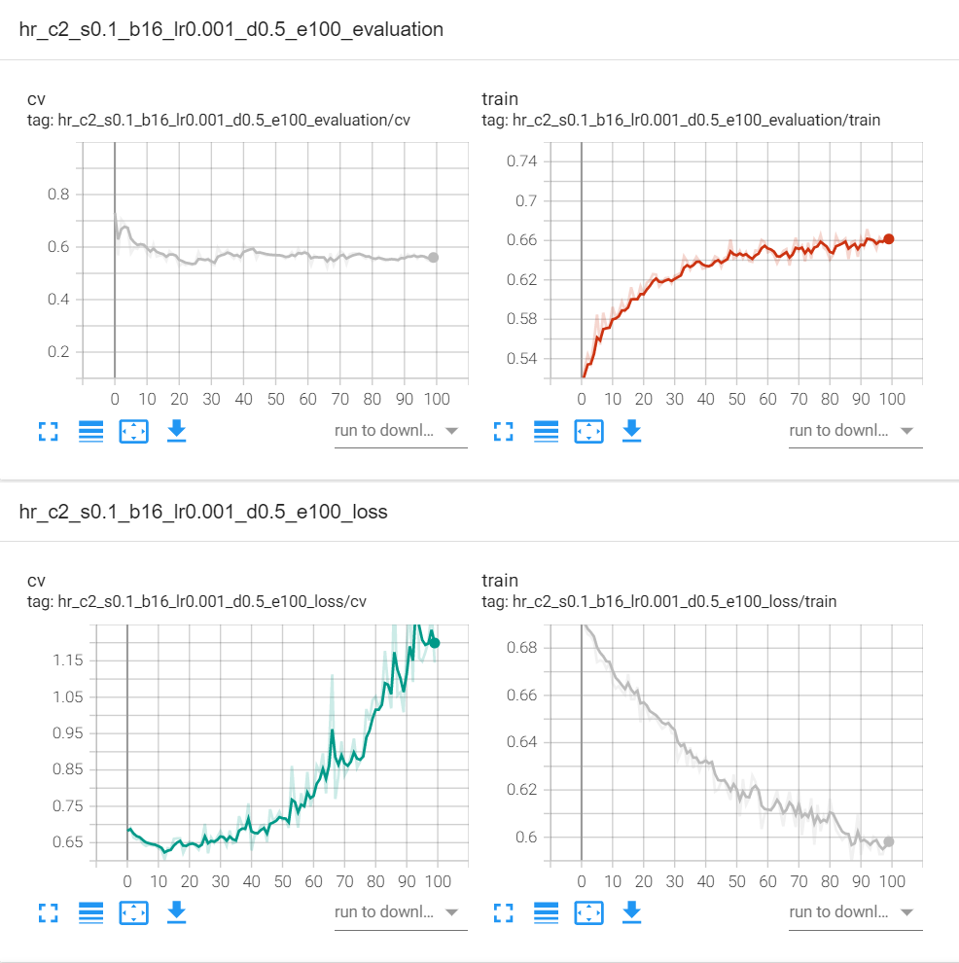

## 张江高科

训练集 zj_space_1d_rate_20d_12-21_pre

测试集 zj_space_1d_rate_20d_22-22_pre

模型 model_zj_c2_s0.1_b16_lr0.001_d0.5_e30.pth

精确率 tensor([0.8333, 0.6000])

准确率 tensor(0.6452)

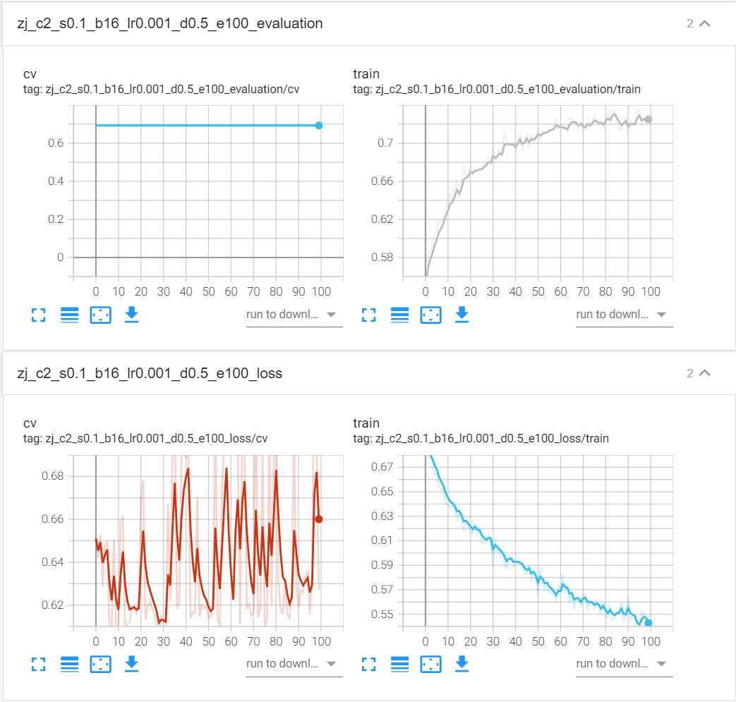

## 首开股份

