## 贵州茅台

model_mt_c2_s0.1_b16_lr0.001_d0.5_e80.pth

tensor([0.5625, 0.4000])

tensor(0.4839)

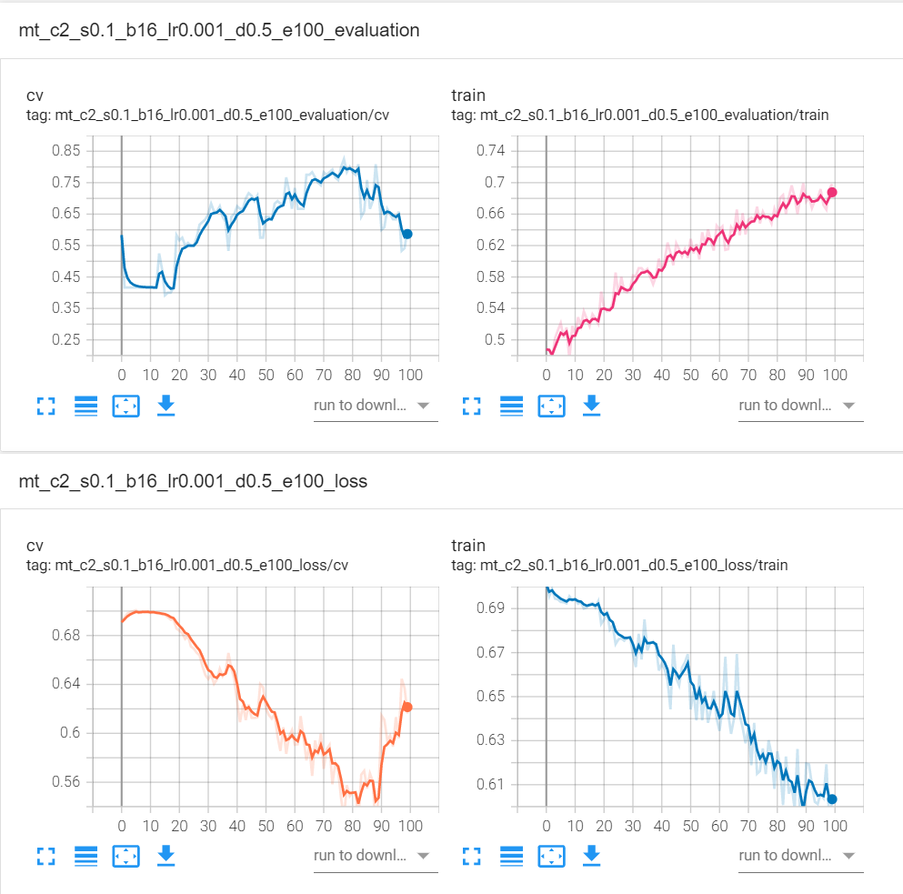

## 五粮液

model_wly_c2_s0.1_b16_lr0.001_d0.5_e20.pth

tensor([0.2143, 0.2941])

tensor(0.2581)

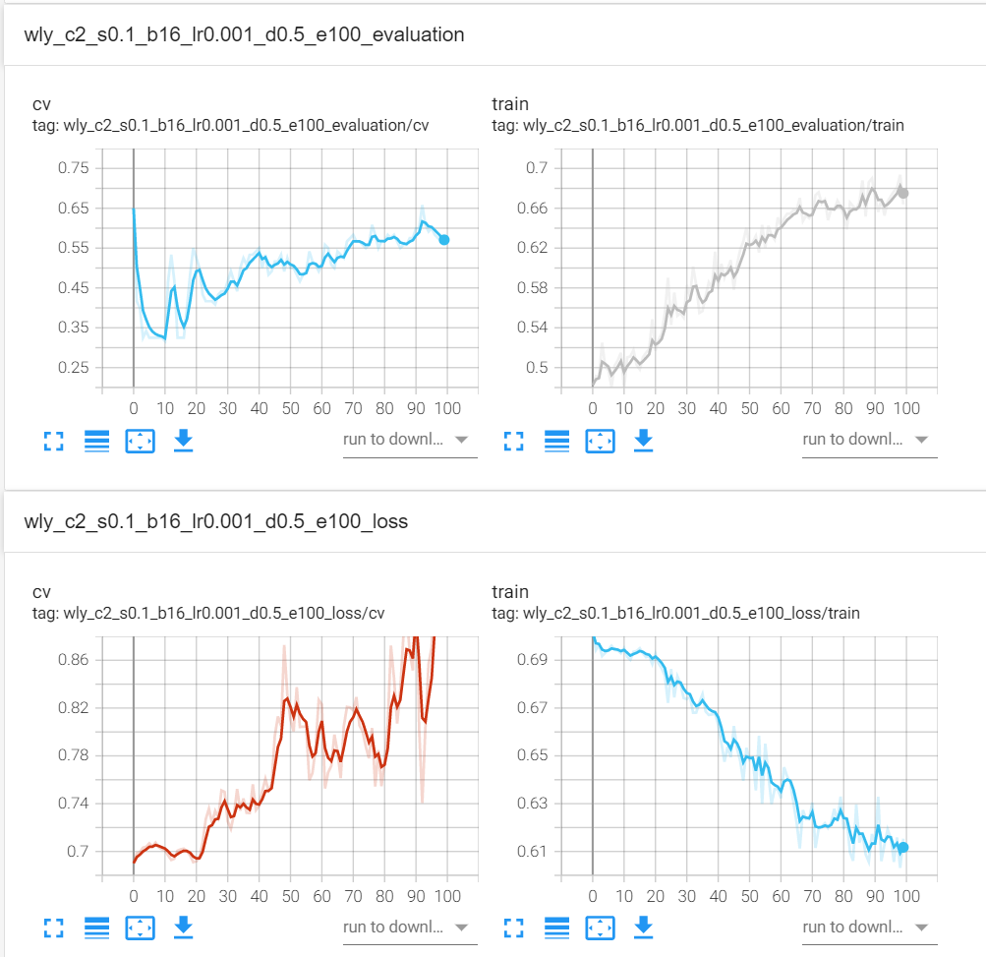

## 平安银行

model_pa_c2_s0.1_b16_lr0.001_d0.5_e40.pth

tensor([0.8889, 0.5909])

tensor(0.6774)

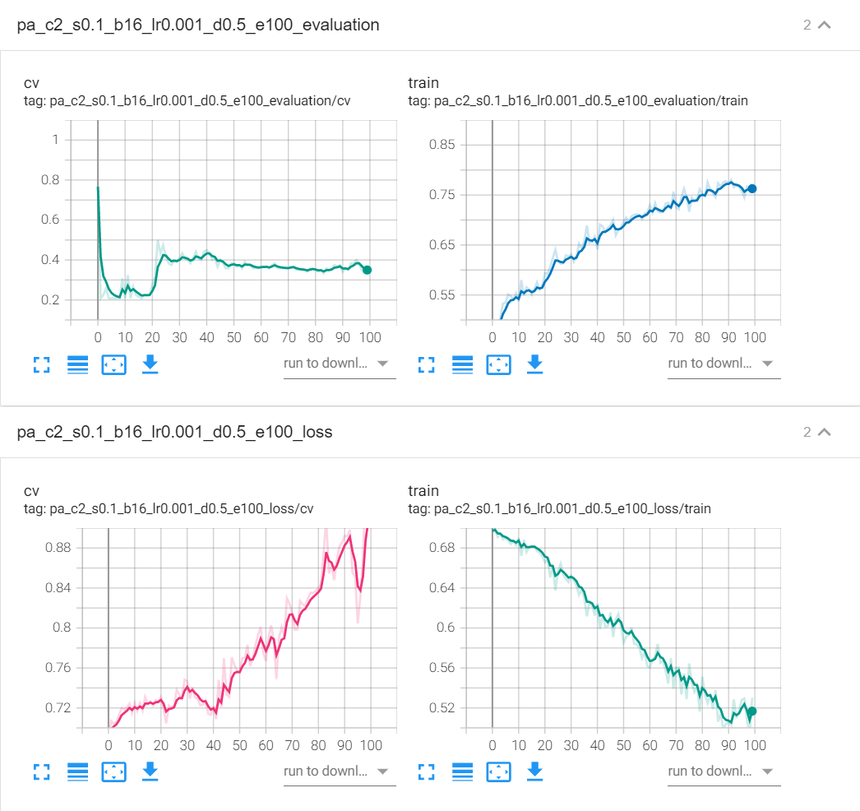

## 招商银行

model_zs_c2_s0.1_b16_lr0.001_d0.5_e50.pth

tensor([0.8750, 0.6667])

tensor(0.7742)

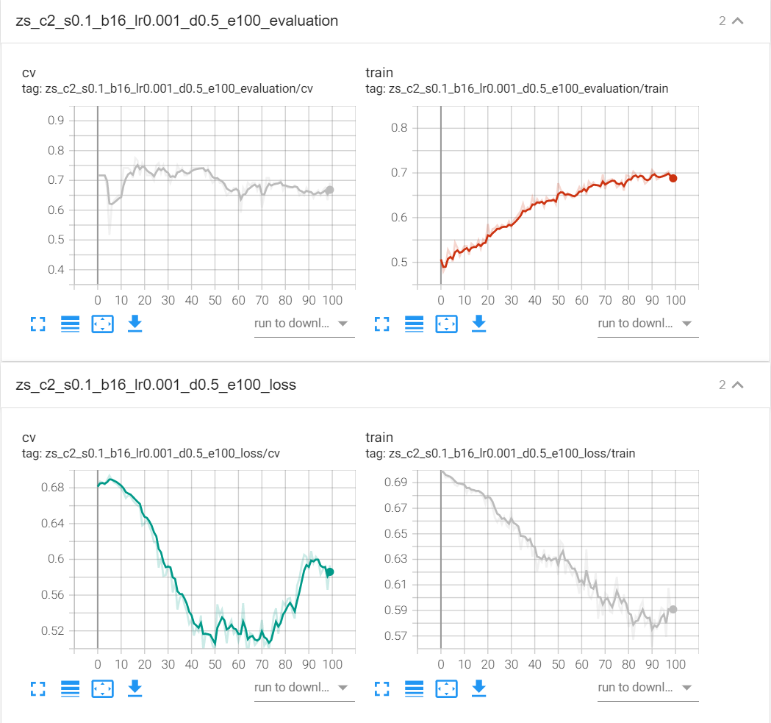

## 上汽集团

model_sq_c2_s0.1_b16_lr0.001_d0.5_e30.pth

tensor([0.4000, 0.6364])

tensor(0.4839)

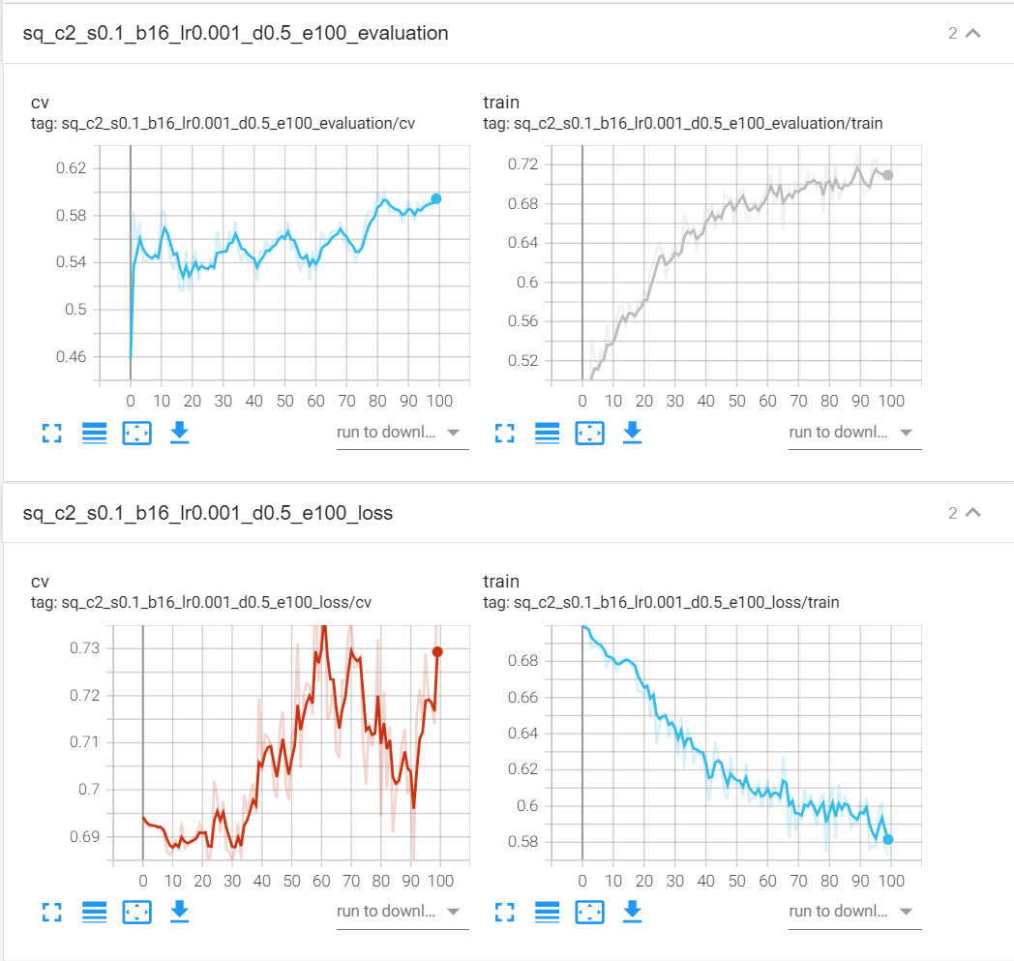

## 宇通客车

model_yt_c2_s0.1_b16_lr0.001_d0.5_e90.pth

tensor([0.3636, 0.2500])

tensor(0.2903)

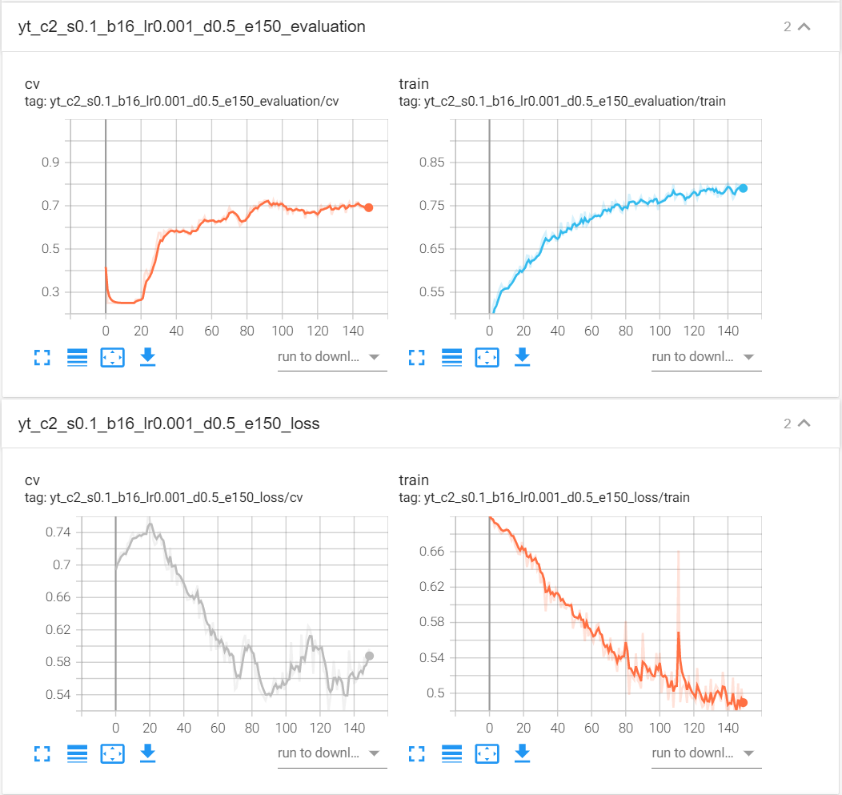

## 同仁堂

tensor([0.6000, 0.5385])

tensor(0.5484)

model_trt_c2_s0.1_b16_lr0.001_d0.5_e20.pth

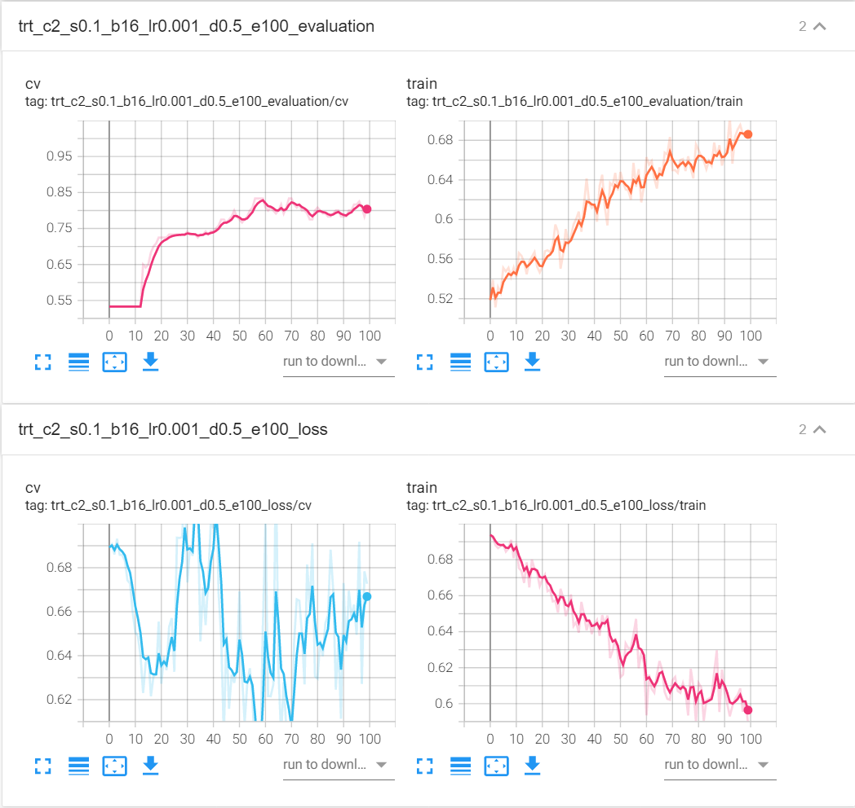

## 恒瑞医药

model_hr_c2_s0.1_b16_lr0.001_d0.5_e10.pth

tensor([0.6000, 1.0000])

tensor(0.6774)

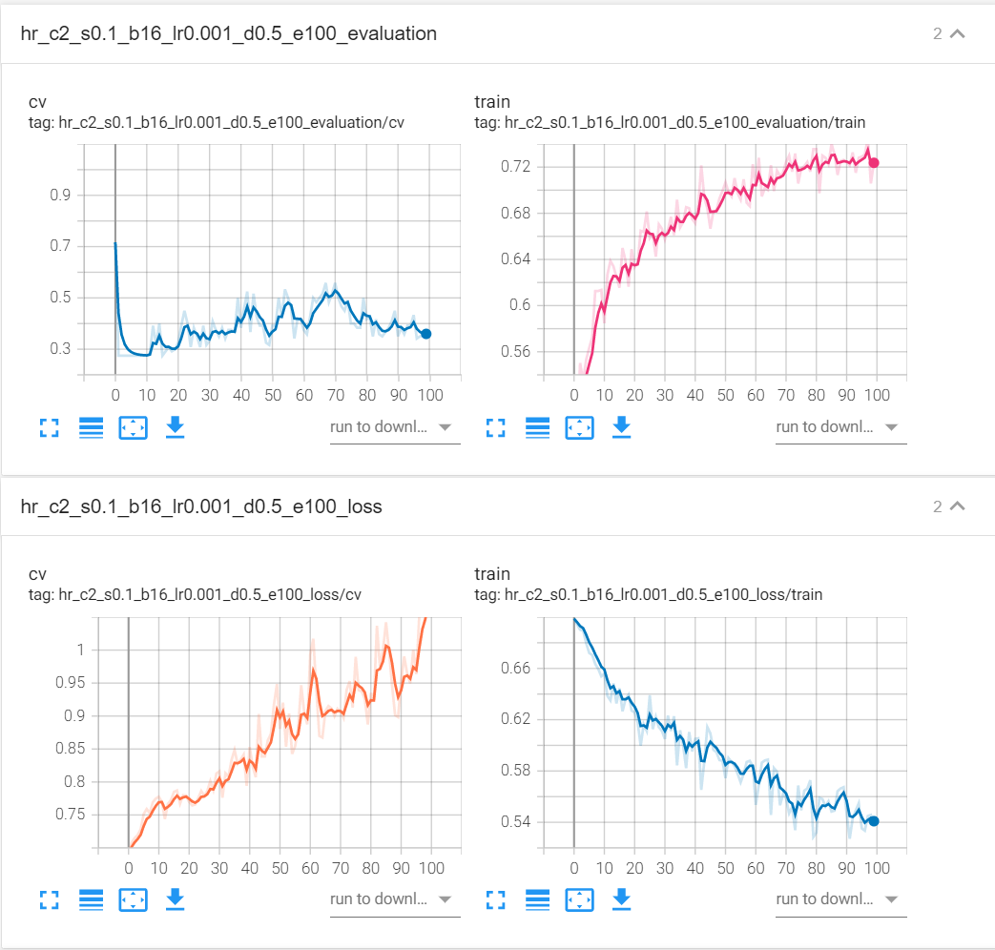

## 张江高科

model_zj_c2_s0.1_b16_lr0.001_d0.5_e20.pth

tensor([0.8000, 0.5769])

tensor(0.6129)

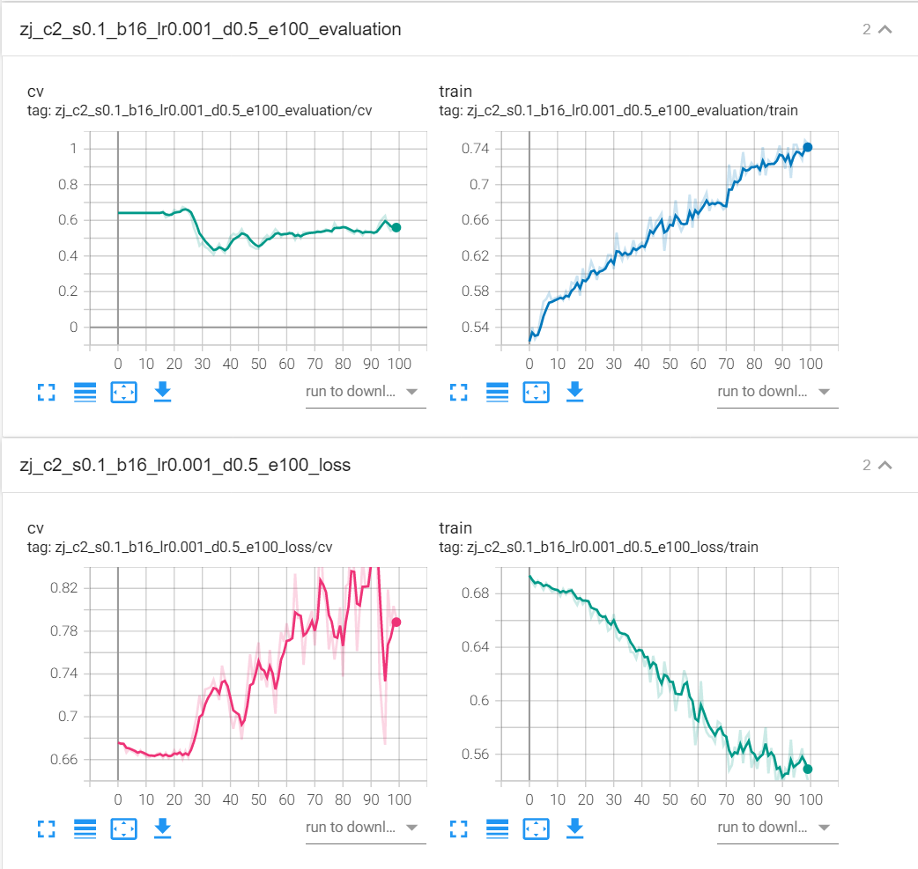

## 首开股份

model_sk_c2_s0.1_b16_lr0.001_d0.5_e20.pth

tensor([0.5000, 0.6471])

tensor(0.5806)

