## 贵州茅台

model_mt_c2_s0.1_b16_lr0.001_d0.5_e30.pth

tensor([0.4706, 0.2857])

tensor(0.3871)

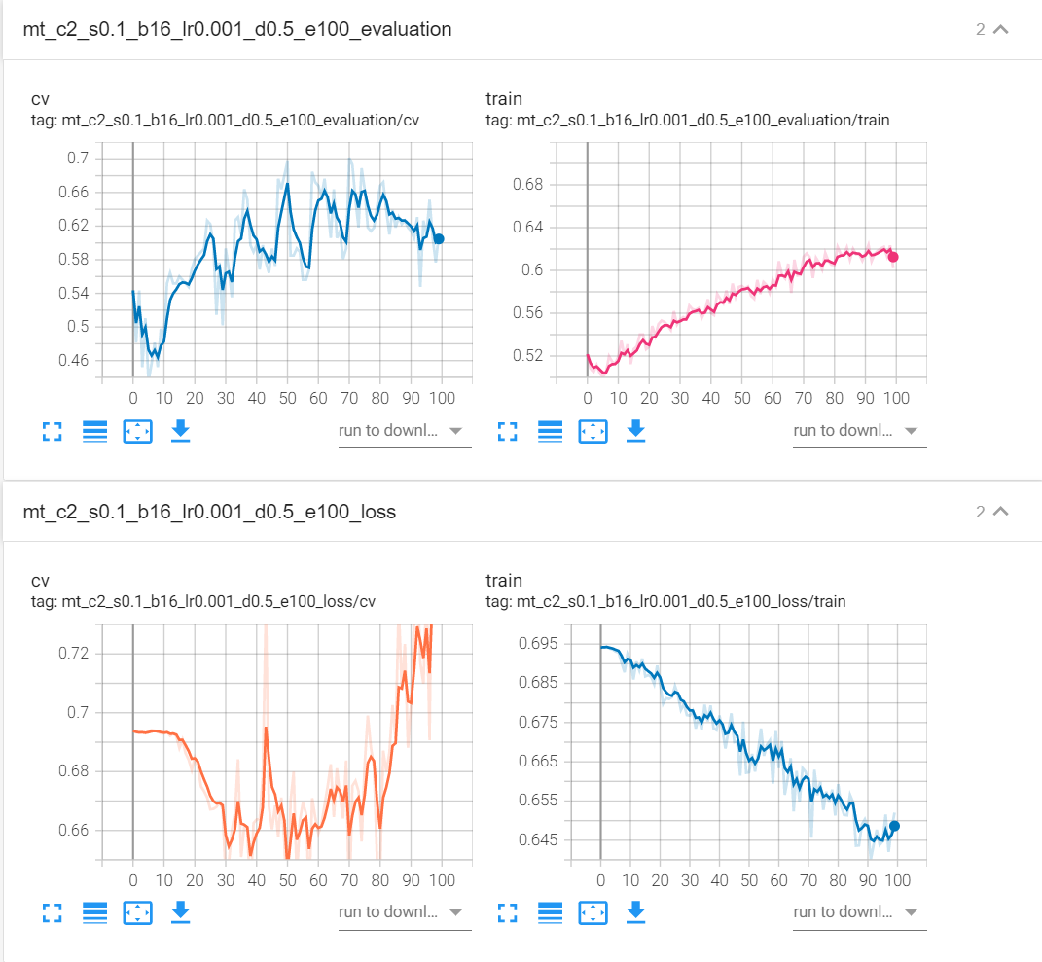

## 五粮液

model_wly_c2_s0.1_b16_lr0.001_d0.5_e10.pth

tensor([0.5000, 0.6000])

tensor(0.5161)

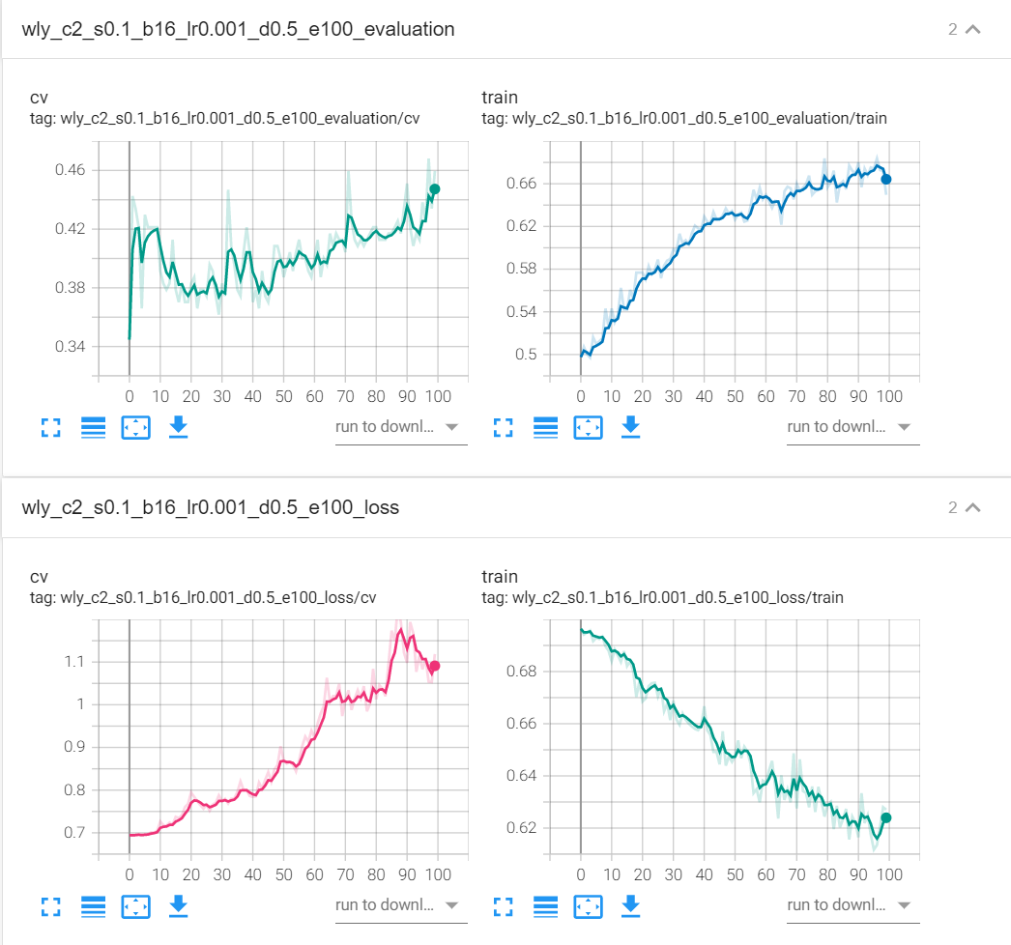

## 平安银行

model_pa_c2_s0.1_b16_lr0.001_d0.5_e50.pth

tensor([0.5714, 0.4706])

tensor(0.5161)

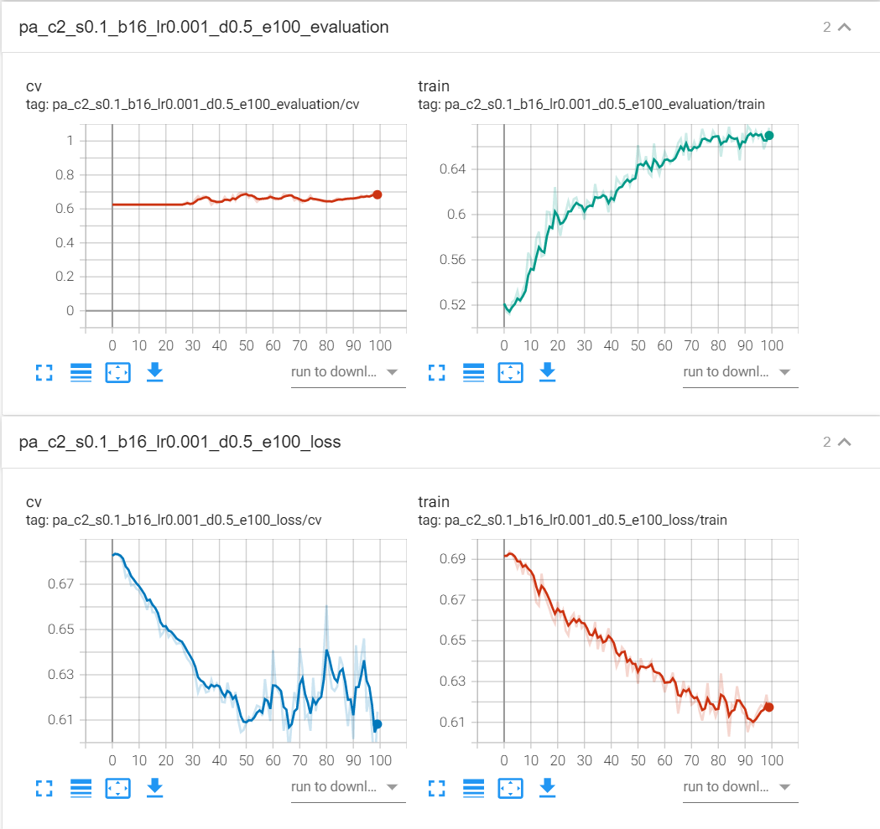

## 招商银行

model_zs_c2_s0.1_b16_lr0.001_d0.5_e30.pth

tensor([0.8571, 0.5882])

tensor(0.7097)

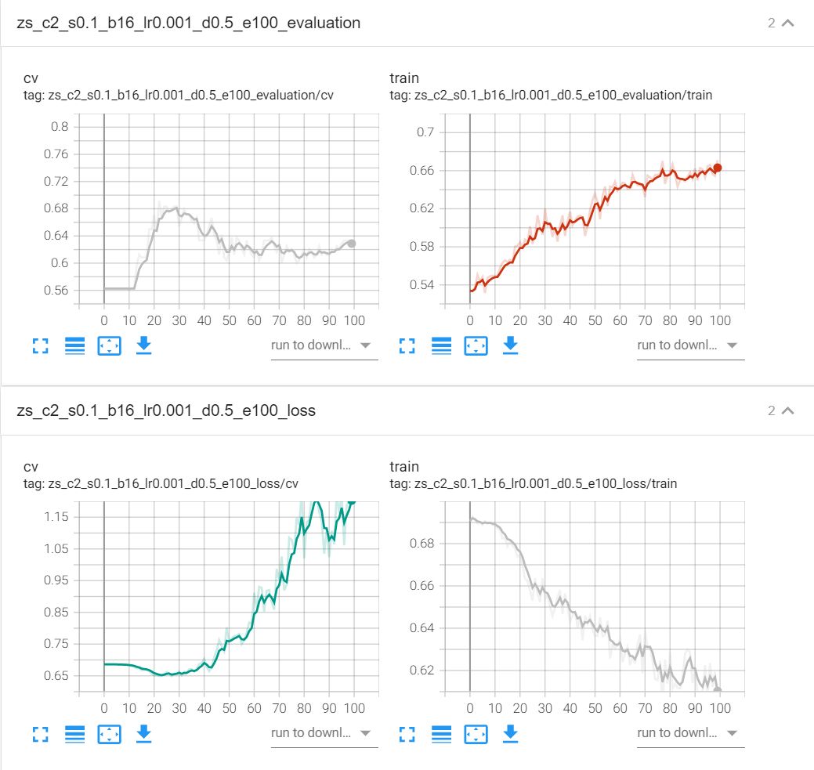

## 上汽集团

model_sq_c2_s0.1_b16_lr0.001_d0.5_e30.pth

tensor([0.4286, 0.7000])

tensor(0.5161)

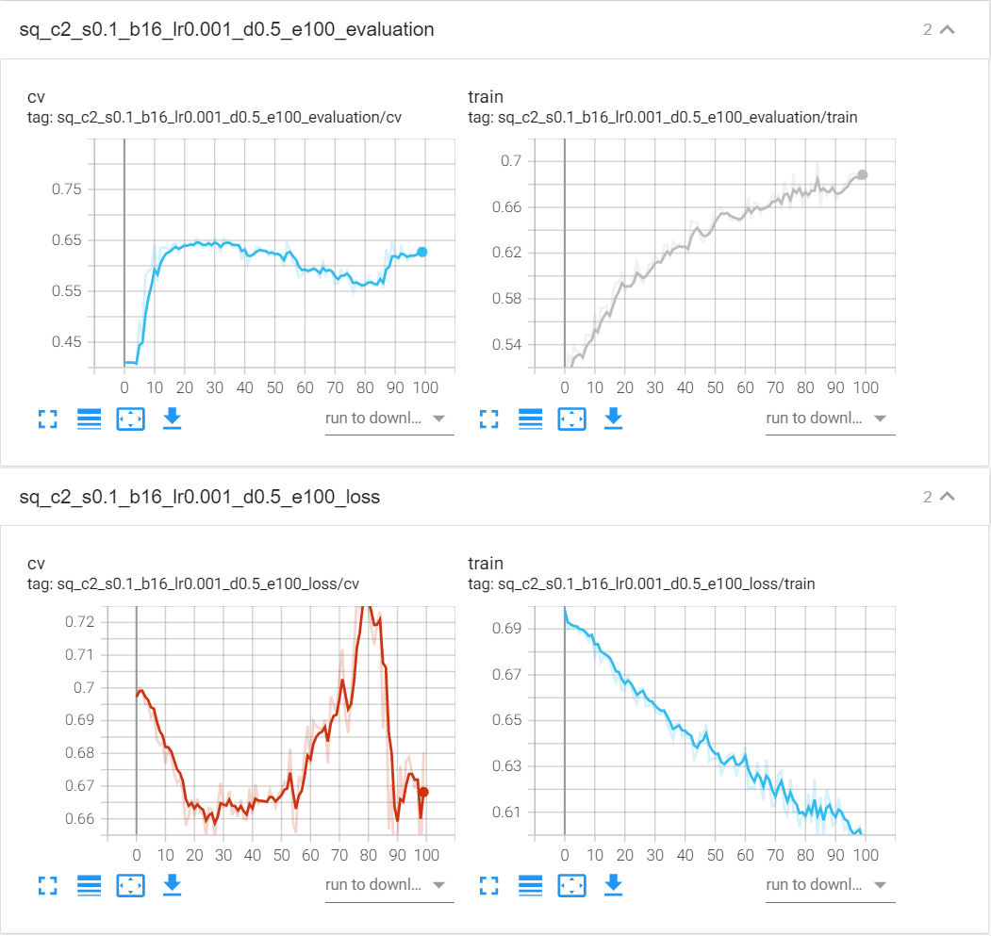

## 宇通客车

model_yt_c2_s0.1_b16_lr0.001_d0.5_e200.pth

tensor([0.4545, 0.3000])

tensor(0.3548)

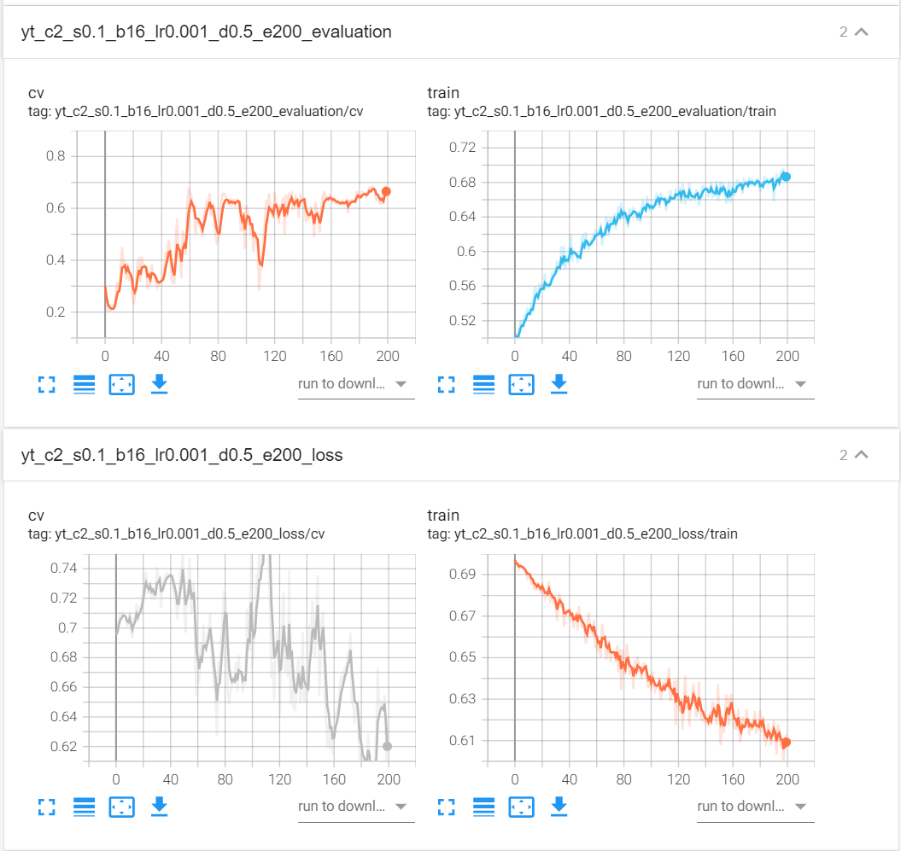

## 同仁堂

model_trt_c2_s0.1_b16_lr0.001_d0.5_e70.pth

tensor([0.6364, 0.6000])

tensor(0.6129)

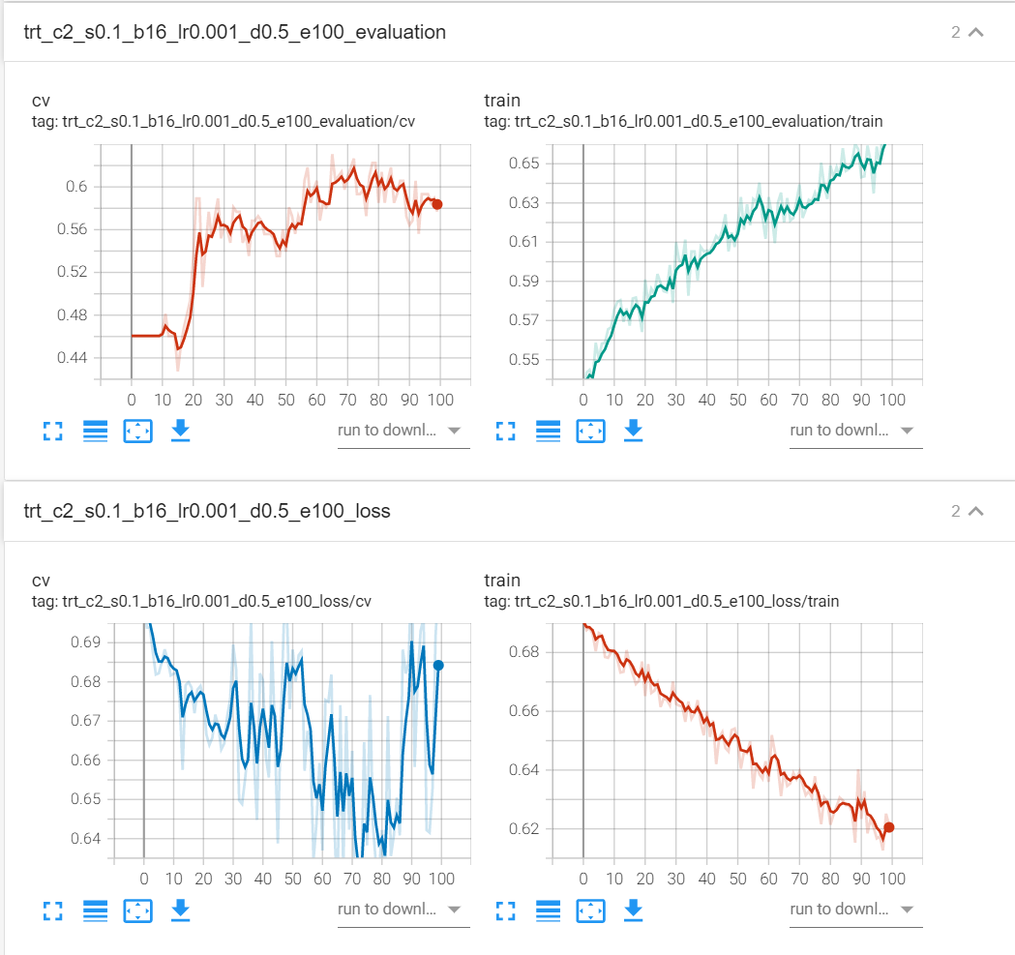

## 恒瑞医药

model_hr_c2_s0.1_b16_lr0.001_d0.5_e20.pth

tensor([0.6923, 0.6667])

tensor(0.6774)

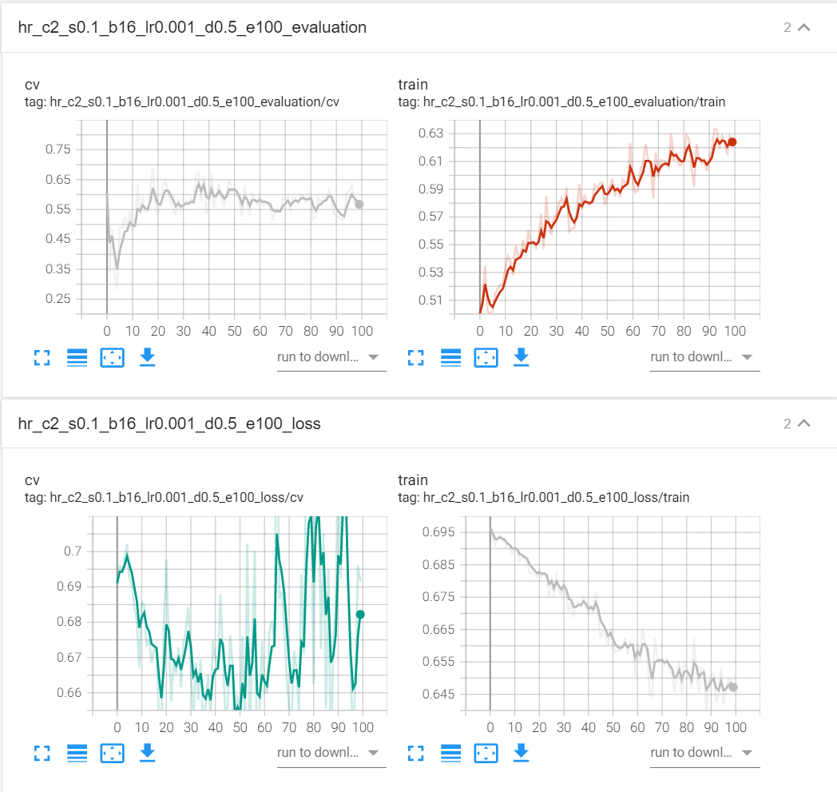

## 张江高科

model_zj_c2_s0.1_b16_lr0.001_d0.5_e30.pth

tensor([0.4706, 0.5000])

tensor(0.4839)

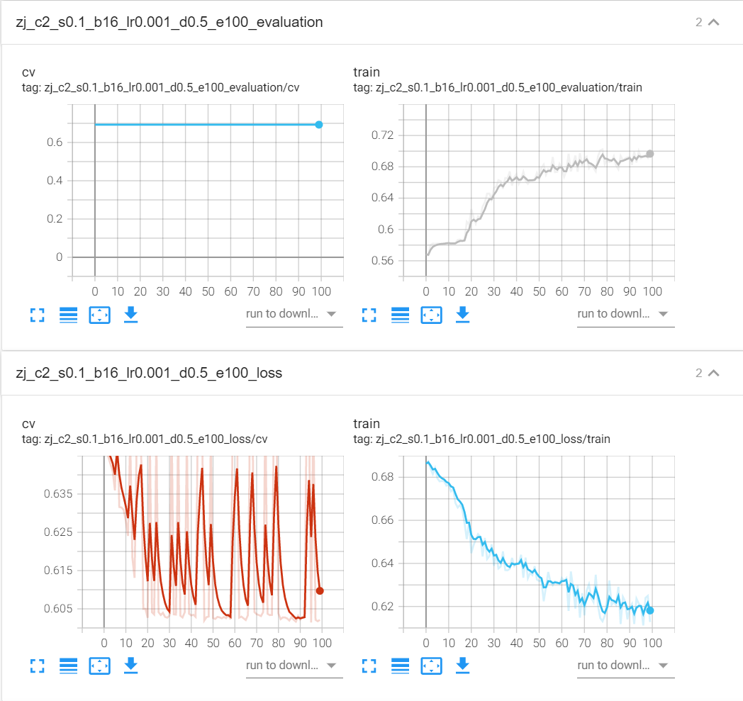

## 首开股份

model_sk_c2_s0.1_b16_lr0.001_d0.5_e35.pth

tensor([0.4667, 0.6250])

tensor(0.5484)

