1. Left side is fixed version via JS standard, right side is my original code

Only errors I am getting from standard site is about indenting comment.

As you can see from image below, only change I had to was location of ‘else’, standards was asking me to put else in the same line with closing curly brace.

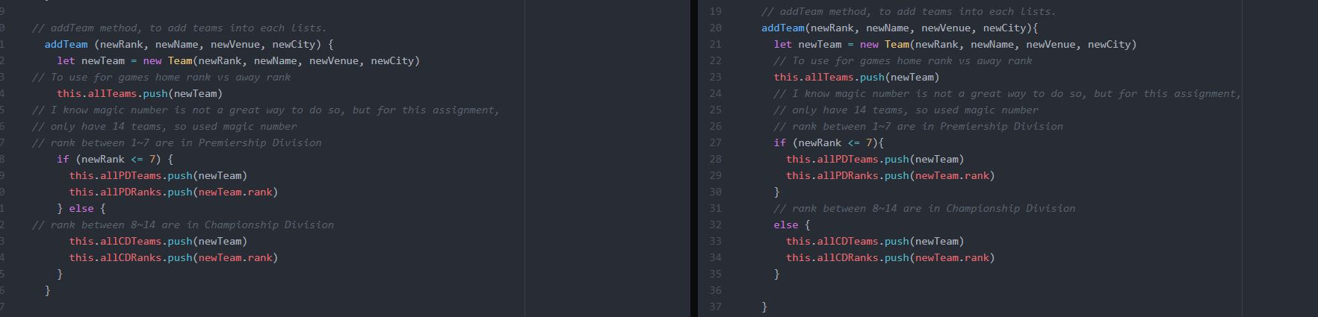

For next six pictures, they all have same issue, so I will just explain once here. Fortunately, our variable names aren’t that long, so I could put them in one line, but I chose to split them (like on right side to make it look better with my personal opinion). However, standards didn’t like it, so I put it back to one line of code. Also, instead of using double quote (“”) asking me to use single quote (‘’)

(I couldn’t find the command to add to ignore this on JS Standards)

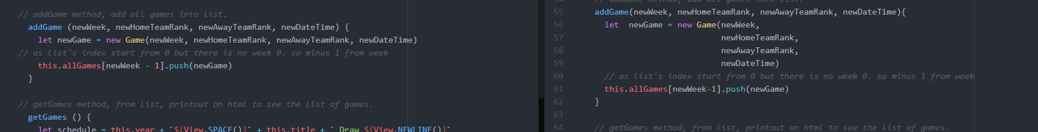

Those two photos are for getGames() method, but top one is one without linewrap ( Soft Wrap from Atom) and bottom one is the one with linewrap. As you can see bottom looks way better than top one but I still prefer the way I wrote as we can see line by line for this case.

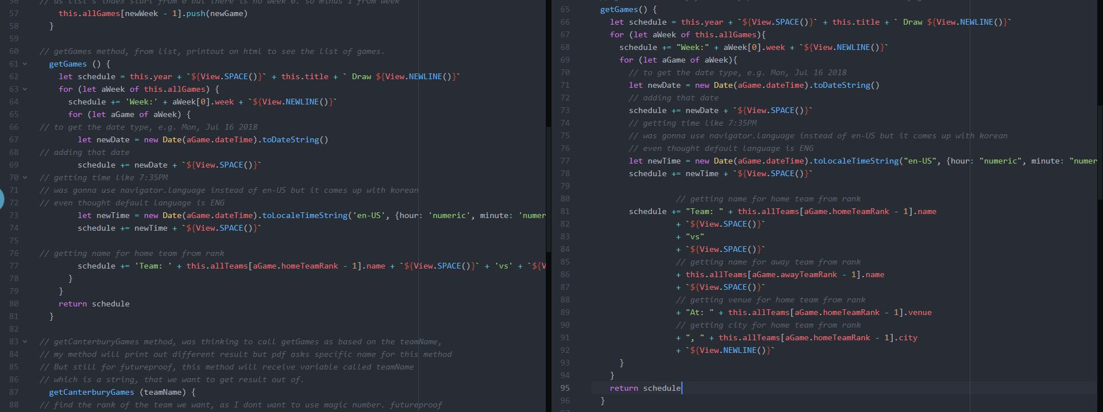

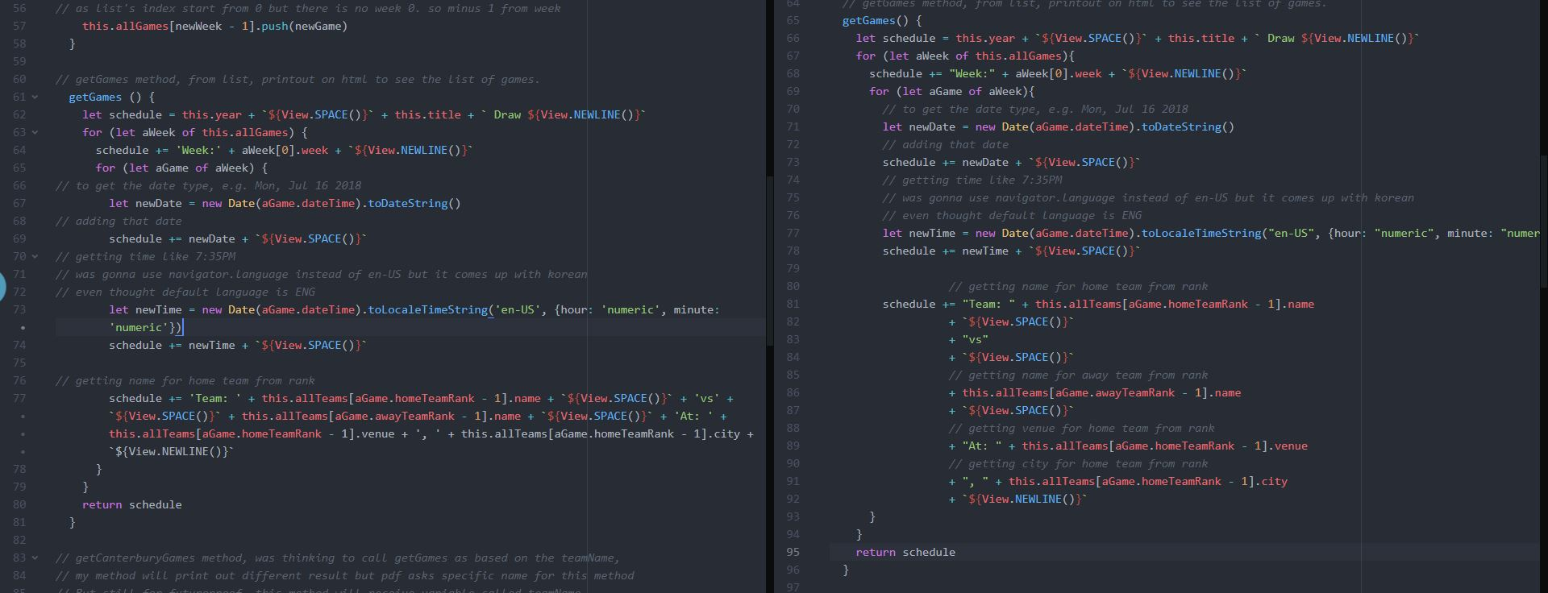

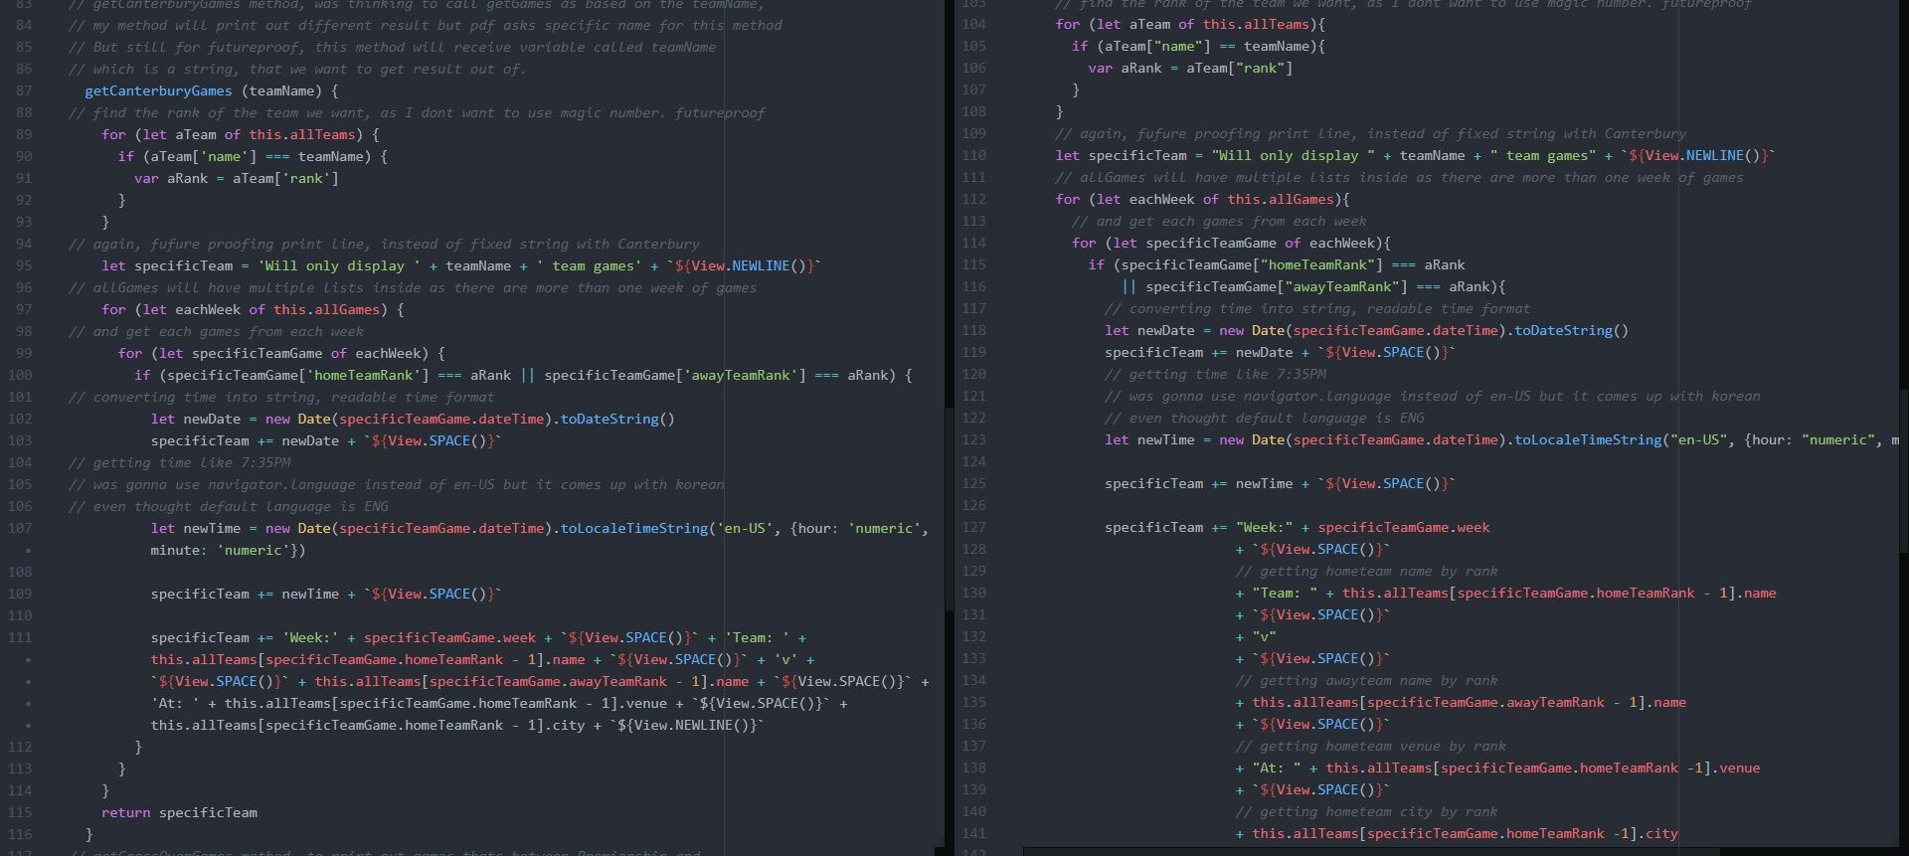

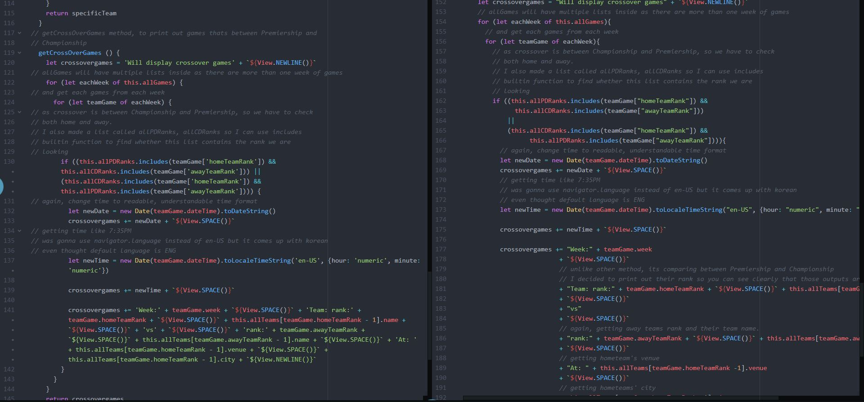

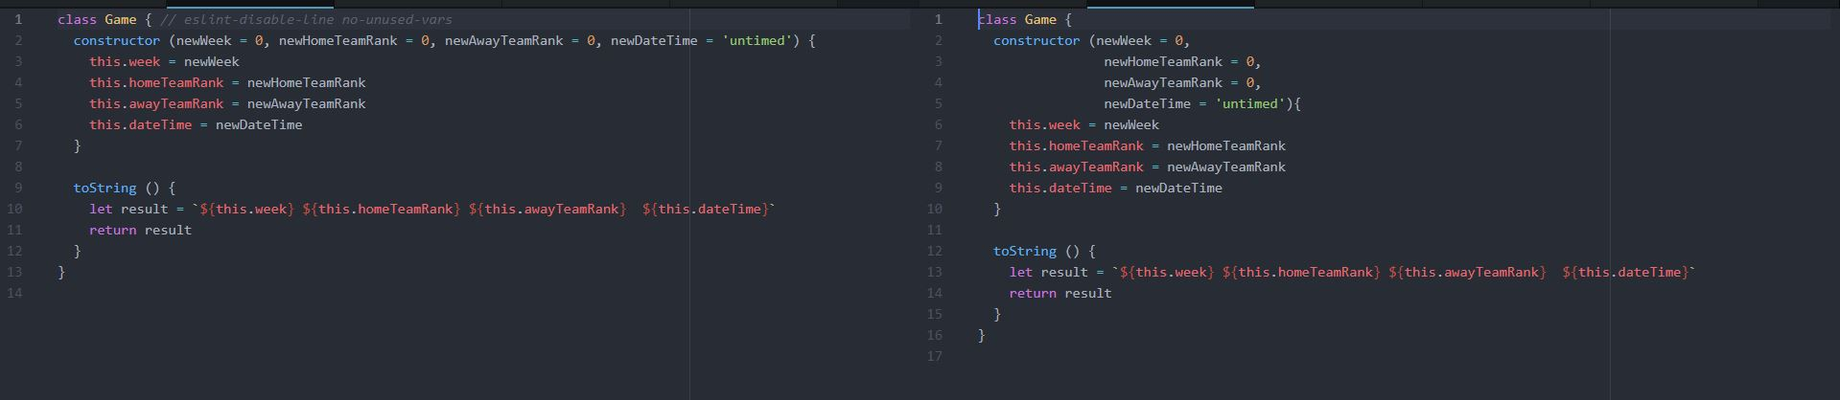

Standards like to have single quote not double quotes.

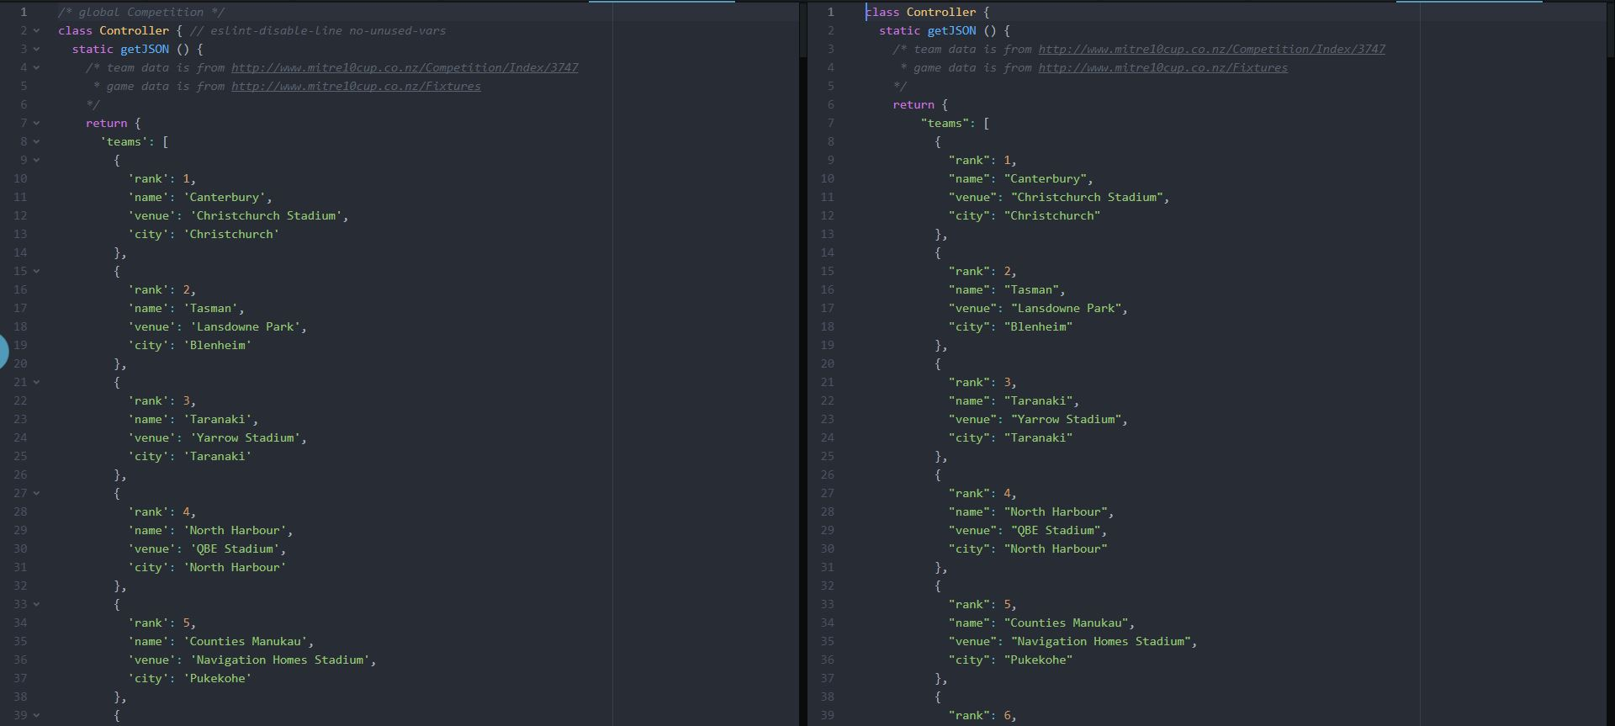

2. Left side is fixed version via PyCharm, right side is my original code

Number of tabs on line 20, 21 were 3 with Atom and fixed to 4 as PyCharm was expecting number of tabs = x * 4.

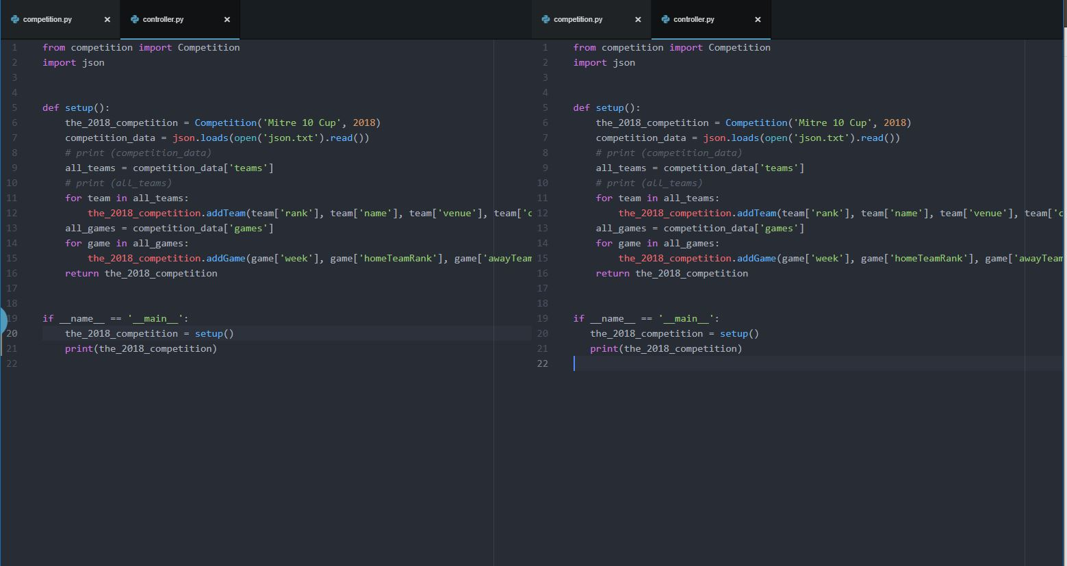

Line number 21, PyCharm didn’t want me to have () around newRank <= 7 which kind of make sense as we are only trying to compare one variable. Also, asked me to have two spaces before class Competition whereas I had one space before.

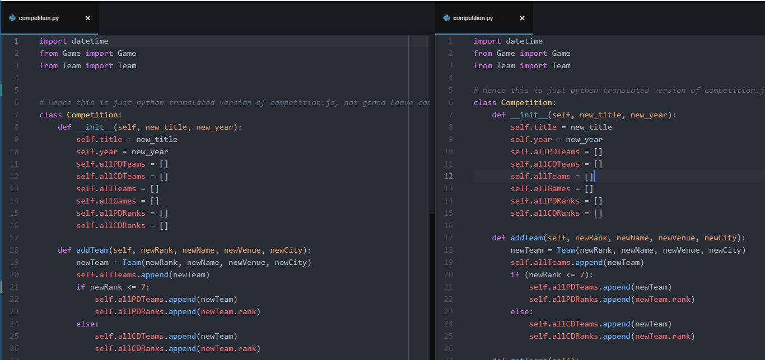

Same as previous one, line number 60, 63, didn’t want me to have () around compare statement.

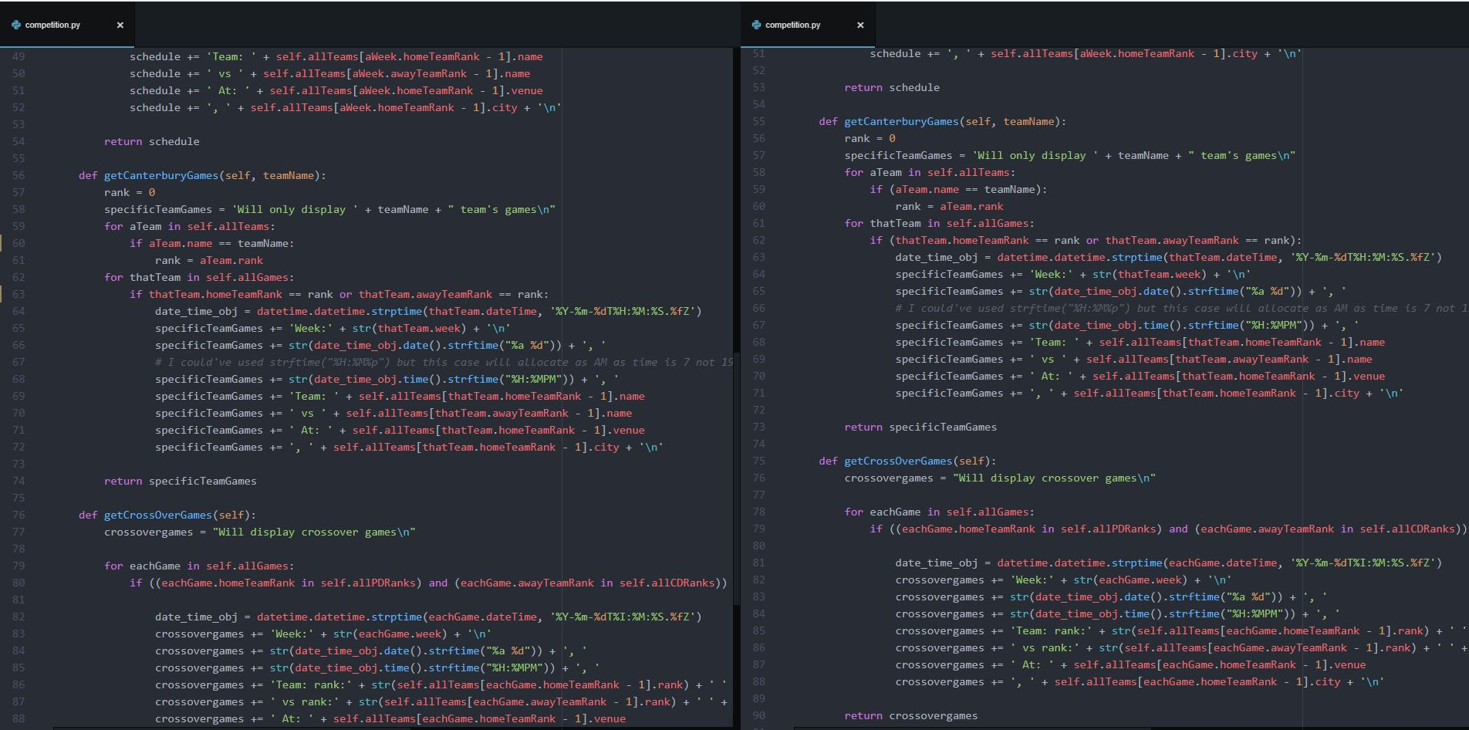

Fortunately no issues were found for Team.py and Game.Py

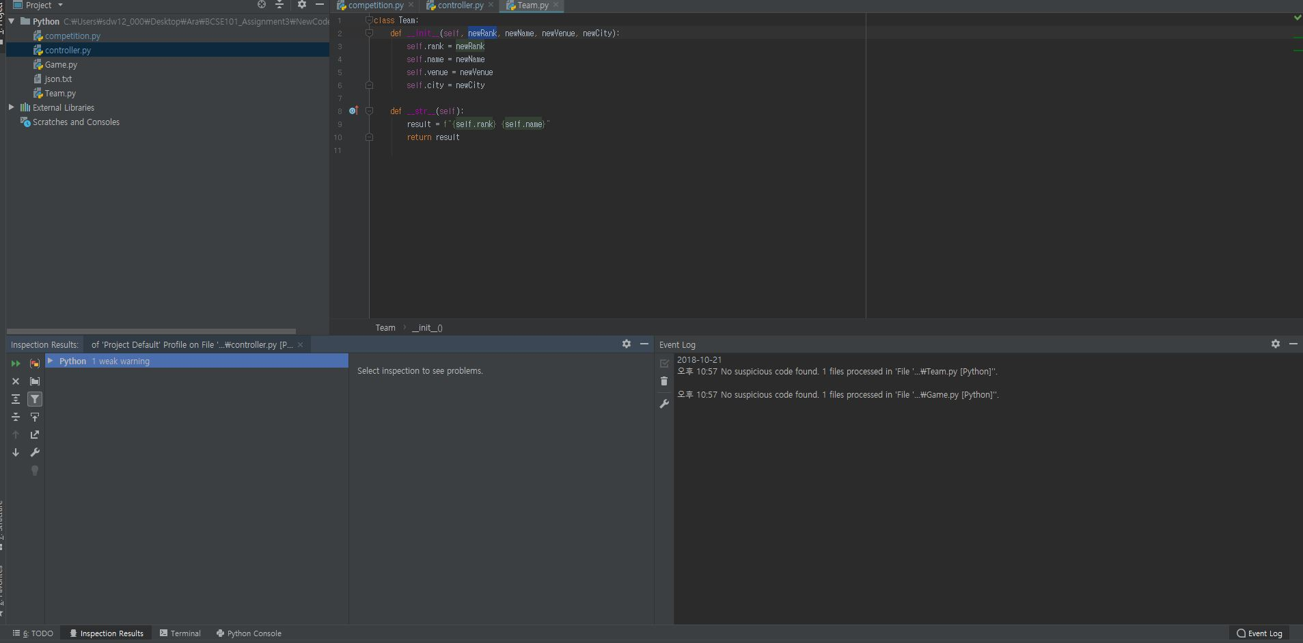

The_2018_competition, as I am trying to use variable name function inside the function, but this function is also a global variable. This warning is there to help me prevent bugs that might be caused by me trying to access the global variable but getting the local variable instead.

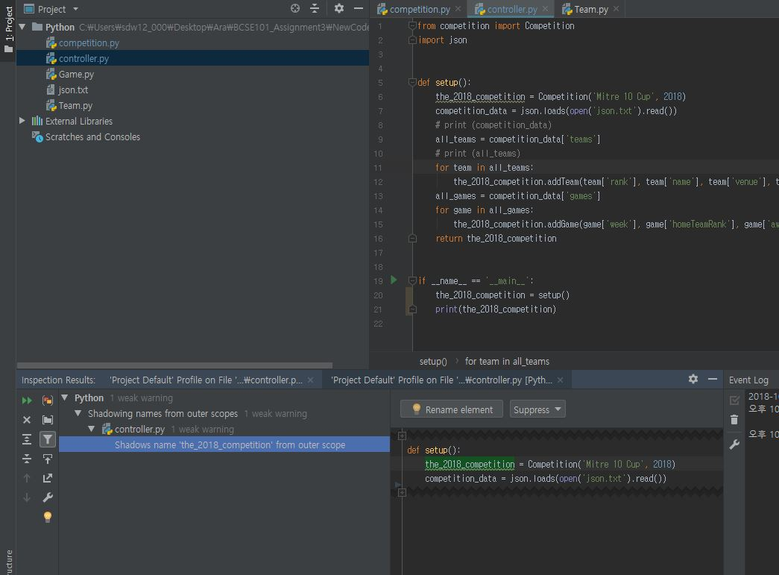

Issues for Competition are typo, but strftime is actually a built-in function with python so it’s not a typo, also it’s a comment.

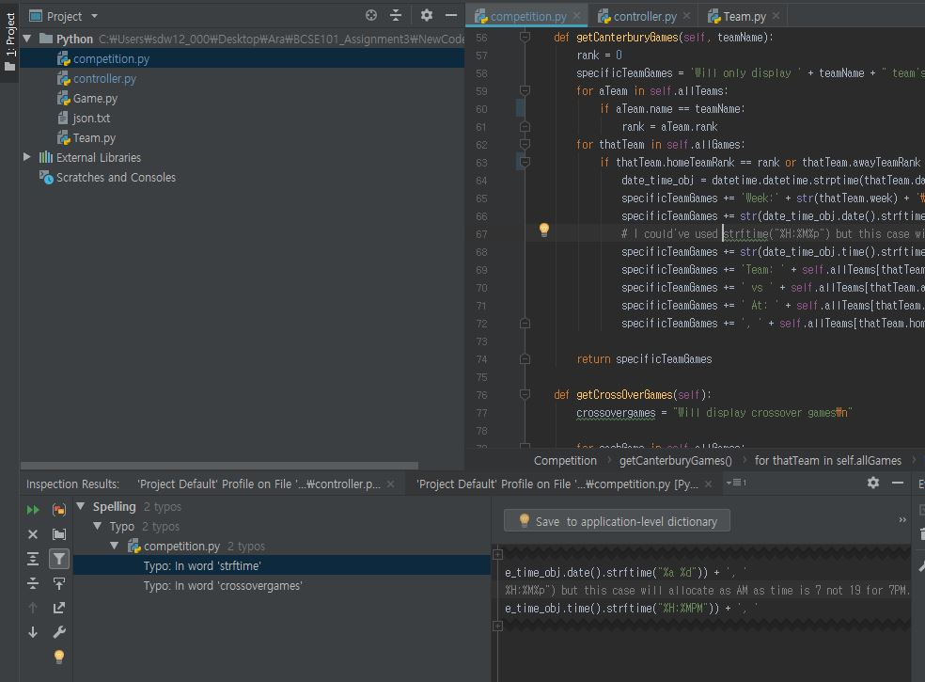

Crossovergames is just a variable name I made, so don’t really need to worry about as typo.

