# Proposed Title

EmoMelodies- Music Aligned with Facial Emotions

# Field of Invention

# Artificail Intelligence and Machine Learning

# Background (Reason to work)

* **Personalized Music Experience:** By integrating facial emotion detection with music play, the system can analyze the user's emotional state in real-time and curate a playlist that matches their mood. This enhances the listening experience and creates a more personalized music journey.
* **Mood Regulation:** Music has a powerful impact on our emotions. By detecting the user's facial expressions and emotions, the system can select songs that align with their current mood, helping to regulate and improve their emotional state.
* **Therapeutic Applications:** Music therapy is known to have therapeutic benefits for mental health. By combining facial emotion detection with music play, the system can tailor music playlists to support emotional well-being and provide a therapeutic experience.
* **Interactive Performances:** In live performances or interactive installations, facial emotion detection can be used to create dynamic and interactive experiences. The system can analyze the audience's emotions and adjust the music or visuals accordingly, creating a unique and engaging performance.
* **Research and Study:** Facial emotion detection with music play can be a valuable tool for researchers studying the relationship between music and emotions. It allows for the collection of data on how different types of music influence emotional responses, aiding in understanding the psychological and physiological effects of music.

# Objectives

* Creating an immersive and personalized music experience based on the user's emotional state.
* Developing algorithms to accurately detect and interpret facial expressions and emotions.
* Designing a user-friendly interface that seamlessly integrates facial emotion detection with music play.
* Conducting research to explore the correlation between facial expressions, emotions, and music preferences.
* Enhancing the emotional impact of music by dynamically adjusting the playlist based on real-time facial emotion analysis.
* Investigating the therapeutic potential of combining facial emotion detection with music play for mental health and well-being.
* Testing and refining the system's accuracy and effectiveness through user feedback and usability studies.
* Collaborating with musicians, psychologists, and technologists to optimize the integration of facial emotion detection and music play.
* Exploring the potential applications of the technology beyond music, such as in virtual reality experiences or interactive installations

# Flow Chart

Start

Emotion Mapping

Analyze Facial Emotions

Caputre Facial Data

Facial Emotion Updates

Play Music

Select Music

End

**UML Diagram:**

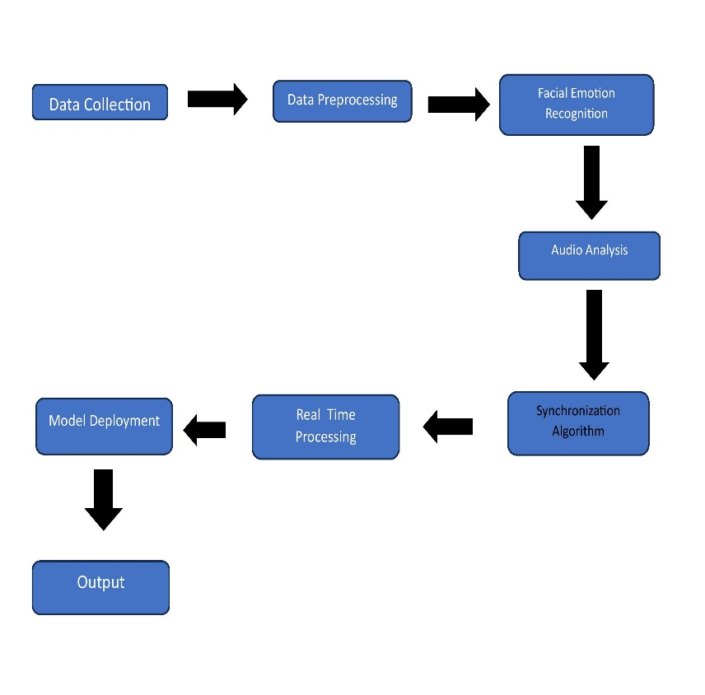

**USE CASE DIAGRAM:**

**Claims**

* It can enhance the immersive experience of virtual reality fitness. It can create personalized playlists based on your emotions during workouts.
* It can create a more personalized and engaging fitness experience by adjusting the music based on your emotions.
* It can help improve motivation and performance during workouts by playing music that matches your mood.
* It can provide valuable data and insights on how different emotions impact your exercise routine.
* It can enhance the overall enjoyment and satisfaction of virtual reality fitness by creating a dynamic and immersive atmosphere.

# Technology used

The technology used in this project often involves computer vision algorithms that analyze facial expressions and emotions. It uses machine learning techniques to detect and interpret facial features such as eyebrows, eyes, mouth, and overall facial expressions. This information is then used to determine the user's emotional state and select appropriate music to enhance their experience.

# Abstract

This project combine Artifical Intelligence and Machine Learning to analyze and interpret facial expressions. By tracking and analyzing the movements and features of the face, such as the eyebrows, eyes, and mouth, this technology can accurately determine the user's emotional state. Based on this analysis, appropriate music is selected to enhance the user's experience. This innovative application has the potential to create more personalized and engaging experiences in various fields, such as virtual reality fitness, where music can be dynamically adjusted to match the user's emotions during workouts. By leveraging the power of technology and music, facial emotion detection with music play opens up exciting possibilities for enhancing user engagement and satisfaction.

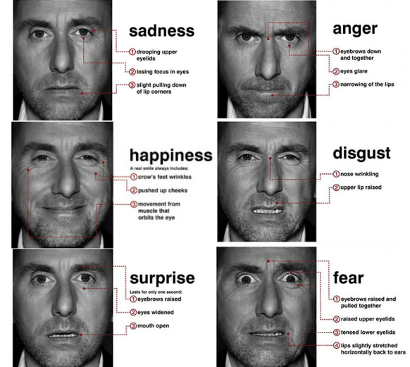

Fig: Different kinds of facial expression

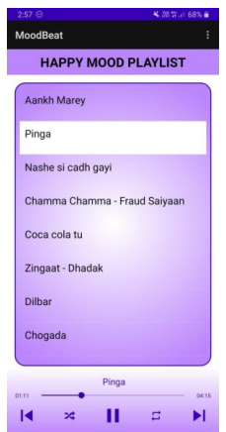

Fig: Playlist for “Happy” mood where a song is being played

**SYSTEM ARCHITECTURE DIAGRAM:**

# End user

The end users in this project can include individuals who are looking for a more immersive and personalized experience in various domains, such as virtual reality fitness, gaming, therapy, and entertainment. It can be beneficial for anyone who wants to enhance their emotional connection with music and create a more engaging and tailored experience.

# Advantages

1. **Emotional Connection:** Deeper emotional connection with music.

2. **Personalization:** Highly personalized music experiences.

3. **Stress Reduction:** Music for stress relief and relaxation.

4. **Productivity Boost:** Enhances focus and motivation.

5. **Entertainment:** Adaptive music for parties and events.

6. **Learning and Therapy:** Supports emotional expression and therapy.

7. **Research Opportunities:** Data for music and emotion research.

8. **Accessibility:** Benefits emotional disabilities.

9. **HCI Innovation:** Advances human-computer interaction.

10. **Commercial Potential:** Business opportunities in personalized entertainment.

# Summary/ Conclusion

It is an exciting project that combines Artificail Intelligence and machine learning to analyze facial expressions and select music based on the user's emotions. By tracking facial features and movements, this technology can accurately determine the user's emotional state and enhance their experience with personalized music. It has potential applications in various fields, such as virtual reality fitness, gaming, therapy, and entertainment. This innovative project aims to create more immersive and engaging experiences by leveraging the power of technology and music.