**Building an Alarm**

Computer Science 207

Ihor Tytarenko

April, 2017

Content:

Introduction

Inspirations

Design Process

Build Process

Setbacks and Failures

Conclusion

References

Introduction:

Project for this class is a compact alarm based on Arduino UNO which is included in “Experimenter’s Kit for Arduino”. Propose of this project is to create laser alarm, with as less additional costs as possible. In best case project would not take any additional money. This aim was reached, project uses only components which are included in the kit and laser pointer.

Unfortunately, only one laser pointer, that was found, was made from metal and it is not possible to break it or take what is inside, so project was changed.

Basic idea is photo resistor, which gives information about brightness in room, and if room is not bright enough trigger starts buzzer. To stop buzzer you have to press 2 buttons in special order. As an example, used easy password (button 1, the button 2 and button 1 again).

Project is not original, so you can find a lot of examples in internet; project wasn’t based on any on them, all sources were used just for understanding principles of all components and how to use them.

As buzzer makes annoying sound, instead of just turning it on, program was changed, so it plays part of “Imperial March”. Example was taken from web source “How to Easily Play Music With Buzzer on Arduino (The Imperial March - STAR WARS) by [eserra](http://www.instructables.com/member/eserra/) in [arduino](http://www.instructables.com/tag/type-id/category-technology/channel-arduino/)” and changed for easier and appropriate use.

Inspirations:

Idea came in class. First it was just something exiting, but after some time it becomes too easy. It was too late to change project, so to make project more special, was made decision to not use much information and side components.

Both “challenges” was reached.

Choice of music for alarm was made by author. “Imperial March” used by author of project in most on times.

Design Process:

Design is simple. There are 4 separate circles, one for photo resistor, 2 for buttons and one for buzzer.

Circles with buttons and photo resistor use 560 Ohms resistors.

Buttons send “1” to digital pins when pressed.

Build Process:

Because project has 4 simple circles it is easy to build and will not makes problem.

Setbacks and Failures:

Biggest problem was with integrating song into program. It has delay, but those delays are very short, so it doesn’t make problem. Second problem was way to interrupt and stop it, because song is too long. Problem was solved by adding arrays. One array has notes, second – delays. To make it easier to read, array was changed from 2D into 3D and uses inside 2 loops.

Second problem was with password. It was not clear where and how to add it. After few tries problem was solved; and become even better than first idea, as now it uses function. Function use variable state, which shows step of entering password, after that read information from buttons pins and change state value needed. After all, function sends value back.

All other problems were small problems which appear by mistakes of build and there is no need to tell about them.

Conclusion:

Alarm is easy project for anybody even with lack of experience. Unfortunately first propose off project, which is using as an alarm, wasn’t reached, because needed laser wasn’t found, but it might be used with other aim. As an example, because it is portable, easy to hide, you might use it to surprise you friend, by hiding it in dark room and when light will be turned on it will make unexpected noise.

Project might be easily changed depends on your needs, either with adding new details or just by changing program part. And because, as already said, it is easy to build for everybody, project is good choice for novice, and does not required much knowledge or materials, what will help to understand basics of programing, gadget building and inspire new persons to try new fields.

References:

[1] How to Easily Play Music With Buzzer on Arduino (The Imperial March - STAR WARS), from

<http://www.instructables.com/id/How-to-easily-play-music-with-buzzer-on-arduino-Th/>

## [2] Official Arduino web-site. Button, from

<https://www.arduino.cc/en/tutorial/button>

[3] Official Arduino web-site. Return, from

<https://www.arduino.cc/en/reference/return>

## [4] Official Arduino web-site. Functions, from

<https://www.arduino.cc/en/Reference/FunctionDeclaration>

[5] Official Arduino web-site. Forum, from

<http://forum.arduino.cc/index.php?topic=44438.0>

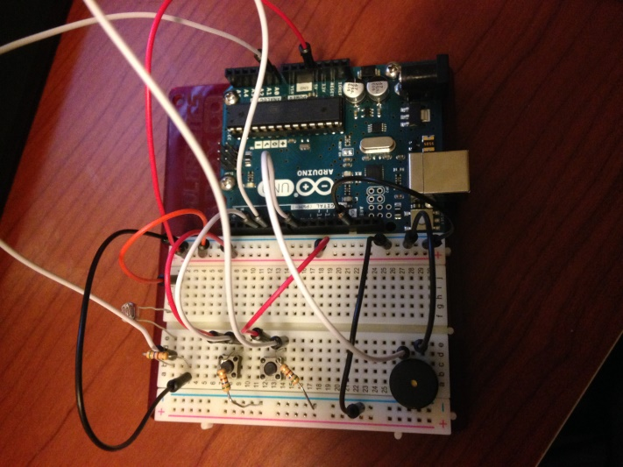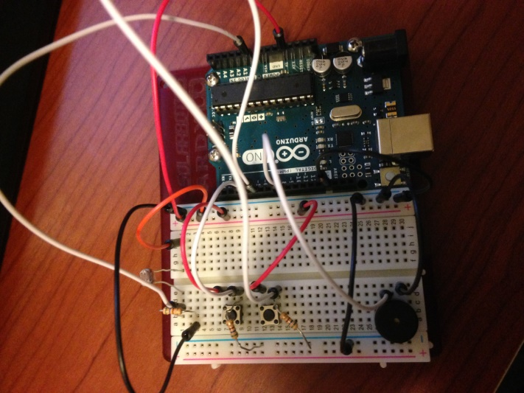

Couple photos of final build