Software Requirements Specification

for

Spa and Salon Management

Version 1.0 approved

Prepared by Ha Thanh Vi

and Le Thi Quynh Nhu

Process Impact

June 18, 2021

Table of Contents

Revision History iii

1. Introduction 1

1.1 Purpose 1

1.2 Document Conventions 1

1.3 Project Scope and Product Features 1

1.4 References 1

2. Overall Description 2

2.1 Product Perspective 2

2.2 User Classes and Characteristics 2

2.3 Operating Environment 3

2.4 Design and Implementation Constraints 3

2.5 Assumptions and Dependencies 3

3. System Features 4

3.1 Manage staff information 5

3.2 Manage customer information 6

3.3 Manage service information 7

3.4 Manage voucher information 8

3.5 Booking service 9

3.6 Payment 11

3.7 View all services 12

3.8 Logout 13

3.9 Register a new account 14

3.10 Login 16

3.11 View schedule 17

3.12 Edit profile 18

3.13 View profile 19

4. Data Requirements 20

4.1 Logical Data Model 20

4.2 Data Dictionary 21

4.3 Reports 22

4.4 Data Integrity, Retention, and Disposal 22

5. External Interface Requirements 23

5.1 User Interfaces 23

5.2 Software Interfaces 23

5.3 Hardware Interfaces 23

5.4 Communications Interfaces 23

6. Quality Attributes 24

6.1 Usability Requirements 24

6.2 Performance Requirements 24

6.3 Security Requirements 24

6.4 Safety Requirements 24

6.5 Availability Requirements 24

6.6 Robustness Requirements 24

Appendix A: Analysis Models 25

Revision History

|  |  |  |  |
| --- | --- | --- | --- |
| **Name** | **Date** | **Reason For Changes** | **Version** |
| Nhu and Vi | 06/15/21 | Add figures, write for 1, 2, 4 | 1.0 draft 1 |
| Nhu and Vi | 06/17/21 | Add figures, write for 5, 6 | 1.0 draft 2 |
| Nhu and Vi | 06/24/21 | Add figures, write for 3 | 1.0 approved |

# Introduction

## Purpose

This SRS describes the functional and nonfunctional requirements for software release 1.0 of the Spa and Salon Management. This document is intended to be used by the members of the project team who will implement and verify the correct functioning of the system. Unless otherwise noted, all requirements specified here are committed for release 1.0.

## Document Conventions

No special typographical conventions are used in this SRS.

## Project Scope and Product Features

Since ancient times, people have known beauty. At first, natural herbal treatments were rudimentary and outdated. Now a day, people's beauty needs are more and more popular and widespread. As society develops, environmental pollution becomes more and more serious, affecting the environment making each of us seem to age over time. And work to strengthen our youth. is one of the important and urgent issues that we humans need to pay attention to and focus on. Therefore, the current special requirement is to have a modern and suitable care center for everyone. Based on that need, the "Spa and Salon" center was born. With the desire to bring beauty to everyone and partially meet everyone's relaxation needs Spa and Salon Management System is an online system that the staff and management can manage management works.

Building a system management application to help manage Spa and Salon. Manage staff at spas and beauty salons effectively, saving a lot of time and costs. The management of customer information is more convenient, customer information is more secure, and it is easy to contact customers. Manage service orders, conveniently and help the store achieve more revenue.

## References

# Overall Description

## Product Perspective

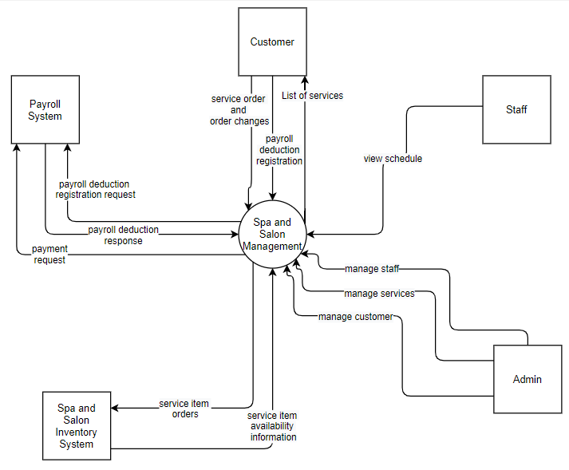

Figure 1. Context diagram for release 1.0 of the Spa and Salon Management.

## User Classes and Characteristics

|  |  |
| --- | --- |
| Staffs | Save more time and effort in store management, customer management. Increasing the working capacity of employees, the management will become lighter, ensuring the target progress of the store. |
| Customers | Booking an appointment also becomes faster and more convenient. Save more time in searching and selecting. |
| Inventory management | Save a lot of time in inventory management, easily check out items in the store |
| Manage spa and salon stores | Helping Spa and Salon save a lot of costs on personnel, staff, save time in managing Spa and Salon stores. Increase the store's profitability even more. |

## Operating Environment

OE-1: The Spa and Salon Management shall operate correctly with the following web browsers: Windows Internet Explorer versions 7, 8, and 9; Firefox versions 12 through 26; Google Chrome (all versions); and Apple Safari versions 4.0 through 8.0.

OE-2: The Spa and Salon Management shall operate on a server running the current corporate-approved versions of Red Hat Linux and Apache HTTP Server.

OE-3: The Spa and Salon Management shall permit user access from the corporate Intranet, from a VPN Internet connection, and by Android, iOS, and Windows smartphones and tablets.

## Design and Implementation Constraints

CO-1: The system’s design, code, and maintenance documentation shall conform to the Process Impact Intranet Development Standard, Version 1.3 [2].

CO-2: The system shall use the current corporate standard Oracle database engine.

CO-3: All HTML code shall conform to the HTML 5.0 standard.

## Assumptions and Dependencies

AS-1: The Spa and Salon is open for days in which customer are expected to be on site.

DE-1: The operation of the Spa and Salon Management depends on changes being made in the Spa and Salon Inventory System to update the availability of services as Spa and Salon Management accepts service orders.

# System Features

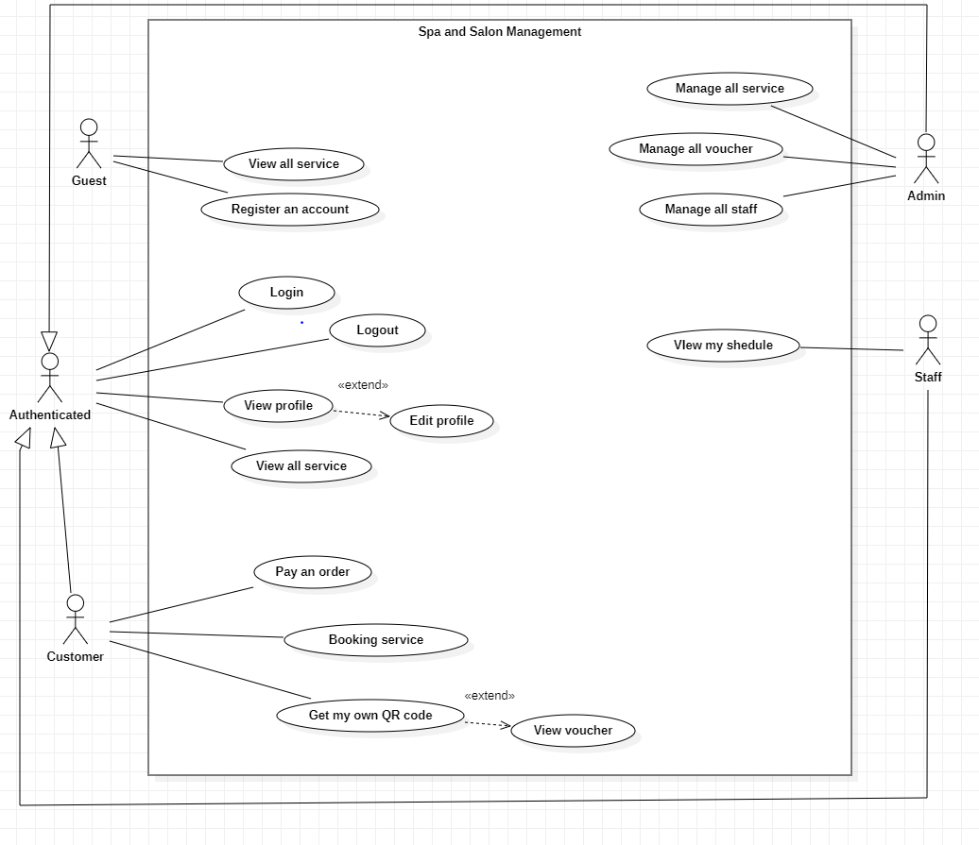

## Manage staff information

|  |  |  |  |
| --- | --- | --- | --- |
| ID and Name: | **UC-1 Manage all staff** | | |
| Created By: | Thanh Vi | Date Created: | 30/05/2021 |
| Primary Actor: | Admin | Secondary Actors: | Spa and Salon Management System |
| Description: | The administrator enters the information of the staff into the system, and can delete any staff if this staff is not working at the store, can create work schedules for staffs, change work schedules for staffs. | | |
| Trigger: | The administrator wants to manage the staff in the store. | | |
| Preconditions: | The administrator is required to log in to the system. | | |
| Postconditions: | POST-1. List the staff available in the store.  POST-2. Remove unnecessary staff.  POST-3. Create work schedules for staff.  POST-4. Update word schedule for staff. | | |
| Normal Flow: | **1.0 List the staff available in the store.**   1. The admin clicks on button “Create new staff”. 2. System response to admin Create new staff page. 3. The admin just enter position and nameID for staff. 4. Click on “Save” to save data. 5. System show message “Create successfully”. 6. **Delete staff.** 7. Admin select the staff to delete. 8. Click on button “Delete” to delete this staff. 9. System response the screen 1 message warning “Are you sure to delete this staff” 10. Admin need to confirm this message. (YES-NO) 11. The system will remove that staff from the staff list.   **3.0 Create work schedules for staff.**   1. Admin select this staff to create work schedule. 2. Admin click on button “Create schedule for staff”. 3. System will return page to fill out the create work schedule information page. 4. Admin enter work schedule information for staff. 5. Click on button “Save” to save work schedule information.   **4.0 Update work schedules for staff.**   1. Admin select this staff to update work schedule. 2. Admin click on button “Update schedule for staff”. 3. Admin change work schedule information for staff. 4. Click on button “Save” to save work schedule information. | | |
| Alternative Flows: | None | | |
| Exceptions: | Send message to admin when add new staff but duplicate ID staff. | | |
| Priority: | High | | |
| Frequency of Use: | Approximately one user, average of one usage in one month. | | |
| Business Rules: | When add new staff, do not add duplicate staff ID.  When update a staff do not update duplicate staff ID.  Only 1 account can be created at a time. | | |
| Other Information: | None | | |
| Assumptions: | None | | |

## Manage customer information

|  |  |  |  |
| --- | --- | --- | --- |
| ID and Name: | **UC- 2 Manage all customer** | | |
| Created By: | Thanh Vi | Date Created: | 01/06/2021 |
| Primary Actor: | Admin | Secondary Actors: | Spa and Salon Management System |
| Description: | The administrator wants to manage the customer in the store more conveniently and efficiently. Customer classification according to points accumulated, looking out at the store VIP customers. | | |
| Trigger: | The administrator wants to manage the customers in the store. | | |
| Preconditions: | The administrator is required to log in to the system. | | |
| Postconditions: | POST-1: Customer classification according to points.  POST-2: Contact customers quickly.  POST-3: View history booking. | | |
| Normal Flow: | * 1. **Contact customers quickly**   1. View profile information of customer.   1. After reviewing customer information, you can contact the customer based on the information stored on the system. 2. The system will rely on the information provided by the customer, and will notify the customer with a reminder message before coming to the appointment to book the service.    1. **View history booking.** 3. Administrators can view the customer's booking history by clicking the button "View history booking". 4. The system will return a list booking history. 5. Based on that, the system will store and classify potential customers. | | |
| Alternative Flows: | None | | |
| Exceptions: | System response message when admin edit customer information.  System response message when admin edit points accumulated of customer. | | |
| Priority: | Medium | | |
| Frequency of Use: | Approximately 1 user, average of one usage in year. | | |
| Business Rules: | 1. Information in booking history cannot be edit. 2. Do not delete the data of customer information. | | |
| Other Information: | None | | |
| Assumptions: | None | | |

## Manage services information

|  |  |  |  |
| --- | --- | --- | --- |
| ID and Name: | **UC-3 Manage all service** | | |
| Created By: | Thanh Vi | Date Created: | 29/05/2021 |
| Primary Actor: | Admin | Secondary Actors: | Spa and Salon Management System |
| Description: | The administrator enters the specific information of the service into the system, can update the service's data, and can delete any service if it is not needed for the store. | | |
| Trigger: | The administrator wants to manage the service in the store. | | |
| Preconditions: | The administrator is required to log in to the system. | | |
| Postconditions: | POST-1. List the services available in the store.  POST-2. Update service details.  POST-3. Remove unnecessary services. | | |
| Normal Flow: | **1.0 List the services available in the store.**   1. Admin click on button “Add new service”. 2. System will return a page to fill out the add new service information page. 3. Admin enter service details. 4. Click on button “Save” to save service information. 5. **Update service details.** 6. Admin click on button “Update a service”. 7. System show all list service. 8. Admin select the service to update. 9. System will return a page to fill out the update a service information page. 10. Admin change update service information. 11. Click on button “Save” to save service information.   **3.0 Delete service.**   1. Admin select the service to delete. 2. Admin click on button “Delete” to delete this service. 3. The system will remove that service from the service list. | | |
| Alternative Flows: | None | | |
| Exceptions: | Send message to admin when add new service but duplicate ID service.  Send message to admin when enter the service price as a negative number. | | |
| Priority: | High | | |
| Frequency of Use: | Approximately one user, average of one usage in one month. | | |
| Business Rules: | When add new service, do not add duplicate service ID.  When update a service, do not update duplicate service ID. | | |
| Other Information: | None | | |
| Assumptions: | None | | |

## Manage voucher information

|  |  |  |  |
| --- | --- | --- | --- |
| ID and Name: | **UC-4 Manage all voucher** | | |
| Created By: | Thanh Vi | Date Created: | 29/5/2021 |
| Primary Actor: | Admin | Secondary Actors: | Spa and Salon Management System |
| Description: | The administrator enters the specific information of the voucher into the system, can update the voucher’s data, and can delete any voucher if it is not needed for the store. | | |
| Trigger: | The administrator wants to manage the voucher in the store. | | |
| Preconditions: | The administrator is required to log in to the system. | | |
| Postconditions: | POST-1. List the vouchers available in the store.  POST-2. Update voucher details.  POST-3. Remove unnecessary vouchers. | | |
| Normal Flow: | **1.0 List the vouchers available in the store.**   1. Admin click on button “Add new voucher”. 2. System will return page to fill out the add new voucher information page. 3. Admin enter voucher details. 4. Click on button “Save” to save voucher information. 5. **Update voucher details.** 6. Admin select the voucher to update. 7. Admin click on button “Update a voucher”. 8. System will return page to change voucher information. 9. Admin change update voucher information. 10. Click on button “Save” to save voucher information.   **3.0 Delete voucher.**   1. Admin select the voucher to delete. 2. Admin click on button “Delete” to delete this voucher. 3. The system will remove that voucher from the voucher list. | | |
| Alternative Flows: | None | | |
| Exceptions: | Send message to admin when add new voucher but duplicate ID voucher. | | |
| Priority: | High | | |
| Business Rules: | When add new voucher do not add duplicate voucher ID.  When update a voucher, do not update duplicate voucher ID. | | |
| Other Information: | None | | |
| Assumptions: | None | | |

## Booking service

|  |  |  |  |
| --- | --- | --- | --- |
| ID and Name: | **UC-5 Booking service** | | |
| Created By: | Quynh Nhu | Date Created: | 02/06/2021 |
| Primary Actor: | Customer | Secondary Actors: | Spa and Salon Management System |
| Description: | This use case allows customer to order services. | | |
| Trigger: | In service detail screen:   * Select times of service. * Click “Order” button. | | |
| Preconditions: | - Customer must login into the system.  - Service is still available. | | |
| Postconditions: | Success: New order will be added, service time will be balanced.  Fail: Show error message. | | |
| Normal Flow: | 1. Customer selects time of service and then clicks “Order” button.   - Redirect to PayPal payment website. (Reference Payment Use case).  - Insert order to database and change the quantity of service time. In case service time quantity is running out, no order will be added and redirect to apologize page.  - Redirect to confirm page which contains:  - “Service name”: label.  - “Service time”: label.  - “Service experts”: label.  - “Price”: label.  - “Total”: label.  - “Phone”: label.  - “Cancel”: button.  - “Pay”: button.  - Countdown message: 15 minutes. After 15 minutes, order state will set to cancel and service time quantity will be balanced in database.   1. Customer clicks “Pay” button.   - Order state will be changed to complete in database.  - Redirect to “Thank You” page which contains order information:  + “Service name”: label.  + “Service time”: label.  + “Service experts”: label.  + “Price”: label.  + “Total”: label.  + “Phone”: label.  + “Print Invoice”: button.  + “Back to Home Page”: button.   1. Customer clicks “Print Invoice” button.   Generate order history’s file to download.   1. Member clicks “Cancel” button.   Order state will set to cancel and service time quantity will be balanced in database. Redirect to main page.   1. Customer clicks “Back to Home Page” button.   Redirect to main page. | | |
| Alternative Flows: | N/A. | | |
| Exceptions: | 1. Customer account balances lower than total amount.  - Redirect to PayPal page.  2. Value of “Service Time” field is greater than remaining service time.  - System shows error message: “Over the time remaining”.  3. Value of “Service Time” field is less than 30 minutes.  - System shows error message: “Service time cannot be under 30 minutes”.  4. “Service Time” field is empty.  - System shows error message: “Service time cannot be empty”. | | |
| Priority: | High | | |
| Frequency of Use: |  | | |
| Business Rules: | - When an order is made, service time available quantity will be decreased by the time serving of order.  - When an order state is changed to cancel, service available time will be increased by the time serving of order (reverted) | | |
| Other Information: | N/A. | | |
| Assumptions: | N/A. | | |

## Payment

|  |  |  |  |
| --- | --- | --- | --- |
| ID and Name: | **UC-6 Payment** | | |
| Created By: | Quynh Nhu | Date Created: | 02/06/2021 |
| Primary Actor: | Customer | Secondary Actors: | Spa and Salon Management System |
| Description: | This use case allows customer to pay for his/her booking. | | |
| Trigger: | In service detail screen:   * Select times of service. * Click “Pay” button. | | |
| Preconditions: | - Customer must login into the system. | | |
| Postconditions: | Success: Redirect to confirm for booking page.  Fail: Show error message. | | |
| Normal Flow: | 1. Customer inputs username, password and then clicks “Login” button.   Redirect to PayPal website for payment which contains:  - Order list.  - Login panel.  Order list displays information of booking:  - Event name: label.  - Service time quantity: label.  - Subtotal: label.  - Total: label.  Login panel contains:  - Username: textbox.  - Password: textbox.  - Login: button.   1. Customer reviews billing information and clicks “Continue” button.   Redirect to confirm page to continue booking process.   1. Member clicks “Cancel” link.   Redirect to the Home Page. | | |
| Alternative Flows: | N/A. | | |
| Exceptions: | 1. Service is sold out.  - Redirect to out of stock error page. | | |
| Priority: | High | | |
| Frequency of Use: |  | | |
| Business Rules: | - PayPal system will handle the process of login and money transfer.  - This payment uses express checkout method from PayPal | | |
| Other Information: | N/A. | | |
| Assumptions: | N/A. | | |

## View all services

|  |  |  |  |
| --- | --- | --- | --- |
| ID and Name: | **UC-7 View all services** | | |
| Created By: | Quynh Nhu | Date Created: | 02/06/2021 |
| Primary Actor: | Customer | Secondary Actors: | Spa and Salon Management System |
| Description: | This use case allows customer to view all available services. | | |
| Trigger: | Customer touches tab “Services” to view the list of available services. | | |
| Preconditions: | Customer must login into the system. | | |
| Postconditions: | Success: Show list of all available services.  Fail: Show error message. | | |
| Normal Flow: | 1. Customer touches tab “Services” to view the list of available services.   Show list of services as a grid which shows the following information:  - “Service Name”: label.  - “Timeserving”: label.  - “Price”: label. | | |
| Alternative Flows: | N/A. | | |
| Exceptions: | 1. Connect to database fail.  - System shows error message: “Cannot connect to database. Reload the page”.  2. Time out when connect to server.  - System shows error message: “Time out connecting”. | | |
| Priority: | High | | |
| Frequency of Use: |  | | |
| Business Rules: | - List of services are always gotten from database.  - When having internet connection, Sync happens to synchronize mobile database and server database.  - List of services are sorted by nomination level.  - Search bar on the top and fast scroll bar on the right help user finding services faster.  - Services’ details can update information when the owner of it updates their information. | | |
| Other Information: | N/A. | | |
| Assumptions: | N/A. | | |

## Logout

|  |  |  |  |
| --- | --- | --- | --- |
| ID and Name: | **UC-8 Logout** | | |
| Created By: | Quynh Nhu | Date Created: | 02/06/2021 |
| Primary Actor: | Authenticated User | Secondary Actors: | Spa and Salon Management System |
| Description: | This use case allows authenticated user to log out of the system. | | |
| Trigger: | Authenticated User clicks on “Logout” link. | | |
| Preconditions: | User is an authenticated user. | | |
| Postconditions: | Success: Authenticated user log out of the system.  Fail: Do nothing. | | |
| Normal Flow: | Authenticated User clicks on “Logout” link.   1. Clear session and log user out of the system. 2. Navigate to home page. | | |
| Alternative Flows: | N/A. | | |
| Exceptions: | N/A. | | |
| Priority: | Medium | | |
| Frequency of Use: |  | | |
| Business Rules: | After log out process, user will be navigated to home page regardless of which role user is. | | |
| Other Information: | N/A. | | |
| Assumptions: | N/A. | | |

## Register a new account

|  |  |  |  |
| --- | --- | --- | --- |
| ID and Name: | **UC-9 Register an account** | | |
| Created By: | Quynh Nhu | Date Created: | 02/06/2021 |
| Primary Actor: | Guest | Secondary Actors: | Spa and Salon Management System |
| Description: | This use case allows guest to register an account in the system. | | |
| Trigger: | Guest clicks “Register” link | | |
| Preconditions: | N/A. | | |
| Postconditions: | Success: Insert new account in the database.  Fail: Show error message. | | |
| Normal Flow: | 1. Guest clicks “Register” link.   Navigate to register page which contains:  - “Account”: textbox, required, min length: 6, max length: 20.  - “Password”: password, required, min length: 6, max length: 20.  - “Confirm Password”: password, required, min length: 6, max length: 20.  - “Email”: textbox, required, email, max length: 50.  - “Name”: textbox, required, max length: 50.  - “Sex”: radio button.  - “Date of Birth”: datetime picker.  - “Phone Number”: textbox, required, cell phone number.  - “Clear”: button clears form fields when click.  - “Register”: button.   1. Guest inputs information and clicks “Register” button.   - Insert new member account into the database.  - Send a message contains active code.  - Redirect user to verify account page. | | |
| Alternative Flows: | N/A. | | |
| Exceptions: | 1. “Account” is empty.  * System shows error message: “Have not input account name”.  1. Length of “Account” is under 6 characters.  * System shows error message: “At least 6 characters”.  1. Length of “Account” length is over 20 characters.  * System shows error message: “Maximum 20 characters”.  1. Value of “Account” has already existed.  * System shows error message: “Account has been registered”.  1. “Password” is empty.  * System shows error message: “Have not input password”.  1. Length of “Password” is under 6 characters.  * System shows error message: “At least 6 characters”.  1. Length of “Password” length is over 20 characters.  * System shows error message: “Maximum 20 characters”.  1. “Confirm Password” is empty.  * System shows error message: “Have not confirm password”.  1. Value of “Confirm Password” is different to “Password”.  * System shows error message: “Password does not match”.  1. “Email” is empty.  * System shows error message: “Have not input email”.  1. Length of “Email” length is over 50 characters.  * System shows error message: “Maximum 50 characters”.  1. “Name” is empty.  * System shows error message: “Have not input name”.  1. Length of “Name” length is over 50 characters.  * System shows error message: “Maximum 50 characters”.  1. “Phone Number” is empty.  * System shows error message: “Have not input phone number”.  1. Value of “Phone Number” is in wrong format.  * System shows error message: “Format: +84XXXXXXXXXX”. | | |
| Priority: | Medium | | |
| Frequency of Use: |  | | |
| Business Rules: | - After registered, customer account will be in deactivate state until member enter the verify code which sent to his/her cell phone.  - Verify code is a 4 characters code auto generated by system.  - After 3 days from registration, member account will be removed if it hadn’t been activated | | |
| Other Information: | N/A. | | |
| Assumptions: | N/A. | | |

## Login

|  |  |  |  |
| --- | --- | --- | --- |
| ID and Name: | **UC-10 Login** | | |
| Created By: | Quynh Nhu | Date Created: | 02/06/2021 |
| Primary Actor: | Guest | Secondary Actors: | Spa and Salon Management System |
| Description: | This use case allows guest to login into system. | | |
| Trigger: | Guest clicks “Login” link. | | |
| Preconditions: | Guest has not logged in the system. | | |
| Postconditions: | Success: User logged and redirect to appropriate page.  Fail: Show error message | | |
| Normal Flow: | 1. Guest clicks “Login” link.   Navigate to login page which contains:  - “Account”: textbox, required.  - “Password”: password, required.  - “Login”: button   1. Guest inputs information and clicks “Login” button.   Authentication and authorization.  - If guest is customer, navigate to home page.  - If guest is staff, navigate to staff dash board.  - If guest is admin, navigate to admin dash board. | | |
| Alternative Flows: | N/A. | | |
| Exceptions: | 1. “Account” is empty.  * System shows error message: “Have not input account name”.  1. “Password” is empty.  * System shows error message: “Have not input password”.  1. Account is deactivated.  * System shows error message: “Your account has been deactivated”.  1. Account has not been activated.  * System shows error message: “Your account has not been activated”. | | |
| Priority: | Medium | | |
| Frequency of Use: |  | | |
| Business Rules: | - Logged in account’ expire duration is 2 hours.  - Only active account can login into the system | | |
| Other Information: | N/A. | | |
| Assumptions: | N/A. | | |

## View schedule

|  |  |  |  |
| --- | --- | --- | --- |
| ID and Name: | **UC-11 View schedule** | | |
| Created By: | Thanh Vi | Date Created: | 31/05/2021 |
| Primary Actor: | Staff | Secondary Actors: | Spa and Salon Management System |
| Description: | The staff want to view 1-week work schedule to come to work on time and achieve high efficiency in work. | | |
| Trigger: | The staff view schedule. | | |
| Preconditions: | The staff is required to log in to the system. | | |
| Postconditions: | POST-1 View schedule | | |
| Normal Flow: | 1. **View schedule** 2. The staff click on “View schedule” 3. This schedule is show them. | | |
| Alternative Flows: | None | | |
| Exceptions: |  | | |
| Priority: | Medium | | |
| Frequency of Use: | Approximately 50 user, average of many usage in one week. | | |
| Business Rules: | When view work schedule, the staff can not edit work schedule.  When view work schedule, the staff can not delete work schedule. | | |
| Other Information: | None | | |
| Assumptions: | None | | |

## Edit profile

|  |  |  |  |
| --- | --- | --- | --- |
| ID and Name: | **UC-12 Edit profile** | | |
| Created By: | Thanh Vi | Date Created: | 31/05/2021 |
| Primary Actor: | Authenticated | Secondary Actors: | Spa and Salon Management System |
| Description: | The authenticated want to edit profile’s information. | | |
| Trigger: | The authenticated edit profile. | | |
| Preconditions: | The authenticated is required to log in to the system. | | |
| Postconditions: | POST-1 Edit profile. | | |
| Normal Flow: | **1.0 Edit profile.**   1. The authenticated click on button “Edit profile”. 2. System response profile page, and show for authenticated. 3. The authenticated edit profile’s information. 4. Click on button “Save” to save profile. | | |
| Alternative Flows: | None | | |
| Exceptions: |  | | |
| Priority: | Medium | | |
| Frequency of Use: | Approximately 200 user, average of many usage in one month. | | |
| Business Rules: | Profile information do not empty. | | |
| Other Information: | None | | |
| Assumptions: | None | | |

## View profile

|  |  |  |  |
| --- | --- | --- | --- |
| ID and Name: | **UC-13 View profile** | | |
| Created By: | Thanh Vi | Date Created: | 30/05/2021 |
| Primary Actor: | Authenticated | Secondary Actors: | Spa and Salon Management System |
| Description: | The authenticated can view their profile. | | |
| Trigger: | The authenticated want to view profile. | | |
| Preconditions: | The administrator is required to log in to the system. | | |
| Postconditions: | POST-1 View profile. | | |
| Normal Flow: | **1.0 View profile.**   1. The authenticated click on button “View profile” 2. System response profile information page. 3. This profile is show them. | | |
| Alternative Flows: | None | | |
| Exceptions: |  | | |
| Priority: | Medium | | |
| Frequency of Use: | Approximately 200 user, average of many usage in one month. | | |
| Business Rules: | Do not view other profile information.  Do not edit other profile information. | | |
| Other Information: | None | | |
| Assumptions: | None | | |

# Data Requirements

## Logical Data Model

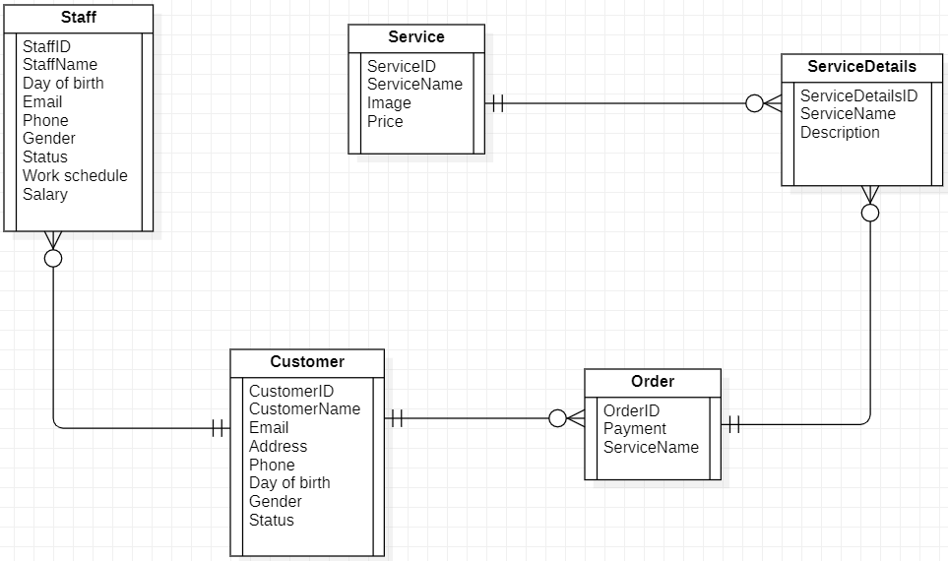

Figure 2. Partial data model for release 1.0 of the Spa and Salon Management.

## Data Dictionary

|  |  |  |  |  |  |  |
| --- | --- | --- | --- | --- | --- | --- |
| Entity | Field Name | Data Type | Filed Length | Constrain | Description | Example |
| Staff | Staff ID | Integer | 10 | Not null | Unit number ID for Staff, auto generated. | ST001 |
| Staff | Staff Name | Nvarchar | 50 | Not null | Name of Staff. | Như |
| Staff | Day of birth | Date | 20 | Not null | DOB of Staff, format date DD/MM/YYYY. | 25/11/2000 |
| Staff | Email | Varchar | 50 | Not null | Email of Staff, format email [xxx@gmail.com](mailto:xxx@gmail.com) | [nhu@gmail.com](mailto:nhu@gmail.com) |
| Staff | Phone | Varchar | 10 | Not null | Phone of Staff. | 0147856932 |
| Staff | Gender | Boolean | 1 | Not null | Gender of Staff. (Male/Female) | Female |
| Staff | Status | Boolean | 1 | Not null | Status of Staff. (On/Off) | On |
| Staff | Work schedule | Varchar | 100 | Not null | Work schedule of Staff | Monday to Friday ( 7h -12h) |
| Staff | Salary | Double | 15 | Not null | Salary of Staff. | 10.000.000 |

|  |  |  |  |  |  |  |
| --- | --- | --- | --- | --- | --- | --- |
| Entity | Field Name | Data Type | Filed Length | Constrain | Description | Example |
| Service | Service ID | Integer | 10 | Not null | Unit number ID for Service, auto generated. | SE001 |
| Service | Service Name | Varchar | 50 | Not null | Name of Service. | Massage body |
| Service | Image | Varchar | 200 | Not null | Link image. | http://spaphuonganh.vn/wp-content/uploads/2020/06/dvc03.jpg |
| Service | Price | Double | 10 | Not null | Price of Service. | 2.000.000 |

|  |  |  |  |  |  |  |
| --- | --- | --- | --- | --- | --- | --- |
| Entity | Field Name | Data Type | Filed Length | Constrain | Description | Example |
| Order | Order ID | Integer | 10 | Not null | Unit number ID for Order, auto generated. | O001 |
| Order | Payment | Varchar | 20 | Not null | A payment can be made in the form of services exchanged, cash, check, wire transfer, credit card, or debit card. | Cash, Debit cards, Credit cards, Momo, PayPal |
| Order | Service Name | Varchar | 50 | Not null | Service Name when order service | Massage body |

|  |  |  |  |  |  |  |
| --- | --- | --- | --- | --- | --- | --- |
| Entity | Field Name | Data Type | Filed Length | Constrain | Description | Example |
| Customer | Customer ID | Integer | 10 | Not null | Unit number ID for Customer, auto generated. | C001 |
| Customer | Customer Name | Nvarchar | 20 | Not null | Name of Customer. | Vi |
| Customer | Email | Varchar | 50 | Not null | Email of Customer, format email [xxx@gmail.com](mailto:xxx@gmail.com) | [vi@gmail.com](mailto:vi@gmail.com) |
| Customer | Address | Nvarchar | 100 | Not null | Address of Customer. | Vinhomes Grand Park, Nguyễn Xiễn, Quận 9. |
| Customer | Phone | Varchar | 10 | Not null | Phone of Customer. | 0852369741 |
| Customer | Day of birth | Date | 20 | Not null | DOB of Customer, format date DD/MM/YYYY. | 22/01/1995 |
| Customer | Gender | Boolean | 1 | Not null | Gender of Customer. (Male/Female) | Female |
| Customer | Status | Boolean | 1 | Not null | Status of Customer. (On/Off) | Online at 1 hours ago |

|  |  |  |  |  |  |  |
| --- | --- | --- | --- | --- | --- | --- |
| Entity | Field Name | Data Type | Filed Length | Constrain | Description | Example |
| Service Details | Details ID | Integer | 10 | Not null | Unit number ID for Service Details, auto generated. | SD001 |
| Service Detail | Description | Nvarchar | 300 | Not null | Specific service description | Massage body benefits can include: Reducing stress and increasing relaxation. Reducing pain and muscle soreness and tension. Improving circulation, energy and alertness. |

## Reports

## Data Integrity, Retention, and Disposal

# External Interface Requirements

## User Interfaces

UI-1: The Spa and Salon Management screen displays shall conform to the *Process Impact Internet Application User Interface Standard*.

UI-2: The system shall provide a help link from each displayed webpage to explain how to use that page.

UI-3: The webpages shall permit complete navigation and service item selection by using

the keyboard alone, in addition to using mouse and keyboard combinations.

## Software Interfaces

SI-1: Spa and Salon Inventory System

SI-1.1: The Spa and Salon Management shall transmit the timeserver ordered to the

Spa and Salon Inventory System through a programmatic interface.

SI-1.2: The Spa and Salon Management shall poll the Spa and Salon Inventory

System to determine whether a requested service item is available.

SI-2: Payroll System

The Spa and Salon Management shall communicate with the Payroll System through

a programmatic interface for the following operations:

SI-2.1: To allow a Customer to register and unregister for payroll deduction.

SI-2.2: To inquire whether a Customer is registered for payroll deduction.

SI-2.3: To inquire whether a Customer is eligible to register for payroll deduction.

SI-2.4: To submit a payment request for a purchased meal.

SI-2.5: To reverse all or part of a previous charge because a Customer rejected an

order or wasn’t satisfied with it.

## Hardware Interfaces

No hardware interfaces have been identified.

## Communications Interfaces

CI-1: The Spa and Salon Management shall send an email or text message (based on user account settings) to the Customer to confirm acceptance of an order, and price.

CI-2: The Spa and Salon Management shall send an email or text message (based on user account settings) to the Customer to report any problems with the service ordered.

# Quality Attributes

## Usability Requirements

USE-1: The Spa and Salon Management shall allow a Customer to retrieve the previous

service ordered with a single interaction.

USE-2: 95% of new users shall be able to successfully order a service without errors on their first try.

## Performance Requirements

PER-1: 95% of webpages generated by The Spa and Salon Management shall download

completely within 4 seconds from the time the user requests the page over a 20Mbps or faster

Internet connection.

PER-2: The system shall display confirmation messages to users within an average of 3

seconds and a maximum of 6 seconds after the user submits information to the system.

## Security Requirements

SEC-1: All network transactions that involve financial information or personally identifiable

information shall be encrypted.

SEC-2: Users shall be required to log on to The Spa and Salon Management for all operations

except viewing list of services.

SEC-3: The system shall permit Customers to view only orders that they placed.

## Safety Requirements

## Availability Requirements

AVL-1: The Spa and Salon Management shall be available at least 98% of the time between

5:00 A.M. and midnight local time and at least 90% of the time between midnight and 5:00

A.M. local time, excluding scheduled maintenance windows.

## Robustness Requirements

ROB-1: If the connection between the user and The Spa and Salon Management is broken

prior to a new order being either confirmed or terminated, The Spa and Salon Management

shall enable the user to recover an incomplete order and continue working on it.

Appendix B: Analysis Models

# Sequence Diagrams

* 1. **View Schedule**

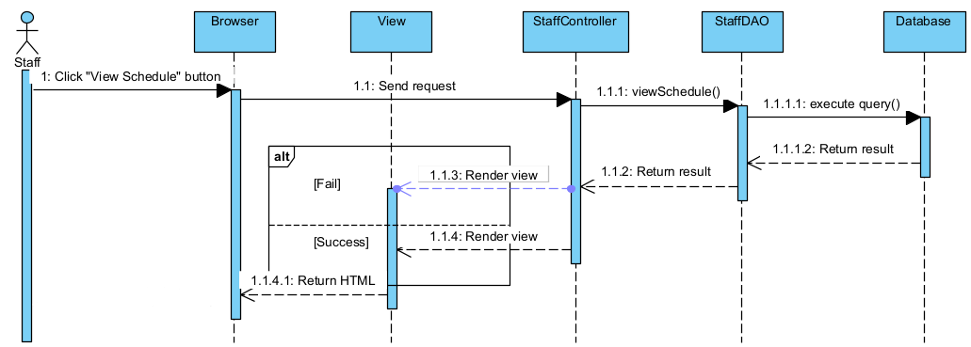

* 1. **Register**

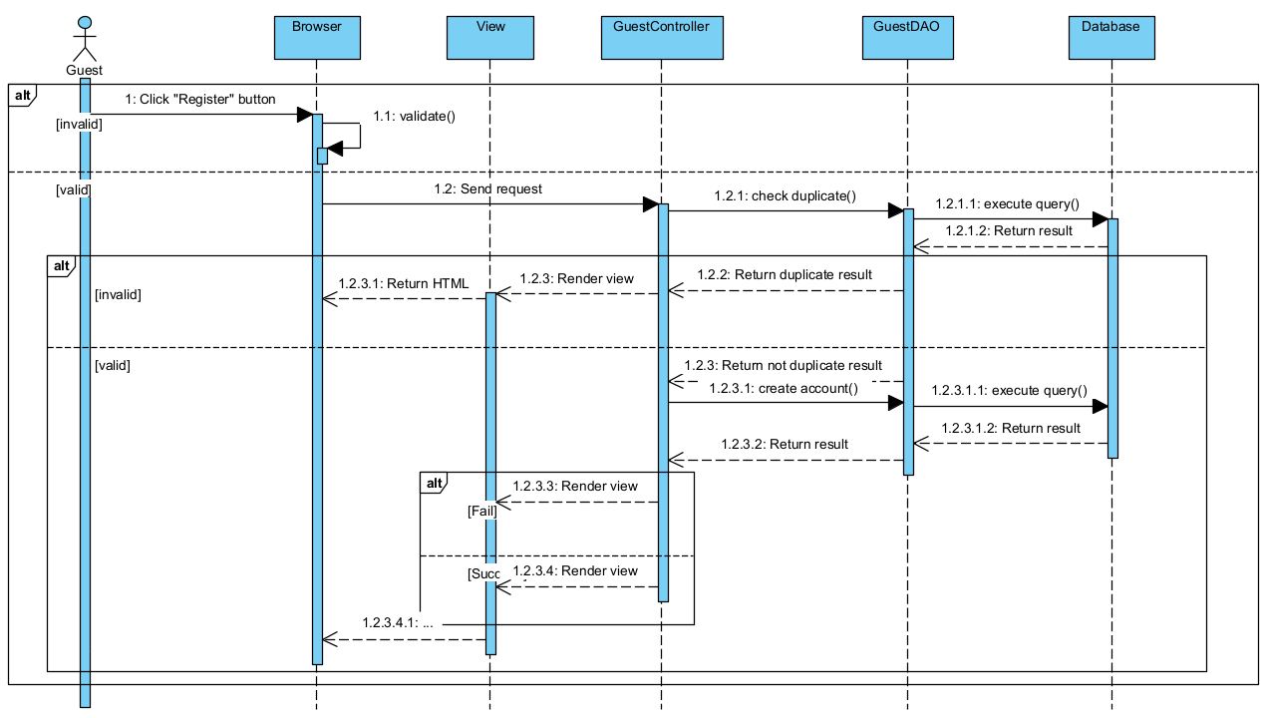

1. **Class Diagrams**
   1. **Register**

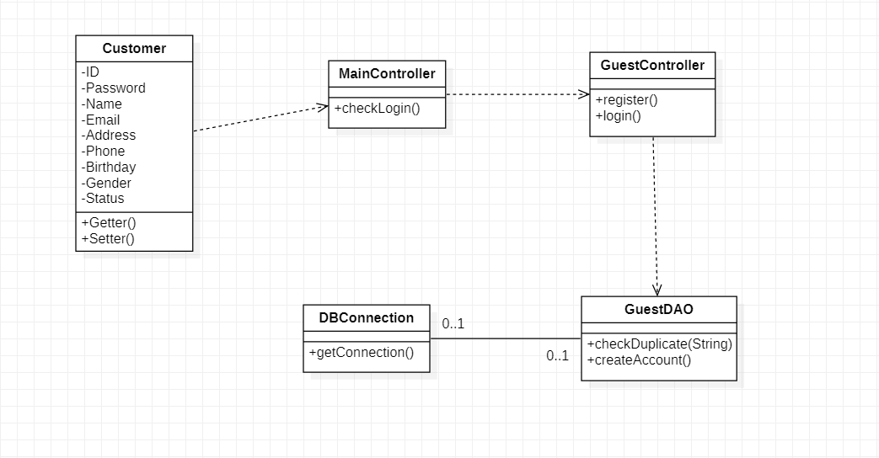

* 1. **View schedule**

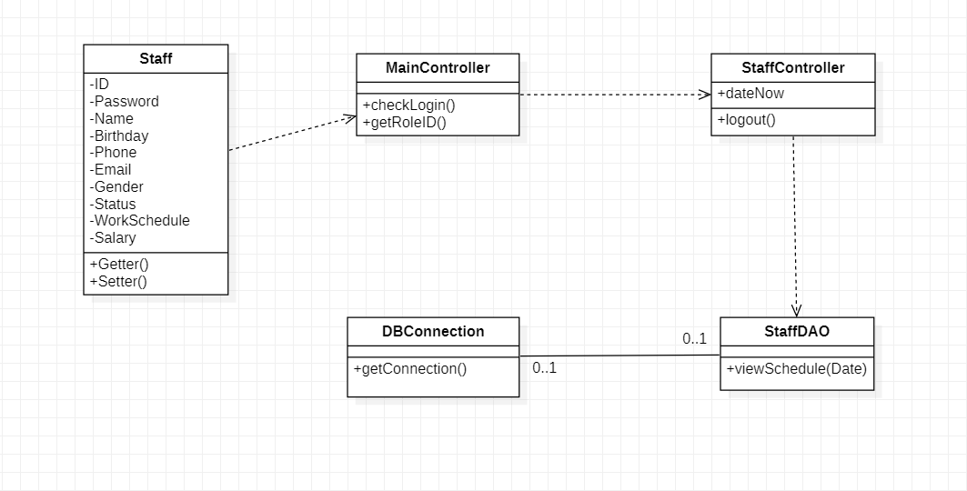

1. **StateChart Diagrams**
   1. **View Schedule**

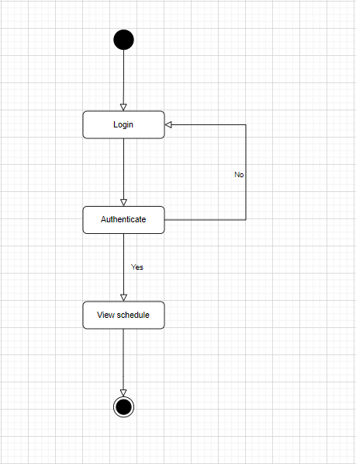

* 1. 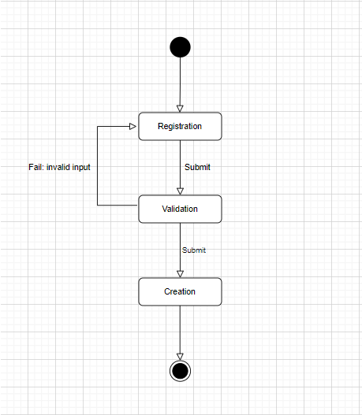**Register new account**