I. Troubleshooting Default Gateway Issues

Addressing Table  


Testing and Verification Documentation  


II. Verifying IPv4 and IPv6 Addressing  


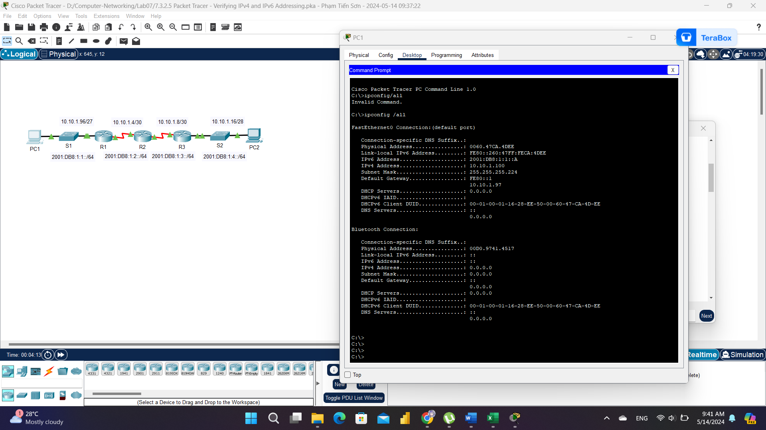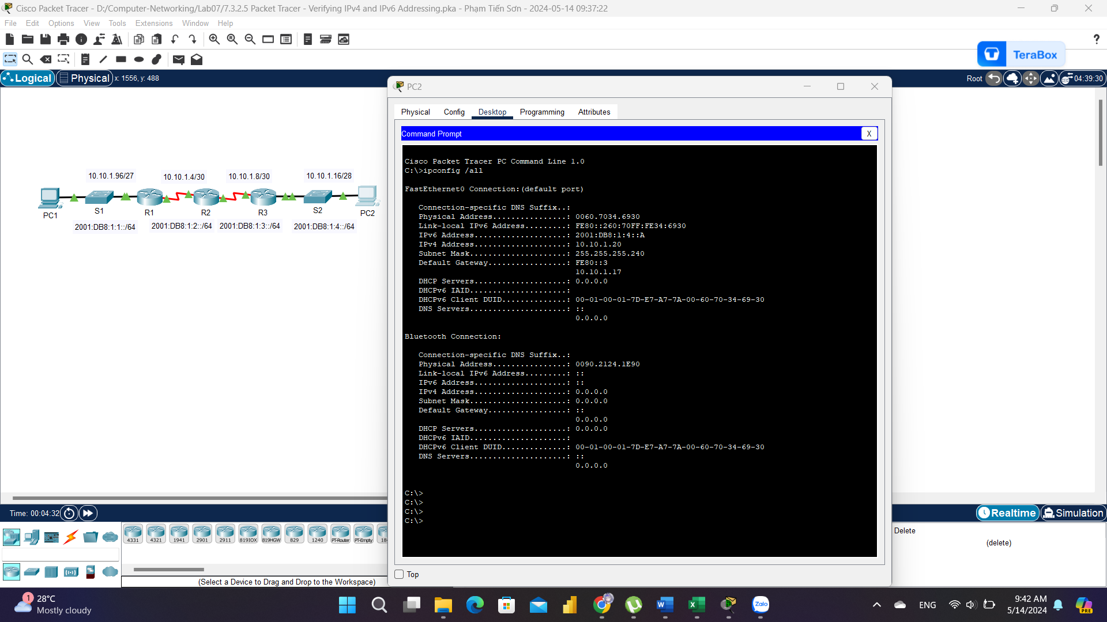  
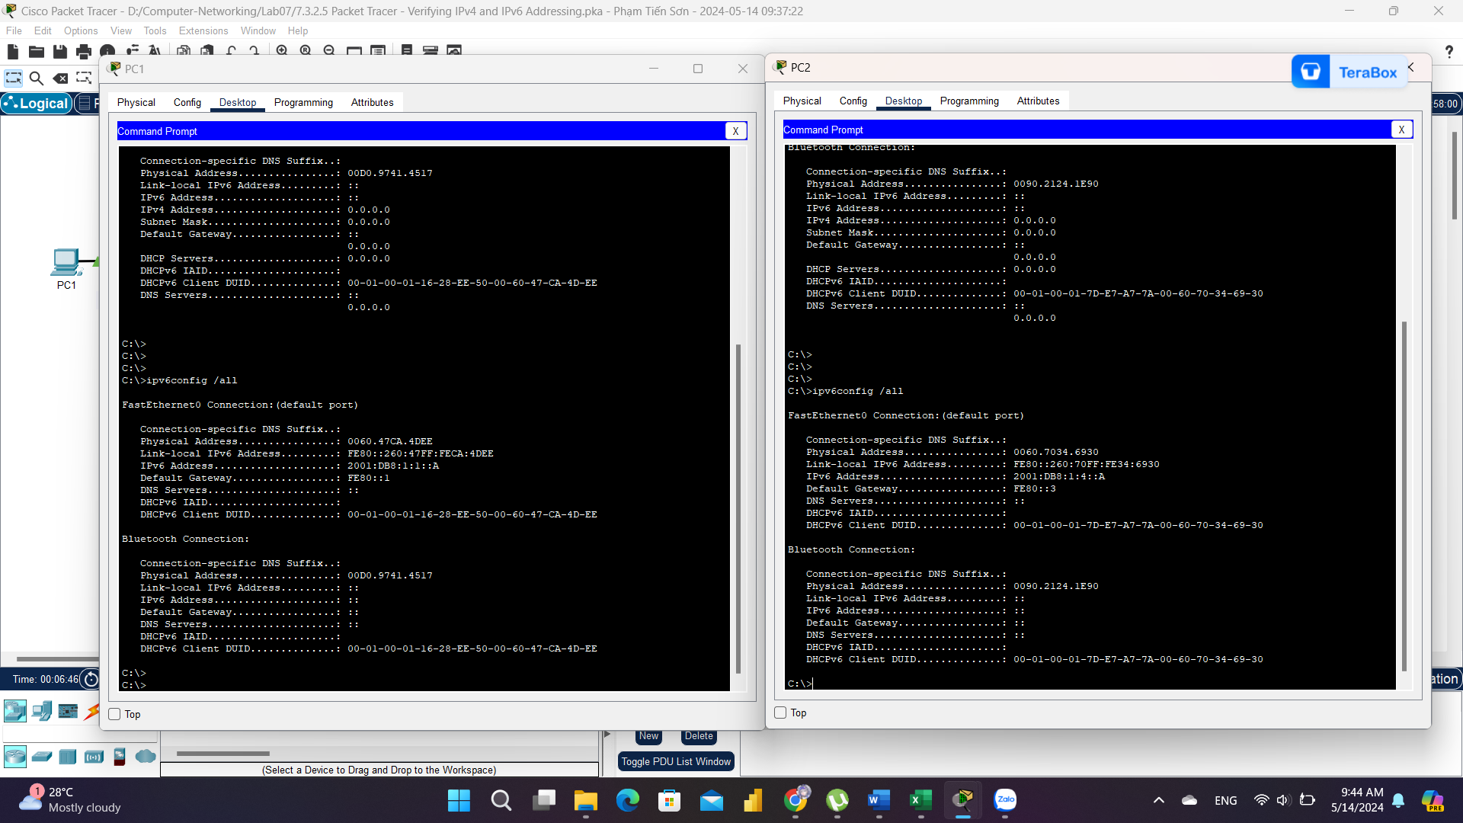

Step 1: Use ping to verify IPv4 connectivity.  
a. From PC1, ping the IPv4 address for PC2. Was the result successful? Thành công

b. From PC2, ping the IPv4 address for PC1. Was the result successful? Thành công

Step 2: Use ping to verify IPv6 connectivity.  
a. From PC1, ping the IPv6 address for PC2. Was the result successful? Thành công

b. From PC2, ping the IPv6 address of PC1. Was the result successful? Thành công  
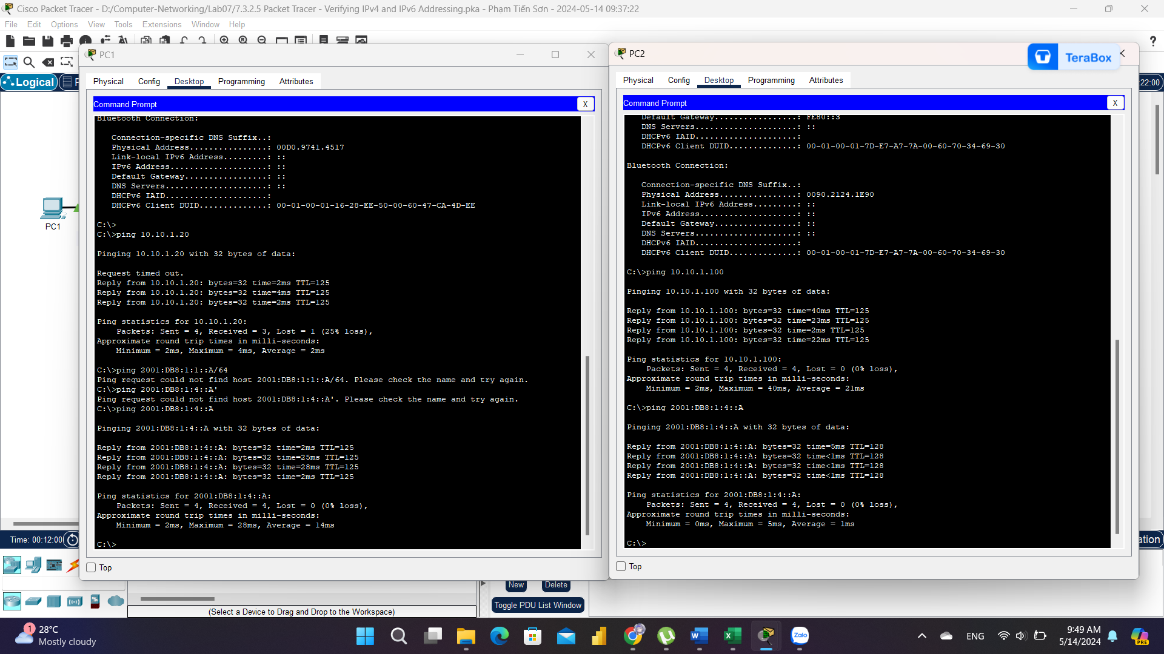  
a. From PC1, trace the route to PC2.  
What addresses were encountered along the path?   
10.10.1.97, 10.10.1.5, 10.10.1.10, 10.10.1.20  
With which interfaces are the four addresses associated?   
G0/0 of R1, S0/0/0 on R2, S0/0/01 on R3, NIC of PC2

b. From PC2, trace the route to PC1.  
What addresses were encountered along the path?   
10.10.1.17, 10.10.1.9, 10.10.1.6, 10.10.1.100

With which interfaces are the four addresses associated?   
G0/0 of R3, S0/0/1 of R2, S0/0/1 of R1, NIC of PC1  
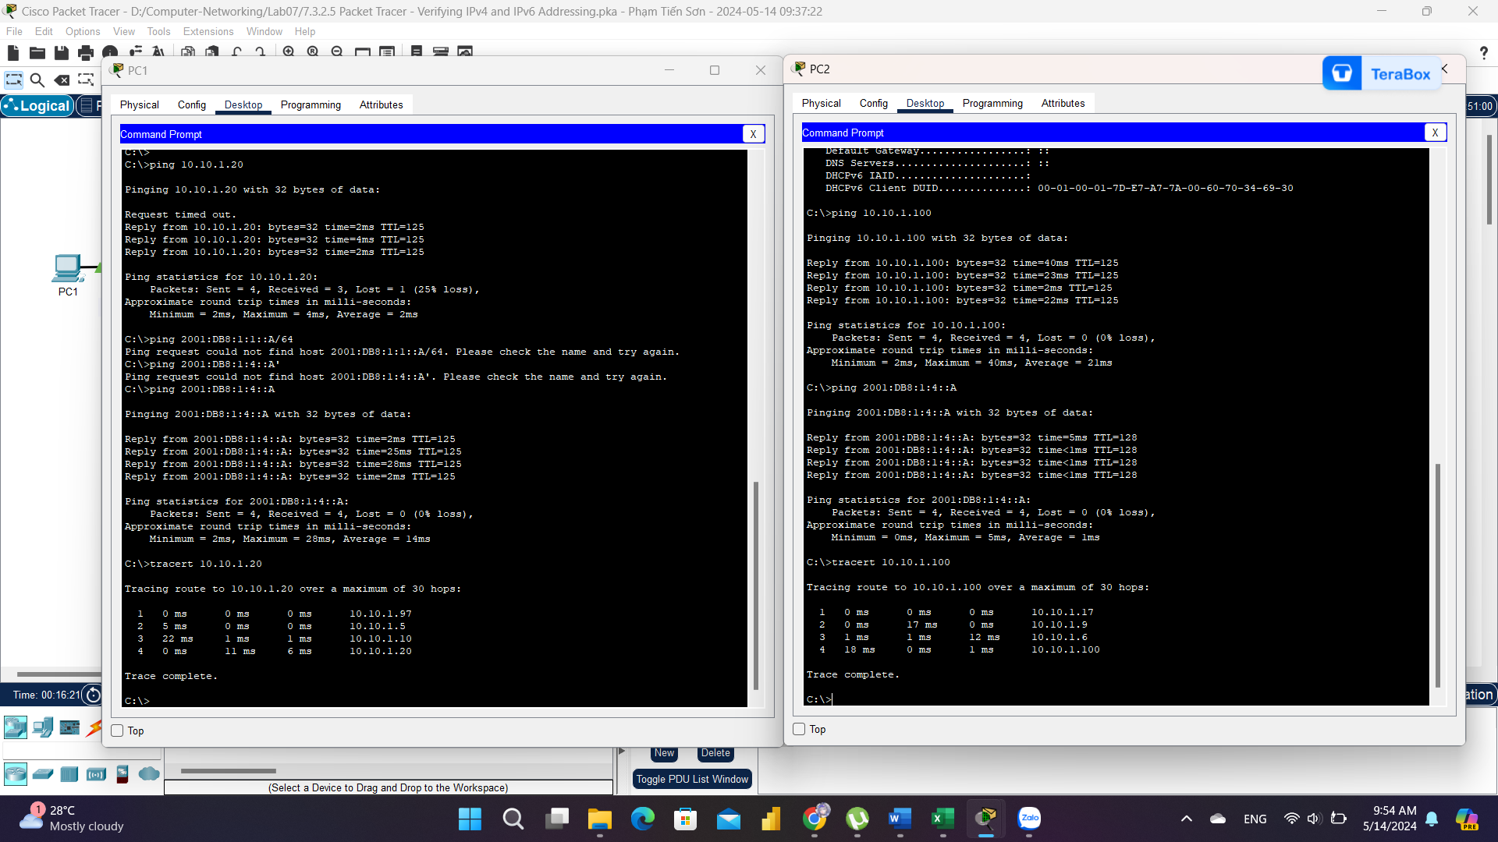

Step 2: Use tracert to discover the IPv6 path.

a. From PC1, trace the route to the IPv6 address for PC2.  
What addresses were encountered along the path? 2001:DB8:1:1::1, 2001:DB8:1:2::1, 2001:DB8:1:3::2, 2001:DB8:1:4::A

With which interfaces are the four addresses associated?   
g0/0 of R1, S0/0/0 of r2, S0/0/1 of R3, NIC of PC2

b. From PC2, trace the route to the IPv6 address for PC1.  
What addresses were encountered along the path? 2001:DB8:1:4::1, 2001:DB8:1:3::1, 2001:DB8:1:2::2, 2001:DB8:1:1::A  
With which interfaces are the four addresses associated? Ga0/0 of R3, S0/0/1 of R2, S0/0/1 of R1, NIC of PC1  
