JSON FILES
Login to SnowSQL
snowsql -a <account_name> -u <username>
Create Database:
Create database Walmart_json;
Create Schema and Stage:
Create schema product_json;
Create stage stage_walmart;
Create Table:
Create or replace table customer_json(raw variant);
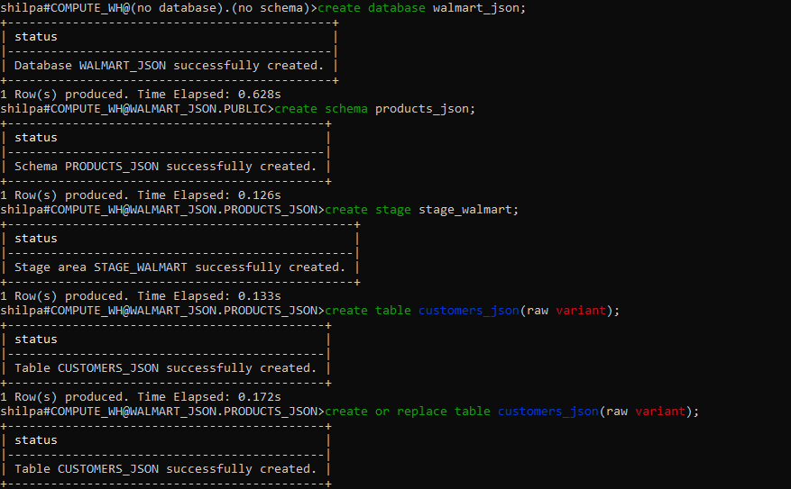
Create File Format:
Create or replace file format FF_JSON_FLAT
type ='JSON'
STRIP_OUTER_ARRAY =FLASE;

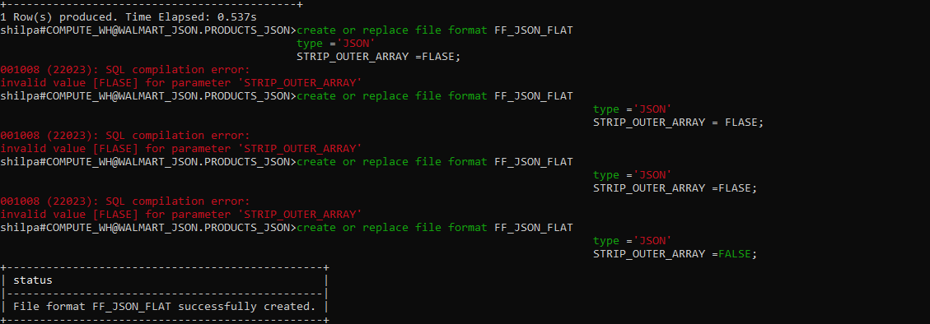
Upload JSON File
PUT 'FILE://C:/Users/Admin/Downloads/snowsql.json' @stage_walmart;
Copy Data into Table
copy into customer_json from @stage_walmart/snowsql.json
FILE_FORMAT=(FORMAt_NAME ='FF_JSON_FLAT');
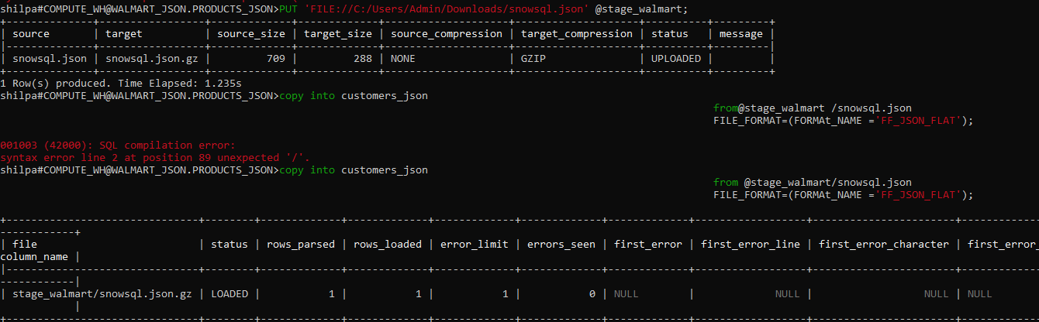
Verify Data
Select * from customer_json;
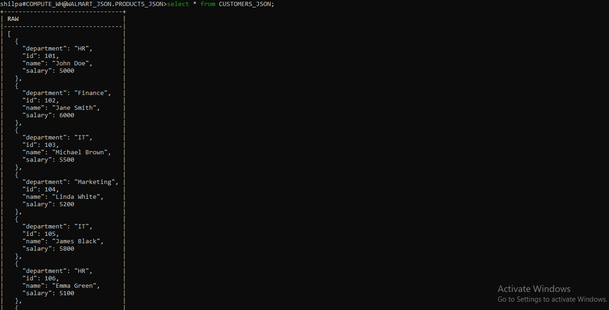
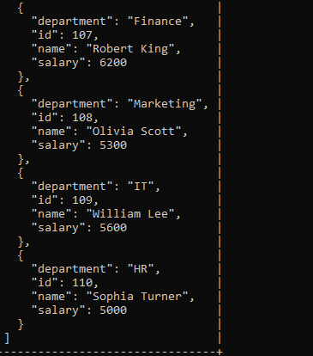
Query JSON Fields
Select
value:id::INT AS ID,
value:name::STRING AS Name,
value:department::STRING AS Department,
value:salary::INT AS Salary
FROM customers_json,
LATERAL FLATTEN(input => raw);

Nested_json:
Create Database,Schema,Stage
create database company;
create schema project;
create stage stage_json;
Create Table:
create table project_nested(raw variant);
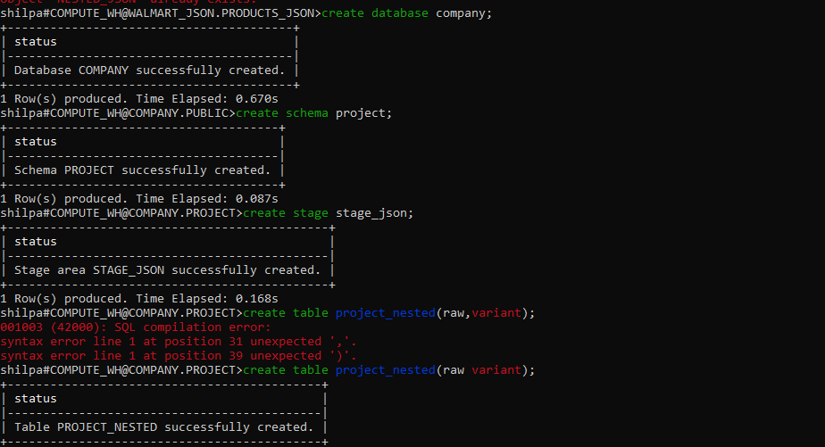
Upload Nested_Json:
put 'fILE://C:/Users/Admin/Downloads/snowsql2.json' @stage_json;
Create File Format:
create or replace file format FF_JSON_FLAT type =’JSON’ STRIP_OUTER_ARRY = FLASE;
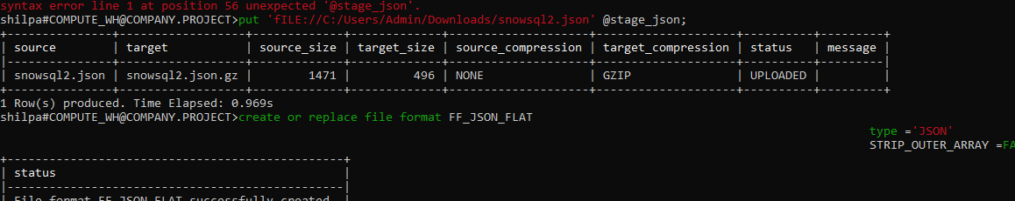
Copy Data into Table
copy into project_nested
fro@stage_json/snowsql2.json
FILE_FORMAT=(FORMAT_NAME='FF_JSON_FLAT');
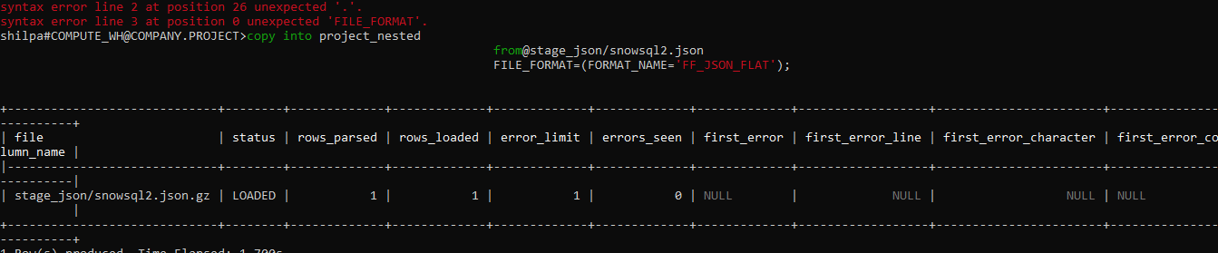
Verify Data
Select * from Project_nested;
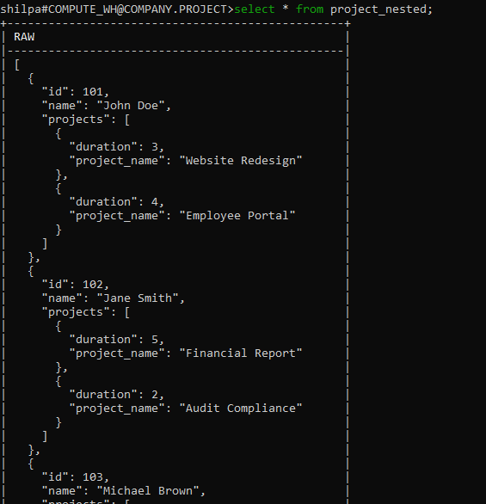
Query Nested_Json Fields

SELECT emp.value:id::INT AS Employee_ID,
emp.value:name::STRING AS Employee_Name,
proj.value:project_name::STRING AS Project_Name,
proj.value:duration::INT AS Duration
FROM project_nested,
LATERAL FLATTEN(input => raw) emp,
LATERAL FLATTEN(input => emp.value:projects) 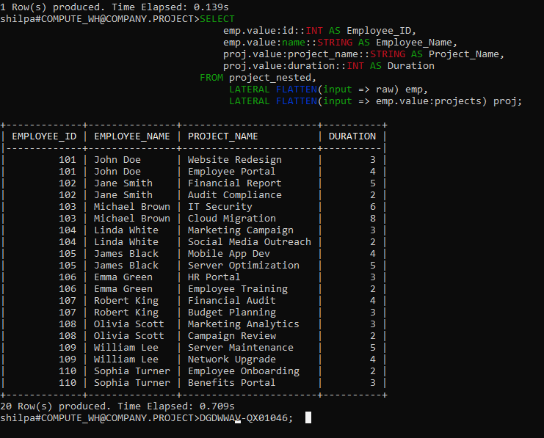

Xml Normal:-
I Reused the same database
Create Schema and Stage
create schema client;
create stage xml_stage;
Upload XML Normal File:
put 'file://C:/Users/Admin/Downloads/snowsql3.XML'@xml_stage;
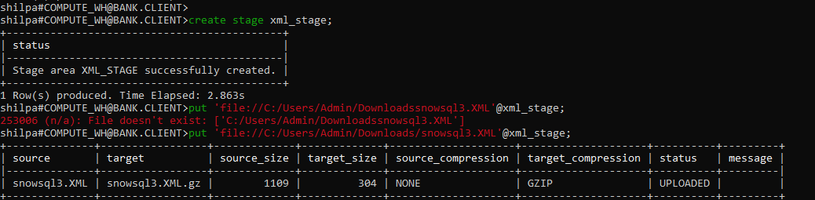
Create File Format:
CREATE OR REPLACE FILE FORMAT my_xml_format
TYPE = 'XML'
STRIP_OUTER_ELEMENT = TRUE

Copy Into Table:-
COPY INTO xml_table (xml_doc)
FROM @xml_stage/snowsql3.XML
FILE_FORMAT = (FORMAT_NAME = 'my_xml_format');
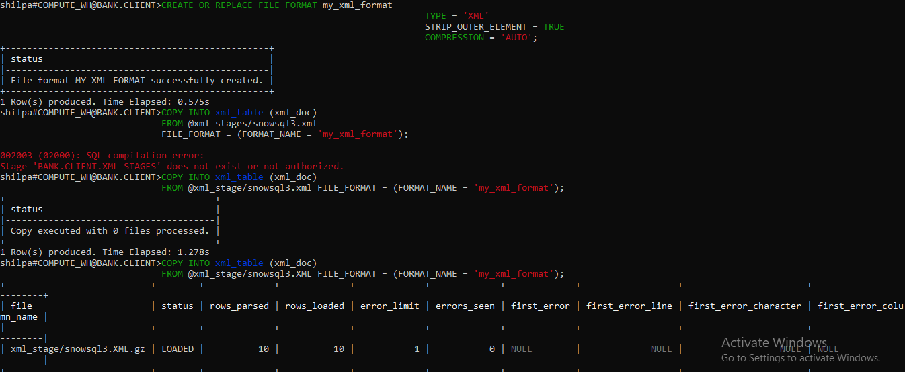
Select Query:
SELECT * FROM xml_table;
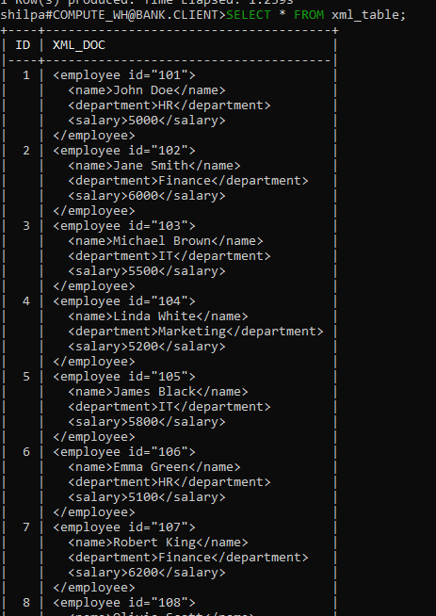
Create and Insert:
CREATE OR REPLACE TABLE SNOWSQL3_FINAL (ID INT,NAME STRING,DEPARTMENT STRING,SALARY INT);
INSERT INTO SNOWSQL3_FINAL (ID, NAME, DEPARTMENT, SALARY)
SELECT
XML_DOC:"@id"::string::int AS ID,
XMLGET(XML_DOC, 'name'):"$"::string AS NAME,
XMLGET(XML_DOC, 'department'):"$"::string AS DEPARTMENT,
XMLGET(XML_DOC, 'salary'):"$"::int AS SALARY
FROM xml_table;
XML Final Out Put:
SELECT * FROM SNOWSQL3_FINAL;
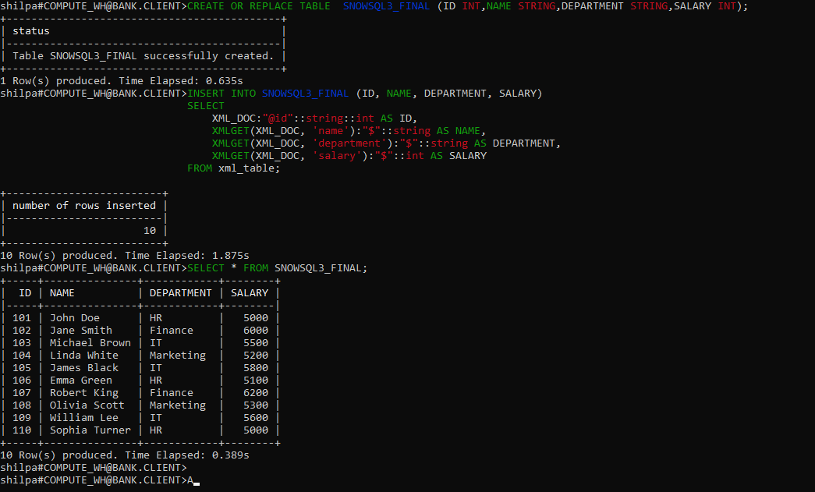

NESTED_XML

Use database company;
Create schema and Create table

create schema documents;

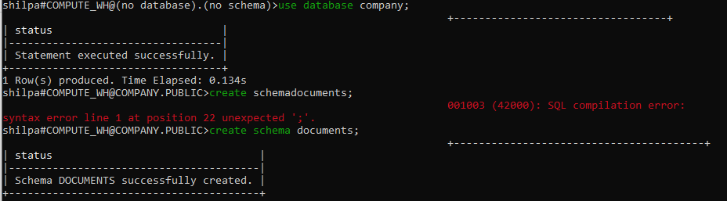
Create table:
Create or replace table
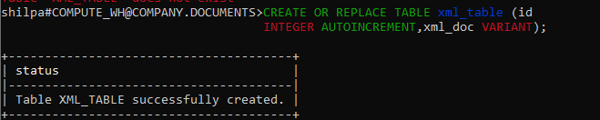
Upload NESTED_XML File
put 'file://C:/Users/Admin/Downloads/snowsql4.xml' @xml_nested;
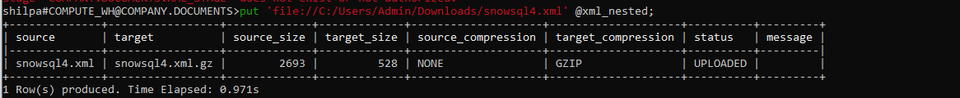
Create File Format:
CREATE OR REPLACE FILE FORMAT my_xml_format TYPE =
'XML'STRIP_OUTER_ELEMENT = TRUE COMPRESSION = 'AUTO'; 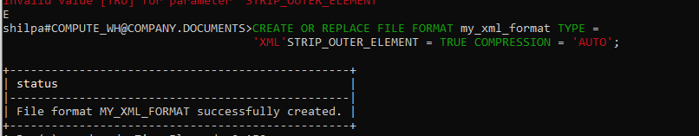

Copy Into Table:-
Copy into xml_table(xml_doc)from @xml_nested/snowsql4.xml file_format = (format_name = 'my_xml_format');
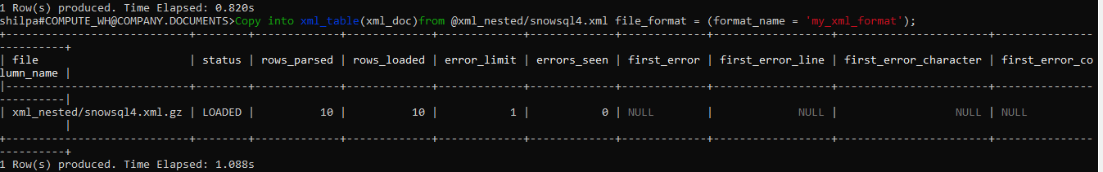
Select Query:

select * from xml_table;
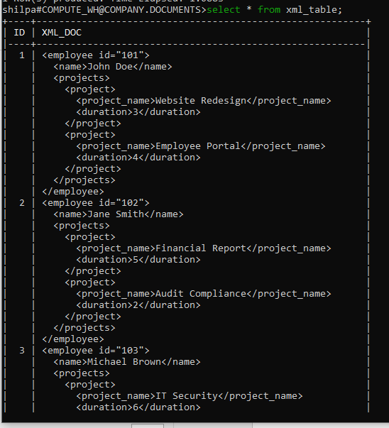
Create and Insert:

CREATE OR REPLACE TABLE SNOWSQL4_FINAL (ID INT,NAME STRING,DEPARTMENT STRING,SALARY INT);
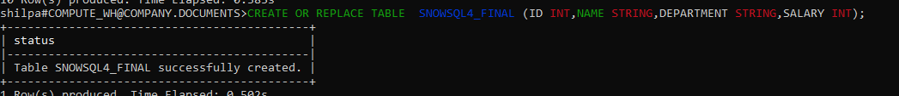

INSERT INTO SNOWSQL4_FINAL (ID, NAME, DEPARTMENT, SALARY)
SELECT
XML_DOC:"@id"::string::int AS ID,
XMLGET(XML_DOC, 'name'):"$"::string AS NAME,
XMLGET(XML_DOC, 'department'):"$"::string AS DEPARTMENT,
XMLGET(XML_DOC, 'salary'):"$"::int AS SALARY
FROM xml_table;

SELECT * FROM SNOWSQl4_FINAL;
