Secure Data Sharing
Secure Data Sharing
Secure Data Sharing lets a Snowflake account (the provider) share data objects with another Snowflake account (the consumer) without copying or transferring data. Shared data stays in the provider’s storage and is read-only in the consumer account.
Key ideas
Provider creates a share — a container that lists objects (tables, views, etc.) and consumer accounts.
Consumer imports the share as a database and can query it like a local database (read-only).
No storage copy, so consumers pay only compute for queries, not storage.
Sharing Data as a Provider
A provider must:
- Create a share
- Grant privileges to the share
- Add consumer accounts
You can either grant privileges directly to a share or via database roles.
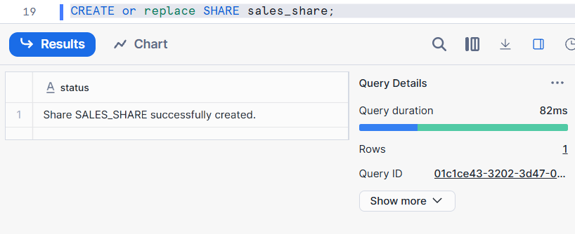
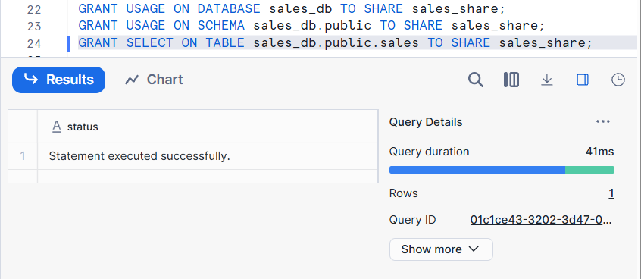
CREATE SHARE — container for shared objects.
GRANT — adds privileges on objects to that share.
ALTER SHARE ADD ACCOUNTS — lists consumer accounts allowed access.
It does not support for self-sharing…need to share for another account
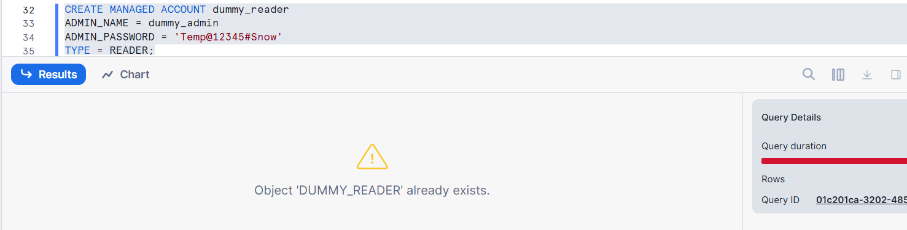
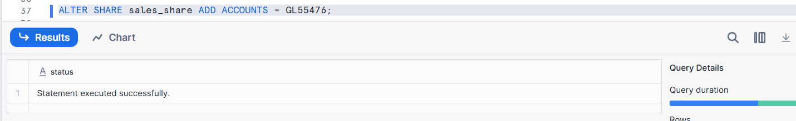
Consuming Shared Data
Consumers convert a share into a database they can query.
👉 Consumer = the account that receives data via a SHARE
👉 Provider = the account that created the SHARE
Consumer account receives data via SHARE and uses it without copying.
Data physically stays in provider
Consumer creates database FROM SHARE
Data is read-only
Always real-time
✔ No storage cost
✔ Always sees latest data
✔ Read-only
Sharing Data Across Multiple Database
Snowflake by default allows sharing from one database only per object.
Solution:
Use SECURE VIEW + REFERENCE_USAGE
If you want to share data from more than one database in the same account:
- Create a secure view that references tables from multiple databases.
- Grant REFERENCE_USAGE on each referenced database to the share.
Create a secure view
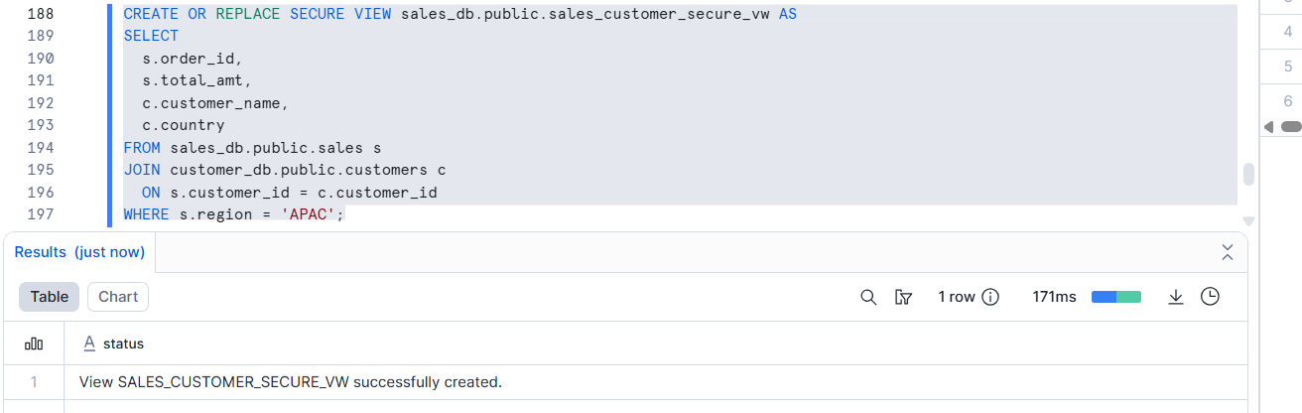
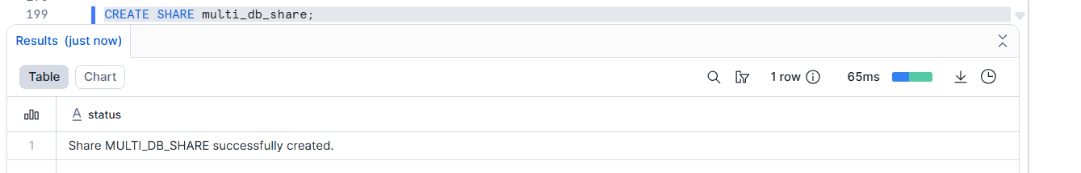
Grant USAGE on View’s Database & Schema
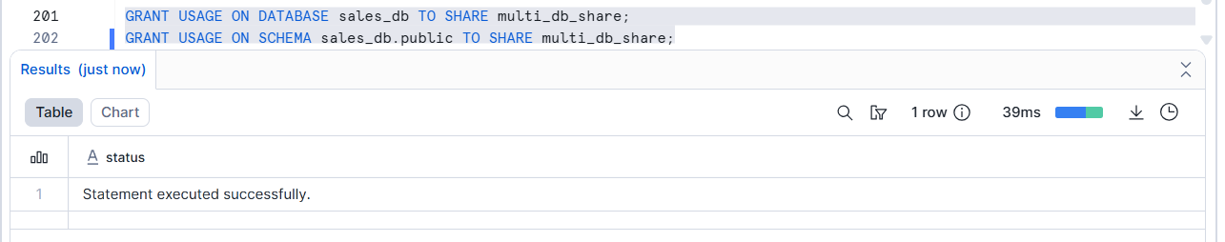
Grant REFERENCE_USAGE
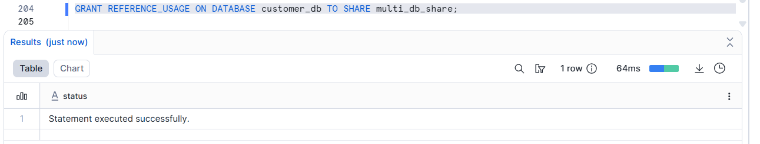
Grant SELECT on SECURE VIEW
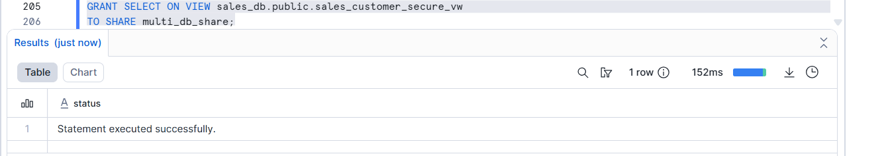
Add Consumer Account
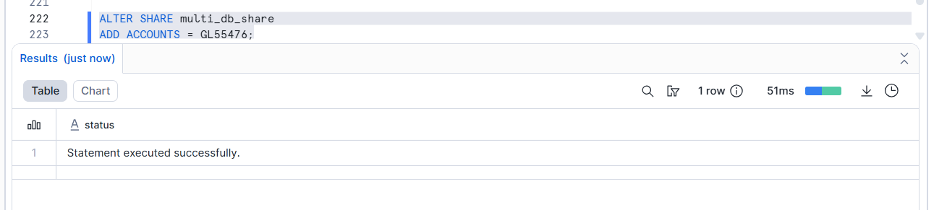
RESULT:
Consumer creates database from share:
CREATE DATABASE shared_sales_db
FROM SHARE provider_account.multi_db_share;
Query:
SELECT * FROM shared_sales_db.public.sales_customer_secure_vw;
Sharing Across Regions and Cloud Platforms
Snowflake uses replication groups to replicate data and shares to target regions. Then you add consumer accounts in the target region to the share.
Snowflake supports cross-cloud and cross-region data sharing with automatic secure replication.
Steps (High-Level)
- Enable replication for accounts in source and target region.
- Create a replication group including your database(s) and share.
- Replicate to target region account(s).
- Add consumer accounts to the replicated share.
Secure Views and Secure Materialized Views
Standard views aren’t allowed in shares — you must use secure views to protect logic and restrict access.
❗Snowflake will error if a non-secure view is in a share.
Sharing Policy-Protected Data
If tables are protected by row access policies or masking policies, you can share them by also sharing a database role that meets the policy’s conditions.
Policy-protected data means data secured using Snowflake policies, such as:
🔹 Types of policies:
- Masking Policy – Column-level security
- Row Access Policy – Row-level security
These policies continue to be enforced even when data is shared with another account.
How it works
- Policy calls IS_DATABASE_ROLE_IN_SESSION for role evaluation.
- Provider grants the database role to the share.
- Consumer must activate the database from the share to meet policy conditions.
Step 1: Create a base table
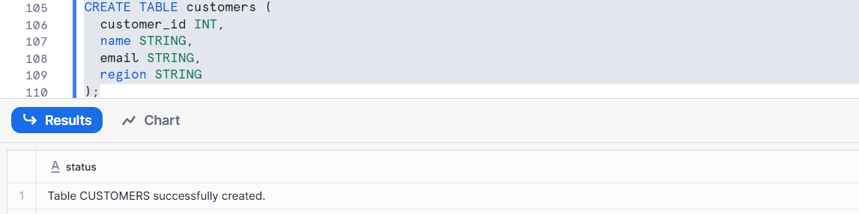
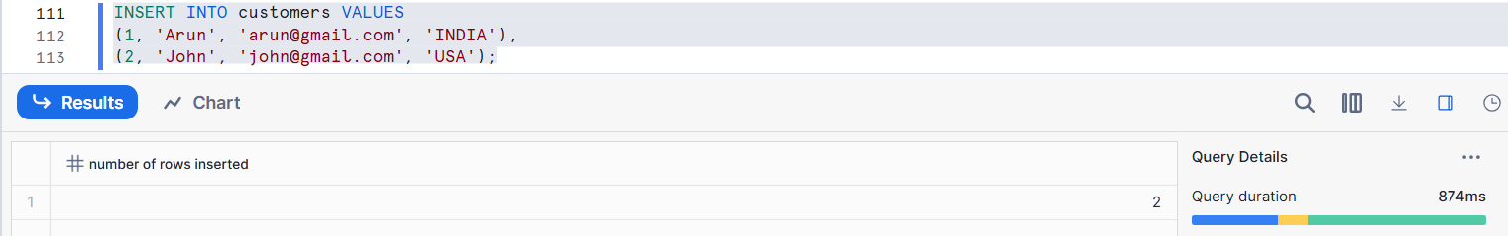
STEP 2: Create a masking Policy
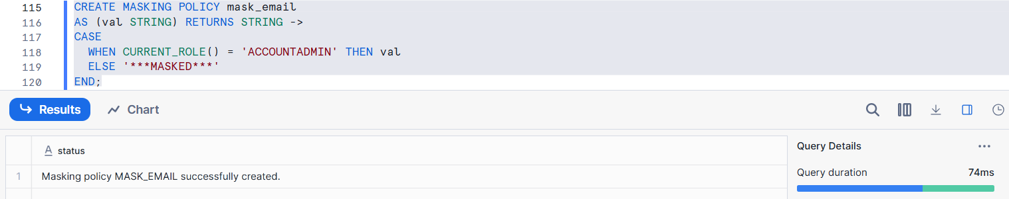
Set masking policy
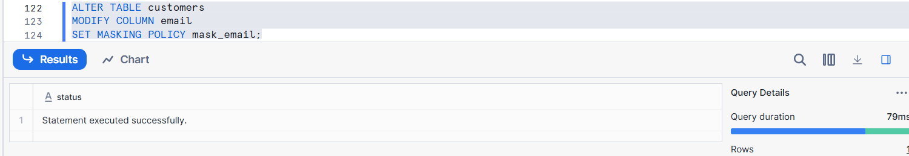
Row access policy
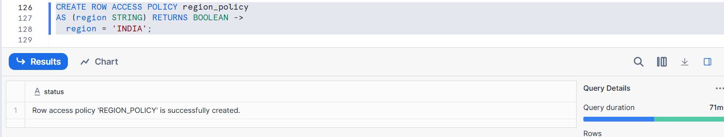
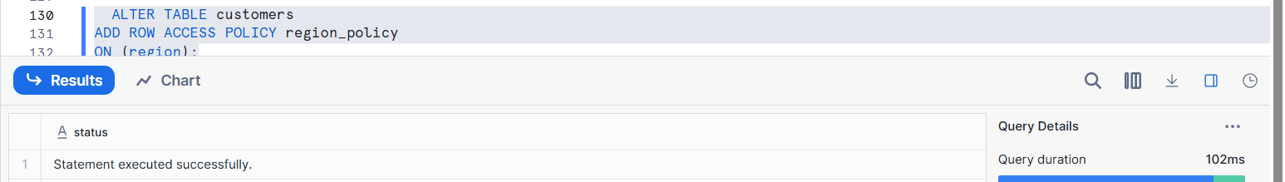
Only rows where region = 'INDIA' will be visible.
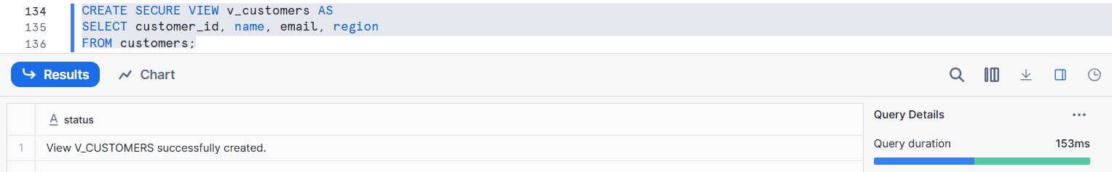
Grant usage for all: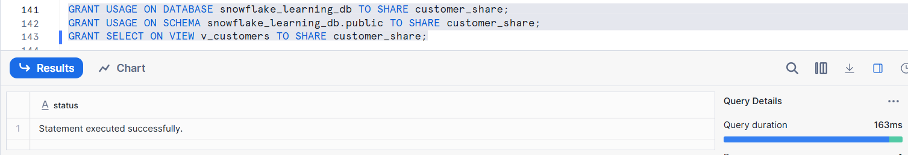
Consumer Privileges (Using Shared Databases)
Provider account → creates & shares data
Consumer account → receives the shared data
Once the consumer imports the share, the data appears as a read-only database.
After a consumer imports a shared database in Snowflake, the database is available in read-only mode. To allow users to query the shared data, the consumer must grant IMPORTED PRIVILEGES on the shared database to the required roles. If the provider has shared database roles for security or policy control, those roles must also be granted to consumer roles. This ensures users can access shared data while all provider-defined security policies continue to be enforced.
Override Share Restrictions
Snowflake restricts sharing between different editions or regions, for example:
- Business Critical → Standard
- Government → Commercial
- Cross-cloud / cross-region
Snowflake may restrict data sharing between accounts due to differences in editions, regions, or platforms. In such cases, a user with the OVERRIDE SHARE RESTRICTIONS privilege can relax these limitations on a share. This allows controlled data sharing across restricted account types while maintaining Snowflake’s security and governance standards.
Data Exchange & Marketplace Privileges
Snowflake also supports:
Data Exchange — invite groups of accounts to share/list shares.
Snowflake Marketplace — offer data products publicly or privately.
To manage these, you need privileges like:
Snowflake Data Exchange enables organizations to share data with multiple known accounts, such as partners or vendors, in a controlled manner. Snowflake Marketplace allows providers to publish data products publicly or privately for wider consumption. To manage these options, users need specific privileges like CREATE LISTING, MODIFY, OWNERSHIP, and IMPORT SHARE, which control the creation, management, and consumption of shared data products.

