SECURITY
Securing Snowflake
Snowflake is built with strong security features that protect data, accounts, and users from unauthorized access and threats.
Snowflake provides industry-leading security features to protect:
- Your Snowflake account
- Users and roles
- Data stored in Snowflake
These features are mainly handled by administrative roles such as:
- ACCOUNTADMIN
- SYSADMIN
- SECURITYADMIN
Authentication
Authentication defines how users and applications log in to Snowflake.
Snowflake supports multiple secure authentication methods to protect access.
Overview of Snowflake Authentication
Snowflake authentication refers to the different ways users and applications securely connect to Snowflake. The goal is to make sure only authorized people and systems can access your Snowflake environment.
1. Authentication for Snowsight Users
This is for people who log in to Snowflake through the web interface (Snowsight).
Single Sign-On (SSO)
Multi-Factor Authentication (MFA)
2. Authentication for Applications
Applications are systems that connect to Snowflake without a human clicking in a browser — like ETL jobs, APIs, dashboards, or cloud workloads.
Interactive applications Apps that act on behalf of a user (e.g., BI tools)
Service-to-service applications Back-end systems without human interaction (e.g., automation, pipelines).
1. Authentication Policies
Authentication policies let administrators control how users and applications authenticate to Snowflake.
They help enforce security requirements such as:
Which clients can connect (web UI, CLI, drivers)
Which authentication methods are allowed (password, SAML/SSO, OAuth, key-pair, tokens, workload identity)
When MFA is required
Which security integrations (identity providers) are available during login
You can apply these policies either:
- At the account level (applies to all users), or
- At the user level (overrides account policy for a specific user)
DEMO :
Step 1 - Create a Role for Managing Policies
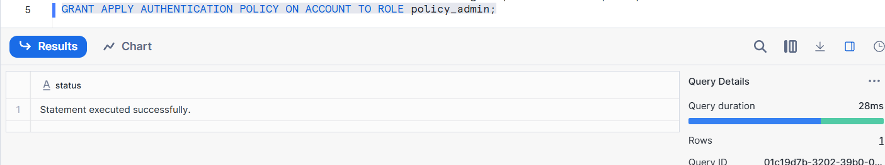
Step 2 - Create an Authentication Policy
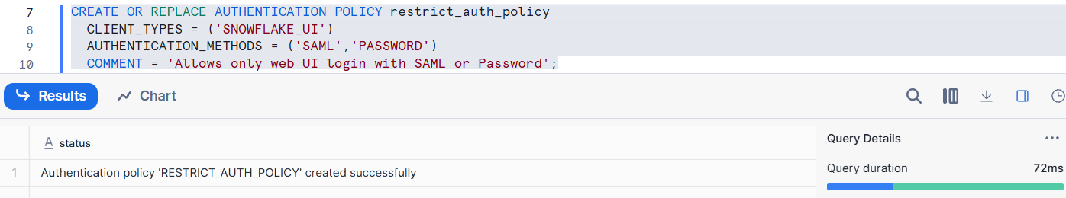
Step 3 — Apply the Policy to the Account or a User
FOR ACCOUNT:
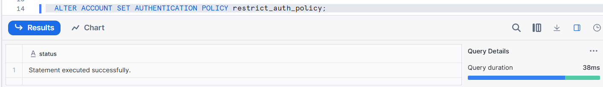
FOR USER:
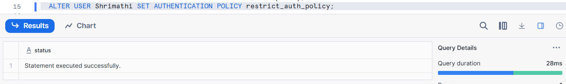
If both account and user have policies, the user policy takes priority.
Step 4 — Require MFA via Authentication Policy
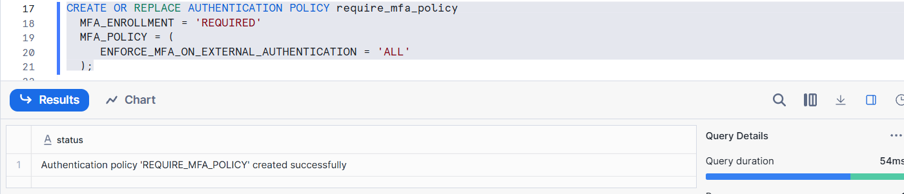
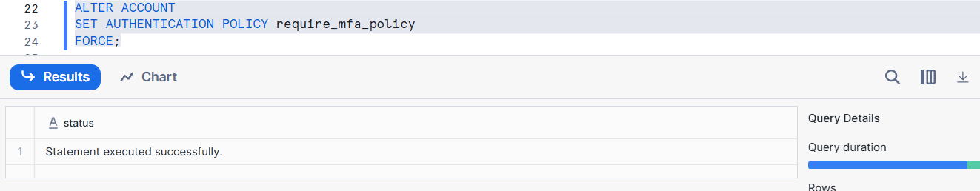
MFA_ENROLLMENT = ‘REQUIRED’ forces users to enroll in MFA if they haven’t.
ENFORCE_MFA_ON_EXTERNAL_AUTHENTICATION = 'ALL'
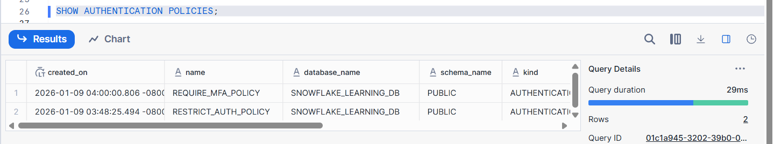
Helps verify who the policy is applied to.
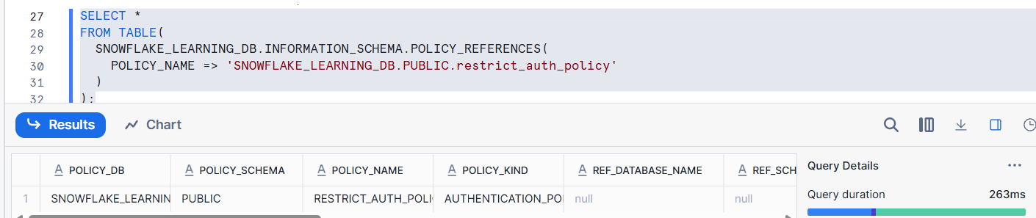
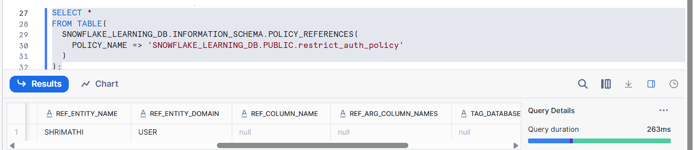
2. Multi-Factor Authentication (MFA)
Multi-Factor Authentication (MFA) adds an extra layer of security on top of passwords. When a user signs in with a password, Snowflake requires a second factor (like a passcode or authenticator app) before granting access.
MFA adds an extra layer of security by requiring:
- Something the user knows (password)
- Something the user has (OTP, mobile app, hardware token)
Single passwords can be stolen or guessed.
With MFA, even if someone knows a user’s password, they still need the second factor to successfully log in.
This dramatically reduces security risk and unauthorized access
STEP 1 — Enroll a user in MFA
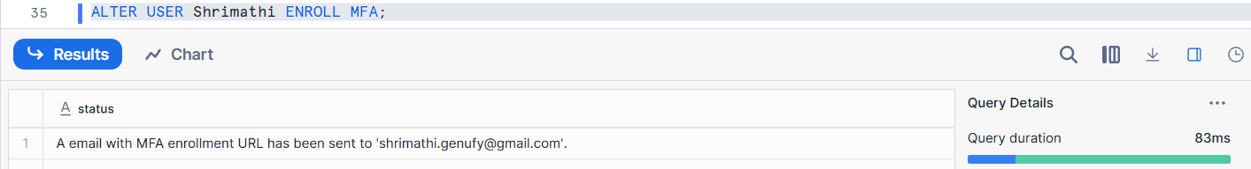
This command prompts Snowflake to start MFA setup for the user. They will receive a setup page or email.
STEP 2 — Verify MFA Methods
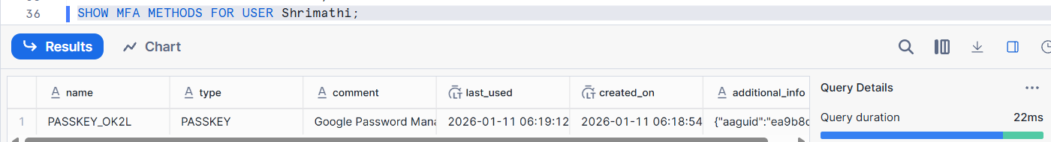
3. Key-Pair Authentication & Key-Pair Rotation
Key-pair authentication lets applications or users authenticate to Snowflake using a public/private key pair instead of a password.
This is:
✔ Stronger security
✔ No passwords transmitted
✔ Ideal for automated tools, scripts, service accounts
It uses:
- Private key — kept securely by the client/app
- Public key — stored in Snowflake
PART 1 — GENERATE KEY PAIR (Outside Snowflake)
# Generate a private key (PEM RSA 2048-bit)
openssl genpkey -algorithm RSA -out rsa_key.pem -pkeyopt rsa_keygen_bits:2048
# Extract public key
openssl rsa -pubout -in rsa_key.pem -out rsa_key.pub
PART 2 — ASSIGN THE PUBLIC KEY TO A SNOWFLAKE USER
Choose the user who needs key-pair auth
Use the public key contents in Snowflake
ALTER USER app_user
SET RSA_PUBLIC_KEY='<paste the base64 public key here>';
Verify Public Key Set:
SELECT name, rsa_public_key
FROM SNOWFLAKE.ACCOUNT_USAGE.USERS
WHERE name = 'APP_USER';
NOW LOGIN :
snowsql -c keypair_demo
4. Programmatic Access Tokens
Programmatic access tokens are time-limited credentials that allow applications or users to authenticate to Snowflake without a password.
Better than passwords: PATs expire and are short-lived. If compromised, they are less harmful.
Easy programmatic authentication: Useful for tools that only support username/password fields.
Scoped to roles: PATs can be restricted to a specific role, limiting privilege scope.
Step 1: Check which authentication policy is applied
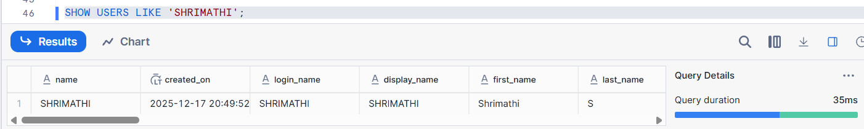
Step 2: Describe that authentication policy
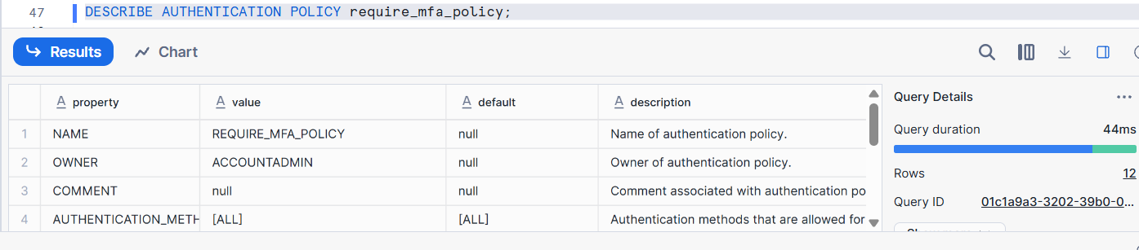
Step 3: ALTER the Authentication Policy (FIX)
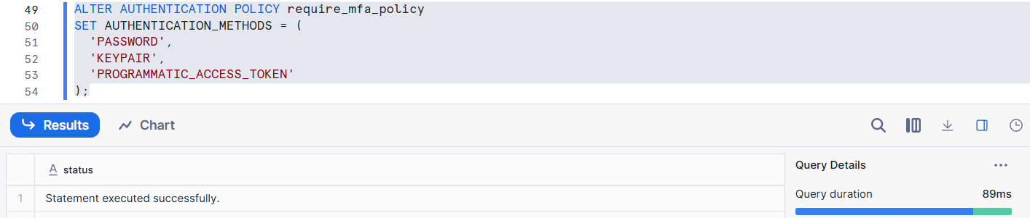
Step 4: Retry Creating the Token
Token is created
Token secret is shown ONCE
Copy it immediately
Verify Token
SHOW USER PROGRAMMATIC ACCESS TOKENS FOR USER Shrimathi;
Programmatic access tokens are controlled by authentication policies. Even if a user has permission, Snowflake blocks token creation unless the policy explicitly allows PROGRAMMATIC_ACCESS_TOKEN. This ensures strict governance over authentication methods.
5. OAuth (Snowflake OAuth & External OAuth)
OAuth allows applications to access Snowflake without sharing usernames and passwords.
Two types:
- Snowflake OAuth – Snowflake manages tokens
- External OAuth – External IdP manages tokens
An Identity Provider (IdP) is a system that verifies who you are and confirms your identity when you try to log in.
Snowflake OAuth lets Snowflake act as both:
OAuth Authorization Server — issues access tokens after user consent
OAuth Resource Server — accepts access tokens to access Snowflake data securely
How Snowflake OAuth Works (High-Level Flow)
Here’s the typical OAuth authorization code flow:
- User/Client initiates OAuth login
  - App redirects user to Snowflake OAuth authorization endpoint
  - User provides Snowflake credentials
- User logs in & consents
  - Snowflake asks user to grant access for a specific Snowflake role
- Snowflake returns an authorization code
  - App passes this to Snowflake’s token endpoint
- App exchanges code for access token (and refresh token)
  - Access token has short lifetime (~10 mins)
  - Optionally receive a refresh token to get new access tokens
- App connects to Snowflake with the access token
  - Snowflake verifies token and creates a session with the specified role
  - Client can now query data using that session
6. Workload Identity Federation
Workload Identity Federation (WIF) is a passwordless, secretless authentication method for applications, services, and containers to connect to Snowflake using cloud provider identity systems, such as:
✔ AWS IAM roles
✔ Microsoft Entra ID (Azure)
✔ Google Cloud service accounts
✔ Any OIDC-compatible identity provider
Instead of storing and rotating long-lived credentials (like passwords, API keys, key pairs, or tokens), the workload uses an attestation (proof of identity) from the cloud provider to authenticate directly to Snowflake.
7. External API Authentication & Secrets
API Authentication in Snowflake refers to the secure ways systems or applications connect to Snowflake’s REST/SQL API endpoints without using a username/password directly.
This is often used when you want:
✔ Applications to call Snowflake using REST APIs
✔ External tools to authenticate programmatically
✔ No interactive login (service-to-service)
1. Key-Pair Authentication
Apps authenticate using:
- Private Key (stored securely)
- Public Key mapped to a Snowflake user
No passwords → very secure
2. OAuth Tokens (Snowflake or External OAuth)
Apps authenticate using:
- Access Tokens issued by Snowflake OAuth server
- OR Tokens from external OAuth Authorization Server
These tokens are passed to API calls instead of passwords
This is perfect for modern API flows.
Network Security :
Snowflake lets you control and protect access to your account from unwanted or suspicious sources using:
- Malicious IP Protection
- Network Policies
- Network Rules
All three work together to secure your Snowflake access from unauthorized network sources and IP threats.
Snowflake provides layered network security through Malicious IP Protection, Network Policies, and Network Rules. Malicious IP Protection leverages threat intelligence to block known bad IP addresses automatically. Network Policies let us explicitly define which IPs can connect to our account or even specific users. Network Rules provide more granular conditions — for example combining IP restrictions with client types
Malicious IP Protection:
✔ Automatically detects and blocks connections from known malicious IP addresses (IPs linked to threats like scanning, brute force, bot attacks, malware, etc.).
✔ Uses threat-intelligence lists from Snowflake partners.
It operates automatically — no manual configurations required by default.
If Snowflake identifies an IP as malicious, it prevents login or API access from that source.
You also get alerts when such an event is blocked.
Correct Way to Query Malicious IP Events
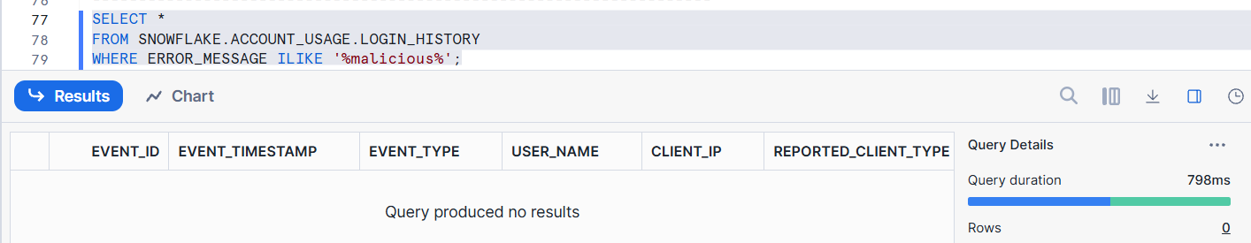
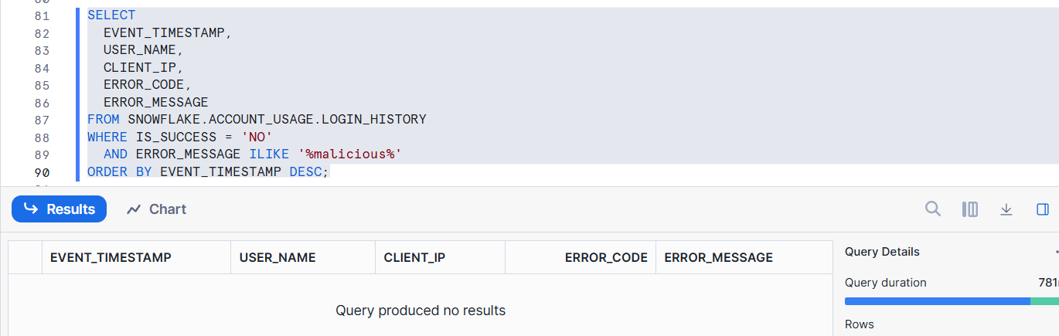
If You Still See 0 Rows
That is NOT an error.
It means:
- No malicious IP has attempted to log in
- Snowflake had nothing to block yet
Malicious IP Protection is event-based. If no known malicious IP connects, Snowflake will not generate records.
Network Policies
Network Policies allow you to control which IP addresses can connect to your Snowflake account.
They let you:
✔ Restrict access by IP address (only allow known, trusted addresses)
✔ Deny access from all others
✔ Combine policies with user-based access
You can apply network policies:
- At the account level
- At the user level
Snowflake supports both allow lists and deny lists.
Create & Apply a Network Policy
Create a policy:
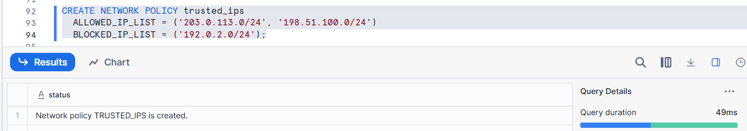
Apply at Account Level
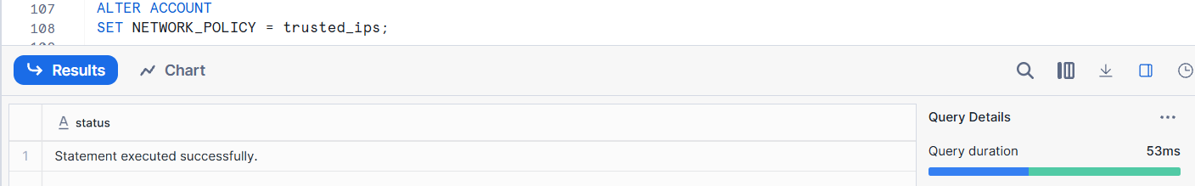Apply at User Level
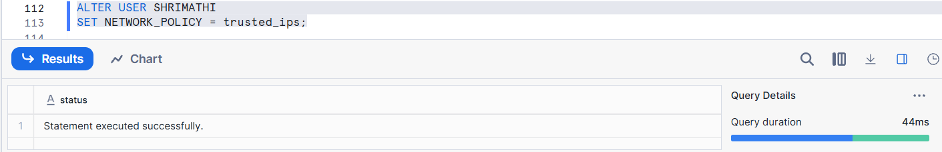
Network Rules
Network Rules are more granular conditions that can be applied within network policies.
Rules include:
✔ IP list conditions
✔ Client type restrictions (e.g., only Snowflake UI vs drivers)
✔ Host/Port matching
✔ Combinations of conditions (IP + client type)
This allows only UI and JDBC connections from the 203.0.113.0/24 subnet, and blocks SnowSQL connections even from trusted IPs.

Private Connectivity
Private connectivity refers to making Snowflake accessible only via private network paths inside your cloud (VPC / VNet / private service network) instead of over the public internet. This is important for environments where security, compliance, or network isolation matters (e.g., financial, healthcare, enterprise).
Inbound Private Connectivity
Inbound private connectivity means incoming traffic from your network to Snowflake must use private endpoints provided by your cloud provider — not the public Snowflake internet URLs.
What it applies to:
✔ Snowflake Service (SQL engine)
✔ Web UI / Snowsight
✔ Snowflake Intelligence
✔ Snowpark container services
✔ Snowflake internal stages (storage areas for data loads/unloads)
PrivateLink (AWS & Azure) / Private Service Connect (GCP)
🔹 AWS PrivateLink
AWS PrivateLink provides VPC interface endpoints that connect your AWS VPC to Snowflake’s VPC without traversing the public Internet. Traffic remains entirely inside the AWS backbone.
How it works:
- You provision a VPC endpoint in your AWS account.
- You authorize Snowflake to accept connections from that endpoint.
- You use the privatelink Snowflake URL to connect.
🔹 Azure Private Link
Azure Private Link works similarly — a private endpoint maps into Snowflake service, so all calls stay inside Azure’s private network.
You can also use it to connect to internal stages (your Azure storage) privately.
🔹 GCP Private Service Connect
On Google Cloud, Snowflake supports Private Service Connect (PSC) for inbound connectivity, creating PSC endpoints in your VPC to connect to Snowflake privately.
How to Enable Private Connectivity
There are a few important documented steps you typically follow:
📌 For AWS PrivateLink:
- Use Snowflake functions like SYSTEM$AUTHORIZE_PRIVATELINK to authorize your AWS account.
- Create the PrivateLink endpoint in AWS.
- Verify with SYSTEM$GET_PRIVATELINK.
- Then connect to Snowflake using the privatelink URL.
Disabling Public Access
Once private connectivity is configured and tested, you can disable all public internet access to your Snowflake account.
- This means Snowflake will respond with 404 account not found for public URLs.
- It hides your account from internet guessing attacks.
- It only affects Snowflake service endpoints — internal stages are separate.

Pinning Private Endpoints (Stability)
Snowflake rotates infrastructure resources over time, which can change internal endpoint IDs.
Pinning private endpoints ensures your Snowflake account only accepts traffic from specific pinned private endpoints.
This reduces your network attack surface and ensures stable access from your private endpoints.

Private Internal Stages (Cloud Storage)
Snowflake uses internal cloud storage for loading/unloading data. By default, this storage might use public endpoints. Snowflake supports private internal stages so that data transfers stay inside your cloud network:
🔹 AWS Private Internal Stages
- Uses AWS VPC interface endpoints (AWS PrivateLink for S3) so internal stage traffic stays within AWS network.
- A private S3 endpoint URL like bucket.vpceID.s3.region.amazonaws.com is used.
- You config with Snowflake account parameter ENABLE_INTERNAL_STAGES_PRIVATELINK.

🔹 Azure Private Internal Stages
- You configure Azure private endpoints for your internal stage storage (Azure Blob).
- Once set up, traffic to internal stage storage uses Azure Private Link (.privatelink.blob.core.windows.net).
- You can optionally block public access to this internal stage using a special Snowflake function — not network policies.

🔹 GCP Internal Stages
Snowflake supports private connectivity for GCP internal stages — although for some services like PSC to GCS it’s limited.

Outbound Private Connectivity
Snowflake often needs to talk to external services, such as:
- Cloud storage buckets (S3 / Blob / GCS)
- SaaS APIs
- External authentication providers
- Third-party services
By default, these are accessed via the public internet.
Inbound = Users → Snowflake
Outbound = Snowflake → External services
Outbound private connectivity allows Snowflake to securely access external resources through private endpoints inside the cloud provider network.
Aws End Point
In AWS, Private Endpoints (via AWS PrivateLink) let Snowflake communicate privately with AWS services.
This keeps the traffic inside the AWS backbone — never on the public Internet.
Common AWS services for private outbound access:
✔ Amazon S3
✔ AWS KMS
✔ AWS Secrets Manager
✔ AWS API Gateway
✔ Other AWS managed services
Azure End Point
In Azure, Private Endpoints (via Azure Private Link) let Snowflake access Azure services privately.
Some common services:
✔ Azure Blob Storage
✔ Azure Data Lake Gen2
✔ Azure Key Vault
✔ Azure APIs accessed by Snowflake
GCP End Point
Google Cloud doesn’t use AWS PrivateLink/Azure Private Link. Instead, it has networking options like:
✔ Private Service Connect (PSC)
✔ VPC Peering
✔ Cloud NAT (for some use cases)
Snowflake uses these to build private networking paths when talking to GCP services.
DATA INTEGRATION

1. Snowflake Openflow – Modern Data Integration Service
Snowflake Openflow
Snowflake Openflow is a fully managed, extensible data integration service that helps you move data from any source to any destination — including Snowflake — efficiently and securely.
It’s a popular open-source data integration engine, and enhanced by Snowflake with enterprise features like security, governance, observability, and simplified operations.
- It supports structured, semi-structured, and unstructured data (like text, images, audio, video, and sensor data).
- You get connectors for various sources including databases, SaaS platforms, streaming systems, and APIs.
There are two deployment models:
Openflow – Snowflake Deployment
• Runs on Snowflake’s Snowpark Container Services (SPCS)
• Easier setup and native integration with Snowflake security
• Good for most use cases where you want Snowflake-managed pipelines
Openflow – Bring Your Own Cloud (BYOC)
• You run the data flow engine in your own cloud environment (e.g., AWS VPC)
• Good flexibility and control for sensitive data or network requirements
Why Openflow Matters:
✔ Unified data integration — batch & real-time both supported
✔ Supports many data types and sources — wide applicability
✔ Enterprise-ready — security, roles, logs, observability included
✔ Runs where you need it — Snowflake SPCS or your cloud VPC
Major components:
- Control Plane
➡ Hosted and managed by Snowflake
➡ Orchestrates deployments, runtimes, and pipelines
- Deployments
➡ Containerized environments where flows actually run
➡ Can be SPCS (Snowflake hosted) or BYOC (your cloud)
- Runtimes
➡ Execution engines for your data flows
➡ Each runtime runs processors and connectors
- Connectors / Processors
➡ Built-in or custom blocks that pull, transform, and move data
➡ Examples: REST APIs, databases, SaaS systems, message streams
2. Apache Iceberg™ Tables – Open Data Lake Format in Snowflake
Apache Iceberg™
Apache Iceberg™ is an open table format for large analytic datasets stored in object storage (like S3, Blob, GCS).
Iceberg adds:
✔ ACID transactions
✔ Schema evolution
✔ Hidden partitioning
✔ Snapshots for time travel
✔ Support for open file formats (especially Parquet)
It’s designed to make big data lake tables behave more like managed database tables.
Snowflake Uses Iceberg
Snowflake supports Apache Iceberg™ tables natively, enabling:
📈 Query performance similar to Snowflake tables with external storage overlays
📈 Support for external query engines (e.g., Spark) via catalog services
Snowflake manages metadata and operations while storing data files externally.
Iceberg Is Important
✔ Interoperability: Multiple engines (Snowflake, Spark, Trino) can work on Iceberg tables.
✔ Open formats: No vendor lock-in — you can use tools that understand Iceberg.
✔ Large datasets: Great for data lakes with analytic workloads.

