Stream & Task Basics
- Create a source table orders_source with columns (order_id INT, customer_id INT, amount FLOAT, order_date DATE).
Create a stream on orders_source to capture all changes.
Create the source table orders_source
CREATE OR REPLACE TABLE orders_source (
order_id INT,
customer_id INT,
amount FLOAT,
order_date DATE
);
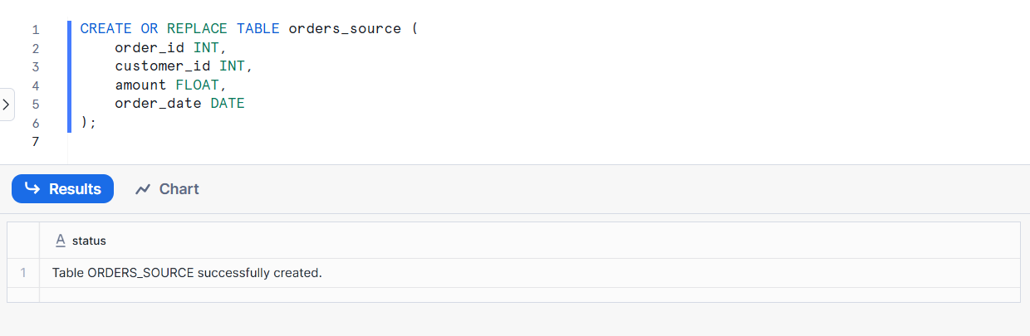
Insert sample data into orders_source
INSERT INTO orders_source VALUES
(1, 101, 500.50, '2025-01-01'),
(2, 102, 1200.00, '2025-01-02'),
(3, 103, 750.75, '2025-01-03');
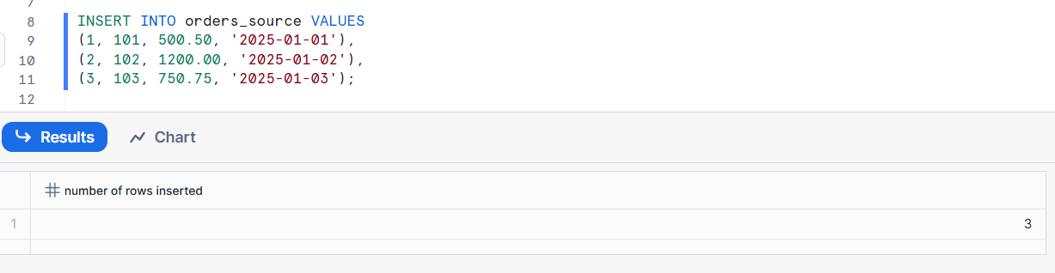
Create a stream on orders_source
CREATE OR REPLACE STREAM orders_source_stream
ON TABLE orders_source;

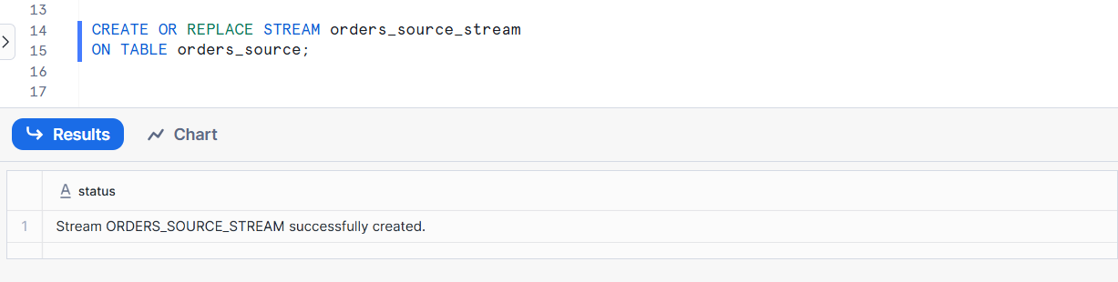
Check the stream data
SELECT * FROM orders_source_stream;
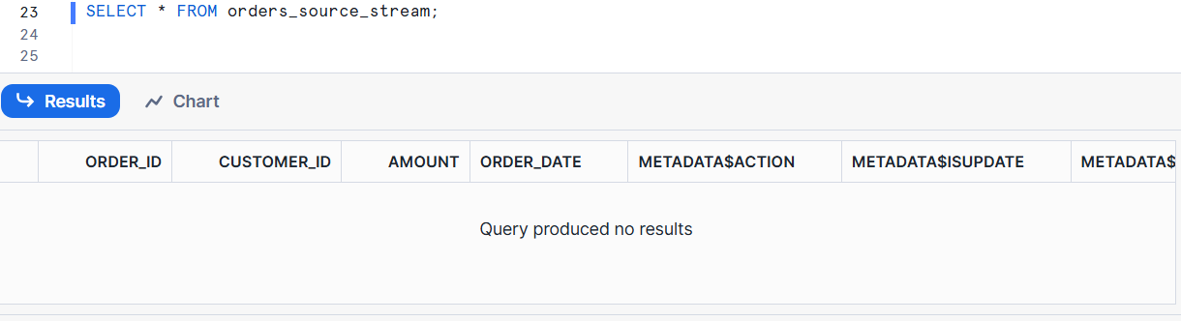
Make changes to the source table
Insert a new row
INSERT INTO orders_source VALUES
(4, 104, 900.00, '2025-01-04');
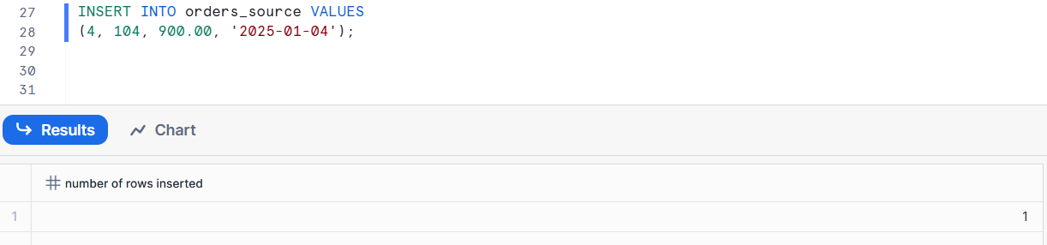
Update a Row
UPDATE orders_source
SET amount = 600.00
WHERE order_id = 1;
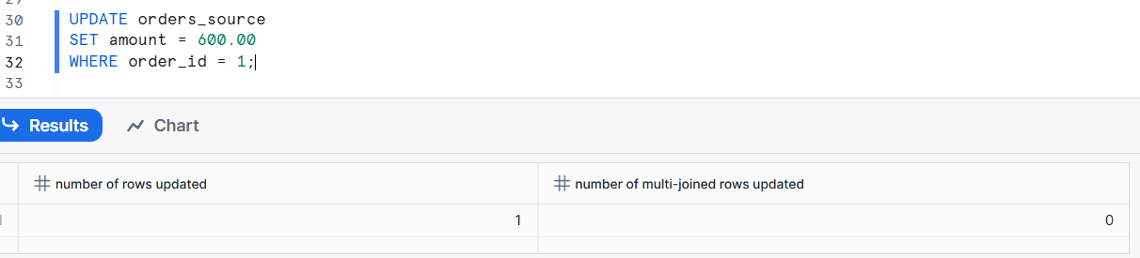
Delete a Row
DELETE FROM orders_source
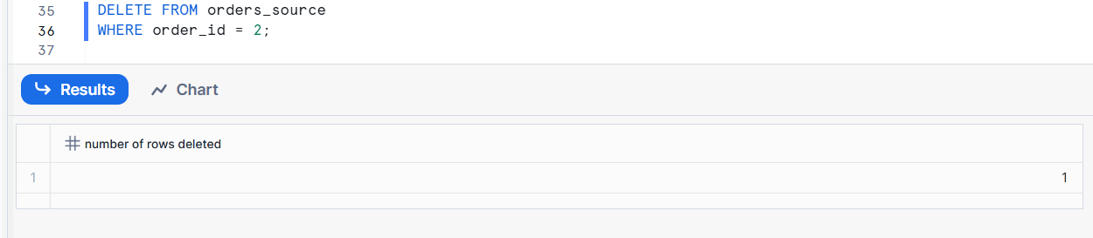
Query the stream again
SELECT * FROM orders_source_stream;
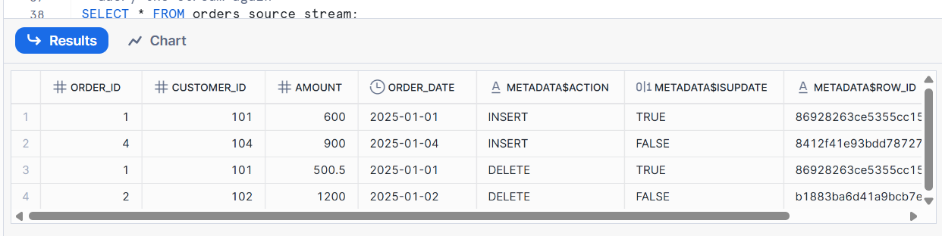
- Create a target table orders_target with the same structure as orders_source.
Write a task that runs every 5 minutes to merge changes from the stream into orders_target.
Create the target table orders_target
CREATE OR REPLACE TABLE orders_target (
order_id INT,
customer_id INT,
amount FLOAT,
order_date DATE
);

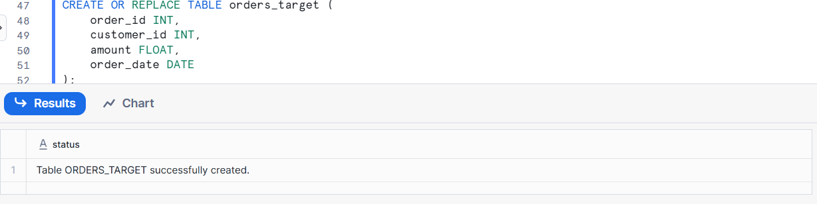
Verify source stream exists

SHOW STREAMS;

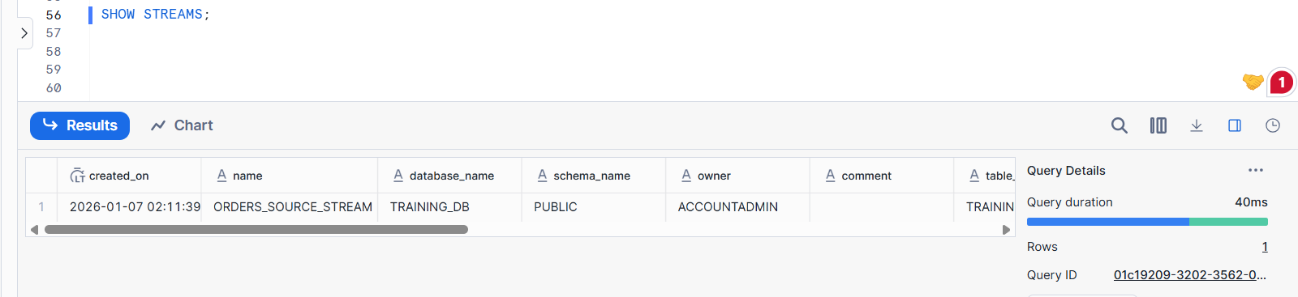
Create a warehouse for the task
CREATE OR REPLACE WAREHOUSE task_wh
WAREHOUSE_SIZE = XSMALL
AUTO_SUSPEND = 60
AUTO_RESUME = TRUE;
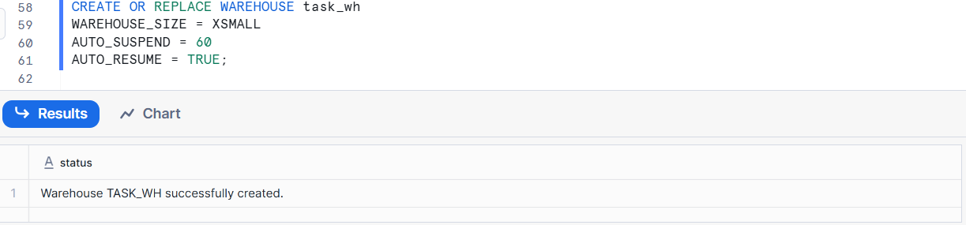
Create the TASK to merge stream data into target table
CREATE OR REPLACE TASK orders_merge_task
WAREHOUSE = task_wh
SCHEDULE = '5 MINUTE'
AS
MERGE INTO orders_target t
USING (
SELECT *
FROM orders_source_stream
) s
ON t.order_id = s.order_id

DELETE records
WHEN MATCHED
AND s.METADATA$ACTION = 'DELETE'
AND s.METADATA$ISUPDATE = FALSE
THEN DELETE

UPDATE records
WHEN MATCHED
AND s.METADATA$ACTION = 'INSERT'
AND s.METADATA$ISUPDATE = TRUE
THEN UPDATE SET
t.customer_id = s.customer_id,
t.amount = s.amount,
t.order_date = s.order_date

INSERT records
WHEN NOT MATCHED
AND s.METADATA$ACTION = 'INSERT'
THEN INSERT (
order_id,
customer_id,
amount,
order_date
)
VALUES (
s.order_id,
s.customer_id,
s.amount,
s.order_date
);

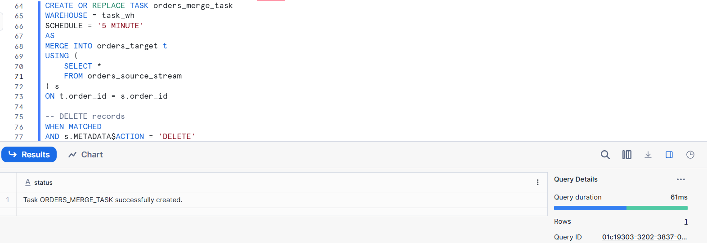
Start (resume) the task
ALTER TASK orders_merge_task RESUME;
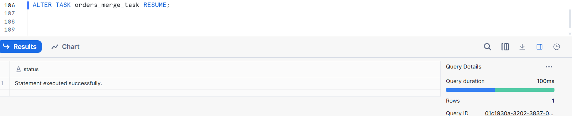
Test the full flow
Insert new data into source table
INSERT INTO orders_source VALUES
(5, 105, 1500.00, '2025-01-05');
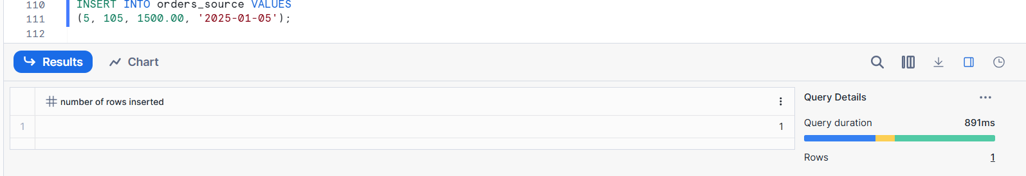
After 5 mins I check this
SELECT * FROM orders_target;

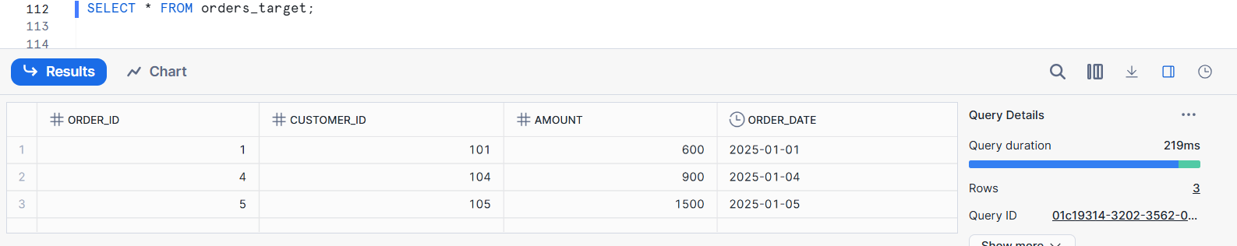
Update source data
UPDATE orders_source
SET amount = 1600.00
WHERE order_id = 5;
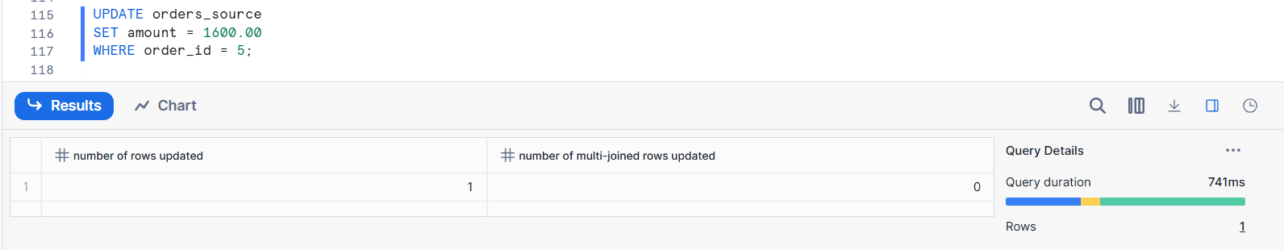
Delete source data
DELETE FROM orders_source
WHERE order_id = 5;
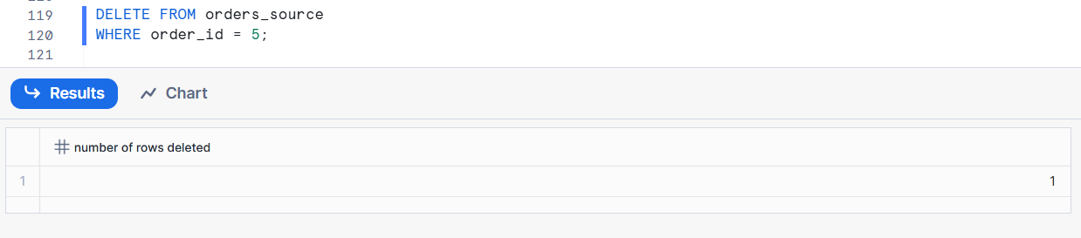
Monitor task execution
SELECT *
FROM TABLE(INFORMATION_SCHEMA.TASK_HISTORY())
ORDER BY COMPLETED_TIME DESC;

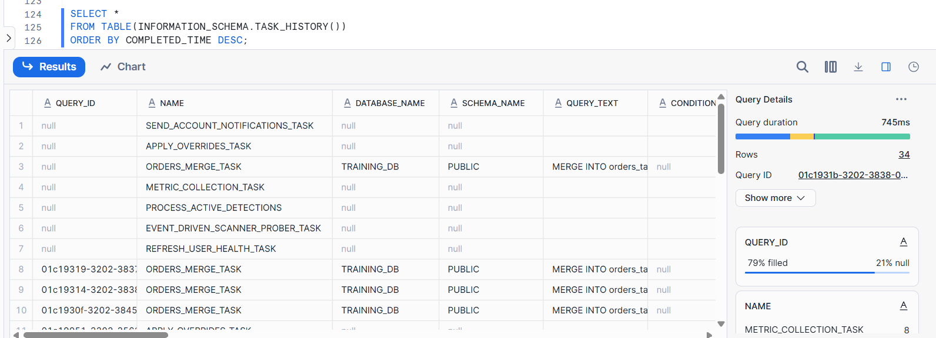
- Insert sample data into orders_source and demonstrate how the stream captures these changes.
Show the effect of running the task on the orders_target table.
Check current data
Source table
A source table is the original table where data is first stored.
SELECT * FROM orders_source;
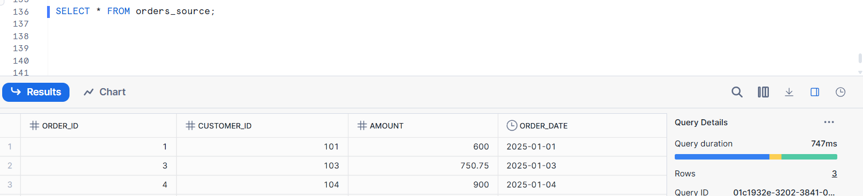
Stream (should be empty if already consumed)
SELECT * FROM orders_source_stream;
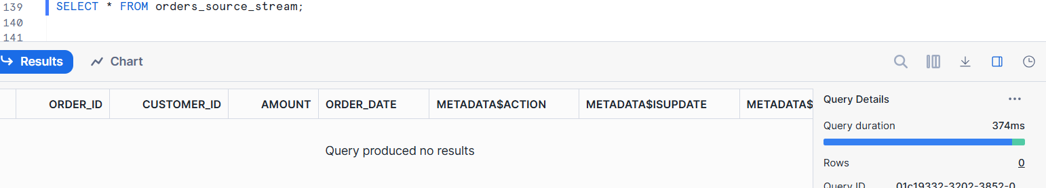
Target table
SELECT * FROM orders_target;

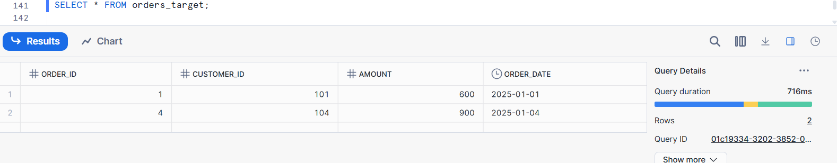
Insert sample data into orders_source
INSERT INTO orders_source VALUES
(10, 201, 500.00, '2025-01-10'),
(11, 202, 1200.50, '2025-01-11'),
(12, 203, 800.75, '2025-01-12');

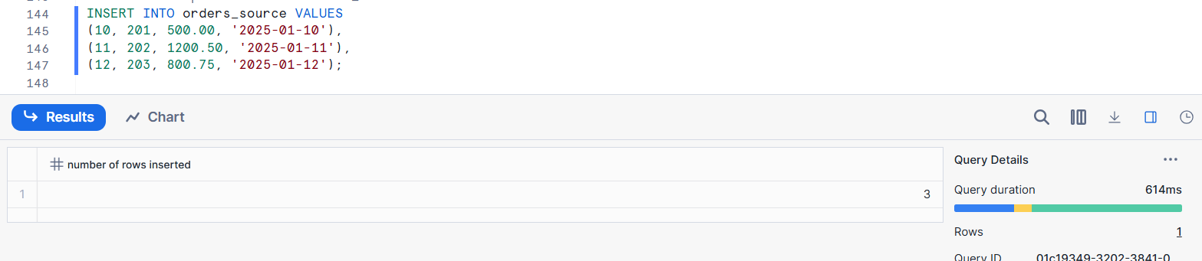
Verify data in source table
SELECT * FROM orders_source;
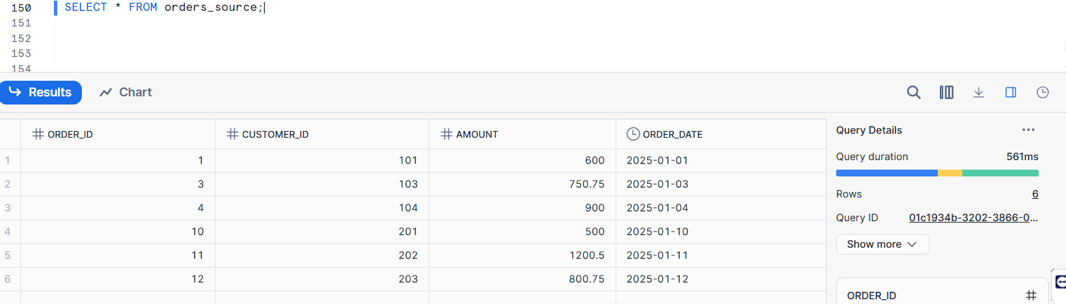
Check how the STREAM captures the changes
SELECT
order_id,
customer_id,
amount,
order_date,
METADATA$ACTION,
METADATA$ISUPDATE
FROM orders_source_stream;
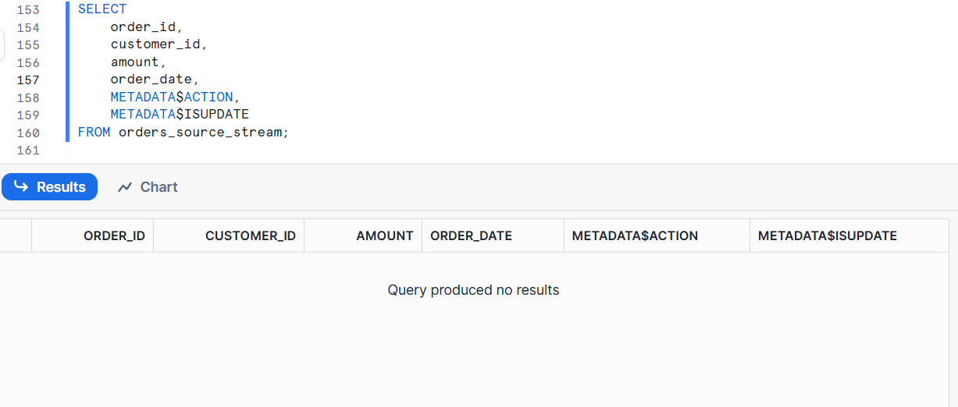

Insert new data into source table
INSERT INTO orders_source VALUES
(30, 401, 2000, '2025-01-30');
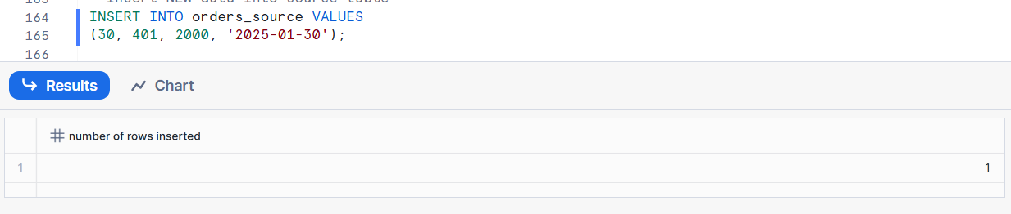
After inserting data into the orders_source table, I ran the below query and got this result.
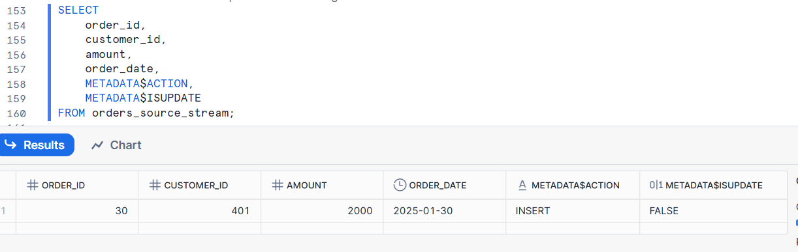

Traditional Batch & Multiple Tasks
- You have three tables:
  - staging_sales(id INT, product_id INT, sale_amount FLOAT)
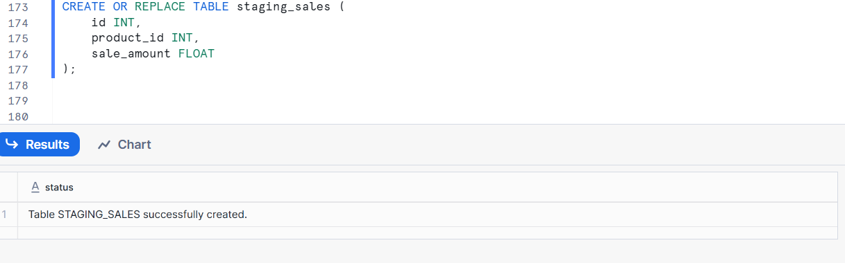
  - clean_sales(id INT, product_id INT, sale_amount FLOAT)
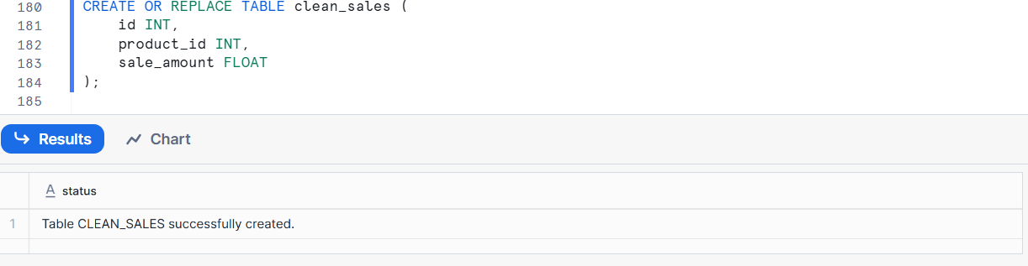
  - sales_summary(product_id INT, total_sales FLOAT)
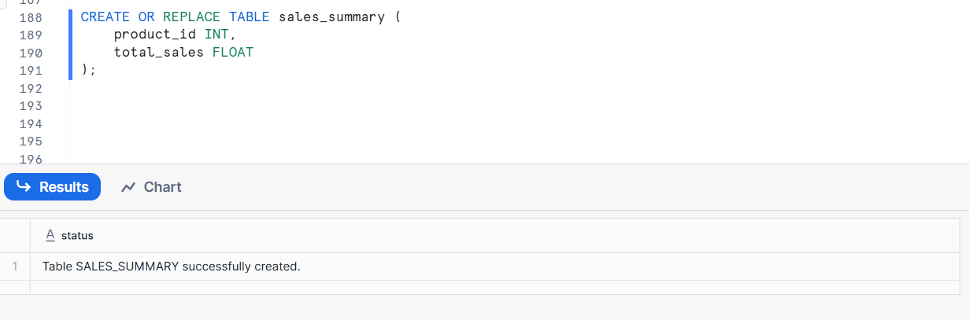
Write SQL queries for three tasks that:
  - Task 1: Load raw data into staging_sales from an internal stage.

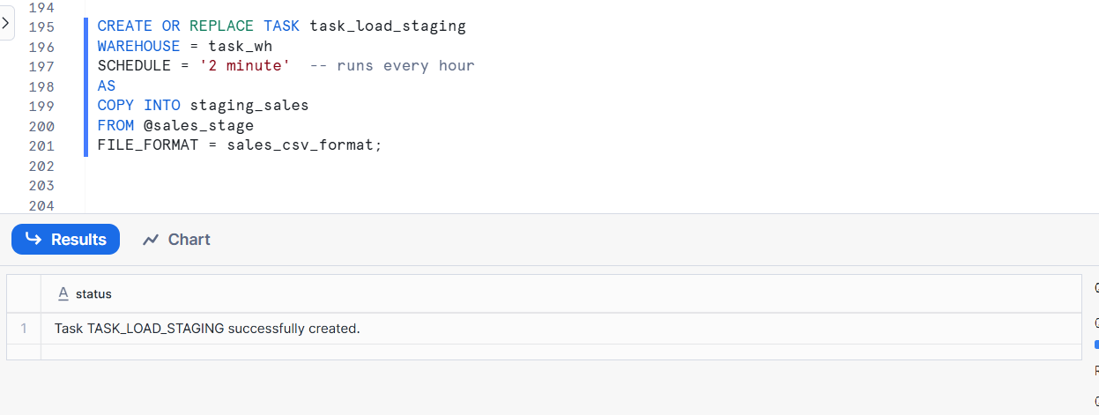
  - Task 2: Transform and insert new records from staging_sales to clean_sales.
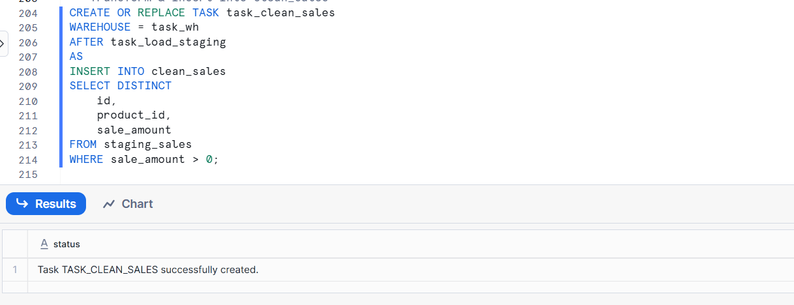
  - Task 3: Aggregate data from clean_sales into sales_summary.
CREATE OR REPLACE TASK task_load_staging
WAREHOUSE = task_wh
SCHEDULE = '2 minute' -- runs every hour
AS
COPY INTO staging_sales
FROM @sales_stage
FILE_FORMAT = sales_csv_format;

---Transform & insert into clean_sales
CREATE OR REPLACE TASK task_clean_sales
WAREHOUSE = task_wh
AFTER task_load_staging
AS
INSERT INTO clean_sales
SELECT DISTINCT
id,
product_id,
sale_amount
FROM staging_sales
WHERE sale_amount > 0;

---Aggregate into sales_summary
CREATE OR REPLACE TASK task_sales_summary
WAREHOUSE = task_wh
AFTER task_clean_sales
AS
MERGE INTO sales_summary t
USING (
SELECT
product_id,
SUM(sale_amount) AS total_sales
FROM clean_sales
GROUP BY product_id
) s
ON t.product_id = s.product_id
WHEN MATCHED THEN
UPDATE SET t.total_sales = s.total_sales
WHEN NOT MATCHED THEN
INSERT (product_id, total_sales)
VALUES (s.product_id, s.total_sales);
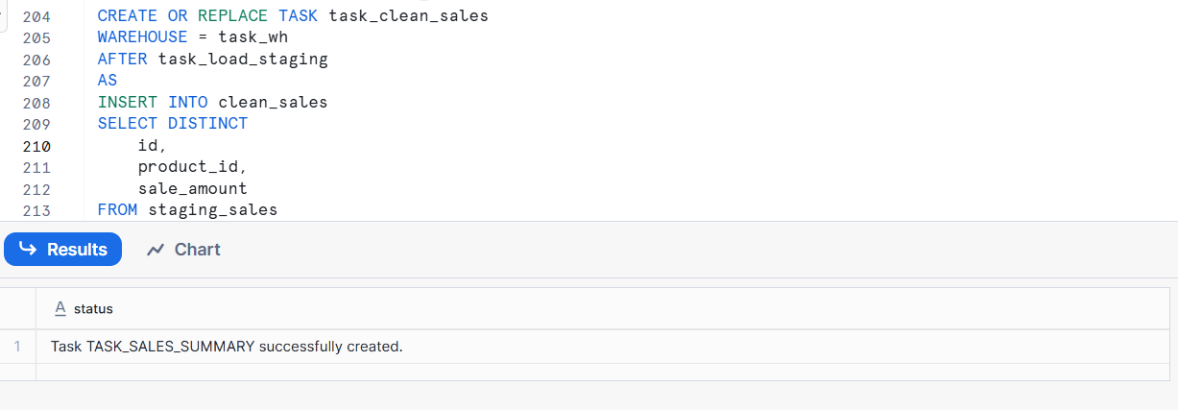

- Schedule these tasks to run sequentially every day at 1 AM, 2 AM, and 3 AM respectively.
Create Task 1 (Run At 1 AM)
CREATE OR REPLACE TASK task_1
WAREHOUSE = my_wh
SCHEDULE = 'USING CRON 0 1 * * * Asia/Kolkata'
AS
INSERT INTO table_1
SELECT * FROM source_table;

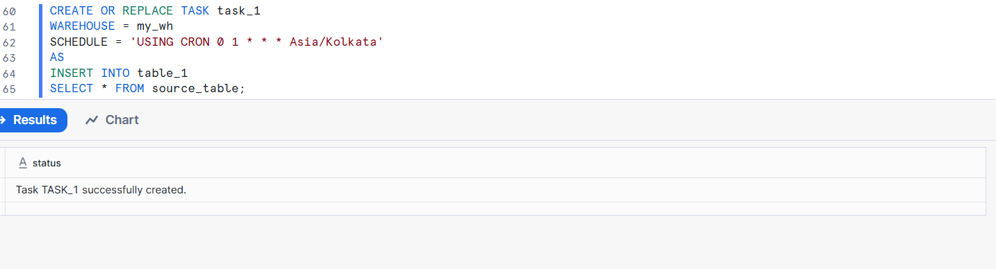
Create Task 2 (Run At 2 AM)
CREATE OR REPLACE TASK task_2
WAREHOUSE = my_wh
SCHEDULE = 'USING CRON 0 2 * * * Asia/Kolkata'
AS
INSERT INTO table_1
SELECT * FROM source_table;

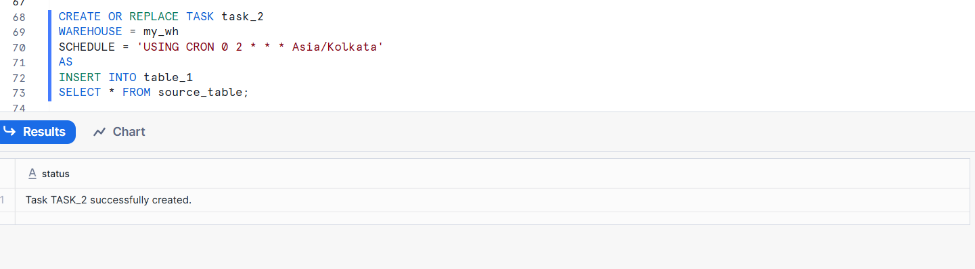
Create Task 3 (Run At 3 AM)
CREATE OR REPLACE TASK task_3
WAREHOUSE = my_wh
SCHEDULE = 'USING CRON 0 3 * * * Asia/Kolkata'
AS
INSERT INTO table_1
SELECT * FROM source_table;

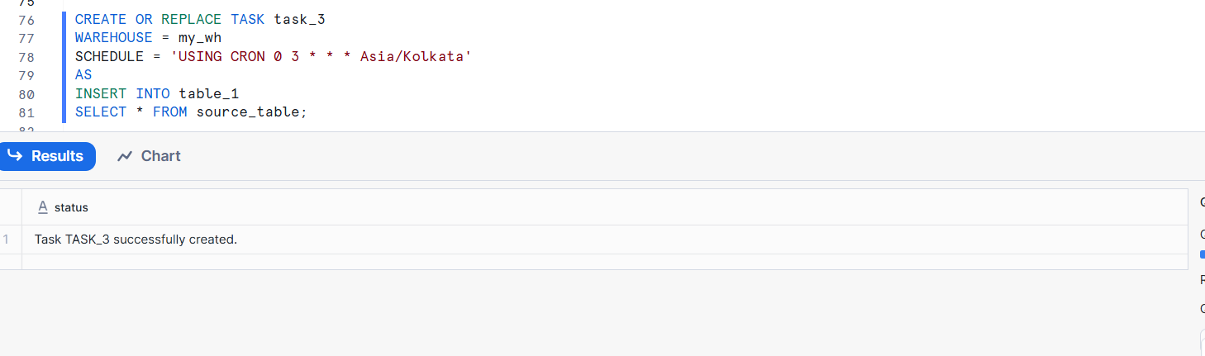
Show Tasks:-
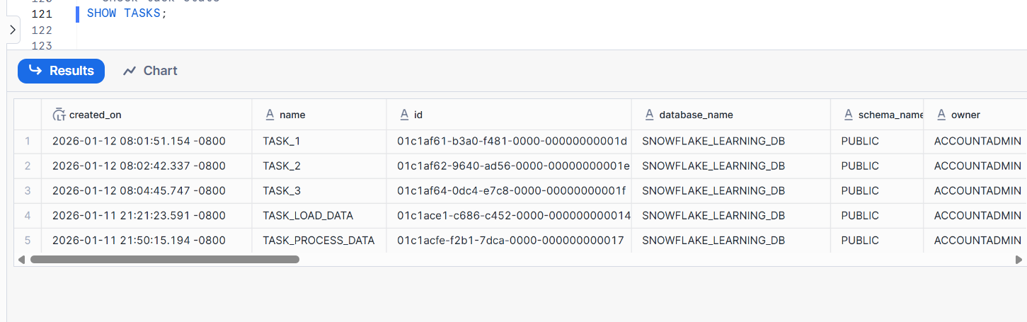

SCD1 Implementation
- Create tables:
  - employee_source(emp_id INT, emp_name STRING, department STRING, salary FLOAT)
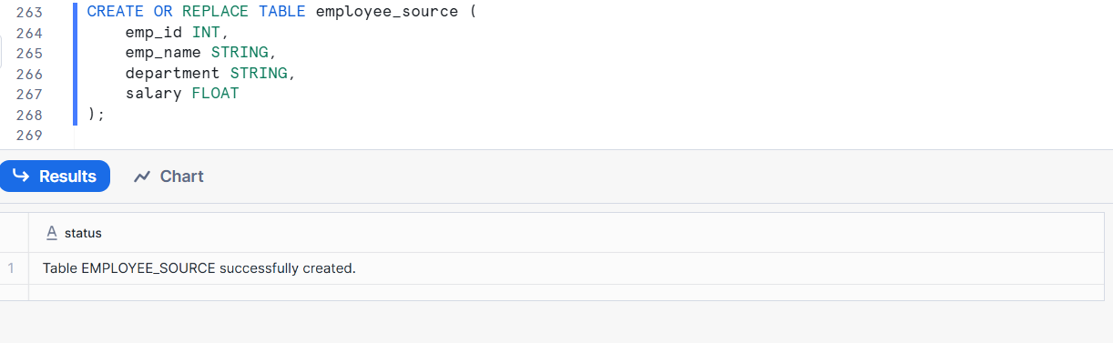
  - employee_target(emp_id INT, emp_name STRING, department STRING, salary FLOAT)
CREATE OR REPLACE TABLE employee_target (
emp_id INT,
emp_name STRING,
department STRING,
salary FLOAT
);

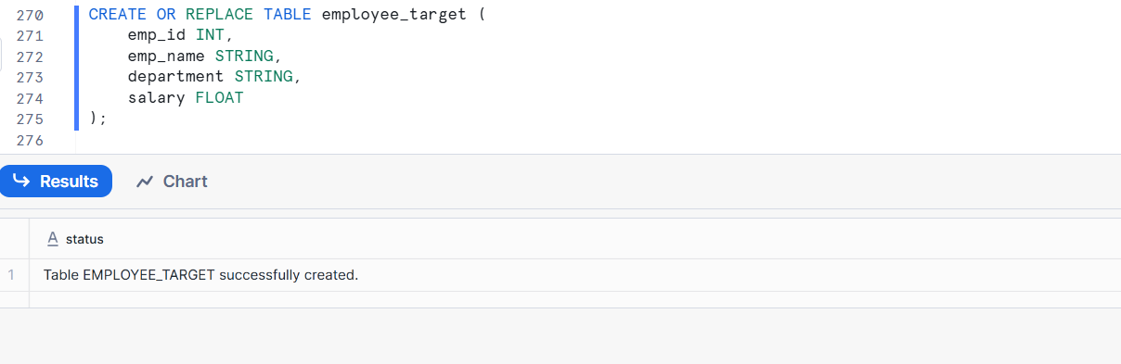
Insert sample data into source
INSERT INTO employee_source VALUES
(1, 'Ramesh', 'IT', 50000),
(2, 'Suresh', 'HR', 45000),
(3, 'Mahesh', 'Finance', 60000);
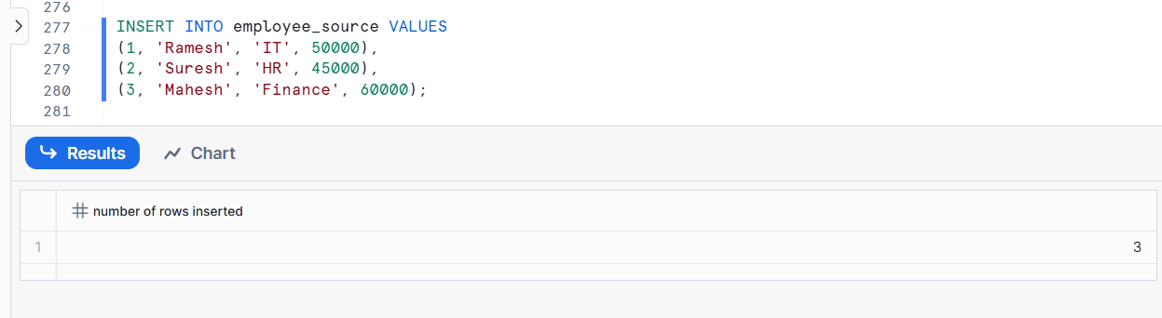
Write a stream on employee_source and a task to merge changes into employee_target implementing SCD Type 1 logic (overwrite existing data).
Create a STREAM on employee_source
CREATE OR REPLACE STREAM employee_source_stream
ON TABLE employee_source;
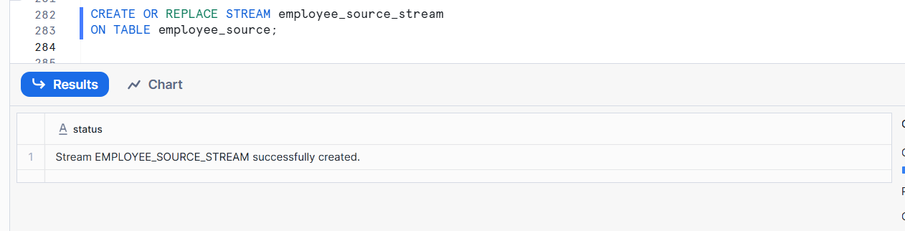
Create a warehouse for the task
CREATE OR REPLACE WAREHOUSE emp_task_wh
WAREHOUSE_SIZE = XSMALL
AUTO_SUSPEND = 60
AUTO_RESUME = TRUE;
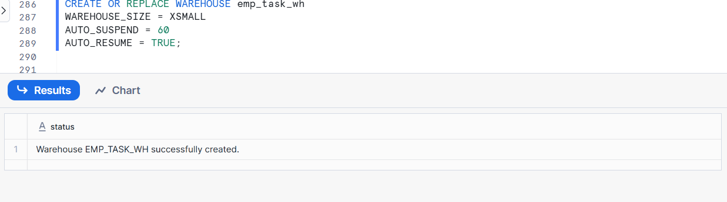
Create TASK to merge changes (SCD Type 1)
CREATE OR REPLACE TASK employee_scd1_task
WAREHOUSE = emp_task_wh
SCHEDULE = '5 MINUTE'
AS
MERGE INTO employee_target t
USING (
SELECT *
FROM employee_source_stream
) s
ON t.emp_id = s.emp_id

-- Handle DELETE
WHEN MATCHED
AND s.METADATA$ACTION = 'DELETE'
AND s.METADATA$ISUPDATE = FALSE
THEN DELETE

-- Handle UPDATE (overwrite existing data)
WHEN MATCHED
AND s.METADATA$ACTION = 'INSERT'
AND s.METADATA$ISUPDATE = TRUE
THEN UPDATE SET
t.emp_name = s.emp_name,
t.department = s.department,
t.salary = s.salary

-- Handle INSERT (new employee)
WHEN NOT MATCHED
AND s.METADATA$ACTION = 'INSERT'
THEN INSERT (
emp_id,
emp_name,
department,
salary
)
VALUES (
s.emp_id,
s.emp_name,
s.department,
s.salary
);
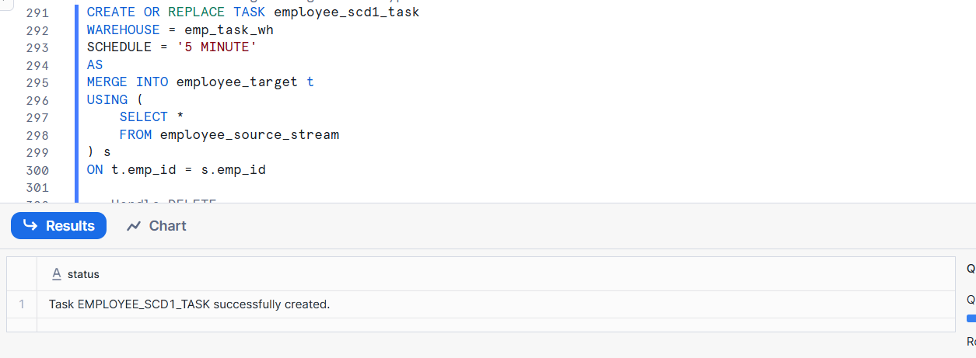
Resume the task
ALTER TASK employee_scd1_task RESUME;
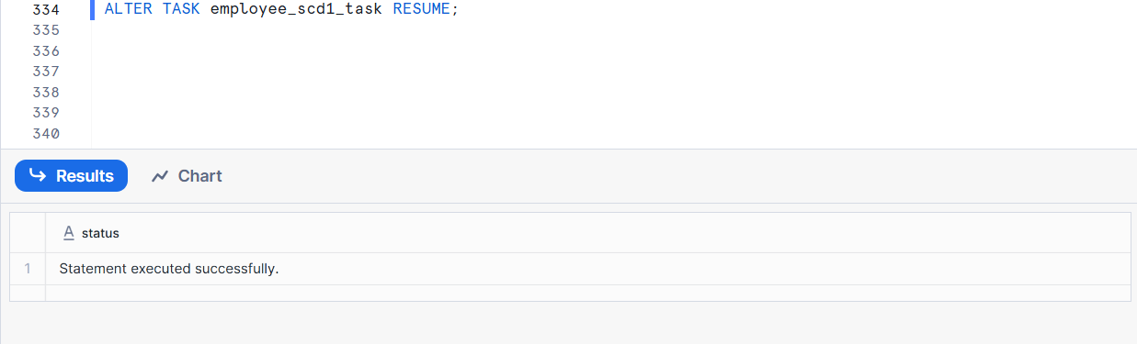
Test SCD Type 1 behavior
INSERT INTO employee_source VALUES
(4, 'Anita', 'IT', 55000);
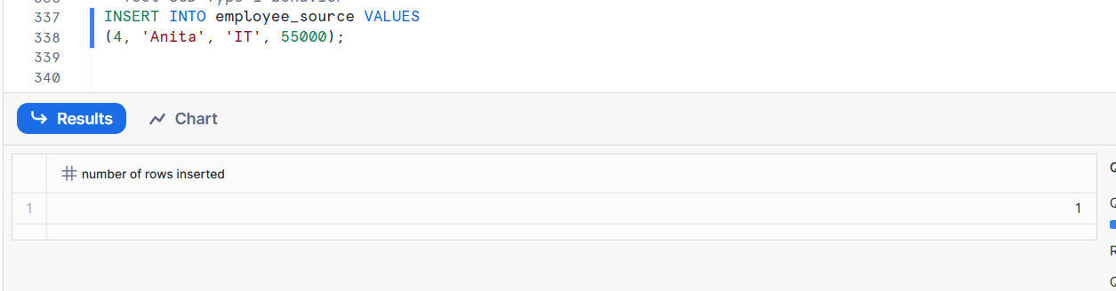
Update employee (overwrite old data)
UPDATE employee_source
SET salary = 65000
WHERE emp_id = 1;
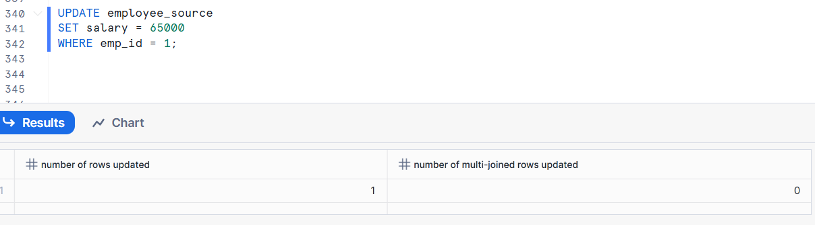
Delete employee
DELETE FROM employee_source
WHERE emp_id = 2;

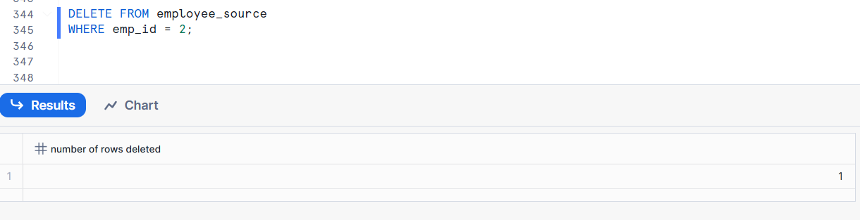
SELECT * FROM employee_target;

SELECT * FROM employee_target;

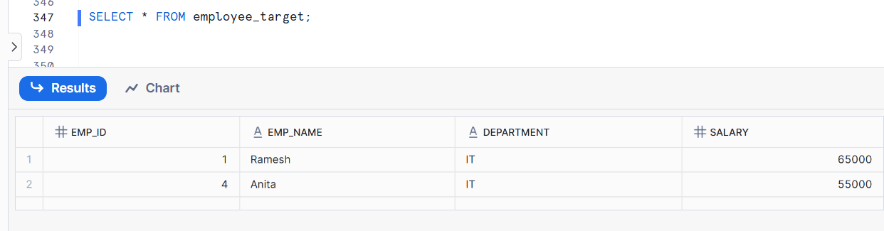

SCD2 Implementation
- Create tables:
  - product_source(product_id INT, product_name STRING, category STRING)
Create Source Table
CREATE OR REPLACE TABLE product_source (
product_id INT,
product_name STRING,
category STRING
);
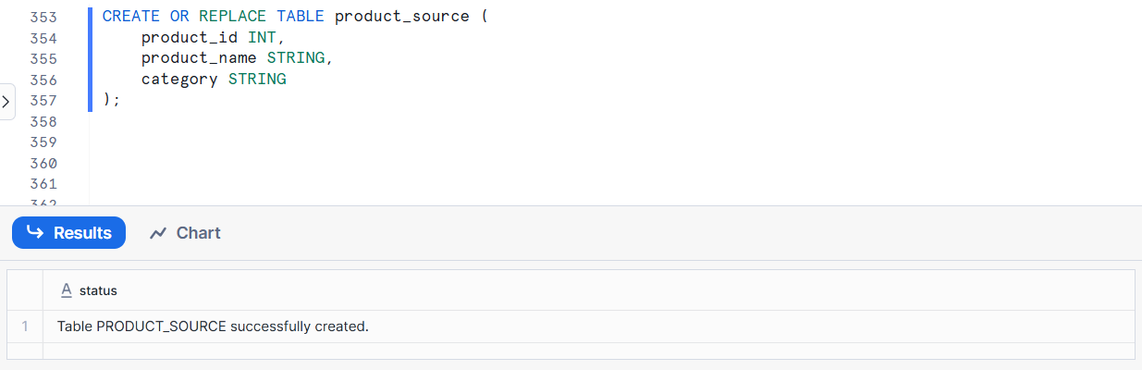
Instert Data
INSERT INTO product_source VALUES
(1, 'iPhone', 'Mobile'),
(2, 'MacBook', 'Laptop');
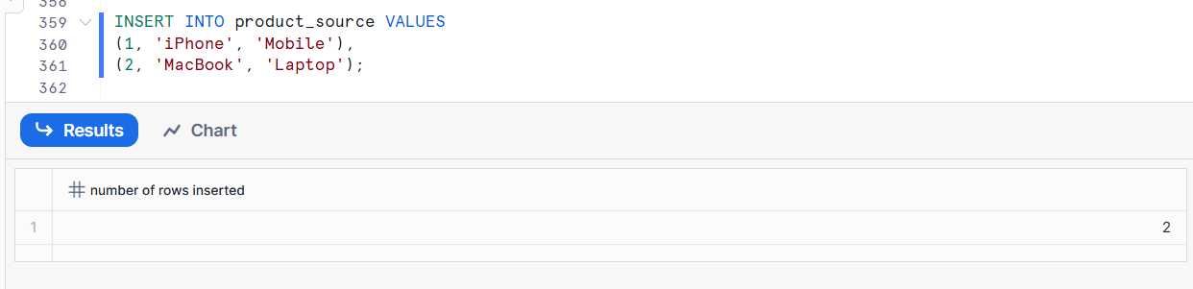
  - product_target(product_id INT, product_name STRING, category STRING, start_date
DATE, end_date DATE, is_current BOOLEAN)
Create Target Table (SCD2 Table)
CREATE OR REPLACE TABLE product_target (
product_id INT,
product_name STRING,
category STRING,
start_date DATE,
end_date DATE,
is_current BOOLEAN
);
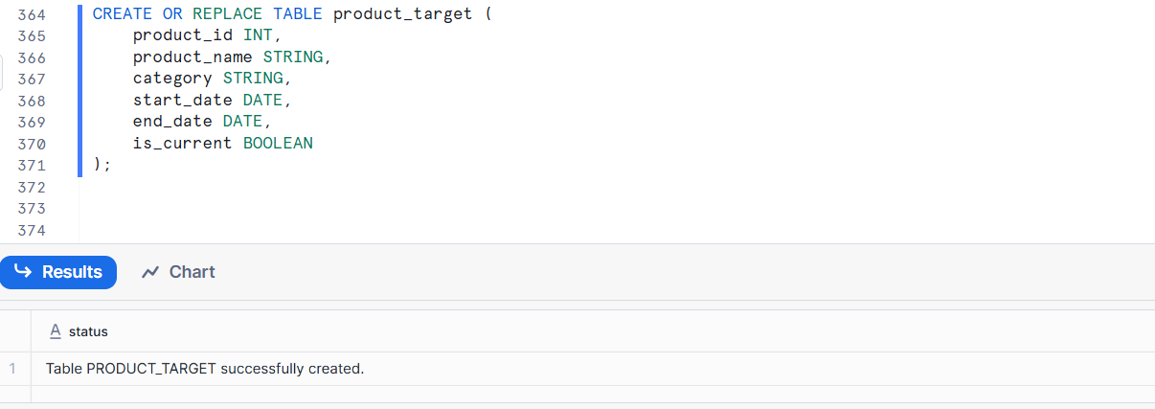
Initial Load into Target
INSERT INTO product_target
SELECT
product_id,
product_name,
category,
CURRENT_DATE,
NULL,
TRUE
FROM product_source;
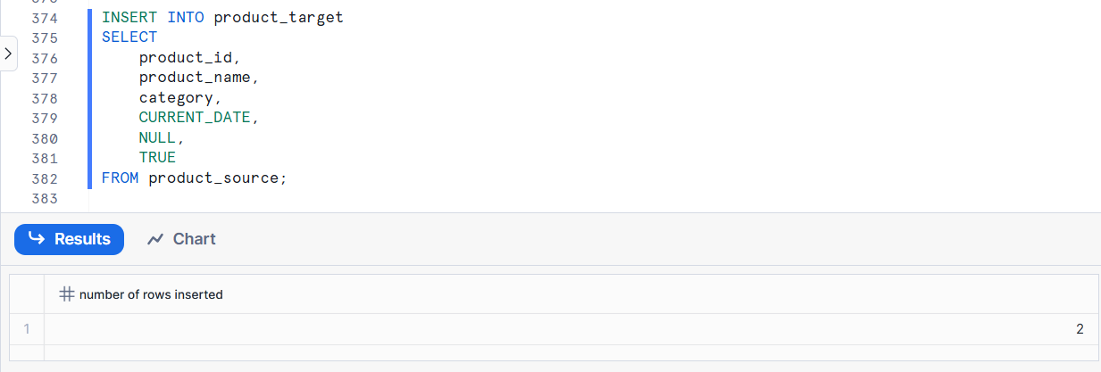
Write a stream and task that implement SCD Type 2 logic by tracking historical changes in product_target.
Create Stream on Source Table
CREATE OR REPLACE STREAM product_stream
ON TABLE product_source;
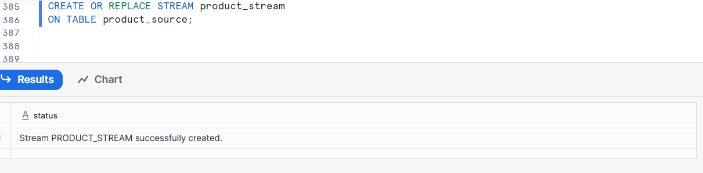

Create Task for SCD Type 2 Logic

CREATE OR REPLACE TASK product_scd2_task
WAREHOUSE = COMPUTE_WH
SCHEDULE = '1 MINUTE'
AS

-- 1. Expire existing records
UPDATE product_target t
SET
end_date = CURRENT_DATE,
is_current = FALSE
FROM product_stream s
WHERE t.product_id = s.product_id
AND t.is_current = TRUE
AND (
t.product_name <> s.product_name OR
t.category <> s.category
);

-- 2. Insert new version of record
INSERT INTO product_target
SELECT
s.product_id,
s.product_name,
s.category,
CURRENT_DATE,
NULL,
TRUE
FROM product_stream s
LEFT JOIN product_target t
ON s.product_id = t.product_id
AND t.is_current = TRUE
WHERE t.product_id IS NULL
OR (
t.product_name <> s.product_name OR
t.category <> s.category
);
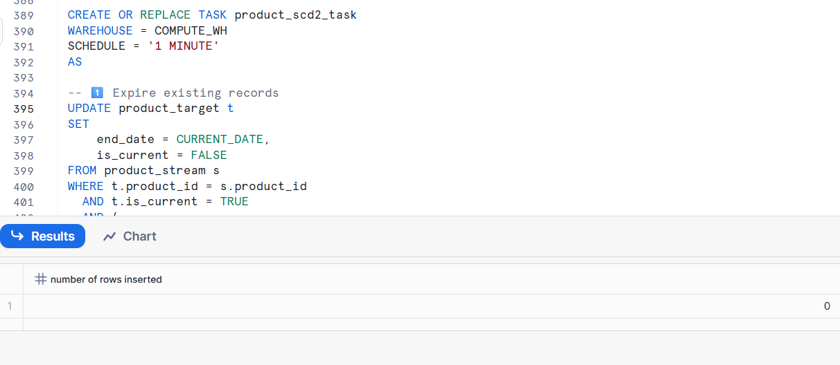
Start the Task
ALTER TASK product_scd2_task RESUME;
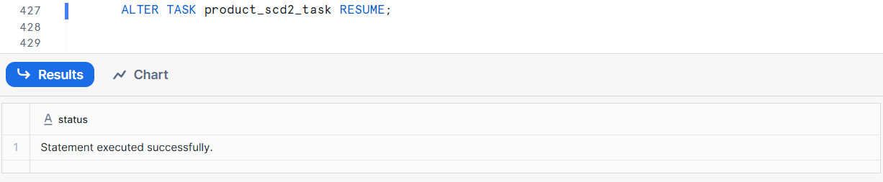
Test the SCD Type 2 Behavior
UPDATE product_source
SET category = 'Smartphone'
WHERE product_id = 1;
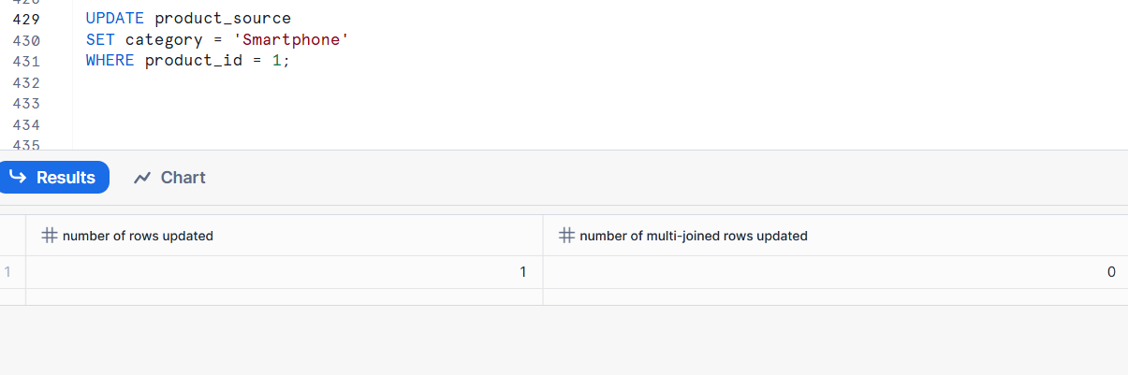
Check Target Table
SELECT * FROM product_target
ORDER BY product_id, start_date;
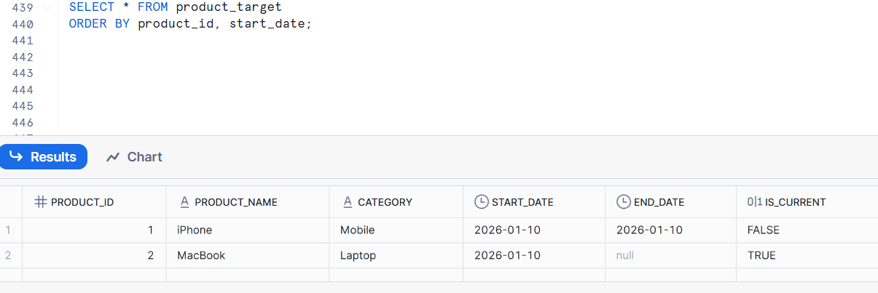

Truncate & Load Scenario
- Given the table daily_sales(date DATE, product_id INT, sales_amount FLOAT), write a task that truncates this table daily at midnight and loads fresh data from a stage.
Create Daily_sales Table

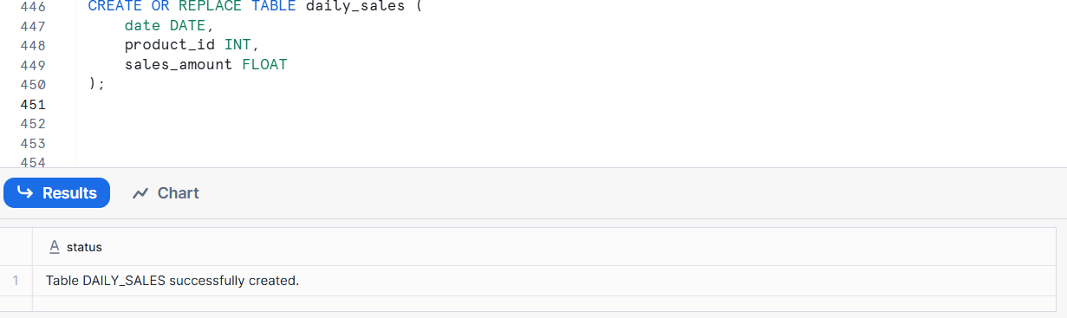
Insert Data Daily_sales
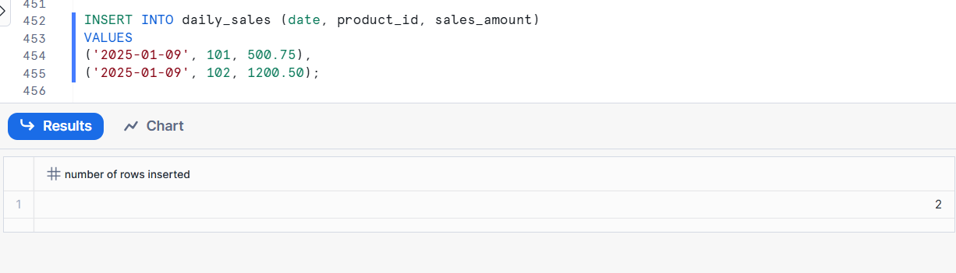
Create File Format sales_csv_format

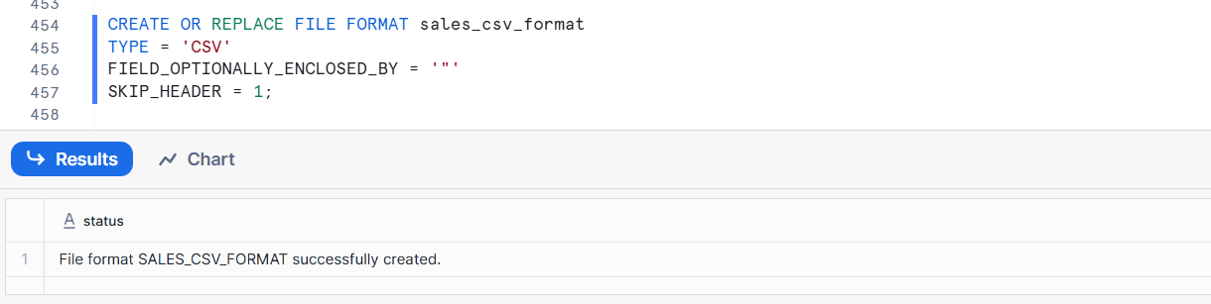
Create stage

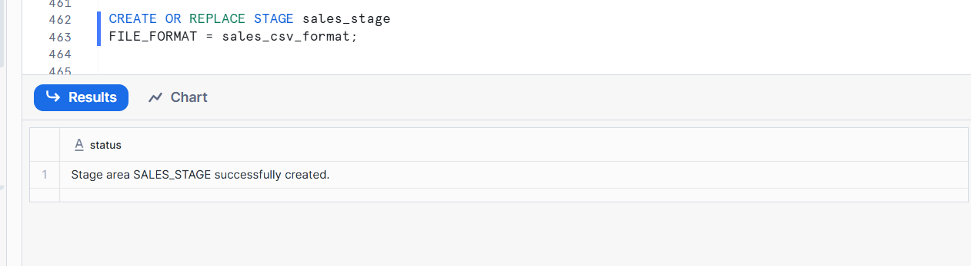

Multiple Tasks with Dependencies
- Write SQL to create two tasks:
  - task_load_data: Loads data into raw_data table every hour.
Create the raw table
CREATE OR REPLACE TABLE raw_data (
id INT,
value STRING,
load_time TIMESTAMP
);
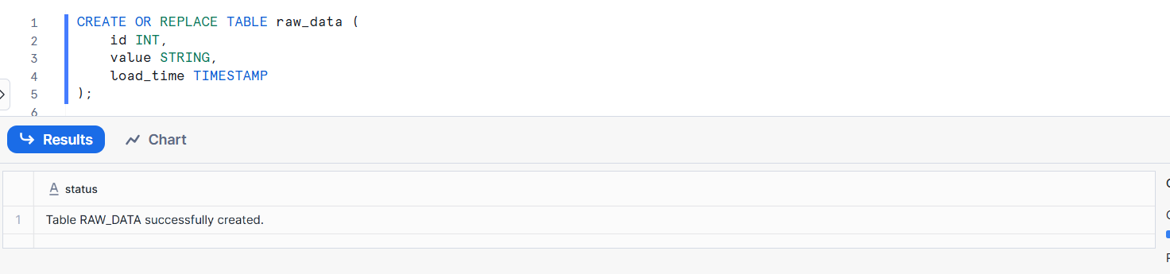

Create a warehouse for the task
CREATE OR REPLACE WAREHOUSE task_wh
WAREHOUSE_SIZE = XSMALL
AUTO_SUSPEND = 60
AUTO_RESUME = TRUE;
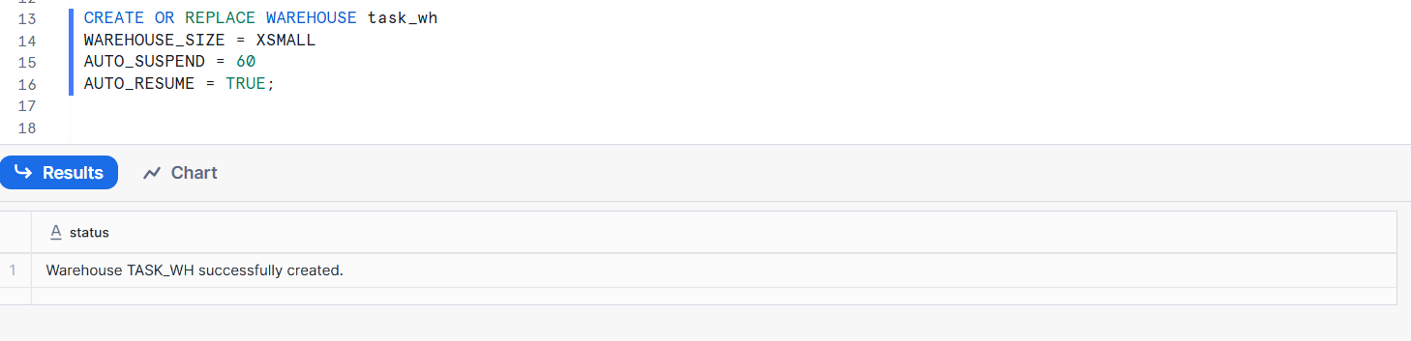
Create task_load_data (runs every hour)
CREATE OR REPLACE TASK task_load_data
WAREHOUSE = task_wh
SCHEDULE = '60 MINUTE'
AS
INSERT INTO raw_data
SELECT
SEQ4() AS id,
'sample_value' AS value,
CURRENT_TIMESTAMP AS load_time;
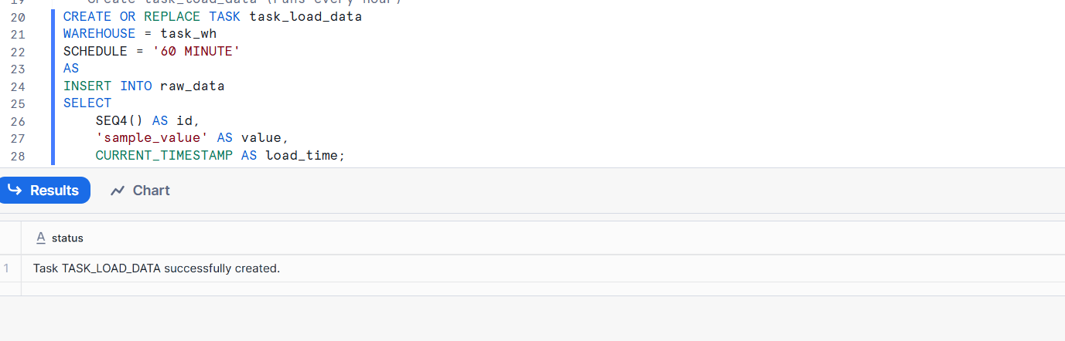
Enable the task
ALTER TASK task_load_data RESUME;
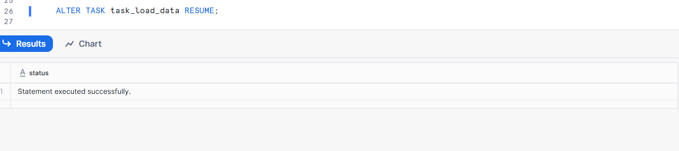
Verify
SHOW TASKS;
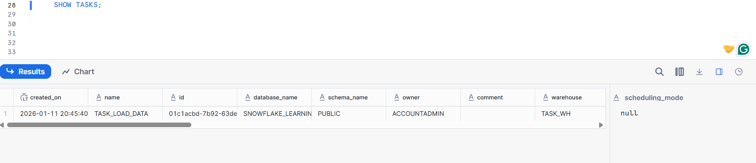

  - task_process_data: Processes data in raw_data and loads into processed_data table, but only runs after task_load_data completes.
Make sure parent task exists
SHOW TASKS;

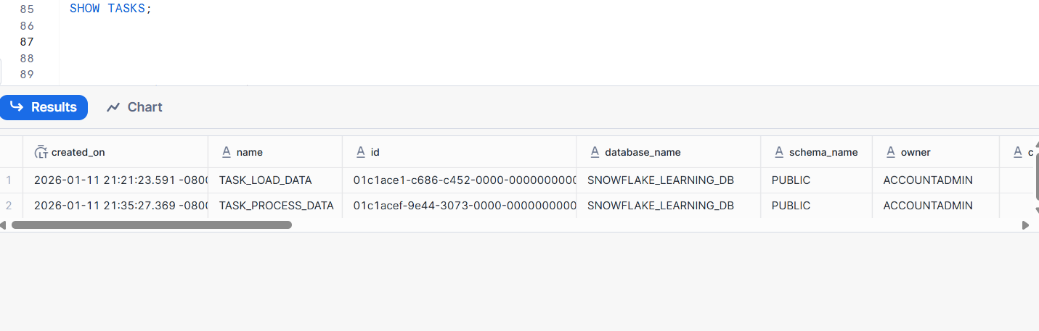
Suspend the parent task
ALTER TASK task_load_data SUSPEND;
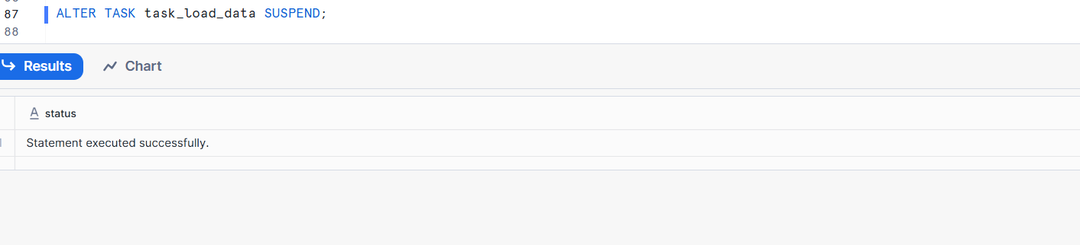
Create the target table
CREATE OR REPLACE TABLE processed_data (
id INT,
value STRING,
processed_time TIMESTAMP
);

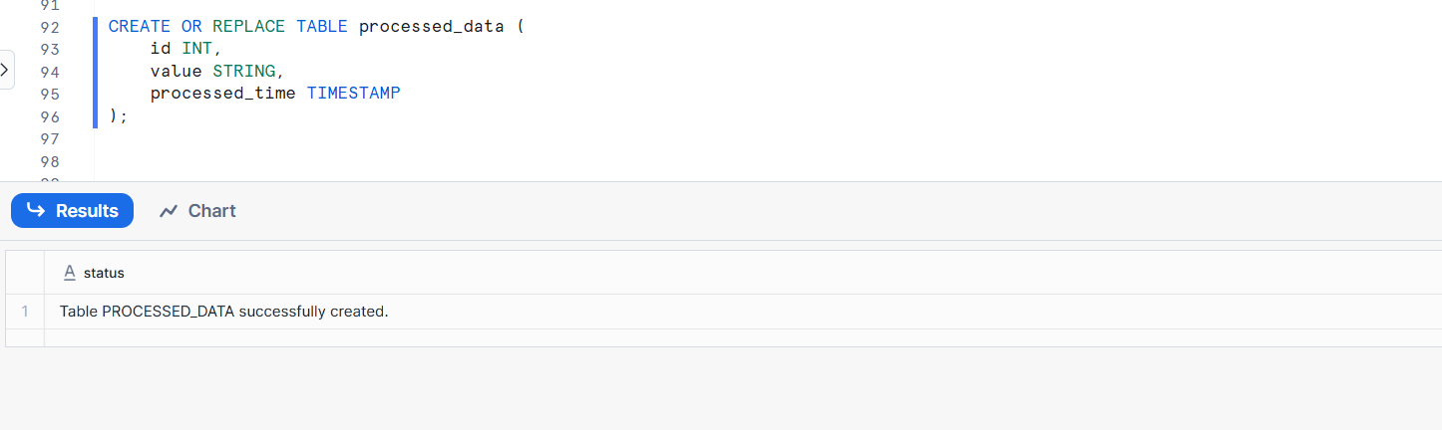
Create task_process_data

CREATE OR REPLACE TASK task_process_data
WAREHOUSE = task_wh
AFTER task_load_data
AS
INSERT INTO processed_data
SELECT
id,
value,
CURRENT_TIMESTAMP AS processed_time
FROM raw_data;
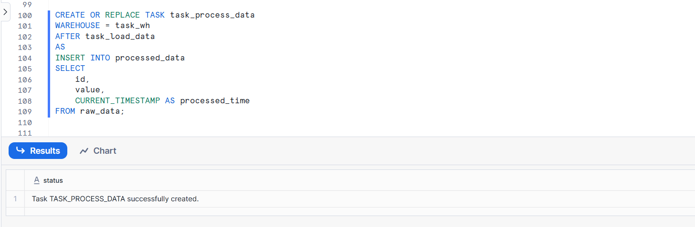
Resume tasks
ALTER TASK task_process_data RESUME;
ALTER TASK task_load_data RESUME;
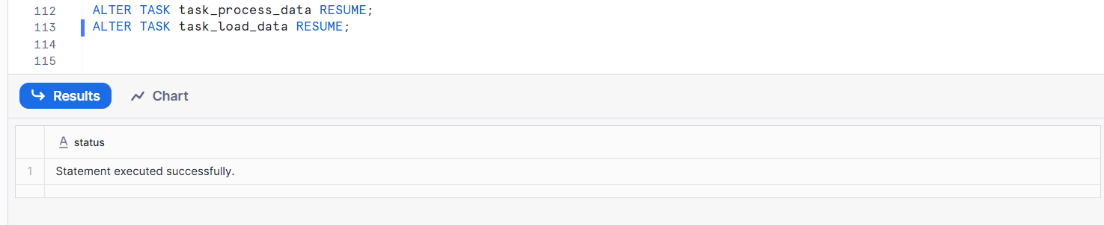
Verify
SHOW TASKS;
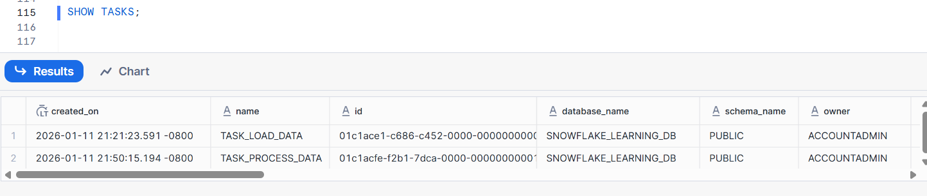
Check execution history
SELECT *
FROM TABLE(INFORMATION_SCHEMA.TASK_HISTORY())
ORDER BY SCHEDULED_TIME DESC;
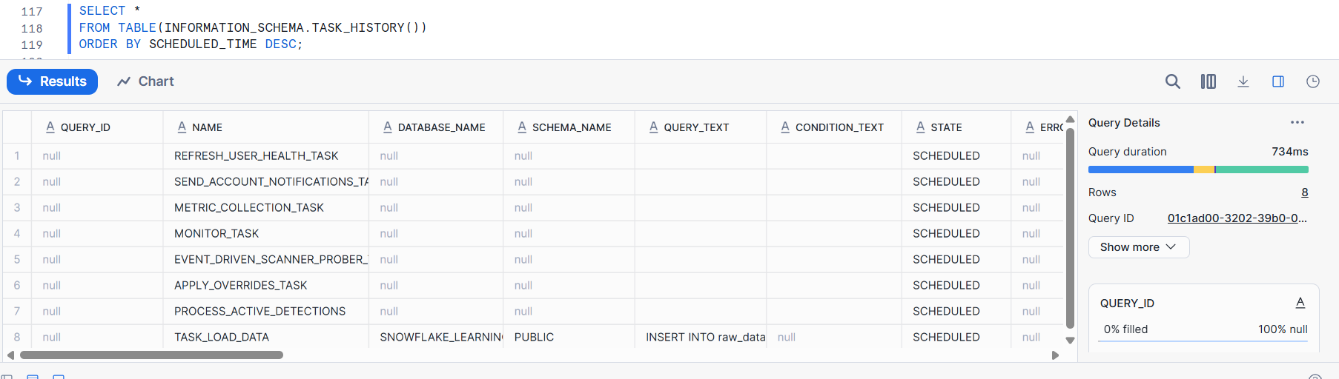

Bonus: Troubleshooting
- Explain what could cause a task not to run even though it is scheduled and how to troubleshoot it.
A scheduled Snowflake task may not run due to suspended state, parent task failure, warehouse or permission issues, SQL errors, or incorrect scheduling. We troubleshoot using SHOW TASKS, TASK_HISTORY, warehouse checks, and privilege validation.

