GNFAC Android Application

The GNFAC Application is just a thin wrapper around content provided by a few URL's. The app just displays the web content, implements the native platform navigation paradigm, and shows up on the desktop / launcher as a native app. The main screen just contains buttons that link to web views, and an embedded map object that is loaded from a web URL, but that is sized to fit.

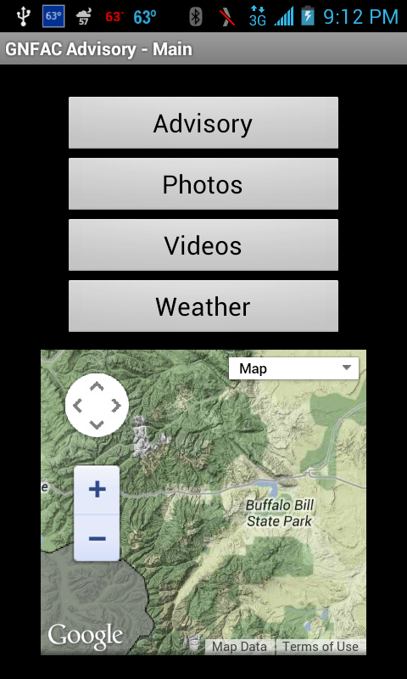

Main Screen Bottom

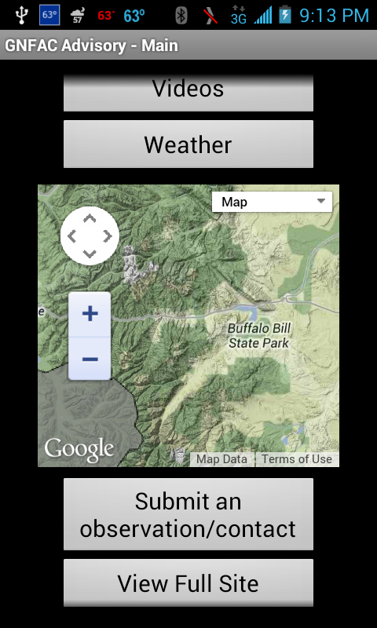

URL Mapping

Embedded Map on Main Screen: http://national-map.jhavalanche.org/iframe.php?center=GNFAC

Advisory: http://www.mtavalanche.com/current?theme=mobile_simple

Photos: http://www.mtavalanche.com/photo?theme=mobile_simple

Video / YouTube: http://www.youtube.com/playlist?list=PLXu5151nmAvT7gHqdNajDBGfGY4u5XMSL&feature=view_all

Weather: http://www.mtavalanche.com/weather?theme=mobile_simple

Submit Observation: http://www.mtavalanche.com/node/add/snow-observations?theme=mobile_simple

View Full Site: http://www.mtavalanche.com

