EE5175-Assignment-2

Winston Doss
EE23E008

REPORT
Change Detection:
matplotlib.image and sympy was used to solve the problem in this assignment.
We were given the following point-correspondance.
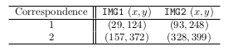

Using the above point correspondance the rotation and translation required to align the image is found by subsituiting values for (xt,yt) [from image 1] and (xs,ys)[from image 2]. We obtain 4 equations which are solved using solve() of sympy library.

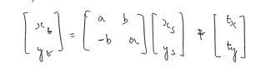

We obtain the values of a,b,tx,ty by the solving the equations.
These values were used to rotate and translate the img2.
Observation:
The values of (a,b,tx,ty) are as follows:
(0.8654551047086868, -0.4992182093148438, 72.31879117217338, -137.0601594340348)
We obtain the following image:
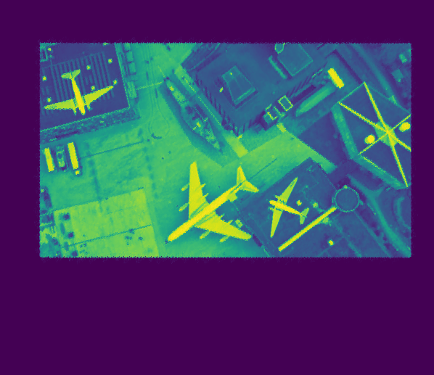
(Stored as rotated_img2.png)
The image 1 was of different size than the image 2. So we had make a canvas of the same size as image 2 and copy image 1 on it. We call that our source image.
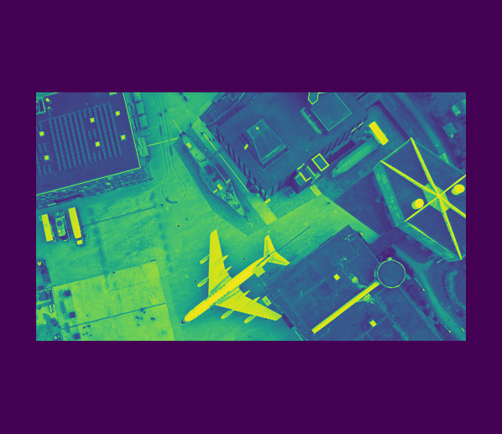
(Stored as source.png)

Observation:
Notice that the source and the rotated image are not really aligned.
The rotated image is has a little offset.

To fix this offset, we find the first pixel coordinate of both source image and the rotated image. We find the offset with the differce between these coordinates.

Observation:
The offset is calculated as (-55,15)

We translate the rotated image by that offset to obtain the below image.
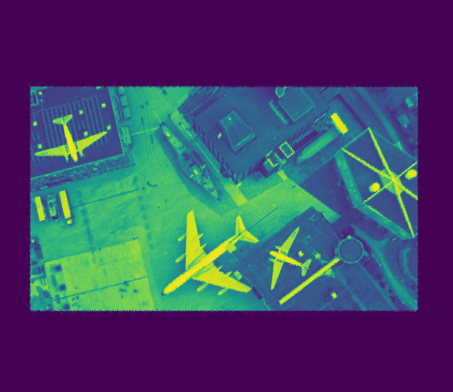
(Stored as aligned_target.png)
Observation:
Notice that now the source and the newly aligned image are aligned.

Now we subtract the image matrix of image1 and aligned image to obtain the difference between the two, which is shown below.
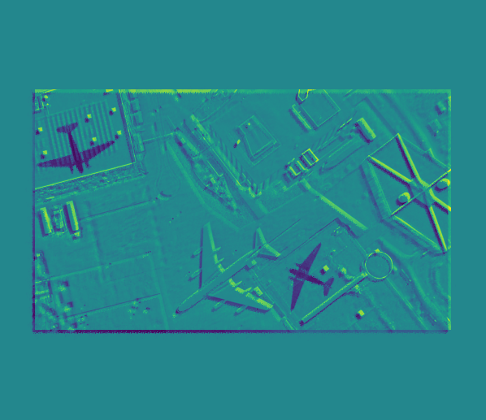
(Stored as changed.png)

Observation:
The change is shown in higher darkness(Black). The green areas correspond to close to zero values in the image matrix.

