EE5175-Assignment-3

Winston Doss
EE23E008

REPORT
Image mosaicing:
cv2(Just to read images and perform sift) and sympy was used to solve the problem in this assignment.
The provided code implements image stitching using RANSAC (Random Sample Consensus) algorithm for robust homography estimation and blending techniques to create a seamless stitched image.
Step 1:
Feature matching is performed between pairs of images (img1-img2 and img1-img3) using the SIFT (Scale-Invariant Feature Transform) algorithm.
Step 2:
RANSAC algorithm is applied to each pair of images to estimate the homography matrix robustly. It randomly samples a minimal set of point correspondences, computes the homography using these correspondences, and evaluates its quality by counting inliers that agree with the model.
Computation of homography:
form_part_a_matrix():
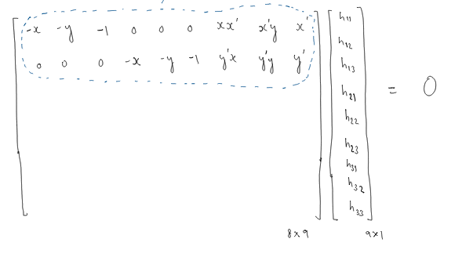
This function return the circled part given 1 point correspondance as input.
In this way 4 parts of A matrix are made with 4 point correspondance.
All of these are stacked in form_a_matrix().
Nullspace() takes the svd of A matrix and return the last column of V.
form_homo_mat() arranges the solution obtained from nulspace function in a 3x3 matrix form.

Step 3:
The estimated homographies are used to transform the coordinates of pixels from the source images to the reference image (img1). This involves mapping pixels from each source image to the reference image using the estimated homographies.
Step 4:
The pixel values from multiple images are blended together to create a seamless stitched image. This is achieved by averaging pixel values at corresponding locations in the canvas, considering contributions from all images.
Step 5:
The final stitched image is saved as 'Canvas.png'.

Observation:
- It is important to make sure you maintain the coordinates as homogenous. I had assigned the last element as 0 instead of 1 and my output was just chaos.
- Do not forget bilinear interpolation. It really improves the image quality.

Output:
Given Images:
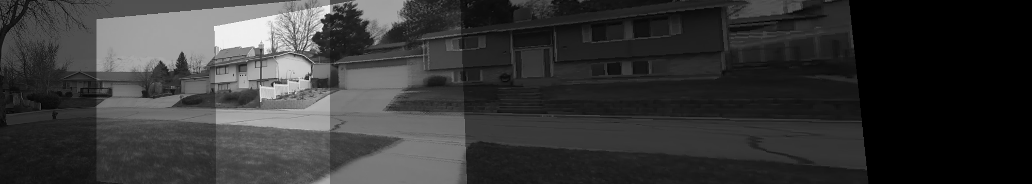
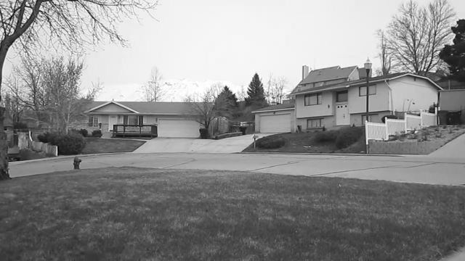
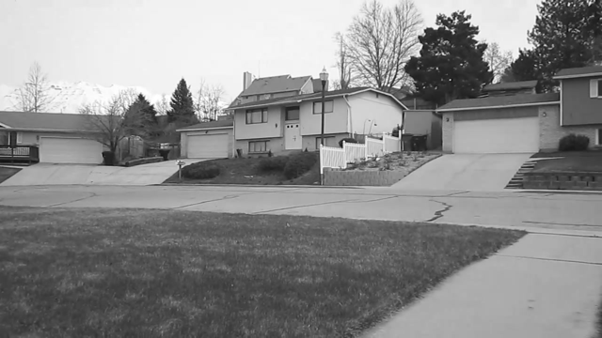
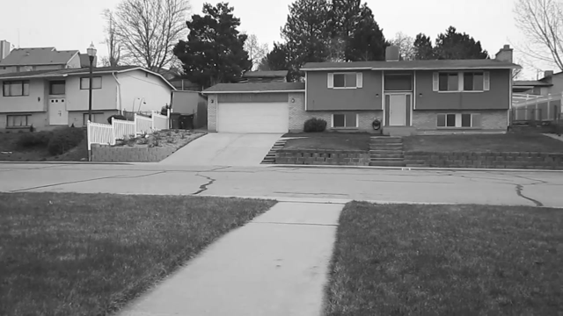

Pictures taken form ED balcony:
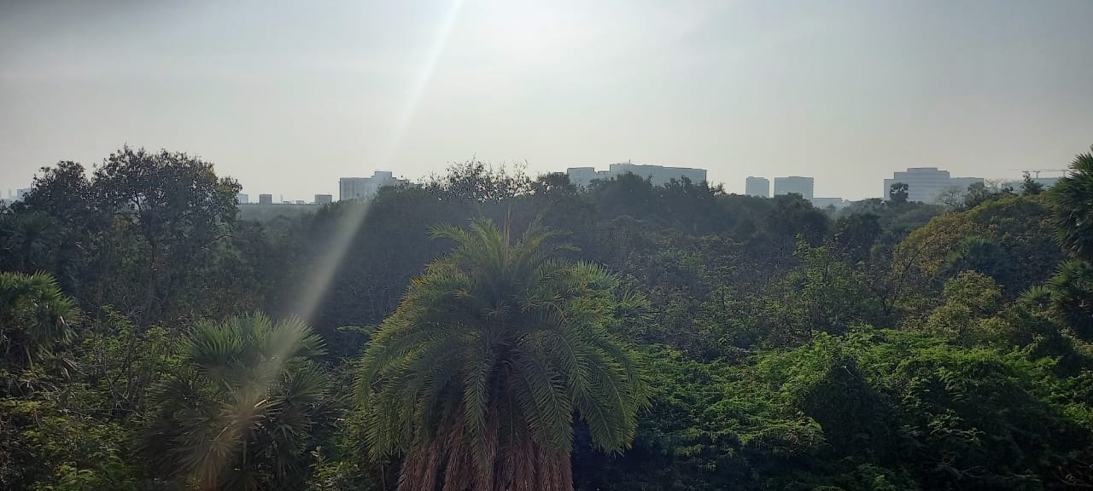
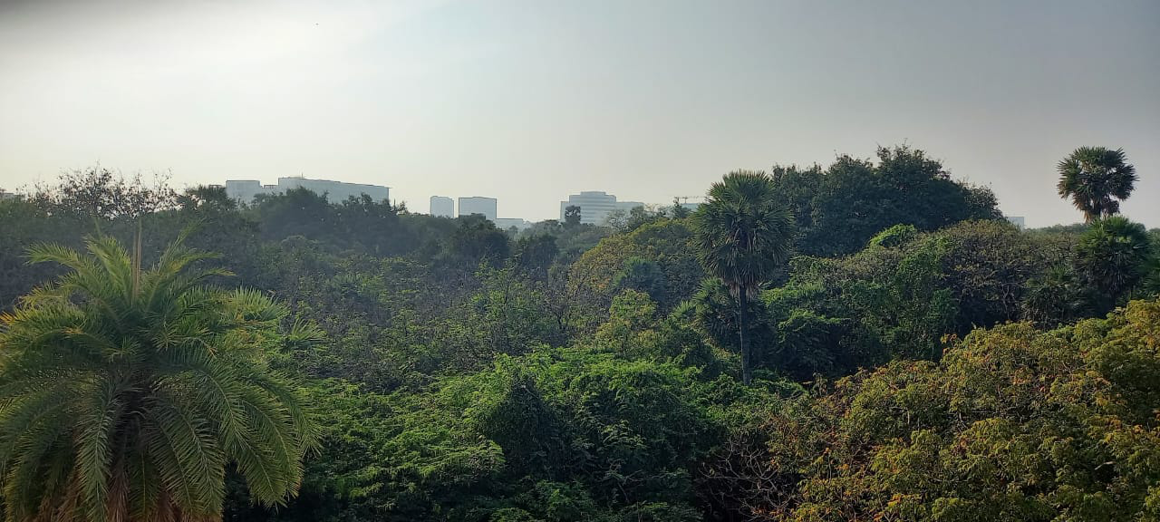
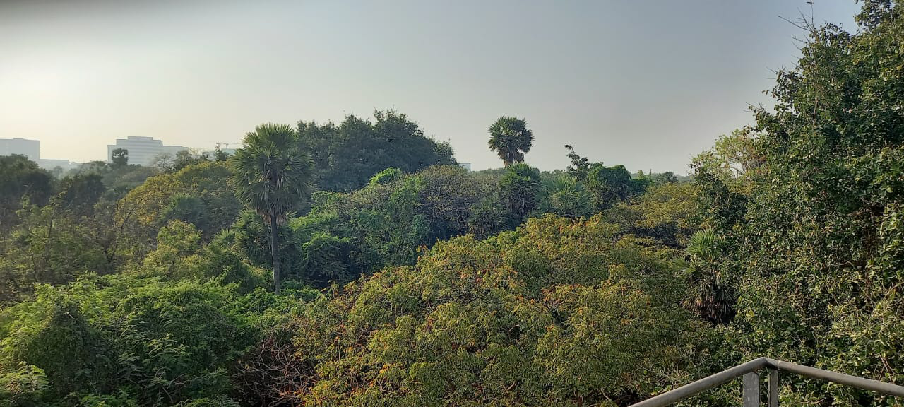

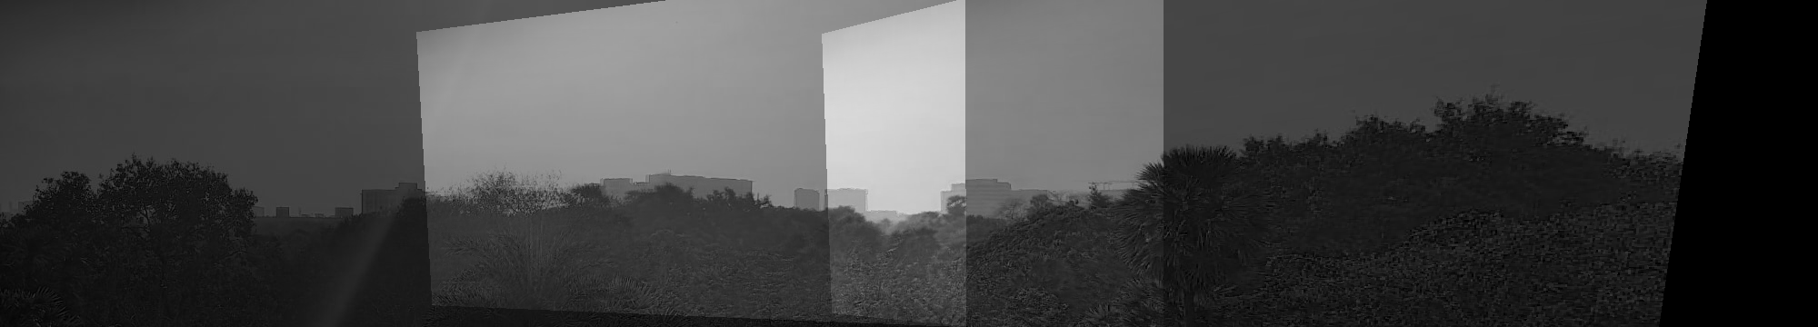
(Just the top part is mosaiced)

