EE5175-Assignment-4

Winston Doss
EE23E008

REPORT
Gaussian blurring of images:
Gaussian blur is a commonly used image processing technique that helps to reduce noise and detail in images by applying a weighted average to each pixel based on a Gaussian distribution. In this report, we discuss the implementation of Gaussian blur using convolution with a Gaussian kernel.
Step 1:
A 2D Gaussian kernel is generated based on a specified sigma value. The gaussian() function computes the values of the Gaussian distribution and constructs a kernel of appropriate size.
To ensure that the kernel can be applied to all pixels of the image, the input image is padded with zeros around the edges. This padding allows the kernel to overlap with pixels at the image boundaries.

Step 2:

The input image is convolved with the Gaussian kernel using the sliding kernel method. The conv() function slides the kernel over the image and computes the weighted sum of pixel intensities within the kernel's neighborhood.

Observation:
- Padding is needed to be done so that the center of the kernal is aligned with the images pixel which will be places at the same corresponding location in the output images.
- 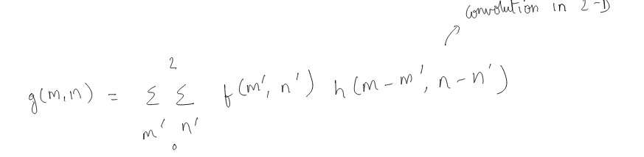
- If the above formula is implemented with nested loops the program runs for too long. And so sliding kernal is used.
- At σ=0.3 the image becomes distrorted.

Output:
Given Image:
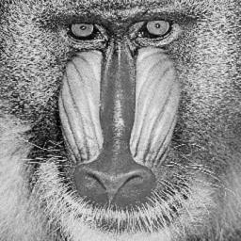

Output images:
σ=1.6
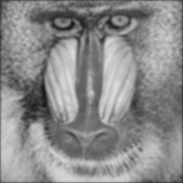

σ=1.2
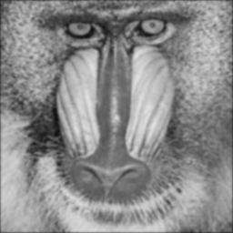

σ=1.0
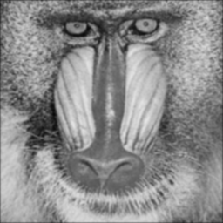

σ=0.6
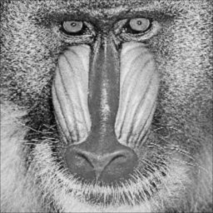

σ=0.3
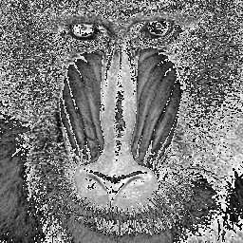

σ=0

ZERO DIVISION IS NOT POSSIBLE

