EE5175-Assignment-5

Winston Doss
EE23E008

REPORT
Q1:
Gaussian blurring of images(with sigma as a gaussian distribution):
The provided code implements Gaussian convolution with adaptive sigma for image blurring. Gaussian convolution is a widely used technique in image processing for smoothing or blurring images. Unlike traditional Gaussian convolution, which uses a fixed sigma value for blurring, this implementation dynamically adjusts the sigma value based on the local characteristics of the image.
Adaptive Sigma Calculation
The sigma value for each pixel in the image is dynamically calculated based on its position and the size of the image. The sigma_calculation function computes the sigma value for a given pixel position (m, n) and the total size of the image N. This calculation follows a predefined formula that incorporates the pixel position relative to the center of the image and an empirically determined scaling factor a. The sigma value is adjusted to ensure that it decreases as the distance from the image center increases, leading to a smoother transition of blurring across the image.
Gaussian Distribution Calculation
The core of the implementation lies in the calculation of the Gaussian distribution and the corresponding sigma value. The gaussian_value function computes the value of the Gaussian distribution at a given pixel location (x, y) with respect to the center (midx, midy) and a specified sigma. This function follows the standard formula for the Gaussian distribution. The gaussian function generates a Gaussian kernel based on a given sigma value. It iterates over the kernel matrix and computes the Gaussian value at each position using the gaussian_value function. The resulting kernel is normalized to ensure that its elements sum up to 1, maintaining energy conservation.
Convolution Process
The conv function performs the actual convolution operation on the input image. It iterates over each pixel in the image and generates a Gaussian kernel with an adaptive sigma value based on the pixel's position. For each pixel, the function computes the size of the kernel, pads the input image to handle boundary conditions, and convolves the kernel with the corresponding image region. The resulting convolution output is stored in the output matrix.

The code reads an input grayscale image, 'Globe.png', using the OpenCV library. It then applies the adaptive Gaussian convolution to blur the image, generating an output image with reduced noise and smoother transitions between image features. Finally, the blurred output image is saved as 'output.png'.

Input Image: Output Image:
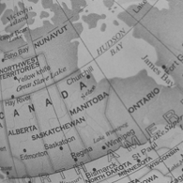
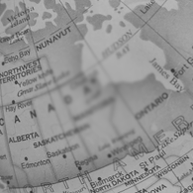

Observation:
The sigma at the centre is high. And so the image is also highly blurred. As we go towards the edges the sigma reduces and so the image becomes more sharper.

Q2:
a & b)
In part a, We use the space invariant blurring code done in assignment 4 with sigma=1
In part b, we set the sigma(m,n) as 1. Basically the sigma is not varying.

Both the outputs were obtained. They are attached below.
Output a Output b

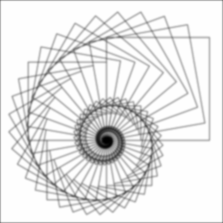

Observation:
Both outputs are equally blurred.

