EE5175-Assignment-6

Winston Doss
EE23E008

REPORT

The code presented aims to analyze depth information from a stack of images using a focus operator and visualize it in a 3D scatter plot. The depth information is derived from the sharpness of each pixel across multiple frames.

1. The code begins by loading a stack of images from a MATLAB file using scipy.io.loadmat.
2. Focus operator is applied on all the images. We use the SML operator.

2.1 We apply below kernal on all the images and an anologous kernal about y.
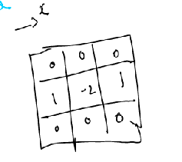

2.2 Now we have 2 stacks of images. We take the modulus of them.
2.3 We sum the 2 stacks.
2.4 We add the neighbours of a point and assign that value to the point. This is done by using the kernal that has all ones.

3. Now, for one pixel, we compare all the value for that in the stack and find the maximum. That will be fm. We also consider fm-1 and fm+1. And we apply the below formula.

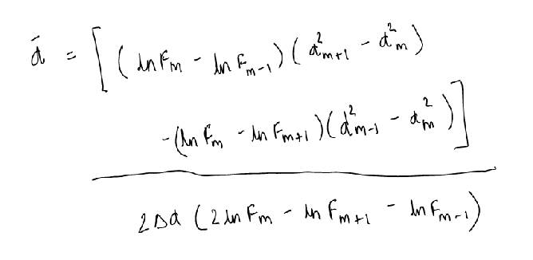

5. We do the same for all pixel coordinates and plot the 3d map.

