EE5175-Assignment-7

Winston Doss
EE23E008

REPORT

In this assignment we have performed image reconstruction using the magnitude and phase spectra obtained from the 2D Discrete Fourier Transform (DFT). The 2D DFT is calculated using row-column decomposition. After obtaining the magnitude and phase spectra from two input images, the code reconstructs two new images by swapping their magnitude and phase information.

1D Discrete Fourier Transform (DFT):
We define a function dft_1d(signal) to perform 1D DFT on a given signal. This function calculates the Discrete Fourier Transform using the twiddle factor matrix

2D Discrete Fourier Transform (DFT):
- The dft_2d(image) function computes the 2D DFT of the input image. It first applies 1D DFT along the rows and then along the columns using row-column decomposition.
- The magnitude and phase spectra of the image are obtained by calculating the absolute value and angle of the shifted DFT result.
Inverse 1D DFT:
- The code defines a function idft_1d(spectrum) to perform the inverse 1D DFT. It computes the Inverse Discrete Fourier Transform using the twiddle factor matrix
Inverse 2D DFT:
- The idft_2d(spectrum) function performs the inverse 2D DFT. It first applies inverse 1D DFT along the rows and then along the columns.
Image Reconstruction:
- After obtaining the magnitude and phase spectra of two input images, the code reconstructs new images by combining the magnitude of one image with the phase of the other image, and vice versa.

OUTPUT:

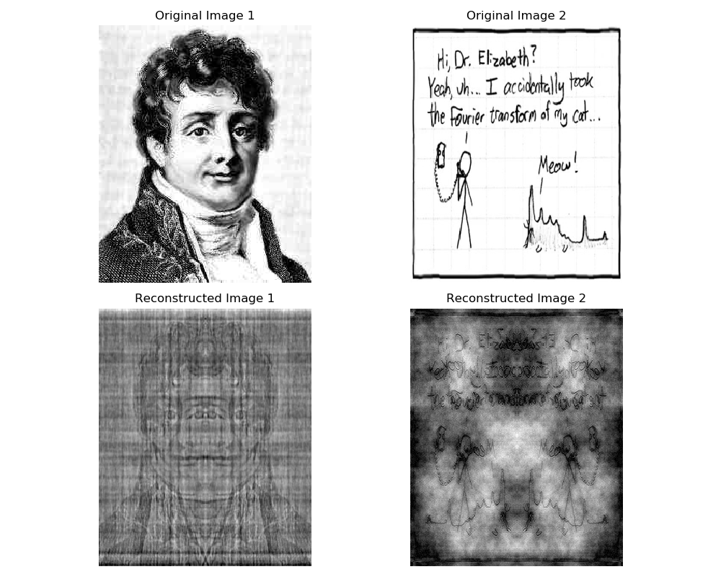

OBSERVATIONS:

Phase seems to play a major part in how the image looks. Because even after we exchanged the magnitude and phase. The image looks like the image corresponding to the phase of that.

